RFP OF VIRTUAL EMAIL SYSTEM

Technologie Solution, www.technologiesolution.com , looking for experienced PHP programmer (Core php) who can work on this project's functionality. We have to develop virtual mail functionality.
Requirement Explanation: Website is for products where Buyer and Seller can post or buy any products.
After selecting product and when Buyer wants to interact with Seller, he can send messages through any webmail (e.g. gmail, yahoo, aol). Buyer and seller can communicate with Virtual mail system without knowing each other's email id. More description is mentioned in image below.

Reference site: www.craiglist.org

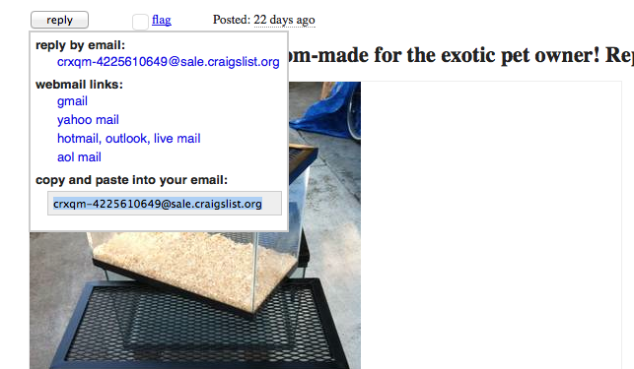

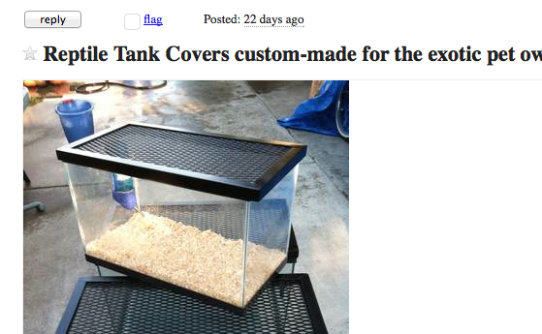
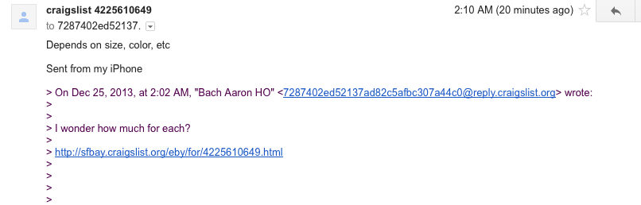
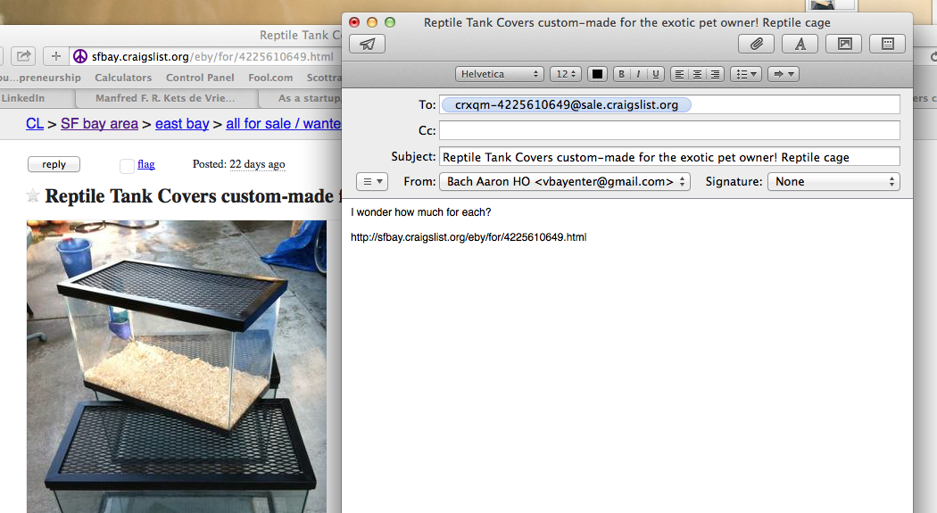
If I choose virtual-hiden-email-identity, then my real email will not show in seller email inbox, but only machine that virtually create to pass a message to seller. Even when I put my real email to reply, but the system will not use my real email to seller.
If I choose one of the list below by webmail such as gmail, yahoo mail, Hotmail, outlook, live mail, or aol mail, then I’m using my real email identity to contact with the seller. What I mean real email identity is when I contact with the seller with option webmail, my email will show in seller email inbox.
After I click on the reply button, a pop up list of option that I can use to contact seller.

This is a reply button to make contact or deal with seller
When choose an ad, I click on the ad specific information. I read through all the info and decide to contact a seller. There is a button show “reply”. This button is shown to contact seller for more information or to make deal.
When seller reply to my question regards of an ad, my real email is not shown in seller inbox, but instead, the system creates a virtual email from (craigslist) under @reply (buyer). This virtual email is then forward to my real email.
This is a virtual email that the system creates to forward to seller without showing real buyer email and it is the same to seller when reply to buyer message. Notice this, when the system creates virtual email for seller, the @sale is emphasized to seller indication.
My real email requires to input to let the system knows that when seller reply back to me, the system will forward to my real email.
Please notice that when seller responds to my information question, his real email is also not shown in my email inbox either, but instead, a virtual email that created by the system forward to my inbox. So when seller and buyer use default virtual email, hoolist will create an email system to send the message back and ford. For example, craigslist uses @sale for seller/offerer and uses @reply for buyer/wanted.
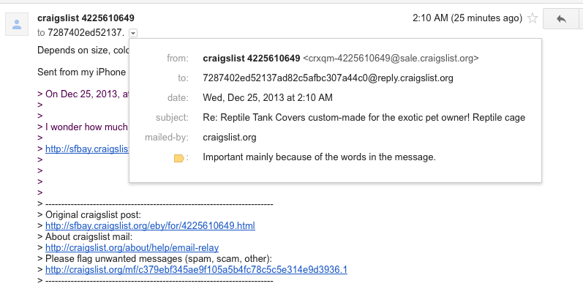
Please notice that when seller responds to my information question, his real email is also not shown in my email inbox either, but instead, a virtual email that created by the system forward to my inbox. So when seller and buyer use default virtual email, hoolist will create an email system to send the message back and ford. For example, craigslist uses @sale for seller/offerer and uses @reply for buyer/wanted.

