 |  | TRUCK ACCESSORIES
 |  | Bidders shall submit one original and one copy of their bid response to the Division of Purchases.
 |  | Pricing to be based on the State being responsible for delivering the vehicles to the vendors installation location. The truck dealer located in Shawnee, KS, charges $1.50 per mile to deliver the vehicles, this cost will be added to the bidder’s pricing to determine the lowest total cost. The bidder will be responsible for delivering the completed trucks to the KDOT destination.
 |  | Show installation location:___________________________________
Show mileage from Shawnee, KS to the installation location:
________________ miles.
As an Alternate Bid, show the amount to add per truck if the bidder is
responsible for transporting the KDOT trucks from the Ford truck dealer
in Shawnee, KS to the installation site: Add $___________________ per
truck. The vendor will be responsible for inspecting the vehicles for
damage prior to transporting and not accepting any damage vehicles.
Transporting the trucks by the vendor may be accomplished by transport
truck or by driving the vehicle. Vendor will provide coverage to cover loss or damage to the vehicle while in the vendor's possession prior to taking possession of the trucks.
Equipment to be furnished and installed in accordance with Specification
No. MS 217.01, dated 11/18/09, and shall be equipped with the features
noted on page 2 of the above referenced specifications and the items listed for each vehicle.
 |  | PR# 017736, KDOT PR# 476812
 |  | Delivery to Topeka, KS.
1 | Each | Vendor Furnished & Installed Accessories for KDOT Owned 2010 Ford  F-250 Cab, Fleetside Pick-up Truck.
 |  | To include: Black Tool Box for Fleetside body, L-Shaped Fuel Tank, Grille Guard, Light Bar Rack, Light Bar, DMI, Temperature Unit.
1 | Each | Vendor Furnished & Installed Accessories for KDOT Owned 2010 Ford F-250 Regular Cab, Fleetside Pick-up Truck.
To include: Black Tool Box for Fleetside boy, Grille Guard, Light Bar
Rack, Light Bar.
1 | Each | Vendor Furnished & Installed Accessories for KDOT Owned 2010 Ford F-250 Regular Cab, Fleetside Pick-up Truck.
To include: Black Tool Box, for Fleetside body, L-Shaped Fuel Tank,
Grille guard, Light Bar Rack, Light Bar, DMI, Temperature Unit.
1 | Each | Vendor Furnished & Installed Accessories for KDOT Owned 2010 Ford F-250 Regular Cab, Fleetside Pick-up Truck.
To include: Black Tool Box for Fleetside body, L-Shaped Fuel Tank,
Grille, Guard, Light Bar Rack, Light Bar, DMI, Temperature Unit.
1 | Each | Vendor Furnished & Installed Accessories for KDOT Owned 2010 Ford F-250 Cab and Chassis Truck.
To include Utility Bed, Rectangular Fule Tank, Grille Guard, Light Bar
Rack, Light Bar, DMI, Temperature Unit.
1 | Each | Vendor Furnished & Installed Accessories for KDOT Owned 2010 Ford F-250 Cab and Chassis Truck.
 |  | To include: Utility Bed, Grille Guard, Light Bar Rack, Light Bar.
1 | Each | Vendor Furnished & Installed Accessories for KDOT Owned 2010 Ford F-250 Cab and Chassis Truck.
To include: Utility Bed, Rectangular Fuel Tank, Grille Guard, Light Bar
Rack, Light Bar, DMI Temperature Unit.
PR # 017754, KDOT PR #476303
Delivery to Salina, Kansas
3 | Each | Vendor Furnished & Installed Accessories for KDOT Owned 2010 Ford  F-250 Cab and Chassis Truck.
To include: Utility Bed, Rectangular Fuel Tank, Grille Guard, Light Bar
Rack, Light Bar, DMI, Temperature Unit.
PR# 017755, KDOT PR# 476415
Delivery to Chanute, Kansas
4 | Each | Vendor Furnished & Installed Accessories for KDOT Owned 2010 Ford  F-250 Cab and Chassis Truck.
To include: Utility Bed, Rectangular Fuel Tank, Grille Guard, Light Bar
Rack, Light Bar, DMI, Temperature Unit.
PR# 017757 KDOT PR# 479306
Delivery to Hutchinson, Kansas
3 | Each | Vendor Furnished & Installed Accessories for KDOT Owned 2010 Ford  F-250 Cab and Chassis Truck.
To include: Utility Bed, Rectangular Fuel Tank, Grille Guard, Light Bar
Rack, Light Bar, DMI, Temperature Unit.
1 | Each | Vendor Furnished & Installed Accessories for KDOT Owned 2010 Ford F-250 Regular Cab, Fleetside Pick-up Truck.
 |  | To include: Tool Box, L-Shaped Fuel Tank, Grille Guard, Light Bar Rack, Light Bar, DMI, Temperature Unit.
PR# 017758 KDOT PR# 478976
Delivery to Garden City, Kansas
1 | Each | Vendor Furnished & Installed Accessories for KDOT Owned 2010 Ford  F-250 Regular Cab, Fleetside Pick-up Truck.
To include: Tool Box, L-Shaped Fuel Tank, Grille Guard, Light Bar
Rack, Light Bar, DMI, Temperature Unit.
 |  | Show additional unit cost of the following options if not previously specified:
 |  | Black color powder coat paint on toolboxes: $___________________
 |  | 10 inch step bumper in lieu of 8 ½ inch on utility bodies: $____________
Grille guard mounting hardware required for trucks without tow hooks:
$__________________
 |  | Bidders must return with the bid the attached specifications properly completed showing any and all exceptions.
The brand names shown are given only to assist in identifying the type and quality of product required. Bids on comparable brands are invited.

The specifications were written with the intent of permitting competitive bidding. The Division of Purchases reserves the right to waive minor deviations in the specifications which inadvertently restrict bidding to a single manufacturer (or vendor) or when such deviations do not alter nor deter the Agency from accomplishing the intended use or function. However, it shall be the bidder's responsibility to advise the Division of Purchases of any specifications, language, other requirements, or any combinations thereof, which restricts or limits bidding. Such notification must be submitted in writing and must be received by the Division of Purchases no later than five (5) days prior to the bid closing. Each bid shall include descriptive literature and specifications on the product bid. However, the providing of this material shall not be considered a substitute for listing deviations.
POLITICAL SUBDIVISION USAGE
Political Subdivisions throughout the State (City, County, School District, etc.) are permitted to utilize contracts administered by the Division of Purchases if agreed to by the contractor.
 |  | The State has no responsibility for payments owed by the political sub-divisions. The vendor must deal directly with the political subdivision.
 |  | Awards shall not be based on which of these statements is selected. However, conditions included in this contract shall be the same for political subdivisions unless stated otherwise below:
 |  | Indicate below, by checking () one of the boxes, if you will or will not extend pricing to Political Subdivisions. Refusal will not be a determining factor in the award of this contract.
- Yes, pricing is available to Political Subdivisions of the State of Kansas.

- No, pricing is not available to Political Subdivisions of the State of Kansas.
If yes, for what time period and are there any additional restrictions or conditions?

_________________________________________________________________

_________________________________________________________________

_________________________________________________________________

Request for Quotation No.: 12731
Page 5 of 33

Tax Clearance
PLEASE NOTE: This information has changed effective 10/27/09

Per KSA 75-3740-(c), the Director of Purchases may reject the bid of any bidder who is in arrears on taxes due the State of Kansas. The Secretary of the Kansas Department of Revenue is authorized to exchange such information with the Director of Purchases as is necessary to determine a bidder’s tax clearance status, notwithstanding any other provision of law prohibiting disclosure of the contents of taxpayer records or information.

A “Tax Clearance” is a comprehensive tax account review to determine and ensure that the account is compliant with all primary Kansas Tax Laws administered by the Director of Taxation. Information pertaining to a Tax Clearance is subject to change(s), which may arise as a result of a State Tax Audit, Federal Revenue Agent Report, or other lawful adjustment(s).
Bidders (and their subcontractors) are expected to submit a current Tax Clearance Certificate with every event response. Bidders can obtain a Kansas Tax Clearance Certificate through the Kansas Department of Revenue’s secure website (http://www.ksrevenue.org/taxclearance.htm).

Please Note: For applications entered prior to 5:00 PM Monday through Friday, results typically will be available the following business day. Individual and business applications are available. Tax clearance requests may be denied if the request includes incomplete or incorrect information.

Information about Tax Registration can be found at the following website:
http://www.ksrevenue.org/busregistration.htm

The Division of Purchases reserves the right to confirm tax status of all potential contractors and subcontractors prior to the release of a purchase order or contract award.

In the event that a current tax certificate is unavailable, the Division of Purchases reserves the right to notify a bidder (one that has submitted a timely event response) that they have to provide a current Tax Clearance Certificate within ten (10) calendar days, or the Division may proceed with an award to the next lowest responsive bidder, whichever is determined by the Director of Purchases to be in the best interest of the State.

Contact Information: Please provide the attached contact information for use should the State of Kansas need to contact the appropriate officials within your company to discuss your tax clearance / registration status.

CONTRACTOR
Contact Person for Tax Issues:
Company Name:
FEIN / Tax Number:
CAUTION: If your tax number is the same as your Social Security Number (SSN), you must leave this line blank. DO NOT enter your SSN on this Tax Clearance Form. If your SSN is required to process a contract award, including any tax clearance requirements, you will be contacted by an authorized representative of the Division of Purchases at a later date.

Mailing Address
City & State Zip Code
Toll Free Telephone Local Cell: Fax
E-Mail

SUBCONTRACTOR(S)
Contact Person for Tax Issues:
Company Name: Tax Number:
Mailing Address
City & State Zip Code
Toll Free Telephone Local Cell: Fax
E-Mail
Additional pages may be added, as required, indicating the same information for multiple subcontractors.

Request for Quotation No.: 12731
Page 6 of 33

CERTIFICATION REGARDING
IMMIGRATION REFORM & CONTROL

All Contractors are expected to comply with the Immigration and Reform Control Act of 1986 (IRCA), as may be amended from time to time. This Act, with certain limitations, requires the verification of the employment status of all individuals who were hired on or after November 6, 1986, by the Contractor as well as any subcontractor or sub-subcontractor. The usual method of verification is through the Employment Verification (I-9) Form. With the submission of this bid, the Contractor hereby certifies without exception that Contractor has complied with all federal and state laws relating to immigration and reform. Any misrepresentation in this regard or any employment of persons not authorized to work in the United States constitutes a material breach and, at the State’s option, may subject the contract to termination and any applicable damages.

Contractor certifies that, should it be awarded a contract by the State, Contractor will comply with all applicable federal and state laws, standards, orders and regulations affecting a person’s participation and eligibility in any program or activity undertaken by the Contractor pursuant to this contract. Contractor further certifies that it will remain in compliance throughout the term of the contract.

At the State’s request, Contractor is expected to produce to the State any documentation or other such evidence to verify Contractor’s compliance with any provision, duty, certification, or the like under the contract.

Contractor agrees to include this Certification in contracts between itself and any subcontractors in connection with the services performed under this contract.

____________________________________________ ______________________
Signature, Title of Contractor Date

Request for Quotation No.: 12731
Page 7 of 33
State of Kansas
Department of Administration
Division of Purchases

Supplier Diversity Survey Form

Why is the Division of Purchases requesting this information?

Current statutes governing the activities of the Kansas Division of Purchases do not include preferences or set-asides for Small Business Enterprises (SBEs). The Division of Purchases is interested in determining to what extent purchase orders and contracts are awarded to SBEs under existing work efforts. Please Note: You must submit this form with each bid opportunity.

Persons or concerns wishing to receive a Purchase Order or Contract Award resulting from this bid opportunity must provide the information contained in this document before the award is made. To help expedite this procurement, it is requested that you submit this form with your bid.

COMPANY DATA

Legal Company Name
Doing Business As (if applicable)
Federal Tax ID Number / FEIN
Diversity Program Contact Name Title
Phone Number Fax Number
E-Mail Address Company Web
Address
City State Zip Code
Legal Structure: □ Corporation □ Partnership □ Non-Profit □ Sole Proprietorship □ LLC

Signature Date:

COMPANY DIVERSITY DATA

(A) Business Classification (See Appendix A for definitions):
Is your business a Small Business Enterprise (SBE) as defined by the SBA?
□ Yes □ No □ Don’t Know
Check all that Apply: □ Disabled (DIS) □ SBA-Small Disadvantage Business (SDB)
□ Veteran-Owned (VBE) □ Women-Owned (WBE) □ Service-Disabled Veterans-Owned (DVBE)
□ African American □ Native American □ Minority-Owned Business Enterprise (MBE)
□ Hispanic American □ Asian Pacific American □ Disadvantaged Business Enterprise (DBE)
□ Asian Subcontinent American □ Other: __________________________________________________________

(B) Has your Business Classification Status been certified by a state, municipal, federal or other certifying agency?
□ No □ Yes Certifying Entity:

Other State of Kansas Resources for Small Business Enterprises (SBE)

Kansas Department of Commerce
Office of Minority/Women Business Development
http://www.kansas.gov/ksbdc/
Request for Quotation No.: 12731
Page 8 of 33

State of Kansas
Department of Administration
Division of Purchases
Supplier Diversity Survey Form

Appendix A
Definition of Terms

Small Business Enterprise / Concern (SBE)
SBEs are businesses that do not exceed the size standard for the product or service it is providing as measured by its employment and/or business receipts in accordance with the U.S. SBA numerical size standards. These standards are defined as FAR 52.219-8, 13 CFR Part 121 and 13 CFR 121.410.

Disadvantaged Business Enterprise (DBE)
DBEs are defined as a business which are (a) owned by socially disadvantaged individuals who have been subjected to racial or ethnic
prejudice or cultural bias because of their identity as a member of a group without regard to their individual qualities; or (b) owned by economically disadvantaged individuals whose ability to compete in the free enterprise system has been impaired due to diminished opportunities to obtain capital and credit as compared to others in the same line of business who are not socially disadvantaged.

Disabled Business Enterprise (DIS)
DIS businesses are at least 51% owned and controlled by one or more U.S. citizens who has a physical or mental impairment which substantially limits one or more of such person’s major life activities.

Small Disadvantage Business Concern (SDB)
SDB businesses are certified by the SBA as meeting the following criteria: (1) they are small business concern and (2) must be at least 51% owned and controlled by one or more U.S. citizens who are socially and economically disadvantaged. African Americans, Asian Pacific Americans, Asian Subcontinent Americans, Hispanic Americans and Native Americans are presumed to qualify as being socially disadvantaged. Other individuals can qualify if they show by a preponderance of the evidence that they are socially disadvantaged. In addition, the personal net worth of each eligible owner applicant must be less than $750,000, excluding the values of the applicant’s ownership interest in the business seeking certification and the owner’s primary residence. Successful applicants must also meet applicable size standards for small businesses in their industry. SDB regulations can be found in FAR 52.219-8 and 13 CFR parts 121 & 124.

Veterans-Owned Business Concern (VBE)
VBE businesses are at least 51% owned and controlled by one or more U.S. citizens who are Veterans of the U.S. Armed Forces. In the case of any publicly owned business, at least 51% of the stock is owned by one or more veterans and one or more veterans must control the management and daily business operation. The term “Veteran” means a person who served in the active military, naval or air service and who was discharged or released there from under conditions other than dishonorable. VBE regulations can de found in FAR 52.219-9 & 38 USC 101 (2).

Service-Disabled Veterans-Owned Business Concern (DVBE)
DVBE businesses are at least 51% owned and controlled by one or more U.S. citizens who are service-disabled Veterans of the U.S. Armed Forces. In the case of any publicly owned business, at least 51% of the stock is owned by one or more service-disabled veterans and one or more veterans must control the management and daily business operation. The term “Veteran” means a person who served in the active military, naval or air service and who was discharged or released there from under conditions other than dishonorable. The term “Service-Disabled” means a veteran of the U.S. Military Service has a service-connected disability with a disability rating of 0%-100%. In the case of permanent or severe disability, the spouse of caregiver of such a service-disabled veteran may control the management and daily operations. DVBE regulations can be found in FAR 52.219-9 & 38 USC 101 (2) & USC 101 (16).

Women-Owned Business Concern (WBE)
WBE businesses are at least 51% owned and controlled by one or more U.S. citizens who are female gender. In the case of any publicly owned business, at least 51% of the stock is owned by one or more women and one or more women must control the management and daily business operations. For Federal contracting regulations see FAR 52-219-8.

Minority-Owned Business Enterprise (MBE)
MBE businesses are at least 51% owned and controlled by one or more U.S. citizens belonging to certain ethnic minority groups. In the case of any publicly owned business, at least 51 % of the stock is owned by one or more minorities, and one or more minorities must control the management and daily business operations. “Ethnic Minority Groups” are people of Asian Pacific American, Asian Subcontinent American, African American, Hispanic American and Native American descent.
- African Americans: People whose origins lay in any of the Black racial groups of Africa.
- Asian Pacific Americans: People whose origins lay in Brunei, Burma, China, Guam, Indonesia, Japan, Kampuchea (Cambodia), Korea, Laos, Malaysia, Northern Mariana Islands, Republic of the Marshall Islands, Federated States of Micronesia, Republic of Palau (U.S. Trust Territory of the Pacific Islands), the Philippines, Samoa, Singapore, Taiwan, Thailand and Vietnam.
- Asian Subcontinent Americans: People whose origins lay in Bangladesh, Bhutan, India, Pakistan, Sri Lanka or Nepal.
- Hispanic Americans: People whose origins are in the South and Central America, Mexico, Puerto Rico, Cuba or the Iberian Peninsula (including Portugal).
- Native Americans: American Indians, Inuit (Eskimos), Aleuts, and native Hawaiians of Polynesian ancestry.

Date of Last Update: March, 2007

Request for Quotation No.: 12731

Specification No.: MS 217.01

Date: 11/18/2009
Page 9 of 33

VENDOR ACCESSORIZED

MAINTENANCE PICKUPS

STATE OF KANSAS

KANSAS DEPARTMENT OF TRANSPORTATION

SPECIFICATION FOR A

VENDOR ACCESSORIZED 3/4 TON MAINTENANCE PICKUP

The following specifications and dimensions shall apply to a VENDOR ACCESSORIZED 3/4 TON MAINTENANCE PICKUP for the Kansas Department of Transportation. The State reserves the right to waive minor technicalities under this specification. Federal and State laws supersede any conflicting part of this specification.

Each accessory described in this specification shall be new and unused, and, with the exception of the lightbar support racks, shall be a current model under standard production by the manufacturer, with parts stocked at one or more locations in Kansas or the greater Kansas City area. The requirement for parts to be stocked at locations in Kansas or the greater Kansas City area may be waived if the bidder provides an alternative parts availability plan acceptable to the Agency. ALTERNATIVE PARTS AVAILABILITY PLANS MUST BE APPROVED PRIOR TO CLOSING OF BID.

The bidder agrees, if his proposal is accepted, to warrant all parts, materials and labor supplied including the design of the unit bid for a period of one year. Such warranty shall be in addition to any manufacturer’s warranties on the cab, chassis, engine, etc. and shall include 100% of all costs to repair or replace any defective material or workmanship. A copy of the warranty shall accompany the bid. Warranty coverage shall include costs of transporting the unit to and from dealer's shop, when outside a 150 mile radius of the delivery point.

Complete specifications and literature on the unit bid shall accompany the bid. Any exceptions to these specifications shall be indicated on the bid or on a separate attachment to the bid, labeled as such.

Any “equal” or “equivalent” items for brand specified components shall be listed with the bid package. Complete description and literature on the “equal”/“equivalent” components shall be supplied for consideration by the KDOT. The burden of proof regarding “equal”/“equivalent” items shall be upon the vendor. Note that some equipment in this specification must be evaluated prior to the bid closing to be considered “equivalent” to accepted components.

PRE-DELIVERY SERVICE: Each vendor accessorized pickup shall be delivered complete and fully operational. It shall be properly serviced, free of leaks, and all mechanical adjustments made prior to delivery. A minimum of three days notice prior to delivery shall be given to the person to whom the unit is to be shipped. Delivery shall be between the hours of 9 AM and 3:30 PM.

This specification is divided into three major sections:
- Accessories to be installed on KDOT owned fleetside pickup.
- Accessories to be installed on KDOT owned cab and chassis pickup.
- Accessories to be installed on both a fleetside and cab and chassis pickup.

PICKUP TRUCK SUPPLIED TO VENDOR Pickup year, make, and model is SPECIFIED on the Request for Quotation (RFQ). The types of pickup truck(s) that may be supplied to the vendor are as follows:

FLEETSIDE BODY TRUCK: KDOT may supply a new ¾ ton pickup truck(s) with standard fleetside pickup bed to the vendor. The number of fleetside pickups supplied to the vendor will be SPECIFIED on the Request for Quotation (RFQ). and if SPECIFIED on the Request for Quotation (RFQ), a fuel tank, distance measuring instrument (DMI) and/or a temperature sensor, all as described in this specification. A receiver hitch, combination pintle with 2" ball, and trailer wiring and connector will be delivered with the truck.
OR
MAINTENANCE CAB AND CHASSIS TRUCK: KDOT may supply a new ¾ ton cab and chassis pickup truck(s) with fuel cap and hose kit to the vendor. The number of cab and chassis only pickups supplied to the vendor will be SPECIFIED on the Request for Quotation (RFQ). Each truck is to be equipped by the vendor with a utility body, an adjustable pintle hook mount with four pairs of holes, hitch and trailer connector, lightbar support rack, light bar, grille guard, and if SPECIFIED on the Request for Quotation (RFQ), a fuel tank, distance measuring instrument (DMI) and/or a temperature sensor shall also be installed on the truck as described in this specification. A receiver hitch, combination pintle with 2" ball, and trailer wiring and connector will be delivered with the truck.

INSURANCE The successful vendor will be responsible to supply full replacement cost insurance for each pickup while in the possession of the vendor and to remain in force until final delivery and acceptance by KDOT at each location specified. The vendor shall supply a copy of the policy declaration page to the KDOT Equipment Section no later than 10 days after notification of award at:

Equipment Section
Bureau of Construction and Maintenance
Kansas Department of Transportation
Eisenhower State Office Building, 6th Floor
Topeka, Kansas 66603-3745
Attn: KDOT Equipment Engineer
PRINTED MANUALS: One shop manual, parts manual, and operator manual shall be supplied with each accessory unit, with one additional set of each manual supplied to each delivery point. The manuals shall fully and clearly cover all components of the unit.

SECTION 1

ACCESSORIES TO BE INSTALLED ON A FLEETSIDE PICKUP

- - Adjustable Pintle Hook Mount - -

EXCEPTIONS TO
MFG. CODE SPECIFICATION SPECIFICATIONS

GENERAL:

A receiver hitch, combination pintle with 2" ball, and trailer wiring and connector will be delivered with the truck.

_____________ _____________ Truck hitch is to be equipped with an adjustable pintle hook mount with four pairs of holes.

- - Light Bar Support Rack - -

SHOW MFG. & MODEL OFFERED _________________________________________

EXCEPTIONS TO
MFG. CODE SPECIFICATION SPECIFICATIONS

GENERAL:

_____________ _____________ Light bar rack is to be fabricated as described in the drawing on the next page of this specification.

_____________ _____________ Light bar rack is to support a light bar specified elsewhere in this specification.

_____________ _____________ Entire unit shall be painted with black powdercoat paint.

_____________ _____________ Expanded metal utilized on the unit shall be ¾" No. 13 carbon steel, diamond pattern.

_____________ _____________ Example unit shall be fabricated, painted and approved by KDOT prior to remaining units being produced.

* * See drawing next page * *
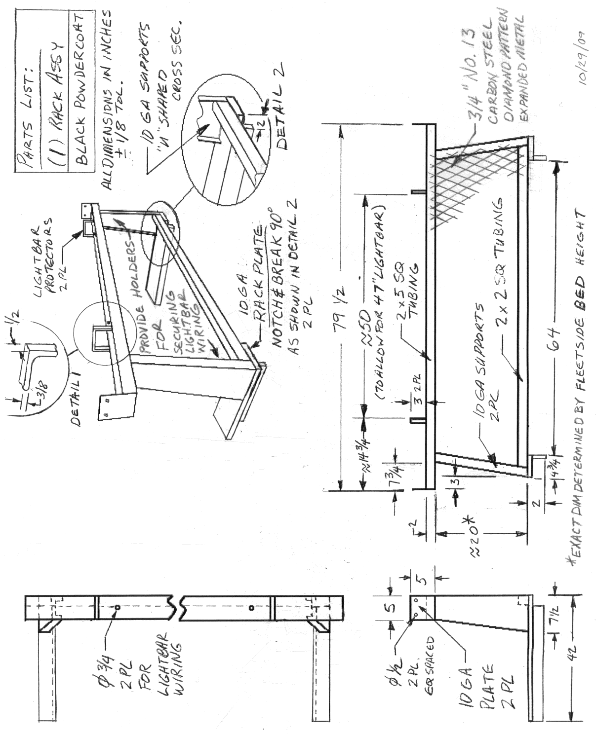

SHOW MFG. & MODEL OFFERED _________________________________________

EXCEPTIONS TO
MFG. CODE SPECIFICATION SPECIFICATIONS

GENERAL:

_____________ _____________ The dimensions given below are approximate and shall be adjusted as necessary for individual manufacturers. In every case, the tool boxes offered by the bidder shall be designed to fit a full size (8 ft) bed.

_____________ _____________ The set shall include two Weatherguard Model R-174, or approved equal, low profile side mounted utility boxes.

The boxes shall be constructed of 3003 aluminum diamond plate:

_____________ _____________ 0.058" thick minimum, for the body and cover;

_____________ _____________ 0.100" thick minimum, for the bottom,

_____________ _____________ with fully welded joints.

_____________ _____________ The boxes shall be supported by steel support legs, one front and one rear, between the underside of the box and the body floor.

_____________ _____________ The boxes shall be approximately 54 inches in length; with a 12 inch depth; and 15 inch width, across the top.

_____________ _____________ The deep tool storage bin shall run the length of the box with a minimum 8 inch width.

_____________ _____________ Each box shall have a minimum of 4 cubic feet of storage area.

_____________ _____________ Each sidebox shall have a parts tray.

GENERAL (Continued):

_____________ _____________ The set shall also include one cross box Weatherguard Model R-127, or approved equal, with a minimum 11 cubic foot capacity and a single, full length lid shall be provided.

_____________ _____________ The cross box shall have approximate dimensions of 6 foot length, 20 inch width, and 15 inch height.

_____________ _____________ The top of truck bed sides to bottom of tool box (when box is installed properly) shall be an absolute maximum of 11" to allow for auxiliary equipment to be mounted in the truck bed under the tool box.

_____________ _____________ Lid shall be able to be locked and unlocked from either side and shall be capable of being opened and closed from either side. Boxes that require the operator to walk to both sides of the truck to open/close the lids are unacceptable.

_____________ _____________ Each crossbox shall have a parts tray.

_____________ _____________ The top, bottom and front and back sides shall be constructed of rib-formed panels or shall have longitudinal cover channels for reinforcing.

_____________ _____________ The lid shall overlap the box and shall be weather stripped to provide full weather-proofing.

_____________ _____________ The lid shall have a full-length aluminum piano type hinge or at least 4 heavy duty hinges; and self-locking supports to prevent accidental closing.

_____________ _____________ The lids shall have push-button latches and locks or stainless steel paddle latches.

_____________ _____________ All locks in a set shall be keyed the same. Three keys shall be provided for each set.
OPTIONAL PRICING FOR POWDERCOATING:

_____________ _____________ Please provide optional pricing for black color powder coat paint.
Cost: $_____________

SHOW MFG. & MODEL OFFERED _________________________________________

EXCEPTIONS TO
MFG. CODE SPECIFICATION SPECIFICATIONS

_____________ _____________ When SPECIFIED on the Request for Quotation (RFQ), an auxiliary fuel tank shall be installed.

GENERAL:

_____________ _____________ All painted surfaces are to be properly primed and painted white or an approved factory color.

_____________ _____________ The unit shall be an L-shaped single compartment with baffles.

_____________ _____________ Approximate dimensions shall be 26 inches high, 30 inches wide with an absolute maximum length of 55 inches.

_____________ _____________ The bottom leg of the "L" shall have an absolute maximum overall height of 7.75 inches.

_____________ _____________ The upright portion of the "L" shall be a maximum of 11 inches wide.

_____________ _____________ The unit shall hold 88 gallons of fuel, minimum allowing for 10% expansion of tank contents.

_____________ _____________ A two inch reinforced pump/fill opening shall be provided on the top of each outside end of the tank. One 2 inch fill cap shall be provided with each tank.

_____________ _____________ Each tank shall have a two - 1/2 inch minimum diameter drain openings, one in each lower, rear facing corner.

_____________ _____________ The unit shall have brackets at the bottom of the tank to secure the tank to the vehicle. (A minimum of one in each corner of the tank.)

_____________ _____________ Reinforce area of tank to which bracket is welded.
GENERAL (Continued):
_____________ _____________ Each tank shall have a minimum of two lifting lugs, one at each end of the tank, to aid in installation and removal.

FUEL TRANSFER PUMP:
The fuel transfer pump shall be:
_____________ _____________ 12-volt DC powered,

_____________ _____________ self priming,

_____________ _____________ U.L. listed, and

_____________ _____________ provide a minimum flow rate of 10 gallons per minute.

The fuel transfer pump shall be equipped with a:
_____________ _____________ check valve,

_____________ _____________ continuous duty solenoid,

_____________ _____________ spin-on fuel filter housing, example Wix #24034,

_____________ _____________ spin-on 10 micron fuel filter, example Wix #24006,

_____________ _____________ strainer,

_____________ _____________ totally enclosed switch,

_____________ _____________ sealed explosion proof and weather proof motor compartment,

_____________ _____________ meter and totalizer,

_____________ _____________ adjustable suction pipe,

_____________ _____________ 12 foot hose and lockable manual nozzle, and

_____________ _____________ ¾ inch double jointed swivel to relieve stress on the nozzle end of the hose, example Husky VI Model 0350 multi-plane swivel.

SHOW MFG. & MODEL OFFERED _________________________________________

EXCEPTIONS TO
MFG. CODE SPECIFICATION SPECIFICATIONS

GENERAL:

_____________ _____________ Utility body is to be Stahl Model 96-CVS, Knapheide Model 796, Reading 967AB, Omaha Standard 96VH or approved equivalent with standard compartments and shelving.

_____________ _____________ Depth of side compartments shall be a minimum of 14.5 inches.

_____________ _____________ Body length shall be a minimum of 96 inches.

_____________ _____________ Body shall be mounted with U-Bolts or brackets bolted in the existing bolt holes of the truck frame. Units welded to any part of frame will not be accepted. The integrity of the truck frame shall not be diminished by any drilling, cutting, or welding.

_____________ _____________ All painted surfaces shall be painted to match cab color, except bottom side of body may be painted black.

_____________ _____________ All compartments must lock securely, using the same key to all compartments. Two keys shall be provided.

_____________ _____________ Compartments shall have rotary style paddle latches and spring loaded door retainers. A “T-handle” latching system which latches the doors in 3 locations is also acceptable.

_____________ _____________ All lights and reflectors shall conform to the Motor Vehicle Laws of the State of Kansas.

_____________ _____________ All added wiring shall be a minimum of 14-gauge SJTO primary cable.

GENERAL (Continued):

_____________ _____________ All added wire splices and connections shall be soldered with plastic or resin type solder (acid not approved) and then covered with moisture proof shrink tubing for complete encapsulation.

_____________ _____________ Rear lights shall be mounted same height, both sides, and shall include back up lights and directional signals. Rear lights shall be recessed.

_____________ _____________ Stop/tail/turn lights shall be LED.

_____________ _____________ Light guards shall be installed inside compartment to provide protection to the back side of the recessed lights.
REAR BUMPER:

_____________ _____________ Install heavy duty trailer towing type step bumper, minimum of 8 ½ inch, mounted to the main frame of the truck, bumper and hitch shall be rated for a minimum of 4000 lb. gross trailer weight and 500 lb. tongue weight.

_____________ _____________ Provide OPTIONAL PRICING for same bumper as above except with a step bumper, minimum of 10 inch.
Cost: $___________

LOW PROFILE OPTION: (Shall be included in bid price WHEN SPECIFIED on the Request for Quotation [RFQ].)

_____________ _____________ WHEN SPECIFIED, the unit shall be a low profile body meeting all prior specifications except for height dimensions.

EXCEPTIONS TO
MFG. CODE SPECIFICATION SPECIFICATIONS

GENERAL:

A receiver hitch, combination pintle with 2" ball, and trailer wiring and connector will be delivered with the truck.

_____________ _____________ Truck hitch is to be equipped with an adjustable pintle hook mount with four pairs of holes.

_____________ _____________ Truck/utility body is to be equipped with a hitch, combination pintle with 2" ball, and trailer wiring and connector supplied with truck.

- Light Bar Support Rack - -

SHOW MFG. & MODEL OFFERED _________________________________________

EXCEPTIONS TO
MFG. CODE SPECIFICATION SPECIFICATIONS

GENERAL:

_____________ _____________ Light bar rack is to be fabricated as described in the drawing on the next page of this specification.

_____________ _____________ Light bar rack is to support a light bar specified elsewhere in this specification.

_____________ _____________ Entire unit shall be painted with black powdercoat paint.

_____________ _____________ Expanded metal utilized on the unit shall be ¾" No. 13 carbon steel, diamond pattern.

_____________ _____________ Example unit shall be fabricated, painted and approved by KDOT prior to remaining units being produced.

* * See drawing next page * *

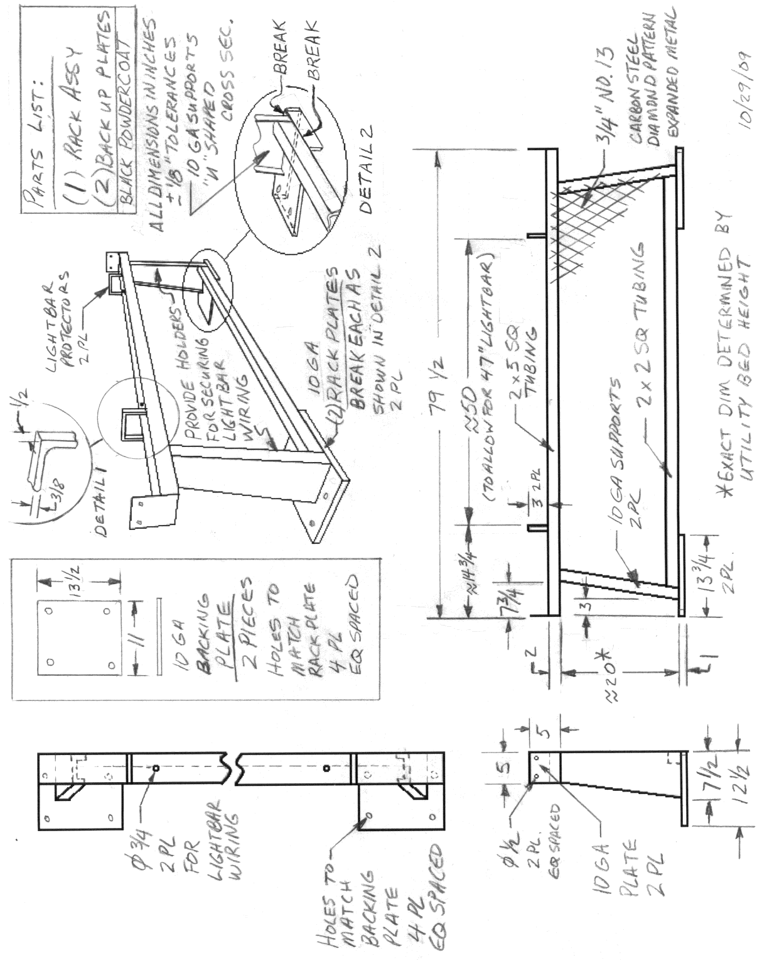
SHOW MFG. & MODEL OFFERED _________________________________________

EXCEPTIONS TO
MFG. CODE SPECIFICATION SPECIFICATIONS

_____________ _____________ When SPECIFIED on the Request for Quotation (RFQ), an auxiliary fuel tank shall be installed.

GENERAL:

_____________ _____________ All painted surfaces are to be properly primed and painted white or an approved factory color.

_____________ _____________ The unit shall be a rectangular single compartment tank with baffles.

_____________ _____________ Dimensions shall be approximately 24 inches high by 29 inches wide with an absolute maximum length of 48 inches.

_____________ _____________ The unit shall have a capacity of 98.5 gallons of fuel, minimum, allowing for 10% expansion of tank contents.

_____________ _____________ Each tank shall have a two inch reinforced pump/fill opening on the top of each end of the tank. The two openings shall be located at the outside edges of the tank for easy access. One 2 inch fill cap shall be provided with each tank.

_____________ _____________ Each tank shall have a two - 1/2 inch minimum diameter drain openings, one in each lower, rear facing corner.

_____________ _____________ The unit shall have brackets at the bottom of the tank to secure the tank to the vehicle. (A minimum of one in each corner of the tank.)

_____________ _____________ Reinforce area of tank to which bracket is welded.

_____________ _____________ Each tank shall have a minimum of two lifting lugs, one at each end of the tank, to aid in installation and removal.

FUEL TRANSFER PUMP:
The fuel transfer pump shall be:
_____________ _____________ 12-volt DC powered,

_____________ _____________ self priming,

_____________ _____________ U.L. listed, and

_____________ _____________ provide a minimum flow rate of 10 gallons per minute.

The fuel transfer pump shall be equipped with a:
_____________ _____________ check valve,

_____________ _____________ continuous duty solenoid,

_____________ _____________ spin-on fuel filter housing, example Wix #24034,

_____________ _____________ spin-on 10 micron fuel filter, example Wix #24006,

_____________ _____________ strainer,

_____________ _____________ totally enclosed switch,

_____________ _____________ sealed explosion proof and weather proof motor compartment,

_____________ _____________ meter and totalizer,

_____________ _____________ adjustable suction pipe,

_____________ _____________ 12 foot hose and lockable manual nozzle, and

_____________ _____________ ¾ inch double jointed swivel to relieve stress on the nozzle end of the hose, example Husky VI Model 0350 multi-plane swivel.

SHOW MFG. & MODEL OFFERED _________________________________________

EXCEPTIONS TO
MFG. CODE SPECIFICATION SPECIFICATIONS

GENERAL:

_____________ ___________ The light bar shall measure approximately 2.7 inches high x 12 inches wide x a maximum of 47 inches long (excluding mounting brackets) to mount to the lightbar support rack called out elsewhere in this specification and to match the pickup model(s) listed in the Request for Quotation.

_____________ _____________ Example light bar meeting this specification: Whelen LFL Liberty light bar model KDOTLIB2, PSE light bar model 2747A-CC-KDOT, Federal Signal LGD45-01149-KDOT, or equivalent. All other light bars must be evaluated and approved by KDOT prior to closing of bid to be considered “equivalent”.

_____________ _____________ The light bar must meet all Federal Motor Vehicle Safety Standards and Society of Automotive Engineers (SAE) Class I requirements.

_____________ _____________ For strength and durability, the framework of the light bar must be made of extruded aluminum.

_____________ _____________ The light bar must contain one control module I/O board which must control all internal light heads.

_____________ _____________ The I/O Board shall produce a minimum flash rate of seventy five flashes per minute.

_____________ _____________ There shall be a minimum of ten flash patterns from which to choose.

_____________ _____________ Each set of two light-emitting diode (LED) lamps must be capable of operating in a different flash pattern.

GENERAL (Continued):

_____________ _____________ Light bars with more than one internal electronic module control to control all internal lights is not acceptable.

_____________ _____________ The light bar must operate on a voltage range of 10 – 16 VDC.

_____________ _____________ The component configuration shall correspond to the “Light Bar Diagram” in this section of the specification.

_____________ _____________ The wiring configuration (if applicable) shall correspond to the “Light Bar Diagram” in this section of the specification.

WARRANTY:

_____________ _____________ All components of the light bar shall be warranted free from defects for a minimum period of five years from the date of installation.

_____________ _____________ All components of the light bar shall have a lifetime warranty against hail damage.

LED MODULES:

_____________ _____________ The light bar must contain a minimum of 96 “Whelen ‘Super-LEDs’, ‘Generation 3.5’, or equivalent.”

_____________ _____________ The light bar must have a maximum of four Whelen “ ‘Linear-LED’ or equivalent” modules, one in each corner.

_____________ _____________ Each corner Linear module must consist of a minimum of twelve Whelen high output LEDs or equivalent permanently mounted within a single “removable” highly mirrored parabolic reflector for maximum light output.
LED MODULES (Continued):

_____________ _____________ The forward and rear facing LED modules shall be mounted in a straight line.

_____________ _____________ The LED modules shall have a single diffuser panel mounted in front of them for maximum light output.

_____________ _____________ Light bars that utilize individual reflectors for each LED or that use mirrors to reflect light are not acceptable.

_____________ _____________ All front-facing LED panels shall be the same design as the corner “Linear-LEDS” described above, but shall contain a minimum of six high output LEDs.

_____________ _____________ The rear “Linear-LED” panels shall contain a minimum of six high output LED’s within the light head.

_____________ _____________ All rear LEDs must produce a minimum of a 90 degree light pattern.

_____________ _____________ LED panels that do not produce significant light output at 45 degrees are not acceptable.

The light bar shall be designed to have:

_____________ _____________ a minimum of seven modules to the front (including corners),

_____________ _____________ a minimum of seven modules to the rear (including corners),

_____________ _____________ and one (empty module slot) on each end.

_____________ _____________ The light bar LED colors will be amber; all with clear polycarbonate lenses.
LED MODULES (Continued):

_____________ _____________ The light bar shall also be capable of low power, to reduce the brightness for night time operation.

_____________ ___________ The LED panel must be mounted within the light bar.

_____________ ___________ Systems in which the LED panel/lens assembly makes up the outside configuration of the light bar are not acceptable.

FACTORY IN-DASH SWITCH CONNECTIONS

_____________ ___________ The light bar shall be connected to and controlled by four factory installed in-dash switches.

The four switches shall operate the light bar as follows:

_____________ _____________ Switch #1 – on/off master switch. When initially turned “on”, the light bar will operate in random rapid flash mode for front, rear, and sides.

_____________ _____________ Switch #2 – “left” arrow.

_____________ _____________ Switch #3 – “right” arrow.

_____________ _____________ Switch #4 – “dim” the light bar.

WIRING HARNESS:

_____________ _____________ The harness shall be wired on the passenger side.

WIRING HARNESS (continued):

The harness shall have:

_____________ _____________ a single harness containing hot, ground, and switching wires
or
_____________ _____________ a separate hot/ground harness and switching harness.

_____________ _____________ The harness shall be wired directly to a fused link at the battery.

MOUNTING BRACKETS:

_____________ _____________ Each light bar must be supplied with two slide bolts for mounting on rear headache racks.

MODULE CONFIGURATION (See diagram):

_____________ _____________ Front: Two Whelen “Linear12 Super-LED or equivalent” modules [amber].
Two Whelen “Linear6 Super-LED or equivalent” modules [amber].

_____________ _____________ Rear: Two Whelen “Linear12 Super-LED or equivalent” modules [amber].
Six Whelen “Linear6 Super-LED or equivalent” modules [amber]

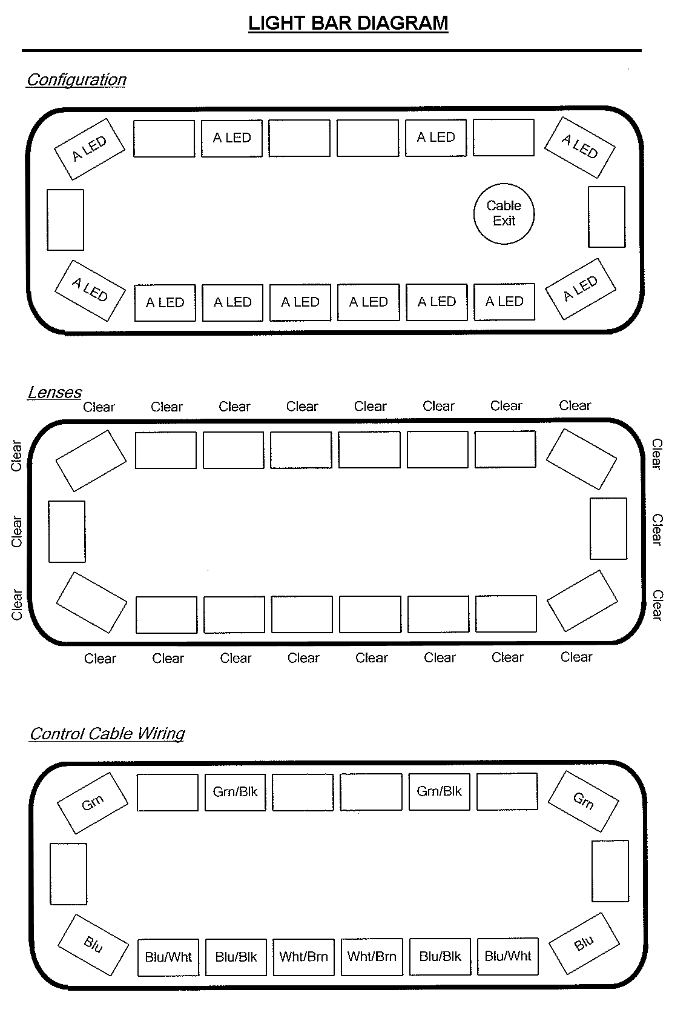
SHOW MFG. & MODEL OFFERED _________________________________________

EXCEPTIONS TO
MFG. CODE SPECIFICATION SPECIFICATIONS

GENERAL:

_____________ _____________ The unit shall be a Perry Company Renegade, Go Industries Rancher or approved equal.

_____________ _____________ The unit shall be custom designed and manufactured to fit a ¾ ton pickup. Specific pickup year, make, and model is SPECIFIED on the Request for Quotation (RFQ).

_____________ _____________ The unit shall mount to the frame of the pickup truck using existing factory holes. Bumper mounts are not acceptable.

_____________ _____________ State the cost of OPTIONAL mounting hardware required for trucks without tow hooks.
Cost: $_____________

_____________ _____________ The unit shall not interfere with mounting and use of factory tow hooks.

_____________ _____________ The unit's main frame shall be constructed of steel pipe or tubing having an outside diameter of at least 1.3" and weighing at least 1.6 pounds per foot. Larger diameters and weights will be given preference.

_____________ _____________ The unit shall be continuously welded leaving no unwelded seams.

_____________ _____________ The unit shall incorporate a steel mesh or punched plate center grille of at least 16 gauge thickness.

_____________ _____________ The unit shall be finished with black powder coat.

_____________ _____________ The unit shall extend the full width of the grille, protecting the lights.

GENERAL (Continued):

_____________ _____________ The unit shall be designed such that light from headlights or turn/parking lamps is not obstructed or reflected from the unit toward the operator or other vehicles on the roadway.

_____________ _____________ Three copies of descriptive literature including size and thickness or gauge of pipe or tubing shall be provided.

_____________ _____________ The name and location of a dealer or distributor having this model in stock for inspection shall be provided.

_____________ _____________ Detailed photos of the bid unit installed on the specific pickup listed on the Request for Quotation (RFQ) shall be provided.

SHOW MFG. & MODEL OFFERED _________________________________________

_____________ _____________ When SPECIFIED on the Request for Quotation (RFQ), a distance measuring instrument (DMI) shall be installed as described below.

_____________ _____________ When SPECIFIED on the Request for Quotation (RFQ), the unit is to be equipped with an RS-232 port for inventory survey uploading to a personal computer.

_____________ _____________ When SPECIFIED on the Request for Quotation (RFQ), the unit is to be equipped with an electronic interface and cable kit that is universally compatible between make and models of vehicles.

GENERAL:

_____________ _____________ Unit is to be obtained according to existing KDOT contract found at:
http://prodnet2/FiscalContracts/Default.aspx

WIRING:

_____________ _____________ Interface shall be installed and wiring shall be run by the vendor so that head can be installed on any part of the dashboard.

_____________ _____________ Distance Measuring Instrument head will be provided by the vendor with the truck but will be installed by KDOT.

Request for Quotation No.: 12731
Specification No.: MS 217.01
Page: 33 of 33

ACCESSORIES TO BE INSTALLED ON

BOTH FLEETSIDE AND UTILITY BODY TRUCKS
- - Distance Measuring Instrument - -

EXCEPTIONS TO
MFG. CODE SPECIFICATION SPECIFICATIONS

SHOW MFG. & MODEL OFFERED _________________________________________

When SPECIFIED on the Request for Quotation (RFQ), a pavement temperature sensor shall be installed:

GENERAL:

_____________ _____________ An infrared pavement temperature sensor shall be properly mounted per the manufacturer’s recommendations.

_____________ _____________ The gauge shall be mounted in the location shown in the dash layout diagram, below.

_____________ _____________ The gauge shall display both air and pavement temperature simultaneously

_____________ _____________ The infrared pavement temperature sensor shall be a Sprague Roadwatch or Quixote Transportation Technologies Surface Patrol or approved equal.
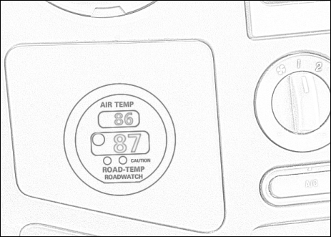


ADDENDUM

December 29, 2009

Addendum Number: 1

RFQ Number: 12731

PR Numbers: 017736, 017754, 017755, 017757, 017758

Closing Date: January 5, 2010, 2:00 P.M. (SEE BELOW)

Procurement Officer: John T. Lowe
Telephone: 785-296-3126
E-Mail Address: john.lowe@da.ks.gov
Web Address: http://da.ks.gov/purch

Item: Truck Accessories

Agency: Department of Transportation
Topeka, KS

Conditions:

- Closing Date has been extended to January 12, 2010.

- Please see attached .pdf

There are no other changes at this time.

A signed copy of this Addendum must be submitted with your bid. If your bid response has been returned, submit this Addendum by the closing date indicated above.

I (We) have read and understand this addendum and agree it is a part of my (our) bid response.

NAME OF COMPANY OR FIRM:

SIGNED BY:

TITLE: DATE:

It shall be the vendor's responsibility to monitor this website on a regular basis for any changes/addenda.
http://da.ks.gov/purch/rfq/rfqdata/12731.doc

ADDENDUM

January 6, 2010

Addendum Number: 2

RFQ Number: 12731

PR Numbers: 017736, 017754, 017755, 017757, 017758

Closing Date: January 12, 2010 (SEE BELOW)

Procurement Officer: John T. Lowe
Telephone: 785-296-3126
E-Mail Address: john.lowe@da.ks.gov
Web Address: http://da.ks.gov/purch

Item: Truck Accessories

Agency: Department of Transportation
Topeka, KS

Conditions:

- Closing Date has been extended to January 14, 2010.

- The following Item is added to PR# 017758 (KDOT PR# 478976) for delivery to Garden City, KS:

1 Each Vendor Furnished & Installed Accessories for KDOT $___________
Owned 2010 Ford F-250 Cab and Chassis Truck.

To include Utility Bed, Grille Guard, Light Bar Rack, Light
Bar, and Rectangular fuel tank

There are no other changes at this time.

A signed copy of this Addendum must be submitted with your bid. If your bid response has been returned, submit this Addendum by the closing date indicated above.

I (We) have read and understand this addendum and agree it is a part of my (our) bid response.

NAME OF COMPANY OR FIRM:

SIGNED BY:

TITLE: DATE:

It shall be the vendor's responsibility to monitor this website on a regular basis for any changes/addenda.
http://da.ks.gov/purch/rfq/rfqdata/12731.doc

