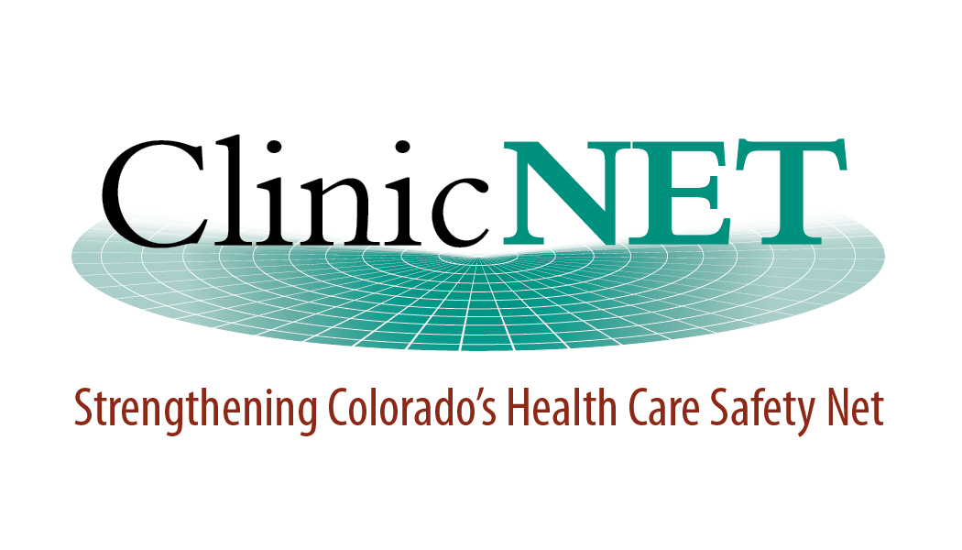


Date of Issue: March 25, 2010

Request for Proposal (RFP)
Safety Net Quality Improvement Specialist

Deadline for RFP Submittal: April 18, 2010

Safety Net Quality Improvement Specialist RFP

- Organizational Information:

The Colorado Rural Health Center (CRHC) is a non-profit organization serving as the Colorado State Office of Rural Health. CRHC identifies and addresses rural health issues by administering programs and services, and providing training, resources, and technical assistance.

ClinicNET is a Colorado non-profit organization providing a centralized voice for Community-Funded Safety Net Clinics (CNSCs) and certified Rural Health Clinics (RHCs). ClinicNET enhances the capacity of non-federally qualified safety net clinics to serve medically vulnerable Coloradans by informing health policy, providing education and technical assistance, and facilitating clinic participation in strategic patient care initiatives.

- Purpose:
CRHC and ClinicNET received a grant from Caring for Colorado to retain a Safety Net Quality Improvement Specialist to provide safety net clinics with a variety of different technical assistance services tailored to meet the needs of the individual clinic sites. All clinics do not operate on the same level in serving their communities; there is a wide continuum of ability to effectively and efficiently operate among Colorado’s non-FQHC safety net clinics. Many clinics exist without sustainable business practices in place, even though they are the healthcare lifeline for many underserved Colorado citizens. Through collaboration, onsite technical assistance, and leveraging resources, the Specialist will assist safety net clinics with implementing proven enhancements and processes, ultimately improving the quality of primary care delivered at the local community level.
- Scope of Service:

Under the direction of CRHC and ClinicNET, the Specialist will be responsible for working with selected RHCs and CSNCs to enhance existing quality improvement initiatives and identify new quality improvement opportunities that help achieve Patient Centered Medical Home or other process and quality related standards. Essential duties will include, but will not be limited to:
- Participate in the selection of 10-12 clinics for assessment and coaching.
- Complete assessment process with participating clinics and assist clinics with developing project plans.
- Introduce clinics to CRHC’s Practice Improvements and Enhancements (PIE) continuum and other pertinent tools and resources.
- Provide oversight and assistance for implementation of clinic project plans and assist in each clinic’s identified goals and objectives.
- Assist clinics with team-based quality improvement efforts and understanding, interpreting, and implementing change
- Identify opportunities for learning and sharing lessons learned with other participating clinics as applicable by developing mechanisms for communication and networking between clinics.
- Identify and mobilize consultants and organizational partners to assist with projects and provide resources to clinics.
- Represent ClinicNET and CRHC at related stakeholder meetings and discussions.
- Participate in ClinicNET and CRHC staff and program meetings.
- Develop and implement a process for tracking and demonstrating programmatic results and impact.
- Assist CRHC and ClinicNET with ensuring that requirements and objectives of the Caring for Colorado grant are met.

- Criteria for Contractor Selection:

Proposals are sought from organizations and/or individuals willing and able to travel throughout Colorado and with previous experience in the following areas:

- Outpatient clinical practice, preferably in a safety net clinic (serving low income and medically vulnerable populations)
- Healthcare quality improvement methods and tools
- Facilitation of team activities and leadership for change
- Practice redesign and patient centered care
- Health information technology

Proposals should include the following:

- Primary contact name, contact information, and organization name.

- Description of qualifications and experience relevant to the scope of work and selection criteria.

- Resumes or brief biographical sketches of key staff.

- Proposed fees and reimbursable expenses associated with carrying out the scope of work.

- At least three professional references.

- Terms and Conditions:

If available, the contractor will provide a certificate of liability insurance.

Proposals should be submitted in writing: By April 18, 2010

To: Sharon Adams, Executive Director, ClinicNET, 3033 S. Parker Road, Suite 606, Aurora, CO, 80014 or via email to sharon.adams@clinicnet.org

