

SharePoint Project Specifications
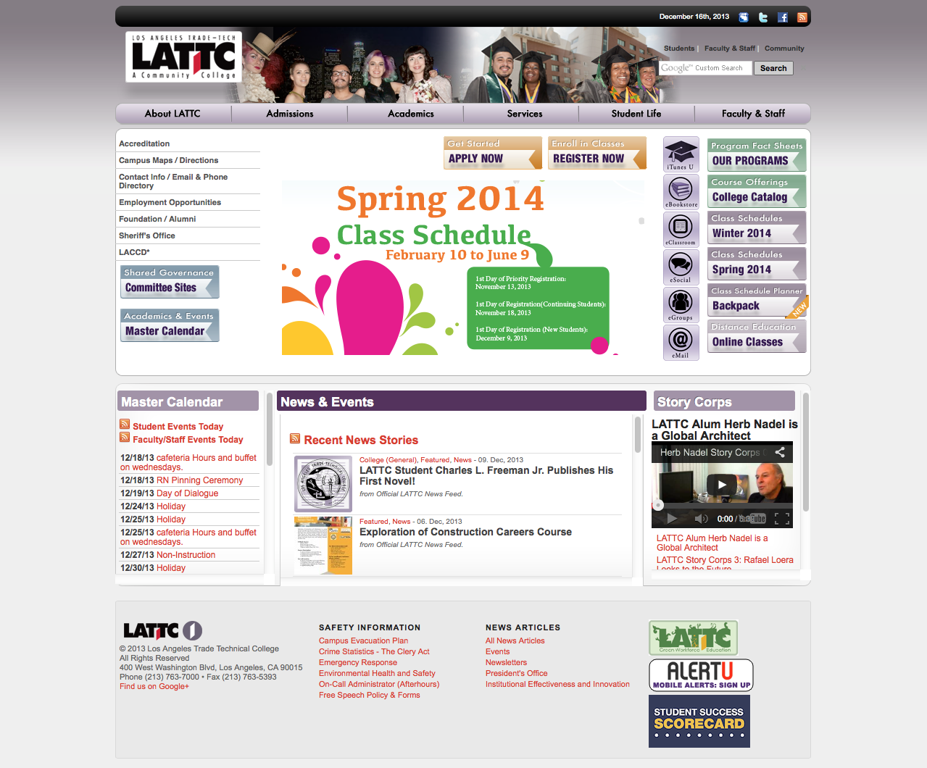

Office of Institutional Effectiveness

Statement of Purpose
Los Angeles Trade Technical College (LATTC) moved to its current location in 1957. In 1966, an existing educational institution with a strong business program, Metropolitan College, was merged with Trade-Tech, resulting in an even broader range of educational offerings. Finally, in 1969, LATTC joined Los Angeles Community College District (LACCD), making LATTC one of the nine colleges that comprise the District.
Trade-Tech occupies a unique position among institutions of higher education. Throughout eight decades, the college has remained true to its’ founding premise of vocational education, while expanding to provide transfer programs, adapt to rapidly changing technologies and remain responsive to the needs of the surrounding community. Students come from all over the Los Angeles basin to participate in our unique mix of programs, some of which have been in existence since the school’s inception.

Website Overview
Since 2009 LATTC has been using its own web solution WordPress as the content management system. After many updates, customizations, and changes in configuration, the College still uses WordPress.
One of the main features of the website was the news blog on the homepage, which aggregated the blog of all of the individual sites. By 2011, it was very clear that it was unreasonable for every site to have its own blog for several reasons, especially security and data management. At that point, the website was divided into two separate websites using WordPress. The College Website, supporting the College Homepage and all of the departments and services websites, was setup for the use of one blog (at the root level), which would propagate to the individual sites through use of categories to generate RSS feeds and an RSS parser on the site homepages. The second WordPress install, the Shared Governance Website, used the default blog configuration, so that all committee documents would remain within the individual committee site structure for consistent information architecture.
Currently, LATTC is looking to take the website in a new direction. The College is in need of a consultant to install, develop, customize, and deploy a SharePoint Site, which will take the place of the current Shared Governance Website (College Committees), create a site collection template for External Partnerships and a site collection template for Institutional Effectiveness, as well as a new SharePoint Intranet. This site will need to be able to support all SharePoint collaboration, Business Intelligence, and workflow features that work with both Microsoft Office 2010 and Office 2013.
The installation shall use five (5) VM’s (provided by LATTC IT Staff) to be configured by consultant as one (1) SQL Server, one (1) Application, one (1) Load Balance Server and two (2) Web Servers. The LATTC IT Staff will provide the FQDN’s and IP addresses for said servers, the licenses for SharePoint installs, AD accounts as needed (for users and service accounts to perform installations), Passphrase for SharePoint farm, and will be responsible for NAT’ing the public IP to the internal IP addresses of the web servers.

Project Description

Phase 1: Installation

Technical Architecture
- Must authenticate using AD as main IP-STS
  - Back up authentication method must also be included - Admin account using Windows (AD), as well as FBA
- Server Setup (1 App server, 1 SQL Server, 2 Web Servers, 1 Load Balancer)
  - Load Balancing
  - Failover Protection
- Office Integration (MS Office 2010 & 2013), Collaboration, and BI (Office Web Apps)
  - Activation of Access Services, Excel Services, Reporting Services, Visio Services, etc.
  - Business Intelligence with dashboards, etc.
- Confirmation of Features and Site Structure
  - Files to be stored on separate drive from main SQL database drive
- Memory optimization and log directory limits
- Customizations and Plugin Installations
- FAST Search Center
  - Custom Scopes, Keywords, and Best Bets
- Automated Features and Workflows
  - Automated Backups (Daily, Weekly, Monthly, and Yearly)
  - Automated Quick Launch menu based on site Pages (site home to be included)
  - Workflow Samples
    - Push files from Intranet to Internet site with ability to choose the Collection, Site, and Library (approval required)
  - Site update audits and email notifications
    - Monthly emails to Site Owners - Overview of site update activity and traffic
    - Monthly emails to webmaster with overview of site updates and visitor statistics
    - Automated emails to Site Owners, Site Designers, and Webmaster after 30 days with no updates
    - Audits must include future sites

Phase 2: Set up

Information Architecture

Site Structure
- Intranet Site (Login Only)
  - Institutional Effectiveness
- Internet Site (Anonymous Access)
  - Shared Governance (site collection)
    - FAST Search Center (site) – not included in navigation
    - College Council Committees (site)
    - Academic Senate Committees (site)
    - District Committees (site)
    - Other Committees (site)
  - Institutional Effectiveness (site collection)
  - External Partners (site collection)
- Current site structure and SharePoint site structure to be provided and may change prior to installation
- Consultant will provide a list of service accounts to be created by LATTC in AD for application services for added security

Templates (Web and Mobile)
- Site Collection Templates
  - Shared Governance
  - Institutional Effectiveness
  - External Partners
- Site Templates (automated features as aforementioned)
  - Committee Sites
  - FAST Search Center
  - Committee Meeting Workspaces
  - General Site
  - External Partners Site
- Page Templates
  - Top-Level Page
  - Contact Forms
- Graphic elements of the design will be provided for appropriate coding*
  - *Individual elements of the design may change over the course of the project

Committee Collection Elements
- RSS parser for Master Calendar dates
- A headlines area that appears when applicable
- Aggregates new documents within the “Approved Minutes” on all committee sites
- Synced with master calendar
- Workspace per meeting (automated)
- Sub Navigation to include related sites/committees

Customizations
- Out-of-the-box Quick Launch links and heading to be hidden to anonymous users (to appear below the main left navigation)
- Site Pages to appear automatically within left column navigation upon page creation
  - Ability for users to manually edit navigation (both exclude/include and order of pages)
  - Sub-sites of a site to appear below local site pages with relative heading
  - Sites of the Site Collection to appear below local site pages with relative heading

Phase 3: Deploy

Populate
- Site migration (cost separately)
- Setup Load Balancer with test subdomain

Test
- Confirmation of features and site structure
- Site analysis and corrections
- Test, validate, and document backup and restore function/procedure

Prelaunch Training
- Web Managers (and activity supervisors)
- Web Gatekeepers

Phase 4: Deliver and Support

Launch
- Update DNS and FQDN registry for www.lattc.edu (IT Staff & ISP)
- Update Load Balancer to use www prefix (consultant)
- Create redirects in IIS (IT Staff)
- Archive WordPress sites (IT Staff)

Documentation
- Activity Logs
- Cloned farm backup (on physical media)
  - Source files (not included in clone)
- User Training Videos
  - Overview of SharePoint, navigation global vs. local, and concepts of pages and libraries
  - Overview of front-end login and editing page content and libraries
  - Updating navigation menus
  - Using the SharePoint Workspace in Office 2010 and Office 2013

Support
- Provide 3 months of post-launch support

Proposal & Selection Process

Submitting a Proposal
- Proposals must be submitted in the form attached. Proposals not presented in the provided form shall be disregarded.
- Completed proposals must be sent to: ietrade@lattc.edu
- All Proposal Forms shall be submitted to the above email no later than 2:00 p.m. on August 4, 2014.

Selection Process
- Candidates will present portfolio, explain services to be rendered to LATTC, followed by Q&A
- Candidates will have 2 business days to updated proposal document based on meeting with LATTC
- Selection Criteria will be based on the following combined steps:
- Proposal Price (calculation of Part A and Part B below; completed by LATTC)
- Portfolio
- Web conference demo or in-person demo

Terms & Conditions
- Terms and conditions of the contract or proposed contract template to be offered to the successful proposer, if award is made.
 | Los Angeles Trade-Technical College  Proposal Form

Instructions to bidders:
- Proposals not presented in this form shall be disregarded.
- Completed proposals must be sent to: ietrade@lattc.edu
- All Proposal Forms shall be submitted to the above email no later than 2:00 p.m. on August 4, 2014.

Proposal price and recommendations:
PART A

Stage | Estimated Work Hours
Phase 1 - Installation
Phase 2 – Set up
Phase 3 – Deploy
Site migration (cost separately)
Phase 4 – Deliver and support
Hourly Rate
Total Cost of Project
PART B
Estimated Needs*
(Hardware/Software)
Hardware/Software Requirements
Recommended Licenses
Estimated Hard Drive Allocations
*costs will be derived by the College from the estimations above based on the College infrastructure

Portfolio:
Provide a minimum of two websites you have developed and deployed, along with contact references.

Web conference demo or in person demo:
Selected proposals will be invited to provide either a conference or in person demo, as appropriate.

Install additional plugins per client request. List of the plugins will be discussed and identified prior to installation.

