Wanzek Construction Inc.

P.O. Box 2019
Fargo, ND 58107

Document Control System

Request for Proposal

Responses due: March 28, 2011

Introduction

Purpose
The purpose of this Request for Proposal (RFP) is to supply and integrate a Document Control System. The responses to this RFP will be used to select a commercially available off-the-shelf (COTS) solution that integrates with our other existing systems consistent with the included requirements description.

Wanzek
Wanzek (www.wanzek.com) is a heavy industrial contractor that provides construction expertise in the industries of Wind Energy, Power, Renewable Energy, Heavy/Civil, Oil/Gas/Chemical and Industrial/Food Process headquartered in Fargo, ND. Wanzek is a wholly owned subsidiary of MasTec (www.mastec.com, NYSE:MTZ) headquartered in Coral Gables, FL.
As a construction contractor, Wanzek has jobs throughout North America. Many jobs are in remote locations with limited or sporadic network connectivity. The job durations typically range from a few months to a year or more. Job sizes are typically $1 Million to $100 Million and personnel counts of 20 to 500 people at a job at a time. Typically, there are 800 hourly and 100 salaried employees at 12 or more sites.
The IT functions for Wanzek are hosted by the parent company, MasTec, so they would also be interested in a solution that will scale to other parts of the company as needed. The types of documents Wanzek document control processes must manage for a typical job include: bid and other contract documents; engineering drawing, plan, and permit documents; project control documents; QA/QC documents; safety documents; equipment documents; HR documents; and accounting documents.

Objective
Wanzek team members must have access to a workable document management system to manage the many projects efficiently. Team members must be able to identify and act on all new relevant documents that are the direct result of the projects for which they are responsible.
Wanzek has a mix of mainly manual and some automated processes for managing and tracking documents. Wanzek is looking to add an Enterprise Content Management System to store and manage documents from the different source systems in our company and treat them as a single set of documents. These systems include SharePoint, file shares, ViewPoint ERP system, Outlook, Data-Maxx time and attendance system, QMS and QDMS project software, EcoSys earned value software, Primavera scheduling software, and some MS Access databases. Maintaining the different source systems (backed by the ECM system) allows users to continue working as they have been, in environments they are familiar with, while process improvements are rolled out.
We have seen capabilities classified into different categories. As we understand them, we are not looking for Web Content Management at all at this time. Collaborative Content Management is a very minor component of what we are looking for as SharePoint seems to be enough for what we are doing in this category. Transactional Content Management or Case Management seems to be the closest category, however it is mainly in the Business Process Management sense.
To automate some of the processes, Wanzek currently uses SharePoint workflow to a limited extent. Wanzek would like to have a more feature rich workflow engine in which business users are able to easily create workflows that span systems, nest workflows, allow complex routing, etc.
One scenario to be supported would be drawing management (see the Process Documentation attachment). It would look like the following: a new revision of a drawing is emailed to the project manager; the project manager saves the drawing from his email to the document control system; the document control system prompts for any needed metadata and stores the revised drawing; the document control system looks up who has the previous revision of the drawing and sends the update to those people; and the document control system starts any workflow related to the new revision such as scheduling a task to review the bill of materials associated with the drawing.
Another scenario to be supported would be QA/QC document audits (see the Process Documentation attachment). It would look like the following: a new QA/QC document is scanned in; the project engineer saves the drawing from his scanner to the document control system; the document control system prompts for any needed metadata and stores the QA/QC document based on the metadata. Each audit (per project) begins independently based on a schedule and compares the list of files stored in the document control system with a list of expected files while referencing a third document for milestones. The results of the audit are published to a dashboard or by email.
Additional scenarios being considered at this time are AR/AP, estimating, equipment tracking, small tool tracking, progress tracking, and material control/inventory.

Information Being Requested
For your proposal, you can assume 900 employees at 12 sites. There would be about 30 named users (five concurrent users) for the first scenario and about 200 named users (20 concurrent users) when the additional scenarios are included.
Wanzek requests that you review the threshold requirements in the next section and determine if your company’s solution(s) would be a good fit for our company's environment and satisfies what we are looking for.
Your proposal should include the completed criteria spreadsheet with a score for each of the criterion using the codes provided. The items in the spreadsheet should not be taken as must have requirements (other than those referenced in the Threshold Requirements section below), but as an indication of what the areas of interest are and can influence the evaluation of the total cost of ownership. Please do not reformat the spreadsheet.
Your proposal should describe your process and methodology including sample deliverables from past projects of similar size and scope.
Your proposal should include a sample schedule with milestone dates, required information and resources (including hardware) from Wanzek, and payment requirements. If your proposal involves a multi-phase approach, please provide approximate timeframes.
Your proposal should provide specifications of any hardware and network requirements as part of your proposed solution.
Your proposal should include assumptions including quantity and type of database Client Access Licenses, SharePoint Client Access Licenses, and any other licenses that your solution would depend on.
Your proposal should include an unsigned copy of your standard service contract for our review and any additional stipulations of which we should be aware.
Your proposal should include a typical funding profile listing all licensing, hardware, implementation, training, and support and maintenance costs broken down by category for the first five years.
Your proposal should include references, preferably large construction contractors. A list of contacts you have worked with at ViewPoint would be helpful also.
Your proposal should provide the typical qualifications and experience of the consultants, programmers, designers, etc. that would be working on the implementation.
Your proposal should include an estimate of how much notification you would need to prepare for the demonstration scenarios listed in the attachment if your solution is selected as one of the top proposals received. Include an estimate of how long the demonstrations will take.
Your proposal may include the name and description of other products that your solution has worked with as part of a complete construction management package.
Your proposal may include innovative strategies as alternative solutions that would reduce cost or improve business efficiency.

Threshold Requirements
Respondents must meet all of the Threshold Requirements for their proposals to be considered under this RFP. The Threshold Requirements are indicated by a "5" in the Interest Level column of the evaluation criteria spreadsheet. These requirements can be satisfied by your solution or a 3rd party solution that you include in your proposal and reference in the notes as directed in the spreadsheet instructions.

Response Submission
Responses to this RFP must be submitted via email to _WZECMRFP@wanzek.com with a subject of “Document Control System RFP Response” no later than 8:00 AM US Central Time on March 28, 2011 for the response to be used. Attach the response sheet with your scores and answers to the email using the name of your solution as the name for the file. If you have multiple solutions, you may submit response sheets for each in your email. Please provide follow up contact information in the email to include phone number, mailing address, and email (if different).

Questions
Vendors should send questions or other communication regarding this RFP to _WZECMRFP@wanzek.com.
Alternatively, you may send mail to:
Steve Larson
Wanzek Construction
P.O. Box 2019
Fargo, ND 58107
Wanzek will send clarifications and changes to the email address associated with each vendor that indicates that they intend to respond to the RFP.

Reimbursement
Wanzek will not reimburse submitters for any costs in conjunction with their responses to this RFP.

Expectations
Wanzek will has done some initial research of solutions that are available, but has not picked a short list. This RFP is going directly to about three dozen vendors that have requested it. It is also available to others that request it up to the deadline for submission. Vendors should look at the Threshold Requirements to see if they are a good fit and ask for clarification of items where they have questions.
Based on the general information obtained during the research, Wanzek anticipates a solution should be available for under $150,000.

Review Process
Wanzek will prefer a solution that is part of a complete construction site management package that could meet future requirements.
Solutions Wanzek may consider include 1) modifications to existing systems including the ViewPoint ERP software and SharePoint intranet software, and 2) implementation of a suite of products that interfaces with existing systems.
Wanzek may update its selection criteria based on responses.

Primary
Wanzek will combine the scores for each response with the weight assigned to each criterion. Not all criteria listed are “must have” requirements. Wanzek will assign an ROI value using the computed total for the response, the costs given for that response, and any additional information. To comprehend fully the information provided within the response, Wanzek may request further clarification on that response. This clarification may be requested in the form of brief verbal communication by telephone, written communication, electronic communication, or a presentation.

Secondary
If your proposal is one of the top proposals received, Wanzek will request a demonstration of your solution showing key scenarios such as those in the Demo Scenarios attachment to understand how easy it will be for the different users to use. For functionality or integrations that are not part of your product already, an alternative would be for the vendor to discuss the mechanism they would use for the functionality or integration and show what they have done that is similar in the past.

Pilot or Proof of Concept
If it is difficult to determine if a system would fit our environment, Wanzek may request a pilot or proof of concept. Any costs for a pilot or proof of concept would be negotiated at that time.

Acceptance of Proposal
Wanzek may pursue any or none of the solutions provided in the responses and may pursue solutions not yet identified. The highest rated, lowest priced, or any proposal will not necessarily be accepted.

Negotiation
Negotiation sessions may be held to work out contract details and other expectations of the parties applicable to the services/work, based on the RFP and the proposal(s) submitted.

Disclosure
All documents submitted shall become the property of Wanzek. Proposal information is proprietary and, as such, shall be treated as confidential.

Schedule
The schedule for this RFP is expected to be as follows.
RFP issued: | February 28, 2011
Notice of intent to submit a proposal: | Any time to receive updates
Deadline for submission of questions: | March 23, 2011 at 3pm Central time
RFP responses due: | March 28, 2011 at 8am Central time
Review of RFP responses: | March 28, 2011 through April 15, 2011
Notification to respondents of next steps: | April 18, 2011

Attachments
Evaluation Criteria
ViewPoint Tables and Relationships
Process Documentation
Demo Scenarios

Evaluation Criteria

ViewPoint Tables and Relationships

Process Documentation

This is a general description of the drawing management processes.
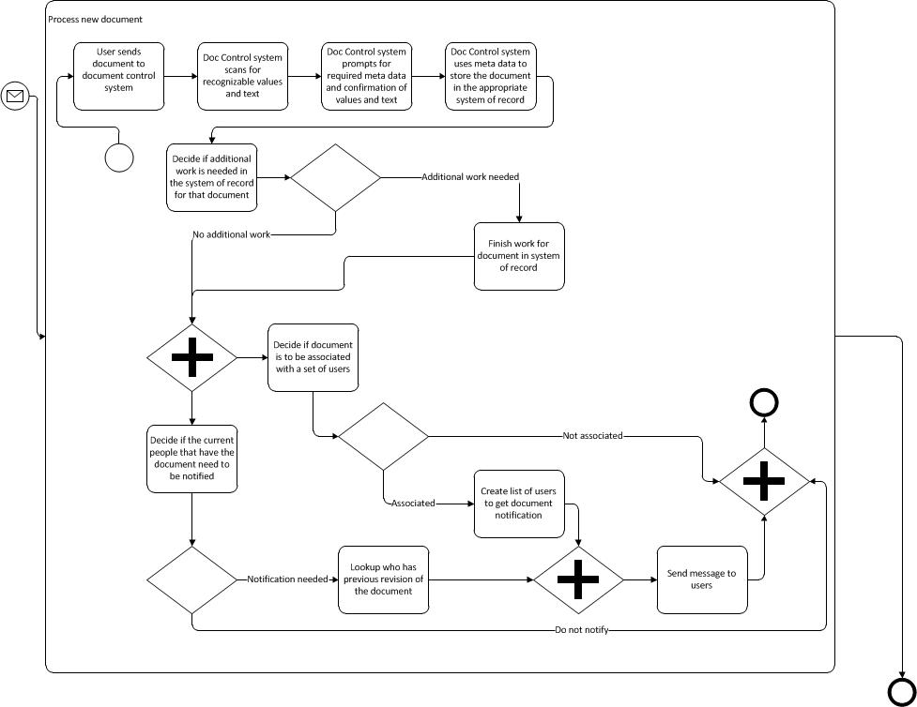
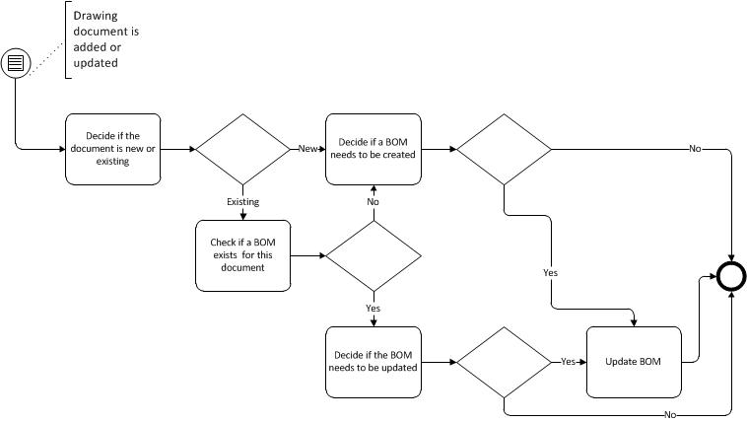

This is a general description of the QA/QC document audit process.
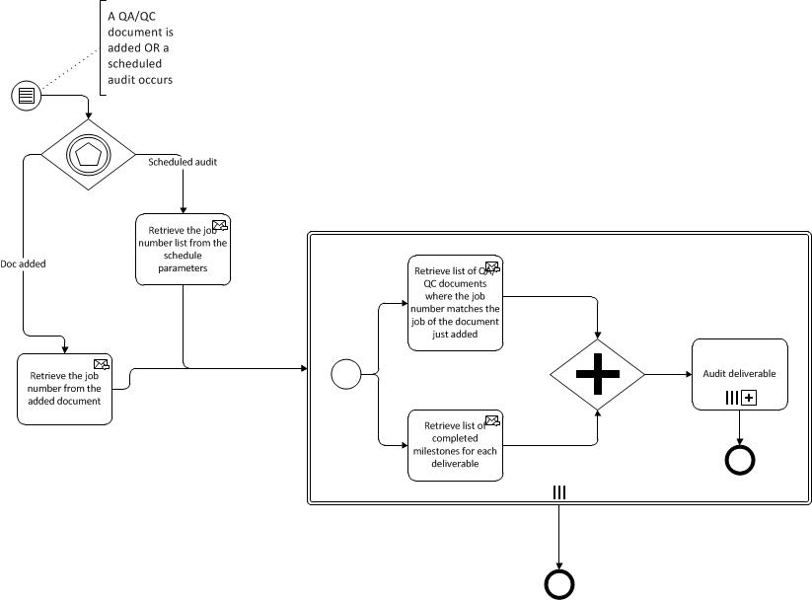

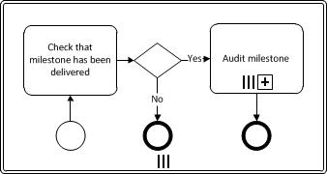

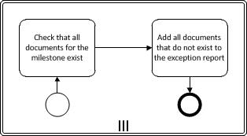

Demo Scenarios
Show deployment steps for a user. (2-4, 2-8, 2-9)
Show how documents and associated metadata are shared/synchronized/moved between your system, ViewPoint, SharePoint, Outlook, and file shares. (1-1, 1-2)
Show how the metadata can act as links between the document control system and ViewPoint, email, and SharePoint. (1-1, 1-2)
Show finding and editing of a MS Word, Excel, PowerPoint, Visio, Outlook, etc. document that is stored in the document control system. This should be done from the context of the native application that created the document and from any representation/link to the document. (1-1, 1-2, 1-3)
Show setting legal hold on a set of documents selected by topic. Show the selection and release of a set of documents from legal hold. (9-5)
Show saving and indexing a typical day's mail. (4-15, 4-*, 13-3)
Show saving and retrieving documents at a remote site. (2-4, 11-16, 13-20)
Show auto filing of documents when metadata is provided. (4-17)
Show selecting email based on rules (for auto-filing project documents). (1-5)
Show setting up alerts for new documents based on rules (i.e. I want to know about anything that comes in for project 123 from anyone at ABC company and Joe at DEF company). (3-7)
Show a search for all W2’s for employees on a job. (7-6, 7-7, 9-6)
Show transmittal tracking capabilities. (3-22, 5-1, 6-4, 6-5)
Show a search that displays documents that are opened right now. (6-1, 11-14)
Show how multiple documents can be checked out at a time. (13-6)
Show how document history is viewed and what version would be selected. (5-5, 13-5)
Show how exceptions and audit logs are viewed. (9-4, 9-5)
Show mass editing of metadata and adding metadata types. (31-1, 13-2)
Show how documents are viewed based on administrator and user defined taxonomies. (5-12)
Show how personal workspaces and draft documents are handled. (13-22)

BPM Scenarios
Show how processes/workflows are modeled. (3-*)
Show how interfaces with other systems (like database events in a timekeeping system) are created and used in a workflow. (1-15, 3-14)
Show creating a workflow that accesses data from an external database and a SharePoint list. (1-2, 1-15, 3-14)
Show how a workflow template would be created for handling several similar workflows. (For each job, for each milestone, for each inspection, and for each deadline; notify deadline owner based on date in Excel spreadsheet.) (3-4, 3-10)
Show how workflows/sub-workflows can be linked and used in another workflow. (3-10)
Show how predefined and ad-hoc workflows are started and executed. (3-3, 13-4, 13-10)
Show automated and manual escalation of a workflow. (3-9)
Show how running and completed workflows are discovered and monitored. (3-3)
Show how errors or unhandled exceptions are surfaced and dealt with.

Security Scenarios
Show how to apply roll/group/user based security to a set of documents like a folder structure. An example of this would be applying write permissions to each of the Safety folders in each project for the safety group. (9-6, 9-7, 9-11)
Show how permissions for a user are added, deleted, and queried across the system. (9-2)

