

Request for Proposals
For
Structured Data and Communications Cabling

Table of Contents
Table of Contents 2
1 INTRODUCTION 4
1.1 PATHFINDER INTERNATIONAL BACKGROUND 4
1.2 RFP PURPOSE 4
1.3 RFP TERMS AND CONDITIONS 4
1.3.1 Definition of Terms 4
1.3.2 Confidentiality 5
1.3.3 Marketing References 5
1.3.4 Proposal Validity 5
1.3.5 Acceptance or Rejection of Submissions 5
1.3.6 Contract Negotiation and Execution 6
1.4 RFP SCHEDULE 6
1.5 COMMUNICATIONS 6
1.5.1 How to communicate with Pathfinder International 6
Cabling.RFP@pathfinder.org 6
1.5.2 No other methods are acceptable 6
1.6 QUESTIONS 7
1.6.1 Methodology 7
1.6.2 Live Q&A Session Information 7
1.6.3 Written Questions 8
1.6.4 Format of Proposal 8
1.6.5 Withdrawal or Modification 8
1.6.6 Cost Proposal Instructions 8
1.7 EVALUATION CRITERIA 8
2 Proposal Contents 9
2.1 EXECUTIVE OVERVIEW 9
2.2 COMPANY BACKGROUND 9
2.3 COST 9
2.4 CUSTOMER REFERENCES 9
3 Work required 10
3.1 DESCRIPTION OF WORK 10
3.1.1 This work includes the installation of: 10
3.1.2 This work does not include the purchase or installation of: 10
3.2 PRODUCTS 11
3.2.1 Potential for Voice Over IP (VOIP) phone system 11
3.2.2 Cabling 11
3.2.3 Modular Jacks 11
3.2.4 Data Cabling Support Equipent 12
3.2.5 Telephone Cabling Support Equipment 12
3.2.6 Fiber Optic Cabling Support Equipment 12
3.3 EXECUTION 13
3.3.1 General 13
3.3.2 Installation of Structure Voice (Telephone) Cabling 14
3.3.3 Installation of Structure Data Cabling 14
3.3.4 Testing - General 14
3.3.5 Testing – Structured Voice (Telephone) Cabling 15
3.3.6 Testing – Structured Data Cabling 15
4 SERVICES 16
4.1 MAINTENANCE AND SUPPORT 16
4.2 WARRANTY AND REPAIR 16
4.3 PROFESSIONAL SERVICES 16
4.4 PROJECT MANAGEMENT AND IMPLEMENTATION 16
4.5 RENOVATION SCHEDULE 16
4.6 SUBVENDORS OR SUBCONTRACTORS 17
4.7 PRICING 17
4.7.1 Vendor Pricing and Cost Information 17
5 Appendix A – Renovation Plans 18
6 Appendix B – Power & Signal Plan 19
7 Appendix C – Phasing Plans 20

INTRODUCTION

PATHFINDER INTERNATIONAL BACKGROUND

For more than 50 years, Pathfinder International has been a global leader in reproductive health care. Pathfinder’s mission is to ensure that people everywhere have the right and opportunity to live a healthy reproductive life.

Pathfinder is headquartered in Watertown, MA with remote field offices in 22 countries in Africa, Asia and the Near East and Latin America. We maintain another small US field office located in Washington D.C. Our total worldwide workforce is approximately 850 people.

A renovation of Pathfinder’s office space at the Watertown, MA headquarters is planned to take place over the next 12 months. One half of the space will be renovated at a time and occupants will be moved to a temporary location allowing for a complete floor to ceiling renovation. All voice and data local area network cabling will need to be replaced.
More information about Pathfinder can be found at our web site www.pathfinder.org.

RFP PURPOSE

We are seeking proposals for the purchase and installation of voice and data local area network cabling for 30,000 sq.ft. as part of a turnkey renovation at our headquarters in Watertown, MA. The renovations are in partnership with our landlord, REIT Management Inc., and are being conducted starting in mid-August 2012 until April 2013.

RFP TERMS AND CONDITIONS
By responding to this RFP the Vendor signifies agreement with and is bound by the following Terms and Conditions.

Definition of Terms
Participating vendor: a company that has submitted a proposal in response to this Request for Proposals (whether or not it is successful).
Proposal: A response to this RFP submitted by a Participating Vendor.
RFP: Request for Proposals.
Vendor: any company or individual that has received a copy of this Request for Proposals.

Confidentiality
Pathfinder International expects the Vendor to respect the confidentiality of our information. The Vendor shall treat all information gained through participation in this RFP as confidential and shall not use or disclose the information beyond the intended purpose, being the Vendor’s preparation and response to this RFP; and shall not disclose the information to any third party, except where the information exists in the public domain and/or is exempt from protection under applicable law. Any other distribution, copying or disclosure is strictly prohibited.
If the Vendor is required to release any of the information to a third party for the purposes of preparing for its proposal, the Vendor is required to solicit at least the same confidentiality obligations from this third party prior to releasing the information.
Pathfinder International will consider proposals submitted by Vendors as confidential. All materials submitted by the Vendor will become the property of Pathfinder International and will not be returned.

Marketing References
All Vendors responding to this RFP shall be prohibited from making any reference to Pathfinder International in any literature, promotional material, brochures, or sales presentations without the express written consent of Pathfinder International as applicable.

Proposal Validity
Proposals and pricing must be valid for one year from the Proposal Due Date.

Acceptance or Rejection of Submissions
Pathfinder International is not obligated to accept the lowest cost or any proposal.
Pathfinder International reserves the right to:
- Reject any or all proposals;
- Issue no contract for any of the services described within this RFP;
- Negotiate any or all of the scope and terms of any contract that flows, directly or indirectly, from this RFP;
- Add or remove scope into the contract negotiation process;
Pathfinder International has no obligation to reveal the basis for contract award or to provide any information to vendors regarding the evaluation or negotiation processes.
All participating vendors will be notified promptly of bid acceptance or rejection.

Contract Negotiation and Execution
It is the intent of Pathfinder International that, after the successful vendor has been selected, Pathfinder International and the selected vendor will enter into contract negotiations containing all terms and conditions of the proposed service. Any acceptance of a proposal is contingent upon the execution of a written contract and Pathfinder International shall not be contractually bound to any vendor prior to the execution of such written contractual agreement.

RFP SCHEDULE
July 12th 2012 RFP Issued
July 16th 2012, 5pm ET Vendor notifies Pathfinder International of intent to respond
July 18th 2012, 5pm ET Written Questions Due to Pathfinder
July 20th 2012 5pm ET Responses received from Pathfinder to written questions
July 23th 2012, 2pm-4pm ET Live Q&A Session
July 27th 2012, 5pm ET RFP Responses due
July 31st 2012 Final selection
August 2012 Implementation period begins
Proposals that are late may be rejected.

COMMUNICATIONS

How to communicate with Pathfinder International
Vendor’s intent to respond, questions and final proposals should be sent to:

Cabling.RFP@pathfinder.org

No other methods are acceptable
Any additional attempts or methods used to contact Pathfinder staff are not acceptable for the purposes of this RFP and may be counted against the vendor in the final evaluation of proposals.

QUESTIONS

Methodology
It is the Vendor’s responsibility to clarify their interpretation of any item in the RFP of which they are not certain. Pathfinder International will respond to questions in a Live Q&A session which will be an open call for vendor’s to ask any questions. The call will be hosted on Webex. Vendors will submit written questions via chat and Pathfinder International staff will respond to each question.

Live Q&A Session Information
Topic: Pathfinder Cabling RPF - Live Q&A Session
Date: Monday, July 23, 2012
Time: 2:00 pm, Eastern Daylight Time (New York, GMT-04:00)
Meeting Number: 731 606 945
Meeting Password: 9galenst
To join the online meeting go to:
https://pathfinderinternational.webex.com/pathfinderinternational/j.php?ED=194036132&UID=501974467&PW=NYTBhNzg5ZDRl&RT=MiMxMQ%3D%3D
Call-in toll number (US/Canada): 1-650-479-3207
Access code:731 606 945
For assistance:
1. Go to https://pathfinderinternational.webex.com/pathfinderinternational/mc
2. On the left navigation bar, click "Support".
To update this meeting to your calendar program (for example Microsoft Outlook), click this link:
https://pathfinderinternational.webex.com/pathfinderinternational/j.php?ED=194036132&UID=501974467&ICS=MIU2&LD=1&RD=2&ST=1&SHA2=ldU/BMdK-riZc-00siarjU2wDjDUaNxAERhfHvgV/0Q=
To check whether you have the appropriate players installed for UCF (Universal Communications Format) rich media files, go to: https://pathfinderinternational.webex.com/pathfinderinternational/systemdiagnosis.php.
http://www.webex.com
CCM:+16504793207x731606945#
IMPORTANT NOTICE: This WebEx service includes a feature that allows audio and any documents and other materials exchanged or viewed during the session to be recorded. You should inform all meeting attendees prior to recording if you intend to record the meeting. Please note that any such recordings may be subject to discovery in the event of litigation.

Written Questions
Please submit your questions in a Microsoft Excel spreadsheet with the following:
- A clear and concise question;
- A question number for reference
- References to specific sections and paragraphs within this RFP if appropriate.

All vendors will receive a copy of all responses to all questions.

Format of Proposal
- All proposal must be submitted electronically and contain details of the proposed system, company, relevant customer references and costs
- Proposals should consist of not more than 10 readable pages

Withdrawal or Modification
A Vendor may, without prejudice to itself, modify or withdraw its response by written request, provided that the request is received by Pathfinder prior to the proposal due date.

Cost Proposal Instructions
Pricing shall be provided completion of the proposal including all labor, parts, materials, project management, shipping and foreseeable contingencies. Vendor shall state all assumptions used for pricing.

EVALUATION CRITERIA
Pathfinder will evaluate participating vendor proposals on all elements of each response. The approximate criteria for evaluation will be:

- Cost 50%
- Reputation, customer service, service 30%
quality, availability and resiliency
- Quality of proposal 20%

Proposal Contents

Vendor proposals should include the following information

EXECUTIVE OVERVIEW
Provide an executive summary of the system being proposed.

COMPANY BACKGROUND
Provide an overview of your company, number of years in business, size and experience with similar work.

COST

Provide a comprehensive and detailed cost breakdown for each component of the work described.

CUSTOMER REFERENCES
Please submit at least 3 customer references where you have implemented a similar solution including coordination, staging, assembly, installation, testing and all training through system acceptance.

Work required

DESCRIPTION OF WORK

This work includes the installation of:
- Telephone structured building cabling, Category 3.
- Computer structured building cabling, Category 6.
- Telephone and computer modular outlets: where shown on the plans provide combination types and configurations as detailed.
- Telephone "punch-down" blocks.
- Computer patch panels.
- Multi-pair telephone cabling.
- Fiber optic cables.
- Fiber optic termination panels.

Summary of quantities are as follows:

Item | Quantity
Office / cube / conference room data drops | 200--250
Office / cube / conference room voice drops | 100-150
Hallway or common area data drops | 30-50
Hallway or common area voice drops | 15-20
Patch panel ports | 300-375
Fiber cabling | 600 ft of 6 pair
Fiber termination | 6

This work does not include the purchase or installation of:
- Telephone switch
- Computer system and associated equipment
- Owner’s telephone vendor shall perform the cross-connect

PRODUCTS

Potential for Voice Over IP (VOIP) phone system

Pathfinder is actively considering a changeover to a VOIP phone system as part of the renovation project. The standards and information provided here are designed to allow us the flexibility to choose to implement the computer cabling only or a combination of computer and phone cabling. Vendors should provide propsoals and costs such that Pathfinder can use the responses to consider and select based on either scenario.

Cabling

Cabling will be installed in provided conduit with pull string. Vendor will not be responsible for installing conduit.

Telephone cabling shall be Category 3 UTP, 4 pair, #24 AWG plenum rated.

Data building cabling shall be 4 pair Category 6 UTP #24 AWG plenum rated.

Telephone service entrance cable shall be 150 pair gel-filled rated for direct burial.

Telephone premise riser cable shall be 75 pair rated NEC CMR.

Fiber optic cable service entrance cable shall be 24 strand 62.5/125μm.

Modular Jacks

Provide voice modular jacks style RJ-11, 6P6C, USOC wired, with 110 style punch down terminations for telephone use.

Provide data modular jacks style RJ-45, 8P8C, 568B wired, with 110 style punch down terminations for computer use.

Provide thermoplastic faceplates with two, three, or four modular ports and configuration of modular jacks as specified on the plans. Where required provide blank closures. Color to match other wiring devices.

Data Cabling Support Equipent

The Vendor is responsible for purchasing and installing new Rack and Patch Panel in Data Center as well as a wall mounted locked rack in 1 supply closet. The Vendor is responsible to install/mount all proposed devices in those racks and put in place all needed patch cables.

Patch Panels: Provide rack mounted Category 6 patch panels wired for 568B as required for termination of computer cables. Configure panels in 24, 48 and/or 96 ports; provide 50% spare capacity in each rack. Each rack shall have a maximum of 240 ports.

Provide floor-mounted rack system for mounting of computer patch panels, fiber optic termination panels, and Owner's equipment. Unit shall be at least 42U in height and 19" in width constructed of anodized aluminum and shall be enclosed with lockable hinged glass front. Rails shall be drilled and tapped.

Provide wall mounted rack(s) for mounting of computer patch panels, fiber optic termination panels, and Owner's equipment. Unit shall be 48” in height and 19" in width constructed of anodized aluminum and shall be enclosed with lockable hinged glass front. Rails shall be drilled and tapped.

Telephone Cabling Support Equipment

Premise telephone wiring shall be terminated on 110 type punch down blocks mounted to terminal boards.

Surge protection shall be provided for the telephone service entrance cable.

Fiber Optic Cabling Support Equipment

Fiber optic cable terminations shall be made in a 6 port fiber rack mounted interconnection unit with ST connectors.

EXECUTION

General

All system components and appurtenances shall be installed in accordance with the manufacturer's instructions as specified and indicated. All installation work must be done in accordance with the safety requirements set forth in the general requirements of ANSI C2 and NFPA 70.

The Vendor shall coordinate with the Project Manager an installation schedule for the entire project. This process is to begin at the Project Initiation Meeting. The Vendor is to deliver a written Project Schedule at this meeting.

Interior cabling shall be installed and terminated at all station locations as indicated on the Drawings and herein specified. Cabling shall take the form of a "Structural Building Wiring Plan" where station cables are wired directly from a distribution point to the appropriate outlet location.

Station cables shall not be installed in the same raceway with AC power cables. Station cables not installed in raceways shall be properly secured above the ceiling on system cable supports as shown on the Drawings. Cables shall not be installed on top of the tiles of lay-in ceiling grid system.

With the installation of equipment and cables, consideration shall be given not only to operational efficiency but also to overall aesthetic factors. The Vendor shall redo any work deemed by Pathfinder that appears sloppy or unprofessionally completed, at no cost to Pathfinder. Pathfinder shall have final decision over whether work must be redone.

The Vendor is responsible for purchasing and installing new Rack and Patch Panel in Data Center as well as a wall mounted locked rack in 1 supply closet. The Vendor is responsible to install/mount all proposed devices in those racks and put in place all needed patch cables. Any questions about use of racks must be directed to the Project Manager.

All rubbish, debris, and dirt resulting from Vendor's work shall be cleaned up as required, removed from the buildings. The premises shall at all times be kept in a clean, safe and professional manner.

Labeling and marking shall be as follows:
- Provide permanent markers on each cable at each termination point for easy identification.
- Jack numbering shall match the corresponding patch panel in the communications closet. Labels are to be machine made; hand written labels are unacceptable.
- Voice jacks shall be numbered with a prefix of “V” to indicate voice.
- Data jacks shall be numbered with a prefix of “D” to indicate data.
- All cables and fiber optics shall be terminated in approved modular jacks or termination enclosures. No cables shall be left "free" unless so stated on the Drawings.

Installation of Structure Voice (Telephone) Cabling

The telephone wiring standard shall be 6P6C, USOC.

The Vendor shall install the telephone system connecting all outlets and cabling to punch down blocks for a complete premise wiring system. This system shall be tested as specified herein.

The Owner will provide the cross-connection between the service and stations.

The telecommunications equipment ground shall be connected to the Ground Window Busbar (GWB).

The GWB shall be a copper ground bar provided for the common connection of all telecommunications equipment.

The GWB shall be connected to the main building ground at the main panel and to a driven ground rod following the most direct route utilizing a copper wire conductor that shall be a minimum of #6 AWG wire.

Installation of Structure Data Cabling

The computer wiring standard shall be T568B.

The Vendor shall install the computer system connecting all outlets and cabling to patch panels for a complete premise wiring system. This system shall be tested as specified herein.

Testing - General

After installation the Vendor shall test the structured cabling systems as outlined below.

The Vendor shall provide the necessary testing equipment for testing all cabling under this project.

The Owner and Pathfinder reserve the right to witness any or all testing. The Vendor shall advise the Owner in writting when testing is scheduled at least one week in advance of actual testing.

Testing – Structured Voice (Telephone) Cabling

Each telephone cable shall be tested from each outlet to the punch down block for the following parameters:

Basic data:
- Cable manufacturer and part number, NVP
- Tester manufacturer, model, serial number and hardware/software versions.
- Project name and circuit ID number
- Autotest specification used
- Overall PASS/FAIL indication
- Date of test

Wire Map:
- Continuity
- Shorts between conductors
- Crossed pairs
- Reversed pairs
- Split/open pairs

Testing – Structured Data Cabling

Each computer cable shall be tested from each outlet (jack) to the patch panel for the following parameters:

Basic data:
- Cable manufacturer and part number, NVP
- Tester manufacturer, model, serial number and hardware/software versions.
- Project name and circuit ID number
- Autotest specification used
- Overall PASS/FAIL indication
- Date of test

Wire Map:
- Continuity
- Shorts between conductors
- Crossed pairs
- Reversed pairs
- Split/open pairs

SERVICES

MAINTENANCE AND SUPPORT
- Please provide a copy of your standard contract or service agreements for maintenance and support of all proposed products and installation.

- What is the structure and schedule for resolving problems reported by Pathfinder International or other renovation vendors during and after the renovation period?

WARRANTY AND REPAIR
- Describe the warranty program including the standard warranty and any extended warranty coverage available for the proposed solution.

- The warranty must cover the replacement or repair of defective product(s) and related labor for the replacement or repair of said defective product(s).

PROFESSIONAL SERVICES
- Describe your professional services to implement and support the proposed solution. Describe any services that further integrate or customize the solution. These services would be “above and beyond” the normal services provided as part of the standard offerings.

PROJECT MANAGEMENT AND IMPLEMENTATION
- Would you provide a dedicated project manager to work with us?

RENOVATION SCHEDULE
- The renovations are planned to happen in two distinct phases:

Phase 1
Construction is currently scheduled from 9/3/2012 until 11/21/2012 – these dates will be confirmed by 7/20/2012
We anticipate that cabling would occur in late September or October 2012.
Phase 2
Construction is currently scheduled from 12/11/2012 until 2/18/2013 – these dates will be confirmed by 7/20/2012
We anticipate that cabling would occur in late December 2012 or January 2013.
Please see attachment for areas of work affected in each phase.

SUBVENDORS OR SUBCONTRACTORS
- Disclose the planned use of any subvendor or subcontractor that will perform twenty percent or more of the services described in your proposal. In addition, you may choose to identify any other subvendor or subcontractor that you believe may add value.

- The vendor will be responsible for the performance of any subvendors or subcontractor and will not be relieved by non-performance of any sub-vendors.

PRICING

Vendor Pricing and Cost Information
All costs must be fully and plainly disclosed at a component level; include component description, part number, manufacturer’s part number, quantity, unit cost, extended unit cost, and comments if necessary.
The cost proposal should be comprehensive to include all foreseen project/work costs including but not limited to all parts, labor, shipping, materials, travel, and project management.
Please provide your costs in a Microsoft Excel spreadsheet. Supplementary materials can be included if necessary.
Pathfinder is evaluating the potential for a VOIP phone system and will decide by 9/1/2012. Please provide phone cabling and associated costs as separate line items for consideration of two scenarios:
- Computer cabling only for use with a VOIP phone system
- Computer and phone cabling

Appendix A – Renovation Plans
Open PDF file for greater detail:
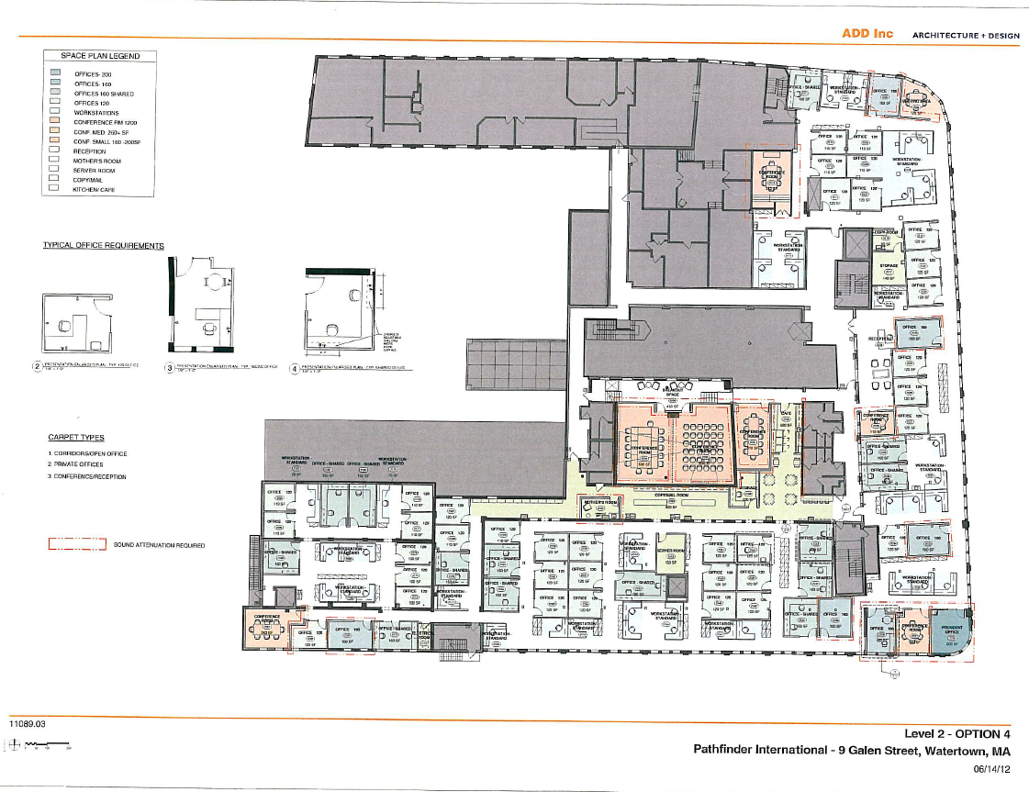

Appendix B – Power & Signal Plan
Open PDF file for greater detail:
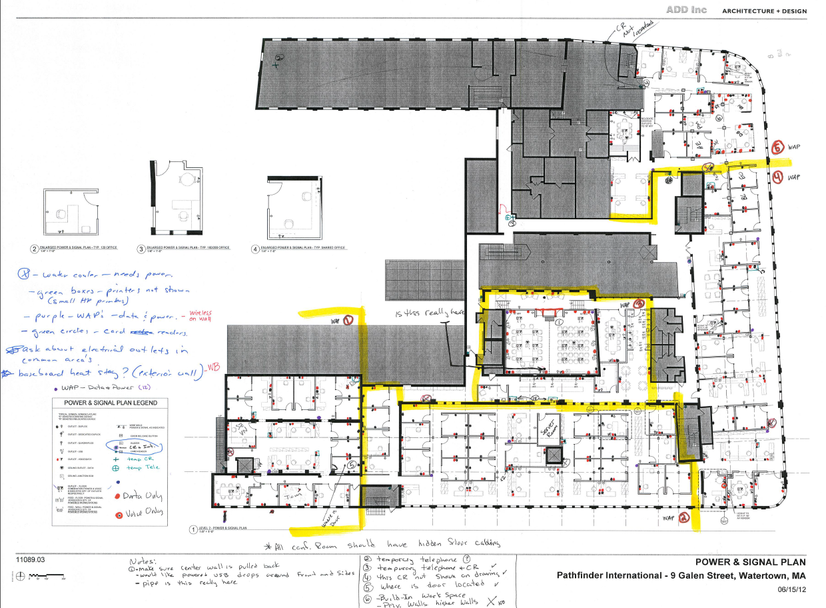

Appendix C – Phasing Plans
Open PDF file for greater detail:


