

Request for Proposals (RFP)

For

System Services & Support

of
Portland State University’s (PSU) LENEL OnGuard PROI Access Control System
(RFP No. 13634)

ATTENTION POTENTIAL
PROPOSERS!!

IMPORTANT NOTICE
Responsibility of Each Vendor Participating in the Bidding Process
It will be the responsibility of each participating Vendor to refer daily to the OUS Business Opportunities website to check for any available amendments or addenda, responses to inquiries and/or questions, cancellations, or intents to award, and any and all additional information regarding this opportunity that is posted. It is not Portland State University’s (“PSU”) responsibility to notify participating Vendors by email or by any other means of any of the above. Copies of this document can be obtained on the web site as well. The web link follows. (The terms “Portland State University”, “PSU”, “campus”, and “University” are used interchangeably in the RFP.)

Web Link: http://www.ous.edu/bapp/bopps/index/pspsu
All Proposal questions and inquiries must be sent by email to contract@pdx.edu. The subject line of the email must state the following: RFP #13634 (Lenel Services) Questions and Inquiries. Any questions and inquiries that are not so submitted and identified will not be responded to.
RFP Data
Commodity Title: Lenel OnGuard PROI System Support
Buyer: State of Oregon, acting by and through the State Board of Higher Education, on behalf of Portland State University (PSU)
Solicitation Officer: Karen Preston, Contracts Officer
Phone/Fax: 503-725-5460, Fax: 503-725-5594
Email: contract@pdx.edu
Date Issued: March 25, 2009

RFP Proposal Deadline for Receipt by PSU Purchasing & Contracting Office

Day/Date: April 17, 2009
Time: 3:00 p.m., Pacific Daylight Time (PDT)
Location/Address: PSU Purchasing & Contracting Office
(hand deliver Proposals here) 724 Southwest Harrison Street, Room 153
Portland, OR 97201

Mailing Address: Portland State University
Purchasing & Contracting Office
PO Box 751 – BAO/PUR
Portland, OR 97207-0751

TABLE OF CONTENTS

Schedule of Events | Page 2
Purpose/Background | Page 3
Section 1: Proposal Information | Page 5
Section 2: Requirements & Specifications | Page 12
Section 3: Pricing Proposal | Page 15
Section 4: Instructions to Proposers: Proposal Content & Evaluation Criteria | Page 16
Section 5: Evaluation Scoring Matrix Summary | Page 23
Section 6: Proposer Certification | Page 24
Section 7: PSU Standard Terms & Conditions | Page 25
Attachments and Exhibits  Technical Specifications/Standards | Pages 32-99

SCHEDULE OF EVENTS
These dates are for reference only; we may change these dates at our discretion. You must check on http://www.ous.edu/bapp/bopps/index/pspsu for any schedule dates change prior to the Proposal due dates.
These dates are for reference only; we may change these dates at our discretion.

Issue RFP March 25, 2009

Mandatory Site Visit and Pre-Proposal Conference
for Sample Projects (9:00 am PDT)
Location: Portland State University March 31, 2009
724 SW Harrison, Neuberger Hall Room 171
Portland, OR

Deadline for Vendor Questions 3:00 pm PDT April 6, 2009

Deadline for PSU to Respond April 10, 2009

Proposals Due* 3:00 pm PDT April 17, 2009

Interviews (to be determined by PSU at PSU’s sole discretion) Week of April 27, 2009

Evaluation Period Ending May 6, 2009

Anticipated Notice of Intent to Award May 8, 2009

Deadline to Protest Award Seven calendar days after notice of intent to award

Anticipated Date of Contract Execution May 25, 2009

* Proposals must be received by the PSU Purchasing and Contracting Office no later than 3:00 p.m. PDT (Pacific Daylight Time) on this date.

PURPOSE & BACKGROUND

Portland State University (“PSU”) is issuing this Request for Proposals (RFP) to establish a “time and materials” system and service support agreement. PSU will utilize said agreement to purchase the various materials and services necessary to support and expand/upgrade its existing LENEL SYSTEMS INTL. INC. (“Lenel”) access control system installed throughout the campus buildings. Competition will be restricted to authorized, full-service Lenel Access Control Integrators in good standing (the “Contractor”), and who meet the requirements of this RFP. The Contractor must have proven qualifications and experience to service, augment and expand PSU’s existing Lenel OnGuard PROI Control System. The words “shall” and “will” are used interchangeably throughout this RFP and the use of either connotes a mandatory requirement. The use of one or the other shall not mean a different degree of right or obligation for either Party.

A. EXISTING ENVIRONMENT

- Current Lenel Access and Security System. Currently PSU has a variety of access control methods and systems. Most door access is by key. PSU also has DSC intrusion alarm systems at various locations around campus; the intrusion alarm systems as well as fire alarms report into a Bosch DD6600 central station receiver at the Campus Public Safety Office’s proprietary monitoring station. Lenel is used as the automation software to display information through the Alarm monitoring module. Lenel is also providing Lenel Network Video Recorder (LNVR) services for cameras in certain locations to a separate video server. Card access on campus provides security (motion and panic alarms), area auditing and controlled access for buildings, parking garages, dorms, elevators (including telecom), server rooms, labs, classroom, dorms, and office suites. Currently for Lenel there are twenty six panels, 24 alarm panels, 93 device inputs with 210 readers, which hold 90,000 cardholders, with 21,000 to 26,000 actively assigned access. The Lenel system also provides images of cardholders to other secure systems on campus and batch process of activations via Lenel Data Exchange. PSU has two (2) mobile badging stations that are deployed during orientations or as needed.

- PSU’s Network. Access Control systems are on a separate, isolated fiber network that is part of the campus backbone data network. PSU has standardized on Cisco Ethernet switches for the campus network. This network is the responsibility of PSU. Lenel panel locations are determined by PSU Networking & Telecom Services (PSU-NTS) and Facilities and Planning. Generally speaking they are located as close to where the network fiber enters the building in the BET (Building Entrance Terminal) rooms. Locations of the field device to be installed can also be a factor and the Lenel system integrator’s recommendations are taken into account by PSU.

- The backbone network terminates in a main wiring room/closet in each building called the BET. Typically in larger buildings there will be more than one wiring distribution closet, but only one BET. As much as is possible, Contractors should plan on locating any building controllers in the main BET, as secure closet space is limited. In those instances where there is not adequate space in the existing BET or associated wiring distribution closets, a location must be chosen that is as close as possible to the existing wiring closets. This determination will be made working with PSU personnel from PSU-NTS.

- Server and Workstation Platforms. PSU uses a dedicated server and workstation for the system. PSU workstations and servers meet or exceed Lenel recommendations for both client and server.
CONTRACT TERM

The initial contract term is for a period of three (3) years and will automatically renew for two additional one-year periods, unless otherwise terminated per termination criteria described in this RFP or separately negotiated by contract. The resulting contract can be extended beyond the initial term and the two one year renewals, and additional work added if necessary, by mutual written agreement of Portland State University and the vendor.

CONTRACT TERMINATION FOR CONVENIENCE

This agreement may be terminated for convenience at any time by mutual consent of both parties, or by either party, upon sixty (60) days notice in writing and delivered by certified mail or in person to the other party.

FINANCIAL CONSIDERATION

The maximum dollar value of any contract awarded under this solicitation shall not exceed five million dollars. This amount may be amended at the University’s sole discretion through the renewal term(s) of any ensuing contract.

COOPERATIVE PURCHASING

All Oregon University System (OUS) institutions and other public agencies may utilize any contract(s) awarded as a result of this Request for Proposal. The OUS institutions and other public agencies shall be individually responsible for their obligations to the awarded vendor(s). Likewise, the vendors shall be responsible to the OUS institution and other public agencies for their obligations to the OUS members and public agencies pursuant to any ensuing contract(s). Any such purchases shall be between the vendor and the participating OUS member or public agency and shall not impact the vendor’s obligation to Portland State University. Portland State University makes no representation or guarantee as to the volume of such additional purchases.

PSU PHYSICAL SECURITY AND INFORMATION TECHNOLOGY SYSTEM SECURITY STANDARDS

All responses will be required to meet any and all Portland State University (PSU) physical security standards and PSU/Oregon University System (OUS) Information Technology (IT) security standards that PSU in its sole discretion deems necessary. PSU’s physical security standards are detailed in Exhibits C and D, incorporated by reference herein. Additionally all responses must comply with all applicable PSU/OUS Information Security Policies, per Exhibit A, hereby incorporated by reference. PSU may contact Proposers for further information and for verification that the proposed product meets or exceeds PSU’s requirements. In the event that the proposed product does not meet PSU’s requirements, the response may be deemed non-responsive and rejected from further consideration
SECTION 1: PROPOSER INFORMATION

All Proposals submitted in response to this RFP are subject to the provisions and requirements of all applicable laws and regulations, included Oregon Revised Statutes (ORS) and the Administrative Rules of the Oregon University System.

- Right to Reject: PSU reserves the right to cancel or reject this procurement, RFP, and any or all Proposals received as a result of this RFP upon finding that it is in the public interest to do so.

- Preparation Costs: PSU shall not be liable for any costs incurred by Proposers in the preparation of Proposals to this RFP, including any meetings and demonstrations that may be required or requested.

- Mandatory Site Visit for Sample Projects: A mandatory site visit will be held at the date, time and location listed in the Schedule of Events. The purpose of this site visit is to conduct a walk-through of the 3 sample projects as detailed later in this RFP. Proposers with questions, concerns or issues regarding these projects should refer to Paragraph 4, below.

Since attendance at this site survey is mandatory, each potential Proposer must send at least one qualified representative for the walk-throughs. Proposers’ representatives will be required to sign in to certify their attendance. Failure to sign in may result in the rejection of a Proposer’s Proposal.

- Questions or Requests For Clarification/Change: All requests for changes or clarifications regarding technical information, procedural requirements, contractual requirements or other issues must be submitted, in writing, and received no later than the date and time listed in the Schedule of Events to the name and address listed on the cover page of this RFP. Proposers must note that PSU is not allowed to consider exceptions to the specifications or terms and conditions after the deadline for which to do so have passed. If you have an exception or a concern with anything in this RFP, you must raise that issue, in writing, which must be received by the deadline date for Requests for Changes, listed in the Schedule of Events.

PSU reserves the right to reject Proposals from respondents that raise any objections to the terms and conditions of this RFP after the deadline date for requests for changes. Proposers’ proposed agreements, including proposed supplemental terms and conditions may be considered by PSU in its sole discretion, pursuant to paragraphs 7 and 17 below.

PSU will consider all protests and requested changes and, if reasonable and appropriate, amend this RFP.

Envelopes or emails or faxes containing requests for change, protest of RFP requirements or contract provisions shall be marked as follows:

- RFP Specification (or Contract Provisions) being questioned;
- Request for Change (or Protest);
- RFP Document Number; and,
- Date Submitted.

Instructions for emailing questions are provided on Page 1 of this RFP.

- Submittal Location: Requests for RFP specification or contract provision change, protest or clarification must be submitted to the following email address: contract@pdx.edu or by mail or hand delivery to the solicitation officer identified in this document. Any such requests sent to anyone but this person will not be considered. Such requests may be submitted via facsimile or email, or first class mail, provided the method of transmission provides for a return receipt to sender.

- Change or Modification Addenda(s): Any change or clarification to the specifications or the procurement process or to the terms and conditions of the contract will be issued in the form of an Addendum to this RFP and will be made available on the website: http://www.ous.edu/bapp/bopps/pspsu.

Only documents issued as addenda by the PSU Office of Business Affairs, Purchasing & Contracting Office will serve to change this RFP in any way. No other direction received by the Proposer, written or oral serves to change this RFP document.

Proposers are not required to return addenda with their RFP Proposal. However, Proposers are responsible for making themselves aware of and obtaining and incorporating any changes made in any addenda issued into their final Proposal. Failure to do so may cause the Proposer’s Proposal to be rejected.

- Proposal Preparation and Submission: Proposals to the RFP shall be of sufficient length and detail to demonstrate that the Proposer has a thorough understanding of the PSU environment.

Proposers shall submit ONE (1) ORIGINAL of all Proposal pages and eight (8) photocopies of the same pages which shall be transmitted in a manner so that it is received by the PSU Purchasing and Contracting Office by the RFP Proposals Due date to the location listed on the cover page of this RFP. The original Proposal shall be marked "ORIGINAL".

Proposals and pricing must be submitted in the format incorporated herein by reference as Attachments 1 and 2. Proposals that do not follow this response format may not be considered.
Proposals shall be prepared in printed form, not handwritten, and shall be signed in ink by an authorized representative of the Proposer. The person signing the RFP shall initial alterations or erasures in ink. The original Proposal submitted by a Proposer must bear an original signature. Failure to submit a Proposal bearing an original signature may result in rejection of the Proposal. No oral, telegraphic, telephone, e-mail or facsimile Proposals will be accepted. Proposals, including pricing, must not be submitted in three ring binders or with any binding that cannot be easily removed. Comb binding or large clips are acceptable. It is also recommended that Proposals be printed on at least 30% recycled paper. Proposals must not include any tabbing or glossy paper, must be printed two sided, and it is recommended that graphics be kept to a minimum. Only those graphics essential to the Proposal should be included. Please do no utilize any plastic cover sheets. Respondents must also submit an electronic copy of the complete Proposal on one CD, and the Pricing Proposal on a separate CD. The content of the CD’s should be in a PC legible format (Adobe PDF format). Each CD should be clearly marked with the respondent’s company name and identified as “Proposal” and “Pricing Proposal”.

Proposals must be submitted in a sealed package(s) or envelope(s). To ensure proper identification and handling, all package(s) or envelope(s) must be clearly marked with the RFP Number and Title and the date and time RFP Proposals are due. Pricing information must be submitted at the same time in a separate sealed package, and must be clearly marked "Pricing Proposal", with the name of the vendor submitting the Proposal clearly identified on each page of the Pricing Proposal. Eight (8) copies of the Pricing Proposal must be submitted. Pricing information must not be included with the rest of the Proposal in any manner whatsoever. Failure to completely separate pricing from the rest of the Proposal may result in rejection of the Proposal.

Proposals and pricing information must be received and time-stamped by the PSU Purchasing & Contracting Office (unless otherwise specified) prior to the scheduled RFP Proposals due date and time listed in the Schedule of Events of this RFP. Late Proposals or modifications will be rejected.

Proposers should note that PSU has an internal campus mail system which is used to distribute all U.S. mail sent to PSU. This internal mail system sometimes experiences delays in distributing mail to campus departments and, upon rare occasion, loses mail intended for campus departments. Thus, Proposers using the U.S. mail to submit their Proposals do so at their own risk.

Proposers must complete all applicable information and provide all information requested in the RFP. Failure to comply may be grounds for Proposal rejection.

Proposer must include a separate cover sheet that identifies the company name, the company’s primary and secondary contact person’s name for the individuals responsible for answering questions in regard to the Proposal, and include the primary and secondary contact person’s email, phone and fax number as well as company’s web address.

7. Proposer Agreements: Proposers may submit proposed agreements of any form (contracts or documents) that contain supplemental terms and conditions that the Proposer desires to be included as part of the contract. By accepting delivery of these items, PSU is not bound to accept them as part of any ensuing contract. PSU may negotiate such supplemental terms and conditions that are not already covered by the contract terms and conditions detailed in this RFP. If the parties do not agree on the inclusion of the supplemental terms and conditions, PSU may: a) enter into a contract with the apparent successful Proposer without the agreements submitted by the Proposer; or b) the submission will be considered non-responsive and PSU may enter into a contract with another responsive Proposer. PSU will not consider any terms and conditions that are not submitted with the Proposal.

8. Public Records: This RFP and one copy of each original Proposal received in Proposal to it, together with copies of all documents pertaining to the Award of a Contract, shall be kept by PSU and shall be open to public inspection. If a Proposal contains any information that is considered a trade secret by the Proposer under ORS 192.501(2), each sheet of such information must be clearly marked with the following:

"This data constitutes a trade secret under ORS 192.501(2), and shall not be disclosed except in accordance with the Oregon Public Records Law, ORS Chapter 192."

The Oregon Public Records Law, ORS 192.501(2), exempts from disclosure only bona fide trade secrets, and the exemption from disclosure applies "unless the public interest requires disclosure in the particular instance." Therefore, non-disclosure of documents or any portion of a document submitted as part of a Proposal may depend upon official or judicial determinations made pursuant to the Public Records Law.

Pricing information cannot be labeled a trade secret and must be open to public inspection. Proposers are requested to mark only specific pages or text in their Proposal considered a “trade secret” under Public Records Law. Proposals in which the entire document is marked or otherwise identified in its entirety as confidential or a "trade secret" will be rejected.

- Information Submitted: Proposers are cautioned that it is the Proposer's sole responsibility to submit information related to the evaluation categories, and that PSU is under no obligation to solicit such information if it is not included within the Proposal. Failure by the Proposer to submit such information may cause an adverse impact on the evaluation of the Proposal, including rejection of the Proposal as non-responsive.

- Evaluation Criteria: Any contract(s) resulting from this RFP will be awarded based upon the evaluation criteria and methodology given in this RFP and in accordance with the Oregon University System, PSU, and State of Oregon administrative purchasing rules and laws.

- The Evaluation Process: All Proposals received by the due time and date will be reviewed by an evaluation committee. Proposals which are not received by the deadline will not be reviewed by the evaluation committee. This committee will determine the extent to which the Proposals conform to the specifications set forth herein and will be evaluated according to criteria identified in this RFP. The following process will be used.

- .Pursuant to the provisions of Oregon Administrative Rule (OAR) 580-061-0010(40), Proposals will be evaluated to determine which are to be considered “responsive” (substantially comply in all material respects with the requirements, specifications and criteria as defined in this RFP), and which Proposals, if any, would be considered “non-responsive” (failed to substantially comply in all material respects with the requirements, specifications and criteria as defined in this RFP). PSU also reserves the right to waive what are, in PSU’s judgment, minor informalities or discrepancies.
- The committee will reject those Proposals that are “non-responsive” within the meaning of the above definition, and as authorized by OAR 580-061-0130 (rejection of individual bids or Proposals). For those Proposals considered “responsive”, the committee will further evaluate them using the mandatory points process to determine that Proposal which would meet PSU’s needs in terms of best overall value pursuant to OAR 580-061-0060.
- Proposals that meet all mandatory requirements will be further evaluated on their value to PSU in meeting PSU’s overall needs. PSU reserves the right to obtain clarification of any point in a vendor's Proposal or to obtain additional information necessary to properly evaluate a Proposal. Failure of a vendor to respond to such a request for additional information or clarification may result in rejection of the vendor's Proposal. PSU’s retention of this right shall in no way reduce the responsibility of vendors to submit complete, accurate, and clear Proposals.
- The selection of “finalist” Proposer(s) will be determined by the evaluation committee independently scoring the Proposals and then combining the scores and pricing information to determine the overall Proposal score.
- Vendors may be invited to make a presentation in support of the Proposal. Such presentations will be made to the evaluation committee, which comprises PSU’s work group. If held, the presentations will be scheduled.
- The findings of the evaluation team will be summarized and the summary and award recommendation(s) will be forwarded to the PSU Purchasing and Contracting Department.
- The PSU Purchasing & Contracting Department will review the recommendation and approve or reject the evaluation team’s selection.

- Investigation of References: PSU reserve the right to investigate the references and the past performance of any Proposer with respect to its successful performance of similar projects, compliance with specifications and contractual obligations, its completion or delivery of a project on schedule, and its lawful payment of suppliers, subcontractors, and workers. PSU may postpone the award or execution of the contract before or after Notice of Intent to Award to complete its investigation. PSU reserves the right to reject any Proposal or to reject all Proposals at any time prior to PSU's execution of a contract in the event Proposer’s reference checks prove unsatisfactory.
- Consideration of Past Performance: PSU reserves the right to consider past performance, historical information and fact, whether gained from the Proposer's Proposal, question and answer conference, references, or any other source in the evaluation process.

- Reservation of Rights: PSU has and reserves the right to refuse to enter into a contract if PSU, based upon reasonable grounds, determines that the interests of PSU would not be served. Specifically, this right may be exercised if PSU does not believe that a given Proposer can perform a contract, or for any reason set forth in Oregon Administrative Rules. PSU, at its option, may give the Proposer notice, specifying the grounds for rejection, and allow the Proposer 15 calendar days to respond in writing. Following such response, PSU, in its sole discretion may reject the Proposal as provided in the referenced administrative rules.

- Post-Selection Review & Finalists: Unless this RFP is canceled, after PSU opens all timely-received Proposals, PSU will evaluate all Proposals in accordance with the evaluation criteria set forth in this RFP. PSU may rank the Proposals to determine the “finalist” Proposers. Finalists will be those highest-ranked responsive, responsible Proposers after evaluation of the Proposals according to the evaluation and selection criteria in the RFP, and applicable statutes and administrative rules. PSU reserves the right to select the Proposal(s) based on the evaluation criteria and scores identified in the RFP. In the event that finalist Proposal(s) do vary significantly, PSU reserves the right to conduct discussions with the finalist Proposer(s), to accept best and final offers from those finalist(s), and to negotiate changes.

PSU reserves the right to select the vendor that, in the collective opinion of the evaluation committee, offers the best overall benefit, convenience, functionality and service at the lowest cost to PSU. In the event that Finalist Proposals do vary significantly, PSU reserves the right to conduct discussions with the Finalist Proposers, to accept best and final offers from those Finalists, and to negotiate changes, if it’s in PSU’s best interest to do so. Should PSU choose to enter into any negotiation of contract terms and conditions with Finalist Proposers, Proposers should pay close attention to the following:

- Supplemental Terms and Conditions: PSU will only negotiate terms and conditions which are supplemental and reasonably related to the Contract and which are contained in any Proposer software licensing agreements, maintenance contracts, technical support agreements, and any other forms or documents that the Proposer desires to be considered for inclusion in the final terms and conditions of the Contract and which have been included in their Proposal pursuant to Paragraph 6 of this Section. Universities will not include in the final Contract, nor consider for negotiation, Proposers’ supplemental terms and conditions that materially conflict with this RFP including the Standard or Special Terms and Conditions, or which would materially change the nature of this solicitation, or adversely affect competition. However, Proposers should note that PSU also reserves the right to select a Proposer for award from the original Finalist Proposals received, so the best possible Proposals should be submitted when first responding to this RFP.

- Negotiations with Finalist Proposer: Once PSU has determined the highest ranked Finalist Proposer, PSU will commence negotiations with that Proposer to obtain a mutually agreeable Contract. If PSU is able to negotiate a mutually agreeable Contract with the highest ranked Proposer, it will award the Contract to the highest ranked Proposer without commencing negotiation with any other Finalist Proposers. If, in PSU’s sole and absolute discretion, it is determined that the Finalist Proposer is not responsive to the process, or that the parties will be unable to negotiate a mutually agreeable Contract, or if the Finalist Proposer decides not to continue participation in the negotiations, PSU may suspend negotiations with the highest ranked Finalist Proposer and commence negotiations with the next highest ranked Finalist Proposer to arrive at a mutually agreeable Contract. If it is in PSU’s best interest to do so, PSU will continue this process of negotiations with Finalist Proposers in descending rank until PSU is able to obtain a mutually agreeable Contract with a Finalist Proposer. Once PSU has obtained a mutually agreeable Contract, PSU will cease negotiations and not negotiate with any lower ranked Proposers.

After receiving the evaluation summary PSU Purchasing & Contracting Office will name one or more apparent successful Proposer(s) and announce its Intent to Award to one or more of these Proposer(s). Identification of the "apparent successful Proposer" is procedural only and creates no right in the named Proposer to award of the Contract. All competing Proposers shall be notified in writing of PSU’s Intent to Award and the identity of the apparent successful Proposer. All competing Proposers shall be given seven (7) calendar days to review the RFP file and evaluation report at the PSU Purchasing and Contracts Office. Any questions or concerns about, or protests of, the evaluation process must be in writing and must be delivered to the PSU Purchasing and Contracts Office within seven (7) calendar days after the date of the letter of Intent to Award identifying the apparent successful Proposer.

Within a reasonable time following the end of this seven (7) day protest period, PSU will consider all protests received, if any, and:

- Reject all protests and proceed with final evaluation of the apparent successful Proposer(s) and, pending the satisfactory outcome of this final evaluation, enter into a Contract with apparent successful Proposer(s); OR

- Sustain a meritorious protest(s) and reject the apparent successful Proposer(s) as non-responsive if such Proposer(s) is unable to demonstrate that its Proposal(s) complied with all material requirements of the RFP and Oregon public procurement law; thereafter, PSU may name a new apparent successful Proposer(s); OR

- Reject all Proposals and cancel the procurement.

- Supplemental Terms and Conditions: While PSU will not consider Proposers’ supplemental terms and conditions that materially conflict with the provisions of this RFP, at PSU’s sole discretion, PSU may choose to consider and negotiate the inclusion of terms and conditions contained in such Proposer agreements and contracts or documents reasonably related to this RFP as supplemental to PSU’s Standard Terms and Conditions contained in this RFP (see Section 6). PSU will not consider any supplemental terms and conditions that have not been submitted with the Proposal. Any respondent that desires to have terms and conditions negotiated must submit the terms and conditions that are to be considered for negotiation at the time of submission of the Proposal. Any terms and conditions that are not submitted with the Proposal will not be considered.

- EXHIBITS AND ATTACHMENTS

The following exhibits and attachments are hereby incorporated by reference into this RFP:

Attachment 1: Proposal Response Format
Attachment 2: Pricing Response Format and Requirement

Exhibit A: OUS/PSU Information Security Policies
Exhibit B: List of Offenses
Exhibit C: Portland State University Physical Security Standards
Exhibit D: Portland State University Installation Standards
Exhibit E: Auto Cad Drawings for Sample Projects

SECTION 2: REQUIREMENTS & SPECIFICATIONS

Proposals may exceed these written specifications and offer other services not stated. The specifications establish the minimum requirements and are not intended to inhibit new technology, innovation, and other efficiencies.

PSU’s system has been built in conformance with the specifications of Lenel’s OnGuard PROI Control System. These specifications are further detailed in Exhibits C, D and E. Any maintenance or expansion of the system must conform to that specification until such time as PSU authorized upgrades are installed. Prices for software that are not Lenel standard will not be accepted and any hardware must be approved in writing by PSU. PSU may require the Contractor to support, augment, and expand the Lenel OnGuard PROII Control System and its infrastructure such that it continues to be compatible with the existing technical architecture in use on the campus.

The inclusion of existing equipment specifications in this Section is intended to demonstrate the minimum requirements for any software or hardware proposed for use by the Contractor at PSU. The system – both data and hardware – must remain functional in the event of power failure for at least six (6) hours, and must be able to function normally in the event that various buildings are taken out of service.

- System’s General Description. The system must be maintained as fully operational and any modifications will be subject to acceptance by PSU. The system is expected to be capable of integrating all security and administrative functions through its network.

- System Server. The server platform runs the Lenel OnGuard PROI Control system. The server is dedicated exclusively to the Access Control system.

Field Hardware Approvals. All hardware must meet the following Underwriters Laboratories listings, NFPA standards, and other applicable standards or listings (as applicable):
  - U.L. 1610
  - U.L. 1076
  - U.L. 864
  - U.L. 294
  - N.F.P.A. 72
  - FM Global

- Lenel System Software. PSU requires the use of Lenel System Software.

- Equipment. System equipment must meet the following requirements:

- Line supervision
- Resistor packs at each door installation
- HID ProxPro Readers or XceedID Readers as requested by PSU
- Auto-boot after power failure
- Minimum of one-year warranty of labor and material
- Regular system upgrades availability

- PROX Cards. Weigand format HID DUOProxII 37 bit with facility code are standard. The Contractor will need to supply cards and coordinate with PSU regarding ordering of cards and system requirements during the term of the Agreement.

6. Contractor Services
- Provide Lenel system training to PSU personnel, as requested.
- Provide full and complete system service and maintenance.
- Provide cohesive and comprehensive technical and budgetary input for future expansion of the system to additional sites upon request for Project quotes/Proposals.
- Integrate various authentication technologies such as biometrics, proximity devices, radio frequency, and physically challenged assistance based devices, as PSU may require.
- Integrate various existing alarm systems into the Lenel reporting system.
- Installation and Maintenance.

7. Operational Functionality. Contractor shall maintain all existing hardware and wire interfacing with the Access Control system. Contractor will be responsible for the operational functionality and, if missing, installation of all of the following when PSU has determined or determined that replacement is required:
- All REX devices when required if not supplied by PSU or other contractor;
- Door hardware when required if not supplied by PSU or other contractor;
- Electric strikes when required if not supplied by PSU or other contractor;
- Electric hinges when required if not supplied by PSU or other contractor;
- Panic hardware when required if not supplied by PSU or other contractor;
- Power assisted swing arms and door openers if not supplied by PSU or other contractor;
- Door closures as required when required if not supplied by PSU or other contractor;
- All wiring to exact location (i.e., Electric hinge, power assisted door opener, electric strikes, readers, contacts, etc. inside the door casing or wall);
- All flexible conduit to panic hardware;
- Final connection to the power door openers for integration with the card access system;
- Cards and proximity readers;
- Infrared devices as needed;
- All door contacts as needed;
- Entrance and exit devices as needed when required if not supplied by PSU or other contractor;
- All material to make the system whole and operational; and
- All documentation and warranty requirements as specified in the RFP document.

Note: PSU plans to retain all existing hardware. The selected Contractor will be expected to consider and propose solutions that will make the system functionally and operationally complete. The Contractor has the final responsibility to ensure complete system operability, including auditing for existing hardware and augmentation of system hardware in instances of missing components at the portal. PSU reserves the right to provide hardware and installation services independently of the Contractor.

8. Level of Performance. The Contractor shall perform all of the services specified in this RFP or finalized in a Contract in the most professional manner and in accordance with the highest industry standards, and to ensure that Contractor's employees, representatives and agents maintain high standards of courtesy and appropriate demeanor at all times. Contractor must conduct its operations in an orderly and appropriate manner satisfactory to PSU personnel, faculty and students, and any PSU contractors or subcontractors. Unless the means or methods of performing a task are specified elsewhere in this document, Contractor must employ methods that are generally accepted and used by the industry. PSU reserves the right to approve of Contractor personnel and, if the University deems necessary, to order the removal of anyone who, in PSU’s judgment, fails to meet the standards of appropriate conduct.

9. Proposer Qualifications. Proposals will be accepted only from those who meet the following requirements:

- Have a minimum of five years of successful professional experience performing services comparable to those required under this contract.

- Provide at least three current professional references, from different firms and clients, supportive of bidder’s ability to comply with the requirements of this contract.

- Submit the Proposer Certification and Pricing Proposal form provided as part of this Request for Proposals. Interested parties must complete these forms and return them along with their Proposal. Failure to provide complete and/or accurate information may be cause for rejection of the RFP.

10. Contact Persons. The Contractor is to designate one or more persons to be responsible for the Contractor’s work under a final Contract. The Contractor must provide PSU with the name(s), address, and telephone numbers of such person(s) and must keep this information current at all times. Our contact person representing PSU is David Hobbs, Assistant Director, Facilities and Planning.

11. Costs for Support, Augmentation, and Expansion of the System. Your Quotation must specify that, aside from the operating environment provided by PSU, and City of Portland building permit fees, if any, no other costs in addition to those contained in your project Quotation will accrue to PSU for such proposed services. All materials shall be delivered FOB Destination. This shall include projects that are authorized by Work /Task Orders from Contractor’s project quote/Proposal.

12. Sustainability. Please describe in specific detail your efforts to date towards environmental sustainability (e.g., recycling of used components, hazardous waste disposal, etc.).

      - Work/Task Orders for New Work. Milestones, description of work, timelines, and costs shall be written in each work/task order. A corrective action plan shall be amended to the work/task order in the event of missed deadlines and qualify of work not accepted by PSU. This written action plan is to be provided by the Contractor upon verbal notice by PSU’s project manager that the work deviates from the work/task order or that the scope of the work/task order is changed and additional services are required.

      - Payment of Contractor Invoices. Separate invoices for services/work performed by Contractor must be submitted following the last scheduled working day of each calendar month. Payment of Contractor invoices for completion of work is normally made within 30 days following the date of receipt of complete and accurate invoices. After 45 days, Contractor may assess overdue account charges up to two-thirds of one percent per month (8% per annum) on the outstanding balance per Oregon Statute (ORS 293.462).

      - PSU’s Responsibilities. PSU is responsible for providing and/or maintaining the following:

- General supervision, administration (including system programming) and design of the Access Control System.
- Computer server and workstations.
- Documentation and architectural drawings as needed and as available.
- Operation of the system on a day-to-day basis.
- Issuing Work/Task Orders to Contractor to solicit quotes/estimates for installation projects.
- Issuing/authorizing Purchase Orders to Contractor as work authorization.

SECTION 3: PRICING PROPOSAL

- When preparing your Pricing Proposal for submission, please remember to place the pricing information in separate sealed envelopes (one marked “original” and 8 copies). The envelopes must be clearly marked “Pricing Proposal”. See Attachment 2 for required format for Pricing Proposal.

- Using Attachment 2, specify the cost to PSU for installation labor, cards and fobs. Include labor rates per hour (both regular and under BOLI prevailing wages) for a certified Lenel engineer and a certified Lenel low voltage technician. Failure to provide cost/pricing information at this level of detail may result in PSU’s determination that the Proposal is non- responsive and the Proposal could thereby be rejected by PSU. (This pricing info is worth 40% of total.)

- Fees for Services. Your Proposal must specify that, aside from the fee(s) you propose, no other costs (such as travel or parking fees is solely the Contractor’s responsibility) will accrue to PSU for the proposed services. In your Proposal indicate the amount of fee(s) you propose for PSU to pay you directly for the services in this RFP. See Attachment 2 for Pricing Proposal form.

- On Attachment 2 provide the following detailed specific information: (Pricing worth 20% of total.)

  - Products - Equipment/Materials. Based on the PSU equipment and material standards detailed under Section VI, EQUIPMENT, in Exhibit C, provide a line item quote (price list) for all hardware and software (if applicable) that is proposed for use on the PSU campus. Indicate any purchase price discounts and all terms and conditions under which these discounts apply. Also, provide a line item quote for all warranty options. Use Attachment 2 to provide this pricing.

  - Service and Maintenance. Using Attachment 2, provide a line item quote for all service and maintenance options: Weekday regular shift (8 hours) labor rate; parts (if applicable); transportation charge for either personnel or parts regardless of time of day (if applicable); overtime charges and the hours that would apply if applicable. Provide a line item quote for additional hours at an hourly rate and for parts, if applicable, as well as transportation and overtime charges for personnel and parts regardless of time of day or day of week.

  - Escalation and Emergency Service. Using Attachment 2, describe in detail the process and/or procedures for receiving emergency service to include time tables and the costs associated with same.

- Pricing for Sample Projects. There are three (3) sample work projects that are further detailed in Section 4, INSTRUCTIONS TO PROPOSERS, under the “Costs” evaluation subsection. These sample projects are representative of typical projects the successful Bidder will be expected to complete during the term of the Contract resulting from this RFP. The projects are broken down as: a) small size, b) medium size, and c) large size. Bidders shall use Attachment 2 to provide their respective pricing for each of these projects. (Pricing worth 40% of total.)

SECTION 4: INSTRUCTIONS TO PROPOSERS

PROPOSAL CONTENT AND EVALUATION CRITERIA

Proposer must incorporate all specifications as identified in Section 2: Specifications of this RFP into the following evaluation criteria. Failure to address each specification individually and may result in PSU’s determination that the Proposal is non- responsive and the Proposal could thereby be rejected.

Company Background / Profile / Drug Testing and Criminal Background Checks
(80 Points)

Company Profile. Provide a brief (two page limit) history of your company, especially as it relates to access control installations at multi-building client campuses. Include your history in the Portland-area market, your approximate revenue level, number of current clients, years in business, number and make up of staff. Demonstrate that your firm has successful business experience performing comparable services to those specified in this RFP. Bidder shall provide a minimum of five (5) references where the contractor has installed and maintained the system for a minimum of five (5) years. The references shall include a description of the project and the names, addresses, and telephone numbers of contact persons. These references may include those in the reference list called for above. Certify that you are licensed to perform this contract by attaching Oregon State Contractors License Number.

MANDATORY: Lenel Authorized Access Control Integrator. Describe/explain your status and training as a Lenel certified integrator. The Contractor must be a Lenel certified Contractor in good standing for at least five (5) continuous years. Provide a letter from Lenel indicating that the Contractor meets the five (5) continuous year requirement of this paragraph. Failure to meet this mandatory criterion will result in rejection of the proposal. (Score: Pass/Fail)

- Company’s Management Ability. Describe the appropriate expertise and management capability of your company that shows the ability to assist PSU to support, augment, and expand our Lenel system.
- Lenel Authorized Access Control Integrator. Explain your status and training as a Lenel integrator. The Contractor must be a Lenel certified Contractor in good standing for at least five (5) continuous years. Provide a letter from Lenel indicating that the Contractor meets the five (5) continuous year requirement of this paragraph.
- Key Personnel. Résumés must be complete and concise, featuring directly relevant experience to the individual’s task responsibility. Résumés must include dates of education, experience, employment and state the functions to be performed on the project by each of the key personnel. Key personnel must be exclusively in the employ of Bidder.
  - Technicians: The Contractor must have a minimum of three Lenel certified staff with at a minimum, one (1) Gold and one (1) Platinum certified engineer or technician available locally for service to the higher aspects of the PSU system.
  - Project Manager: Bidder shall identify the project manager(s) who will be assigned to the project. Include a list of three (3) references of installations managed by this project manager.
  - Start-up Engineer: Bidder shall identify the start-up engineer(s) who will be assigned to the project. Include a list of three (3) references of Lenel installations programmed by this start-up engineer. Include a copy of the access control manufacturer’s certification and the date of training of the startup engineer.
  - CAD Drafter: Bidder shall identify the in-house CAD drafter. Include a list of three (3) references of installations using the proposed access control system drawn by Bidder’s CAD drafter.
    - For all of the above positions, “Travelers” (roving personnel) required to travel more than a two state region in the course of their duties are not acceptable.
    - Bidder shall use AutoCAD 2007 or AUTOCAD file compatible CAD drafting program and a color plotter capable of producing size D drawings. Include a sample full size drawing of the ISC layout provided with the technical specification in this RFP. Include Contractor’s title block.
  - Installers: Bidder shall identify at least five (5) limited energy (low voltage) technicians regularly involved in the installation of Lenel access control products and licensed in the state of Oregon.

  - Account Manager: Who will be the contact person for PSU at your company? Provide Name, Address, Telephone, Pager, and email contact information in addition to resume.

- Criminal Background Checks and Drug Testing. It is critically important to PSU that Contractor employees providing services on the PSU campus pursuant to any contract do not have criminal backgrounds that make them ineligible, and pass a drug screening test, at contractor’s sole expense. Does your company conduct criminal background checks and drug screening on your staff? Name any subcontractors you plan to use at PSU and explain in what capacity. Does your company require criminal background checks and/or drug screening on subcontractors? PSU desired requirements for background checks and drug screening follows:

- Employee Drug Testing:

- Proposer shall require all employees providing services to PSU to pass a drug screening test. Proposer shall not permit an employee(s) who fails any drug screening to be placed on PSU premises for purposes of employment pursuant to any contract.

- Proposers shall submit as part of their response to this RFP an employee drug testing program for employees that includes, at a minimum, the following, which shall be maintained during any contract with the University to provide custodial services to PSU facilities:

  - A written employee drug-testing policy,

  - Required drug testing for all new Subject Employees,

  - Require random testing,

  - Required testing of a Subject Employee when the Proposer or PSU has reasonable cause to believe the subject employee is under the influence of drugs or upon the reasonable request of PSU,

  - Required testing of a Subject Employee when the Subject Employee is involved in: (1) an incident causing an injury requiring treatment by a physician, or (2) an incident resulting in damage to property or equipment.

- Employee Drug Testing:

1) Describe, in detail, your procedures for completing background checks and the information that your process checks for. Proposers shall also submit as part of their response to this RFP their representation and warranty that if they enter into a contract to provide services to the University, prior to commencement of services, they will:

- Provide at no cost to the University criminal background checks of all employees; Proposer shall maintain verification that all Proposer employees, including management staff, have passed fingerprinting and background checks, and shall make the information available to University upon request.
- Provide at no cost to the University, background checks and fingerprinting on employees working at University facilities annually for the duration of the contract, unless otherwise negotiated by contract to determine by PSU.
- Proposer shall not employ on the Premises employees or sub-contractors that have been convicted of a crime(s) involving moral turpitude, whether classified as a felony or misdemeanor, and of any of the crime(s) listed in Exhibit B, incorporated by reference herein, or has been convicted in another jurisdiction of a crime that is substantially equivalent, as defined by rule, of any of the specific crimes listed herein within seven (7) years prior to employment on the Premises. This prohibition shall apply with equal force to said statutes, as they may be amended from time to time, or to successor statutes which are substantially equivalent. This prohibition shall also include any employee currently under a term of judicial oversight, parole or probation for any offense. This list also includes Discretionary Disqualifications that may disqualify a candidate.
- Said screening procedures shall be reasonably tailored to accurately identify any and all arrests and convictions in Oregon, Washington and any other state(s) of residence within the preceding seven (7) years.
- Ensure that no employee shall carry a weapon, firearm, nonprescription drug, or alcohol on PSU’s campus.

Company Experience, Installation, Training
(60 Points)

- Lenel Experience. Provide a letter from Lenel showing your authority to install and maintain Lenel OnGuard systems and how long have you been certified by Lenel. Also, list all Microsoft certifications or other network experience of your staff; also include explanation of the depth of your staff’s knowledge and training in Information Technologies including networking and database administration. Security expertise and burglary/fire system integration with Lenel is an additional skill required. What experience does your company have with Lenel OnGuard ProI or Lenel OnGuard Enterprise systems?

- New Installations and Quotes to Expand System. Indicate in your Proposal your experience in installing a Lenel access control system computer network. Also, address your technical capability and expertise to perform the installation and testing of the remote sensors and readers into the system. Identify what personnel would be available and their experience. What experience does your company have providing technical and budgetary input for expansion of existing systems? What experience does your company have integrating authentication technologies? What experience does your company have integrating existing alarm systems into the Lenel reporting system? What experience does your company have in managing BOLI (prevailing wage rates) projects?

- System Installations. What approach does your company take when it is necessary to install or repair hardware? How does your company provide documentation of “as builts?” What is your technical capability and expertise to perform installation and testing of the remote sensors and readers and integrate them into the system?

PSU requires that as built drawings be turned over within 30-days of an upgrade or project completion. All hand noted as builts will be converted to CAD drawings.

- Lenel System Training. Indicate how you conduct training, identify your trainer(s) and their experience; and list the training materials and manuals that will be provided. Tell us about your experience in training customers on the Lenel Access Control system and informing your customers of changes and upgrades to the Lenel system. How do you conduct Lenel training and what is your experience? Who are your Lenel-certified trainers and what is their experience? Will training on the upgrades be an extra cost item? Indicate how you conduct training, identify your trainer(s) and their experience; and list the training materials and manuals that will be provided.

Provide a detailed description of the training you provide your employees to keep them up-to-date on technological advances and licensure upgrades. Provide names, contact information and qualification of instructors/trainers. In the event of your company’s restructuring, downsizing, or loss of personnel, PSU will expect new information regarding these changes within one month of the changes. Pursuant to Section 2, 6.a), provide a detailed description of the training you will provide to PSU personnel.

- Technical Support Personnel. What personnel of yours are available for network support and what experience do they have? What technical support personnel would you assign to our system and what is their experience? Will support of our system require use of temporary employees by your company? How will our requirements impact your staffing and operations?

Post Sales Support, Warranty
(100 Points)

- System Testing and Problems. Describe what steps your organizations take to test the components, software, and functionality of the system and how systems are tested. Detail how your organization is equipped and staffed to handle system problems. Explain situations requiring the dispatch of personnel to PSU and logistics. The Contractor may be required to provide training to our workstation operators and our supervisors, as requested, and to conduct training at a PSU site as appropriate.

- Warranty. Provide a “warranty matrix” that covers all components listed of this RFP. Minimum acceptable warranty is one (1) year from the date of purchase on all parts and labor. If the manufacturer offers a warranty of greater than one (1) year, clearly indicate the duration on the warranty matrix. Provide an explanation of how warranties with varying “end dates” will be tracked and notification to PSU thirty (30) days prior to expiration of the warranty. Provide a copy of your standard warranty. Provide a description of proposed warranty terms and including any extended warranties, or alternative warranty options.

- Escalation Policy/Procedures. Each Contractor shall provide, in writing, acceptable procedures to PSU for reporting problems in addition to reporting trouble to the account representatives after award of this bid. For problems or trouble with the service, which cannot be readily resolved, the Contractor shall include a set of procedures and policies for escalation. Supply names, titles and telephone numbers of supervisory personnel in the escalation chain. In the effect of a change in the Contractor’s organization or the assigned account representative, changes must be transmitted to the appointed Owner’s representative in writing.

  - Emergency Response. Explain how you are equipped and staffed to respond to service calls from PSU on a 24/7/365 basis.

PSU requires a two (2) hour response time for a service technician to be at the issue location in metropolitan Portland after the service call is placed to the Contractor. Clearly indicate if your guaranteed response time is greater than this requirement.

- Maintenance and Software Upgrades. Describe in detail what experience your company has in providing full and complete service and maintenance for Lenel Access Control systems. In your Proposal clearly indicate the type and level of ongoing/preventive maintenance the PSU system will require. Lenel will issue software upgrades from time to time. Specify the scope of your software support agreement (SSA). Please also explain the service(s) offered as part of the Lenel license and your service scope as an integrator. Describe how Lenel changes and upgrades are communicated to your customers and PSU.

- Describe your company’s experience with data exchange, mobile badging constraints and issues. Clearly indicate your level of support and your engineer’s training in this area.

- Upgrades and Enhancements. To the extent not already stated, provide a description of your policy and procedures regarding the upgrades to the software related to PSU’s needs as identified in this RFP. Indicate if such upgrades are no-charge items and, if so, for what period of time (e.g., warranty period only, extended period, for the life of the equipment).

- Product Support. Please name three of your most frequently tracked complaints, describe your product support, explain the process and identify support levels and identify how many qualified product support technicians you employ or contract with in the State of Oregon. Please provide information on procedures for obtaining and maintaining parts for PSU. Are there any repair/replacement parts you suggest that PSU stock?

- Maintenance Complaints. Please list any and all reported problems associated with security system maintenance provide by Proposer and/or its employees or agents during the past five (5) years. Proposer shall indicate the identity of the reporting agency/company, source of the problem, and any corrective action taken. Corrective action shall be defined as any action taken by Proposer to repair or replace products in the field, as well as any changes made to the manner in which the respondent provides service to access control system users. Provide complete contact information for all reporting agency/company identified pursuant to this section. PSU may decide to contact these agencies and companies and this information may be incorporated into evaluation scoring for reference checks.

- Staffing Capabilities. Please provide a detailed listing of the personnel you propose for this project including but not limited to their relevant work experience (highlighting any education experience), licensure, with applicable dates and location.

- Future Technology. Describe in detail your plan to keep PSU informed of hardware, software and any other technology changes for the duration of the contract

- Service Capabilities. Please provide a description of local and regional service capabilities, including the total number of qualifications of technicians, their training, their base locations, the locations of backup service technicians, and the location of primary and backup spare parts locations.

- Service Equipment/Licenses. If applicable, provide a copy of any service and/or software licensing agreements. List all test equipment, software (if applicable), or other devices required to perform required maintenance and/or repair service.

- Service/Operator Manual. Upon delivery of any product related to this RFP, on copy of each service and operator manual must be provided for all equipment provided. Electronic copies in PDF format are preferred.

Sustainability
(20 points)

Please describe in specific detail your efforts towards environmental sustainability (e.g. recycling of used components, hazardous waste disposal, etc.)

Costs
(180 Points)

- Specify the cost to PSU for installation labor, cards and fobs. Include labor rates per hour (both regular and under BOLI prevailing wages) for a certified Lenel engineer and a low voltage technician and submit all costs identified in Section 3, Pricing Proposal, of this RFP. Failure to provide cost/pricing information at this level of detail may result in PSU’s determination that the Proposal is non- responsive and the Proposal could thereby be rejected.
- SAMPLE PROJECTS
For each of the three (3) sample projects below, Bidders shall appropriately detail their respective costs (hardware, labor, delivery, etc.) and estimated delivery schedule. Further, describe how your proposed solution will perform the actions listed in each example project while maintaining PSU’s current standards as detailed herein. These project costs will be totaled and the lowest cost proposal total will be allocated the maximum number of evaluation points.
A. Small Size Project
Add one (1) door for existing LNL 2000 head-end panel. Wire pull (within normal range from door to panel) and locking hardware provided by PSU. Spare power and inputs for additional door controllers for installation will need to be added. Connect to existing Lenel panel in Room 234.
C101 North door is an existing storefront aluminum hollow metal frame with a powered ADA opener with powered vertical rods and is coordinated with an existing ADA opener currently controlled by PSU burglary system time schedule .Add a card reader (no command functions) for after hours use. Door will continue to operate on an unlock schedule through Lenel replacing the burglary interface. PSU to remove burglary system devices as needed. See drawing details (Exhibit E-1).
B. Medium Size Project
Add one (1) card reader door V102 entry to existing LNL 2000 head-end panel. Locking hardware provided by PSU. Install door contacts and REX to other two door leafs for this entry to allow monitoring and locking ability of entry way via time schedule or remotely. See drawing details (Exhibit E-2).

C. Large Size Project
Build, install and mount new Lenel head end in 115A following all PSU specifications. Provide and install Invonics 4 port wireless receiver and provide wireless panic button to be used at the circulation counter. See drawing details (Exhibit E-3).

NOTE: All Parking costs are the responsibility of the Contractor. PSU assumes no responsibility or liability for parking violations or parking citations.

SECTION 5: EVALUATION SCORING

- Method of Award. The Contract will be awarded to the Proposer whose Proposal received the highest awarded points and is the best value to meet PSU’s needs. PSU will submit Proposals to the Review Committee of at least three members. For the cost section, the Proposal with the lowest total cost will receive the full points allocated to the Pricing Plan.

Summary of Evaluation Criteria
Criteria
- Company Profile
- Company’s Management Ability
- Lenel Authorized Access Control Integrator
- Key Personnel
a. Technicians
b. Project managers
c. Start-up Engineers
d. CAD Drafter
Travelers
AutoCAD 2007
e. Installers
f. Account Manager
- Lenel Experience
- New Installations and Quotes to Expand System
- System Installations
- Lenel System Training
- Technical Support Personnel
- System Testing and Problems
- Warranty
- Escalation Policy/Procedures & Emergency Response
- Maintenance and Software Upgrades
- Sustainability
- Costs

80 points maximum for Company Background/Profile

60 points maximum for Company Experience, Installation, Training

100 points maximum for Post Sales Support, Warranty
20 points maximum for Sustainability

180 points maximum for Costs (see Attachment 2 for breakdown)

440 total possible
30 points possible for optional interview (If held, interviews, and those invited to participate in interviews, will be at PSU’s sole discretion.)
470 total possible points w/optional interview

- Proposal Clarification and Interviews. PSU may request clarification of any Proposal by phone, in writing, or during an in-person interview. The Evaluation Committee may at its sole discretion invite the top two or three highest rated for a question and answer meeting. During the meeting, the Proposer will not be allowed to make changes to his/her Proposal. The meeting is an opportunity for the Committee to meet key personnel and seek clarification of items indicated in the Proposal, and to re-score a Proposal if new information is disclosed. The Committee may award at its discretion a maximum of 30 additional points based on the interview.
SECTION 6: PROPOSER CERTIFICATION

EACH PROPOSER MUST READ AND COMPLY WITH THE FOLLOWING SECTIONS. FAILURE TO DO SO MAY RESULT IN PROPOSAL REJECTION.
SUBSECTION I: CERTIFICATION OF COMPLIANCE WITH TAX LAWSAs required by ORS 305.385(6), I, the undersigned duly authorized representative of the Proposer, hereby certify under penalty of perjury that the Proposer is not, to the best of my knowledge, in violation of any of the tax laws described in ORS 305.380(4).

SUBSECTION II: FINANCIAL RESPONSIBILITYPSU reserves the right to investigate and evaluate, at any time prior to award and execution of the contract, the apparent successful Proposer’s financial responsibility to perform the contract. Submission of a signed Proposal shall constitute approval for PSU to obtain any credit report information PSU deems necessary to conduct the evaluation. PSU shall notify the apparent successful Proposer(s), in writing, of any other documentation required, which may include, but need not be limited to, recent profit-and-loss history; current balance statements; assets-to-liabilities ratio, including number and amount of secured versus unsecured creditor claims; availability of short and long-term financing; bonding capacity and credit information, etc. Failure to promptly provide this information may result in Proposal rejection.PSU may postpone the award or execution of the contract after announcement of the apparent successful Proposer(s) in order to complete its investigation and evaluation. Failure of an apparent successful Proposer to demonstrate financial responsibility, as required under OAR 580-040-0275 shall render the Proposer non-responsible and shall constitute grounds for Proposal rejection, as required under OAR 580-040-0275.

The undersigned agrees and certifies that he/she:
- Has read and understands all bid (Proposal) instructions, specifications, and terms and conditions contained herein (including any attachments listed in this document);
- Is an authorized representative of the Proposer, that the information provided in this Proposal is true and accurate, and that providing incorrect or incomplete information may be cause for Proposal rejection or contract termination;
- Is bound by and will comply with all requirements, specifications, and terms and conditions contained herein;
- Will furnish the designated item (s) and/or service(s) in accordance with the RFP, Proposal and the agreement; and
- Proposer will provide/furnish federal tax ID, federal employee identification number or social security number with Proposal submission.

SUBSECTION III: SIGNATURE BLOCK Company Name:

Signature of Proposer’s duly authorized representative for (Contractor)

_______________________________________________________________

Printed Name and Title: ___________________________________________

Phone Number: ______________________ Date: _______________________

Tax ID / Federal Employer Identification Number (FEIN): __________________

An authorized representative of the Proposer must sign this Proposal as well as initial any alterations or erasures in ink.

SECTION 7: PSU STANDARD CONTRACT TERMS & CONDITIONS

(The following terms and conditions will govern the agreement entered into by Contractor and PSU, resulting from this RFP.)

- DEFINITIONS:
“Agreement” or “Contract” means the entire written agreement between the parties, including but not limited to any Work Order and any subsequent change notices. “Contractor” means a person or organization with whom PSU has contracted for the purchase of goods or services. The terms “Contractor” and “Seller” as used in the Uniform Commercial Code (ORS Chapter 72) are synonymous. “ORS” means Oregon Revised Statutes. “PSU” means the State of Oregon acting by and through the State Board of Higher Education on behalf of Portland State University, making the purchase and is synonymous with “Buyer” as used in ORS Chapter 12. “PSU” also means another Oregon Public agency if the purchase is being made under a cooperative purchasing program as authorized by ORS 190.240.

- ACCESS TO RECORDS:
Contractor shall maintain all records pertinent to this agreement in such a manner as to clearly document Contractor’s performance. Contractor acknowledges and agrees that PSU, the Oregon Secretary of State’s Office, federal government, and their duly authorized representatives shall have access to such fiscal records and other books, documents, paper, plans and writings of Contractor that are pertinent to this Agreement to perform examination and audits and make excerpts and transcripts. Contractor shall retain and keep accessible all such records for a minimum of six (6) years, or such longer period as may be required by applicable law, following final payment and termination of this agreement, or until the conclusion of any audit, controversy or litigation arising out of or relating to this agreement, whichever date is later.

- AMENDMENTS:
The terms of this agreement shall not be waived, altered, modified, supplemented or amended in any manner whatsoever without the prior written approval of PSU..

- APPROVALS:
No work shall commence under this agreement until the agreement has been approved and signed by all parties.

- ASSIGNMENT/SUBCONTRACT:
Contractor shall not assign, sell, transfer, subcontract or sublet rights, or delegate responsibilities under this agreement, in whole or in part, without the prior written approval of PSU. No such written approval shall relieve Contractor of any obligations of this agreement, and any transferee or subcontractor shall be considered the agent of Contractor. Contractor shall remain liable as between the original parties to the agreement as if no such assignment had occurred.

- BREACH OF AGREEMENT:
If Contractor breaches any of the provisions of this agreement, PSU reserves the right to cancel this agreement effective immediately upon written notice to Contractor. Contractor shall be liable for any and all damages, including incidental and consequential damages, suffered by PSU as the result of Contractor’s breach of agreement. PSU shall also have any and all remedies provided under the Uniform Commercial Code (ORS chapter 72) in the event of breach of agreement by Contractor.

- CAPTIONS:
The captions or headings in this agreement are for convenience only and in no way define, limit, or describe the scope or intent of any provisions of this agreement.

- CASH DISCOUNT:
If PSU is entitled to a cash discount, the period of computation shall commence on the date the entire order is delivered or the date the invoice is received, whichever is later.

- COMPLIANCE WITH APPLICABLE LAW:
Contractor shall comply with all federal, state, and local laws, codes, regulations and ordinances applicable to the goods to be purchased and the work to be done under this Agreement. Contractor shall comply with the Americans with Disabilities Act of 1990 (Public Law No. 101-336), Title VI of the Civil Rights Act of 1964, Section V of the Rehabilitation Act of 1973, ORS 659.425, and all regulations and administrative rules established pursuant to the laws. Failure to comply with such requirements shall constitute a breach of Agreement and shall be grounds for agreement cancellation. Damages or costs resulting from noncompliance shall be the sole responsibility of Contractor.

- CONFIDENTIAL INFORMATION:
Contractor acknowledges that it and its employees or agents may, in the course of performing their responsibilities under this contract, be exposed to or acquire information that is confidential to PSU or the State of Oregon. Any and all information of any form obtained by Contractor or its employees or agents in the performance of this contract shall be deemed confidential information of PSU and of State (“Confidential Information”). Contractor agrees to hold Confidential Information in strict confidence, using at least the same degree of care that Contractor uses in maintaining the confidentiality of its own confidential information, and not to copy, reproduce, sell, assign, license, market, transfer or otherwise dispose of, give, or disclose Confidential Information to third parties or use Confidential Information for any purposes whatsoever other than in the performance of the contract, and to advise each of its employees and agents of their obligations to keep Confidential Information confidential. Contractor agrees that Contractor will not at any time during or after the term of this contract disclose, directly or indirectly, any Confidential Information to any person, and that upon termination of this contract, or at PSU’s request, Contractor will turn over to PSU all documents, papers and other material in Contractor’s possession which contain Confidential Information.

- CONFLICT OF INTEREST:
Contractor covenants that it presently has no interest and shall not acquire any interest, direct or indirect, which would conflict in any manner or degree with the performance of its services hereunder. Contractor further covenants that in the performance of this agreement no person having any such interest shall be employed by Contractor.

- CONSIDERATION:
The consideration paid in this agreement represents the total amount of remuneration for goods and services.

- DEFAULT:
PSU by written notice of default (including breach of agreement) to Contractor may terminate the whole or any part of this Agreement: (a) If Contractor institutes or has instituted against it insolvency, receivership or bankruptcy proceedings, makes an assignment for the benefit of creditors, or ceases doing business on a regular basis; or (b) If Contractor no longer holds a license or certificate that is required for Contractor to perform services under the contract, and Contractor has not obtained such license or certificate within ten (10) business days after delivery of PSU’s notice; or (c) If Contractor fails to provide services or materials called for by this agreement within the time specified herein or any extension thereof; or (d) If Contractor fails to perform any of the other provisions of this Agreement , or fails to pursue the work so as to endanger performance of this Agreement in accordance with its term and, after receipt of written notice from PSU, fails to correct such failures within 10 days or such longer period as PSU may authorize. The rights and remedies of PSU provided in the above clause related to defaults (including breach of agreement) by Contractor shall not be exclusive and are in addition to any other rights and remedies provided by law or under this agreement. Contractor shall be liable for any and all damages, including incidental and consequential damages, suffered by PSU as the result of Contractor’s breach of agreement. In the event of repeated breach of public and/or private contracts, Contractor shall be subject to possible disqualification as a bidder on future PSU contracts.

- DELIVERY:
All deliveries shall be F.O.B. destinations with all transportation and handling charges being paid by Contractor. Responsibility and liability for loss or damage shall remain with Contractor until final inspection and acceptance, when responsibility shall pass to PSU except as to latent defects, fraud and Contractor’s warranty obligations.

- ECONOMIC OPPORTUNITIES:
Contractor shall, when applicable, have made good faith efforts to subcontract or establish joint ventures with or obtain materials to be used in performing the agreement from minority, women, or emerging small business enterprises.

- FORCE MAJEURE:
Neither party to this agreement shall be held responsible for delay or default caused by fire, riot, acts of God and/or war which is beyond that party’s reasonable control. PSU may terminate this Agreement upon written notice after determining such delay or default will reasonably prevent successful performance of the agreement. Contractor shall, however, make all reasonable efforts to remove or eliminate such a cause of delay or default and shall, upon cessation of the cause, diligently pursue performance of its obligation under this agreement.

- FOREIGN CONTRACTOR:
If Contractor is not domiciled in or registered to do business in the State of Oregon, Contractor shall promptly provide to the Oregon Department of Revenue and the Oregon Secretary of State Corporation Division all information required relative to this agreement. Contractor shall demonstrate its legal capacity to perform under this agreement in the State of Oregon prior to entering into this agreement.

- GOVERNING LAW:
This agreement shall be governed and construed in accordance with the laws of the State of Oregon without regard to principles of conflicts of law. Any claim, action, suit or proceeding (collectively “claim”) between PSU and Contractor that arises from or relates to this Agreement shall be brought and conducted solely and exclusively within the Circuit Court of Multnomah County for the State of Oregon; provided, however, if a claim must be brought in a federal forum, then it shall be brought and conducted solely and exclusively within the United States District Court for the District of Oregon. CONTRACTOR, BY EXECUTION OF THIS AGREEMENT, HEREBY CONSENTS TO THE IN PERSONAM JURISDICTION OF SAID COURTS.

- INDEMNIFICATION:
Contractor shall be responsible for all damage to property, injury to persons, and loss, expense, inconvenience, and delay which may be caused by, or result from, the conduct of work under this Agreement, or from any act, omission, or neglect of Contractor, its subcontractors, or employees. Contractor shall save, indemnify, and hold harmless the State of Oregon, the Oregon University System, the State Board of Higher Education, PSU, and their agencies, subdivisions, officers, employees and agents from all claims, suits, actions, losses, damages, liabilities, costs and expenses of any nature resulting from or arising out of, or relating to the activities or omissions of Contractor or its officers, employees, subcontractors, or agents acting under this agreement.

- HOURS OF WORK:
The Contractor shall comply with the Oregon Bureau of Labor and Industries rules pertaining to hours of work.

- INDEPENDENT CONTRACTOR:
The services to be rendered under this agreement are those of an independent contractor. Contractor is not to be considered an agent or employee of PSU for any purpose and neither Contractor nor any of Contractor’s agents or employees is entitled to any of the benefits that PSU provides for its employees. Contractor will be solely and entirely responsible for its acts and for the acts of its agents or employees during the performance of this agreement. This agreement is not intended and nothing contained herein shall be construed to create the relationship of agent, servant, employee, partnership, joint venture, or association between PSU and Contractor, but is rather an agreement between independent parties, these being PSU and the Contractor.

- INSURANCE:
Contractor shall secure at its own expense and keep in effect during the term of this agreement either comprehensive general liability insurance with broad form CGL endorsement or commercial general liability insurance with a minimum limit of $1,000,000 per occurrence and auto liability insurance with a minimum limit of $1,000,000 per occurrence. Insurance policies, which cannot be excess to a self-insurance program, are to be issued by an insurance company authorized to do business in the State of Oregon. The State of Oregon acting by and through the Oregon State Board of Higher Education on behalf of Portland State University, and their officers and employees, shall be included as additional insureds in said insurance policy(ies). If any of the liability insurance is arranged on a “claims made” basis, tail coverage will be required at the completion of this agreement for duration of twenty-four (24) months.

- INSURANCE CERTIFICATION:
Before Contractor commences work under this agreement, Contractor must furnish to the designated PSU Contracts Officer certificate(s) of insurance as evidence of the insurance coverage required by this Agreement, including workers’ compensation. The certificate(s) shall provide that the insurance company will give a 30-day written notice to PSU’s Contracts Officer before the insurance is canceled or materially changed.

- OWNERSHIP OF WORK PRODUCT:
All work product of Contractor that results from this Contract (“Work Product”) is the exclusive property of PSU. PSU and Contractor intend that such Work Product be deemed “work made for hire” of which institution shall be deemed the author. If for any reason the work product is not deemed “work made for hire”, Contractor hereby irrevocably assigns to University all its right, title, and interest in and to any and all of the Work Product, whether arising from copyright, patent, trademark, trade secret, or any other state or federal intellectual property law or doctrine. Contractor shall execute such further documents and instruments as PSU may reasonably request in order to fully vest such rights in PSU. Contractor forever waives any and all rights relating to the work product, including without limitation, any and all rights arising under 17 USC 106A or any other rights of identification of authorship or rights of approval, restriction or limitation on use or subsequent modifications.

- NO THIRD PARTY BENEFICIARIES:
PSU and Contractor are the only parties to this agreement and are the only parties entitled to enforce its terms. Nothing in this agreement gives, is intended to give, or shall be construed to give or provide any benefit or right, whether directly, indirectly, or otherwise, to third persons unless such third persons are individually identified by name herein and expressly described as intended beneficiaries of the terms of the agreement.

- NONDISCRIMINATION:
Contractor shall comply with all applicable requirements of federal and state civil rights and rehabilitation statutes, rules and regulations.

- NOTICES AND REPRESENTATIVES:
All notices, certificates, or other communications rendered shall be sufficiently given when delivered or mailed postage prepaid to the representatives of the parties at their designated places of business as follows: a) to PSU at its Purchasing and Contracting Office, as set forth on Page 1 of the solicitation document, and b) to Contractor as set forth on the Bid or Proposal Statement. Any communication or notice so addressed and mailed shall be deemed to be given five (5) days after mailing. Any communication or notice delivered by facsimile shall be deemed to be given when satisfactory receipt of the transmission is generated by the transmitting machine. To be effective against PSU, such facsimile transmission must be confirmed by telephone notice to PSU’s contracting representative. Any communication or notice by personal delivery shall be deemed to be given when actually delivered.

- PAYMENT:
Payment for completion of PSU contracts are normally made within 30 days following the date the entire order is delivered or the date the accurate and complete invoice is received, whichever is later. After 45 days, Contractor may assess overdue account charges up to two-thirds of one percent per month (8% per annum) on the outstanding balance per (ORS 293.462).

- PAYMENTS REQUIRED:
For all goods and services provided under this agreement, Contractor shall: (a) pay promptly, as due, all persons supplying labor or material; (b) pay all contributions or amounts due the industrial accident insurance provider from the Contractor or any subcontractors; (c) not permit any lien or claim to be filed or prosecuted against PSU therefore; and (d) pay to the Oregon Department of Revenue all sums withheld from employees pursuant to ORS 316.167.

- PSU PAYMENT OF CONTRACTOR CLAIMS:
If Contractor fails, neglects, or refuses to pay promptly, as due, any claim for labor or services furnished to the Contractor or any subcontractor by any person in connection with the goods, or services if applicable, provided under this agreement, PSU may pay such claim and charge the amount of the payment against funds due or to become due the Contractor under this agreement. The payment of a claim by PSU pursuant to this paragraph shall not relieve the Contractor or its surety, if any, from obligation with respect to any unpaid claims. Contractor shall promptly pay any person or entity that furnishes medical care to Contractor’s employees those sums which Contractor agreed to pay for such services and all money Contractor collected or deducted from employee’s wages to provide such services.

- RECYCLED PRODUCTS:
Contractor shall use recyclable products to the maximum extent economically feasible in the performance of this agreement work set forth in this document.

- RETIREMENT SYSTEM STATUS:
Contractor is not a contributing member of the Oregon Public Employees' Retirement System and will be responsible for any federal or state taxes applicable to payment under this contract. Contractor will not be eligible for any benefits from these contract payments of federal Social Security, employment insurance, workers' compensation or the Public Employees' Retirement System, except as a self-employed individual.

- SAFETY AND HEALTH REQUIREMENTS:
Equipment and services supplied shall comply with all federal Occupational Safety and Health Administration (OSHA) requirements and with all Oregon safety and health requirements, including those of the State Workers’ Compensation Department.

- SEVERABILITY:
If any provision of this agreement is declared by a court of competent jurisdiction to be illegal or in conflict with any law, the validity of the remaining terms and provisions shall not be affected, and the rights and obligations of the parties shall be construed and enforced as if the agreement did not contain the particular term or provision held to be invalid.

- SUCCESSORS IN INTEREST:
The provisions of this agreement shall be binding upon and shall inure to the benefit of the parties hereto and their respective successors and assigns.

- TAX COMPLIANCE CERTIFICATION:
Contractor hereby affirms, under penalty of perjury, as provided in ORS 305.385(6), that to the best of the Contractor’s knowledge the Contractor is not in violation of any of the tax laws described in ORS 305.380(4).

- TAXES – FEDERAL, STATE & LOCAL:
PSU will not be responsible for any taxes coming due as a result of this contract, whether federal, state, or local. It is agreed that the Contractor has anticipated these taxes and included them in the Proposal.

- TERMINATION:
a. This agreement may be terminated for convenience at any time by mutual consent of both parties, or by either party upon sixty (60) days notice in writing and delivered by certified mail or in person to the other party.

b. PSU may also terminate this agreement effective upon delivery of written notice to Contractor or at such later date as may be established by PSU under any of the following conditions:

    - if federal or state regulations or guidelines are modified or changed in such a way that the materials or services are no longer allowable or appropriate for purchase under this agreement; or,

    - if PSU fails to receive funding, appropriations, limitations, allotments, or other expenditure authority as contemplated by the PSU budget or spending plan and PSU determines, in its assessment and ranking of the policy objectives explicit or implicit in the PSU budget or spending plan, that it is necessary to terminate this Agreement.

- TIME IS OF THE ESSENCE:
Contractor agrees that time is of the essence under this agreement.

- DAVIS BACON AND RELATED ACTS
By signing this Agreement, contractor certifies that it, and it subcontractors, if any, comply and will continue to comply with the Davis-Bacon Act and any other similar or related federal or state laws to the extent such laws are applicable and warrants that proper wages will be calculated and applied as necessary to comply with law.

- COMPLIANCE WITH BOLI WAGE REQUIREMENTS
In accordance with ORS 279.348 to 279.380, Contractor, and all subcontractors used by Contractor, shall be required to pay workers the prevailing wage rates prescribed by the Oregon Bureau of Labor and Industries (BOLI) to the extent required to do so by law. Contractor is responsible for determining whether BOLI or non-BOLI rates apply, and to price its bid quotes accordingly. Contractor will be responsible for compliance with all BOLI rules and regulations with regard to its employees and BOLI reporting requirements. Contractor shall also be required to maintain all documentation and pay any administrative fees as may be required for compliance with BOLI. Additional prevailing wage information can be found on the Internet at www.boli.state.or.us.

42. WORKERS’ COMPENSATION:
Contractor, its subcontractors, if any, and all employers providing work, labor or materials under this agreement are subject employers under the Oregon Workers’ Compensation Law, and shall comply with ORS 656.017 which requires Contractor to provide workers’ compensation coverage that satisfies Oregon law for all their subject workers, or shall comply with the exemption set out in ORS 656.126.

43. MERGER:
This agreement and attached exhibits and appendices, the RFP, any RFP amendments and Contractor’s Proposal constitute the entire agreement between the parties on the subject matter hereof. There are no understandings, agreements, or representations, oral or written, not specified herein regarding this agreement.

44. WAIVER:
No waiver, consent, modification or change or terms of this agreement shall bind either party unless in writing and signed by both parties and all necessary PSU approvals have been obtained. Such waiver, consent, modification or change, if made, shall be effective only in the specific instance and for the specific purpose given. The failure of PSU to enforce any provision of this agreement shall not constitute a waiver by PSU of that or any other provision.

ATTACHMENT 1

PROPOSAL RESPONSE FORMAT

RESPONDENTS SHALL ORGANIZE THEIR PROPOSAL UTILIZING THE SECTION HEADINGS AND ORDER AND FORMAT SET FORTH BELOW

Company Background / Profile / Drug Testing and Criminal Background Checks
(80 Points)

Company Profile. Provide a brief (two page limit) history of your company, especially as it relates to access control installations at multi-building client campuses. Include your history in the Portland-area market, your approximate revenue level, number of current clients, years in business, number and make up of staff. Demonstrate that your firm has successful business experience performing comparable services to those specified in this RFP. Bidder shall provide a minimum of five (5) references where the contractor has installed and maintained the system for a minimum of five (5) years. The references shall include a description of the project and the names, addresses, and telephone numbers of contact persons. These references may include those in the reference list called for above. Certify that you are licensed to perform this contract by attaching Oregon State Contractors License Number.

MANDATORY: Lenel Authorized Access Control Integrator. Explain your status and training as a Lenel integrator. The Contractor must be a Lenel certified Contractor in good standing for at least five (5) continuous years. Provide a letter from Lenel indicating that the Contractor meets the five (5) continuous year requirement of this paragraph. Failure to meet this mandatory criterion will result in rejection of the proposal. (Score: Pass/Fail)

- Company’s Management Ability. Describe the appropriate expertise and management capability of your company that shows the ability to assist PSU to support, augment, and expand our Lenel system.
- Lenel Authorized Access Control Integrator. Explain your status and training as a Lenel integrator. The Contractor must be a Lenel certified Contractor in good standing for at least five (5) continuous years. Provide a letter from Lenel indicating that the Contractor meets the five (5) continuous year requirement of this paragraph.
- Key Personnel. Résumés must be complete and concise, featuring directly relevant experience to the individual’s task responsibility. Résumés must include dates of education, experience, employment and state the functions to be performed on the project by each of the key personnel. Key personnel must be exclusively in the employ of Bidder.
  - Technicians: The Contractor must have a minimum of three Lenel certified staff with at a minimum, one (1) Gold and one (1) Platinum certified engineer or technician available locally for service to the higher aspects of the PSU system.
  - Project Manager: Bidder shall identify the project manager(s) who will be assigned to the project. Include a list of three (3) references of installations managed by this project manager.
  - Start-up Engineer: Bidder shall identify the start-up engineer(s) who will be assigned to the project. Include a list of three (3) references of Lenel installations programmed by this start-up engineer. Include a copy of the access control manufacturer’s certification and the date of training of the startup engineer.
  - CAD Drafter: Bidder shall identify the in-house CAD drafter. Include a list of three (3) references of installations using the proposed access control system drawn by Bidder’s CAD drafter.
    - For all of the above positions, “Travelers” (roving personnel) required to travel more than a two state region in the course of their duties are not acceptable.
    - Bidder shall use AutoCAD 2007 or AUTOCAD file compatible CAD drafting program and a color plotter capable of producing size D drawings. Include a sample full size drawing of the ISC layout provided with the technical specification in this RFP. Include Contractor’s title block.
  - Installers: Bidder shall identify at least five (5) limited energy (low voltage) technicians regularly involved in the installation of Lenel access control products and licensed in the state of Oregon.

  - Account Manager. Who will be the contact person for PSU at your company? Provide Name, Address, Telephone, Pager, and email contact information in addition to resume.

- Criminal Background Checks and Drug Testing. It is critically important to PSU that Contractor employees providing services on the PSU campus pursuant to any contract do not have criminal backgrounds that make them ineligible, and pass a drug screening test, at contractor’s sole expense. Does your company conduct criminal background checks and drug screening on your staff? Name any subcontractors you plan to use at PSU and explain in what capacity. Does your company require criminal background checks and/or drug screening on subcontractors? PSU desired requirements for background checks and drug screening follows:

A. Employee Drug Testing:

- Proposer shall require all employees providing services to PSU to pass a drug screening test. Proposer shall not permit an employee(s) who fails any drug screening to be placed on PSU premises for purposes of employment pursuant to any contract.

- Proposers shall submit as part of their response to this RFP an employee drug testing program for employees that includes, at a minimum, the following, which shall be maintained during any contract with the University to provide custodial services to PSU facilities:

  - A written employee drug-testing policy,

  - Required drug testing for all new Subject Employees,

  - Require random testing,

  - Required testing of a Subject Employee when the Proposer or PSU has reasonable cause to believe the subject employee is under the influence of drugs or upon the reasonable request of PSU,

  - Required testing of a Subject Employee when the Subject Employee is involved in: (1) an incident causing an injury requiring treatment by a physician, or (2) an incident resulting in damage to property or equipment.

B. Background Checks

1) Describe, in detail, your procedures for completing background checks and the information that your process checks for. Proposers shall also submit as part of their response to this RFP their representation and warranty that if they enter into a contract to provide services to the University, prior to commencement of services, they will:

  - Provide at no cost to the University criminal background checks of all employees; Proposer shall maintain verification that all Proposer employees, including management staff, have passed fingerprinting and background checks, and shall make the information available to University upon request.
- Provide at no cost to the University, background checks and fingerprinting on employees working at University facilities annually for the duration of the contract, unless otherwise negotiated by contract to determine by PSU.
- Proposer shall not employ on the Premises employees or sub-contractors that have been convicted of a crime(s) involving moral turpitude, whether classified as a felony or misdemeanor, and of any of the crime(s) listed in Exhibit B, incorporated by reference herein, or has been convicted in another jurisdiction of a crime that is substantially equivalent, as defined by rule, of any of the specific crimes listed herein within seven (7) years prior to employment on the Premises. This prohibition shall apply with equal force to said statutes, as they may be amended from time to time, or to successor statutes which are substantially equivalent. This prohibition shall also include any employee currently under a term of judicial oversight, parole or probation for any offense. This list also includes Discretionary Disqualifications that may disqualify a candidate.
- Said screening procedures shall be reasonably tailored to accurately identify any and all arrests and convictions in Oregon, Washington and any other state(s) of residence within the preceding seven (7) years.
- Ensure that no employee shall carry a weapon, firearm, nonprescription drug, or alcohol on PSU’s campus.

Company Experience, Installation, Training
(60 Points)

- Lenel Experience. Provide a letter from Lenel showing your authority to install and maintain Lenel OnGuard systems and how long have you been certified by Lenel. Also, list all Microsoft certifications or other network experience of your staff; also include explanation of the depth of your staff’s knowledge and training in Information Technologies including networking and database administration. Security expertise and burglary/fire system integration with Lenel is an additional skill required. What experience does your company have with Lenel OnGuard ProI or Lenel OnGuard Enterprise systems?

- New Installations and Quotes to Expand System. Indicate in your Proposal your experience in installing a Lenel access control system computer network. Also, address your technical capability and expertise to perform the installation and testing of the remote sensors and readers into the system. Identify what personnel would be available and their experience. What experience does your company have providing technical and budgetary input for expansion of existing systems? What experience does your company have integrating authentication technologies? What experience does your company have integrating existing alarm systems into the Lenel reporting system? What experience does your company have in managing BOLI (prevailing wage rates) projects?

- System Installations. What approach does your company take when it is necessary to install or repair hardware? How does your company provide documentation of “as builts?” What is your technical capability and expertise to perform installation and testing of the remote sensors and readers and integrate them into the system?

PSU requires that as built drawings be turned over within 30-days of an upgrade or project completion. All hand noted as builts will be converted to CAD drawings.

- Lenel System Training. Indicate how you conduct training, identify your trainer(s) and their experience; and list the training materials and manuals that will be provided. Tell us about your experience in training customers on the Lenel Access Control system and informing your customers of changes and upgrades to the Lenel system. How do you conduct Lenel training and what is your experience? Who are your Lenel-certified trainers and what is their experience? Will training on the upgrades be an extra cost item? Indicate how you conduct training, identify your trainer(s) and their experience; and list the training materials and manuals that will be provided.

Provide a detailed description of the training you provide your employees to keep them up-to-date on technological advances and licensure upgrades. Provide names, contact information and qualification of instructors/trainers. In the event of your company’s restructuring, downsizing, or loss of personnel, PSU will expect new information regarding these changes within one month of the changes. Pursuant to Section 2, 6.a), provide a detailed description of the training you will provide to PSU personnel.

- Technical Support Personnel. What personnel of yours are available for network support and what experience do they have? What technical support personnel would you assign to our system and what is their experience? Will support of our system require use of temporary employees by your company? How will our requirements impact your staffing and operations?

Post Sales Support, Warranty
(100 Points)

- System Testing and Problems. Describe what steps your organizations take to test the components, software, and functionality of the system and how systems are tested. Detail how your organization is equipped and staffed to handle system problems. Explain situations requiring the dispatch of personnel to PSU and logistics. The Contractor may be required to provide training to our workstation operators and our supervisors, as requested, and to conduct training at a PSU site as appropriate.

- Warranty. Provide a “warranty matrix” that covers all components listed of this RFP. Minimum acceptable warranty is one (1) year from the date of purchase on all parts and labor. If the manufacturer offers a warranty of greater than one (1) year, clearly indicate the duration on the warranty matrix. Provide an explanation of how warranties with varying “end dates” will be tracked and notification to PSU thirty (30) days prior to expiration of the warranty. Provide a copy of your standard warranty. Provide a description of proposed warranty terms and including any extended warranties, or alternative warranty options.

- Escalation Policy/Procedures. Each Contractor shall provide, in writing, acceptable procedures to PSU for reporting problems in addition to reporting trouble to the account representatives after award of this bid. For problems or trouble with the service, which cannot be readily resolved, the Contractor shall include a set of procedures and policies for escalation. Supply names, titles and telephone numbers of supervisory personnel in the escalation chain. In the effect of a change in the Contractor’s organization or the assigned account representative, changes must be transmitted to the appointed Owner’s representative in writing.

A. Emergency Response. Explain how you are equipped and staffed to respond to service calls from PSU on a 24/7/365 basis.

PSU requires a two (2) hour response time for a service technician to be at the issue location in metropolitan Portland after the service call is placed to the Contractor. Clearly indicate if your guaranteed response time is greater than this requirement.

- Maintenance and Software Upgrades. Describe in detail what experience your company has in providing full and complete service and maintenance for Lenel Access Control systems. In your Proposal clearly indicate the type and level of ongoing/preventive maintenance the PSU system will require. Lenel will issue software upgrades from time to time. Specify the scope of your software support agreement (SSA). Please also explain the service(s) offered as part of the Lenel license and your service scope as an integrator. Describe how Lenel changes and upgrades are communicated to your customers and PSU.

  - Describe your company’s experience with data exchange, mobile badging constraints and issues. Clearly indicate your level of support and your engineer’s training in this area.

    - Describe your company’s experience with data exchange, mobile badging constraints and issues. Clearly indicate your level of support and your engineer’s training in this area.

- Upgrades and Enhancements. To the extent not already stated, provide a description of your policy and procedures regarding the upgrades to the software related to PSU’s needs as identified in this RFP. Indicate if such upgrades are no-charge items and, if so, for what period of time (e.g., warranty period only, extended period, for the life of the equipment).

- Product Support. Please name three of your most frequently tracked complaints, describe your product support, explain the process and identify support levels and identify how many qualified product support technicians you employ or contract with in the State of Oregon. Please provide information on procedures for obtaining and maintaining parts for PSU. Are there any repair/replacement parts you suggest that PSU stock?

- Maintenance Complaints. Please list any and all reported problems associated with security system maintenance provide by Proposer and/or its employees or agents during the past five (5) years. Proposer shall indicate the identity of the reporting agency/company, source of the problem, and any corrective action taken. Corrective action shall be defined as any action taken by Proposer to repair or replace products in the field, as well as any changes made to the manner in which the respondent provides service to access control system users. Provide complete contact information for all reporting agency/company identified pursuant to this section. PSU may decide to contact these agencies and companies and this information may be incorporated into evaluation scoring for reference checks.

- Staffing Capabilities. Please provide a detailed listing of the personnel you propose for this project including but not limited to their relevant work experience (highlighting any education experience), licensure, with applicable dates and location.

- Future Technology. Describe in detail your plan to keep PSU informed of hardware, software and any other technology changes for the duration of the contract.

- Service Capabilities. Please provide a description of local and regional service capabilities, including the total number of qualifications of technicians, their training, their base locations, the locations of backup service technicians, and the location of primary and backup spare parts locations.

- Service Equipment/Licenses. If applicable, provide a copy of any service and/or software licensing agreements. List all test equipment, software (if applicable), or other devices required to perform required maintenance and/or repair service.

- Service/Operator Manual. Upon delivery of any product related to this RFP, on copy of each service and operator manual must be provided for all equipment provided. Electronic copies in PDF format are preferred.

Sustainability
(20 points)

Please describe in specific detail your efforts to date towards environmental sustainability (e.g. recycling of used components, hazardous waste disposal, etc.)

Costs
(180 Points)

SEE Attachment 2: PRICING RESPONSE FORMAT AND REQUIREMENTS

Proposer’s Certification-Mandatory. Properly fill out and sign the Proposer’s Certification in Section 5.
Contract Exceptions: Any and all exceptions to terms and conditions identified within this RFP and attachments. Exceptions to terms and conditions identified herein will not be considered. Identification of exceptions to terms and conditions in no way obligates PSU to negotiate or accept identified exceptions.

Additional information to be considered
ATTACHMENT 2

PRICING RESPONSE FORMAT AND REQUIREMENTS

PSU, at its sole discretion, may require additional information or clarification regarding pricing information submitted. If requested, PSU will provide time lines for Proposer response to the request for additional pricing information.

Overall Pricing Breakdown:

Breakdown of total points possible (180) by category:
Combined, items A, B and C, below, are worth 40% of the total possible, or 72 pts. (0.40 x 180 pts.).
Combined, items D, E and F, below, are worth 20% of the total possible, or 36 pts. (0.20 x 180 pts.).
All 3 projects combined, item G, below, is worth 40% of the total possible, or 72 pts. (0.40 x 180 pts.).

Breakdown of points assignment by ranking in each category:
# of Proposers | Lowest Pricing | Next Lowest | Next Lowest | Next Lowest | Next Lowest
2 | All pts. possible  A, B & C = 72 pts.  D, E & F = 36 pts.  G = 72 pts. | 1/2 pts. possible  A, B & C = 36 pts.  D, E & F = 18 pts.  G = 36 pts. | N/A | N/A | N/A
3 | All pts. possible  A, B & C = 72 pts.  D, E & F = 36 pts.  G = 72 pts. | 2/3 pts. possible  A, B & C = 48 pts.  D, E & F = 24 pts.  G = 48 Pts. | 1/3 pts. possible  A, B & C = 24 pts.  D, E & F = 12 pts.  G = 24 pts. | N/A | N/A
4 | All pts. possible  A, B & C = 72 pts.  D, E & F = 36 pts.  G = 72 pts. | 3/4 pts. possible  A, B & C = 54 pts.  D, E & F = 27 pts.  G = 54 pts. | 2/4 pts. possible  A, B & C = 36 pts.  D, E & F = 18 pts.  G = 36 pts. | 1/4 pts. possible  A, B & C = 18 pts.  D, E & F = 9 pts.  G = 18 pts. | N/A
5 | All pts. possible  A, B & C = 72 pts.  D, E & F = 36 pts.  G = 72 pts. | 4/5 pts. possible  A, B & C = 57.6 pts.  D, E & F = 28.8 pts.  G = 57.6 pts. | 3/5 pts. possible  A, B & C = 43.2 pts.  D, E & F = 21.6 pts.  G = 43.2 pts. | 2/5 pts. possible  A, B & C = 28.8 pts.  D, E & F = 14.4 pts.  G = 28.8 pts. | 1/5 pts. possible  A, B & C = 14.4 pts.  D, E & F = 7.2 pts.  G = 14.4 pts.
And so on…

A) Lenel-Certified Engineer. Bidder must provide the line item price (hourly rate) for a Lenel-Certified Engineer. PSU defines Lenel-Certified Engineer as a person that has successfully completed a Lenel CR40-R course recently and has industry standard certification (Microsoft/Networking) or commensurate equivalent ongoing system experience. Note: if using only experience in lieu of certification, PSU will need demonstrable proof of database customer support for various customers. Please provide a short description of training and experience along with the charge per hour.
1. Billable Hourly Charge for Lenel-Certified Engineer $ /hour
2. If BOLI prevailing wage rate applies $ /hour
ATTACHMENT 2 (cont’d.)

B) Lenel-Certified Technician. In addition PSU requests a line item price (hourly rate) for a Lenel-Certified Technician. PSU defines a Lenel technician as a Low Voltage technician that has successfully completed Lenel technician courses as opposed to a low voltage installer without Lenel training.
Installer:
3. Billable Hourly Charge for Lenel-Certified Technician $ /hour
4. If BOLI prevailing wage rate applies $ /hour
Service Responder:
5. Billable Hourly Charge for Lenel-Certified Technician $ /hour
After Hours Responder:
6. Billable Hourly Charge for Lenel-Certified Technician $ /hour
7. If BOLI prevailing wage rate applies $ /hour
C) Supplies - Fobs. In addition to the equipment/materials pricing requested below, provide pricing for the following supplies:

8. ProxCards HID DUOProx II 37 bit with PSU FAC code $_________________/5,000

9. HID ProxKey II 37 bit with PSU FAC code $_________________/100
D) Products - Equipment/Materials. Based on PSU’s Standards for materials/equipment as detailed in Exhibits C and D, provide line item quotes (price list) for all hardware and software (if applicable) that is proposed for use on the PSU campus. Indicate any purchase price discounts and the terms or
conditions under which the discounts would apply, and provide line item quotes for all warranty options. These quotes should be provided in the following format:

EQUIPMENT/MATERIAL DESCRIPTION | Part Number (if applicable) | Unit & Unit Price | Applicable Discounts & When They Apply | Warranty Options and Pricing

E) Service and Maintenance. Provide line item quotes for all service and maintenance options:

  - Weekday regular shift (8 hours) labor rate;
  - Parts (if applicable);
  - Transportation charges for either personnel or parts regardless of time of day (if applicable);
  - Overtime charges and the hours that would apply (if applicable);
  - Additional hours at an hourly rate and for parts (if applicable) as well as transportation and overtime charges for personnel and parts regardless of time of day or day of week.

ATTACHMENT 2 (cont’d.)

F) Escalation and Emergency Service. Describe in detail the process and/or procedures for receiving emergency service and include time tables and the pricing associated with same.

- Proposer should describe in detail the process or procedures time tables and costs associated with receiving emergency service.
- Process/procedure: [Proposer to insert detail of process and/or procedure time tables and costs associated with Emergency Service.]
- Time tables (i.e. for manufacture response time for technical assistance, general questions and receiving emergency services): [Proposer to insert detail of time tables for items associated with Emergency Service.]
- Normal working hours: hrs.
- Holiday / weekend hours: hrs.
- Emergency hours: hrs.

G) SAMPLE PROJECTS. For each of the three (3) sample projects listed below, Bidders shall appropriately detail their respective pricing (hardware, labor, delivery, et al.) and estimated delivery schedule. Note that all hardware shall conform to the PSU materials/equipment standards as detailed in Exhibit C. Further, describe how your proposed solution will meet the project requirements and perform the actions listed in each example project while maintaining PSU’s current standards as detailed herein.
I. Small Size Project
Add one (1) door for existing LNL 2000 head-end panel. Wire pull (within normal range from door to panel) and locking hardware provided by PSU. Spare power and inputs for additional door controllers for installation will need to be added. Connect to existing Lenel panel in Room 234.
C101 North door is an existing storefront aluminum hollow metal frame with a powered ADA opener with powered vertical rods and is coordinated with an existing ADA opener currently controlled by PSU burglary system time schedule .Add a card reader (no command functions) for after hours use. Door will continue to operate on an unlock schedule through Lenel replacing the burglary interface. PSU to remove burglary system devices as needed. See drawing details (Exhibit E-1).

II. Medium Size Project
Add one (1) card reader door V102 entry to existing LNL 2000 head-end panel. Locking hardware provided by PSU. Install door contacts and REX to other two door leafs for this entry to allow monitoring and locking ability of entry way via time schedule or remotely. See drawing details (Exhibit E-2).

III. Large Size Project
Build, install and mount new Lenel head end in 115A following all PSU specifications. Provide and install Invonics 4 port wireless receiver and provide wireless panic button to be used at the circulation counter. See drawing details (Exhibit E-3).

ATTACHMENT 2 (cont’d.)

Based on the labor rates listed under A) and B) above and the hardware/equipment prices quoted under C) and D) above, provide detailed pricing for each of the 3 sample projects using the following format.

PROJECT I (Small): Provide narrative description of the project and how your proposed solution will meet the requirements of the project. Include estimated schedule and milestones/deliverables (if applicable; if not, note as N/A). Provide pricing details as formatted below:

MATERIALS/EQUIPMENT DESCRIPTION | PART NUMBER (if applicable) | UNIT PRICE | QUANTITY | EXTENDED PRICE (Unit Price x Qty)
 | TOTAL MAT/EQP PRICE

LABOR DESCRIPTION (both BOLI and non-BOLI labor) | LABOR RATE/HOUR | # OF HOURS | EXTENDED PRICE (Rate/Hr. x # Hrs.)
TOTAL LABOR PRICE (both BOLI & non-BOLI)

DELIVERY/SHIPPING PRICE (if applicable): _______________________
TOTAL PROJECT I PRICE: (Total Mat/Eqp Price + Total Labor Price + Delivery/Shipping)
BOLI: $_____________________ Non-BOLI: $_____________________

PROJECT II (Medium): Provide narrative description of the project and how your proposed solution will meet the requirements of the project. Include estimated schedule and milestones/deliverables (if applicable; if not, note as N/A). Provide pricing details as formatted below:

MATERIALS/EQUIPMENT DESCRIPTION | PART NUMBER (if applicable) | UNIT PRICE | QUANTITY | EXTENDED PRICE (Unit Price x Qty)
 | TOTAL MAT/EQP PRICE

ATTACHMENT 2 (cont’d.)

LABOR DESCRIPTION (both BOLI and non-BOLI labor) | LABOR RATE/HOUR | # OF HOURS | EXTENDED PRICE (Rate/Hr. x # Hrs.)
TOTAL LABOR PRICE (both BOLI & non-BOLI)

DELIVERY/SHIPPING PRICE (if applicable): _______________________
TOTAL PROJECT II PRICE: (Total Mat/Eqp Price + Total Labor Price + Delivery/Shipping)
BOLI: $_____________________ Non-BOLI: $_____________________

PROJECT III (Large): Provide narrative description of the project and how your proposed solution will meet the requirements of the project. Include estimated schedule and milestones/deliverables (if applicable; if not, note as N/A). Provide pricing details as formatted below:

MATERIALS/EQUIPMENT DESCRIPTION | PART NUMBER (if applicable) | UNIT PRICE | QUANTITY | EXTENDED PRICE (Unit Price x Qty)
 | TOTAL MAT/EQP PRICE

LABOR DESCRIPTION (both BOLI and non-BOLI labor) | LABOR RATE/HOUR | # OF HOURS | EXTENDED PRICE (Rate/Hr. x # Hrs.)
TOTAL LABOR PRICE (both BOLI & non-BOLI)

DELIVERY/SHIPPING PRICE (if applicable): _______________________
TOTAL PROJECT III PRICE: (Total Mat/Eqp Price + Total Labor Price + Delivery/Shipping)
BOLI: $_____________________ Non-BOLI: $_____________________

EXHIBIT A:

OUS Information Security Policies – Approved June 2008

NOTE TO PROPOSERS: If any questions arise regarding the policies identified within this Exhibit A it is the proposers responsibility to submit those questions by the Deadline for Vendor Questions identified in the Schedule of Events of this RFP.

- OUS has a responsibility to protect its Information Assets, business processes, and follow appropriate laws and regulation relating to information security.
- OUS will meet its obligations by each member institution implementing an ongoing information security program.
- Each Institution’s President (or designee) will have overall responsibility for institution’s program.
- Each Institution will assign Chief Information Security Officer (CISO) duties to a qualified person.
- Each Institution’s CISO or equivalent will be responsible for the security program and for ensuring that institutional policies, procedures, and standards are developed, implemented and maintained
- Each Institution will create Information Systems Policies that cover at a minimum: Classification Standards that at least identify Essential and Highly Sensitive data, processes, and systems; security baselines commensurate with classification; and labeling and handling standards for Highly Sensitive data, processes, and systems.
- Each Institution will create Personal Information and User Policies that cover at a minimum: Securing Personally Identifiable Information; Acceptable Use of Computing Resources; employee polices for security-sensitive personnel; and account management policies.
- Each Institution will create Security Operations policies that cover at a minimum: a notification and escalation plan for breaches of personally identifiable information, a risk assessment program; and an incident response plan.
- Each Institution will create Network and Telecommunications Policies which at a minimum ensure that Highly Sensitive Information Assets are in a secured zone on the network and are not transmitted outside of secured zones in clear text.
- Each Institution will establish physical security standards that protect Essential or Highly Sensitive Information Assets which are critical to the functioning of the institution and ensure that disposal procedures remove or render sensitive data irretrievable from Hard Drives, Compact Disks, External Memory, PDAs, etc.
- Each Institution will establish a Disaster Recovery Plan for Essential Information Assets.
- Each Institution will develop awareness and training programs for all Information Asset users regarding Information Security.
- OUS Internal Audit will conduct periodic Information Security Policy Audits.

This policy applies to the Oregon University System as organized and empowered by ORS Chapters 351 and 352, and is specifically authorized under ORS 351.087. This policy is applicable to all OUS member institutions as well as all employees, students, contractors, consultants, agents, and vendors working on their behalf. It is applicable to all OUS Information Assets, regardless of form or media. It applies to information gathering, protection, use, processing, storage, communications, and transit.

OUS Member Institution policies, procedures, standards, and work instructions are required to comply with this policy.

For PSU’s specific Information Security Policy, go to: http://www.oit.pdx.edu/infosecpol/.

EXHIBIT B:

LIST OF OFFENSES THAT WILL REQUIRE

MANDATORY OR DISCRETIONARY DISQUALIFICATION

MANDATORY DISQUALIFICATIONS:
Oregon Revised Statutes: 2005 EDITION

OFFENSES AGAINST PERSONS
163.005 | Criminal homicide
163.095 | “Aggravated murder” defined
163.115 | Murder; affirmative defense to certain felony murders; sentence of life imprisonment required; minimum term
163.118 | Manslaughter in the first degree
163.125 | Manslaughter in the second degree
163.145 | Criminally negligent homicide
163.185 | Assault in the first degree
163.235 | Kidnapping in the first degree
163.355 | Rape in the third degree
163.365 | Rape in the second degree
163.375 | Rape in the first degree
163.385 | Sodomy in the third degree
163.395 | Sodomy in the second degree
163.405 | Sodomy in the first degree
163.408 | Unlawful sexual penetration in the second degree
163.411 | Unlawful sexual penetration in the first degree
163.412 | Exceptions to unlawful sexual penetration prohibition
163.415 | Sexual abuse in the third degree
163.425 | Sexual abuse in the second degree
163.427 | Sexual abuse in the first degree
163.435 | Contributing to the sexual delinquency of a minor
163.445 | Sexual misconduct
163.465 | Public indecency
163.525 | Incest
163.547 | Child neglect in the first degree
163.575 | Endangering the welfare of a minor
163.670 | Using child in display of sexually explicit conduct
163.684 | Encouraging child sexual abuse in the first degree
163.686 | Encouraging child sexual abuse in the second degree
163.687 | Encouraging child sexual abuse in the third degree
163.688 | Possession of materials depicting sexually explicit conduct of a child in the first degree
OFFENSES AGAINST PROPERTY
164.043 | Theft in the third degree
164.045 | Theft in the second degree
164.055 | Theft in the first degree
164.205 | Definitions for ORS 164.205 to 164.270
164.215 | Burglary in the second degree
164.225 | Burglary in the first degree
164.315 | Arson in the second degree
164.325 | Arson in the first degree
164.335 | Reckless burning
164.365 | Criminal mischief in the first degree
164.395 | Robbery in the third degree
164.405 | Robbery in the second degree
164.415 | Robbery in the first degree
TREASON, RIOT, DISORDERLY CONDUCT AND RELATED OFFENSES
166.085 | Abuse of corpse in the second degree
166.087 | Abuse of corpse in the first degree
PROSTITUTION AND RELATED OFFENSES
167.007 | Prostitution
167.012 | Promoting prostitution
167.017 | Compelling prostitution
OBSCENITY AND RELATED OFFENSES
167.062 | Sadomasochistic abuse or sexual conduct in live show
167.065 | Furnishing obscene materials to minors
167.070 | Sending obscene materials to minors
167.075 | Exhibiting an obscene performance to a minor
167.080 | Displaying obscene materials to minors
167.087 | Disseminating obscene material
167.089 | Exemption from prosecution under ORS 167.087
167.090 | Publicly displaying nudity or sex for advertising purposes
LIQUOR; DRUGS UNIFORM CONTROLLED SUBSTANCES ACT
475.846 | Unlawful manufacture of heroin
475.848 | Unlawful manufacture of heroin within 1,000 feet of school
475.850 | Unlawful delivery of heroin
475.852 | Unlawful delivery of heroin within 1,000 feet of school
475.854 | Unlawful possession of heroin
475.856 | Unlawful manufacture of marijuana
475.858 | Unlawful manufacture of marijuana within 1,000 feet of school
475.860 | Unlawful delivery of marijuana
475.862 | Unlawful delivery of marijuana within 1,000 feet of school
475.866 | Unlawful manufacture of 3,4-methylene- dioxymethamphetamine
475.868 | Unlawful manufacture of 3,4-methylene- dioxymethamphetamine within 1,000 feet of school
475.870 | Unlawful delivery of 3,4-methylenedioxymethamphetamine
475.872 | Unlawful delivery of 3,4-methylenedioxymethamphetamine within 1,000 feet of school
475.874 | Unlawful possession of 3,4-methylenedi-oxymethamphetamine
475.876 | Unlawful manufacture of cocaine
475.878 | Unlawful manufacture of cocaine within 1,000 feet of school
475.880 | Unlawful delivery of cocaine
475.882 | Unlawful delivery of cocaine within 1,000 feet of school
475.884 | Unlawful possession of cocaine
475.886 | Unlawful manufacture of methamphetamine
475.888 | Unlawful manufacture of methamphetamine within 1,000 feet of school
475.890 | Unlawful delivery of methamphetamine
475.892 | Unlawful delivery of methamphetamine within 1,000 feet of school
475.904 | Unlawful manufacture or delivery of controlled substance within 1,000 feet of school
475.908 | Causing another person to ingest a controlled substance
475.910 | Application of controlled substance to the body of another person; prohibition

DISCRETIONARY DISQUALIFICATIONS:

813.010 | Driving Under the Influence of Intoxicants
811.700 | Failure to Perform Duties of Driver when Property is Damaged
811.182 | Criminal Driving While Suspended or Revoked or in Violation of a Permit
811.540 | Fleeing or Attempting to Elude Police
811.140 | Reckless Driving
EXHIBIT C:

Portland State University Physical Security Standards

- TERMS
  - The following terms shall apply to this document:
    - PSU is Portland State University, implies all entities within PSU, but specifically the PSU (FAP) Facilities and Planning Office.
    - Owner is Portland State University as defined above.
    - SVC is Security Vendor/Contractor.
- RELATED DOCUMENTS
  - Related Codes and Standards shall include, but not be limited to the following documents:
    - Oregon Structural Specialty Code as currently adopted.
    - Oregon Fire Code as currently adopted.
    - Oregon Electrical Code as currently adopted.
    - Where conflicts arise between this Standard, the applicable codes, and other PSU Standards the following hierarchy will be used to determine applicability:
      - Adopted Codes and their referenced “standards”.
      - This Security Standard.
      - Other PSU Standards
    - The Owner may, at their discretion, instruct the SVC to re-prioritize other PSU Standards over this Security Standard to meet the requirements of a specific project.
      - PSU will provide this clarification in writing or via email.
  - Related specification sections shall include, but not be limited to:
    - CSI 1995 Master Format
      - Division 1, General Terms and Conditions
      - Division 2, Underground Work
      - Division 8, Doors and Door Hardware
      - Division 13, Specialty
      - Division 15, Mechanical Systems
      - Division 16, Electrical Systems
    - CSI 2004 Master Format
      - In cases where the Architect has chosen to use the CSI 2004 Master Format, the Divisions noted above shall be changed to reflect the appropriate division numbering under this format.

Exhibit C contd.
- DEFINTIONS
  - A Glossary of Terms for PSU FAP Standard can be found at the conclusion of this Standard.
  - Should other terms and definitions from this Standard conflict with other terms and definitions from other PSU Standards, the SVC should immediately seek written clarification of the meanings.
    - This clarification request shall be in writing or via email and the associated response shall be in writing or via email by the Owner.
  - Key Terms and Definitions:
    - The following are key terms and definitions that should be borne in mind by the SVC during the performance of their services.
      - “Approved by Owner” shall be meant to indicate that a product or service substitution by a contractor and/or vendor shall require approval by the Owner under all circumstances, and that “approval” is the final arbiter of the substitution request.
- SCOPE OF WORK
  - Specifications
    - Specifications, shall be written and provided to PSU in an acceptable PSU authorized electronic format via email. They will cover :
      - Project Description
      - System Description
          - Including equipment Vendor, Model#, Description of Materials and Services for each door.
          - Equipment Schedule/Method of Operation. The SVC shall make clear and concise correlations for the interoperability of the sub-systems for the specified project.
    - Specifications may be required by PSU to be submitted in the standard 3-Part CSI Master Format. SVC will be advised to this requirement by PSU for certain projects.
    - The SVC shall modify the specification to comply with the requirements for the project under consideration.
      - The specification should allow for foreseeable conditions on the given project. “Canned” or “boiler-plate” specifications are not deemed acceptable.
    - The use of “attachments”, as provided as samples in this Standard, shall be used to clarify the requirements of the specification.
      - Power Supply Matrix: The “party” deemed contractually responsible for the final system design shall prepare a “Power Supply Matrix” utilizing a MS Excel spreadsheet.
        - The spreadsheet shall indicate the anticipated loads on each power supply and its respective individual terminals.
        - Loading shall comply with the requirements of this Standard.
          - See Power Supplies under Acceptable Equipment.
        - The SVC shall provide final power supply calculations based upon final loading and complying this Standard’s requirements.
      - Cable Labeling Scheme: The SVC shall provide a unique “Cable Labeling Scheme” for each system to be provided on the project.
        - The SVC shall utilize the abbreviations found in the Standard for all access control systems labeling.
Exhibit C contd.

        - The SVC should be prepared to provide a labeling scheme for meeting the format requirements indicated for DVMS (CCTV), IDS and SIS.
          - Verify with Owner if formats have been created in the duration between the writing of this Standard and the subsequent project.
      - Security Door Matrix: The SVC shall provide a “Security Door Matrix” for all doors that are to be configured on the system.
        - The purpose of the Security Door Matrix is to be the master coordinating document between the various design disciplines and trades involved in the installation.
        - The SVC shall provide significant input into the selection of the appropriate electrified door hardware and field devices at each door to be configured utilizing the PSU standards.
      - Cable/Wire Schedule: The SVC shall provide a “Cable/Wire Schedule” which shall call-out all cable and wire required on the project.
        - The sample indicated has been previously approved by the Owner, and additions and/or changes should be made only with the Owner’s written approval.
      - System Commissioning (Cx) Forms: The SVC shall prepare and provide “System Commissioning (Cx) Forms” for each major sub-system (i.e. ACS, IDS, DVMS, etc…) and the major system components for each sub-system.
        - Samples have been provided in Attachment “B” of this Standard. The following table outlines those provided, and the modifications allowed.
System | Cx Sheet | Status | Modification
ACS/IDS | Control Panels | Standardized | Modify w/Owner Approval
ACS/DVMS | Power Supplies | Standardized | Modify w/Owner Approval
ACS | Field Hardware | Standardized | Modify w/Owner Approval
ACS/IDS | Alarm Points | Standardized | Modify w/Owner Approval
DVMS | Cameras | Sample Only | Modify for Unique Requirements of Project
DVMS | DVR Training | Sample Only | Modify for Unique Requirements of Project
Table 1 – Cx Forms
        - When additional Cx forms are required, the SVC shall provide the necessary forms.
          - Cx Forms shall be provided as a template to the SVC, who will complete and provide Cx forms as required by the specification.
      - All matrices and Cx forms shall be created in MS Excel.
  - Drawings
    - The SVC should anticipate providing drawings of the following types when providing services on a PSU security project.
    - Floor Plans:
a. Floor pans shall be to the scale determined by the Architect or Owner. Where no scale has been determined, the SVC should provide no less than 1/8” = 1’ drawings. Where multiple sheets are required to depict a floor plan, match lines are required.

Exhibit C contd.

        - For smaller projects, more than one floor plan may be associated with a single drawing so long as there is not any confusion or use of different scales.
      - ACS Doors:
        - ACS doors shall be depicted on the drawings with a “pin point” and leader to a “tag”. (See the description of “Door/Device Tags” below for clarification.)
        - Each ACS door shall have a unique “door identifier” symbol associated with it. The door identifier shall clearly indicate the secured versus the unsecured side of the door.
          - See the attached “Symbols Legend and Door/Device Tag Nomenclature”, Attachment “C” for further clarification.
        - Unique devices such as work stations, remote power supplies, and door devices not immediately adjacent to the respective door shall be indicated with the device symbol and an appropriate sheet note.
      - Panel Elevation and Detail Drawings:
        - The centralized components of the ACS are to be referred to “access control panel(s)” (ACP).
        - The SVC should furnish ACP “elevation” drawings indicating the required enclosures, power supplies, battery cabinets, gutters and conduits (including 120VAC) for the project.
          - This should be a detail in the drawing set, and be at a minimum of ½” = 1’ (1:24).
          - Each enclosure, control panel and power supply should have a “detail call-out” associated with it.
          - The SVC’s responsibility by providing this detail in the construction package is to ensure that the required equipment and components will have sufficient wall space including a 20% expansion allotment for the future addition of door readers and associated power supplies and other required equipment.
            - Future enclosures, power supplies, battery cabinets, and gutter should be indicated by a lighter, dashed line with a “(F)”associated with each future component.
        - The SVC shall provide ACP panel layout details scaled at no less than 6” = 1’ (1:2). The detail shall indicate all modules, terminal blocks, wire finger duct, and associated equipment required on each panel.
          - All finger ducts in the enclosure shall be affixed to the backplane only. It is not acceptable to affix the finger duct to the sides of the enclosure.
          - The following is a list of potential panels and associated components that the SVC should be prepared to provide in a construction document set:
            - Control Panel w/associated I/O and Readers
            - Reader Panel
            - Elevator Control and Floor Tracking
            - ACS Power Supplies
            - DVMS back panel
            - DVMS Power Supplies
            - IDS Panels/Power Supplies
            - SIS Panels/Power Supplies

Exhibit C contd.

          - The details provided with this technical specification are not to scale, but are provided to give a general impression of the level of detail required.
      - Door Detail: The SVC shall provide a “Door Detail” for each unique door configuration on a project. The SVC shall use the “library” of details that the Owner has amassed and catalogued. See Attachment “A” – Security Detail Matrix for further clarification. The following are the essential requirements of these details:
        - The detail shall include a plan view of the door and shall include the following:
          - Bill of Material
          - Notes
          - Responsibilities
        - Generic point-to-point diagram for terminal blocks and connections.
          - It will be the responsibility of the SVC to provide a detailed configuration for each unique door in their shop drawings.
        - Owner will specify the door function. SVC responsible to detailing this information in project scope documentation.
a) Readers shall default to a Facility mode only configuration when operating in an “off-line” mode.
i. SVC will be provided with door number, port, and address and will program this basic information.
b) The contractor may be asked to provide other programming (not included above) necessary for a complete and operational system.
        - A door “transfer” configuration which clearly outlines the wire color coding scheme during the various transitions.
          - Molex connectors will be used to make the connections for the various wire-to-wire connections. (See EQUIPMENT for further clarification.)
      - Conduit Coordination Detail: Each Door Detail will have a corresponding “Conduit Coordination Detail” for each Door Detail furnished with a project.
        - This Detail shall reflect the following:
          - Elevation view of the door with all necessary boxes, conduits, and door preps.
          - Bolt centerline (CL) for specified locking device.
          - Critical distance measurements.
          - Notes for clarification of intent.
        - If a Conduit Coordination Detail meets the “exact” requirements for more than one door configuration, it shall be used for those doors.
        - See Attachment “A” – Security Detail Matrix for further clarification.
- THEORY OF DESIGN & OPERATION

  - The Owner’s “Theory of Operation” for an access control system is, unless stipulated otherwise, for all doors shall be “free egress” at all times.
    - “Free Egress” shall mean that no special knowledge is required to exit the door. To this end, the use of electro-magnetic locks (“maglocks”) shall not be used unless approved by the Owner.

Exhibit C contd.

  - Exterior doors shall use mortise case devices, electric locks or panic devices when controlled by access control systems. When handicap operators (HO) are required, electric latch retraction (EL) panic bars shall be used. These (EL) devices may require special power supplies. These power supplies are exempt from PSU’s standard battery back-up requirements, and will use the manufacturer’s recommended battery back.

  - The preferred method for locking interior access control doors that do not require panic devices shall be electrified mortise case locks. The following exceptions are allowed:
    - When the risk assessment indicates that a less resilient lock will suffice such as an electrified cylindrical lock set.
      - A HO is required on the interior door, and an EL device has been deemed too costly, or the handing of the door prevents the EL installation, an electric strike may be installed. A latch guard may be required to be affixed to the door.
      - A retrofit installation does not make it physically or financially reasonable to install a mortise lock.
    - When the use of the facility mandates the use of a double door with a removable mullion, a keyed removable mullion shall be used. Removable mullions shall not be used for a wire path to any component. Electric strikes shall not be used with removable mullions. Any use of mullions installations would have to be approved by Owner
  - The SVC should be aware of architectural considerations that may require them to advise the Owner on the design considerations. The following are some examples of that may arise:
    - Stairwell doors in building more than four (4) stories in height require unlocking of the stairwell doors during a fire alarm. The SVC should confer with the Owner and Tenant(s) to confirm their desire to unlock the stairwell doors during other emergencies such as earthquake.
    - Roof access shall be secured on preventing access onto the roof without card reader authentication. Free exit will be allowed off the roof. Integrated all weather REX will be installed in the door hardware from the roof.
  - Owner to specify HO installation standards Elevator Floor Control and Floor Tracking
    - The SVC shall work with the Owner to determine the appropriate access control application for each elevator and/or bank of elevators in a specific building. The potential options are:
      - Basic access control which has a card reader on the outside of the designated elevator lobby, and when a valid card is presented, it shall make the “call” button active, allowing the elevator to be called or allow the door to open if already there.
      - Floor control shall require a card reader in each elevator cab and require interface to the floor call buttons. Presentation of a valid card shall make the programmed floor call buttons “active”.
      - Floor tracking shall be similar to floor control with the additional aspect of requiring an input to the ACS for each floor button selected after a valid card presentation.
    - All elevators configured for F.1.b and c above shall be Specified by Owner sample configurations are as follows:
      - Floor control shall be designed for each floor served by an elevator or bank of elevators.
      - Space shall be made available for adding the components necessary for “floor tracking” in each elevator access control cabinet (EAC) for all floors served by an elevator or bank of elevators in the future when floor control only is initially selected. The EAC shall be in its own enclosure, and contain only the ACS components necessary to provide the appropriate
    - The SVC should confirm the functional requirements of the elevator control and floor tracking with the Owner and tenants prior to finalization of the design.
    - Each elevator machine room shall have a dedicated EAC with its own associated power supply. No other ACS functions may be associated with the EAC.
Exhibit C contd.

    - Supervised inputs:
      - The monitoring of the power supply as required by other sections of this standard shall be performed from inputs at the ACP, and home-run (See Glossary) to the EAC.
      - The power supply cabinet tampers and EAC tamper switch may be monitored from the designated tamper inputs on the 1100, 1200, and 1300 modules.
    - The SVC shall be prepared to assist the AE with the elevator traveler cable required for the associated ACS functions. NO not typically with the new elevators. Additionally, the SVC shall assist in determining the demarcation of connections between the elevator control contractor’s requirements and the SVC.
  - The SVC should confer with the Owner, to determine the Reader Numbers, reader naming, input and output naming, alarm descriptions etc. that will be assigned to each specific door or alarm point. These should be reflected throughout the documentation created for the project. The Owner shall have the sole authority for all naming of readers, inputs, outputs, alarm descriptions etc.
- EQUIPMENT
  - The Owner has brand name/manufacturer exemptions for distinctive components and systems integral to the Physical Security of the PSU buildings.
  - The following are the approved manufacturers for the “major” systems.
    - The ACS shall be a Lenel OnGuard ProI.
    - PSU standard is Lenel NVR, providing the equipment, occasionally the cameras, network interface etc.
        - PSU standard does support integration between IDS and ACS systems. Support of a BOSCH D6600 receiver for that integration will be necessary.
    - When SIS is required, Aiphone is the required manufacture.
    - Lockable (J-Box Cylinder) Hoffman Enclosures with backplane mounted in a secured area are standard for ISC and Field Devices. Size of enclosure to be determined by equipment installation. Any deviations from PSU standards must be approved by Owner. All enclosures will be tampered and monitored. See PSU Specification drawings.
  - ACS
    - The SVC shall coordinate with Owner for software upgrades required for each project. This typically can include a Lenel OnGuard PRO-64RUP reader capacity upgrade.
    - Owner to specify all hardware provided must be 100% compatible with the existing Lenel server and field hardware currently installed in other PSU facilities.
    - The following are the system components furnished by Lenel.
      - Intelligent System Controller (ISC)
        - The ISC shall be located in the ACP.
        - The ISC shall be specified to have 8 MB of memory at the time of installation. Owner to specify requirements for ISC installation.

All network communications devices shall be Lantronix.
      - Input Control Module (ICM)
        - Auxiliary inputs and outputs on each DRI shall be used exclusively for the door controlled by that DRI only, and will include tampers and power supply status when the power supply is associated only with that door. Deviations from that standard will be authorized by Owner.

Exhibit C contd.
      - Star Configuration Splitters (MUX)
        - When other modules such as ICM, OCM, SRI, and DRIs are required to be field located, MUXs shall be used to facilitate “home-run” (See Glossary) wiring configurations. In this configuration point to point wiring should be used. As an example the data wire would come from the door module in the field directly into the MUX without utilizing the TBM at the ACP. Unless specifically approved by the Owner, these field located modules will not be “daisy-chained” together. This includes the associated 12VDC and 24VDC power requirements. MUX modules shall not be located in the field under any condition. MUX modules shall be located in the same enclosure as the ISC whenever possible or in close proximity.
    - Proximity Card Readers-Owner to specify for installations. Typical readers used are listed below. All readers to be programmed to indicate red LED when card only or locked. LED shall show green when unlocked. No flashing LED displays. Exceptions to guidelines are command program doors with key pads and auxiliary displays. Owner to advise function on specialty doors.
      - The XceedID Multi-Technology Card Reader XF2100 is the required reader by PSU for ALL new installations. It shall be controlled and configured via the OnGuard ProI software. The tamper switch shall be monitored. The XceedID unit also offers an optional integrated keypad for PIN entry (XF2110).
      - The HID ProxPro™ Card Reader. Only to be used for existing reuse of current equipment. It shall be controlled and configured via the OnGuard ProI software. The tamper switch shall be monitored. The ProxPro unit also offers an optional integrated keypad for Command Programming functionality.
      - The HID ThinLine™ Card Reader is only for existing reuse of current equipment.
    - ACS Power Supplies
      - To maintain consistency throughout the PSU owned or maintained buildings Altronix AL600ULM ACS power supplies are the required standard. Battery backup shall consist of 38AH batteries configured to support 12VDC or 24VDC. Batteries shall be installed in a Bosch BATB-80 or Owner Approved Substitution. All must be in a lockable enclosure- with key provided to owner.
        - The SVC shall provide battery calculations, reflecting the actual load capacity for each power supply. This calculation shall indicate each fused power output on the respective power supply.
          - The current load on the overall power supply shall not exceed 4.2-Amperes, or 70% of the rated capacity.
          - The current load shall be distributed equally between all 12VDC outputs. At no time shall the power limited circuits of the power supply exceed 1.75-amperes per output, or 70% of the rated capacity.
        - Each power supply shall be individually monitored for each condition:
          - AC Fail
          - DC Fail
          - Battery Fail
          - Power Supply Cabinet Tamper
          - Battery Cabinet Tamper
        - No more than one (1) conductor shall be under any given termination within a power supply. When more than one connection is required for a given output, a distribution terminal block shall be located within the power supply.

Exhibit C contd.

        - The following guidelines are to be used when determining power supply requirements:
          - The ISC shall be directly connected to its own designated power output in the power supply.
          - The MUX, ICM and OCM modules will be “homerun” to the power distribution (PD) terminal block in the power supply.
          - 12VDC to the SRI and/or DRIs associated with that power supply, and those relays and devices requiring 12VDC.
          - 24VDC to the door locking device and/or the long range reader associated with that door.
        - When possible, all power supplies shall be connected to the building’s emergency power system.
        - A quick-disconnect shall be used on the 120VAC terminal of each power supply. The quick-disconnect shall have the hot and neutral wires from the line side enclosed in one female nylon housing which will plug into a male nylon housing containing the hot and neutral wires of the step down transformer. The housings shall have at the minimum passive (friction) locking ramp to aid in securing the two parts together. Molex part numbers that may be considered are 02-09-2101, 03-09-1022, 03-09-1022, and 02-09-1102. Alternatively, Phoenix “slide disconnect” terminal blocks may be used.
          - Line voltage for power supplies may be “daisy-chained” off the same 120VAC circuit so long as the load does not exceed the requirements of the Electrical Code.
    - Request-To-Exit (REX) Sensors shall be used on all doors that require “free exiting” during an alarmed state. The sensor shall be a Detection Systems DS160i Series or Owner Approved Substitution such as Thermacon T-90-SPDT-POT.
      - Provide REX sensor for each door requiring electromechanical locking (includes card reader doors) and per the locations noted on the contract documents and meeting the following requirements:
      - Sensor shall operate from 12VDC power source
      - The sensor shall be configured using mounting orientation and height, angle of the lens, and masking wedges to provide the following coverage:
        - Single door – 4 feet wide by 2.5 feet deep (tight to door)
        - Double door - 10 feet wide by 2.5 feet deep (tight to door)
      - The sensor shall operate in fail-secure mode, so that a loss of power will not shunt the door contacts.
      - The timer shall be configured with Switch 2 “Off”, and the timer shall be valid for 1 second upon cessation of motion.
      - All REX shall be supervised and request-to-exit sensor are to be wired and configured such that the piezo sounder in the request-to-exit sensor will sound a local alarm if the door is forced or propped open beyond a certain time period. The sounder will continue to operate until the secure status of the door is restored (door is closed). Owner will direct SVC to exceptions to this standard.
    - Door Contacts shall be furnished as follows:
      - General requirements:
        - All door contacts shall have their contact in a closed state when the associated door is closed.
        - Contacts shall have the magnetic, reed switch, and the required end of line resistor potted and hermetically sealed with the reed switch in the housing of the contact.
          - The EOL resistor values shall be 1K ohm/1K ohm.
Exhibit C contd.

        - When possible provide all wire leads and/or stainless steel flexible conduit with sufficient length to reach the appropriate junction box with no splicing.
        - George Risk Industries (GRI) has been specified as the standard of quality to be met. GE Sentrol contacts may be used, so long as they meet the requirements outlined above and below.
        - Wood frame doors shall use recessed door contacts. Surface mounted door contacts shall not be used unless prior approval by owner.
      - New construction “man” doors using hollow metal frames or aluminum storefront shall use concealed, steel door contacts utilizing an ANSI cutout. These contacts shall have the following features:
        - Contact and magnet shall fit an ANSI prepped cutout on steel or aluminum framed doors.
        - Both the contact and magnet shall be constructed of one piece of thick walled, flame retardant ABS plastic, and secured to an ANSI plate.
        - The contact shall be a GRI 229 Series or equal.
      - New construction “man” doors using wood doors and/or frames shall utilize “press-to-fit” contacts. These contacts shall have the following features:
        - Contact shall fit a 3/8” hole prepared on a wood door frame.
        - Magnet shall fit a 3/8” hole prepared on a wood frame. Magnet shall fit a ¾” or 1” hole prepared on a steel frame.
        - Both the contact and magnet shall be constructed of one piece of thick walled, flame retardant ABS plastic.
        - The contact shall have terminals for connecting the circuit to it.
        - The contacts shall be the following:
          - Wood doors with wood or aluminum frames: 4473 with MM-9RS magnet.
          - Wood doors with steel frames: GRI 184-12 switch with GRI M-16 magnet.
      - Surface Mounted Contacts for Overhead Doors, Gates, Coiling Grills, etc shall have the following features:
        - Mounting holes shall be on 2” centers. Provide appropriate mounting bracket for each specific application.
        - Provide length of stainless steel flexible conduit for wiring leads as required in 7.a.3) above.
        - Both the contact and magnet shall be constructed in brushed anodized aluminum tube housing. The contact and magnet should be rated and approved for exterior applications.
  - Miscellaneous Equipment shall be furnished to provide a complete and operational system. Significant components are listed in the following, however, the SVC should ensure when writing the project specification that all major and significant components are covered in the specification.
    - Enclosures for SECs (ISC, ICM, OCM, SRI, DRI, and MUX) shall be NEMA 1 rated enclosure with the following features:
      - All enclosures (including power supplies and battery enclosures) shall be keyed alike using a CAT 102. A single key shall gain access to all enclosures. The owner can supply a copy of the key if needed.
      - Provide Hoffman A36N30ALP enclosure with A36N30MP plate or Owner Approved Substitution for equipment enclosures.
Exhibit C contd.

    - Enclosures for SJBs shall be of the following minimum configurations:
      - SJB shall be Hoffman enclosure with plate or Owner Approved Substitution.
      - When configurations require multiple remote modules in the same enclosure, the SVC shall determine the minimum/maximum size allowed.
      - When a SJB must be used for an outdoor application, or any application in which moisture may be a problem, furnish an appropriately sized lockable fiberglass enclosure as manufactured by Hoffman or Owner Approved Substitution. Provide with snap lock to assure tight fit. When rating is not an issue provide a lock keyed to (CAT 102). Lock with PSU provided padlock when NEMA 4 rating is an issue. The SVC shall specify model series appropriate for application.
      - The SVC is responsible for assuring all applicable UL listing, such as UL508, have been complied with.
    - Lay-In Type 1 Painted Flat Cover Wireway shall be an open wireway for routing cabling and conduit at equipment enclosure locations. The SVC shall specify the required sizes on the required detailed elevation drawing
      - Gutter is required unless a single ACP enclosure and its associated power supplies are close-nippled together.
        - The SVC shall depict the desired size and layout in the elevation drawings. Capacity shall be the designed so as to allow 20% additional wiring (based on cross sectional area), and to not exceed the limit allowed by the NEC when the additional wire is installed.
      - Specify and provide the manufacturer’s accessories for wireway such as tees and elbows.
      - Covers to be secured with Torx Plus screws.
    - “Finger Duct” shall be provided for a wire routing system, for the purpose of routing, segregating, and protecting the various cabling types required in the control panels. Finger duct shall be mounted to the back plate of the equipment panels only. Mounting finger duct to any other part of the enclosure is not permitted. The finger duct shall be provided with snap on covers and fittings as necessary for a clean and workmanlike installation.
      - The manufacturer’s standard fittings shall be used at all time.
      - Provide Panduit Type “G” wiring duct or Owner Approved Substitution.
    - Heat Shrink Laser Labels shall be used to mark wiring as required by this Standard. The heat shrink label shall have the following characteristics:
      - Material type: polyolefin.
      - White, ¼” diameter
      - Rated for plenum spaces.
      - Text shall be Arial font, 12 point.
      - Provide Panduit or Owner Approved Substitution.
    - Owner to specify enclosure labeling requirements. When a project requires surface mounting of raceway in a location conduit is not acceptable the SVC shall specify “Interior Surface Mounted, Metallic Raceway”. The raceway shall be Wiremold V700 series or Owner Approved Substitution.

Exhibit C contd.

Terminal Blocks, Fuses, and Relays shall be DIN rail mounted as noted in detail drawings. To maintain consistency a typical installation of DIN rail mounted terminal blocks would include mounting them vertically on the right side of the enclosure with all wire from field devices connected to the right side of the terminal blocks. The terminal block shall consist of a series of Phoenix brand series DIN rail mounted fuses, and screw down terminals, and DIN rail mounted Idec relays. Relay terminal block shall be a minimum of Idec SY2S-05 OR approved equal with appropriately rated plug-in relays. These should be identical to those in existing PSU access control enclosures unless substitutes are approved. The SY2S-05 relay base shall be an exception to the “left/right” rule for panel and field wiring. Please see appropriate details for clarification.
Part # | Manufacturer/Description | Model
3004362 | Phoenix Terminal Block, Pass Thru | UK-5N
2812018 | Phoenix Terminal Block Fuse Holder | UK4-TG
O921011 | Phoenix Fuse Holder Cartridge | ST-SI-UK4
N/A | Idec Relay, 24V-3A w/Diode on Coil Input | RY2S-UD-DC24V
N/A | Idec Relay, 12V-3A w/Diode on Coil Input | RY2S-UD-DC12V
N/A | Idec Socket, Relay | SY2S-05
3003020 | Phoenix End Cover for Terminal Block | D-UK 4/10
3003224 | Phoenix Separating Plate, Required between 120VAC and low voltage monitoring relays and between associated groups of relays | ATP-UK
GGM-1A | Gould Fuse, 1A Fast Blow 5 x20mm | GGM-1A
GGM-3A | Gould Fuse, 3A Fast Blow 5x20mm | GGM-3A
GGM-5A | Gould Fuse, 5A Fast Blow 5x20mm | GGM-5A
O800886 | Phoenix End Clamp | E-NS35N
O801733 | Phoenix Din Rail, Perforated | NS35/7.5
Table 2 – ACP/SJB Terminals and Relays

Part # | Manufacturer/Description | Model
2967235 | Phoenix PLC Relay, 12 VDC, 6 Amp Contact (Base and Relay) | PLC-RSC-12DC/21-21
2967060 | Phoenix PLC Relay, 24 VDC, 6 Amp Contact (Base and Relay) | PLC-RSC-24DC/21-21
2967138 | Phoenix PLC Relay, 120 VAC, 50mA Contact (Base and Relay) | PLC-RSC-120UC/21-21AU
Table 3 – PS873 Monitoring Relays
    - Tamper Resistant Fasteners: Use only stainless steel screws with Torx Plus head design for exposed fasteners on access control system devices and equipment for all locations. The SVC shall ensure that the proper screw head and threading are used. As an example, if the ANSI door contact requires a “pan-head” type screw it shall be furnished.
    - Enclosure Tamper Switches shall be provided for each enclosure furnished with project, furnish a “plunger” type enclosure tamper switch. Provide GRI or Owner Approved Substitution.
    - Transient Surge Protection shall be provided for all security system related devices that are mounted remotely from the building at gates or poles. The purpose of the surge protection shall be to protect the head end components from a transient surge or lightning strike. Provide Transtector DRDC surge suppressor or Owner Approved Substitution.

Exhibit C contd.
    - Quick Disconnects shall be furnished for the following applications:
      - 120VAC quick disconnect of 120VAC circuit to power supplies. Molex part numbers that may be considered are 02-09-2101, 03-09-1022, 03-09-1022, and 02-09-1102.
      - Low voltage quick disconnects for wiring to electrified door locking hardware. Molex VersaBladeTM connectors shall be utilized at the locking device for six (6), four (4), or two (2) conductors as indicated in the detail.
      - All connectors shall have a positive latching feature.
    - Fire Stopping shall comply with other Sections of the PSU standard that address this issue.
    - Supports for “open” wiring shall comply with the Electrical Code and the PSU Electrical standards.
    - Raceways shall be provided on new installations whenever possible from an accessible junction box to all switches, strikes, transfer hinges, REXs and keycard readers. The term “accessible” means no more than 18 inches in height above the ceiling grid and at no time shall exceed 12 feet above the floor.
- DOOR HARDWARE

  - Mortise Case Locks (non-electrified and electrified) shall have a minimum of 1-1/2” (an inch and a half) space “behind” the casing to allow for monitoring components at time of install or in the future.
B. Door Issues and Preparation for new doors.
    - Hollow metal frames with metal doors shall have the door and frame prepped for an ANSI door contact on the top of the door with minimum space requirement of 2” from the door’s open edge to the near edge of the contact.
    - Hollow metal or wood frames with wood doors shall be prepared in the field by the SVC. A minimum space requirement of 2” from the door’s open edge to the center of the contact shall apply
    - Aluminum Storefront doors will require special address by the SVC for the following issues:
      - The ANSI door contacts need to be designed to be located on the top of the door. The SVC shall determine exact location depending on the stile width and hardware used on the door. The contact should not exceed 8” to center from the edge of the door without owner approval. The SVC should provide a detail for this configuration.
  - When a door power transfer (EPT-10) is indicated in the door detail drawing, the door shall be prepared to accept the EPT as indicated on the detail including the “coring” of the door. The SVC should coordinate with the Owner to ensure that the door and door hardware suppliers are cognizant of the door preparation requirements.
  - Door Hardware and/or specifications will be provided to SVC by Owner for each project
    - As a standard all keyed locks associated with the Von Duprin (VD) electronic door locking hardware indicated in Tables 6 and 7 should be configured with a “night latch” function. Using a key will draw the latch back only and will not leave the lock in an unlocked mode.
    - Interior ACS doors with handicap operators can be configured with either method indicated below:
      - Electric Latch Retraction (EL) device with panic device or mortise lock for higher security applications.
      - Electric Strike (ES) for lower security applications.
    - Von Duprin PS-873 power supplies will be furnished by Division 8 and installed by Division 16. With Owner approval, the Altronix StrikeIt1 power supply may be used.

Exhibit C contd.
    - Electrified Von Duprin (E) exit device shall use the same power supply (Altronix) as other electrified lock hardware.
      - The SVC shall provide a separate enclosure to house backup batteries and the Idec relays to monitor the following conditions:
        - 120VAC Power Fail
        - Battery Fail
        - 24VDC Power Fail
        - Provide a separation barrier between the 120VAC coil relay and the 24VDC coil relays.
      - The PS873 shall have the following features:
        - Battery Backup
        - Keyed Lock (key with CAT 102)
        - Provide with power supply manufacturer’s standard two (2) –door control board.
      - Provide an enclosure tamper as required elsewhere in this Standard.
      - The SVC shall provide connection details for these power supplies in their shop drawings.
      - The Owner’s desire is to locate the PS873 power supplies at the SJB location under the following conditions:
        - The actual wire distance does not exceed 50’ from PS873 to EL locking device.
          - If the 50’ distance cannot be achieved, then the SVC should determine an alternate location. All monitoring requirements shall be enforced.
          - No more than two (2) EL devices shall be connected to each PS873 power supply.
        - #12 AWG shall be used for all “EL” applications regardless of distance.
  - Keying: PSU Locksmith will handle all cylinders and installations. Likewise the door hardware contractor will be handling the construction cores.
    - Door Closers shall be LCN or Owner Approved Substitution.
      - Typical door closer would be non-handed and non-sized (4041EDA).
    - ADA door operator shall be LCN OR Tormax (Brand Name Exemption applied).
    - ADA door operator Time Delay Module shall be Horton model C7220-1. Supplied by the SVC.
    - Electric Power Transfers shall be Von Duprin EPT-10 or Owner Approved Substitution.
- INSTALLATION PRACTICES

  - Panel Wiring Information
  - Labeling practices to be supplied by Owner to SVC as needed per installation.
    - The following drawings shall be furnished for each location as indicated. All as built drawings described in this section shall be printed in color.
      - ACP
        - The “main” ACP locations shall have one set of full-size “D” “record drawings” folded and inserted into a pocket attached to the interior of an enclosure door. Use the manufacturer’s standard “pocket” listed with the enclosure.

Exhibit C contd.
        - Provide each unique door configuration of each door detail, laminated and placed in pocket noted in B.1.a.1) above. This would include ADA door configuration.
        - Provide a copy of all unique door details and place in pocket noted in B.1.a.1) above. These do not need to be laminated.
      - EAC and Remote ACP
        - The EAC and remote ACP locations shall have all of the relevant “record drawings” (full-size “D”) associated with that location folded and inserted into a pocket attached to the interior of an enclosure door. Use the manufacturer’s standard “pocket” listed with the enclosure.
    - Each cable that enters or leaves an enclosure shall be labeled as required in the labeling portion of this specification.
    - All system component wiring shall be configured identical to other Access Control panels in other PSU owned building in order to maintain consistency at all wiring termination points. Any variation from this standard of installation will be considered non-compliant and unacceptable. See the Attachments associated with this Standard as an example of the quality expected in workmanship and drawings.
  - Wiring
    - All wiring shall be home-run (See Glossary) from the ACP to the SJB.
      - The only exception to this may be IDS devices that are zone or wired on a circuit or with Owner written or via email approval.

There shall be no splices in any wiring.
    - Surge protection shall be given due consideration by the SVC during the design process, and appropriate surge protection shall be specified.
    - Terminations that do not require Molex connectors shall be made with a soldered lineman’s splice and encased in heat shrink tubing. The use of “Beanies” is not acceptable unless prior approval by owner. If “Beanies” are used the wires must first be soldered and then wrapped with electrical tape.
    - As provided in the PSU Electrical Standards all security wiring shall have a green jacket except as noted in attachment “C” “Cable Legend”.
  - Observation and Testing
    - The Owner and/or their designated representative reserve the right to observe and test any portion of the equipment and/or materials during the progress of its erection. The SVC shall test all wiring for proper connection, continuity, and resistance to ground.
      - The SVC shall create a specification that requires the SVC to submit documentation prior to owner acceptance testing indicating that all wiring is free of grounds, shorts, faults, opens, and has the correct voltage on the circuit. The SVC shall submit samples of the verification forms with submittals.
    - The SVC shall outline in the specification any “phased-in” testing of the system that may be required to demonstrate functionality prior to final acceptance testing.
  - Project Closeout
    - The SVC shall create a specification that covers the following points and issues:
      - The SVC shall test and demonstrate the system when each phase of the work is completed to assure that all portions are functional according to the design intent. Provide all labor and equipment necessary to conduct these tests. Complete the test forms provided in attachment “C” and deliver to owner upon correction of any and all defects found during SVC test.

Exhibit C contd.
      - Instruct the Owner's staff thoroughly in the proper operation of apparatus and controls at the time of substantial completion of each phase of the work. If required for installation.
      - The owner will perform follow-up testing to confirm results provided by the SVC as accurate and complete. Any discrepancies will be reported to the SVC for correction.
      - The owner shall participate in the commissioning of the access control systems along with the SVC for final approval.
        - The SVC shall furnish personnel necessary to assist with Cx.
      - The SVC shall on completion of each phase of the installation, secure the approval of the Owner.
  - Deliverables for Project Closeout
    - Upon completion of the project the SVC will turn over the following:
      - Include all of the following components in hard copy and electronic format.
        - Drawings: Provide drawings in the following formats (this is in addition to the drawings required at the ACP and EAC locations):
          - Provide plotted drawings of the recorded layout including all aspects of the approved shop drawings including:
Two – (2) set of “D” size drawings
One – (1) set of ½ “D” size drawings
          - Provide CAD electronic copies of all the drawings in the following formats on CD-ROM:
DWG files saved for AutoCAD 2007 or later.
    - Drawing Requirements (for both shop drawings and record drawings):
      - The drawing shall include an accurate line drawing of all boards, LAN communication devices, fuses, isolation relays, power distribution terminals, data distribution terminals, and the appropriate conductors between them. Each conductor shall be labeled.
        - Provide electrical schematic drawings for all electrical power supplies and external devices connected to the system Reword. schematics for all devices connected are too expansive also out of their scope.
        - The Cable Definitions table shall list the necessary wires and conductors to be included in each cable run. The table shall be split up into a header labeled with the name of the table, and four columns. The columns shall each have a label at the top: Code, Type, Wire, and Belden number. Code shall refer to the Cable Code in the call out. Type shall refer to an abbreviated description of what the individual wires will be used for. Wire shall define the wire that will be used to make up this cable run. The Belden column shall give a Belden Wire number.
      - Drawings must include control diagrams, flow diagrams and system relationships.
Exhibit C contd.
Glossary of Terms

Term | Abbreviation | Definition
Access Control Panel | ACP | An enclosure(s) centrally located in a building that house "head-end" and door controller modules and TBMs for an ACS system.
Access Control System | ACS | An electronic system where a valid credential, typically a proximity card, is presented to a reader thereby allowing the electric unlocking of a door.
American National Standards Institute | ANSI | As applies to this Security Standard, it means accepted cutouts and preparation of door frames and doors to allow the application of specific types of devices and locking hardware.
Architect | AE | A State of Oregon registered architect who has overall design responsibility for a contracted design project. The AE may have sub-consultants such as electrical, mechanical and fire protection engineers.
Construction Specification Institute | CSI | The organization that determines the outline and general content of the Master Format specifications. More information may be obtained at http://www.csinet.org/s_csi/index.asp
daisy-chain |  | The wiring practice where like or related devices are wired on the same circuit in an "in/out" method maintaining circuit polarity and continuity.
PSU Electrical Standards |  | The Owner's Electrical Standard as published elsewhere in the overall construction standard. The Electrical Standard is considered to be an integral part of the Security Standard.
Digital Video Management System | DVMS | A digitally recorded closed-circuit television system that records activity based pre-selected parameters.
Elevator Access Control Cabinet | EAC | An enclosure associated with an elevator or bank of elevators whose sole function is to support elevator control and floor tracking.
global programming |  | Programming functions which require the Lenel ACS server to process the commands and outputs.
handicap operator | HO | Electrical or pneumatic door operator that operates a door automatically or with manual input.
home-run |  | The wiring practice where wiring is typically routed from its origination to final connection point with no intervening splices, terminations, or connections. Under this Standard remotely mounted ACS modules will be "home-run", and daisy-chaining will not be used.
images per second | IPS | A rate of recording for an individual video input. The greater the IPS, the more information that can be delineated during review.
Intrusion Detection System | IDS | An electronic system that can detect and report intrusion via various means such as door contacts, glass break sensors, and various types of motion sensors.
Limited Energy "A" | LEA | Installation, alteration, maintenance, replacement or repair of electrical wiring and electrical products that do not exceed 100 volt-amperes in Class 2 and Class 3 installations.
local programming |  | Programming functions which require only the Lenel ISC to process the commands and outputs.
Operation and Maintenance Manuals | O&M | Manuals submitted by the SVC in bound or software version that details the operation and maintenance of a "system" and its various components and devices.
Security Vendor / Contractor | SVC | A contractor/vendor who specializes in providing shop drawings and installation of security systems.
Security Intercom System | SIS | A dedicated intercom system for the sole purpose of allowing verbal communication for security related functions.
Security Junction Box | SJB | An enclosure associated with an ACS door that houses the door's TBM and remotely mounted modules as applicable.
System Commissioning | Cx | The process by which the final system installation and programming is field verified and recorded.
Terminal Block Module | TBM | A group of wire terminals that are grouped together for like or associated functions.
uninterruptible power supply | UPS | Typically a 120VAC input with 120VAC output that has integrals batteries that prevent the dropping of the 120VAC output during times of limited or no 120VAC input.

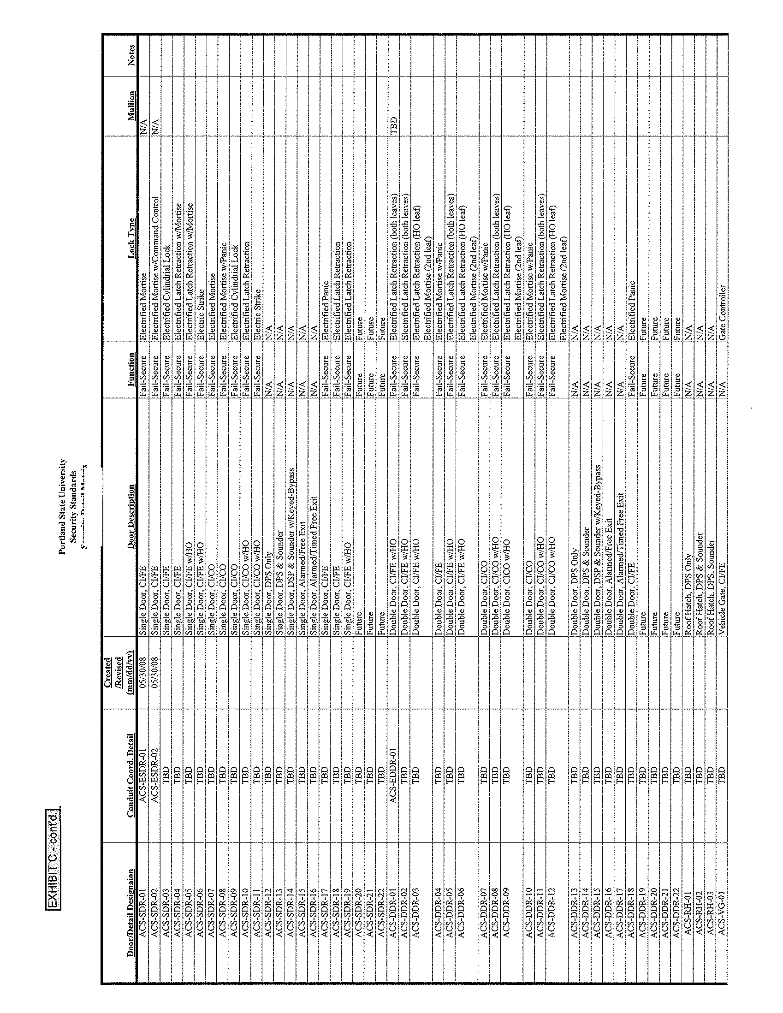

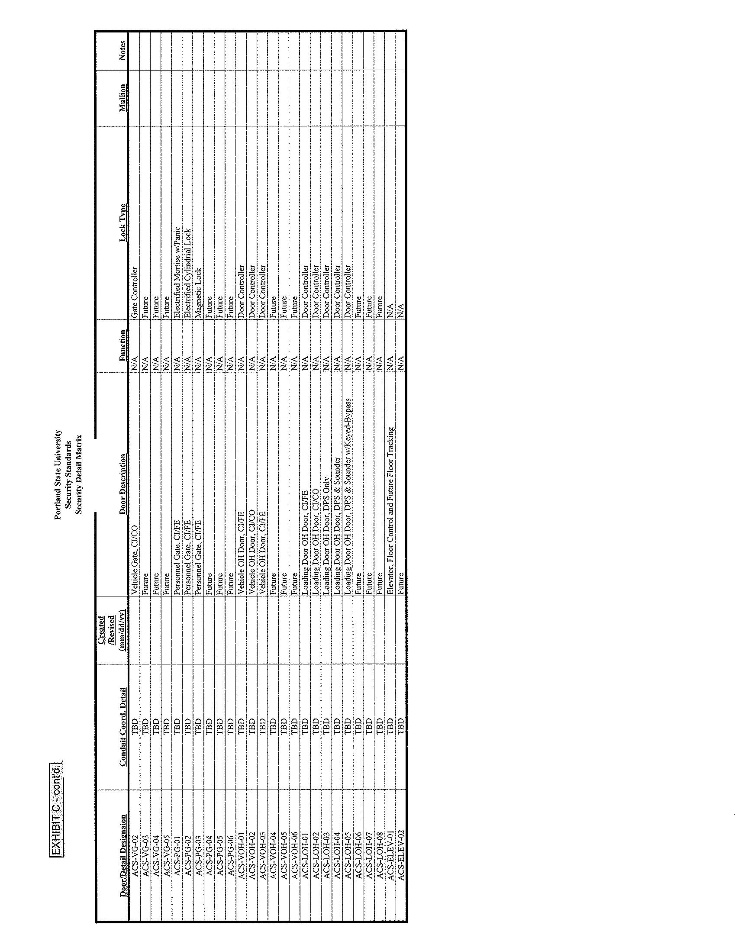

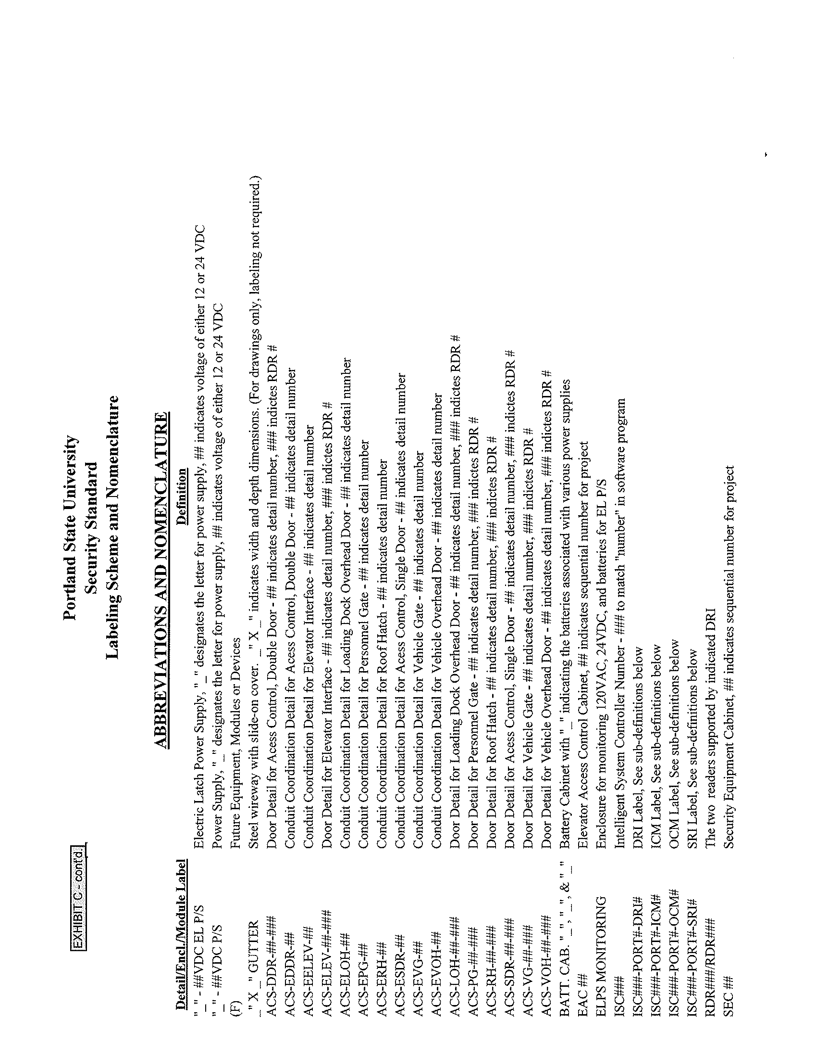

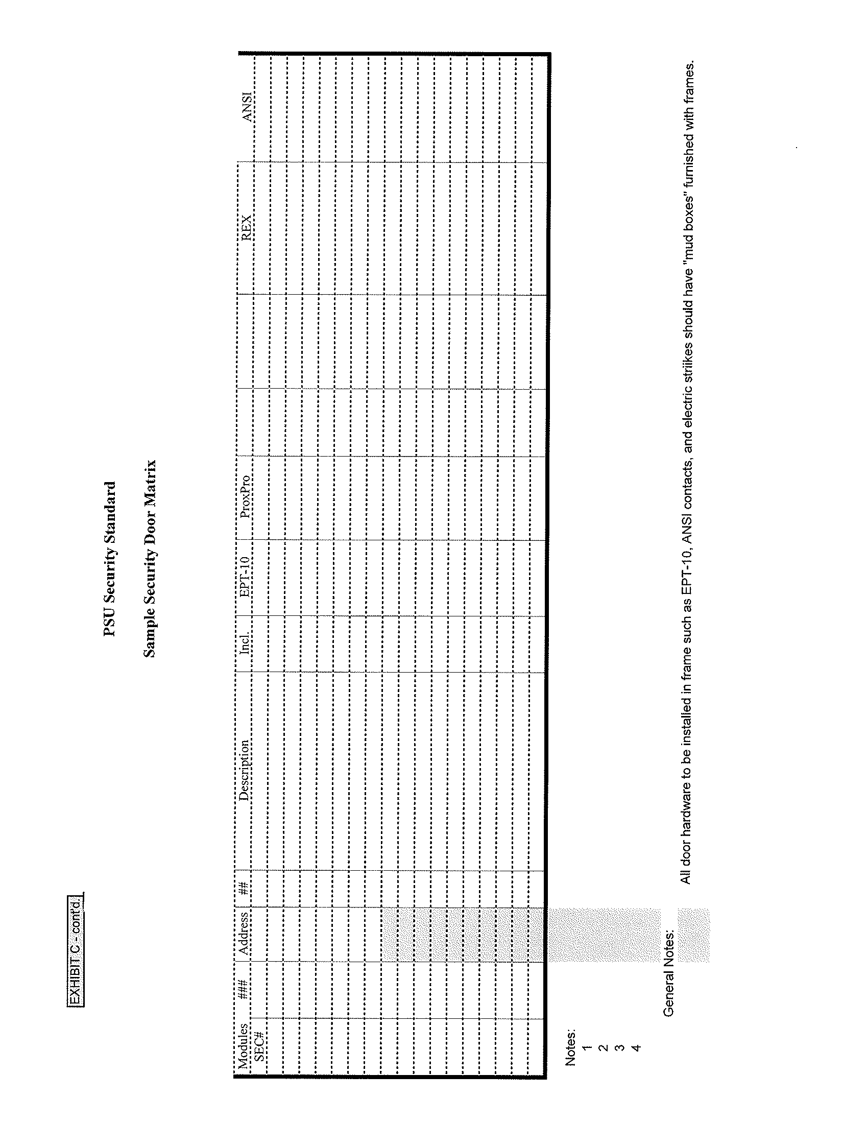



EXHIBIT D:

Portland State University Installation Standards

Doors, Latches & Wiring/Electrical Connections

Detailed Drawings

The following twenty-two (22) pages are all part of Exhibit D and provide detailed drawings of the installation standards used by PSU for doors, latches and wiring/electrical connections associated with same.

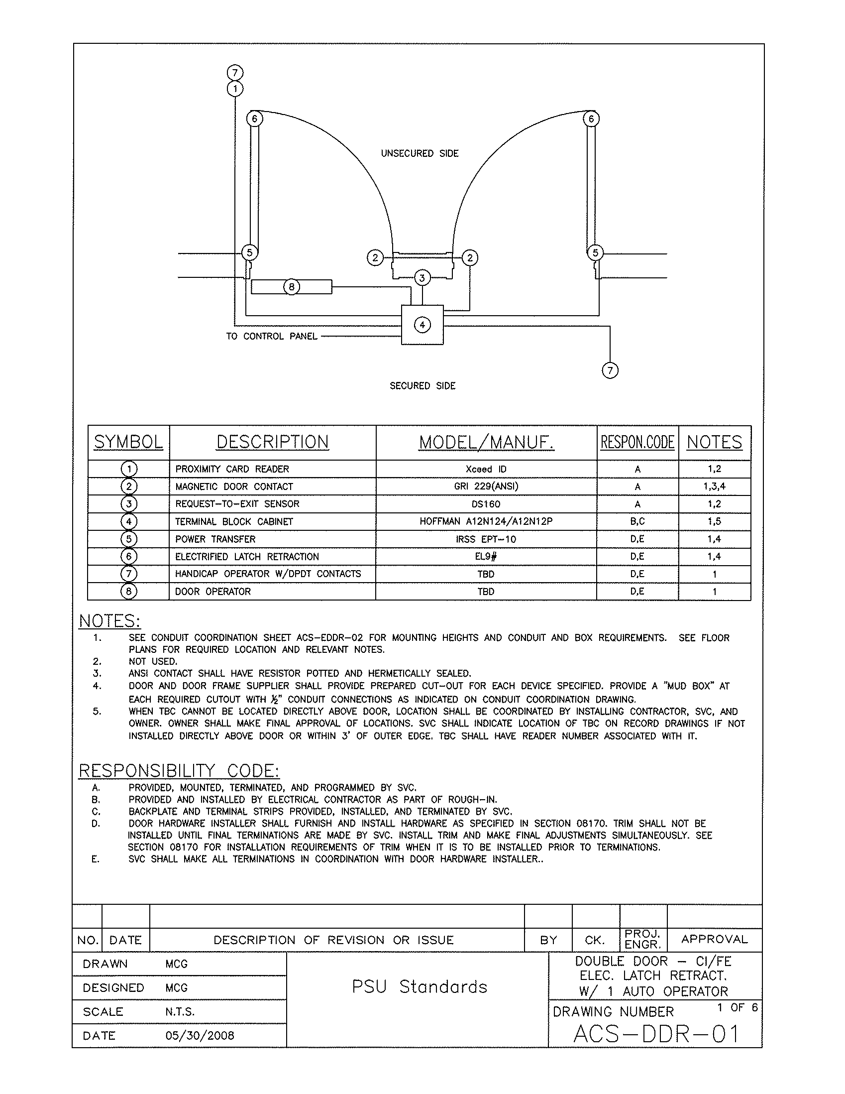

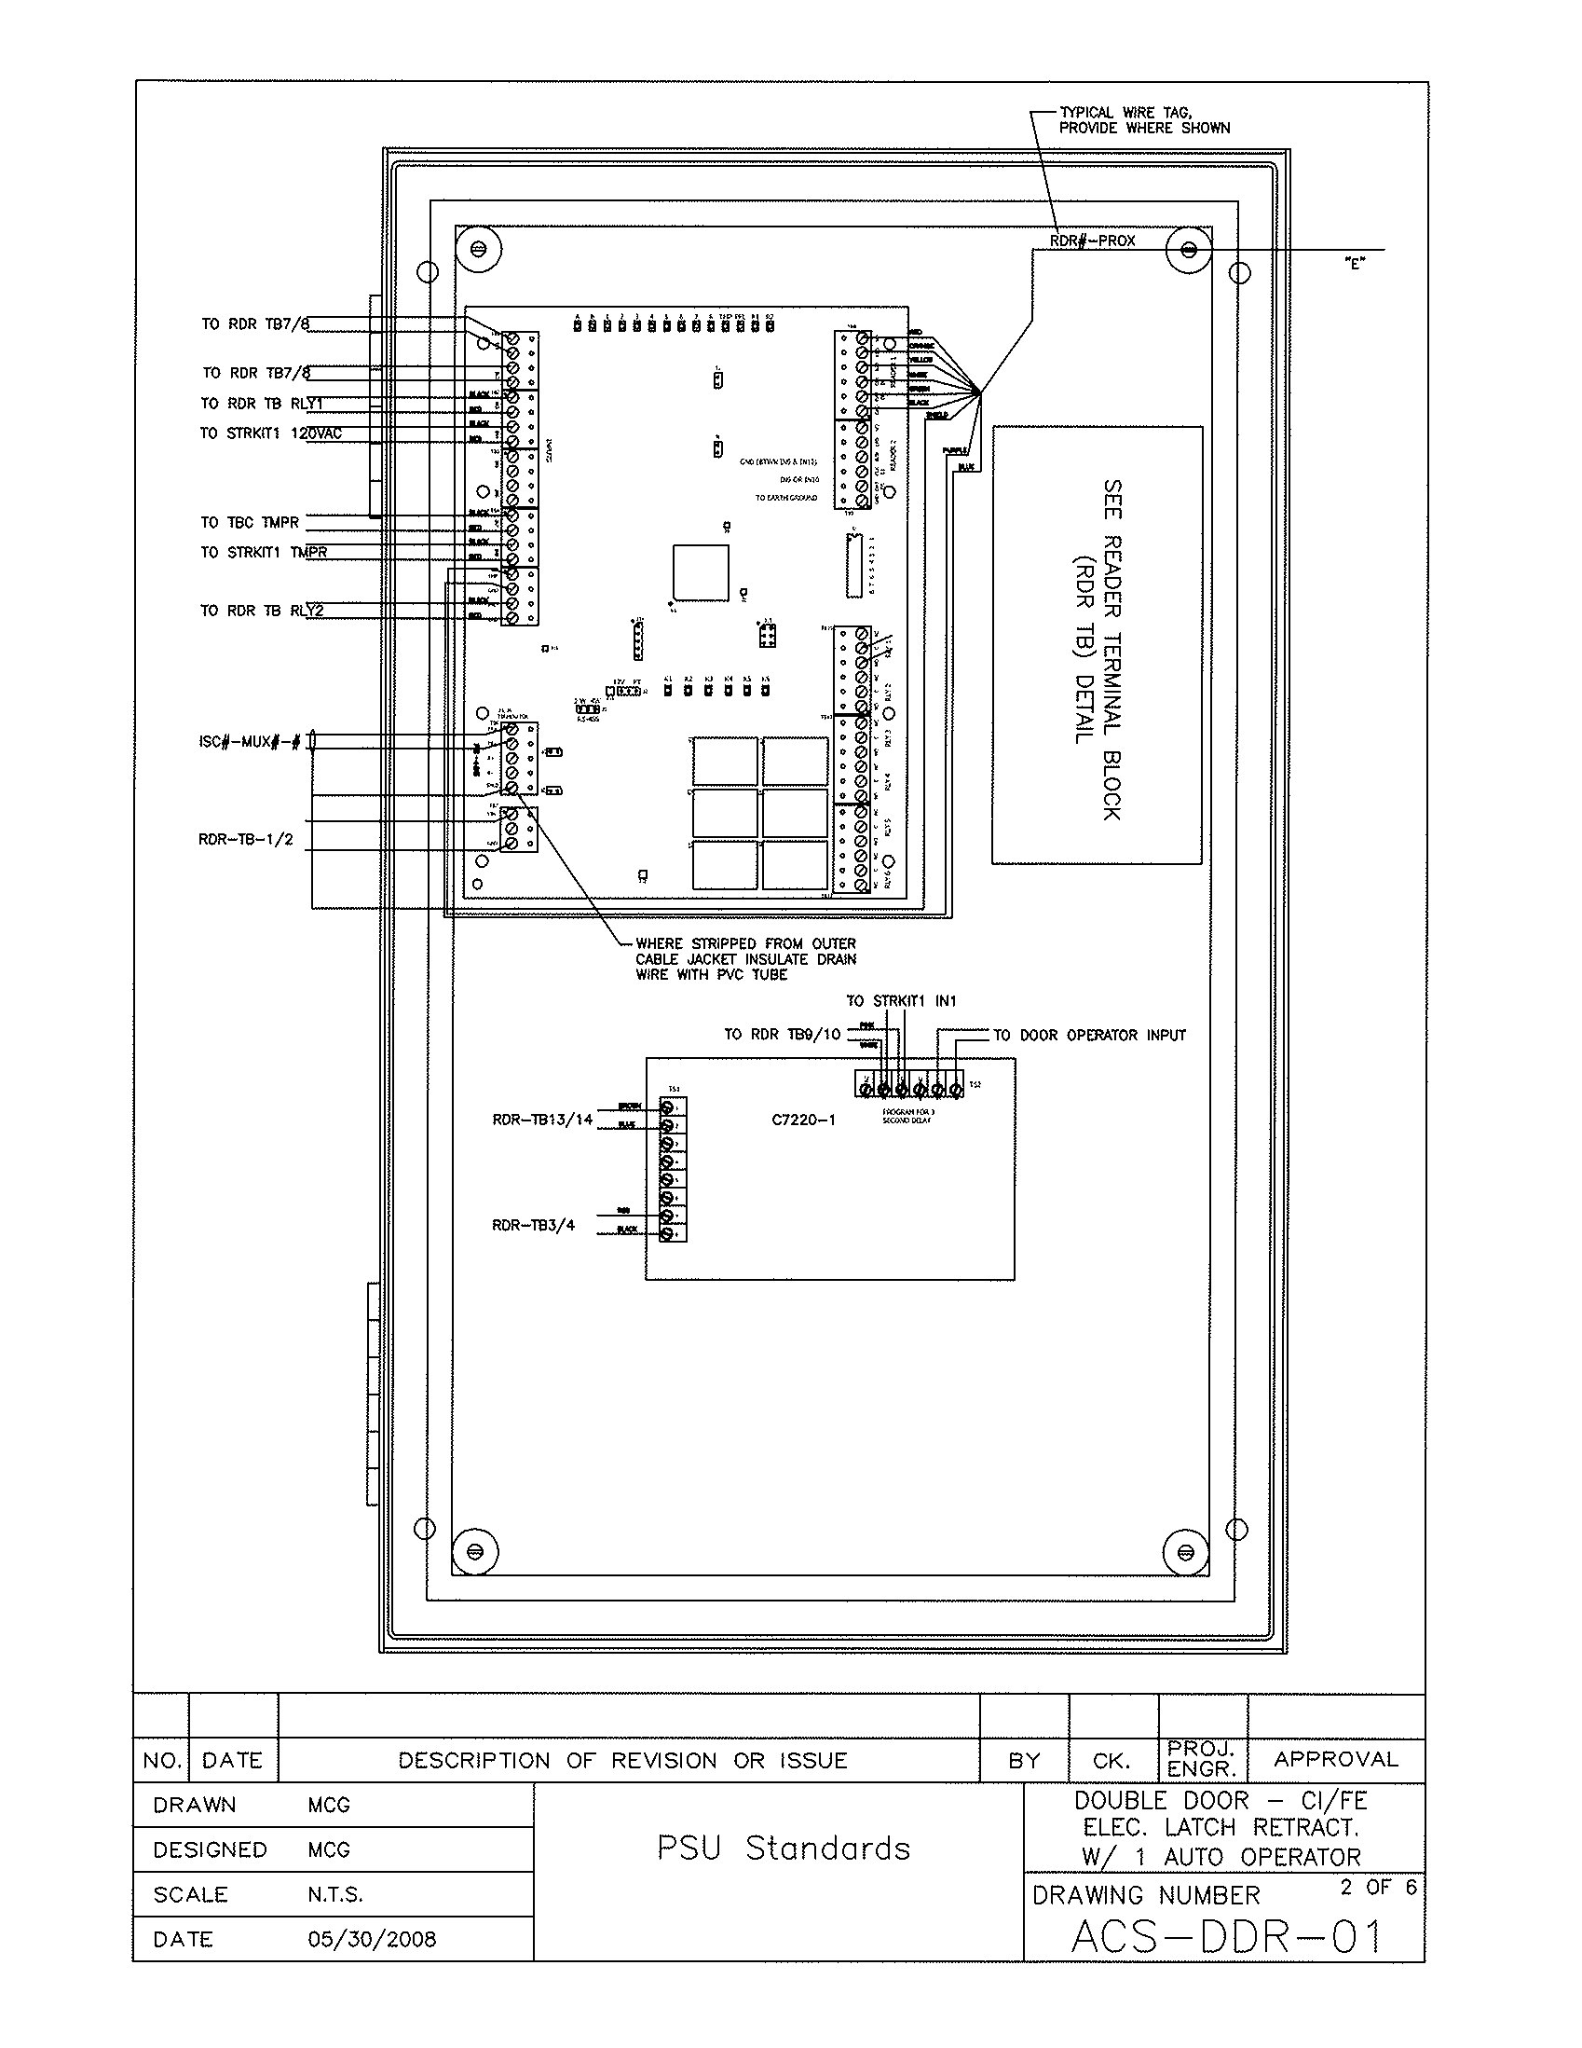

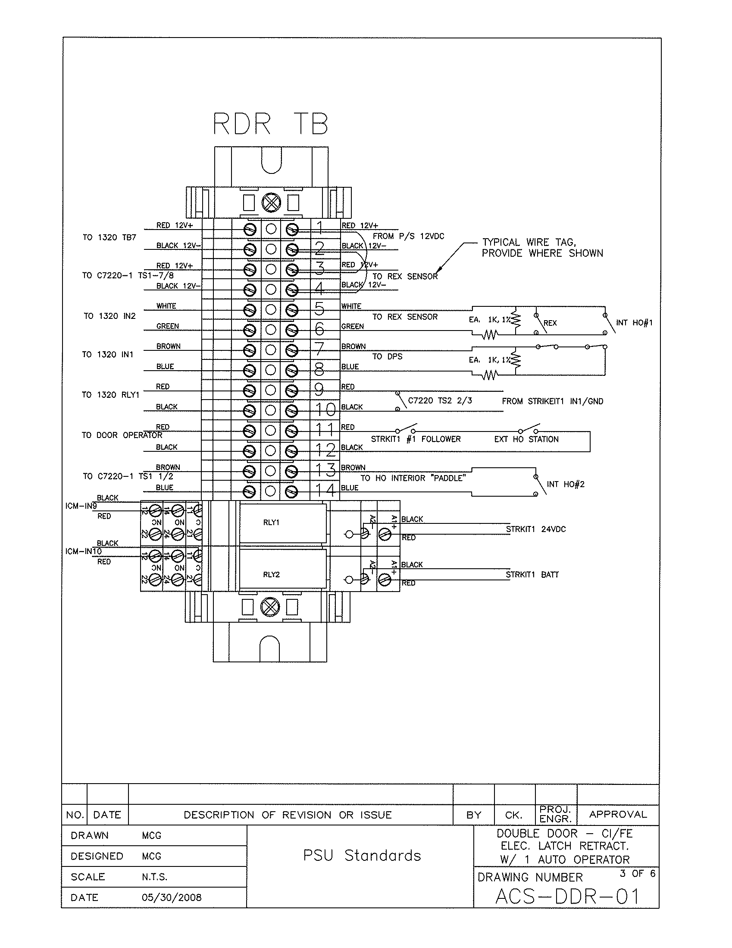

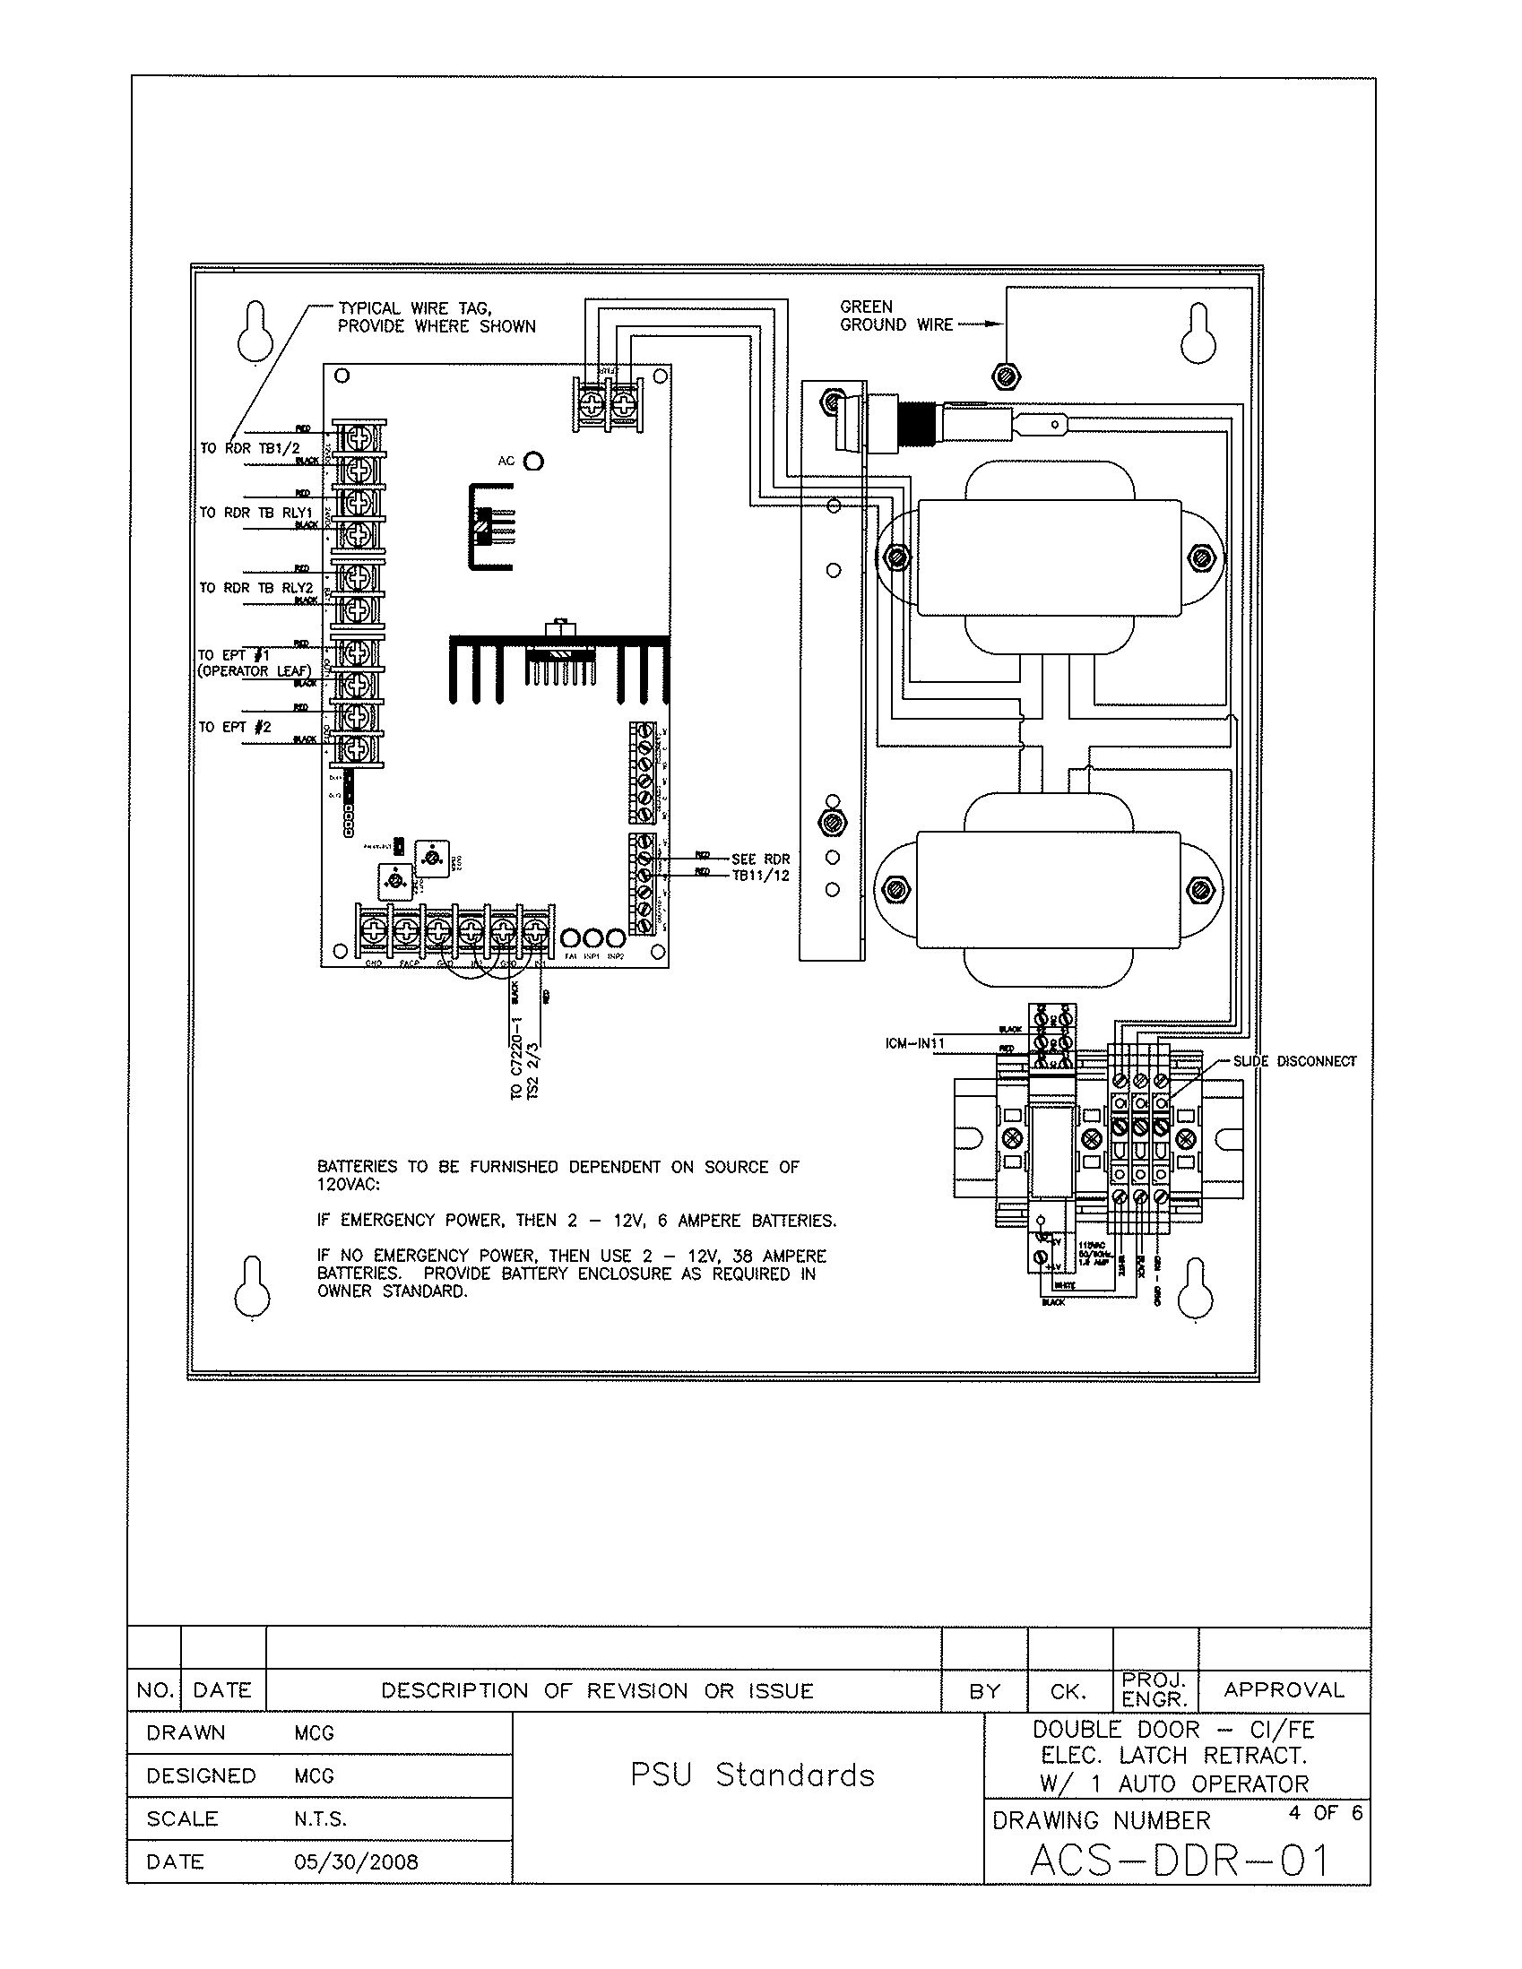

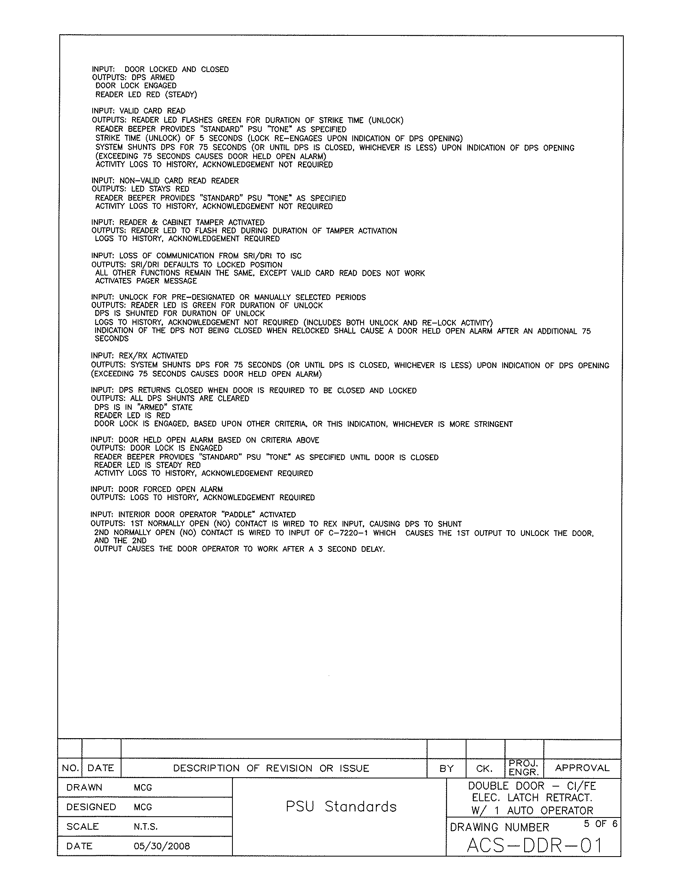

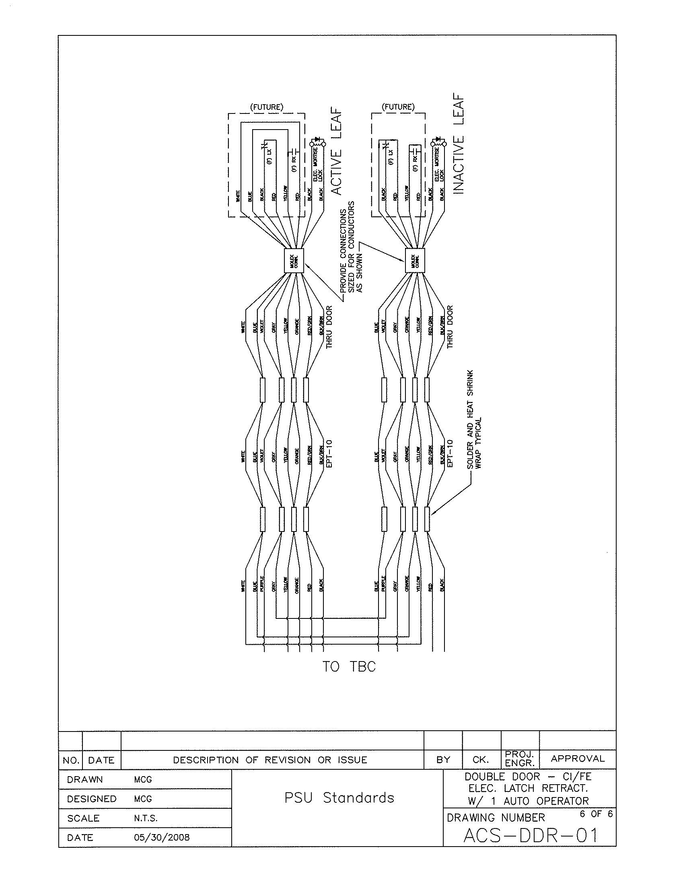

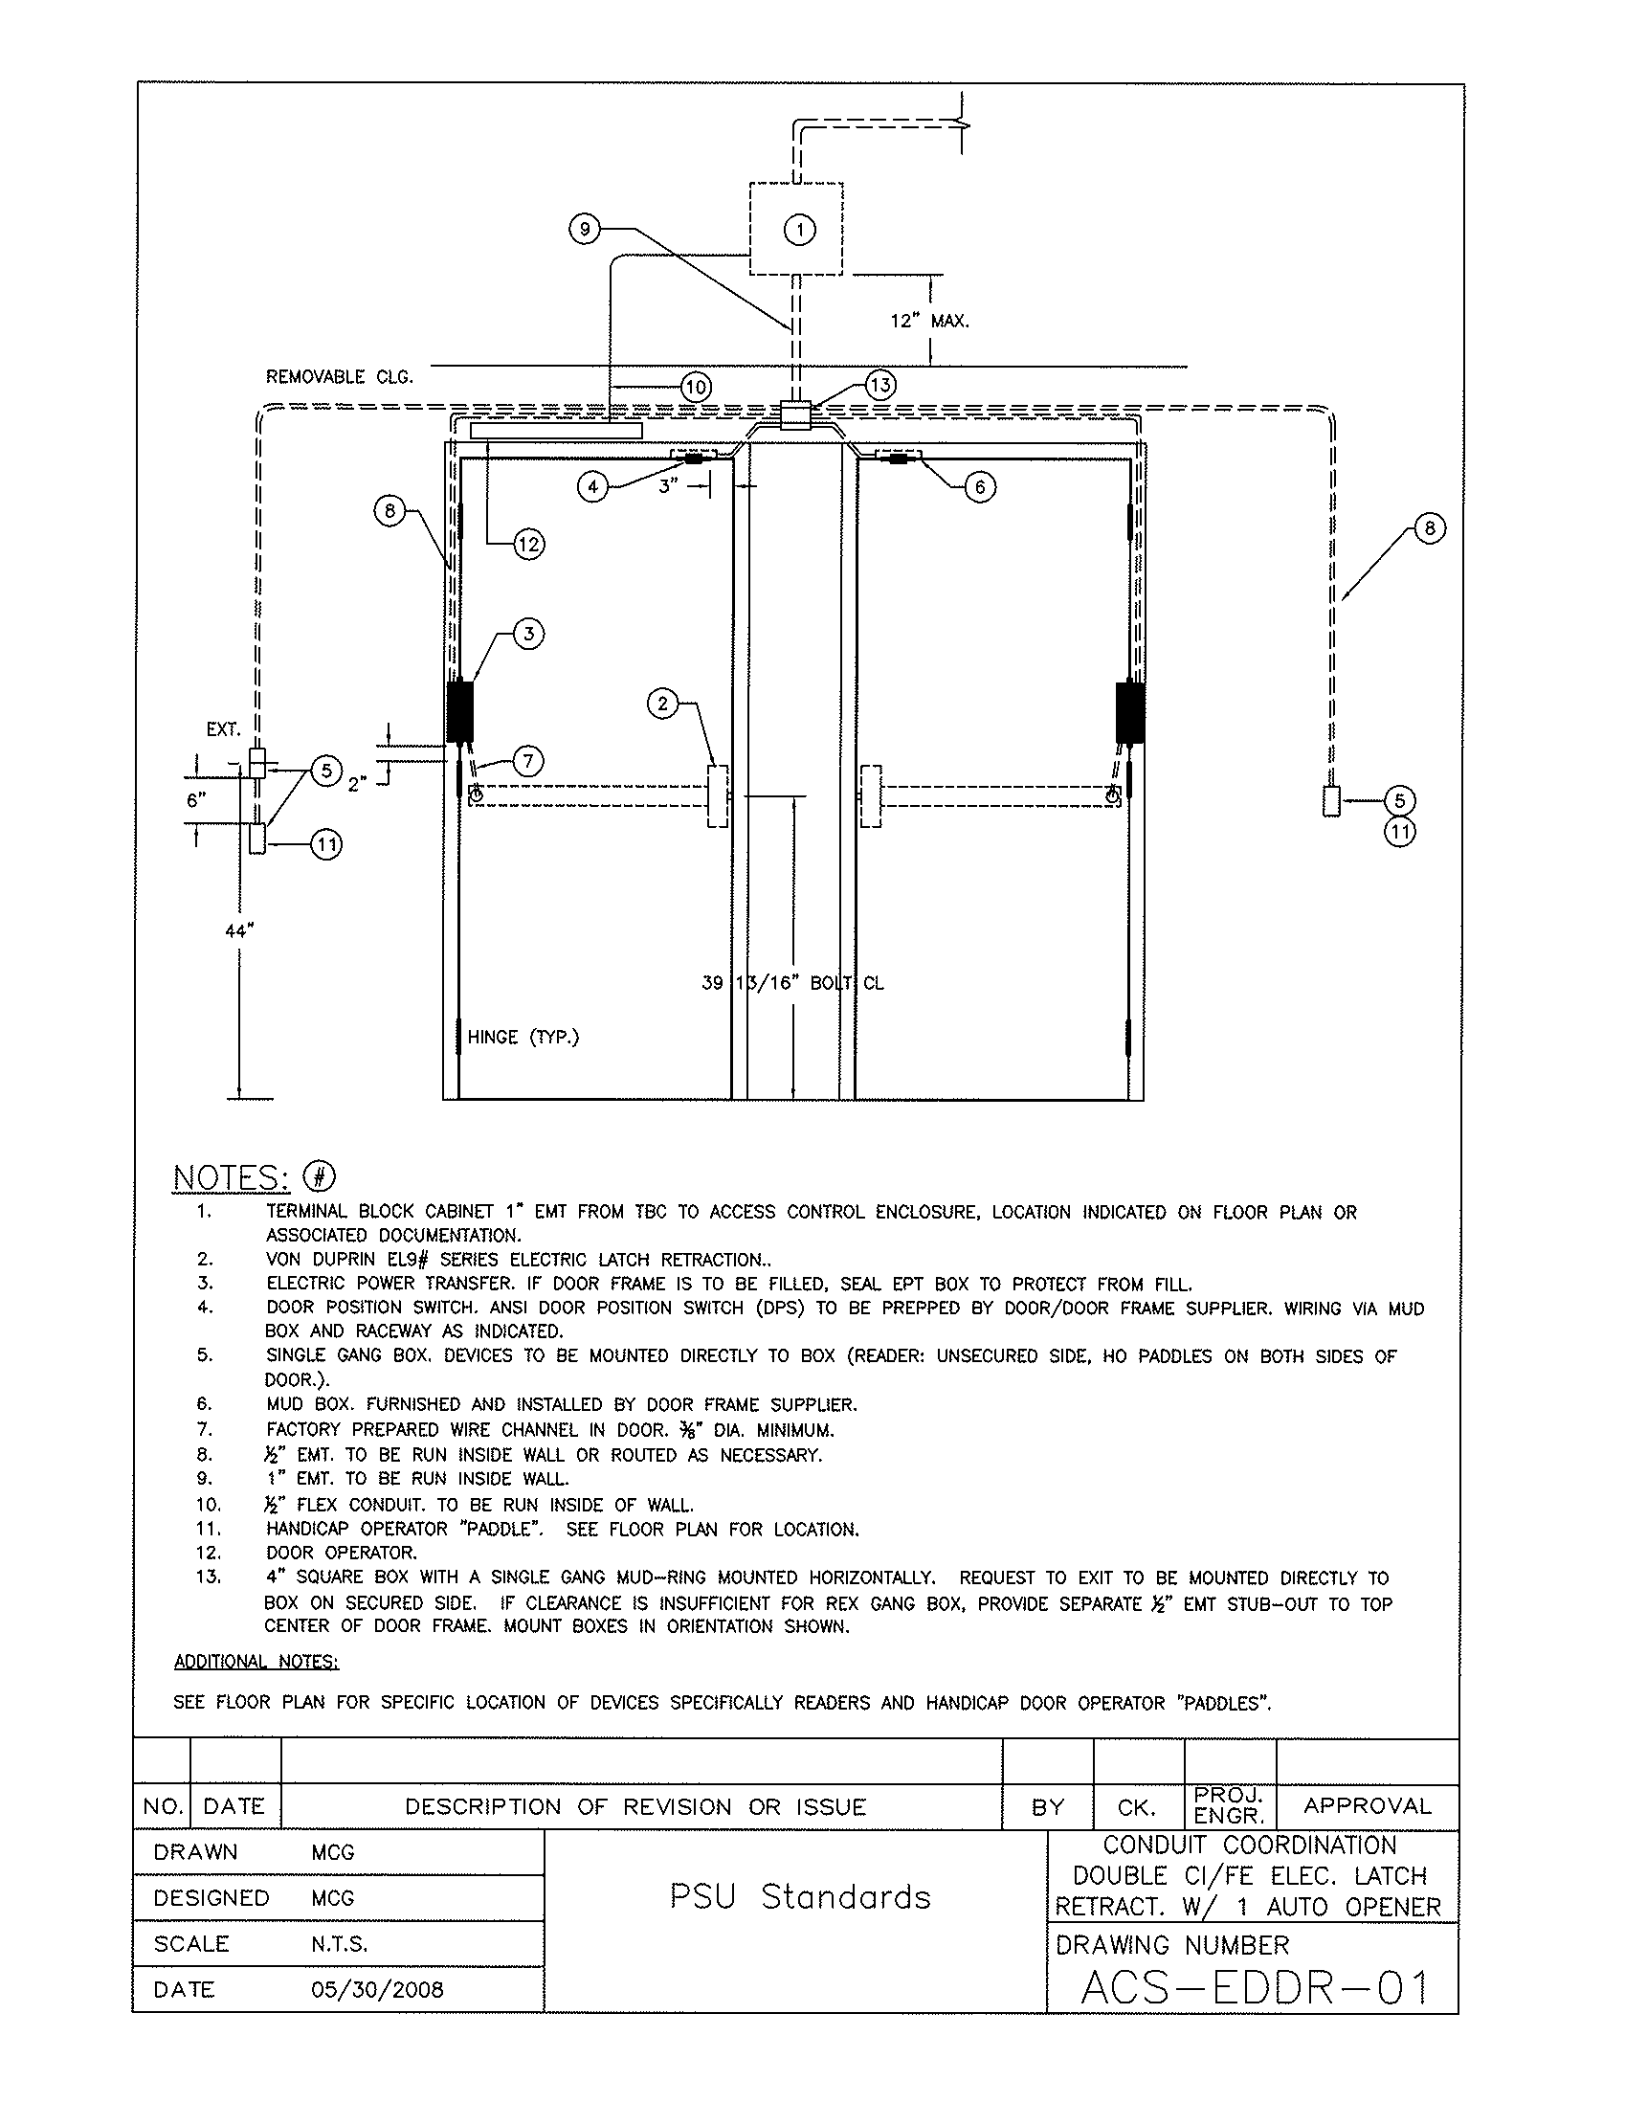

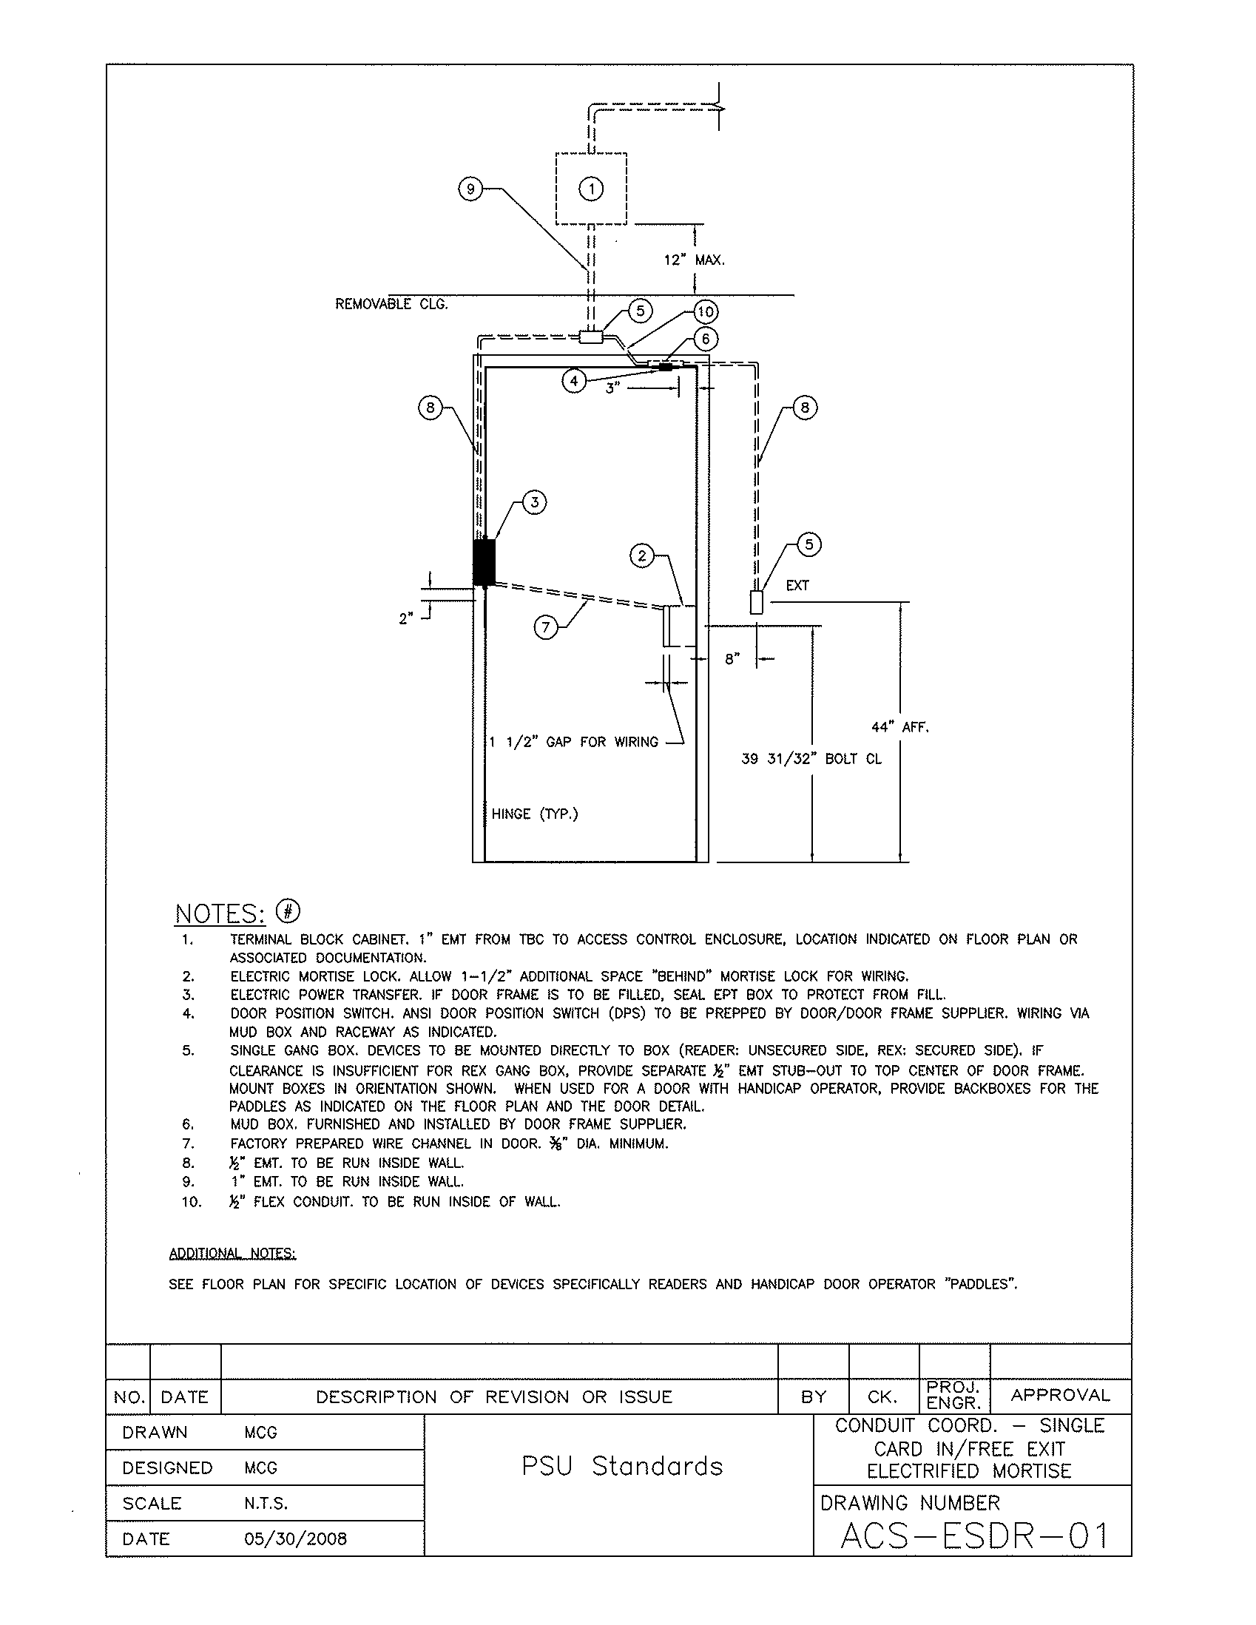

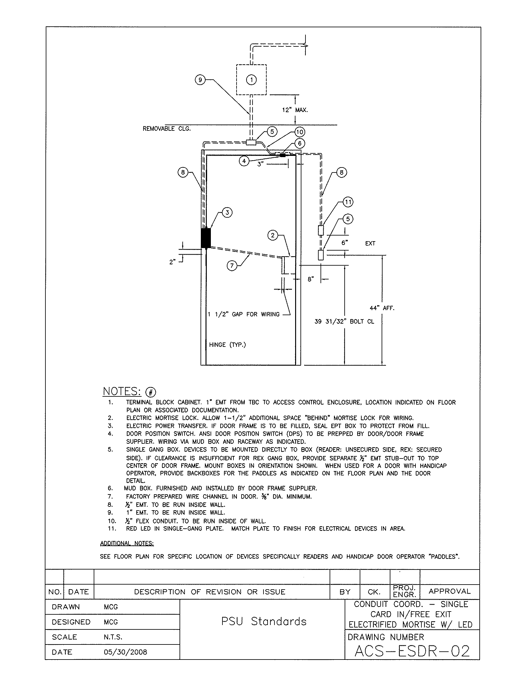

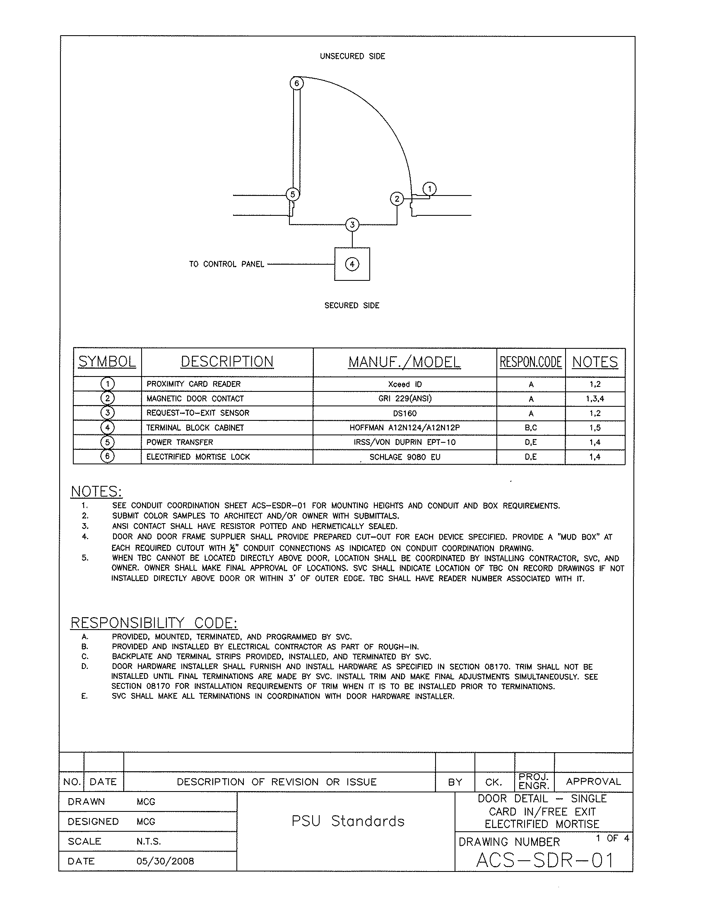

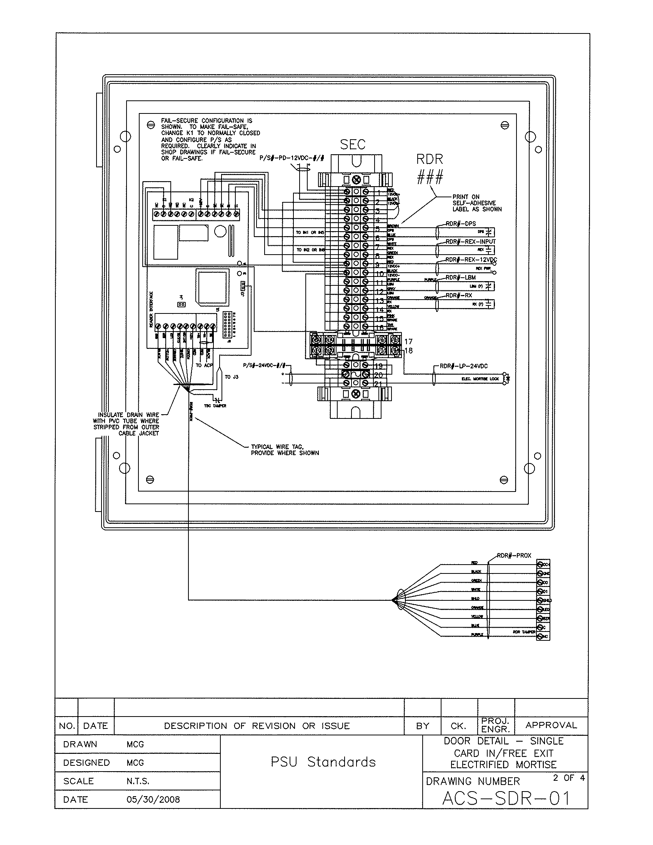

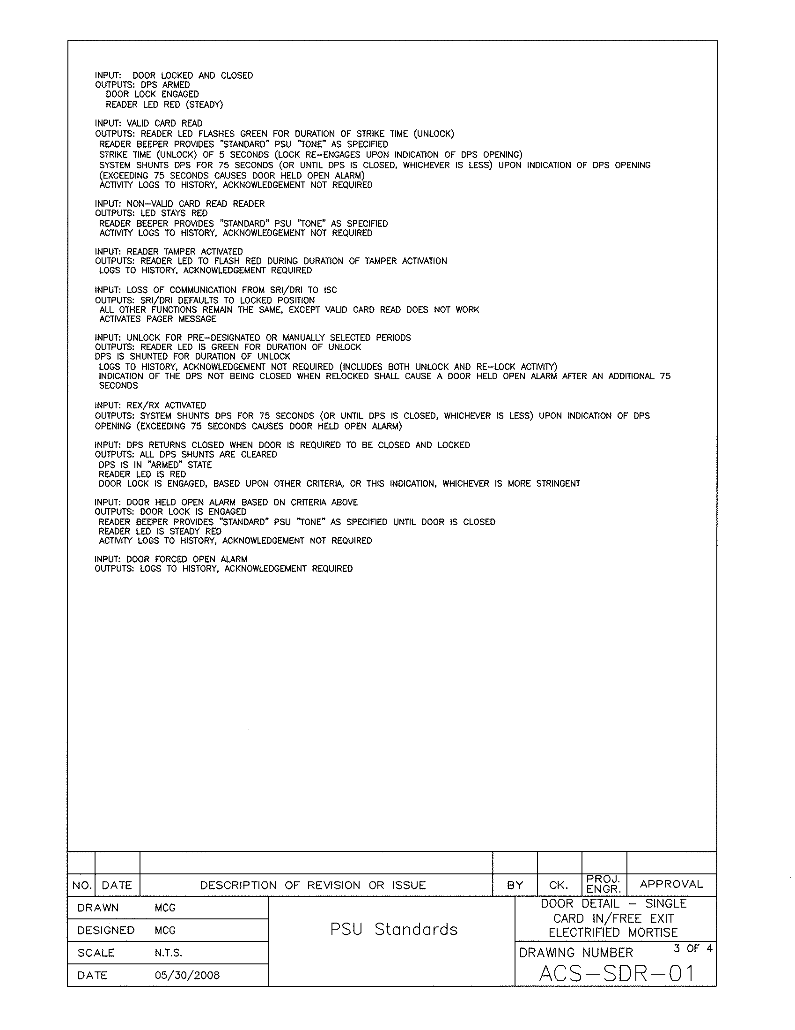

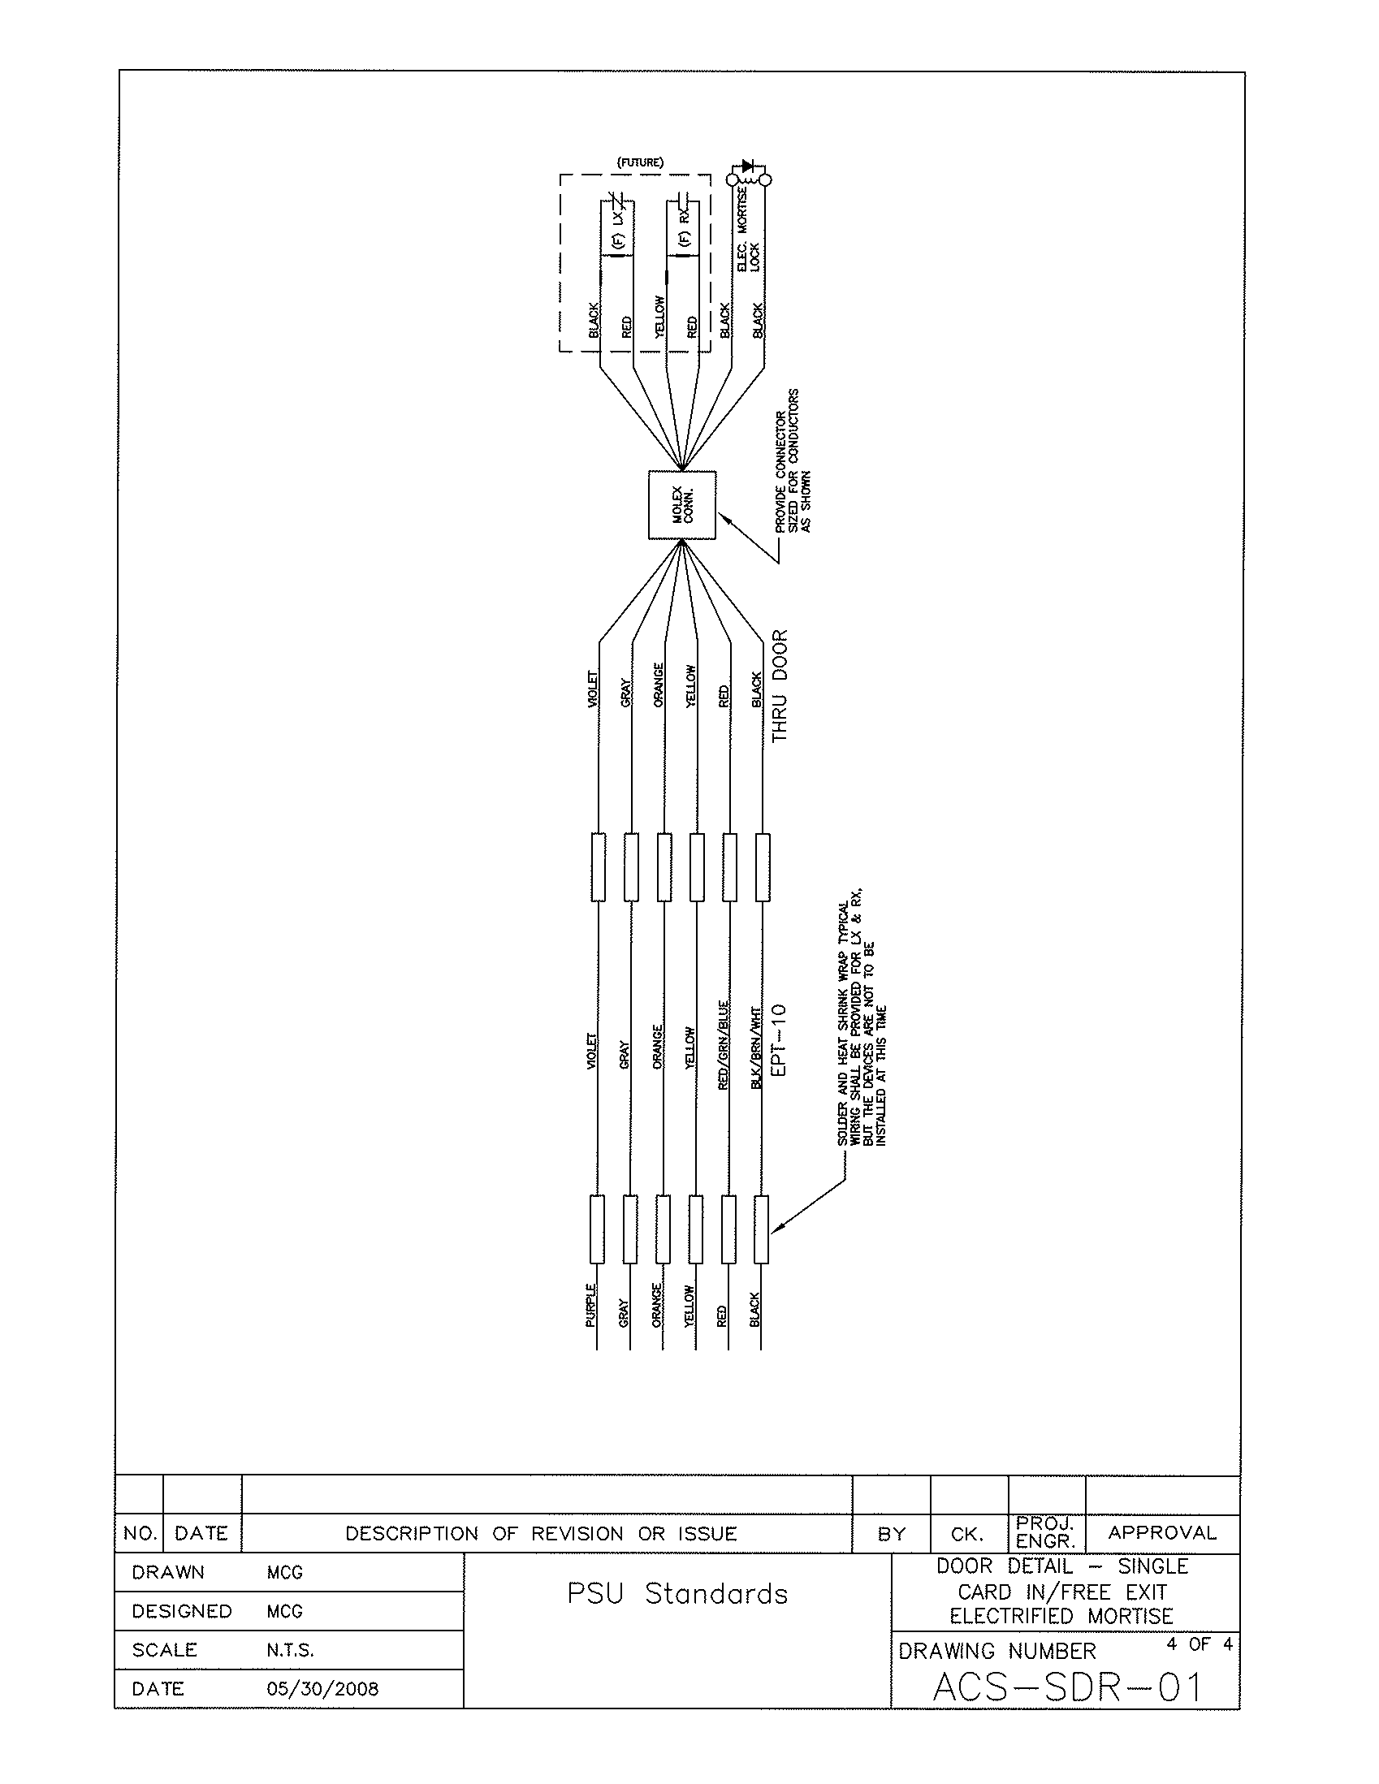

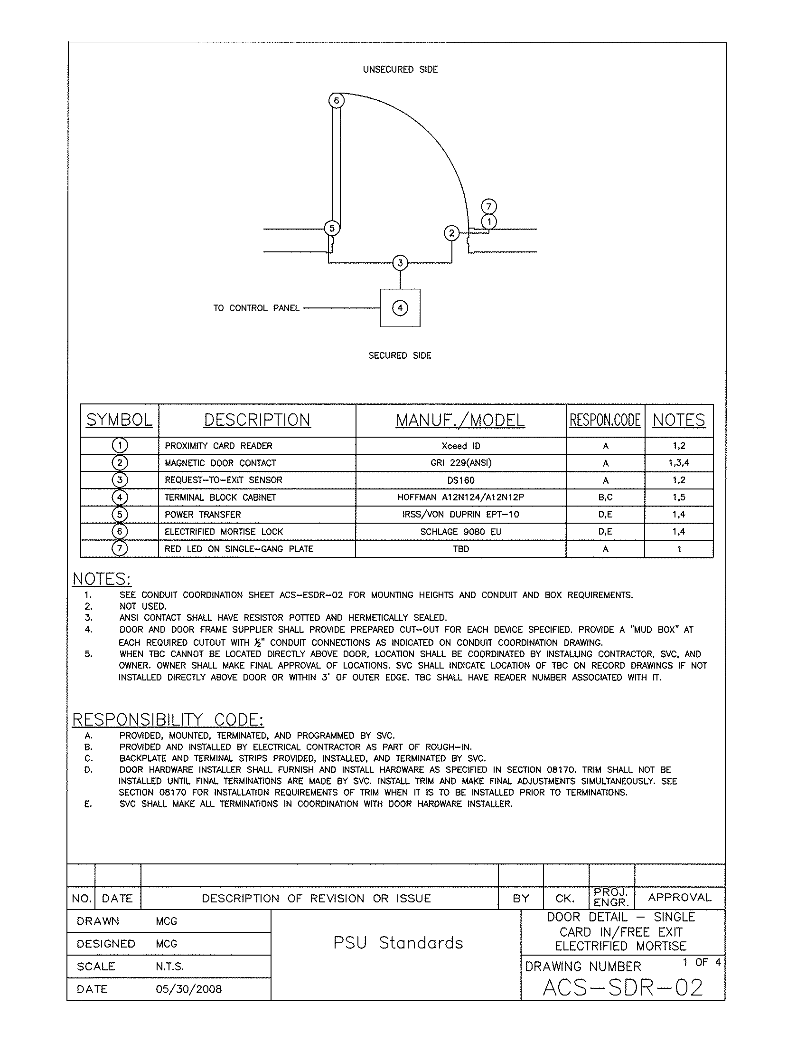

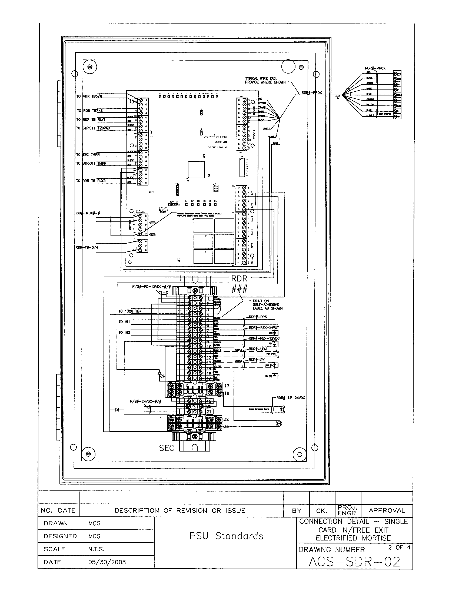

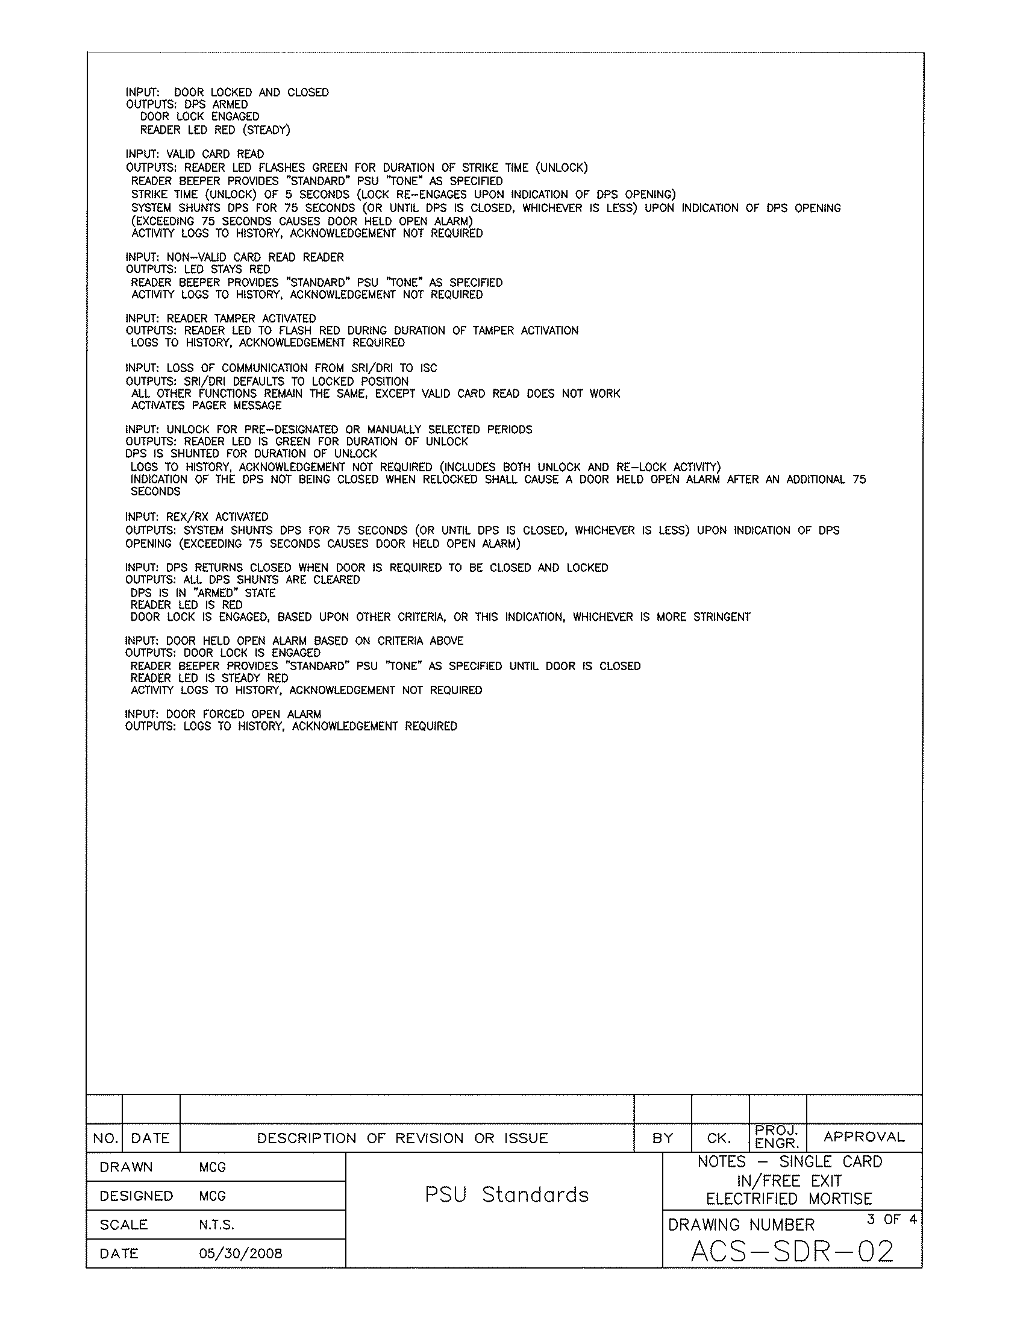

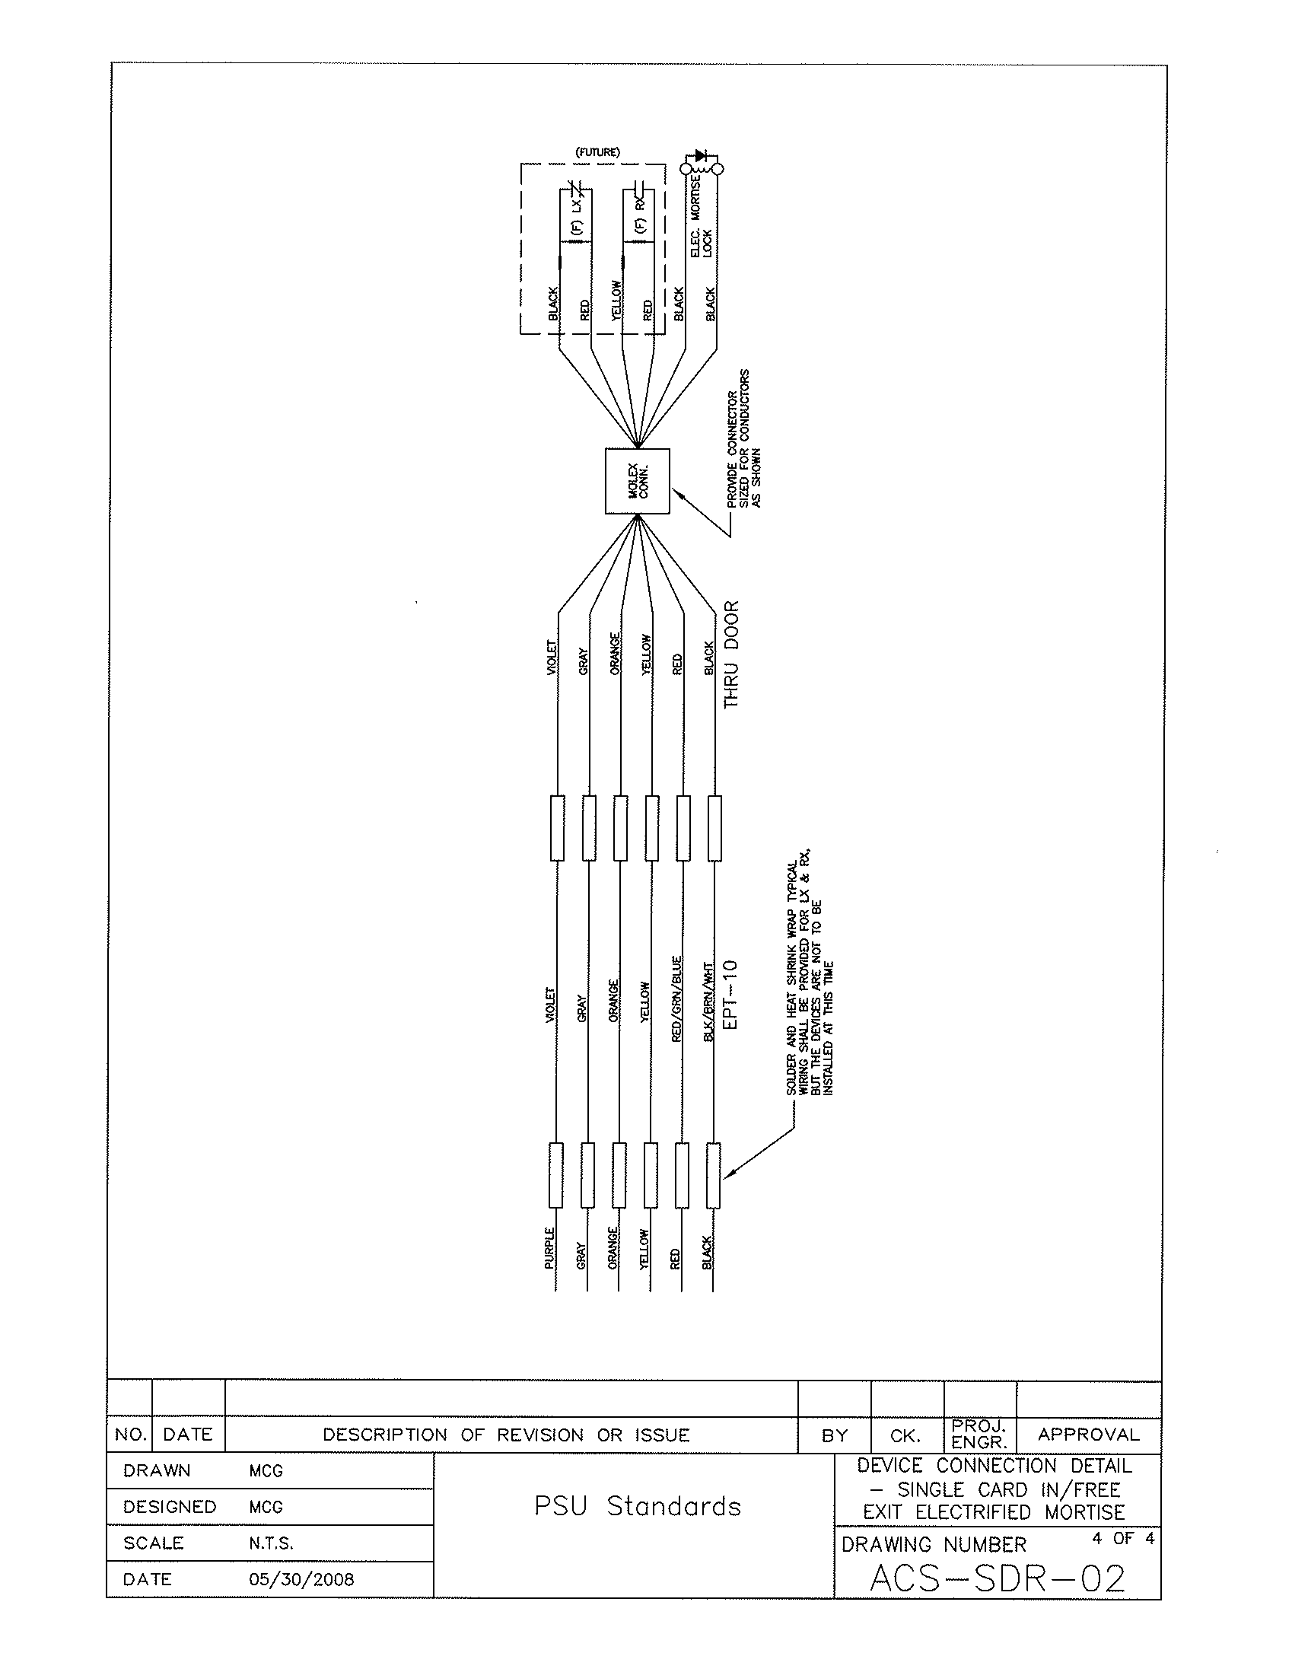

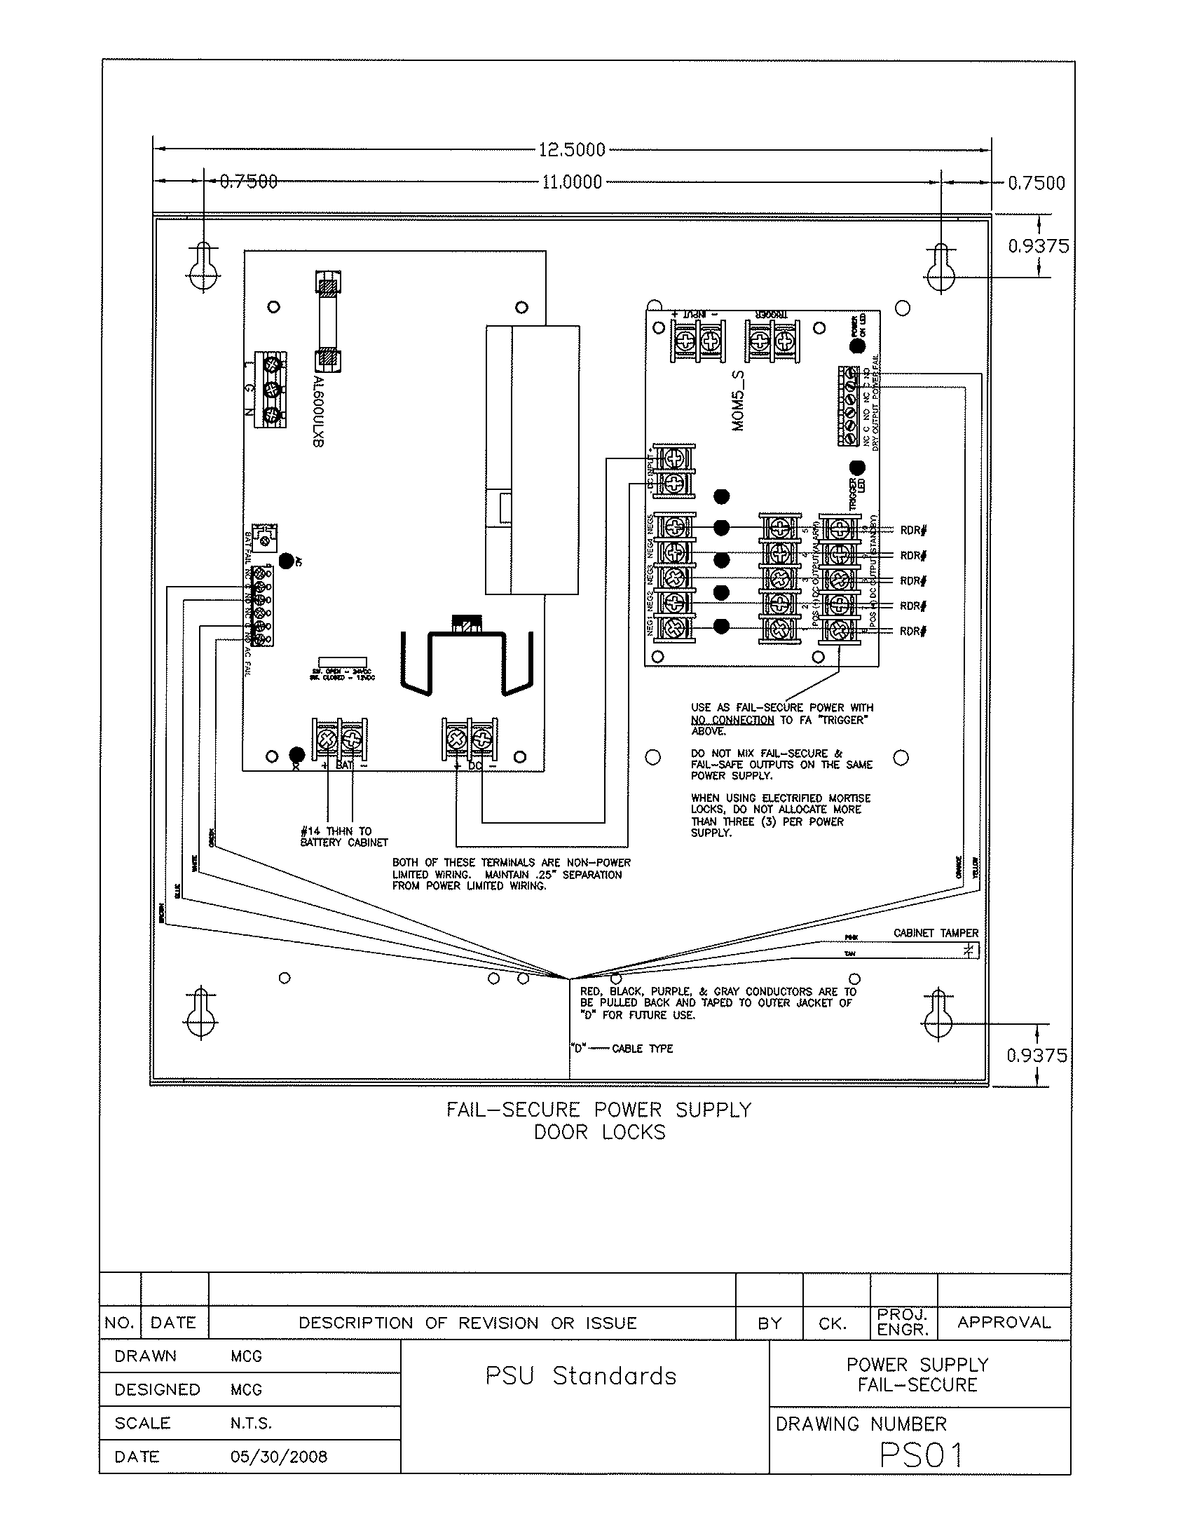

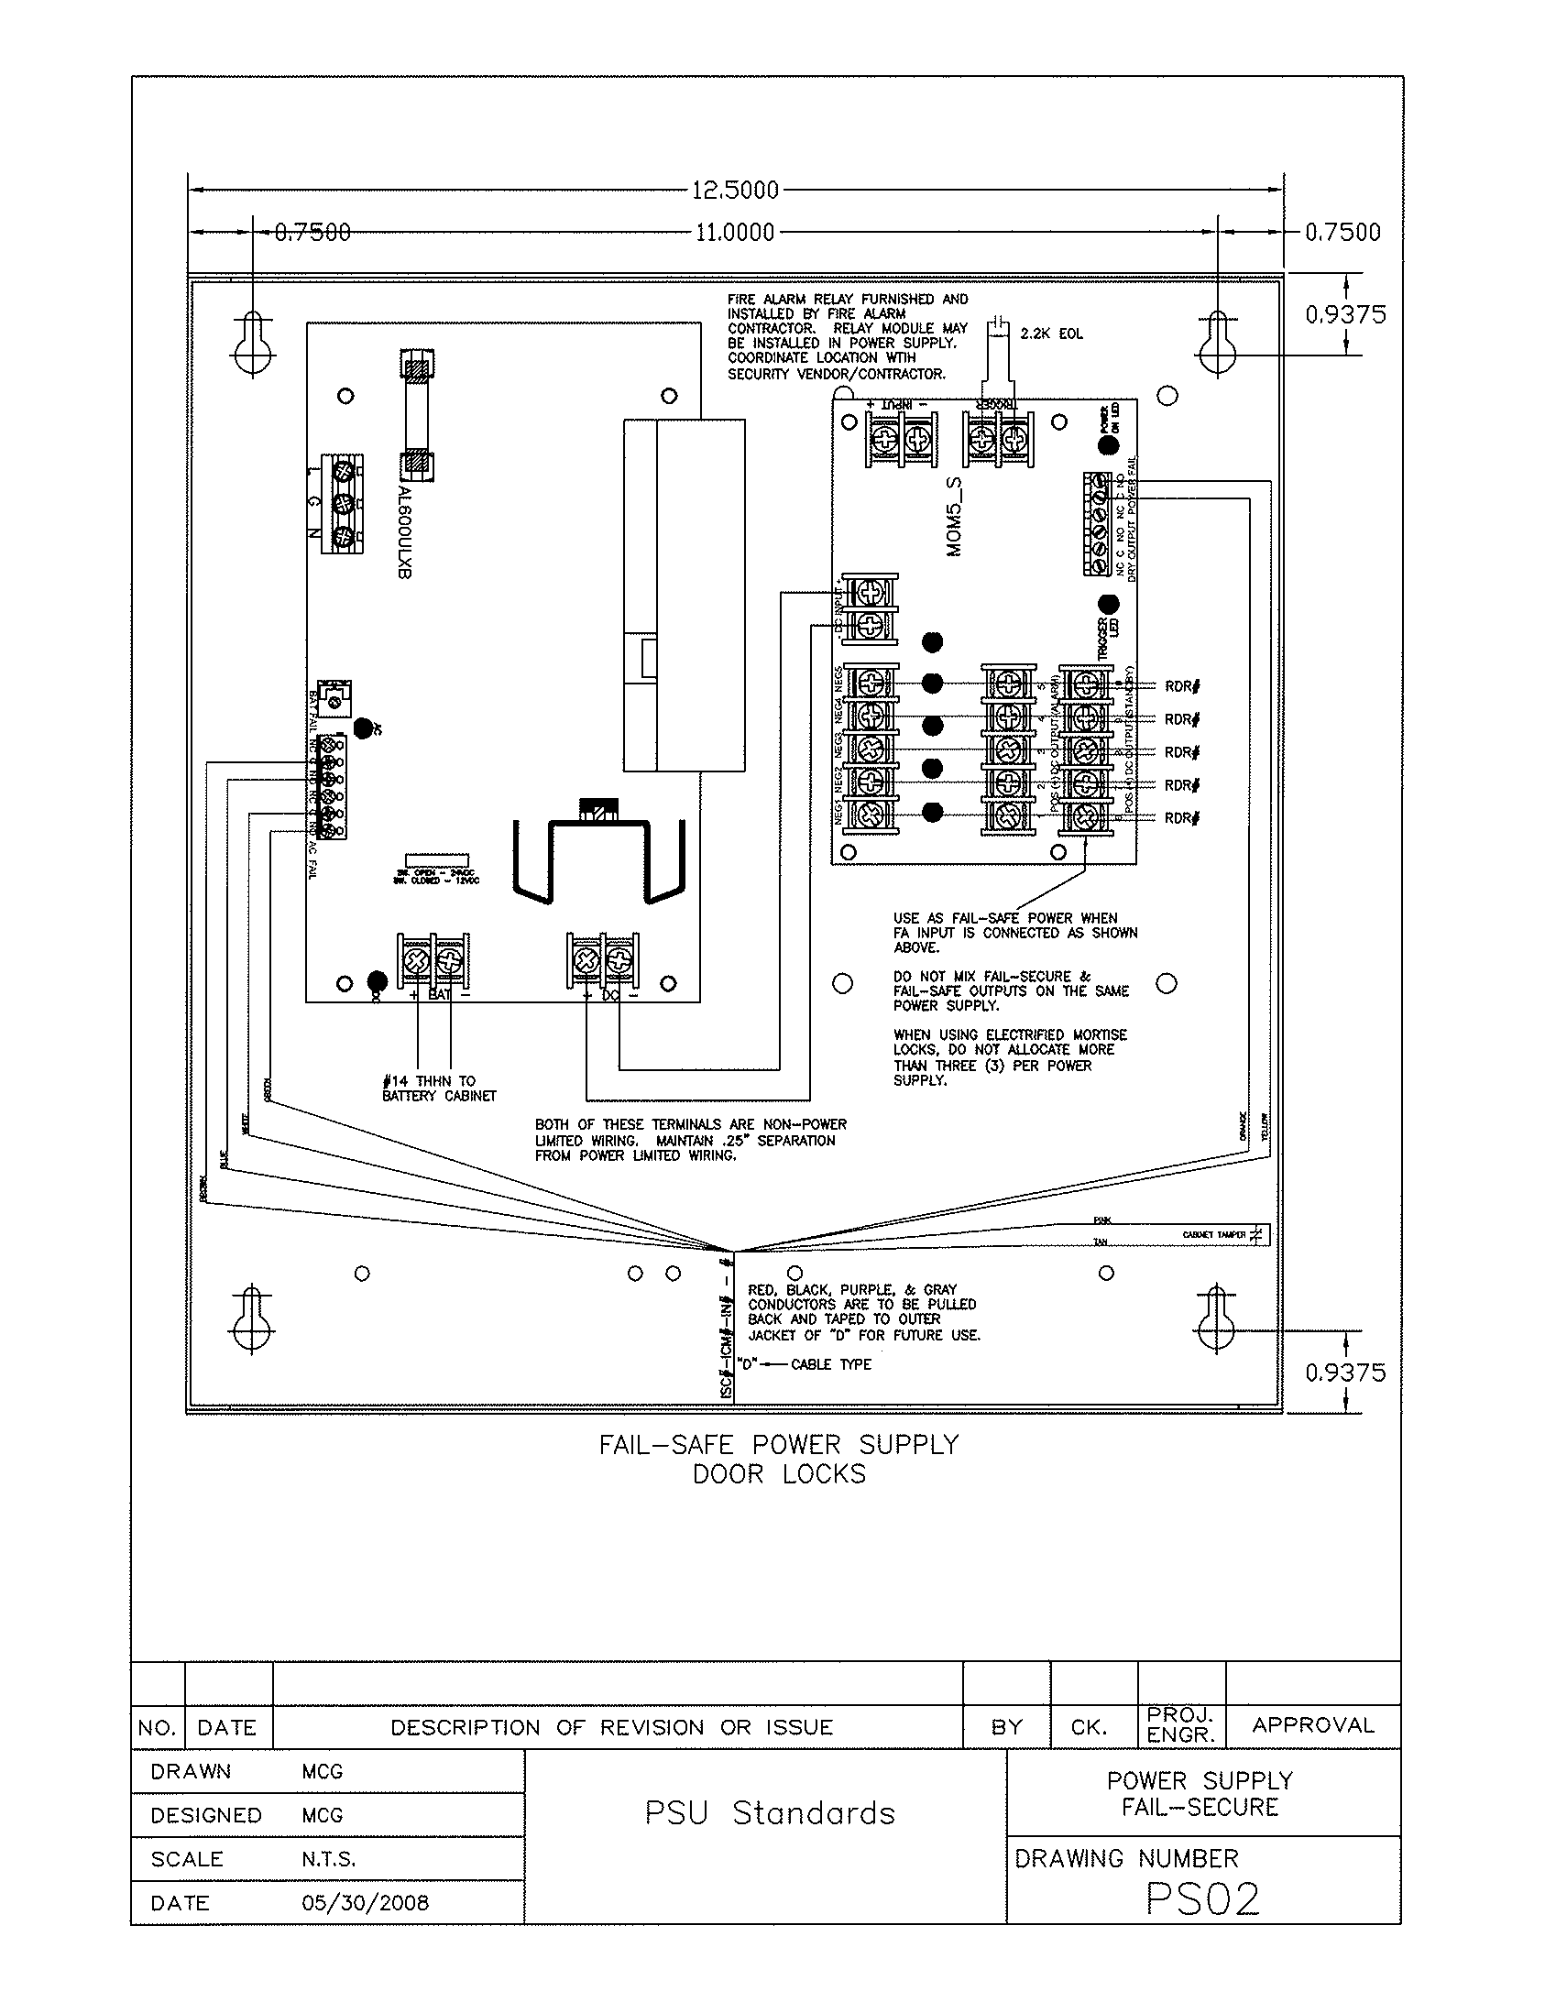

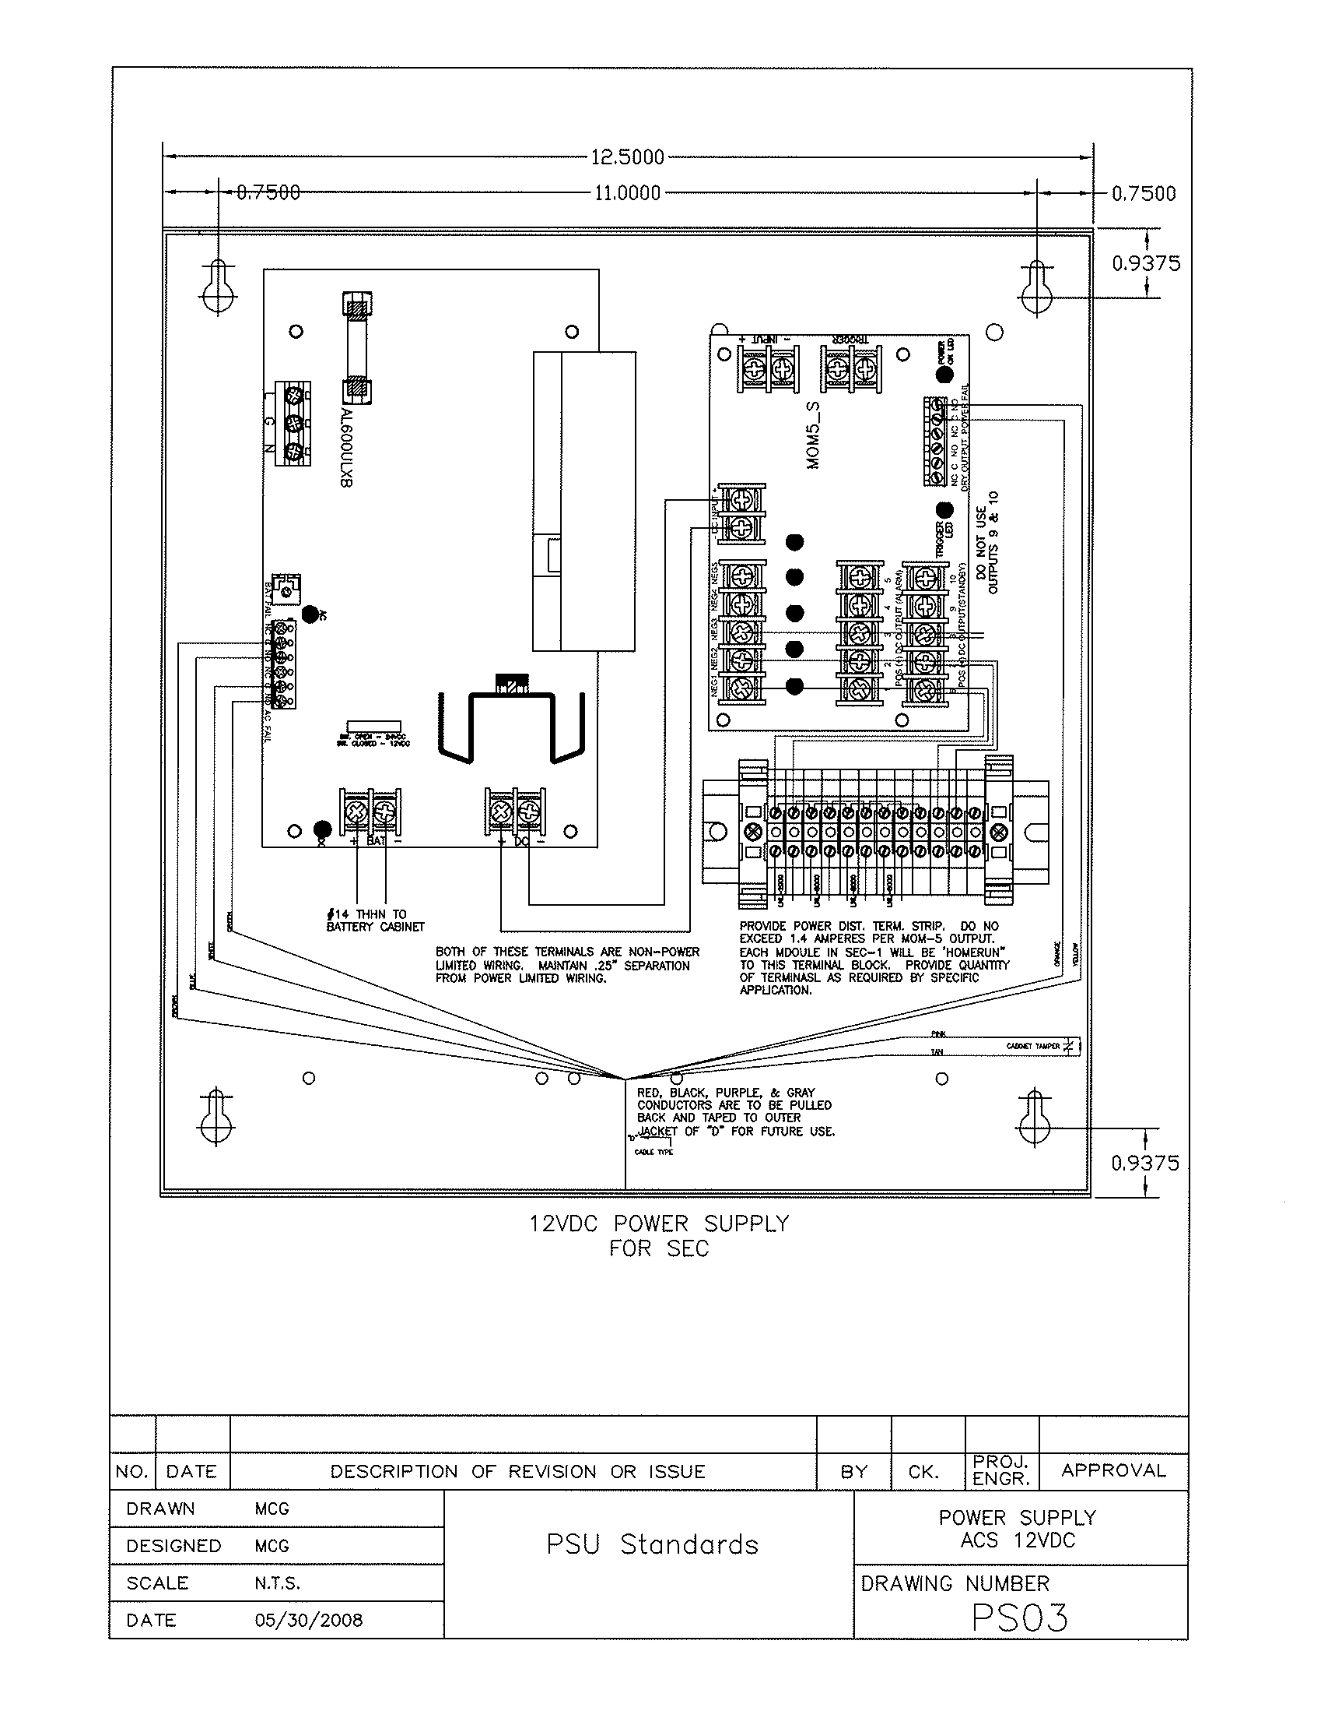

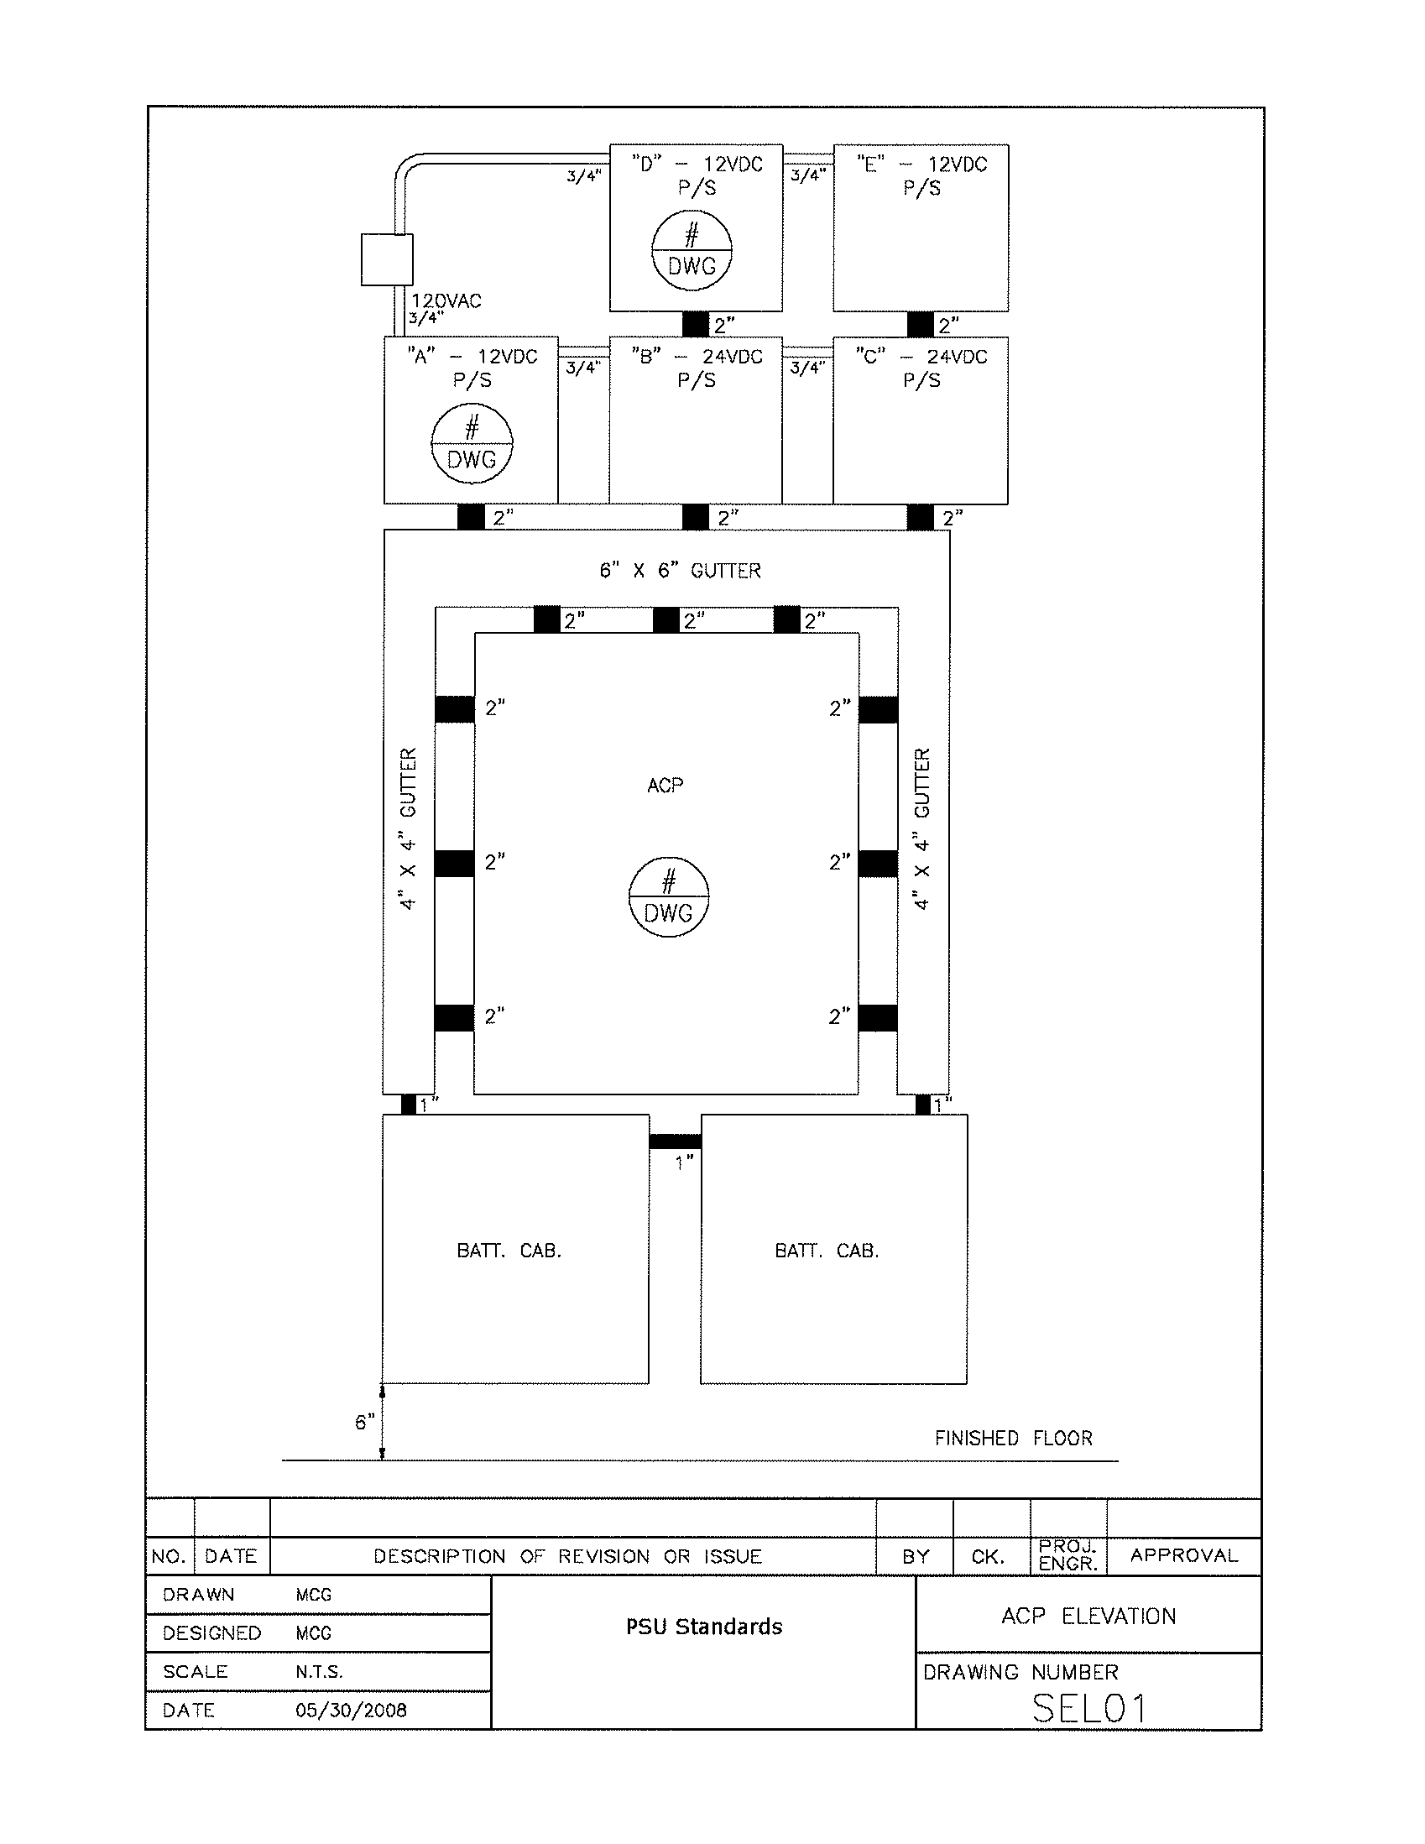

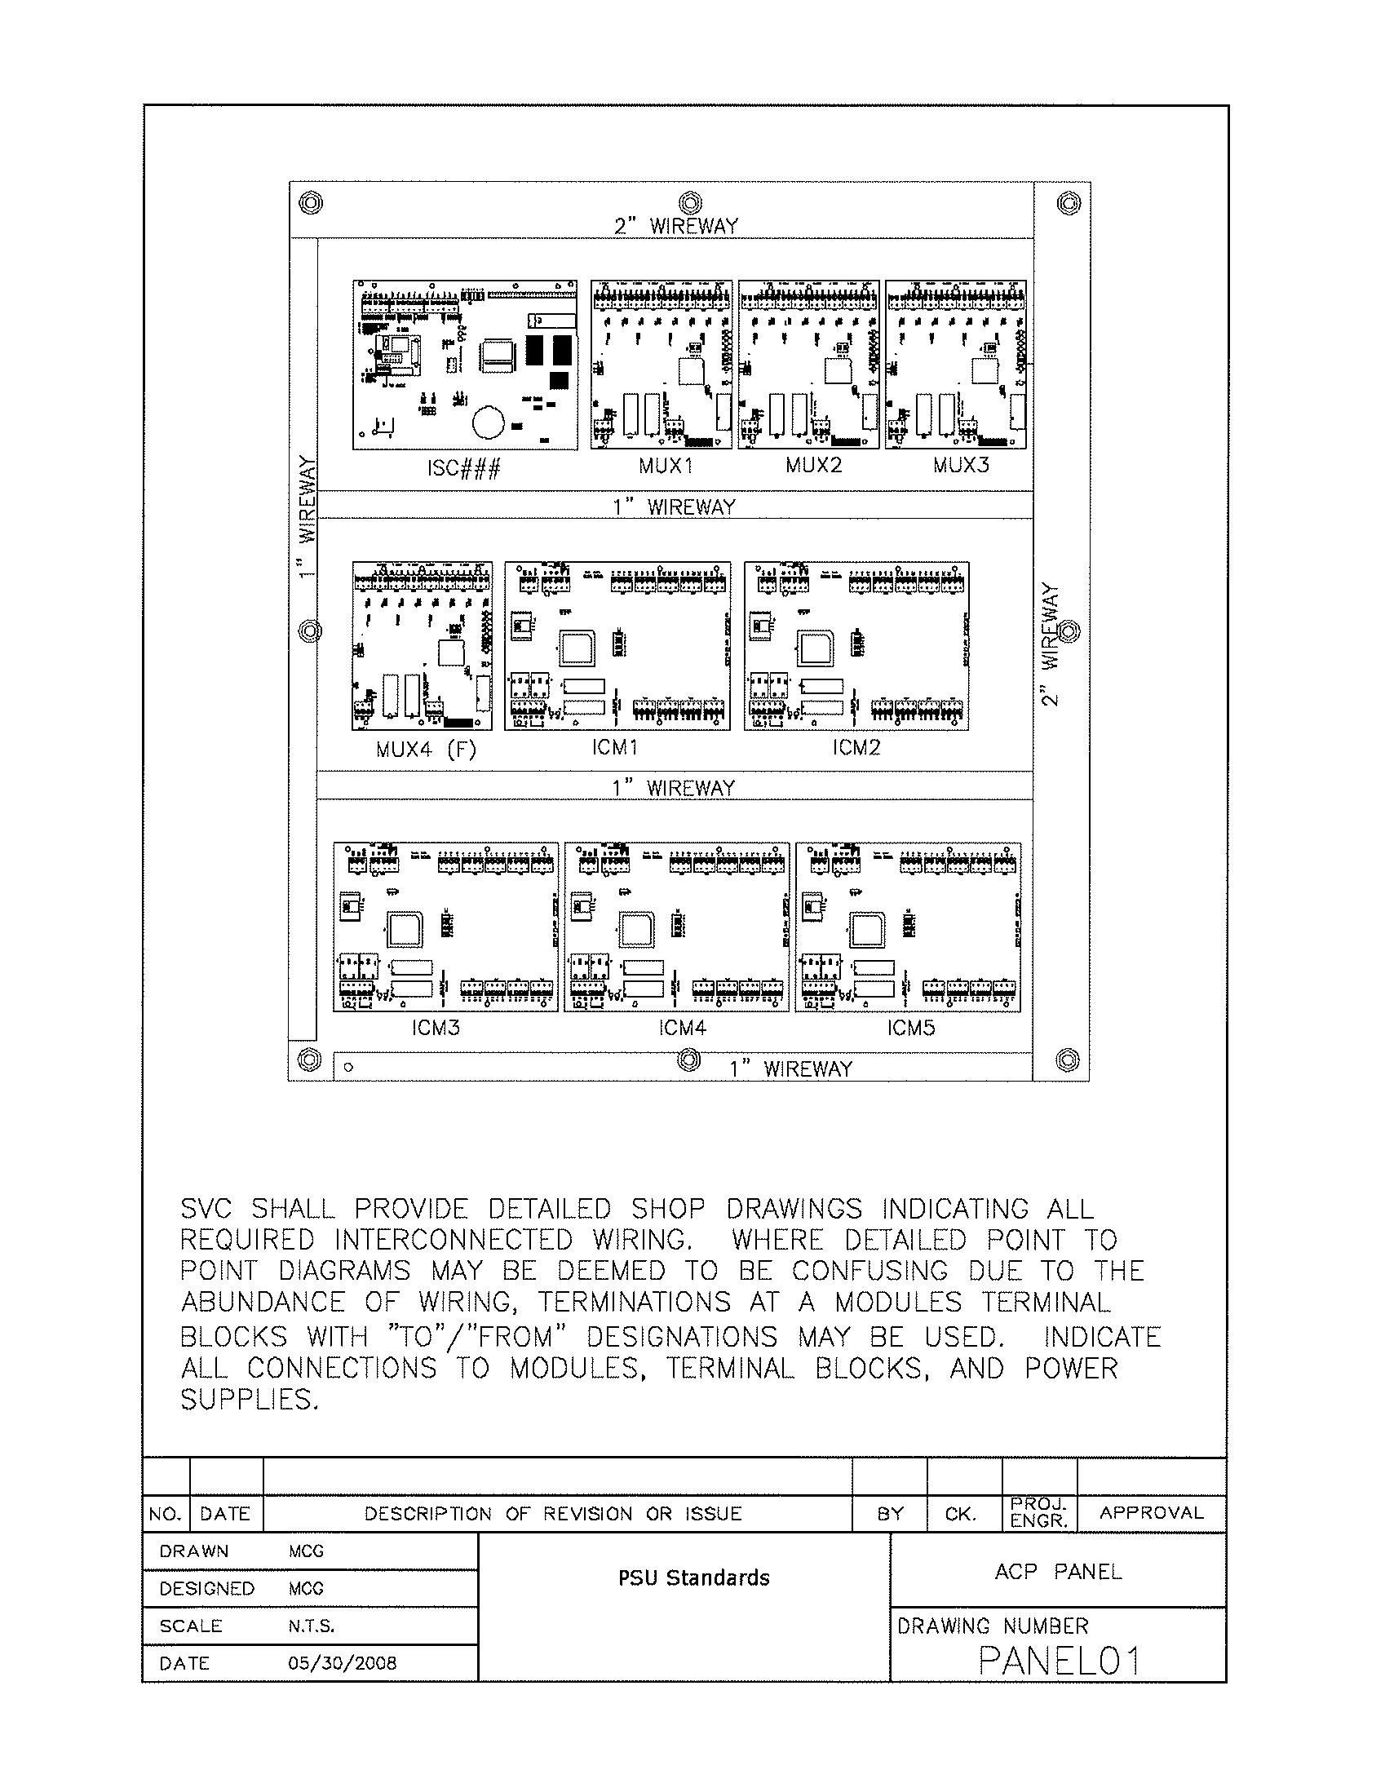

EXHIBIT E:

Portland State University

Sample Installation Projects

Detailed Floor Plans

The following five (5) pages are all part of Exhibit E and break down as follows:

E-1 (2 pages) ---- Sample Project I (University Center Building)
E-2 (2 pages) ---- Sample Project II (Neuberger Hall)
E-3 (1 page) ---- Sample Project III (Millar Library)

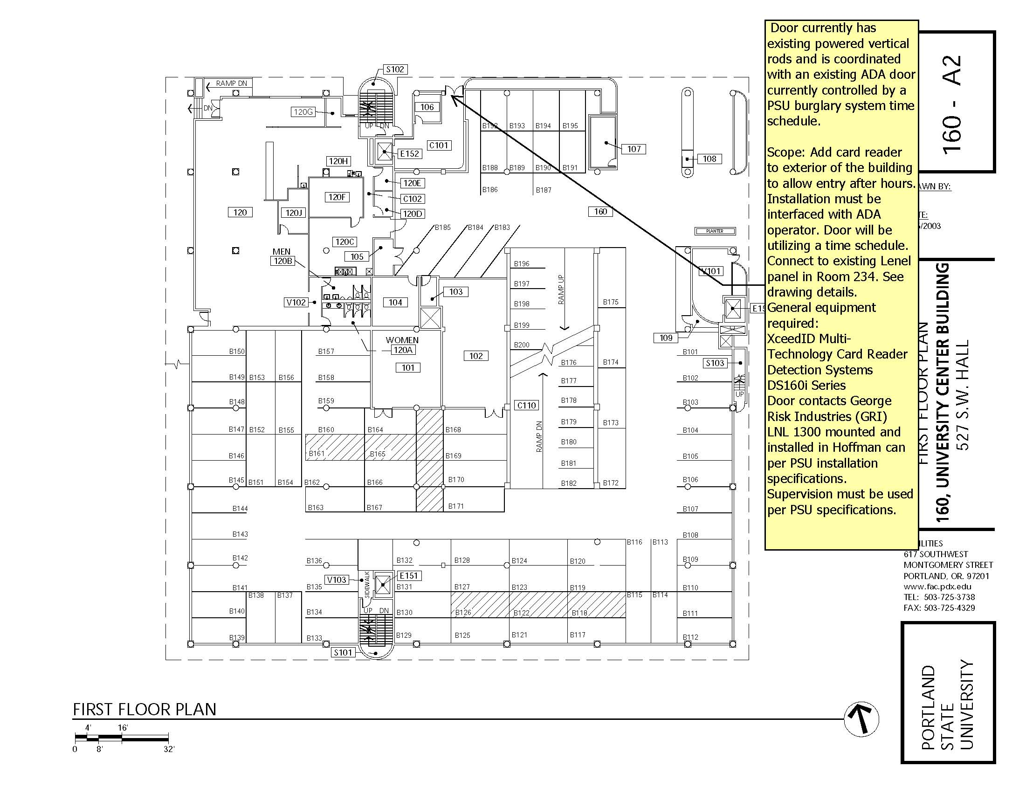

EXHIBIT E-1

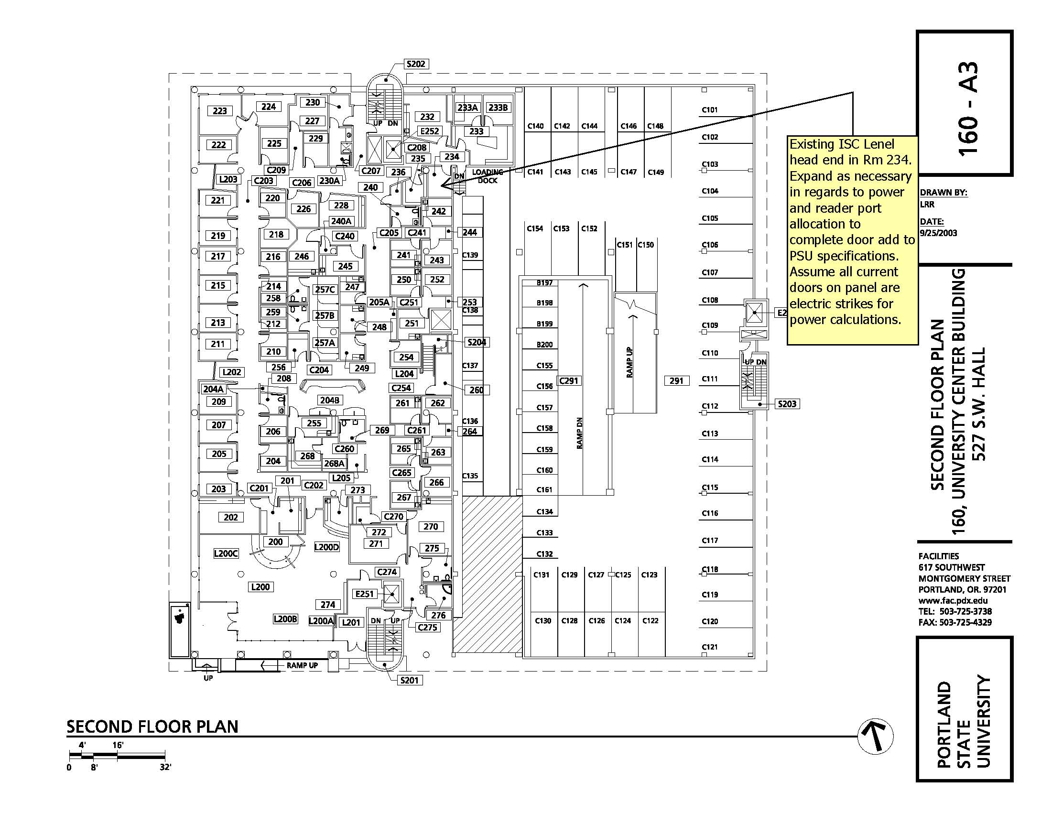

EXHIBIT E-1

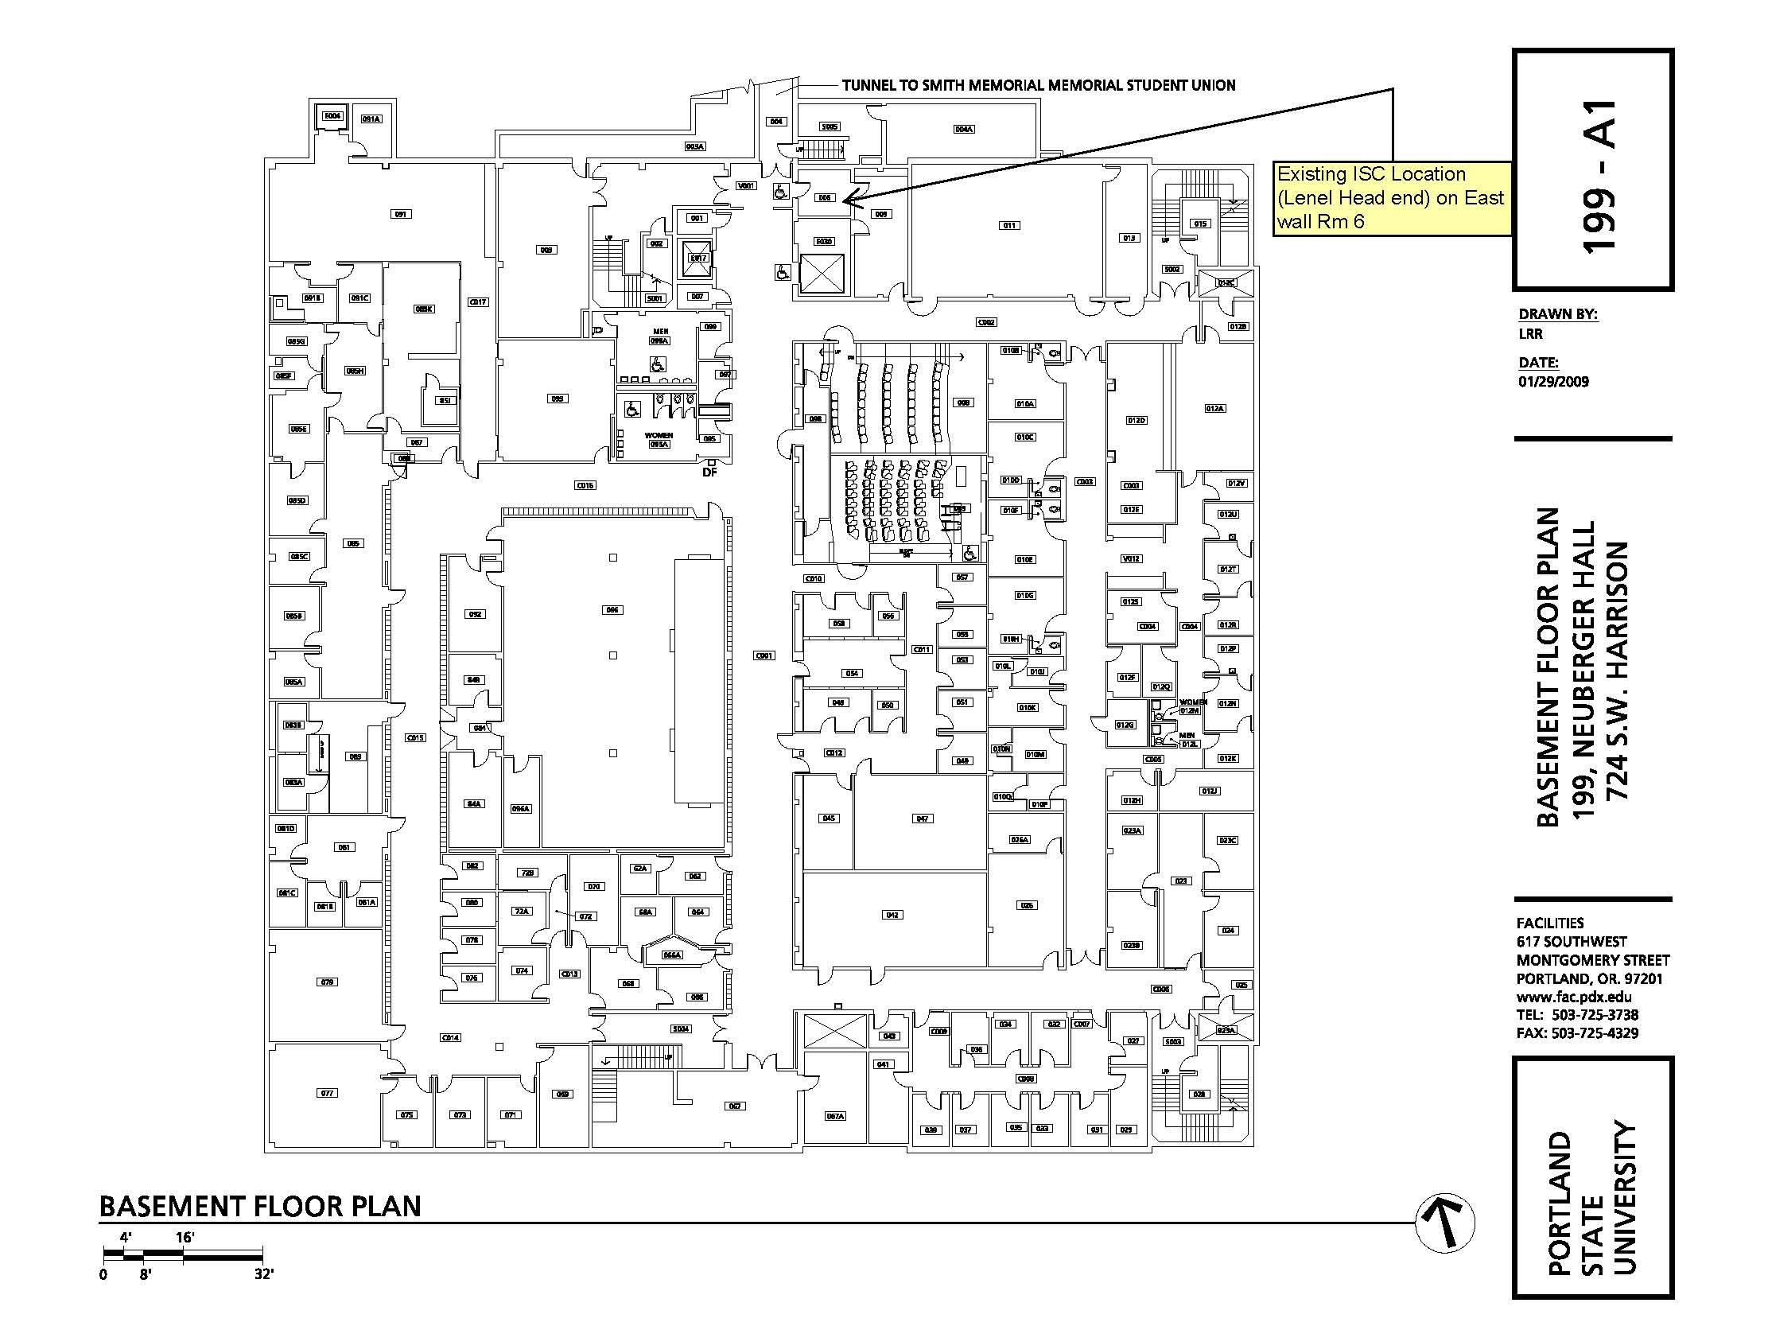

EXHIBIT E-2

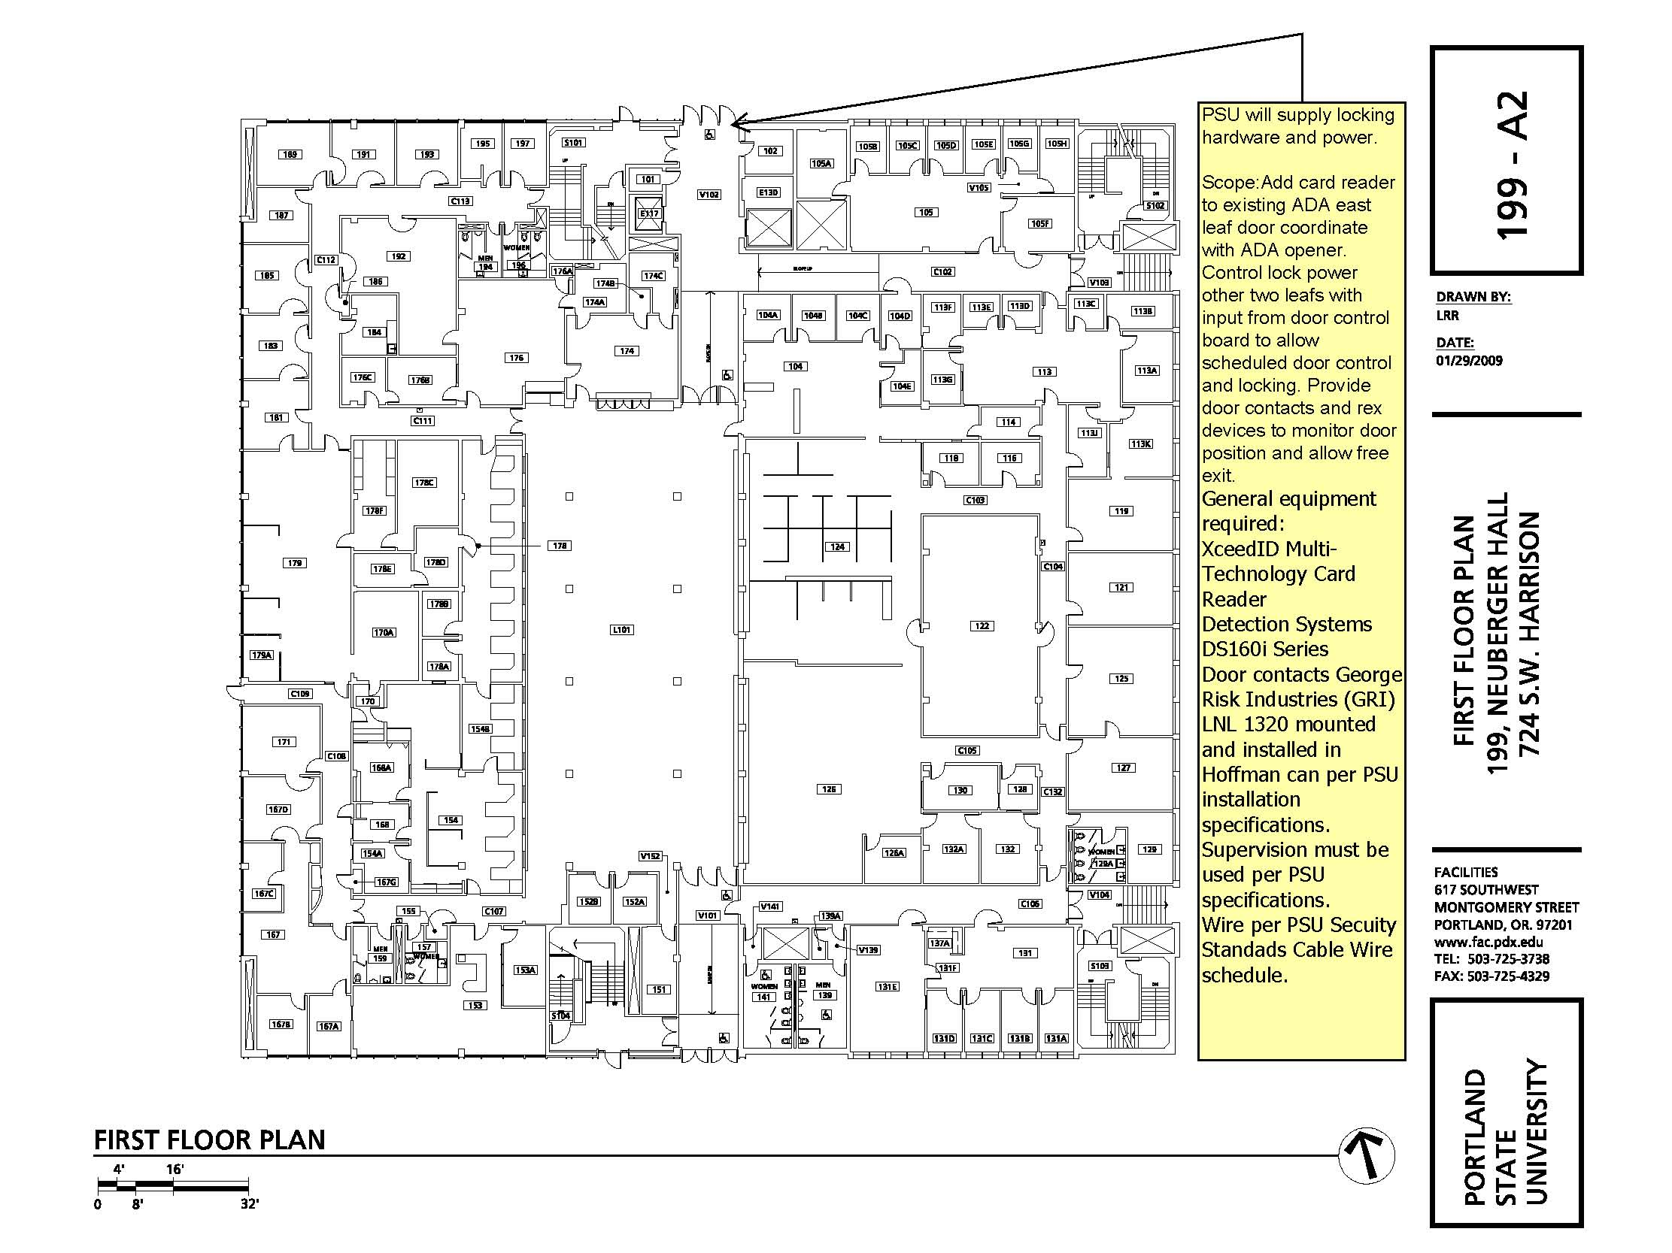

EXHIBIT E-2

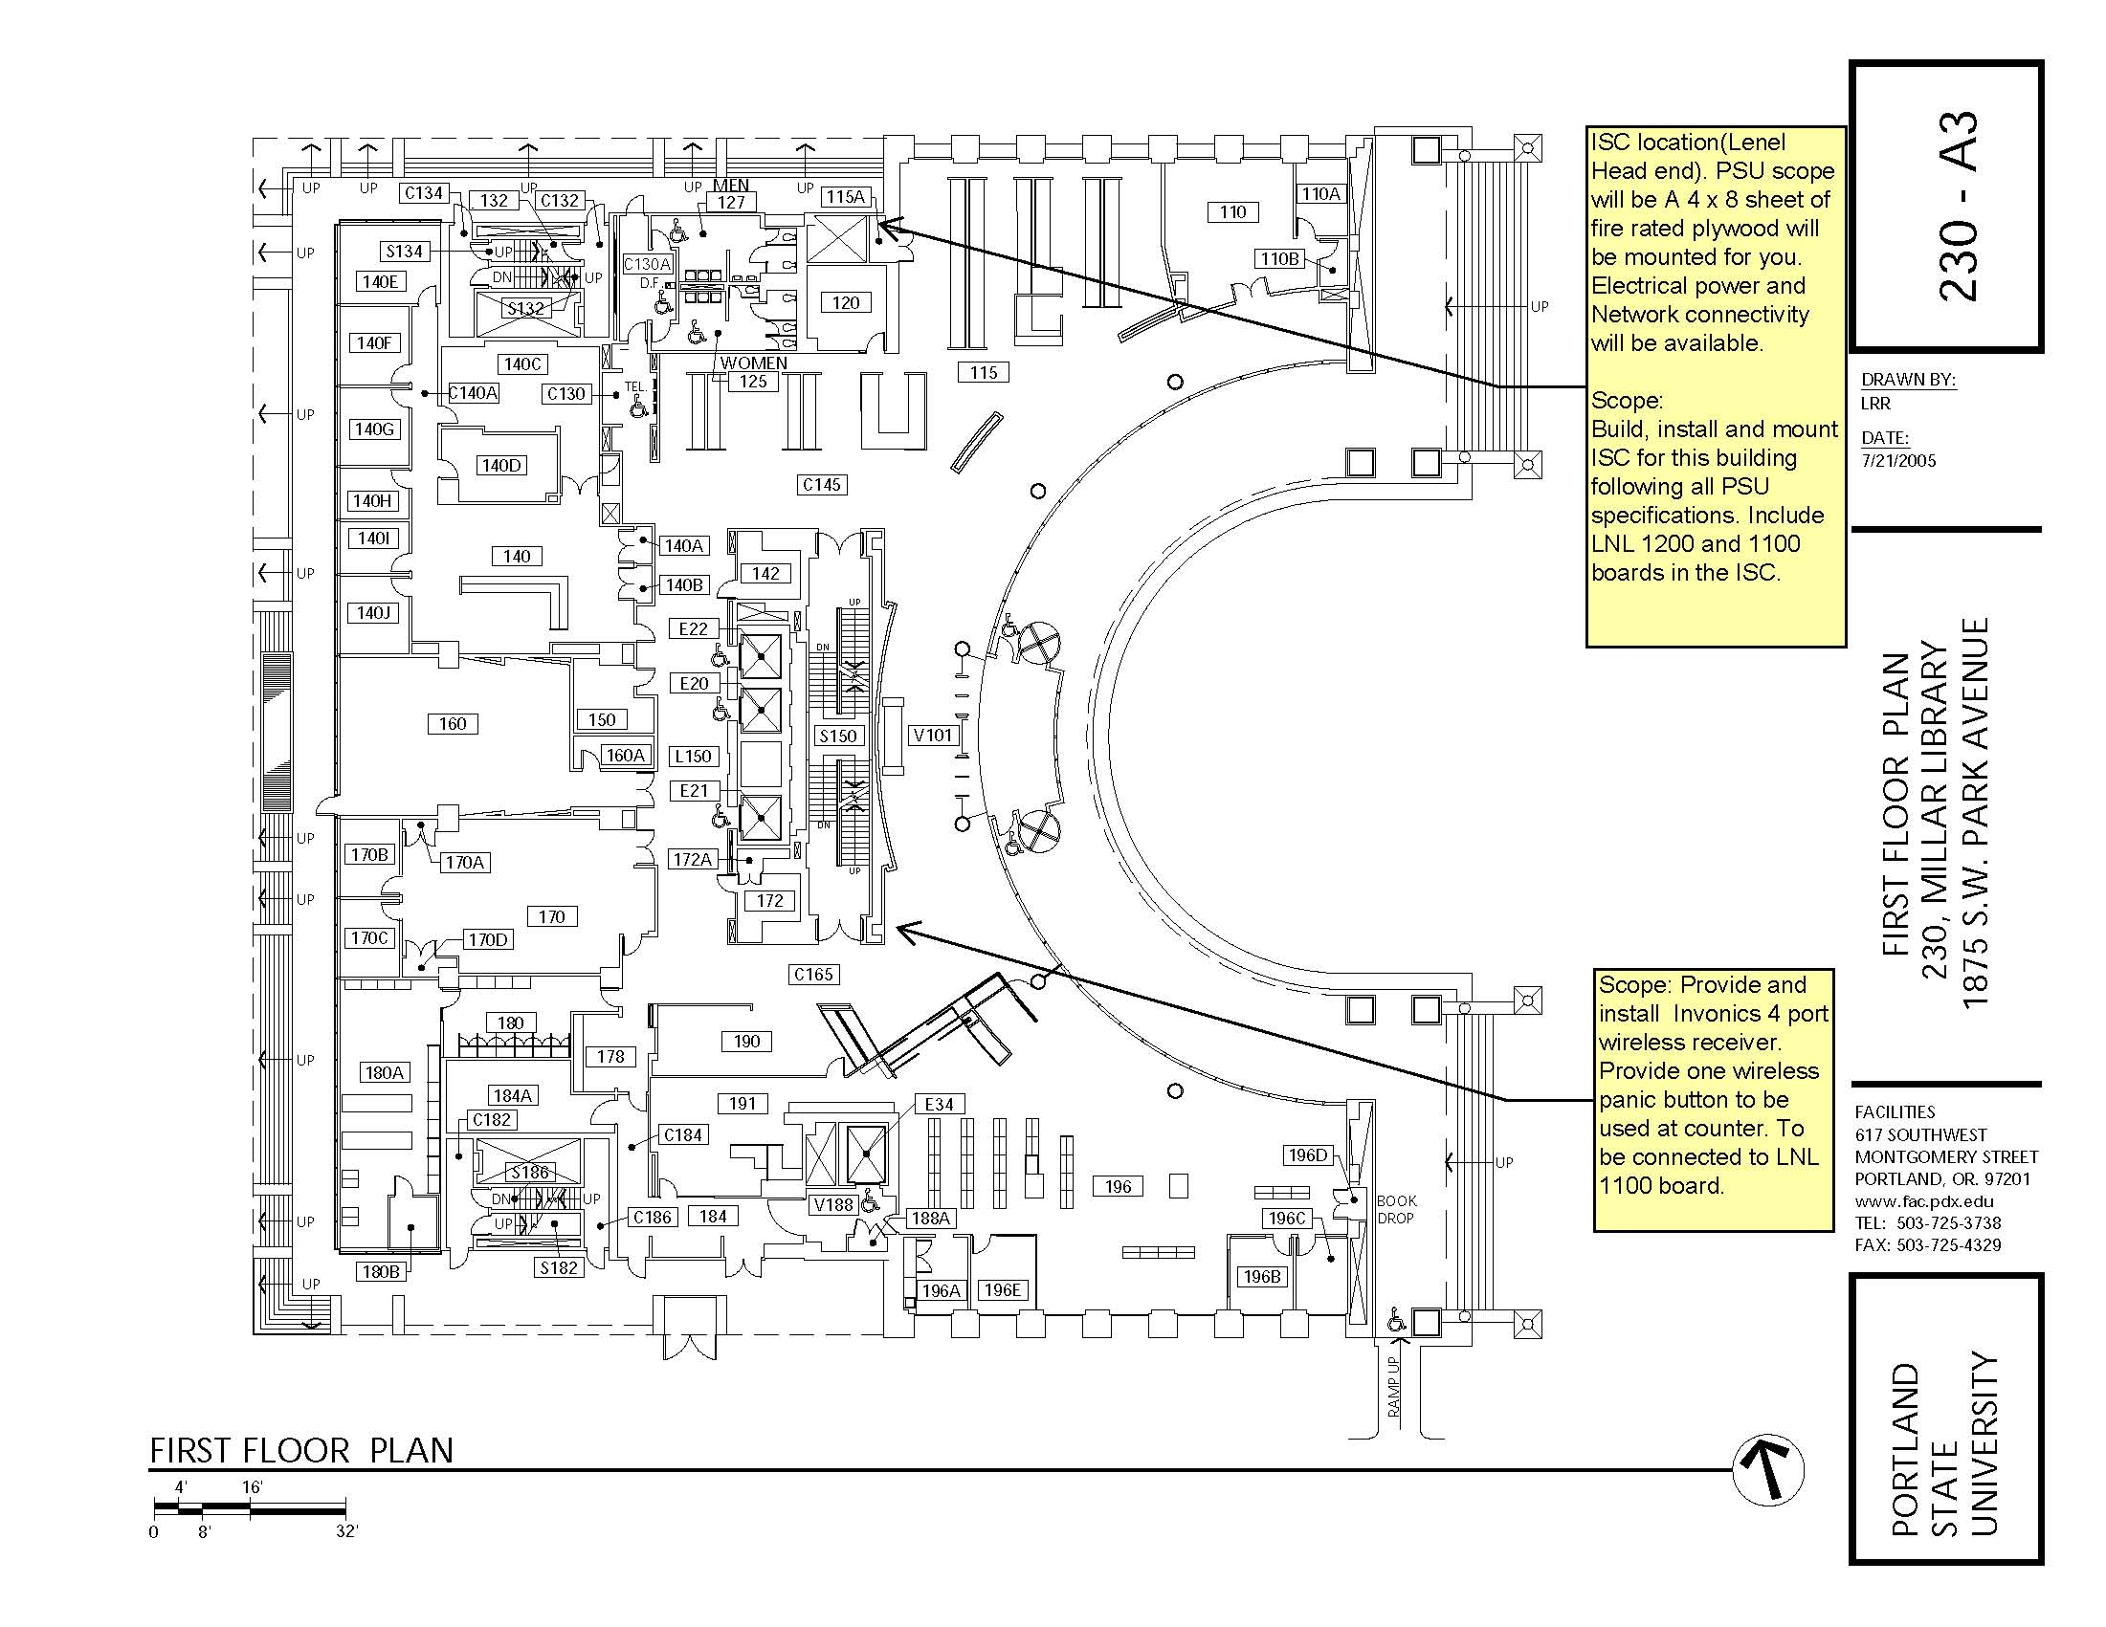

EXHIBIT E-3

