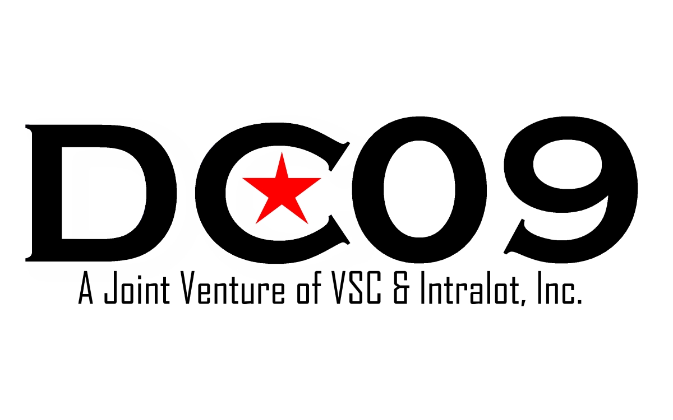
Promotions Team

Request For Proposals

DC09, LLC
55 M St. SE
Suite 350
Washington, D.C. 20003

General Terms
Project Name | Promotions Team FY12
Project Manager | Vivian Byrd
Engagement Duration | FY12
Begin Date | April 1, 2012
End Date | September 30, 2012

Project Overview:
DC09, LLC is committed to providing maximum contracting opportunities to certified business enterprises by using race-neutral, gender-neutral measures to facilitate business participation in the procurement process. DC09 exercises an open door commitment to engaging local, small, and disadvantaged businesses certified under the DC Department of Small and Local Business Development (DSLBD).

DC09 and their client D.C. Lottery and Charitable Games Contol Board (DCLB) requires Promotions Team services for special events and promotions that will occur during FY12 throughout various Washington, D.C. communities. Up to 40 Events are planned beginning in April of 2012 in which the Promotions Team may or may not be required to participate. Co-Ed Teams of 2 will promote various D.C. Lottery Games. Each Event will have a 2 hour minimum appearance for each individual working the Event.

After the contract award and before the first event, a training session will be held for all Team members to provide pertinent (both background and current) information, about D. C. Lottery, its games and marketing strategies. Furthermore, Team members will be required to demonstrate their abilities to engage customers in different scenarios through role play. Our goal is to have a core group of staffers that can provide some level of consistency to minimize training or total staff turnover during multiple day events.
In the Promotions team services, you will be expected to actively promote D. C. Lottery by fully engaging, and educating patrons attending each event. Each member of the Promotions Team will provide a friendly, courteous, efficient and helpful service to the public at all times, while actively maximizing product sales utilizing product knowledge. Team members will be required to perform other duties related to marketing such as Flash Mobs, Jump-outs, Odd Drops and other entertaining duties as deemed necessary by D. C. Lottery and/or DC09 staff. No uniforms will be required.
The Promotions Team Manager will be required to manage all Team members at each event, from beginning to end of event. The Team Manager will be responsible for ensuring that the requested amount of Team members for each event arrive on time, and are in place at least thirty minutes prior to event start-time with the understanding of the lottery games and promotional goals for each event. Team members must have the ability to lift, carry, move, setup and/or breakdown onsite materials as required.
Additionally, team members must possess the following skills: enthusiasm, self-motivation, dedication, leadership and time management skills, enjoy working within teams, sales and marketing skills, good listening skills, and a commitment to high standards.

If selected as a Finalist, The Vendor will provide via a Panel Interview, a synergistic Promotion Plan with measurable goals for an upcoming lottery event, projecting as if you have already been provided details of the event from the Project Manager and are ready to assume the role of a lottery promotions expert. For example, an eight-hour event will take place at a major festival downtown Washington, D. C., NW, on a Saturday afternoon in August. Two on-line games and two instant games will be the feature promotional games of the event. Your staff will provide their sales and marketing skills to ensure that both the promotion and sales goals are realized. Keep in mind that Washington, D. C. has a diverse demographic range which some or all may or may not be lottery players therefore, requiring the need for both creative and innovative promotion and marketing ideas.

You are also required to provide (preferably) video or photos of your team in action, (the creative applications you have employed for past clients).

Delivery Requirements:
To be determined locations in Washington, D.C.

Price:
NTE $20,000. All costs should be included in the proposed offer. As a further point of clarification, the not to exceed amount is for all events combined. The prospective contractor is to submit a price for each event, a price per team member/per event, price per task/per event, etc.
Vendor Requirements:
The Vendor shall present during the Panel Interview, a mock event that will demonstrate their ability to promote an event, display their knowledge of DCLB products, professionally engage the customers, and help build a new customer base that will create market impact and drive revenue growth.

The Vendor shall furnish the necessary experienced co-ed personnel to adequately staff each event in a timely manner.

The Vendor and all personnel must attend all training provided by DC09 staff.

The Vendor must provide Bi-Lingual English/Spanish speaking personnel when required.

The Vendor may make recommendations on best practices and techniques to achieve optimal sales goals.

The Vendor shall demonstrate past performance of its ability to promote to an urban target market.

The Vendor shall notify the Project Manager of any change requests, and seek approval of the change prior to implementing it. Vendor shall document all change requests and provide a statement on anticipated impact that the change may have on the project (positive and negative). Vendor shall also document if a recommended change will increase or decrease the fixed price/cost of the project. Vendor shall seek written approval of all change requests from DC09 prior to implementation.

The Vendor must provide an on-site Event Manager to staff and manage personnel at each event.

DC09 Requirements:
Payment will be made for actual services rendered to DC09 & DCLB.

Project Manager will notify Vendor of confirmed date and time of requested appearances in advance.

Project Manager will provide the necessary training to prepare for services required.

Project Manager will coordinate specifications and event requirements with Vendor prior to engagement.

Project Manager or his or her designee will be on-site at start-up of each event to provide direction to the Event Manager.

Project Manager will review all change requests made on behalf of the Vendor and provide written approval/disapproval of such change(s) to Vendor in a timely manner.

Timeline:
RFP is open on Wednesday, February 8, 2012.

Questions related to this RFP must be submitted via email to Vivian Byrd at vivian.byrd@dc09.us by 12noon on Wednesday, February 22, 2012. Questions received after that date and time may not be answered. A response to questions will be distributed to all participating vendors by 6pm on Wednesday, Feburary 22, 2012 via email.

Proposals are due no later than 12noon on Wednesday, March 7, 2012 via email submission.

Finalist are expected to be contacted by Monday, March 12, 2012.

Panel Interviews for Finalists are targeted for Tuesday, March 20, and Wednesday, March 21, 2012 in the event a second date is deemed necessary.

Contract award is expected to be made no later than Tuesday, March 27, 2012.

Send Responses To:

Vivian Byrd
Senior Marketing Coordinator
DC09, LLC
55 M St. SE Suite 350
Washington, DC 20003
Phone 202-649-1008
vivian.byrd@dc09.us

