LOUISIANA STATE UNIVERSITY IN SHREVEPORT ISSUE DATE: MARCH 6, 2012
Purchasing Office LSUS BID NO 209-JD
One University Place
Shreveport, Louisiana 71115
Email: purchasing@LSUS.edu
(318)797-5272 Fax: (318)795-4242 SEALED
INVITATION, BID AND ACCEPTANCE

INVITATION: Sealed bids, subject to the conditions herein stated and attached hereto, will be received at this office until:
WEDNESDAY, MARCH 28, 2012 @ 2:15 PM CDST
______________________________________________________________________________________________________
And then publicly opened for furnishing the items and/or services as described below for LOUISIANA STATE UNIVERSITY IN SHREVEPORT.

Signed JERI DUPREE
Director of Purchasing Procurement Specialist
______________________________________________________________________________________________________
DESCRIPTION
GENERAL CAMPUS PRINTING
---------------
Per Attached Specifications

INSTRUCTIONS:
1. Your bid should be made on attached form and returned per instructions on page 2 of this bid
2. The University CANNOT accept bids or alterations by wire or phone.
3. Any bid received after bid closing time will be returned unopened.
4. All prices are to be quoted complete & FOB LSU Shreveport (Freight Prepaid)
5. All prices must be firm unless otherwise stated.
6. DO NOT include Federal Excise Tax unless requested.
7. Unless otherwise specified all bids shall be binding for 30 calendar days from date of bid opening.
NOTE: Out of state firms who may be awarded an order as a result of this bid agree to sign a certificate stating: "I hereby certify that I have paid to the State and its political subdivisions all taxes duly assessed by the State of Louisiana and its subdivisions, including Franchise Taxes, Privilege Taxes, Sales Taxes, and all other taxes for which I am liable." Said certificate shall accompany firm's invoice.

BIDDERS PLEASE FILL IN ALL BLANK SPACES AND SIGN BELOW

Payment Terms: _____________ FOB: LSU Shreveport, LA
Will be shipped from: ____________________________________ within _______________days of receipt of order.
Delivery may be a consideration in the award.

In compliance with the above invitation for bids and subject to the condition thereof, the undersigned offers and agrees if this bid be accepted within _______________ days from the date of opening to furnish any or all of the items (or sections) at the price set opposite each item (or section).

Bidder_____________________________________________ ________________________________________________
(Name of Firm) Address

By ________________________________________________ _______________________________________________ (Bidder’s Signature) Title

Phone __________________________ Fax ____________________ Date ________________________________

Acceptance by LOUISIANA STATE UNIVERSITY IN SHREVEPORT Date______________________
(Applicable only case of continuing contract; otherwise purchaseorder constitutes acceptance.)

Accepted as to items numbered: __________________________________________________________________________________

Signed_________________________________________
Director of Purchasing
AN EQUAL OPPORTUNITY EMPLOYER
LSUS-R-2/Rev. 8/97 RETURN THIS COPY

INFORMATION FOR BIDDERS

1. BID SUBMISSION: All bids must be submitted on the forms furnished for this purpose and must be filled out with ink or typewritten (black ink preferred for reproduction purposes) and signed in ink. Each change or correction must be clearly marked and initialed by bidder's authorized representative. Failure to comply with these requirements may cause your bid to be disqualified. Telephone and telegraphic quotations for formal bids will not be accepted. Telegraphic alterations to bids received before bid opening time will be considered, provided formal bid and written telegram have been received and time-stamped before bid opening time.

Bidders are requested to state on bid form when bidding on items on "all or none" basis.

In the case of a lump sum bid, the amount should be expressed in words and figures. In case of any discrepancy between the price written in the bid and that given in figures, the price in writing will be considered as the bid.

In case of an error on extension, the unit price shall prevail.

2. DELIVERY OF BIDS: The bid is to be placed in a sealed envelope which shall be clearly marked on the outside with the information shown on the following sample envelope:
From:

Louisiana State University in Shreveport
Purchasing Department, AD 108
BID Number _____________________ One University Place
Proposal For _____________________ Shreveport, LA 71115-2399
Due Date/Time____________________
From:

Louisiana State University in Shreveport
Purchasing Department, AD 108
BID Number _____________________ One University Place
Proposal for _____________________ Shreveport, LA 71115-2399
Due Date/Time____________________

The name and address of the bidder is to be shown on the envelope. In the event bid contains bulky subject material, the special bid envelope should be firmly affixed to the mailing envelope.

Bids must be delivered to the Purchasing Office, Louisiana State University in Shreveport, Administration Building Room 108,
One University Place, Shreveport, Louisiana, 71115, no later than MARCH 28, 2012 @ 2:15 PM CDST.

It is the sole responsibility of the Bidder for the timely delivery of its bid to the Purchasing Dept., Admin. Bldg, Room 108. Failure to meet the bid opening date & time shall result in rejection of the bid.

The University reserves the right to reject any or all bids.

3. INTERPRETATION OF DOCUMENTS: Any interpretation of the documents will be made by Addenda only, issued by the Purchasing Office, and a copy of such Addenda will be sent to each person receiving a set of the documents. The University will not be responsible for any other explanation of the proposed documents.

4. STANDARDS OF QUALITY: Whenever a material, article or piece of equipment is identified in the specifications by reference to manufacturer's or vendor's names, trade names, catalog number, etc., it is intended merely to establish a quality level and characteristics required; and any material, article or equipment of another manufacturer and vendor which will perform adequately the duties imposed by the general design will be considered equally acceptable provided the material, article, or equipment so proposed is, in the opinion of the University, of equal substance and function.

Bidder should specify the brand and model number of the product offered in his bid. Bids not specifying brand and model number shall be considered as offering the exact products specified in the IBA.

LSUS-P-2b/A-2 Form A-2
Revised 12/06 Page 1

5. DESCRIPTIVE INFORMATION: Bidders proposing an equivalent brand or model should submit with the bid information (such as illustrations, descriptive literature, and technical data) sufficient for LSUS Purchasing Office to evaluate quality, suitability and compliance with the specifications in the IBA. Failure to submit descriptive information may cause bid to be rejected. Any change made to a manufacturer's published specifications submitted for a product shall be verifiable by the manufacturer. If item(s) bid does not comply with specifications (including brand and/or product number), bidder should state in what respect the item(s) deviate. Failure to note exceptions on the response form will not relieve the successful bidder(s) from supplying the actual products requested.

6. QUESTIONS: All questions concerning this bid request must be submitted in writing to the LSUS Purchasing Department NO LATER THAN MAR. 20, 2012 @ 2:00 PM CDST. Fax questions to 318-795-4242 or email to purchasing@LSUS.edu.

7. BID OPENING: Bidders may attend the bid opening, but information and opinions concerning the ultimate contract award will not be given at the bid opening or during the evaluation process. Information pertaining to complete files may be secured by visiting LSU-Shreveport Purchasing Office during normal working hours.

8. BID TERM: All prices bid in response to this request for quotation shall remain firm thirty (30) days after bid opening. In the event more than thirty days elapse from bid opening, prices shall be verified with bidder prior to award.

9. ACCEPTANCE OF PROPOSAL: Only the issuance of a Purchase Order or a signed acceptance of your proposal constitutes acceptance on the part of the University.

10. AWARD: The University reserves the right to award the order by individual items, related items, or by total, whichever is deemed
to be in the best interest of the University.

11. PAYMENT: Payment is to be made within 30 days after delivery of merchandise and/or completion of services in satisfactory condition and upon receipt of properly executed invoice, whichever is later.

12. WARRANTIES: Should merchandise described on this bid contain a manufacturer's warranty, bidders must state the warranty terms in the space provided below. When no warranty applies, clearly state: "NO WARRANTY COVERAGE." Warranty information will be criteria in making this award. Failure of bidders to furnish this data may cause rejection of the complete bid as being non-responsive.
_________________________________________________________________________________________________________________________________________________________________________________________________________________________________________________________________________________________________________________________________

13. CONTRACT PROHIBITION: According to L.R.S. 42:1113 (D) the University is prohibited from entering into any contract of subcontract with a legislator or person who has been certified by the Secretary of State as elected to the Legislature or spouse of a legislator, or any corporation, partnership or other legal entity in which the legislator or his or her spouse owns an interest, except publicly traded corporations. Each bidder shall be required to disclose whether or not it falls into any of these categories.

Each bidder is to disclose the following information by answering yes and no to the following questions:

1. Is the bidder a legislator or person who has been certified by the Secretary of State as elected to the Legislature? _______
2. Is the bidder a spouse of a legislator? _________
3. If the bidder is a corporation, partnership, or other legal entity, does a legislator or his spouse own any interest in that corporation,
partnership or other legal entity? ________
4. If the bidder is a corporation, is it a publicly traded corporation? _____________

LSUS-P-2b/A-2 Form A-2
Revised 12/06 Page 2

14. FACTOR FOR DETERMINING CONFLICT OF INTEREST:

Does the bidder have any relatives currently employed at Louisiana State University in Shreveport?

Yes _____ No _____

If yes, please list the LSUS employee’s name and position below:

_______________________________________ ____________________________________
NAME POSITION

15. PREFERENCE: In accordance with Louisiana Revised Statutes 39:1595, a preference may be allowed for products manufactured,
produced, grown or assembled in Louisiana of equal quality.

Do you claim this preference? Yes___________ No __________

- If YES: Specify Line Number(s): _________________________________________________________________________

- If YES: Specify Location within Louisiana where this product is manufactured, produced, grown or assembled. ______________________________________________________________________________________________
(Note: if more space is required include a separate sheet)

Do you have a Louisiana Business Workforce? Yes_____ No _____
  - If YES, do you certify that at least fifty percent (50%) of your Louisiana Business Workforce is comprised of Louisiana residents? Yes _____ No _____

Failure to specify above information may cause elimination from preferences. Preferences shall not apply to
service contracts.

16. SIGNATURE AUTHORITY: In accordance with L.R.S. 39:1594 (Act 121), the person signing the bid must be:

1. A current corporate officer, partnership member or other individual specifically authorized to submit a bid as reflected in the
appropriate records on file with the Secretary of State; or
2. An individual authorized to bind the vendor as reflected by an accompanying corporate resolution, certificate or affidavit; or
3. An individual listed on the State of Louisiana Bidder's Application as authorized to execute bids.
By signing the bid, the bidder certifies compliance with the above.

LSUS-P-2b/A-2 Form A-2
Revised 12/06 Page 3

GENERAL CONDITIONS

1. PRICES AND PAYMENT TERMS: Unless otherwise specified by LSUS Purchasing Office in the IBA, bid prices must be completed including transportation prepaid by bidder to destination. Bids other than FOB destination may be rejected.

Not withstanding bid response, terms of payment shall be at least Net 30 Days. Discounts offered for payment in less than 30 days will not be considered in making an award. On open-ended requirements contracts, discounts will be accepted, but will not be considered in making an award. Bids containing "payment in advance" or "COD" requirements may be rejected. Payment is to be made within 30 days after receipt of properly executed invoice or delivery, whichever is later.

2. DELIVERIES: Bids may be rejected if the delivery time indicated is longer than that specified in the IBA. Failure to deliver within the time specified in the bid will constitute a default and may cause cancellation of the contract. See Default of Contractor, below.

3. PERMITS, LICENSES, LAWS, AND TAXES: Contractors doing work on University projects shall furnish all necessary permits, licenses, and certificates, and comply with all laws or ordinances applicable to the locality of the building site and the State of Louisiana.

The contractor shall include within his bid all applicable State, Federal, or other local taxes required.

4. LOUISIANA SALES & USE TAXES: LSUS is exempt from the direct payment of Louisiana State sales/use tax on commodities, services, and pubic works, as provided by Louisiana Legislature Act 1029, R.S. 47:301.8a or 47:301.8c, effective September 1, 1992.

5. NEW PRODUCTS: Unless specifically called for in the IBA, all products for purchase must be new, never previously used, and the current model and/or packaging. No remanufactured, demonstrator, used, or irregular product will be considered for purchase unless otherwise specified in the IBA. The manufacturer's standard warranty will apply unless otherwise specified in the IBA.

6. CONTRACT RENEWALS/OPTIONS: Upon mutual agreement of the LSUS Purchasing Office and the contractor, an open-ended requirements contract may be extended for two (2) additional 12-month periods. In such cases, the total contract term cannot exceed 36 months.

7. CONTRACT CANCELLATION: The LSUS Purchasing Office has the right to cancel any contract, in accordance with Purchasing Rules and Regulations, for cause, including, but not limited to, the following: (1) failure to deliver within the time specified in the contract; (2) failure of the product or service to meet specifications, conform to sample quality, or to be delivered in good condition; (3) misrepresentation by the contractor; (4) fraud, collusion, conspiracy, or other unlawful means of obtaining any contract with the state; (5) conflict of contract provisions with constitutional or statutory provisions of state or federal law; and (6) any other breach of contract.

The University will give the contractor written notice of cancellation. Contractor waives any requirement for a legal putting in default.

8. OPTION TO CANCEL CONTRACT: At the option of the University, a contract entered into as the result of this Invitation, Bid and Acceptance may be cancelled by providing vendor a thirty (30) day notice in writing. The University will exercise this option when budgetary reductions and changes in funding priorities by the State are requested.

9. DEFAULT OF CONTRACTOR: Where the University has determined the contractor to be in default, the University reserves the right to purchase any or all products or services covered by the contract on the open market and to charge the contractor with cost in excess of the contract price. Until such assessed charges have been paid, no subsequent bid from the defaulting contractor will be considered.

10. ORDER OF PRIORITY: In the event there is a conflict between the Instructions to Bidders or General Conditions and the Special Conditions, the Special Conditions shall govern.

11. APPLICABLE LAW: All contracts shall be construed in accordance with and governed by the laws of the State of Louisiana.

12. FISCAL FUNDING CLAUSE: The continuation of this contract is contingent upon the appropriation of funds to fulfill the requirements of the contract by the legislature. If the legislature fails to appropriate sufficient monies to provide the continuation of a contract, the contract shall terminate on the date of the beginning of the first fiscal year for which funds are not appropriated.

13. BIDS ARE PUBLIC RECORD: All bids become a matter of public record at bid opening. The University accepts no responsibility for maintaining confidentiality of any information submitted with bid whether labeled confidential or not.

LSUS-P-2b/A-1 Form A-1
Revised 11/06 Page 3

PLEASE READ CAREFULLY
SPECIAL INSTRUCTIONS FOR COMPLETING THIS BID

- Quote pricing on this bid form in the sections provided for that purpose. The university will not accept quotes prepared on the vendors quote forms as a response to this bid.

- This purchase will be limited to the original terms & conditions included in this bid. Do not include any other terms & conditions with your bid submittal. The university will not accept vendor's terms & conditions.

- Your return policy must be included in the bid for review and acceptance if you want your company's return policy to apply.

- LSUS will not accept bids with alterations to the wording or to the terms and conditions as shown in the original bid. When bidding an alternate item, you must show the model/manufacturer of the alternate in the spaces provided for that purpose. Send specifications for the alternate on a separate page. Do not write them into this bid.

- All shipping charges are to be included in the unit price of each item.

- Bids should be submitted with FOB: LSUS

- Will your company/firm accept a purchase order from a state university: ____yes ____no

If your company/firm does not accept purchase orders, your bid could be rejected

If you checked “yes” that you do accept a purchase order; please send the following with your bid proposal:
1. Completed w9 form
2. Any credit application forms you require prior to issued credit of net 30 to the university

- DEFINITIONS: Shall, Must, Will: Denote a mandatory requirement
Should, May, Can: Denote a preference but not a mandatory requirement

For evaluation purposes all charges (shipping charges, etc.) are to be included in the unit price of each item.

ITEMS NOT PRICED PER THIS REQUEST WILL NOT BE CONSIDERED.

MANDATORY REQUIREMENTS

The following requirements are mandatory requirements for this bid. Bids not complying with these
requirements will be rejected.

- Printer must have been in a successful printing operation for a minimum of five (5) years to qualify for award.

This information may be submitted with the bid. However, if not submitted LSUS reserves the right to request this information from the bidder(s). If requested, the printer will have ten (10) days to provide this information to LSUS. Failure to comply may be cause to reject the bid.

Printer must be a full-time operation available for consultation on orders from approximately 8:00 AM to 4:30 PM, Monday through Friday.

- Printer must be proficient with current versions of Quark, Illustrator, Photo-Shop, Adobe, etc., software.

- Printer should be able to have completed jobs delivered to LSUS promptly upon completion of work.

- Printer is required to own (have in-house) the following equipment:

  - At least one (1) high speed four-color one-pass press
  - Binding equipment for handling brochures and small catalogs
  - Folding machine appropriate size to handle jobs listed in this bid
  - High resolution 4 color scanning device (minimum 1500 dpi)
  - High quality film output devices (9 minimum 1500 dpi)
  - Finished film color proofing
  - Size of press: must be appropriate size to handle jobs listed in this bid
  - Web Press process is approved for applicable jobs

- Printer must have at least 1 in-house graphic designer to work with the university on developing a printing piece.

- In house samples of work required upon request.

- Printer should be able to receive, format, and output ASCII Text Files from various computer programs.

- Typesetting: Vendor will be expected to furnish a complete typesetting service so individual jobs will not be delayed when processed if typesetting is required.
SPECIFICATIONS
SCOPE:

To obtain general job-shop printing by offset press, or other equipment in the industry, as well as highly complex printing jobs of very high quality.

Printer must be capable of providing additional features, such as folding, stapling, sorting, collating, punching, etc.

Turn-around time will be negotiated up front on a per-job-basis.

Some “rush” jobs will require delivery within two (2) to three (3) work days.

If, in the opinion of the university, the vendor cannot perform the required job(s), the university may cancel the remaining portion of this contract.

Jobs will range in cost from $20.00 up to $20,000.00.

The university reserves the right to use the printer to handle any printing job above or below this range, and/or separately bid a printing job, whatever is deemed in the best interest of the university. This Bid is not exclusive.

CONTRACT PERIOD: APRIL 20, 2012 THRU APRIL 19, 2013

OPTION TO RENEW:
At the option of the university and written acceptance by the vendor, this bid can be renewed for two (2) additional twelve (12) month periods at the same prices, terms, and conditions as the original bid.

PRINTING:
Printer must be able to furnish all labor and materials necessary to do offset printing. It is understood that only the highest quality offset printing will be acceptable, with clear, even detail on all lettering.

The requirement that the presswork be of the highest quality must be rigidly observed. If the printing shows defects in craftsmanship or does not adhere to the specifications or intent of said specifications in regard to quality, LSUS will have the right to reject any such copy and require the bidder to reprint any such copy without additional cost. Printed copy must be allowed sufficient time to dry before any folding and binding are done.

QUANTITY:
Printing orders will be placed as needed and no specific quantity can be guaranteed.

PRICING:
Printer will be required to price each job submitted and wait for the university’s final price approval (issuance of a university purchase order) before the vendor starts a job.

OWNERSHIP OF ART WORK:
It should be understood that all original art work produced will become the property of LSUS. Vendor must provide a CD of finished job, scans, and any other digital images, and/or negatives.

PROOFS:
Proofs on all printing are required for approval before final printing (unless specifically waived). Printer must be capable of providing laser, blue-line proofs, and color proofs. Also, the university reserves the right to conduct a press check as it deems necessary at no additional charge.

INFORMATION PAGE

THIS BID WILL BE AWARDED IN WHOLE.
THIS BID CONTAINS APPROXIMATE QUANTITIES AND SPECIFICATIONS. THE PURPOSE OF THE BID IS TO ESTABLISH DISCOUNT PRICING THROUGHOUT THE TERM OF THE CONTRACT FOR ITEMS LISTED IN THE BID.

DURING THE TERM OF THE CONTRACT, SOME OF THE SPECIFICATIONS FOR EACH OF THE ITEMS MAY VARY SLIGHTLY. WHEN THIS OCCURS, LSUS WILL OBTAIN A QUOTE (TO INCLUDE THE CHANGED SPECIFICATIONS) FROM THE AWARDED VENDOR. THE QUOTE MUST INCLUDE THE SAME PERCENT DISCOUNT AS REFLECTED IN THE BID.

LSUS HAS THE RIGHT TO OBTAIN QUOTES FROM THE AWARDED VENDOR ON ITEMS THAT ARE NOT CONTAINED IN THIS BID. QUOTED PRICES FOR THESE ADDITIONAL ITEMS MUST BE AT THE SAME PERCENT DISCOUNT REFLECTED IN THE BID.

QUOTATIONS OBTAINED FROM THE AWARDED VENDOR DURING THE TERM OF THIS BID WILL BE LIMITED TO THE PRICING QUOTED HAVING NO MORE THAN FOUR DECIMAL PLACES. THE LSUS PURCHASE ORDER SYSTEM WILL NOT ACCEPT MORE THAN 4 DECIMALS ON THE PRICE OF ITEMS.

ALL QUANTITIES SHOWN ARE ESTIMATED QUANTITIES TO BE USED FOR PRICING PURPOSES ONLY.
FOR EVALUATION PURPOSES, ALL CHARGES INVOLED, INCLUDING SHIPPING CHARGES TO BE INCLUDED IN THE PRICE OF EACH ITEM.

ITEM NO. DESCRIPTION QTY UNIT PRICE TOTAL PRICE

IMPORTANT:
THE LSU SHREVEPORT PURCHASE ORDER SYSTEM WILL NOT ACCEPT MORE THAN 4 (FOUR) DECIMAL PLACES FOR PRICING. WHEN QUOTING YOUR UNIT PRICE DO NOT EXTEND THE UNIT PRICE PAST 4 DECIMAL PLACES. LSUS WILL NOT ACCEPT BIDS WHERE THE UNIT PRICE IS EXTENDED PAST 4 DECIMAL PLACES.

- Enrollment Guide, per the following: 15,000 est $___________ $____________

This job is printed twice a year: Spring Issue (7,500 est. qty.) around March and Summer & Fall Issue (7,500 est. qty.) around October

- Number of Pages: Approximately 24 pages plus cover
- Stock: Cover: 80 lb. Porcelain Gloss Text / Text: 60 lb. White offset
- Size: Flat: 17" x 11"; 8-1/2" x 11” folded (finished)
- Ink Color: Cover: 4-Color Process on one side / Text: Black ink on 2 sides (no bleed)
- Provided: File Furnished in Publisher
- Proofs: Lasers & Blue-line. Proof approval required before final printing.
- Finish:: Score Cover, Fold, Saddle-stitch, trim and carton pack
- Estimated hours of Computer Graphics/Art Time: 5 Hours

- Commencement Programs, complete with Cover and cover and Honor Sheet

NOTE: This job is printed two (2) times per year, December (4,000 est. qty.) / May (4,000 est. qty.)

- Commencement Program 8,000 est $___________ $____________
  - Number of Pages: Approx.8 pages plus cover
  - Cover: 65# Wausau Astroparche Cover Sand
  - Text: 60# Astroparche Text Sand
  - Size: 12” x 9” flat, 6” x 9” folded (finished)
  - Inks: Navy Blue (PMS289 or R-2, G-14, B-94), 2 sides – Text and Cover

- Honor Sheet 8,000 est $___________ $____________
  - Number of Pages: 1 page
  - 65# Wausau Astroparche Cover Sand
  - Size: 5-7/8” x 8-15/16” flat
  - Font Ink: Navy Blue (PMS289 or R-2, G-14, B-94), can be front only or front & back
- LSUS will furnish this information for this sheet is supplied to vendor by noon on the Thursday before the weekend commencement

Delivery of the Commencement Programs & Honor Sheets will be made by the vendor to the LSUS Admissions and Records Office, Administration Bldg., Room 168, by 2:00 PM on the Friday before the weekend commencement. The Honor sheets will be inserted into the Programs by LSUS

Additional Operation(s):
Camera Ready Art Supplied; Shoot Copy; Blue-line Proof; Score and Fold Cover; Saddle-stitch; Poly Wrap Inserts; Bulk Box

ITEM NO. DESCRIPTION QTY UNIT PRICE TOTAL PRICE

- Spectra Magazine, per the following: 1,000 est $___________ $____________

NOTE: This job is printed one (1) time per year (around June)

- Number of Pages: Approximately 60 pages plus cover
- Stock: Cover: 80 lb. Gloss Enamel Cover – White / Text: 70 lb. White offset
- Size: 8-1/2" x 11” Flat, fold, stitch & trim to 5.5" x 8.5” folded
- Ink Color: Cover: 4 color process is bleeds / Text : Black Ink on 2 sides (no bleeds)
- Provided: Disk Furnished text to be formatted (Word Document)
- Proofs: Lasers & Blue-line, color proof on cover. Proof approval required before final printing
- Bindery: Score cover, fold & saddle-stitch, Bulk carton pack
- Estimated hours of computer graphics/art time: 15 Hours

- Baseball Media Guide, per the following: 500 est $___________ $____________

- Number of pages: Approximately 68 pages plus cover
- Stock: Cover - 80 lb. Gloss Enamel Cover, 4cp/4cp / Text - 80 lb. Gloss Enamel Text, 1c/1c
- Size: 17" x 11" flat, 8-1/2" x 11” folded (finished)
- Ink Color: Cover - 4 color process plus aqueous coating on 2 sides (bleeds) / Text - Black ink on 2 sides (bleeds)
- Provided: Word Document to be designed by vendor
- Proofs: Laser, color proof and Blue-line. Proof approval required before final printing.
- Bindery: Score Cover, fold, saddle-stitch, trim & bulk carton pack
- LSUS provided Art
- Estimated hours of Computer Graphics/Art Time: 60 hours

- Digital Baseball Program, per the following: 500 est. $___________ $____________
- Number of Pages: Approximately 12 plus Cover
- Size: Flat Size: 17” X 11”; Folds to: 8-1/2” X 11”
- Text: 70# Gloss Text
- Cover: 111# Gloss Cover
- Ink:
Text: 1 Color (Black) on 2 Sides
Cover: 4 Color Process on Outside and 1 Color (Black) on Inside Coder (Bleeds)
- Provided: Vendor to Computer Assemble
- Press-press: RIP Color
- Finishing: Score (Cover), Trim, Fold, Saddle stitch and Carton Pack
- Proof: Required prior to production
- Estimated hours of Computer Graphics/Art Time: 60 hours
- Graphic Design is to be included in pricing of this item

ITEM NO. DESCRIPTION QTY UNIT PRICE TOTAL PRICE

THE FOLLOWING ITEMS ARE GENERAL SPECIFICATIONS FOR ITEMS LSUS HAS PURCHASED DURING IN THE PAST AND MAY POSSIBLY PURCHASE DURING THE TERM OF THIS BID:

- Post Cards, per the following: 1,000 est $___________ $____________
- 6.5" x 5" Postcard Mailer
- 100# Gloss Cover
- 4cp/4cp, Full Bleed
- LSUS will provide art
- Proof Approval Required
- LSUS will provide Mailing List and Postage

- Post Cards, per the following: 2,000 est $___________ $____________
- 3" x 5" Postcard Mailer
- 16 pt. Cover
- 4cp/4cp, Full Bleed
- LSUS will provide art
- Proof Approval Required
- Finishing: Carton - Medium

- Post Cards, per the following: 10,000 est $___________ $____________
- 8-1/2" x 5-1/2" Postcard Mailer
- 14 Pt. C1S Cover White
- 4 Color Process plus overall UV coating on 1 side, 4 Color Process plus spot UV Coating on mailing side
- LSUS will provide art
- Process: PDF Proof
- Prepare for Mailing: Address, Sorting & Delivery to Post office
- LSUS will provide Mailing List and Postage

- Brochure, per the following: 10,000 est $___________ $____________
- 25" x 3.75" Brochure
- 100# Gloss Cover
- 4cp/4cp
- Score, Perf, Fold to 8.375" x 3.75"
- LSUS will provide art
- Proof Approval Required

- Bookmarks, per the following: 2,000 est $___________ $____________
- Size: 2” X 7”
- 100# Dull Enamel Cover
- Digital 4 Color Process on two sides (Bleeds)
- LSUS will provide art
- Rip Color Proof
- Proof Approval Required
- Finishing: Trim & Carton Pack

- Transcript and Academic Certificates, per the following:
- Printing of the following Transcript/Academic Certificates
- Prints include temperature sensitive inks and anti-photocopying designs
- Transcripts and Academic Certificates are to be printed on Security Paper with Security Features embedded in the paper
- Transcripts are two (2) sided – Samples of front and back are shown below
- There will be a signature embedded in the bottom right corner on both forms.(See samples below)
- Printing of the following could be ordered during the term of the bid:
  - LSUS Transcript paper – Portrait, 8.5" x 11", 2c/1c
  - LSUS Transcript paper – Landscape, 8.5" x 11", 2c/1c
  - LSUS Academic Certification – Portrait, 8.5" x 11", 2c/0
- LSUS will furnish the awarded vendor with the information that is to be printed on the forms at the time a purchase order is issued for that particular form.

Quote pricing below:

  - LSUS Transcript paper 5,000 est. _____________ ________________
Portrait, 8.5" x 11", 2c/1c (Blue)

  - LSUS Transcript paper 5,000 est. _____________ ________________
Landscape, 8.5" x 11", 2c/1c (Blue)

  - LSUS Academic Certification 5,000 est. _____________ ________________
Portrait, 8.5" x 11", 2c (Gold)

SAMPLE OF TRANSCRIPT
(FRONT) #11A

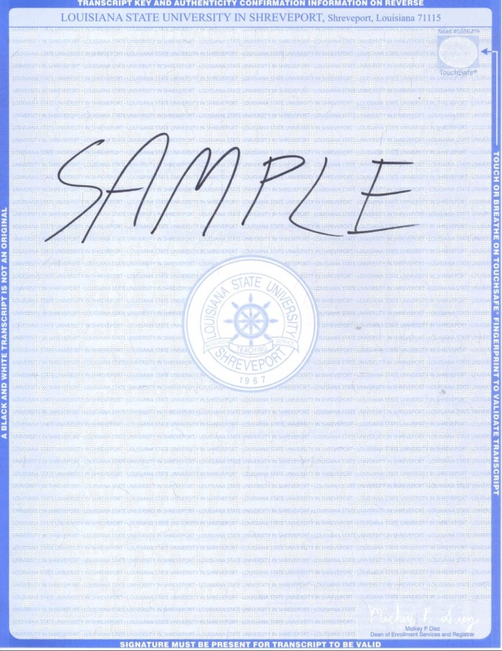

SAMPLE OF TRANSCRIPT
(BACK) #11B

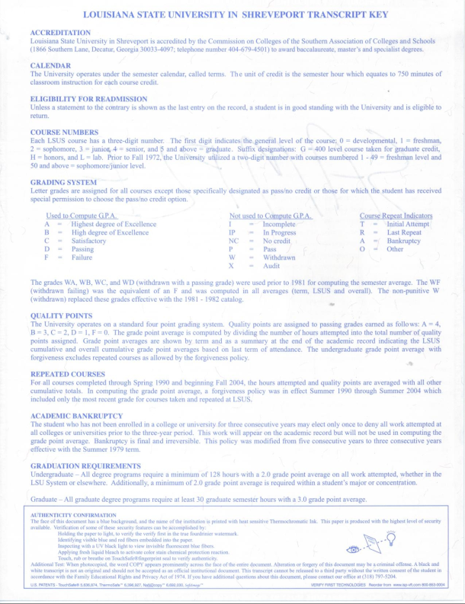

SAMPLE OF Academic Certification
#11C

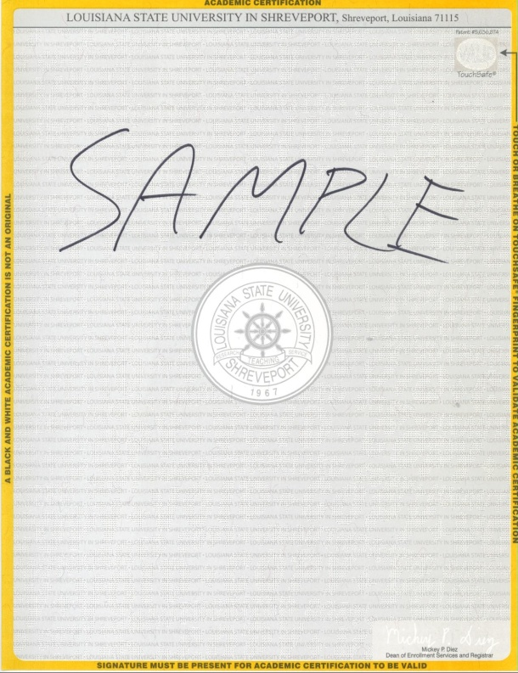

ITEM NO. DESCRIPTION QTY UNIT PRICE TOTAL PRICE

- Mini Overview Book, per the following: 4 ,000 est $___________ $____________
- 25" x 3.75" Paper
- 100# Gloss Cover
- 4cp/4cp, Score, Perf, Fold to 8.375" x 3.75"
- LSUS provided Mailing List & Postage
- LSUS provided Art

Signs shown below are general specifications for signs LSUS may order during the term of the bid.

- Signs, per the following:
- Size: 24" x 24"
- White Anti-Static Corrugated plastic
- Approximately 4mm thickness
- Two (2) each step stakes to be included with each sign

Quote pricing for white anti-static corrugated plastic, with printing on one side of the sign for the # of colors shown:
1 color 5 est _____________ _______________
2 colors 5 est _____________ _______________
3 colors 5 est _____________ _______________
4 colors 5 est _____________ _______________

Quote pricing for white anti-static corrugated plastic, with printing on two sides of the sign for the # of colors shown:
1 color 5 est _____________ _______________
2 colors 5 est _____________ _______________
3 colors 5 est _____________ _______________
4 colors 5 est _____________ _______________

- Signs, per the following:
- Size: 12" x 24"
- White Anti-Static Corrugated plastic
- Approximately 4mm thickness
- Two (2) each step stakes to be included with each sign

Quote pricing for white anti-static corrugated plastic, with printing on one side of the sign for the # of colors shown:
1 color 5 est _____________ _______________
2 colors 5 est _____________ _______________
3 colors 5 est _____________ _______________
4 colors 5 est _____________ _______________

Quote pricing for white anti-static corrugated plastic, with printing on two sides of the sign for the # of colors shown:
1 color 5 est _____________ _______________
2 colors 5 est _____________ _______________
3 colors 5 est _____________ _______________
4 colors 5 est _____________ _______________

AWARD:
BID WILL BE AWARDED BASED ON THE TOTAL COST FOR PRINTING (AND MAILING, WHEN APPLICABLE), OF ALL FOURTEEN (14) JOBS ONE TIME EACH.

TOTAL COST FOR ALL FOURTEEN (14) JOBS (ONE TIME EACH) $_______________________

PROPOSAL FORM
(continued)

Bidder understands that the Owner reserves the right to reject any or all bids and to waive any informality in the bidding.

The bidder agrees that this bid shall be good and may not be withdrawn for a period of 30 calendar days after the scheduled closing time for receiving bids.

Respectfully submitted:

COMPANY:______________________________________________________________________

STREET ADDRESS/P.O. BOX:_______________________________________________________

CITY, STATE, ZIP CODE:___________________________________________________________

TELEPHONE:_____________________________________________________________________

FAX NUMBER:____________________________________________________________________

QUOTED BY:_____________________________________________________________________
(PRINT OR TYPE)

SIGNATURE:_____________________________________________________________________

TITLE:___________________________________________________________________________

E-MAIL ADDRESS:_________________________________________________________________

PAYMENT TERMS: ________________________________________________________________

DELIVERY:_______________________________________________________________________

DATE:__________________________________________________________________

