NOTICE TO BIDDERS

Your bid is hereby solicited for the provision of the consulting services of one (1) Responsive Web Design Developer to assist the New York State Department of Motor Vehicles in the development and implementation of a responsive design for DMV’s internet transactions, as described in further detail at Section 2.1 of the attached INVITATION FOR BID (IFB) with Specifications.

Bids must be returned no later than 2:30PM on April 19, 2013, at which time all bids will be publicly opened.

BIDDERS CHOOSING TO BID MUST COMPLETE AND SUBMIT THE FOLLOWING ITEMS WITH YOUR SEALED BID:

- Affirmation and Disclosures Concerning State Finance Law §§139-j & 139-k (Appendix C-2)
- The MacBride Fair Employment Principles Certification (Appendix-D);
- Statement of Non-Collusion in Bids to the State (Appendix-E);
- Certification of Compliance or Non-Applicability to § 5-a of the NYS Tax Law (Appendix-F);
- Vendor Responsibility Questionnaire (If not submitted online);
- Bids must be signed and submitted on the original Bid Proposal form (Appendix-B);
- Three references must be submitted with your bid (Appendix-I).
- Consultant Disclosure Legislation Form-A (Appendix-J)
- MWBE Form-1: Minority and Women-owned Business Enterprises – Equal Employment Opportunity Policy Statement (Appendix-K).

BIDDERS WHO DO NOT CHOOSE TO SUBMIT A BID IN RESPONSE TO THIS SOLICITATION SHOULD COMPLETE AND RETURN THIS PAGE ONLY.

FAILURE TO RESPOND TO THREE BID INVITATIONS MAY RESULT IN YOUR FIRM BEING REMOVED FROM OUR MAILING LIST FOR THIS SERVICE.

 |  | Please check one of the following:
(___) | 1.. | Please REMOVE our firm from your mailing list for this service. We do not provide the service solicited.
(___) | 2. | Please KEEP our firm on your mailing list for this service. We do not choose to submit a bid in response to this solicitation because: (Please state reason(s) here)  __________________________________________________________________________________
Name of Firm: _____________________________________________________________________________
Mailing Address: ____________________________________________________________________________
Telephone: (____) ________ - ____________ ext. _______ Fax: (____) ______ - __________________
Email: _____________________________________________________________________________
Signature: _________________________________ Title: _____________________________________
Date (mm/dd/yyyy): ___________________________________________________________________________

NOTICE:

New York State Finance Law, as more fully set forth herein, requires bidders and persons acting on their behalf to direct all communications concerning this procurement to the person(s) designated below (“designated contacts”). This restriction on communications will be in effect from the date of publication of the solicitation for this procurement until final approval of a contract by the Office of State Comptroller (the “restricted period”).

INVITATION FOR BID

The New York State Department of Motor Vehicles (referred to herein as “the Department” or “DMV”) is redesigning its internet transactions to make the content and layout responsive to the various computing devices used by DMV’s customers (e.g., computer, tablet, Smartphone). DMV is requesting bids for the provision of consulting services of one (1) Responsive Web Design Developer to assist DMV in the development and implementation of a responsive design for DMV’s internet transactions that permit use via such computing devices.

Bid Opening Date: 4/19/13, 2013
Time: 2:30 PM
Place: Albany, New York
Issuing Office: Procurement Services
Agency: New York State Department of Motor Vehicles
Address: Swan Street Building, Room 528B
Empire State Plaza
Albany, New York 12228
Attention: Micheleen Gregware
Telephone Number: (518) 474-5289

SECTION 1: GENERAL INFORMATION

1.1 Schedule of Pertinent Dates:
- Publication of IFB 3/21/12
- Deadline for Receipt of Written Questions 4/4/13 @ 3:00 PM (EST
- Questions Answered On or Before 4/12/13
- Deadline for Bid Submission & Bid Opening 4/19/12 @2:30PM (EST)
- Announcement of Successful Bidder (estimated) 4/26/12
- Contract Execution by OSC (estimated) 6/1/13

1.2 Questions regarding this IFB:
Bidders are encouraged to submit questions if they require clarification of any portion of this IFB. All questions regarding this IFB must be submitted in writing, by mail, carrier, fax, or email, no later than 3:00 PM, EST, on April 4, 2013.

April 12, 2013, DMV will publish a written response to every timely received question posed by bidders.

All questions must be submitted to:

Micheleen Gregware
New York State Department of Motor Vehicles
6 Empire State Plaza, Room 528B
Albany, NY 12228
Phone: (518) 474-5289; FAX (518) 486-4541
Email: Micheleen.Gregware@dmv.ny.gov

DMV does not automatically provide confirmation of receipt of bids. Bidders who require confirmation of receipt must contact the above.

In response to bidders’ questions, DMV may revise this IFB by formal amendment, at any time prior to the deadline for submission of bids. DMV will provide copies of any amendments to this IFB to all bidders who request or download the IFB. This IFB may only be amended by DMV.

1.3 Bid Submission:
Bids must be signed and submitted on the original Bid Proposal form (Appendix-B). Bids will not be considered if received at a later date or time, subject to the potential exception described in the section entitled, “Rejection of Bids”, below.

The Department will not accept bids sent by facsimile or electronic transmission.

Bids may be sent by regular mail, or via overnight delivery, or may be delivered in person to the above-indicated address, marked to the attention of Micheleen Gregware, Procurement Services. The outside packaging must be clearly marked, “Bid Enclosed for C000787”.

The Department is not responsible for any costs incurred by the Bidder in the preparation, production and delivery of a response to this IFB.

1.4 Bid Proposal Information and Pricing:
A bid proposal form is attached to this IFB (See, Appendix-B). Bidders must provide an hourly rate price for the proposed consultant. DMV will not pay for consultant travel or living expenses. Price must be net and shall be submitted exclusive of Federal, State and local taxes. The bid price shall remain valid for the term of the Contract awarded from this solicitation. Please provide one original and one copy of your bid.

1.5 Bid Amendment/Withdrawal:
A bid may be amended or withdrawn prior to the bid opening. A bidder who wishes to amend or withdraw its bid, must submit the amended bid or bid withdrawal in an envelope which is clearly marked on the outside, “Amended Bid for IFB #C000787”, or “Bid Withdrawal for IFB #C000787”, as appropriate. Any such amendment or withdrawal must contain the signature of a company representative who is duly authorized to amend or withdraw such bid on behalf of the Bidder (preferably the individual who signed the original bid).

Faxed or e-mailed amended bids or bid withdrawals will not be accepted. Amended bids and bid withdrawals may be sent by regular mail, or via overnight delivery, or delivered in person to the attention of Micheleen Gregware, Procurement Services, at the address indicated in Section 1.2 of this IFB.

Amendments received after the bid opening date and time will be considered late and will be subject to the conditions outlined in “Rejection of Bids”, below. Bid withdrawals received after the bid opening date and time will be considered late and therefore invalid, null and void, and of no effect.

Unless properly withdrawn as specified herein, all bids submitted in response to this IFB will remain binding upon bidders for a period of ninety (90) days after the bid opening date.

1.6 Rejection of Bids:
The Department reserves the right to reject any or all bids, in whole or in part, and to waive technicalities, irregularities, and omissions if, in its sole judgment, such action will be in the best interest of the State. In the event that there are no satisfactory bids, which fully comply with the bid specifications, the Department reserves the right to consider late or non-conforming bids. The Department reserves the right to only award the Contract to a responsible bidder that is considered qualified pursuant to the terms and conditions of this proposal. The Department reserves the right to determine, in its sole discretion, whether or not a bidder is deemed responsible and responsive. Neither the Department nor the State of New York shall be liable for any costs incurred by bidders in preparation for, or prior to approval of, an executed contract.

1.7 Signatures:
Bids must be signed by an individual who is duly authorized to bind the Bidder to the terms of the Bid. Upon tentative award of a Contract to a successful bidder, DMV will notify all bidders in writing of such tentative contract award. Such tentatively awarded Contract will be subject to final approval and execution by the Offices of the NYS Attorney General and State Comptroller.

1.8 Conflict of Terms:
The Contract shall incorporate the terms of the following documents. Any conflicts between the terms contained in the main body of the Contract and the terms of such other documents shall be resolved in the following order of precedence, with Appendix-A being highest in order of priority:

- Appendix-A (“Standard Clauses for New York State Contracts”);
- Contract;
- This Invitation for Bid (IFB), dated March 21, 2012, including Appendices-B, C, D, E, F, G, H, I, J, K and L (except Appendix-A), and any amendments of this IFB;
- Contractor’s Bid in response to the IFB.

1.9 Designated Contact Person(s):
Micheleen Gregware is the issuing officer for this procurement. Ms. Gregware, and her alternate, Maureen Younkin are the persons (“designated contacts”) designated to communicate with bidders on behalf of the Department for all matters relating to this IFB.

All proposals and accompanying documentation must be packaged, sealed and submitted to:

Micheleen Gregware |  | Maureen Younkin
Procurement Services |  | Procurement Services
NYS Department of Motor Vehicles | Or her alternate: | NYS Department of Motor Vehicles
6 Empire State Plaza, Room 528B |  | 6 Empire State Plaza, Room 528B
Albany, NY 12228 |  | Albany, NY 12228
(518) 474-5289 (Phone) |  | (518) 474-5289 (Phone)
(518) 486-4541 (Fax)  Micheleen.Gregware@dmv.ny.gov |  | (518) 486-4541 (Fax)  Contracts@dmv.ny.gov

1.10 Contract Award:
The Contract will be awarded to the Bidder that provides the lowest bid, has adhered to the submission requirements, and is considered qualified by the Department to meet the requirements of this Invitation for Bid. Upon full execution of the Contract, such bidder shall thereafter be referred to as the “Contractor”.

The Department will send written notice to all bidders notifying them of an award of a contract. If a bidder has been deemed “non-responsive” and/or “not responsible” (as defined by State Finance Law, Section 163(9)(f)) in the process of determining an award, such bidder will receive, as part of their written notice, the reason(s) why its bid was so deemed.

In the event of a tie, the determining factors for contract award will be the following, in descending order of importance:
- Past Experience
- Interview; and
- References.

1.11 Term:
The term of the Contract arising from this IFB will be for a period of two (2) years, subject to final approval and execution by the NYS Offices of the Attorney General (AG) and the Office of the State Comptroller (OSC).

1.12 Request for Debriefing:
Notice of contract award will be provided to all bidders who submit a bid/proposal in response to this solicitation. Such notice will be provided to bidders by email with hard copy to follow.

In accordance with State Finance Law, Section 163(9)(c), as amended by Section 3 of Chapter 137 of the Laws of 2008, DMV will, upon request, provide a debriefing to any bidder that submitted a bid/proposal in response to this solicitation and was not selected for an award of contract.

Debriefings are intended to assist the unsuccessful bidder in becoming a more viable competitor for the provision of goods and services to the State of New York. To fulfill that objective, the scope of debriefings will be limited to the following:
- the strengths and weaknesses of the bidder’s bid/proposal;
- the provision of information concerning the ranking of the bidder’s bid/proposal in each of the major evaluation categories described in the solicitation document;
- ranking of the bidder’s bid/proposal in both the technical and cost components of the evaluation; and
- identification of any areas in the bid/proposal which DMV found to be deficient.

Debriefings will also address the method employed by the Bid Evaluation team for numerically scoring of the bidder’s bid/proposal. However DMV will not discuss information concerning competitors’ bids/proposals. Such information may be obtained subject to New York “Freedom of Information Law” (FOIL) (Public Officers Law § 89), by filing a request with DMV’s FOIL office.

In the event that any entity provides an unsatisfactory reference for the bidder, DMV will disclose the nature of the unsatisfactory reference but will not identify the entity.

Bidders must submit a written request for debriefing to DMV’s Procurement Services unit within forty-five (45) days from notice of contract award.

1.13 Protest of Contract Award:
After DMV has awarded the contract to a successful bidder, an interested party* may file an initial protest of contract award with the New York State Office of State Comptroller (OSC) in conformance with OSC’s “Contract Award Protest Procedure For Contract Awards Subject to The Comptroller’s Approval”. A copy of such procedure may be obtained from DMV, upon request, or may be obtained directly from OSC’s website at: http://www.osc.state.ny.us/agencies/gbull/attachments/contractawardprotestprocedure.pdf

Such protest must be made in writing, within ten (10) days from notice of contract award; and an initial protest may be made where the facts that give rise to the protest are not known to, and could not have been reasonably known to, an interested party.

If the interested party is not provided with notice of the contract award, the interested party may file a protest with OSC at any time after contract award and prior to OSC’s approval of the Contract.

The protest to the OSC Bureau of Contracts must contain specific factual and/or legal allegations setting forth the basis upon which the protesting party challenges the contract award by DMV. The protest must be filed with OSC at the following address:

Charlotte Breeyear, Director
Bureau of Contracts
New York State Office of the State Comptroller
110 State Street, 11th Floor
Albany, NY 12236

The protesting party must simultaneously deliver a copy of the protest to DMV and the successful bidder, if the protesting party does know the identity of the successful bidder, and must attach to its protest an affirmation in writing as to such delivery. If the protesting party does not know the identity of the successful bidder, the protesting party shall so state in its affirmation and the OSC Bureau of Contracts shall provide the successful bidder with a copy of the protest. Any filing deadlines may be waived by the OSC Bureau of Contracts in its sole discretion.

*An “interested party” means a participant in the procurement process, and those whose participation in the procurement process has been foreclosed by the actions of DMV.

SECTION 2: CONSULTING SERVICES SPECIFICATIONS

Contractor must strictly comply will all specifications contained herein, or as may be revised by formal amendment of this IFB. The Contractor consulting firm shall remain primarily responsible for the work of the consultant assigned by it to this project. In the event that an assigned consultant is at any time deemed to be unsuitable by DMV, the Contractor will promptly provide an alternate consultant to provide the services required hereunder.
The Contractor must ensure that the Responsive Web Design Developer assigned to this project is available to provide services to DMV eight (8) hours per day, during DMV’s regular office hours, Mondays through Fridays, excluding New York State and Federal holidays. Therefore, DMV anticipates the annual estimated number of hours to be worked by the consultant chosen to fill this position to be approximately 2080 hours per year.

2.1 Scope of Work:
DMV is redesigning its internet transactions to make the content and layout responsive to the various computing devices used by DMV’s customers (e.g., computer, tablet, Smartphone). Contractor must assist DMV in meeting its business goals for the redesign of its internet transactions.

DMV’s business goals for the redesign include the following:
- increasing the percentage of DMV transactions completed online vs. by other service channels;
- increasing the percentage of DMV’s customer service inquiries completed online vs. by other service channels;
- improving DMV customers’ navigation to information, transactions and services;
- increasing DMV’s ability to provide personalized self-service for DMV’s customers, including personalized search, content, and services, based on the customer’s needs;
- improving customer satisfaction with use of DMV’s website;
- improving the efficiency of maintaining and enhancing the website by DMV; and
- improving DMV’s ability to obtain customer feedback, and the ability to measure how customers use the website.

The consulting services provided hereunder will include, but may not be limited to, the following:
- Advise DMV on the technical capabilities, opportunities and limitations of the intended platform;
- develop and execute engaging and interactive user interface templates, using a Cascading Style Sheet (CSS), that are scalable, efficient and responsive across a variety of desktop, tablet and mobile environments, based on interface user design best-practices and DMV’s requirements;
- execute page layouts in HTML/Cold Fusion, social or mobile platform using standards-based front-end web technologies;
- collaborate with back-end developers to seamlessly integrate elements of front and back-end development;
- collaborate with back-end developers to integrate front-end designs with back-end functionality;
- help design and execute plans for testing transactions on multiple user platforms (e.g., computer, mobile, etc).
2.2 Professional Experience Mandatory Requirements:
The proposed Responsive Web Design Developer must meet all of the following experience and professional requirements:
- A minimum of four (4) years of Adobe ColdFusion, version 7+ experience.
- A minimum of four (4) years of JavaScript, JQuery, AJAX experience and an understanding of custom JavaScript development.
- A minimum of four (4) years of experience writing standards-based HTML/CSS, including a minimum of eighteen (18) months of experience with HTML5/CSS3.
- A minimum of three (3) years of experience with user experience design and information architecture.
- A minimum of three (3) years of experience with Mobile web transaction and application development.
- A minimum of three (3) years of experience with cross-browser compatibility issues and degradation strategies.
- A minimum of One and a half (1.5) years of experience with developing and implementing responsive designs into web transactions and applications.
- A minimum of two (2) years of experience with semantic markup, for maximizing search engine optimization (SEO).
- A minimum of two (2) years of VB .NET 3.0 Framework experience.
- A minimum of two (2) years of experience which demonstrates an understanding of web accessibility standards.
- TA minimum of two (2) years of experience with Microsoft Office suite products including, but not limited to, Visio, Excel, and Word.

2.3 Non-Technical Mandatory Requirements:
The proposed Responsive Web Design Developer must meet the following mandatory requirements:
- Good oral and written communication skills.
- Demonstrated ability to work with others in a fast-paced flexible team environment.
- Familiarity with, and basic understanding of, state government procedures.

2.4 Resume and References:
Firms must submit with their bid a resume for each proposed consultant which clearly indicates the professional experience requirements stated above. For each consultant, references will be contacted to confirm information provided in their resume. References must be physically located within the Continental United States and/or Canada and must be able to attest to the fact that the proposed consultant possesses the skills and experience required to meet the professional experience requirements stated above. In the event that references are unable to confirm that the consultant satisfies these requirements, that consultant will be disqualified by DMV.

2.5 Interview:
DMV will conduct mandatory personal interviews of proposed Responsive Web Design Developers at DMV’s Central Office in Albany, New York. The personal interview will be used to verify the proposed consultants’ technical expertise, information skills, experience, inter-personal and communication skills. DMV reserves the right, and sole discretion, to disqualify proposed consultants it determines to be unqualified.

SECTION 3: ADDITIONAL TERMS

3.1 Telephone Accessibility:
In the event that the Department calls the Contractor to report a problem, the Contractor must provide a responsible individual who is authorized by the Contractor to return the call and take any action required to respond to the problem. Contractor must respond to the Department’s call during the DMV office’s regular business hours, and no later than the close of business on the first business day following DMV’s call. Throughout the term of the Contract, such individual must be available to receive calls and/or respond to messages left on voicemail from 8:30 AM until 4:30 PM, Monday through Friday, exclusive of state holidays.

3.2 Cure & Cover:
In the event that that the Contractor’s performance fails to conform to the terms of the Contract, the Department will provide Contractor with reasonable notice of such non-conformance, and will permit Contractor to cure such defective performance within the time prescribed in the Contract, or within any extension of such time which is expressly granted by DMV in its sole discretion. If Contractor fails to timely cure its defective performance, then the Department shall have the option to terminate the contract for Contractor’s breach; and DMV reserves the right to thereafter obtain substitute performance (cover) from another vendor. In such event, Contractor shall reimburse the Department for any additional costs incurred to obtain substitute performance from another provider.

The Department reserves the right to collect such costs by adjusting invoices, and by any other means available by law.

3.3 Employees of Contractor:
The Contractor must certify that its employees performing services under the Contract are employable in accordance with all applicable New York State and federal laws. In the event that Contractor fails to so comply at any time during the term of the Contract, the Department reserves the right to immediately terminate the Contract without incurring any liability for breach thereof.

Contractor agrees, during the term of the Contract to maintain at Contractor’s expense, all necessary insurance for its employees, including but not limited to, worker’s compensation, disability and unemployment insurance and to provide the State with certification of such insurance upon request. The Contractor will be responsible for all applicable Federal, State and local taxes and all FICA contributions.

It is understood and agreed that the legal status of the employees is that of an employee of Contractor and in no manner will they be deemed employees of the State of New York and, therefore, are not entitled to any of the benefits associated with such employment.

3.4 Independent Contractor:
It is understood and agreed that the legal status of the Contractor, its agents, officers and employees under the Contract shall be that of an independent Contractor, and in no manner shall they be deemed employees of the DMV or State of New York, and therefore are not entitled to any of the benefits associated with such employment. The Contractor agrees, during the term of the Contract, to maintain at Contractor’s expense those benefits to which its employees would otherwise be entitled by law, including health benefits, and all necessary insurance for its employees, including worker’s compensation, disability and unemployment insurance, and to provide the DMV or OSC with certification of such insurance upon request. The Contractor remains responsible for all applicable federal, state and local taxes, and all FICA contributions.

3.5 Subcontracting:
Contractor shall not use subcontractors in the performance of its obligations under the Contract, without written prior approval by DMV. A subcontractor is any individual or legal entity who had entered into a contract, express or implied, for the performance of a portion of a Contract with a Contractor. The Contractor's use of subcontractors shall not diminish Contractor's primary responsibility for performing its obligations in accordance with the terms of the Contract. The Contractor shall be primarily responsible for the performance of its subcontractors, including controlling, coordinating, and assuming liability for the work of its subcontractors.

All subcontractors employed by the Contractor in the performance of its obligations hereunder must also comply with the applicable provisions of federal and New York State laws, rules and regulations, and must meet the same criteria as if they were the primary Contractor. The Contractor shall provide DMV with copies of contracts with its subcontractors employed for the purpose of this Contract. The Contractor shall notify DMV if it intends to use any subcontractor. DMV reserves the right to disqualify subcontractors who are unfit to perform state contracts. Contractor is responsible for informing subcontractors of all terms, conditions and requirements of the Contract.

3.6 Amendment:
The Contract may only be amended in writing by the Parties to the Contract, and subject to approval by the Offices of the New York State Attorney General and State Comptroller.

3.7 Contractor Indemnification and Liability:
Contractor’s obligation of indemnification and holding harmless specified hereunder shall survive the expiration of the Contract by termination or otherwise.

A. Personal Injury, Property Damage, Wrongful Death, Violation of Intellectual Property Rights: Contractor shall indemnify, keep and hold harmless the State of New York, its agents, officials and employees, from any and all claims for injury or damage to person or property, deaths, losses, damages, suits arising out of the service to be performed under the Contract, including negligence, active or passive, or wrongful or improper conduct of the Contractor, its officers, employees, agents, or sub-contractors, including infringement of any third-party’s patents or copyrights. Contractor shall remain liable, without monetary limitation, for direct, actual damages for personal injury, death or damage to real property or tangible personal property, and intellectual property attributable to the negligence or other tort of Contractor, its officers, employees or agents. The Contractor will also indemnify and hold the DMV harmless from and against any and all damages, expenses (including reasonable attorneys' fees), claims, judgments, liabilities and costs that may be finally assessed against the DMV in any action for infringement of a United States Letter Patent, or of any copyright, trademark, trade secret or other third party proprietary right except to the extent such claims arise from the DMV’s gross negligence or willful misconduct, provided that the State shall give Contractor: (i) prompt written notice of any action, claim or threat of infringement suit, or other suit, (ii) the opportunity to take over, settle or defend such action, claim or suit at Contractor's sole expense, and (iii) assistance in the defense of any such action at the expense of Contractor.

If usage shall be enjoined for any reason or if Contractor believes that it may be enjoined, Contractor shall have the right, at its own expense and sole discretion to take action in the following order of precedence: (i) to procure for the DMV the right to continue Usage (ii) to modify the service or Product so that Usage becomes non-infringing, and is of at least equal quality and performance; or (iii) to replace said service or Product or part(s) thereof, as applicable, with non-infringing service or Product of at least equal quality and performance. If the above remedies are not available, the parties shall terminate the Contract, in whole or in part as necessary and applicable, provided the DMV is given a refund for any amounts paid for the period during which Usage was not feasible.

The acceptance or approval by the Department of any order or procedure, method, structure or equipment submitted or employed by Contractor shall not in any manner relieve Contractor of any liability pertaining Contractor’s negligence in performing such order or procedure, method, structure or providing equipment; provided, however, that if Contractor acts in strict accordance with a specific requirement, specification, instruction, order, mandate (or the like) from the Department, with respect thereto Contractor shall not have an indemnification obligation hereunder.

B. Driver’s Privacy Protection Act & New York State Information Security Breach and Notification Act: By signing the Contract, the Contractor acknowledges that all DMV records containing personal information, as well as DMV-related processing information, is confidential and is the property of the Department and the State of New York, and should such information be used improperly, or become compromised the Contractor may be held liable for violating the federal Driver’s Privacy Protection Act of 1994 (DPPA) (18 U.S.C. §2721, et seq.), and the New York State Information Security Breach and Notification Act (ISBNA) (General Business Law, §899-aa; State Technology Law, §208), and may be required to indemnify DMV for any such violation.

Contractor must report suspected or confirmed violations of the DPPA or ISBNA to the DMV Information Security Office, within one (1) business day of discovering any such violation:
- by email: InformationSecurity@dmv.ny.gov
- or by telephone: (518) 402-2676

- DPPA. A person who knowingly violates the DPPA shall be subject to criminal fines and liability for civil remedies. Contractor shall indemnify and hold harmless New York State, its employees and agents, from and against any claims, demands, loss, damage or expense related solely to a knowing violation of the DPPA committed by Contractor, its employees, officers, agents or sub-contractors. Contractor shall indemnify the Department and the State of New York even if Contractor did not have knowledge of such violation of the DPPA by its officers, employees, agents, or sub-contractors at the time such violation occurred.

- ISBNA. Contractor shall be responsible for complying with the provisions of the ISBNA with respect to any private information (as defined in the ISBNA) received by Contractor its officers, employees, agents, or sub-contractors. In the event of a breach of security, Contractor shall immediately commence an investigation, in cooperation with DMV, to determine the scope of the breach, and Contractor shall assist DMV in restoring the security of the related system in order to prevent any further breaches. Contractor shall notify DMV of any breach of security immediately following discovery of such breach.

Under the ISBNA, DMV is required to notify any individuals whose records have been accessed for unauthorized purposes from a system maintained by DMV.

In furtherance of the investigation of any breach of the ISBNA, the Contractor must receive written authorization from DMV prior to providing notice of such breach to any other entity. Contractor shall be responsible for all costs associated with providing notices required under the ISBNA. The Contract shall not impair the authority of the New York State Office of the Attorney General (OAG) to bring an action against Contractor to enforce the provisions of the ISBNA, or limit Contractor’s liability for any violations of the ISBNA. Additional information concerning the ISBNA and the notification process is available at: http://www.cscic.state.ny.us/security/securitybreach.

3.8 Savings/Force Majeure:
A force majeure occurrence is an event or effect that cannot be reasonably anticipated or controlled. Force majeure includes, but is not limited to, acts of nature, acts of war, acts of public enemies, strikes, fires, explosions, actions of the elements, floods, or other similar causes beyond the control of the Contractor or the DMV in the performance of the Contract which non-performance, by exercise of reasonable diligence, cannot be prevented. Contractor shall provide the Commissioner with written notice of any force majeure occurrence as soon as the delay is known.

Neither the Contractor nor the DMV shall be liable to the other for any delay in or failure of performance under the Contract due to a force majeure occurrence. Any such delay in or failure of performance shall not constitute default or give rise to any liability for damages. The existence of such causes of such delay or failure shall extend the period for performance to such extent as determined by the Contractor and the Commissioner to be necessary to enable complete performance by the Contractor if reasonable diligence is exercised after the cause of delay or failure has been removed.

Notwithstanding the above, at the discretion of the Commissioner where the delay or failure will significantly impair the value of the Contract to the State, the Commissioner may:

- Accept allocated performance or deliveries from the Contractor. The Contractor, however, hereby agrees to grant preferential treatment to DMV with respect to Product subjected to allocation; and/or

- Purchase from other sources (without recourse to and by the Contractor for the costs and expenses thereof) to replace all or part of the Products which are the subject of the delay, which purchases may be deducted from the Contract quantities without penalty or liability to the State; or

- Terminate the Contract or the portion thereof which is subject to delays, and thereby discharge any unexecuted portion of the Contract or the relative part thereof.

In addition, the Commissioner reserves the right, in his/her sole discretion, to make an equitable adjustment in the Contract terms and/or pricing should extreme and unforeseen volatility in the marketplace affect pricing or the availability of supply. "Extreme and unforeseen volatility in the marketplace" is defined as market circumstances which meet the following criteria: (i) the volatility is due to causes outside the control of Contractor; (ii) the volatility affects the marketplace or industry, not just the particular Contract source of supply; (iii) the effect on pricing or availability of supply is substantial; and (iv) the volatility so affects Contractor's performance that continued performance of the Contract would result in a substantial loss.

3.9 Severability:
Should any one or more terms of the Contract be determined by a court of competent jurisdiction to be illegal or unenforceable, then such term(s) shall be conformed as required to so comply. If the term(s) is of such a nature that it cannot be amended without altering the purpose or nature of the Contract, then such term(s) shall be deleted from the Contract as if never included therein, and the remaining terms of the Contract shall remain in full force and effect, unless the deletion of the term(s) renders the Contract unenforceable or frustrates the purpose or intent of the Contract. In which case, the Contract shall be terminable by mutual consent of the Parties. If an ambiguity or question of intent arises, this Agreement will be construed as if drafted jointly by the Parties and no presumption or burden of proof will arise favoring or disfavoring either Party by virtue of authorship of any of the provisions of this Agreement.

3.10 Termination:
- For Cause: The Commissioner may terminate the Contract, upon written notice to the Contractor, in the event that any material breach thereof remains uncured for more than thirty (30) days, or any other period specified by DMV. Such termination for cause shall be at the Contractor’s expense in the event that the Contractor is incapable of performing its contractual obligations or meeting any requirements or qualifications set forth in the Contract, or for non-performance, or upon a determination that the Contractor is non-responsible or non-responsive. Such termination shall be upon written notice to the Contractor. In such event, the Commissioner may complete the contractual requirements in any manner it deems advisable, and DMV may avail itself of all remedies provided by law.

  - For Convenience: The Contract may be terminated by DMV for convenience, at any time, upon thirty (30) days written notice (or other period specified) to the Contractor, without incurring any liability for breach of contract, or liability for payment of any charges beyond payment for conforming goods and/or services accepted by DMV up to and including the date of termination. Contractor shall use due diligence, and shall provide any outstanding deliverables up to the date in which such termination shall be effective.

  - For Violation of the Sections 139-j and 139-k of the State Finance Law: The Commissioner reserves the right to terminate the Contract in the event it is found that the certification filed by the Contractor in accordance with Section 139-k of the State Finance Law was intentionally false or intentionally incomplete. Upon such finding, the Commissioner may exercise its termination right by providing written notification to the Contractor in accordance with the written notification terms of the Contract.

  - Termination without prior Notice in the Event of a Security Breach: Notwithstanding the foregoing, DMV reserves the right to immediately terminate this Contract in the best interests of the State, without providing prior notice of termination to Contractor, in the event the Commissioner determines that a breach of security occurred or that a breach is imminent. In such event, DMV shall provide Contractor with written notice of cancellation within a reasonable time. However, termination of this Agreement will not affect Recipient’s liability for breach of the terms hereof.

3.11 Appendix-A, “Standard Clauses for New York State Contracts:
The Contractor must comply with and is bound by the provisions of Appendix-A hereof.

3.12 Appendix–L, “Standard Security Clauses for Sharing Data with External Entities:
Contractor shall comply with the applicable provisions of Appendix-L hereof.

3.13 Summary of Policy and Prohibitions on Procurement Lobbying:
Pursuant to State Finance Law §§139-j and 139-k, this solicitation includes and imposes certain restrictions on communications between a Governmental Entity and an Offerer/bidder during the procurement process. An Offerer/bidder is restricted from making contacts from the earliest notice of intent to solicit offers through final award and approval of the Procurement Contract by the DMV, if applicable, Office of the State Comptroller (“restricted period”) to other than designated staff unless it is a contact that is included among certain statutory exceptions set forth in State Finance Law §139-j(3)(a).

DMV employees are also required to obtain certain information when contacted during the restricted period and make a determination of the responsibility of the Offerer/bidder pursuant to these two statutes. Certain findings of non-responsibility can result in rejection for contract award and in the event of two findings within a 4 year period, the Offerer/bidder is debarred from obtaining governmental Procurement Contracts.

Further information about these requirements can be found on the Office of General Services Website at: http://ogs.ny.gov/aboutOgs/regulations/defaultAdvisoryCouncil.html.

The Department’s Policy and Procedures with respect to Procurement Lobbying Law is attached as Appendix C-1. The Contract or is required to complete and submit Appendix C-2 with the signed Contract.

3.14 MacBride Fair Employment Principles:
In accordance with the New York State Finance Law, the attached MacBride Fair Employment Principles Certification (Appendix-D) must be completed and must accompany the bid.

3.15 Statement of Non-Collusion:

In accordance with the New York State Finance Law, the attached Non-Collusive Bidding certification (Appendix-E) must be completed and must accompany the bid.

3.16 Part N of Chapter 60 of the Laws Of 2004:
Every bidder must complete and submit Appendix-F, “Certification of Compliance or Non-applicability to § 5-a of the NYS Tax Law”. Please note that this form requires notarization of the signatory.

3.17 Compliance with Laws:

In performing its obligations under the Contract, the Contractor shall comply with all applicable federal, state, and local statutes, ordinances, regulations, and rules, including, but not limited to, NYS printing law, laws regulating the terms and conditions of employment, building and fire codes, zoning laws, privacy, public building requirements for use by the handicapped, and occupational safety and health rules.

3.18 Contractor Certification:
Contractors are required to complete and sign, under penalty of perjury, the “Contractor Certification Form”, ST-220-TD (Appendix-H), in accordance with § 5-a of the NYS Tax Law. Contractors must also submit a copy of the Certificate of Authority, if available, for itself, any affiliates, any subcontractors and any affiliates of subcontractors required to register to collect state sales and compensating use tax.

Pursuant to Tax Law Section 5-a, Contractors are required to complete and sign, under penalty of perjury, the Contractor Certification Form ST-220-CA (Appendix-G) at time of contract execution.

Tax Law Section 5-a applies to all Agreements valued in excess of $100,000 for the sale of goods or services as defined in Article XI of the State Finance Law, and/or tangible personal property or taxable services as defined by the Tax Law.

The Department of Motor Vehicles is not authorized to address questions regarding the Tax Law or its interpretation. Any questions regarding the Law must be directed to the New York State Department of Taxation and Finance.

A COMPLETED ST-220-CA MUST ACCOMPANY THE CONTRACT. IF REQUIRED, THE CONTRACTOR IS RESPONSIBLE FOR FILING THE ST-220-TD WITH THE NYS DEPARTMENT OF TAXATION & FINANCE.

3.19 Policy Statement on Women and Minority-Owned Business Development:

It is the policy of the State of New York to promote equality of economic opportunity for minority and women-owned business enterprises (M/WBEs) in State contracting. In order to comply with the State’s objectives, the Contractor must use “good faith efforts” to provide meaningful participation by M/WBE subcontractors or suppliers in the performance of this contract. Contractor must comply with the provisions of Appendix-K hereof, entitled “Contractor Requirements and Procedures for Business Participation Opportunities for New York State Certified Minority- and Women-Owned Business Enterprises, and Equal Employment Opportunities for Minority Group Members and Women”, and must submit the attached “M/WBE Form-1”, upon contract execution.

3.20 Iran Divestment Act:
As a result of the Iran Divestment Act of 2012 (Act), Chapter 1 of the 2012 Laws of New York, a new provision has been added to the State Finance Law (SFL), § 165-a, effective April 12, 2012. Under the Act, the Commissioner of the Office of General Services (OGS) will be developing a list (prohibited entities list) of “persons” who are engaged in “investment activities in Iran” (both are defined terms in the law). Pursuant to SFL § 165-a(3)(b), the initial list is expected to be issued no later than 120 days after the Act’s effective date, at which time it will be posted on the OGS website.

By submitting a bid in response to this solicitation or by assuming the responsibility of a Contract awarded hereunder, Bidder/Contractor (or any assignee) certifies that once the prohibited entities list is posted on the OGS website, it will not utilize on such Contract any subcontractor that is identified on the prohibited entities list.

Additionally, Bidder/Contractor is advised that once the list is posted on the OGS website, any Contractor seeking to renew or extend a Contract or assume the responsibility of a Contract awarded in response to the solicitation, must certify at the time the Contract is renewed, extended or assigned that it is not included on the prohibited entities list.

During the term of the Contract, should DMV receive information that a person is in violation of the above-referenced certification, DMV will offer the person an opportunity to respond. If the person fails to demonstrate that it has ceased its engagement in the investment which is in violation of the Act within 90 days after the determination of such violation, then DMV shall take such action as may be appropriate including, but not limited to, imposing sanctions, seeking compliance, recovering damages, or declaring the Contractor in default.

DMV reserves the right to reject any bid or request for assignment for an entity that appears on the prohibited entities list prior to the award of a contract, and to pursue a responsibility review with respect to any entity that is awarded a contract and appears on the prohibited entities list after contract award.

3.21 Vendor Responsibility:
Contractors are invited to file the required Vendor Responsibility Questionnaire online via the New York State VendRep System or may choose to complete and submit a paper questionnaire. To enroll in and use the New York State VendRep System, see the VendRep System Instructions available at www.osc.state.ny.us/vendrep or go directly to the VendRep System online at https://portal.osc.state.ny.us. For direct VendRep System user assistance, the OSC Help Desk may be reached at 866-370-4672 or 518-408-4672 or by email at helpdesk@osc.state.ny.us. Bidders opting to file a paper questionnaire can obtain the appropriate questionnaire from the VendRep website www.osc.state.ny.us/vendrep or may contact the DMV or the Office of the State Comptroller for a copy of the paper form.

DMV reserves the right to verify all information provided by the Contractor to whom an award of contract is made. DMV reserves the right to disqualify any contractor as “not responsible”, in the event that the Contractor has intentionally provided false or incomplete information, or has intentionally failed to disclose pertinent information. DMV reserves the right to make further responsibility determinations at any time during the term of the Contract; and DMV will not award a contract to any contractor without evaluating that Contractor’s Vendor Responsibility Questionnaire.

3.22 Jurisdiction:
All controversies concerning the Contract must be resolved by a court of competent jurisdiction in New York State.

APPENDIX-A: STANDARD CLAUSES FOR NEW YORK STATE CONTRACTS

APPENDIX A

STANDARD CLAUSES FOR NEW YORK STATE CONTRACTS

TABLE OF CONTENTS

1. Executory Clause
2. Non-Assignment Clause
3. Comptroller’s Approval
4. Workers’ Compensation Benefits
5. Non-Discrimination Requirements
6. Wage and Hours Provisions
7. Non-Collusive Bidding Certification
8. International Boycott Prohibition
9. Set-Off Rights
10. Records
11. Identifying Information and Privacy Notification
12. Equal Employment Opportunities For Minorities and Women
13. Conflicting Terms
14. Governing Law
15. Late Payment
16. No Arbitration
17. Service of Process
18. Prohibition on Purchase of Tropical Hardwoods
19. MacBride Fair Employment Principles
20. Omnibus Procurement Act of 1992
21. Reciprocity and Sanctions Provisions
22. Compliance with New York State Information Security Breach and Notification Act
23. Compliance with Consultant Disclosure Law
24. Procurement Lobbying
25. Certification of Registration to Collect Sales and Compensating Use Tax by Certain
State Contractors, Affiliates and Subcontractors

STANDARD CLAUSES FOR NYS CONTRACTS

The parties to the attached contract, license, lease, amendment or other agreement of any kind (hereinafter, "the contract" or "this contract") agree to be bound by the following clauses which are hereby made a part of the contract (the word "Contractor" herein refers to any party other than the State, whether a contractor, licenser, licensee, lessor, lessee or any other party):

1. EXECUTORY CLAUSE. In accordance with Section 41 of the State Finance Law, the State shall have no liability under this contract to the Contractor or to anyone else beyond funds appropriated and available for this contract.

2. NON-ASSIGNMENT CLAUSE. In accordance with Section 138 of the State Finance Law, this contract may not be assigned by the Contractor or its right, title or interest therein assigned, transferred, conveyed, sublet or otherwise disposed of without the State’s previous written consent, and attempts to do so are null and void. Notwithstanding the foregoing, such prior written consent of an assignment of a contract let pursuant to Article XI of the State Finance Law may be waived at the discretion of the contracting agency and with the concurrence of the State Comptroller where the original contract was subject to the State Comptroller’s approval, where the assignment is due to a reorganization, merger or consolidation of the Contractor’s business entity or enterprise. The State retains its right to approve an assignment and to require that any Contractor demonstrate its responsibility to do business with the State. The Contractor may, however, assign its right to receive payments without the State’s prior written consent unless this contract concerns Certificates of Participation pursuant to Article 5-A of the State Finance Law.

3. COMPTROLLER'S APPROVAL. In accordance with Section 112 of the State Finance Law (or, if this contract is with the State University or City University of New York, Section 355 or Section 6218 of the Education Law), if this contract exceeds $50,000 (or the minimum thresholds agreed to by the Office of the State Comptroller for certain S.U.N.Y. and C.U.N.Y. contracts), or if this is an amendment for any amount to a contract which, as so amended, exceeds said statutory amount, or if, by this contract, the State agrees to give something other than money when the value or reasonably estimated value of such consideration exceeds $10,000, it shall not be valid, effective or binding upon the State until it has been approved by the State Comptroller and filed in his office. Comptroller's approval of contracts let by the Office of General Services is required when such contracts exceed $85,000 (State Finance Law Section 163.6-a). However, such pre-approval shall not be required for any contract established as a centralized contract through the Office of General Services or for a purchase order or other transaction issued under such centralized contract.

4. WORKERS' COMPENSATION BENEFITS. In accordance with Section 142 of the State Finance Law, this contract shall be void and of no force and effect unless the Contractor shall provide and maintain coverage during the life of this contract for the benefit of such employees as are required to be covered by the provisions of the Workers' Compensation Law.

5. NON-DISCRIMINATION REQUIREMENTS. To the extent required by Article 15 of the Executive Law (also known as the Human Rights Law) and all other State and Federal statutory and constitutional non-discrimination provisions, the Contractor will not discriminate against any employee or applicant for employment because of race, creed, color, sex, national origin, sexual orientation, age, disability, genetic predisposition or carrier status, or marital status. Furthermore, in accordance with Section 220-e of the Labor Law, if this is a contract for the construction, alteration or repair of any public building or public work or for the manufacture, sale or distribution of materials, equipment or supplies, and to the extent that this contract shall be performed within the State of New York, Contractor agrees that neither it nor its subcontractors shall, by reason of race, creed, color, disability, sex, or national origin: (a) discriminate in hiring against any New York State citizen who is qualified and available to perform the work; or (b) discriminate against or intimidate any employee hired for the performance of work under this contract. If this is a building service contract as defined in Section 230 of the Labor Law, then, in accordance with Section 239 thereof, Contractor agrees that neither it nor its subcontractors shall by reason of race, creed, color, national origin, age, sex or disability: (a) discriminate in hiring against any New York State citizen who is qualified and available to perform the work; or (b) discriminate against or intimidate any employee hired for the performance of work under this contract. Contractor is subject to fines of $50.00 per person per day for any violation of Section 220-e or Section 239 as well as possible termination of this contract and forfeiture of all moneys due hereunder for a second or subsequent violation.

6. WAGE AND HOURS PROVISIONS. If this is a public work contract covered by Article 8 of the Labor Law or a building service contract covered by Article 9 thereof, neither Contractor's employees nor the employees of its subcontractors may be required or permitted to work more than the number of hours or days stated in said statutes, except as otherwise provided in the Labor Law and as set forth in prevailing wage and supplement schedules issued by the State Labor Department. Furthermore, Contractor and its subcontractors must pay at least the prevailing wage rate and pay or provide the prevailing supplements, including the premium rates for overtime pay, as determined by the State Labor Department in accordance with the Labor Law. Additionally, effective April 28, 2008, if this is a public work contract covered by Article 8 of the Labor Law, the Contractor understands and agrees that the filing of payrolls in a manner consistent with Subdivision 3-a of Section 220 of the Labor Law shall be a condition precedent to payment by the State of any State approved sums due and owing for work done upon the project.

7. NON-COLLUSIVE BIDDING CERTIFICATION. In accordance with Section 139-d of the State Finance Law, if this contract was awarded based upon the submission of bids, Contractor affirms, under penalty of perjury, that its bid was arrived at independently and without collusion aimed at restricting competition. Contractor further affirms that, at the time Contractor submitted its bid, an authorized and responsible person executed and delivered to the State a non-collusive bidding certification on Contractor's behalf.

8. INTERNATIONAL BOYCOTT PROHIBITION. In accordance with Section 220-f of the Labor Law and Section 139-h of the State Finance Law, if this contract exceeds $5,000, the Contractor agrees, as a material condition of the contract, that neither the Contractor nor any substantially owned or affiliated person, firm, partnership or corporation has participated, is participating, or shall participate in an international boycott in violation of the federal Export Administration Act of 1979 (50 USC App. Sections 2401 et seq.) or regulations thereunder. If such Contractor, or any of the aforesaid affiliates of Contractor, is convicted or is otherwise found to have violated said laws or regulations upon the final determination of the United States Commerce Department or any other appropriate agency of the United States subsequent to the contract's execution, such contract, amendment or modification thereto shall be rendered forfeit and void. The Contractor shall so notify the State Comptroller within five (5) business days of such conviction, determination or disposition of appeal (2NYCRR 105.4).

9. SET-OFF RIGHTS. The State shall have all of its common law, equitable and statutory rights of set-off. These rights shall include, but not be limited to, the State's option to withhold for the purposes of set-off any moneys due to the Contractor under this contract up to any amounts due and owing to the State with regard to this contract, any other contract with any State department or agency, including any contract for a term commencing prior to the term of this contract, plus any amounts due and owing to the State for any other reason including, without limitation, tax delinquencies, fee delinquencies or monetary penalties relative thereto. The State shall exercise its set-off rights in accordance with normal State practices including, in cases of set-off pursuant to an audit, the finalization of such audit by the State agency, its representatives, or the State Comptroller.

10. RECORDS. The Contractor shall establish and maintain complete and accurate books, records, documents, accounts and other evidence directly pertinent to performance under this contract (hereinafter, collectively, "the Records"). The Records must be kept for the balance of the calendar year in which they were made and for six (6) additional years thereafter. The State Comptroller, the Attorney General and any other person or entity authorized to conduct an examination, as well as the agency or agencies involved in this contract, shall have access to the Records during normal business hours at an office of the Contractor within the State of New York or, if no such office is available, at a mutually agreeable and reasonable venue within the State, for the term specified above for the purposes of inspection, auditing and copying. The State shall take reasonable steps to protect from public disclosure any of the Records which are exempt from disclosure under Section 87 of the Public Officers Law (the "Statute") provided that: (i) the Contractor shall timely inform an appropriate State official, in writing, that said records should not be disclosed; and (ii) said records shall be sufficiently identified; and (iii) designation of said records as exempt under the Statute is reasonable. Nothing contained herein shall diminish, or in any way adversely affect, the State's right to discovery in any pending or future litigation.

11. IDENTIFYING INFORMATION AND PRIVACY NOTIFICATION. (a) Identification Number(s). Every invoice or New York State Claim for Payment submitted to a New York State agency by a payee, for payment for the sale of goods or services or for transactions (e.g., leases, easements, licenses, etc.) related to real or personal property must include the payee's identification number. The number is any or all of the following: (i) the payee’s Federal employer identification number, (ii) the payee’s Federal social security number, and/or (iii) the payee’s Vendor Identification Number assigned by the Statewide Financial System. Failure to include such number or numbers may delay payment. Where the payee does not have such number or numbers, the payee, on its invoice or Claim for Payment, must give the reason or reasons why the payee does not have such number or numbers.

(b) Privacy Notification. (1) The authority to request the above personal information from a seller of goods or services or a lessor of real or personal property, and the authority to maintain such information, is found in Section 5 of the State Tax Law. Disclosure of this information by the seller or lessor to the State is mandatory. The principal purpose for which the information is collected is to enable the State to identify individuals, businesses and others who have been delinquent in filing tax returns or may have understated their tax liabilities and to generally identify persons affected by the taxes administered by the Commissioner of Taxation and Finance. The information will be used for tax administration purposes and for any other purpose authorized by law. (2) The personal information is requested by the purchasing unit of the agency contracting to purchase the goods or services or lease the real or personal property covered by this contract or lease. The information is maintained in the Statewide Financial System by the Vendor Management Unit within the Bureau of State Expenditures, Office of the State Comptroller, 110 State Street, Albany, New York 12236.

12. EQUAL EMPLOYMENT OPPORTUNITIES FOR MINORITIES AND WOMEN. In accordance with Section 312 of the Executive Law and 5 NYCRR 143, if this contract is: (i) a written agreement or purchase order instrument, providing for a total expenditure in excess of $25,000.00, whereby a contracting agency is committed to expend or does expend funds in return for labor, services, supplies, equipment, materials or any combination of the foregoing, to be performed for, or rendered or furnished to the contracting agency; or (ii) a written agreement in excess of $100,000.00 whereby a contracting agency is committed to expend or does expend funds for the acquisition, construction, demolition, replacement, major repair or renovation of real property and improvements thereon; or (iii) a written agreement in excess of $100,000.00 whereby the owner of a State assisted housing project is committed to expend or does expend funds for the acquisition, construction, demolition, replacement, major repair or renovation of real property and improvements thereon for such project, then the following shall apply and by signing this agreement the Contractor certifies and affirms that it is Contractor’s equal employment opportunity policy that:

(a) The Contractor will not discriminate against employees or applicants for employment because of race, creed, color, national origin, sex, age, disability or marital status, shall make and document its conscientious and active efforts to employ and utilize minority group members and women in its work force on State contracts and will undertake or continue existing programs of affirmative action to ensure that minority group members and women are afforded equal employment opportunities without discrimination. Affirmative action shall mean recruitment, employment, job assignment, promotion, upgradings, demotion, transfer, layoff, or termination and rates of pay or other forms of compensation;

(b) at the request of the contracting agency, the Contractor shall request each employment agency, labor union, or authorized representative of workers with which it has a collective bargaining or other agreement or understanding, to furnish a written statement that such employment agency, labor union or representative will not discriminate on the basis of race, creed, color, national origin, sex, age, disability or marital status and that such union or representative will affirmatively cooperate in the implementation of the Contractor's obligations herein; and

(c) the Contractor shall state, in all solicitations or advertisements for employees, that, in the performance of the State contract, all qualified applicants will be afforded equal employment opportunities without discrimination because of race, creed, color, national origin, sex, age, disability or marital status.

Contractor will include the provisions of "a", "b", and "c" above, in every subcontract over $25,000.00 for the construction, demolition, replacement, major repair, renovation, planning or design of real property and improvements thereon (the "Work") except where the Work is for the beneficial use of the Contractor. Section 312 does not apply to: (i) work, goods or services unrelated to this contract; or (ii) employment outside New York State. The State shall consider compliance by a contractor or subcontractor with the requirements of any federal law concerning equal employment opportunity which effectuates the purpose of this section. The contracting agency shall determine whether the imposition of the requirements of the provisions hereof duplicate or conflict with any such federal law and if such duplication or conflict exists, the contracting agency shall waive the applicability of Section 312 to the extent of such duplication or conflict. Contractor will comply with all duly promulgated and lawful rules and regulations of the Department of Economic Development’s Division of Minority and Women's Business Development pertaining hereto.

13. CONFLICTING TERMS. In the event of a conflict between the terms of the contract (including any and all attachments thereto and amendments thereof) and the terms of this Appendix A, the terms of this Appendix A shall control.

14. GOVERNING LAW. This contract shall be governed by the laws of the State of New York except where the Federal supremacy clause requires otherwise.

15. LATE PAYMENT. Timeliness of payment and any interest to be paid to Contractor for late payment shall be governed by Article 11-A of the State Finance Law to the extent required by law.

16. NO ARBITRATION. Disputes involving this contract, including the breach or alleged breach thereof, may not be submitted to binding arbitration (except where statutorily authorized), but must, instead, be heard in a court of competent jurisdiction of the State of New York.

17. SERVICE OF PROCESS. In addition to the methods of service allowed by the State Civil Practice Law & Rules ("CPLR"), Contractor hereby consents to service of process upon it by registered or certified mail, return receipt requested. Service hereunder shall be complete upon Contractor's actual receipt of process or upon the State's receipt of the return thereof by the United States Postal Service as refused or undeliverable. Contractor must promptly notify the State, in writing, of each and every change of address to which service of process can be made. Service by the State to the last known address shall be sufficient. Contractor will have thirty (30) calendar days after service hereunder is complete in which to respond.

18. PROHIBITION ON PURCHASE OF TROPICAL HARDWOODS. The Contractor certifies and warrants that all wood products to be used under this contract award will be in accordance with, but not limited to, the specifications and provisions of Section 165 of the State Finance Law, (Use of Tropical Hardwoods) which prohibits purchase and use of tropical hardwoods, unless specifically exempted, by the State or any governmental agency or political subdivision or public benefit corporation. Qualification for an exemption under this law will be the responsibility of the contractor to establish to meet with the approval of the State.

In addition, when any portion of this contract involving the use of woods, whether supply or installation, is to be performed by any subcontractor, the prime Contractor will indicate and certify in the submitted bid proposal that the subcontractor has been informed and is in compliance with specifications and provisions regarding use of tropical hardwoods as detailed in §165 State Finance Law. Any such use must meet with the approval of the State; otherwise, the bid may not be considered responsive. Under bidder certifications, proof of qualification for exemption will be the responsibility of the Contractor to meet with the approval of the State.

19. MACBRIDE FAIR EMPLOYMENT PRINCIPLES. In accordance with the MacBride Fair Employment Principles (Chapter 807 of the Laws of 1992), the Contractor hereby stipulates that the Contractor either (a) has no business operations in Northern Ireland, or (b) shall take lawful steps in good faith to conduct any business operations in Northern Ireland in accordance with the MacBride Fair Employment Principles (as described in Section 165 of the New York State Finance Law), and shall permit independent monitoring of compliance with such principles.

20. OMNIBUS PROCUREMENT ACT OF 1992. It is the policy of New York State to maximize opportunities for the participation of New York State business enterprises, including minority and women-owned business enterprises as bidders, subcontractors and suppliers on its procurement contracts.

Information on the availability of New York State subcontractors and suppliers is available from:

NYS Department of Economic Development
Division for Small Business
Albany, New York 12245
Telephone: 518-292-5100
Fax: 518-292-5884
email: opa@esd.ny.gov

A directory of certified minority and women-owned business enterprises is available from:

NYS Department of Economic Development
Division of Minority and Women's Business Development
633 Third Avenue
New York, NY 10017
212-803-2414
email: mwbecertification@esd.ny.gov
http://esd.ny.gov/MWBE/directorySearch.html

The Omnibus Procurement Act of 1992 requires that by signing this bid proposal or contract, as applicable, Contractors certify that whenever the total bid amount is greater than $1 million:

(a) The Contractor has made reasonable efforts to encourage the participation of New York State Business Enterprises as suppliers and subcontractors, including certified minority and women-owned business enterprises, on this project, and has retained the documentation of these efforts to be provided upon request to the State;

(b) The Contractor has complied with the Federal Equal Opportunity Act of 1972 (P.L. 92-261), as amended;

(c) The Contractor agrees to make reasonable efforts to provide notification to New York State residents of employment opportunities on this project through listing any such positions with the Job Service Division of the New York State Department of Labor, or providing such notification in such manner as is consistent with existing collective bargaining contracts or agreements. The Contractor agrees to document these efforts and to provide said documentation to the State upon request; and

(d) The Contractor acknowledges notice that the State may seek to obtain offset credits from foreign countries as a result of this contract and agrees to cooperate with the State in these efforts.

21. RECIPROCITY AND SANCTIONS PROVISIONS. Bidders are hereby notified that if their principal place of business is located in a country, nation, province, state or political subdivision that penalizes New York State vendors, and if the goods or services they offer will be substantially produced or performed outside New York State, the Omnibus Procurement Act 1994 and 2000 amendments (Chapter 684 and Chapter 383, respectively) require that they be denied contracts which they would otherwise obtain. NOTE: As of May 15, 2002, the list of discriminatory jurisdictions subject to this provision includes the states of South Carolina, Alaska, West Virginia, Wyoming, Louisiana and Hawaii. Contact NYS Department of Economic Development for a current list of jurisdictions subject to this provision.

22. COMPLIANCE WITH NEW YORK STATE INFORMATION SECURITY BREACH AND NOTIFICATION ACT. Contractor shall comply with the provisions of the New York State Information Security Breach and Notification Act (General Business Law Section 899-aa; State Technology Law Section 208).

23. COMPLIANCE WITH CONSULTANT DISCLOSURE LAW. If this is a contract for consulting services, defined for purposes of this requirement to include analysis, evaluation, research, training, data processing, computer programming, engineering, environmental, health, and mental health services, accounting, auditing, paralegal, legal or similar services, then, in accordance with Section 163 (4-g) of the State Finance Law (as amended by Chapter 10 of the Laws of 2006), the Contractor shall timely, accurately and properly comply with the requirement to submit an annual employment report for the contract to the agency that awarded the contract, the Department of Civil Service and the State Comptroller.

24. PROCUREMENT LOBBYING. To the extent this agreement is a "procurement contract" as defined by
State Finance Law Sections 139-j and 139-k, by signing this agreement the contractor certifies and affirms that all disclosures made in accordance with State Finance Law Sections 139-j and 139-k are complete, true and accurate. In the event such certification is found to be intentionally false or intentionally incomplete, the State may terminate the agreement by providing written notification to the Contractor in accordance with the terms of the agreement.

25. CERTIFICATION OF REGISTRATION TO COLLECT SALES AND COMPENSATING USE TAX BY CERTAIN STATE CONTRACTORS, AFFILIATES AND SUBCONTRACTORS.
To the extent this agreement is a contract as defined by Tax Law Section 5-a, if the contractor fails to make the certification required by Tax Law Section 5-a or if during the term of the contract, the Department of Taxation and Finance or the covered agency, as defined by Tax Law 5-a, discovers that the certification, made under penalty of perjury, is false, then such failure to file or false certification shall be a material breach of this contract and this contract may be terminated, by providing written notification to the Contractor in accordance with the terms of the agreement, if the covered agency determines that such action is in the best interest of the State.

APPENDIX-B: BID PROPOSAL FORM
Firms may propose up to three (3) consultants for this position. A resume must be attached for each proposed consultant.

Responsive Web Design Developer
Candidate Name (list all candidates proposed)¹ | Proposed Hourly Rate/

Employers are required by Federal law to verify that all employees are legally authorized to work in the United States. Accordingly, Contractor must provide DMV, upon request, proof of work authorization for each consultant assigned work under any project awarded as a result of this solicitation. In accordance with the provisions of applicable immigration and employment laws, DMV does not discriminate in the employment of any individuals on the basis of national origin or citizenship.

Federal ID Number Company/Bidder

( )

Name (please print) Official Title Phone Number

/ / /
Signature Date
APPENDIX-C-1: STATE OF NEW YORK PROCUREMENT LOBBYING POLICY AND PROCEDURES
Revised March 2012

I. Policy:
It is the policy of DMV to comply with the provisions of State Finance Law §§139-j and 139-k, and related guidance offered by the Advisory Council on Procurement Lobbying and the Office of the State Comptroller.

II. Procedure:
The procedure set forth hereafter applies to “Governmental Procurements” let by DMV.

III. Definitions:
Capitalized terms used but not defined herein shall have the meaning ascribed to them in State Finance Law §§139-j and 139-k (See, attached).

For the purpose of this procurement, the terms “Contact” and “Designated Contact” are ascribed the following meanings:

“Contact” as used herein is defined as (1) any oral, written or electronic communication that is (2) made by the Bidder, or a person acting on behalf of the Bidder, (3) to an employee of DMV or of a Governmental Agency other than the DMV, (4) concerning the related Governmental Procurement, (5) where such communication is made during the “Restricted Period”; and (6) where a reasonable person would infer that such communication was made by the bidder with the intention of improperly influencing the related Governmental Procurement [e.g., any violation of Public Officers Law §73(5) (offer of a gift of $75 or more), or §74 (code of ethics for public officers and employees)].

The term “Contact” does not include permissible communications such as (1) submission of a written proposal, (2) submission of written questions, (3) participation in a bidders’ conference, (4) complaints, (5) contract negotiations subsequent to notice of a tentative award of contract, (6) review of contract award, and (7) protests, appeals or other review proceedings; (8) a communication described in Legislative Law §1-t(e) which is (a) made by a bidder or subcontractor to a bidder qualified by education, training or experience to provide technical services to explain, clarify or demonstrate the qualities, characteristics or advantages of an article of procurement, who (b) provides information to a Designated Contact to assist the Designated Contact in understanding and assessing the qualities, characteristics or anticipated performance of such article of procurement and (c) who does not recommend or advocate contract provisions; or a communication by which the bidder seeks generally available information, including clarification and interpretation, with respect to the solicitation documents or the Governmental Procurement process, including the status or timing of steps in the process.

“Designated Contact” as used herein is defined as one or more employees of DMV identified in the solicitation for the related Governmental Procurement, or thereafter designated by the DMV’s Contract Manager.

IV. Solicitations:
DMV will include the following in every written solicitation for a Procurement Contract:

(1) The name of each Designated Contact person, and a statement which substantially complies with in the following form: “Prior to approval by DMV, or, if applicable, the Office of the State Comptroller, of the contract for which this solicitation has been issued, bidders must direct all communications concerning this solicitation to the person(s) identified as “Designated Contact(s)”;

(2) A summary of DMV’s policy and procedures regarding “contacts”;

(3) A form (See, Appendix C-2, attached) to be submitted by bidders, upon which each bidder affirms in writing (a) its understanding of DMV’s procurement lobbying policy and procedures; and (b) that it will comply with such policy and procedures; and (c) discloses whether it has been determined to be “non-responsible” within the previous four (4) years for violating State Finance Law §139-j, or for having intentionally provided false or incomplete information to a Governmental Entity concerning its compliance with State Finance Law §139-j; and (d) certifies that the bidder has provided accurate and complete information concerning the bidder’s compliance with State Finance Law §§139-j and 139-k within the previous four years.

V. Contracts:
Each Procurement Contract will contain the following statement, substantially in the following form: “DMV reserves the right to terminate this contract in the event that it is determined that the certification filed by the Contractor in accordance with State Finance Law §§139-j and 139-k was intentionally false or intentionally incomplete. Upon such determination, DMV may terminate this Contract by providing written notification to the Contractor, without incurring liability on the part of DMV or the State for breach of contract.”

VI. Records of Contacts:
In the event that DMV employees who are not Designated Contacts are contacted by bidders, or persons acting on the Bidder’s behalf, during the restricted period, the employee will make a record of such Contact and will provide such record to the DMV’s Contract Administrator. DMV employees who become aware of impermissible contacts made to another Governmental Entity concerning this procurement will also make and provide records of any such contacts to Contract Administration. The DMV employee may make one (1) record covering multiple Contacts that are made by the same person within a period of five (5) business days. DMV will make all records of Contacts part of the procurement record. Contracts Administration will promptly provide records of impermissible Contacts to DMV’s Office of the Deputy Commissioner and Counsel for review.

VII. Review and Investigation:
Upon receipt of a record of an impermissible Contact, the Deputy Commissioner and Counsel or her or his designee (“Reviewer”) will review and investigate, within fifteen (15) days from receipt of such information. The Reviewer will notify the Bidder that an investigation is ongoing; give notice of the allegations of misconduct; and give the Bidder an opportunity to respond in writing, within ten (10) days from receipt of notification of the alleged violation. The Bidder will not be entitled to representation by counsel. The Reviewer will determine whether the Bidder has willfully and knowingly made an impermissible Contact. The Reviewer will advise the Bidder and the Contracts Manager, or employee authorized for such purpose, of the final determination made. In the event the Reviewer determines that the Bidder has made an impermissible Contact with a Governmental Entity other than DMV, the Reviewer will so notify the ethics officer, inspector general or other appropriate official of such other Governmental Entity. In the event the Reviewer determines that, as the result of an impermissible Contact, an employee of DMV has violated the provisions of Public Officers Law §73(5) [prohibition of acceptance of a gift of $75 or more] or §74 [code of ethics], the Reviewer will so advise the Commissioner of Motor Vehicles, the State Ethics Commission and the Office of the Inspector General.

VIII. Determinations of Non-Responsibility:
The Reviewer, or employee authorized for such purpose, will determine whether a bidder has been determined to be “non-responsible” because (1) the Bidder has willfully and knowingly made an impermissible Contact, or (2) the Bidder has intentionally failed to make accurate and complete disclosure of prior findings of non-responsibility with respect to Governmental Procurements made within the previous four (4) years. Upon making a determination of non-responsibility, the Contracts Manager, or employee authorized for such purpose, will so notify the Bidder and the Commissioner of Motor Vehicles. A finding of non-responsibility under this section shall result in DMV not awarding the contract to such bidder, unless DMV determines that (1) the award of the contract is necessary to protect public property or public health or safety, and (2) the bidder is the only source capable of supplying the required article of procurement within the required time frame.

APPENDIX-C-2: Affirmation and DISCLOSURES Concerning state finance law §§139-j and 139-k
Procurement Description/ID No.: C000787
Name of Bidder:
Address:
Name and Title of Person Submitting this Form: ___________________________

- Bidder affirms that it has received, reviewed and understands the Policy and Procedure of the Department of Motor Vehicles (DMV), relating to State Finance Law §§139-j and 139-k, and agrees to comply with DMV’s procedure relating to Contacts with respect to this procurement.

- Disclosures:

- Has a Governmental Entity, as defined in State Finance Law §139-j(1)(a), made a determination of non-responsibility with respect to the Bidder within the previous four years where such finding was due to a violation of State Finance Law §139-j or the intentional provision of false or incomplete information with respect to previous determinations of non-responsibility?
No ___ Yes______

If yes, provide the following details:
Governmental Entity which made the finding:
Date of finding:
Basis of finding:

- Has a Governmental Entity terminated or withheld a procurement contract with the Bidder because of violations of State Finance Law §139-j or the intentional provision of false or incomplete information with respect to previous determinations of non-responsibility?
No ___ Yes______

If yes, identify the Governmental Entity, the date of termination or withholding, and related procurement contract:

By: _______________________________ Date: _________________________________

APPENDIX-D: Non-discrimination in employment in northern ireland “macbride fair employment principles”

In accordance with section 165 of the State Finance Law, the bidder, by submission of this bid certifies that it or any individual or legal entity in which the bidder holds a 10% or greater ownership interest, or any individual or legal entity that holds a 10% or greater ownership in the bidder, either: (answer yes or no to one or both of the following, as applicable),
(1) has business operations in Northern Ireland;
Yes ____ or, No ____ if yes;
(2) shall take lawful steps in good faith to conduct any business operations that it has in Northern Ireland in accordance with the MacBride Fair Employment Principles relating to nondiscrimination in employment and freedom of workplace opportunity regarding such operations in Northern Ireland, and shall permit independent monitoring of their compliance with such Principles.
Yes ____ or, No ____

Firm Name ___________________________________________

Signed_______________________________________________

APPENDIX-E: 139.d Statement of non-collusion in bids to the state

State of New York – Department of Motor Vehicles

139-d. STATEMENT OF NON-COLLUSION IN BIDS TO THE STATE

Every bid hereafter made to the state or any public department, agency or official thereof, where competitive bidding is required by statute, rule or regulation, for work or services performed or to be performed or goods sold or to be sold, shall contain the following statement subscribed by the bidder and affirmed by such bidder as true under the penalties of perjury: Non-collusive bidding certification.

By submission of this bid, each bidder and each person signing on behalf of any bidder certifies, and in the case of a joint bid each party thereto certifies as to its own organization, under penalty of perjury, that to the best of his knowledge and belief: 1) The prices in this bid have been arrived at independently without collusion, consultation, communication, or agreement, for the purpose of restricting competition, as to any matter relating to such prices with any other bidder or with any competitor; 2) Unless otherwise required by law, the prices which have been quoted in this bid have not been knowingly disclosed by the bidder and will not knowingly be disclosed by the bidder prior to opening, directly or indirectly, to any other bidder or to any competitor; and 3) No attempt has been made or will be made by the bidder to induce any other person, partnership or corporation to submit or not to submit a bid for the purpose of restricting competition.

A bid shall not be considered for award not shall any award be made where (a) 1), 2), and 3) above have not been complied with; provided however, that if in any case the bidder cannot make the foregoing certification, the bidder shall so state and shall furnish with the bid a signed statement which sets forth in detail the reasons therefore. Where (a) 1), 2), and 3) above have not been complied with, the bid shall not be considered for award nor shall any award be made unless the head of the purchasing unit of the state, public department or agency to which the bid is made, or his designee, determines that such disclosure was not made for the purpose of restricting competition.

The fact that a bidder (a) has published price lists, rates, or tariffs covering items being procured, (b) has informed prospective customers of proposed or pending publication of new or revised price lists for such items, or (c) has sold the same items to other customers at the same prices being bid, does not constitute, without more, a disclosure within the meaning of subparagraph (a).

Any bid hereafter made to the state or any public department, agency or official thereof by a corporate bidder for work or services performed or to be performed or goods sold or to be sold, where competitive bidding is required by statute, rule or regulation, and where such bid contains the certification referred to in subdivision one of this section, shall be deemed to have been authorized by the board of directors of the bidder, and such authorization shall be deemed to include the signing and submission of the bid and the inclusion therein of the certificate as to non-collusion as the act and deed of the corporation.

Firm Name__________________________________________

By, _______________________________________________

Title: ______________________________________________

Date: ______________________________________________

APPENDIX-F: COMPLIANCE OR NON-APPLICABILITY TO § 5-A OF THE NYS TAX LAW

___ Neither the bidding entity, nor any of its affiliates (nor any subcontractors
affiliates) make sales delivered by any means to locations within the state of tangible personal property or taxable services having a value of more than $300,000.00.

-OR-

___ The bidding entity and any and all of its affiliates, subcontractors and subcontractors’ affiliates hold, to the best of the bidder’s knowledge, a valid Certificate of Authority issued by the NYS Department of Taxation and Finance.

-AND-

___ If awarded a contract arising out of IFB C000762-the bidder shall provide three (3) copies of the Certificate of Authority held by it, its affiliates, its subcontractors’ and its subcontractors’ affiliates performing services under the contract with the Department of Motor Vehicles at the time of contract signature.

_____________________________
COMPANY NAME

___________________________
AUTHORIZED SIGNATURE

On the ___________day of _______________, 2012, before me personally came
_________________________________________, to me known, who being duly sworn, deposed and said that (s)he resides in ________________, _______________________; that (s)he is an officer of ___________________________________________________;
namely, the ______________________________ of ____________________________. That (s)he did sign the foregoing instrument on behalf of, and with authority to bind said corporation.

APPENDIX-G: ST-220-CA

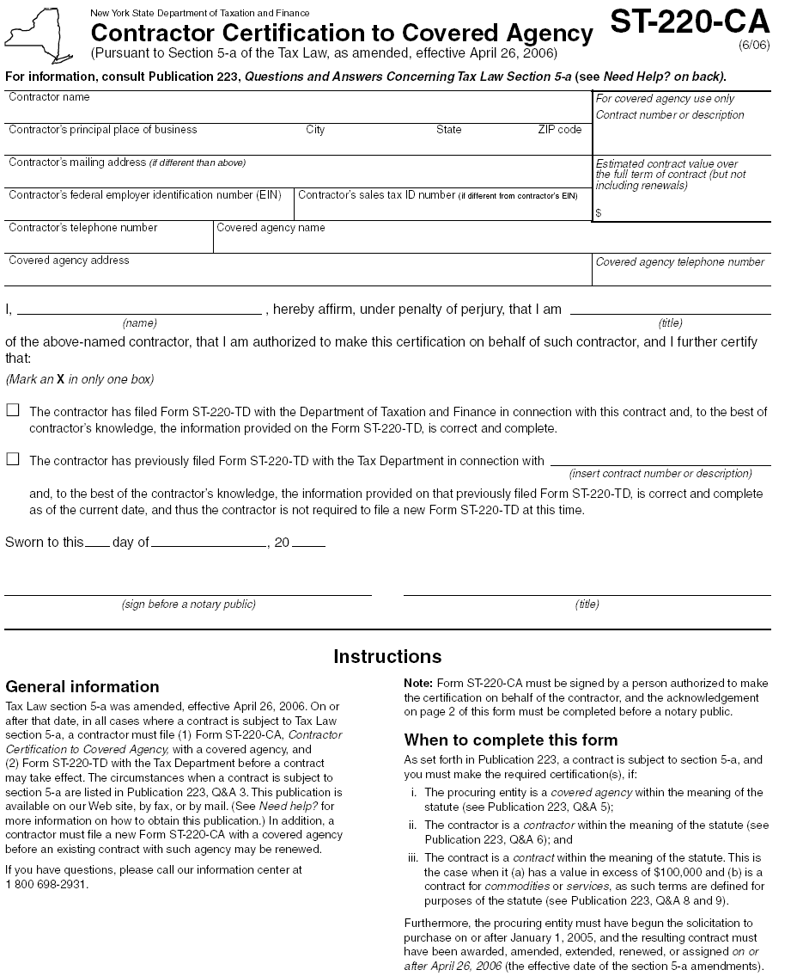

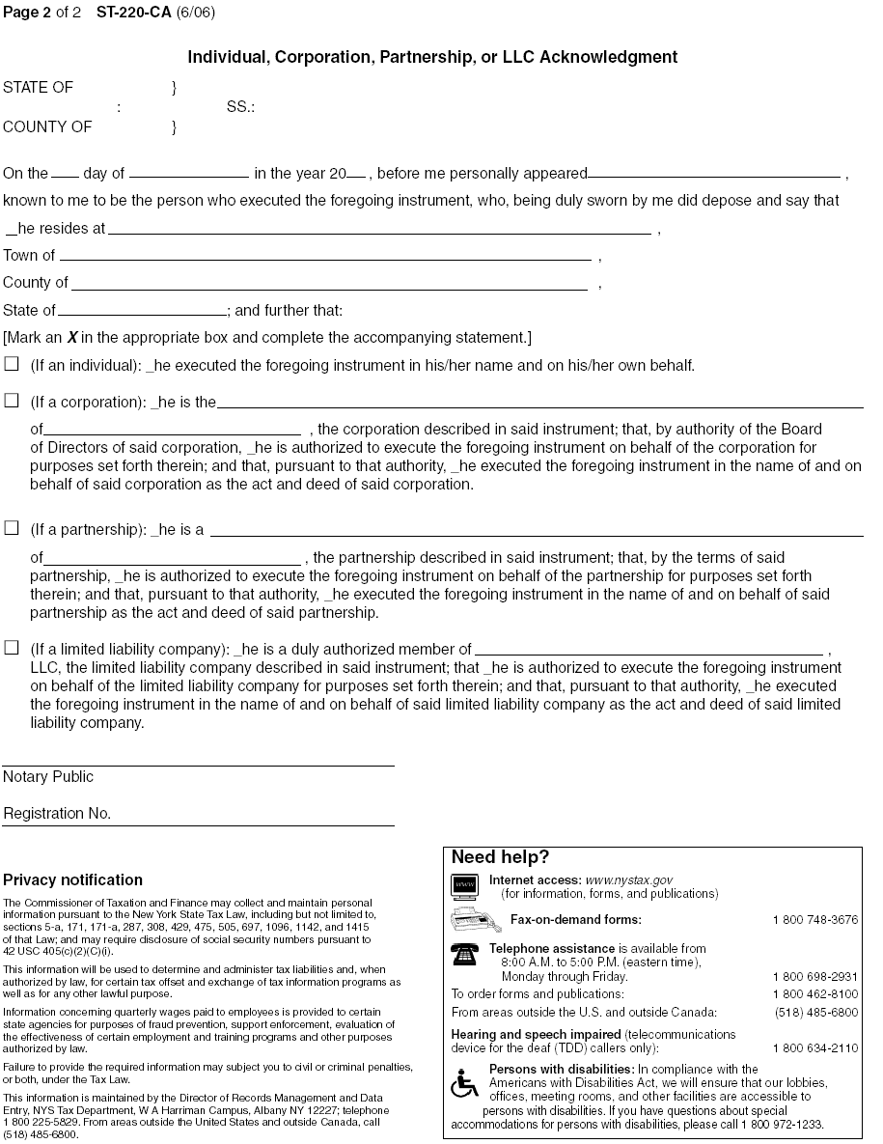
APPENDIX-H: ST-220 TD
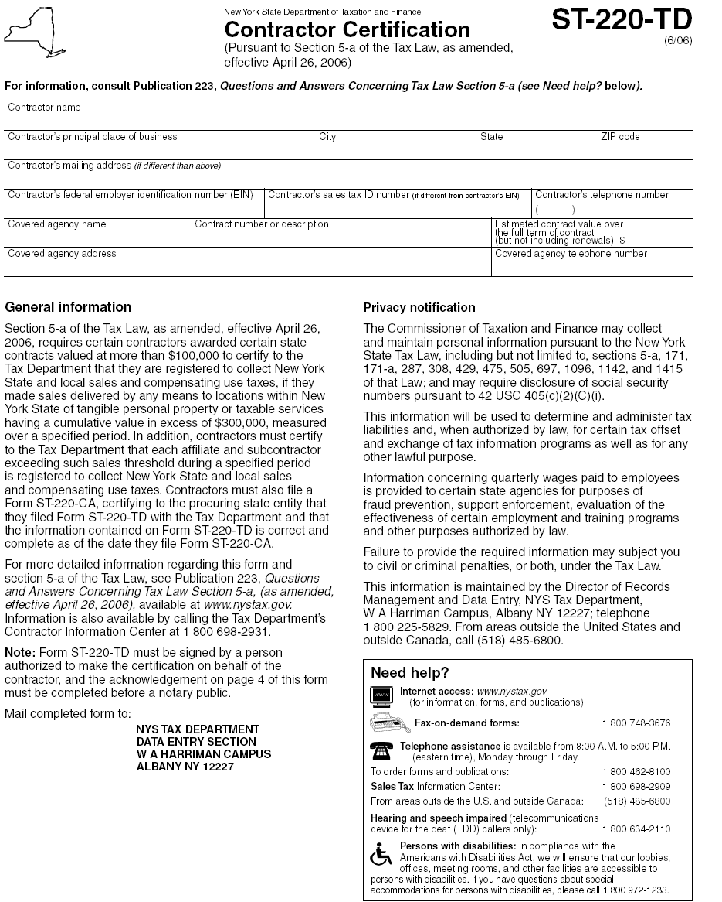
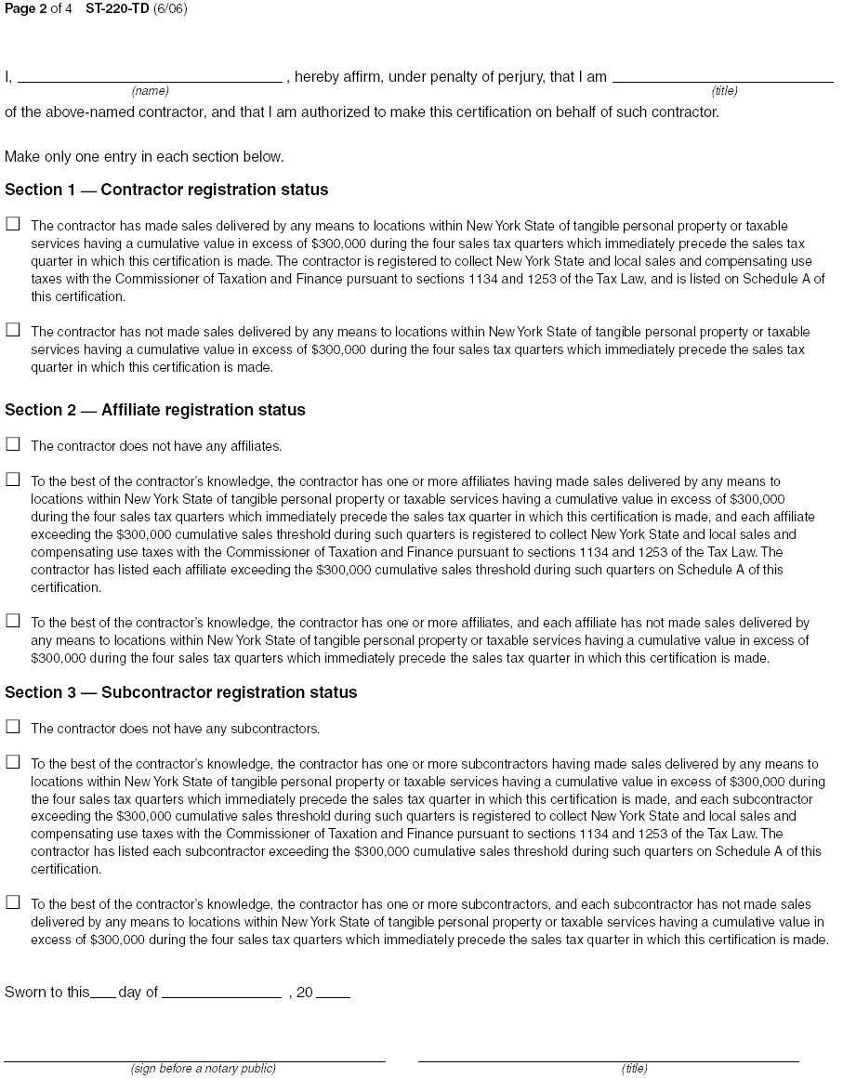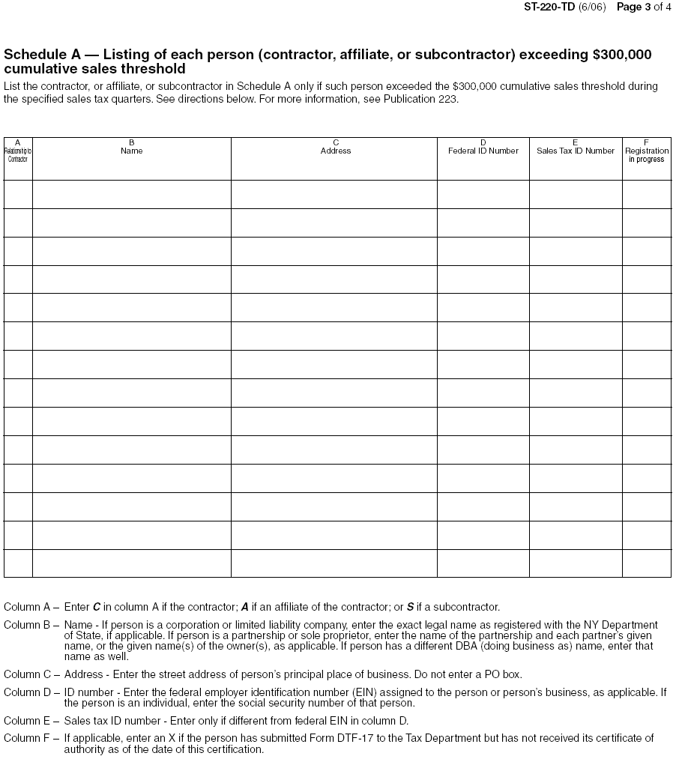
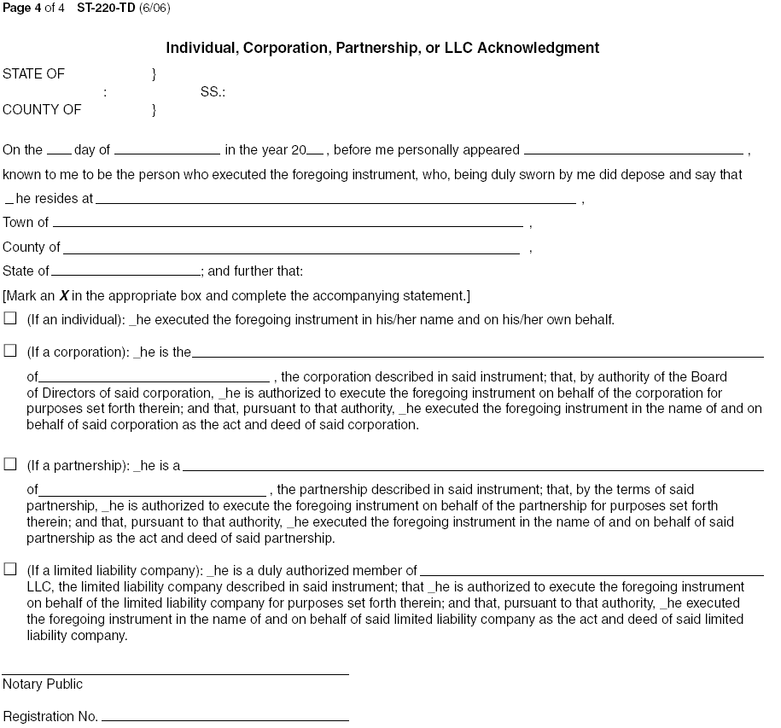

aPPENDIX-I: Reference list

(Please Type or Print Clearly)

COMPANY NAME

ADDRESS, CITY, STATE & ZIP

CONTACT PERSON & TITLE

CONTACT PERSON’S PHONE NUMBER

COMPANY NAME

ADDRESS, CITY, STATE & ZIP

CONTACT PERSON & TITLE

CONTACT PERSON’S PHONE NUMBER

COMPANY NAME

ADDRESS, CITY, STATE & ZIP

CONTACT PERSON & TITLE

CONTACT PERSON’S PHONE NUMBER

NOTE: A minimum of three (3) references are required. Additional references may be provided.

APPENDIX-J: consultant disclosure legislation
 |  |  |  |  |  | OSC Use Only:
 |  |  |  |  |  | Reporting Code:
 |  |  |  |  |  | Category Code:
 |  |  |  |  |  | Date Contract Approved:
FORM -A
State Consultant Services - Contractor's Planned Employment
From Contract Start Date Through The End Of The Contract Term
State Agency Name: |  |  |  |  |  |  | Agency Code:
Contractor Name: |  |  |  |  |  |  | Contract Number:
Contract Start Date: / / |  |  |  |  | Contract End Date: / /
Employment Category |  |  |  | Number of Employees |  | Number of hours to be worked |  | Amount Payable Under the Contract
Total this page |  |  |  | 0 |  | 0 |  | $ 0.00
 | Grand Total
Name of person who prepared this report:
Title: |  |  |  |  |  |  | Phone #:
Preparer's Signature:
Date Prepared: / /
(Use additional pages, if necessary) |  |  |  |  |  |  |  | Page of

 |  |  |  |  |  |  |  |  |  |  | OSC Use Only:
 |  |  |  |  |  |  |  |  |  |  | Reporting Code:
 |  |  |  |  |  |  |  |  |  |  | Category Code:
Form-B
State Consultant Services
Contractor’s Annual Employment Report
Report Period: April 1, to March 31,
Contracting State Agency Name: Agency Code:
Contract Number:
Contract Term: / / to / /
Contractor Name:
Contractor Address:
Description of Services Being Provided:
Scope of Contract (Choose one that best fits):
Analysis Evaluation Research Training
Data Processing Computer Programming Other IT consulting
Engineering Architect Services Surveying Environmental Services
Health Services Mental Health Services
Accounting Auditing Paralegal Legal Other Consulting
Employment Category |  |  | Number of Employees |  |  |  |  | Number of Hours Worked |  |  |  |  | Amount Payable Under the Contract
Total this page |  |  | 0 |  |  |  |  | 0 |  |  |  |  | $ 0.00
Grand Total
Name of person who prepared this report:
Preparer's Signature:___________________________________________________
Title: |  |  |  |  |  | Phone #:
Date Prepared: / /
Use additional pages if necessary) |  |  |  |  |  |  |  |  |  |  |  |  | Page of

APPENDIX-K: CONTRACTOR REQUIREMENTS AND PROCEDURES FOR BUSINESS PARTICIPATION OPPORTUNITIES FOR NEW YORK STATE CERTIFIED MINORITY AND WOMEN-OWNED BUSINESS ENTERPRISES, AND EQUAL EMPLOYMENT OPPORTUNITIES FOR MINORITY GROUP MEMBERS AND WOMEN
(MWBE, v. 2-10-12)

- Introduction:
New York’s Statewide Certified MWBE Program (Program) serves to ameliorate the significant disparities between the level of participation of MWBE’s in state procurement contracting, versus the number of certified minority-and women-owned business enterprises (MWBE’s) that are ready, willing and able to participate in state procurements.

In order to comply with New York State Executive Law Article 15-A (“Participation by Minority Croup Members and Women with Respect to State Contracts”), Article 15 (the “Human Rights Law”), and 5 NYCRR Parts 142-144 (“MWBE Regulations”), for all State contracts as defined therein, and to facilitate the implementation and operation of the Program, State agencies are required to establish goals for maximizing participation of New York State MWBE’s and the employment of minority group members and women in the performance of New York State contracts.

This Section articulates DMV’s goals for promoting such opportunities.

Bidder/Contractor acknowledges that its failure to comply with the following provisions may result in a finding of non-responsiveness, non-responsibility, and/or breach of Contract, which may result in the withholding of payment, suspension or termination of the Contract, or such other actions or enforcement proceedings provided herein or permitted by Law.

- Business Participation Opportunities for MWBEs:
DMV hereby establishes an overall goal of 22% for MWBE participation, 11% for Minority-Owned Business Enterprises (MBE) participation, and 11% for Women-Owned Business Enterprises (WBE) participation (based on the current availability of qualified MBE’s and WBE’s). Contractor must document good faith efforts to provide meaningful participation by MWBE’s as subcontractors or suppliers in the performance of the Contract, and Contractor agrees that DMV may withhold payment pending receipt of the required MWBE documentation.

The directory of New York State Certified MWBE’s can be viewed at: http://www.esd.ny.gov/mwbe.html.

For guidance on how DMV will determine a Contractor’s “good faith efforts,” refer to 5 NYCRR §142.8.

- Liquidated Damages:
In accordance with 5 NYCRR §142.13, Contractor acknowledges that its willful and intentional failure to comply with the MWBE participation goals set forth in the Contract will constitute a material breach of Contract for which DMV may withhold payment from the Contractor as liquidated damages for such breach.

Such liquidated damages shall be calculated as an amount equal to the difference between (1) all sums identified for payment to MWBE’s had the Contractor achieved the contractual MWBE goals, and (2) all sums actually paid to MWBE’s for work performed or materials supplied under the Contract.

- MWBE Utilization Plan:
The Bidder to whom a contract is awarded (Contractor) must submit a MWBE Utilization Plan, upon execution of the Contract. At all times during the performance of the Contract, Contractor must make good faith efforts to utilize MBE’s and WBE’s identified in its MWBE Utilization Plan.

DMV may disqualify a Bidder/Contractor as being non-responsive, under the following circumstances:

a) Bidder/Contractor fails to submit a MWBE Utilization Plan;
b) Bidder/Contractor fails to submit a written remedy to a notice of deficiency;
c) Bidder/Contractor fails totimely submit a request for waiver; or
d) DMV determines that the Bidder/Contractor has failed to document good faith efforts.

Any modifications or changes to the MWBE Utilization Plan made during the term of the Contract must be promptly reported, and such modifications or changes will be subject to DMV’s approval. DMV will review the submitted MWBE Utilization Plan and advise the Contractor of DMV’s acceptance, or issue a notice of deficiency within 30 days of receipt.

- MWBE Waiver Request: Contractor may submit requests for a partial or total waiver of established goal requirements, at any time during the term of the Contract, prior to issuance of final payment on the Contract. If a notice of deficiency is issued, Contractor must respond to the notice of deficiency within seven (7) business days of receipt by submitting to DMV a written remedy that addresses each deficiency contained in the notice of deficiency. If the written remedy that is submitted is not timely or is found by DMV to be inadequate, DMV shall notify Contractor and direct Contractor to re-submit a revised remedy, within five (5) business days. Failure to request the waiver in a timely manner may be grounds for rejection of the request.

- Contractor’s Quarterly Workforce Employment Utilization Report (“Workforce Report”): Contractors are required to submit to DMV, by the 10th day following the end of each quarter during the term of the Contract, a Workforce Report. Such reports document Contractor’s progress made toward achieving the MWBE goals for the Contract. The Workforce Report must document any changes to the “Bid Staffing Plan” that Contractor submitted with its Bid (See, below).

Contractor must submit separate reports for Contractor and any subcontractor performing work on the Contract. In limited instances, Contractor may not be able to separate out the workforce utilized in the performance of the Contract from Contractor's and/or any subcontractor's total workforce. When a separation can be made, Contractor must submit the Workforce Report and indicate that the information provided related to the actual workforce utilized on the Contract. When the workforce to be utilized on the Contract cannot be separated out from Contractor's and/or a subcontractor's total workforce, Contractor must submit the Workforce Report and indicate that the information provided is Contractor's total workforce during the subject time frame, not limited to work specifically under the Contract.

- Equal Employment Opportunity Requirements:
NOTE: The following requirements do not apply to (a) work, goods, or services unrelated to the Contract; or (b) employment outside New York State.

Contractor must ensure that Contractor and its subcontractors undertake or continue programs to ensure that minority group members and women are afforded equal employment opportunities without discrimination because of race, creed, color, national origin, sex, age, disability or marital status. This requirement shall apply to any subcontractors to whom Contractor awards a subcontract for goods or services related to the Contract, valued at over $25,000 for the construction, demolition, replacement, major repair, renovation, planning or design of real property and improvements thereon (except where such subcontract is solely for the beneficial use of the Contractor).

- For these purposes, “equal opportunity” must be provided in the areas of recruitment, employment, job assignment, promotion, upgrading, demotion, transfer, layoff, termination, and rates of pay, or other forms of compensation.

- MWBE Form-1, Contractor’s EEO Policy Statement: Contractor must execute and submit MWBE Form-1 (attached hereto), as its EEO policy statement, within seventy-two (72) hours after DMV issues written notice of award of the Contract to the Contractor.

- Bid Staffing Plan: Bidder must submit with its proposal a Bid Staffing Plan that identifies the anticipated work force to be utilized on the Contract by specified categories, including ethnic background, gender, and Federal occupational categories. Upon DMV’s request, Contractor must promptly submit a workforce utilization report that identifies the workforce actually utilized in the performance of the Contract.

- Non-Discrimination: Contractor agrees that it will not discriminate against any employee or applicant for employment because of race, creed (religion), color, sex, national origin, sexual orientation, military status, age, disability, predisposing genetic characteristic, marital status or domestic violence victim status, and shall also follow the requirements of the Human Rights Law with regard to non-discrimination on the basis of prior criminal conviction and prior arrest; and Contractor shall take reasonable steps to ensure that its subcontractors comport with such non-discrimination provisions during the term of the Contract. Contractor acknowledges that it understands and shall comply with such requirements above, and these provisions shall be deemed supplementary to, and not in lieu of, the nondiscrimination provisions provided by New York State Executive Law Article 15 (the “Human Rights Law”) or other applicable federal, state or local laws.

MWBE Form-1: MINORITY AND WOMEN-OWNED BUSINESS ENTERPRISES – EQUAL EMPLOYMENT OPPORTUNITY POLICY STATEMENT

M/WBE AND EEO POLICY STATEMENT

I, _________________________, the (awardee/contractor) ____________________ agree to adopt the following policies with respect to the project being developed or services rendered at __________________________________________________________________________________

M/WBE

EEO

This organization will and will cause its contractors and subcontractors to take good faith actions to achieve the M/WBE contract participations goals set by the State for that area in which the State-funded project is located, by taking the following steps:

- Actively and affirmatively solicit bids for contracts and subcontracts from qualified State certified MBEs or WBEs, including solicitations to M/WBE contractor associations.
- Request a list of State-certified M/WBEs from AGENCY and solicit bids from them directly.
- Ensure that plans, specifications, request for proposals and other documents used to secure bids will be made available in sufficient time for review by prospective M/WBEs.
- Where feasible, divide the work into smaller portions to enhanced participations by M/WBEs and encourage the formation of joint venture and other partnerships among M/WBE contractors to enhance their participation.
- Document and maintain records of bid solicitation, including those to M/WBEs and the results thereof. Contractor will also maintain records of actions that its subcontractors have taken toward meeting M/WBE contract participation goals.
- Ensure that progress payments to M/WBEs are made on a timely basis so that undue financial hardship is avoided, and that bonding and other credit requirements are waived or appropriate alternatives developed to encourage M/WBE participation.

(a) This organization will not discriminate against any employee or applicant for employment because of race, creed, color, national origin, sex, age, disability or marital status, will undertake or continue existing programs of affirmative action to ensure that minority group members are afforded equal employment opportunities without discrimination, and shall make and document its conscientious and active efforts to employ and utilize minority group members and women in its work force on state contracts.

(b)This organization shall state in all solicitation or advertisements for employees that in the performance of the State contract all qualified applicants will be afforded equal employment opportunities without discrimination because of race, creed, color, national origin, sex disability or marital status.

(c) At the request of the contracting agency, this organization shall request each employment agency, labor union, or authorized representative will not discriminate on the basis of race, creed, color, national origin, sex, age, disability or marital status and that such union or representative will affirmatively cooperate in the implementation of this organization’s obligations herein.
(d) Contractor shall comply with the provisions of the Human Rights Law, all other State and Federal statutory and constitutional non-discrimination provisions. Contractor and subcontractors shall not discriminate against any employee or applicant for employment because of race, creed (religion), color, sex, national origin, sexual orientation, military status, age, disability, predisposing genetic characteristic, marital status or domestic violence victim status, and shall also follow the requirements of the Human Rights Law with regard to non-discrimination on the basis of prior criminal conviction and prior arrest.

(e) This organization will include the provisions of sections (a) through (d) of this agreement in every subcontract in such a manner that the requirements of the subdivisions will be binding upon each subcontractor as to work in connection with the State contract.

Agreed to this _______ day of ____________________, 2___________

By __________________________________________

Print: _____________________________________ Title: _____________________________

_________________________________is designated as the Minority Business Enterprise Liaison

(Name of Designated Liaison)

responsible for administering the Minority and Women-Owned Business Enterprises- Equal Employment

Opportunity (M/WBE-EEO) program.

M/WBE Contract Goals

______20% Minority and Women’s Business Enterprise Participation

________% Minority Business Enterprise Participation

________% Women’s Business Enterprise Participation

EEO Contract Goals

________% Minority Labor Force Participation

________% Female Labor Force Participation

____________________________________________

(Authorized Representative)

Title: ________________________________________

Date: ________________________________________

Appendix-L


NEW YORK STATE
DEPARTMENT OF MOTOR VEHICLES
STANDARD SECURITY CLAUSES
FOR SHARING DATA WITH EXTERNAL ENTITIES

(Revised 5/14/12)

The terms of this Appendix shall be incorporated into an agreement between the New York State Department of Motor Vehicles and the recipient of DMV data. The Parties to the Agreement shall comply with the applicable provisions hereof, to the extent not superseded by federal law.

All data to which the Recipient will be provided access by DMV is proprietary to DMV. Such data shall hereinafter be referred to as “DMV data”. Recipient will safeguard all DMV data and resources to which it is granted access. Such safeguards must provide a level of protection of DMV data which is at least equivalent to those provided under NYS Cyber-Security Policy P03-002-V3.4, and comports with industry standards for such engagements.

- Recipient agrees to limit its use of DMV data to the purpose for which it is provided hereunder, and for no other purpose, unless expressly authorized to do so by DMV.

- Recipient must protect DMV data that is in Recipient’s possession, or under its control from unauthorized access, disclosure, or dissemination.

- DMV data includes information that is:
- provided by DMV which is marked ”Confidential”;
- defined as “Personal, Private and Sensitive Information” (PPSI);
- not expressly granted for public disclosure or dissemination;
- protected by law from disclosure or dissemination;
- concerning DMV’s infrastructure;
- pertinent to an ongoing investigation.

- Recipient must not permit DMV data to be copied or shared with anyone outside of the Recipient’s organization, unless expressly authorized by DMV; and must limit access to, and use of, DMV data to individuals who require access for the purpose fulfilling Recipient’s obligations arising under the terms of this Agreement.

- Recipient must cooperate with DMV in the review of Recipient's data control processes employed for the protection of DMV data.
- In the event that Recipient confirms or suspects the unauthorized use or access of DMV data or resources provided hereunder, Recipient agrees to promptly notify DMV’s Information Security Office, as follows:
  - by email: InformationSecurity@dmv.ny.gov, or
  - by telephone: (518) 402-2676.

- Recipient acknowledges that it understands and must comply with laws concerning the loss, misappropriation, compromise, or misuse of protected data provided hereunder, including:
- the federal Driver’s Privacy Protection Act of 1994 (DPPA) (18 U.S.C. §2721, et seq.), and
- the New York State Information Security Breach and Notification Act (ISBNA) (General Business Law, §899-aa; State Technology Law, §208).

- In the event that the security of personal information is breached in violation of the ISBNA, from a system maintained by Recipient, then the Recipient shall be responsible for providing notice of breach to the person(s) to whom such information pertains. In the event that Recipient is authorized to share such information with another entity, Recipient must hold its recipient responsible for providing such notice. Prior approval from DMV is required before any notifications are made to such persons.

- Recipient must take appropriate measures to advise pertinent staff members, and its re-disclosure recipients (if any), of the penalties associated with unauthorized access, use, or dissemination of protected data.

- Recipient’s obligation of indemnification and holding harmless specified hereunder shall survive the expiration of the Contract by termination or otherwise.

- Recipient shall be solely responsible and answerable in damages for any and all accidents and/or injuries to persons (including death) or property arising out of or related to the services to be rendered by the Recipient or its subcontractors pursuant to this Agreement. The Recipient shall indemnify and hold harmless the State and its officers and employees from claims, suits, actions, damages and costs of every nature arising out of the provision of services pursuant to this Agreement.

- Recipient is an independent contractor and may neither hold itself out nor claim to be an officer, employee or subdivision of the State of New York, nor make any claim, demand or application to or for any right based upon any different status.

- Recipient agrees to comply with DMVs instructions for the secure disposal of agreement-related electronic or hard copy files in Recipient’s possession upon expiration of the term of this Agreement.

- The following provisions apply to circumstances when Recipient or its subcontractors make use of resources provided by DMV:

- Personal Computers (PCs): DMV-provided PCs must only be used for activities related to official assignments and/or job responsibilities. Users are responsible for the use, protection, security and care of all New York State owned personal computers (PCs) and related equipment assigned to them by DMV.

DMV-provided PCs (including laptops, monitors, printers, hardware, peripherals, commercially licensed software, files, programs, and data) are the property of DMV. DMV reserves the right to access or audit PCs, storage drives and removable media, and the information contained therein.

Users must comply with the following restrictions when using DMV-provided PCs:
- Protect against unauthorized access when the PC is left unattended by locking it, or logging-off;
- Log-off the PC at the end of the workday, to ensure that the power remains On;
- Do not leave a laptop unattended or unsecured;
- Do not move the PC or related equipment to another location without approval from your manager/supervisor and DMV’s Information Technology Support Services.
- Do not modify or repair any PC or related equipment without prior approval of DMV’s Information Technology Support Services.
- Do not connect any hardware that is not expressly approved. Users must contact DMV’s Information Technology Support Services for a list of approved hardware.

- Software: Only software that is approved by DMV’s Information Technology Support Services may be installed on DMV-provided computers. Users must abide by all software license agreements. Non-work related software (e.g. games or music downloading programs) must not be installed or used on DMV computers. Users must not install DMV-owned software or programs on a non-DMV-owned computer, unless expressly approved by DMV’s Information Technology Support Services.

- Internet: DMV-provided Internet access must only be used for activities related to official assignments and/or job responsibilities. Users must employ reasonable precautions, including safeguarding and changing passwords, to prevent the unauthorized use of their DMV provided internet account by anyone else. Users must not access third-party internet service providers and webmail accounts (e.g., checking a personal email account on AOL), unless expressly authorized by the DMV’s Information Security Office.

DMV filters websites for inappropriate content. Users must direct requests to unblock or block a website to the DMV’s Information Technology Support Services.

- Network: Users must limit the use of DMV’s network to activities related to official assignments and/or job responsibilities.

- Email: Users must limit the use of DMV-provided email accounts to activities related to official assignments and/or job responsibilities.

Recipient agrees to continuing cooperation with DMV in response to developing security vulnerabilities.

139-j (2)
139-j (5)
139-j (1); 139-k (1)
139-j (3)(a)(1)
139-j (3)(a)(2)
139-j (3)(a)(3)
139-j (3)(a)(4)
139-j (3)(a)(5)
139-j (3)(a)(6)
139-j (3)(a)(7)
139-j (1), (3); 139-k (1)
139-j (3)
139-j (1), (2); 139-k (1)
139-j (2); 139-k (2)
139-j (6)
139-k (2)
Id.
Id.
139-j (10(b); 139-k (5)
Id.
139-j (8), (10)(b); 139-k (4)
Id.
139-j (9)
Id.
139-j (10)(a)
139-j (10)(a)
139-j (8)(a), (c)
139-j (8)( c), (10(b)
Legislative Law: POL §73(5); §74 (Code of Ethics)
139-j (7)
139-j (10)(b)
139-j (10)(b); 139-k (5)
139-j (10)(a)

