Request for Proposal
World Yacht, LLC (referred to as WY) is now taking proposals for a custom application\webapp. The application will be used internally by WY’s staff to link two proprietary reservation\charter databases so certain information can be viewed and reported upon.
The databases in question are:
Zenon Reservation(CRS) system – SQL 2000/2005 based database (developed by
Delphi 9.5 Charter Booking System – SQL 2005 based database (developed by Newmarket International)
This new app will be replacing an older app called “Cruise Schedule”. The current cruise schedule is written in VB5/6 and is no longer functional due to the business evolving over the last 10 years since the app was developed.
Required Functionality
- Basic querying of both databases to produce an event list showing what boats are in operation during a selected date range and the capacity for these events.
- Advanced querying of the database’s to produce reports that can be both printed to screen\printer and exported to Excel.
- Security permissions to control what report different users can access.
- An admin function to allow updating of how special events are displayed in the events list i.e. February 14th showed as Valentine’s Day. Allow editing of permissions. Also allow editing of report structure – all reports will be Crystal Reports and the admin should be allowed to create new links to reports that are created and stored on a network share.
Project Timeline
All proposals must be submitted no later than Friday, February 26th. From the signing of contract date – the project must be developed, tested and deployed within 6 weeks.
Support
Included in the contract should be 1 year of full application support via phone\email. After the initial year, both parties can decide on a future support contract if any.
Documentation
As part of the project, the developer will provide documentation with explaining comments for all developed code. Training documentation must also be provided with screenshots showing new users how to access and use the system. Admin Training documentation must be provided separately from the user documentation showing admin’s how make necessary changes.

The following are screenshots of the current app to give a visual clue of what is needed.
Basic Cruise Schedule Function
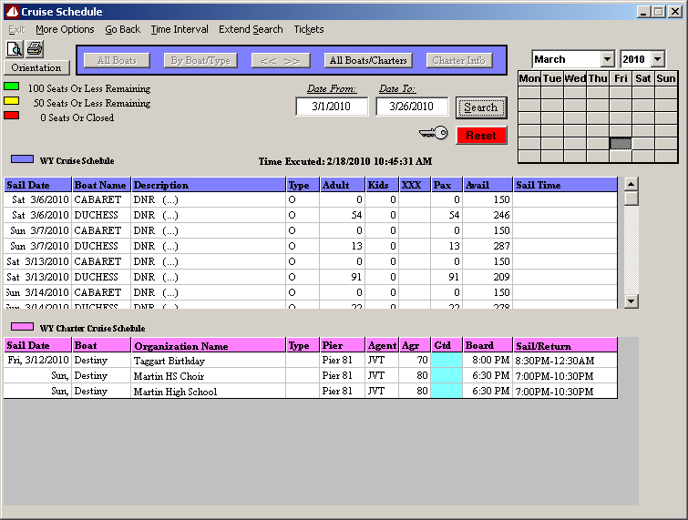

Tour & Travel Department Client Report
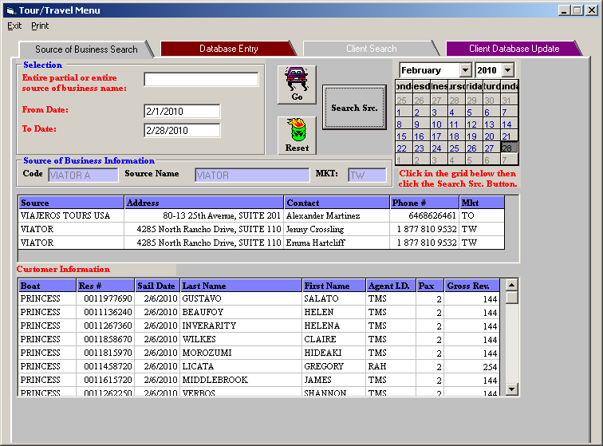

Seating Requirements Report


