REQUEST FOR PROPOSALS
CONFERENCE/MEETING PLANNER

OVERVIEW
Compassion & Choices (C&C) is a nationally recognized nonprofit working to improve care and expand choice at the end of life. Our Consultation Program helps clients and their loved ones face the end of life with calm facts and choices of action during a difficult time. We also aggressively pursue legal reform to promote pain care, put teeth in advance directives and legalize physician aid in dying.

We celebrate diversity in our staff. We are not affiliated with any religious or spiritual organization.

To learn more about our organization, please visit our website at www.compassionandchoices.org.

C&C is planning a National Conference on End-of-Life Issues. The goals of the conference are to:

Engage & Activate Grassroots Organizing
State-based activism in end-of-life care and choice
- Motivate
- Guide
- Train

Expose Compassion & Choices and End-of-life issues to a Wider Audience of Potential Change Agents
- Media Advocacy pre and post
- Plenary Sessions open to Media
- Recruitment tools

Excite & Invigorate Non-Attending Compassion & Choices Supporters
- Give a sense of momentum in the end-of-life choice movement
- Highlight recent advancements
- Get involved

The conference will be held in 2012.

Target Audience:
- Initial goal of 500 attendees
- Activists: changing laws at a grassroots level
- Consultation: ground solutions, volunteer opportunities
- General Interest Groups – current issues and challenges

Services Required:
Conference/meeting planner will provide the following services for C&C.

Timing:
- Work with C&C Project Manager to determine the best time of year to hold conference.
- Work with C&C Project Manager to determine the best time of week – weekday or weekend.
- Work with C&C Project Manager to determine the best location including low cost options in the area for low-income grassroots activist attendees.
Facilities
- Work with C&C Project Manager to conduct site searches, evaluate facilities and negotiate contracts on half of C&C.
- Coordinate workshops (times and locations).
- Arrange food service, refreshment stations and amenities as requested. Suggest menu options for final decisions to be made in conjunction with C&C Project Manager.
- Provide checklist for C&C Project Manager to use in assessing and recording services provided by the facility and audio-visual support services.

Pre-Registration
- Develop a track planning outline for attendees to follow to get the most out of the conference, depending on their particular interests.
- Work with Communications Department to manage onsite organizational brand and signage.
- Work with The Raben Group to develop and nurture relationships with possible sponsors.
- Work with the Development Department to manage conference sponsorship onsite benefits fulfillment.

Speaker Support
- Coordinate travel arrangements for speakers, including air travel, and hotel arrangements as necessary and manage onsite food/bev and technology needs.

On-Site Registration and Support
- Develop all needed materials and ship to conference in a timely manner.
- Generate nametags for each conference participant. Nametags need to be assembled and sorted alphabetically by last name. Nametag mock-up should be submitted to the C&C Project Manager no later than 2 weeks before the conference for approval.
- Generate alphabetical lists of participants.
- Provide mailing labels necessary to communicate with participants.
- Develop a process with C&C to insure that charges to accounts at hotels and other facilities are correct as stated in the contract.
- Verify and review all bills with the C&C Project Manager.
- Primary on-site management to ensure the conference proceeds smoothly and as planned. The Project Manager will provide the Conference Planner with the names, titles and contact information for other staff members that will be onsite and have management authority, including the Project Manager.
- The Conference Planner will ensure constant availability to the staff of Compassion & Choices by carrying a walkie-talkie and wearing a clearly visible nametag in the standard conference format.

Budget
- Prepare an accounting of all expenditures for conference, including copies of receipts, and forward to C&C Project Manager.
- Printing of registration forms, programs, evaluations and other materials will be arranged through C&C Communications department.

Communication
- Phone, fax and e-mail communication will be returned within 24 hours, weekdays, unless C&C Project Manager has been made aware of preexisting arrangements.
- A company representative will be available for conference calls.

Scheduling
- Conference Planner will work with the C&C Project Manager to establish an appropriate and acceptable timeline for the conference. The timeline will be distributed to all involved. Changes to that schedule will be made by joint agreement of both parties.

C&C agrees to:
- Provide final approval on dates and site for event.
- Assign Project Manager to the Conference Planning Team. The Project Manager will work as the primary link of communication between the Conference Planner and the Senior Management Team to ensure timely approval of contracts and expenditures.
- Review timelines for approval.
- Review menu options and other amenities.
- Provide room set up information and AV needs.
- Provide evaluation questions as needed.
How to Submit the Proposal:

In order to better evaluate and compare services and costs, we ask that your proposal be complete and address the following items.

- Describe your company, including date founded, size of company, number of clients, and experience in working with nonprofit professional associations.
- Describe why your company would be an appropriate match for our needs.
- Describe how you would address the scope of work outlined in this proposal, including but not limited to staffing approach, database capabilities, tracking fees, handling credit cards, report preparations, etc. a brief summary of list of other services you provide may also be included.
- Provide a bid that reflects costs for the services requested.
- Include names, addresses, and phone numbers of the three companies/vendors with whom you currently conduct business.

Bidder should submit 3 copies of the bid. Bid should not exceed four pages.

SELECTION TIMELINE: RFP’s are due January 10, 2011. A C&C selection committee will review and interview companies prior to January 20, 2011.

Notification will be given to selected company January 21, 2011 with services to begin immediately upon contract signing.

Bids will be judged on the following criteria:

Responsiveness to the Work Scope of the RFP, relevant experiences/knowledge, proposed budget and proposed schedule.

Send proposal to: Victoria Nolten
Bids may be received by
Fax: 503-228-9160
Electronically: vnolten@compassionandchoices.org.
Proposals will NOT be accepted via US Mail
Authorization:
This request for proposal is authorized for release by:

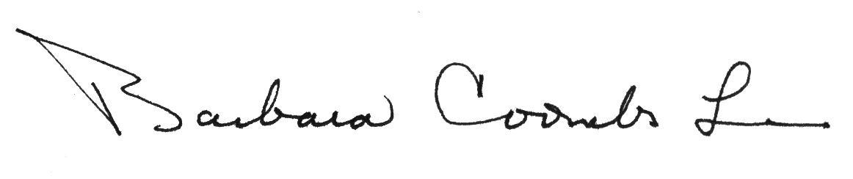
Barbara Coombs Lee
President

