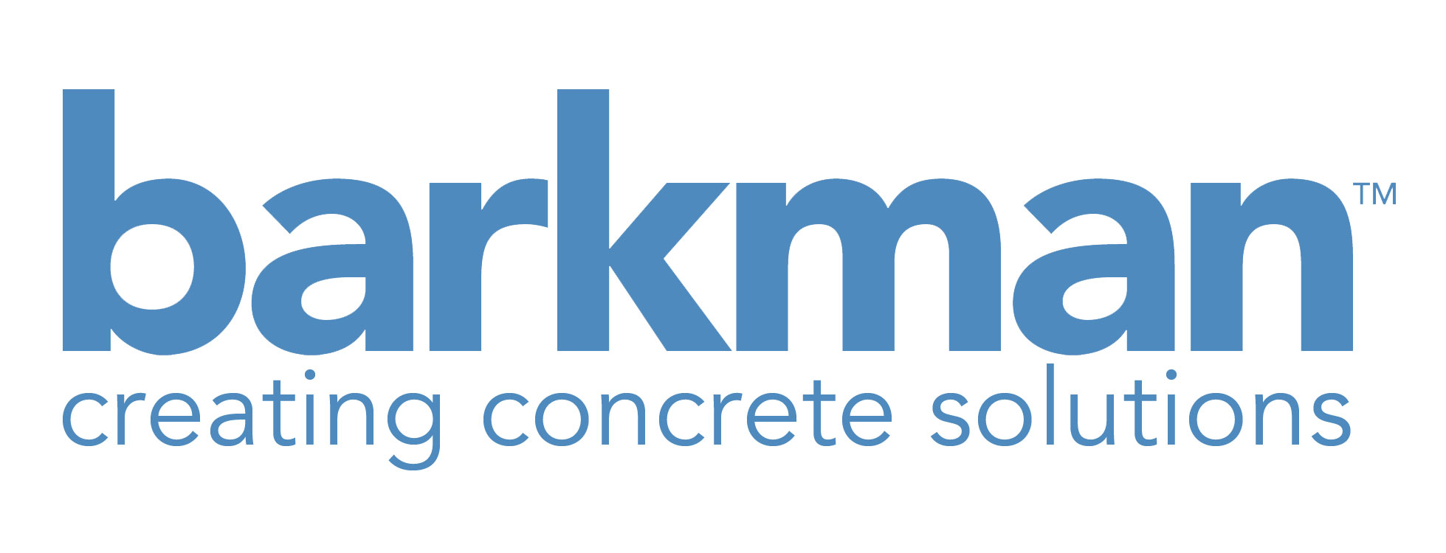

Website Request for Proposal

Company Overview

For 65 years, barkman concrete has developed a name as an innovator and leader in precast concrete manufacturing. Originally founded in Steinbach, Manitoba, barkman now employs 250 people in four different locations across North America. In the past five years, barkman has focused on expanding to the Western provinces and northern United States.

Our product lines come in the form of hardscapes, site furnishings, stone veneer, trenching products, agriculture products, retaining wall systems, skate parks, and other specialty products. We manufacture over 4000 products in-house and continue to expand our product line along the needs of our growing customer base.

Project Background

Five years ago we brought all our products under the one brand of ‘barkman’ and opened an in-house marketing department while defining a strict set of company values and a mission statement. It is within our mission to create concrete solutions through innovative products and a strong customer focus. Our current website www.barkmanconcrete.com no longer serves our customers’ growing needs and wants in 2013 with the advent of mobile browsing, social media and growing product lines. With all this taken into consideration, it is safe to say we intend to redesign and restructure our website to better serve our customers moving forward and 2013 is the time to do so.

The main issue with our current website (www.barkmanconcrete.com) is the fragmentation between domain names and inflexibility when it comes to dynamic updates. Our fragmented domains make it hard for us to track results and gain better search engine optimization for all our established and burgeoning products. Right now we have to update five contact pages in order to have them all uniform throughout.

Further to this, barkman is now participating more in social media, video and blogs which we would like to play more of a role on our main webpage.

Project Objective

- Unify products under one url ‘www.barkmanconcrete.com’
- Drive and increase traffic to all our pages
- Engage all our customers more efficiently in line with vocation
- Efficiently connect potential customers with our company and products
- Efficiently connect current customers with assets and tools
- Generate and track leads/email lists for use with campaign monitor.
- Take full control of our project estimator and sever ties with Depiction Software (http://www.hardscapesoftware.com/default.aspx)
- Connect seamlessly over all of social platforms and blog

Elements of the website that we like and should stay:

- Our wealth of images and resources
- Google analytics
- Content management system

Key Stakeholders for the site are:

- Architects
- Landscape Designers
- Hardscape installers (contractors)
- Home Owners / End Users
- Home Builders
- Commercial Project Leaders
- Municipalities
- Masons
- Dealers and Landscapers
- Engineers (for trenching products)

We are unique in that we are a diverse precast concrete manufacturing company with many products and that is where the challenge lies to create a compelling and simple website.

Design

Site design should be clean, professional and reflective of barkman’s brand identity and image. Accessing the site off a mobile platform should offer similar services and information formatted for their displays and unique capabilities.

Solutions need to be configured to navigate our many products with ease. Please provide navigation solutions and a mobile platform that would work for our company. It would also help to have a suggested structure to make this site easy to navigate without overwhelming our varied customers.

Competitor Sites we like:

http://belgard.biz/index.htm
http://www.unilock.com/default/
http://www.eldoradostone.com/

Development

Site will use a flexible content manager. Currently we have experience in Expression engine and WordPress. Please provide a solution that would fit our company and our project goals as outlined in this document.

Important Site Features:
- News, events and featured content to be displayed on home page with an accompanying slideshow for relevant image and media content. Featured content is concerned with video, blog posts, images and events
- Social media integration. Our Facebook twitter and blog are important aspects of our communication strategy.
- Instant call to actions on home page:
  - Request a catalogue today.
  - Locate a dealer or contractor by zip code.
  - Join the barkman insider newsletter.
  - Call us toll free.
- Product pages/sections with easily updatable information.
- Search function at home page for any of our products utilizing meta tags.
- Estimator feature that consist of product and pattern selections and an estimate on how much product is needed on a particular project. This applies to hardscape products.
- Career page with the ability to receive applications online and serve our HR department
- Back end content for retailers and contractors with all our images and logos hosted for their use
- Back end content for architect and planners for technical documents and assets like hatch patterns, cut sheets paver patterns etc.
- Efficient lead processing

Web design experience

- Please provide 3 – 5 website examples you have designed or developed.
- Please provide identification and resumes for key personnel who will be working on this project.
- Please provide insight on your design and development approach and what is expected of us. Also, please include information regarding technologies, code and standards used.

Project Contact

Jason Krahn
Marketing Coordinator
Email: jkrahn@barkmanconcrete.com
Address: 152 Brandt Street, Steinbach, MB R5G 0R2
Phone: C: 204-295-5297
P: 204-326-3445 ext 296

Project Deadline

RFP Release – April 4th 2013
Submission of questions on RFP
Notification on intention to bid
Answers to questions
Proposal due – May 4th 2013
Finalist Interviews – week of May 15th
Proposed Award date May 24th.
Initial meetings week of May 27th
Beta Site August 2013
Proposed site launch October-ish

Project Budget

We have budgeted between $25 000 to $35 000 for the approved website redesign and restructure.

Terms and Conditions

- We must own and have full access to and have the right and means to customize code and content.
- Proposals should be sent to Jason Krahn at jkrahn@barkmanconcrete.com or at our address at 152 Brandt Street, Steinbach, MB R5G0R2.
- Parties submitting separate proposals may not discuss pricing information or they will be ineligible to bid on the project.
- Bidder status: bidder must disclose any relevant conflicts of interest and/or pending lawsuits.

Suggested Format
1. Executive Summary
2. Technical Volume
a. Web development process: explain the process you will follow to build the Web site, including major milestones and evaluation
b. Address usability standards and testing
c. Address any important technology information and specifications used in your solution (languages, platform, etc.)
3. Management Volume
a. Organizational structure: communication process, reporting; including lines of reporting and any special tools used.
b. Schedule of deliverables -- include major milestones and testing proposal.
4. Budget Volume
Please provide an outline of your proposed budget and its breakdown.
5. Attachments
a. Qualifications and Experience: relevant case histories with information on accessing online demos or examples
b. Biographies of all who will work on account
c. Professional references.

