Request for Qualifications

University of Iowa Hospitals and Clinics
Community-Based Primary Care Clinic & Master Planning-
North Liberty

North Liberty, Iowa
May 16, 2011

- BACKGROUND

In December of 2010, the University of Iowa Hospitals and Clinics (UIHC) purchased nearly 40 acres of land at the intersection of Forevergreen Road and Highway 965 in North Liberty, Iowa (see attached Exhibit ‘A’ for aerial photograph of project location). This land will initially serve as the site for the development of a community-based primary care clinic that is very visible, easily accessed, and welcoming to the community. Preliminary estimates suggest the facility needed to accommodate the primary care services will require approximately 20,000 gross square feet of space. In addition, UIHC’s goal is to develop a master plan for the remainder of the land to support the development of a “Health and Wellness” campus. While the health care clinic represents the first built presence, it needs to be placed and conceived with this broader campus vision in mind. This project is supportive of each of the six major goals that have been established in UI Health Care’s Strategic Plan for FY 2010-2012.

At the February 3, 2011, meeting of the Board of Regents, State of Iowa, the Permission to Proceed with Project Planning for this primary care clinic and campus master planning was approved.

In the spring of 2011, UIHC retained Confluence for consulting services as a local Master Planning partner. Confluence will facilitate the selection of a firm to lead the development of the Community Health Campus Master Plan and will collaborate in the Master Planning process.

- OBJECTIVE

The objective of the Master Plan is to comprehensively develop a community health and wellness campus that provides a framework for development, both for the healthcare clinic and future projects. It is UIHC’s desire to provide a team-based, integrated operating model for patient care, create a model environment for ambulatory care training, and generate growth to support UIHC’s education/training mission by offering a comprehensive array of primary care services for North Liberty and the surrounding communities. Other compatible health and wellness-related services will be considered for inclusion in the overall campus master plan.

UIHC intends to develop the Community Health and Wellness Campus with sustainable principals and practices in mind with the potential for LEED Silver certification.

- SCOPE OF SERVICES

In order to pursue this vision, the UIHC desires a firm that will meet the following scope of services:

  - Conduct kick-off meeting with UIHC to outline schedule, communication paths, and align project goals and objectives.
  - Develop base map, using information provided by UIHC, and prepare site inventory and analysis.
  - Prepare planning alternatives that address optimal land uses, building placement, traffic and parking planning, and open space strategies.
  - Meet with UIHC to review alternatives and gain feedback.
  - Prepare preferred Campus Master Plan, including health and wellness-related services considered to be best suited for this particular campus and that will lend themselves to the overall success of this campus’s development and functioning, including a business development strategy
  - Prepare a construction budget for the Campus Master Plan.
  - Prepare outline of Campus Design Standards and covenant, addressing land use, setbacks, open space, signage, and building material vocabulary.
  - Review outline with UIHC and receive feedback on Campus Design Standards.
  - Prepare support graphics which illustrate the Campus Design Standards and incorporate conceptual-level architectural elevations.
  - Provide 15 hard copies each of the Campus Master Plan booklet, 11x17 format, and one electronic copy.

- SUBMISSION REQUIREMENTS

The RFQ submittal response shall not exceed 25 pages, total (cover/back does not count toward total; printed both sides is acceptable), and shall include the following:

  - Letter of Interest
  - Firm Profile and any sub-consultants that may be part of the team
  - Description of at least 3 relevant projects that key project staff has played a central role in developing which demonstrates your firm’s creativity and integration of the environment, community needs and overall project objective
  - General project approach to projects of this type
  - Name and resumes of specific project team members that will play key roles in this project; the name and resume of the project manager must be included.
  - No more than 5 references for similar projects. Include contact name and current phone number and email address.
  - Outline schedule that concludes with final presentation and turnover of deliverables on October 3, 2011.
  - Additional information that will assist the UIHC Capital Management Committee in considering the Evaluation Criteria listed below.
  - 12 hard copies and one digital copy shall be submitted

- EVALUATION CRITERIA

UIHC Capital Management Committee will review the submitted responses and evaluate each according to the following:

  - Experience in healthcare and wellness campus master planning
  - Personnel assigned to the Project Team
  - Demonstrated knowledge of healthcare and wellness trends
  - Relevant examples of creative solutions to campus master planning challenges
  - Approach to developing a comprehensive master plan
  - Quality of submitted materials and qualifications package
  - Responsiveness to submittal requirements

- SCHEDULE

Submission of Qualifications and the Letter of Interest are to be submitted no later than 5:00 p.m. CST on June 7, 2011. Twelve hard copies and one digital copy of the completed RFQ response must be submitted.

All submittals and inquiries should be addressed to Matthew Berg, Project Manager, University of Iowa Hospitals & Clinics, 200 Hawkins Drive, C-118 GH, Iowa City, IA 52242 or matthew-e-berg@uiowa.edu.

The UIHC intend to select the top 3 candidates by June 17, 2011, with those short-listed firms to be interviewed on June 30, 2011. The UIHC reserves the right to reject or accept any submitted response.

Request for Qualifications

University of Iowa Hospitals and Clinics
Community Health Campus Master Plan – North Liberty Project

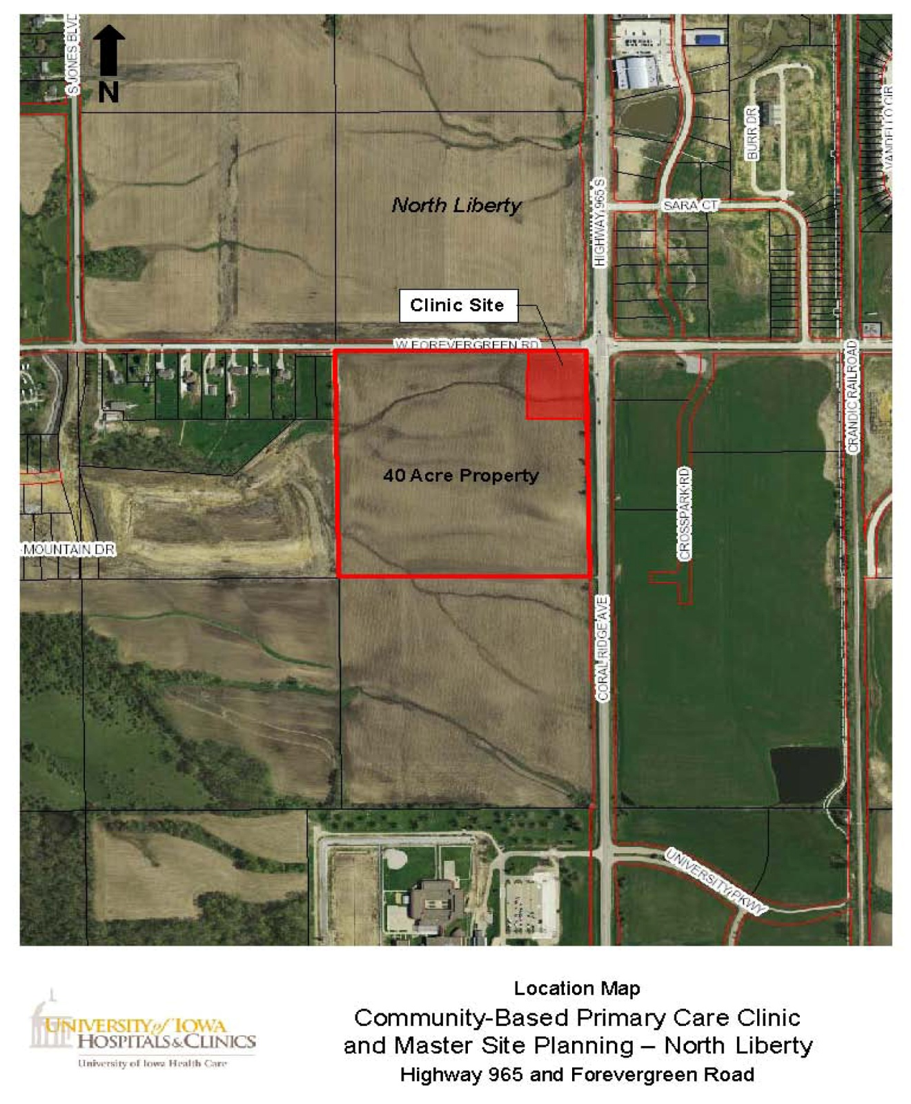
EXHIBIT ‘A’

