 |  | INVITATION  FOR  BID |  | Solicitation Number  Date Printed  Date Issued  Procurement Officer  Phone  E-Mail Address  Director of Procurement | 347809  1/20/10  1/20/10  Amber Whitkaer  803-896-1949  Whitaker.amber@doc.state.sc.us  Ruthie H. Bishop, CPPB
DESCRIPTION: | COW COOLING SYSTEM
USING GOVERNMENT AGENCY: |  |  | SOUTH CAROLINA DEPARTMENT OF CORRECTIONS

The Term "Offer" Means Your "Bid" or "Proposal".

SUBMIT OFFER BY: (Opening Date/Time): | FEBRUARY 9, 2010 @ 10:00 AM | See provision entitled "Deadline for Submission of Offer"

NUMBER OF COPIES TO BE SUBMITTED: | ORIGINAL

QUESTIONS MUST BE RECEIVED BY: | FEBRUARY 1, 2010 | See provision entitled "Questions From Offeror’s"

SUBMIT YOU’RE SEALED OFFER TO EITHER OF THE FOLLOWING ADDRESSES:
MAILING ADDRESS: | PHYSICAL ADDRESS:
SC Department of Corrections  PO Box 212329  Columbia, SC 29221 | SC Department of Corrections  4420 Broad River Road  Columbia, SC 29210
See provision entitled "Submitting Your Offer"

AWARD & AMENDMENTS | Award will be posted at the Physical Address stated above on FEBRUARY 16, 2010. The award, this solicitation, and any amendments will be posted at the following web address: www.state.sc.us/scdc/procurement

You must submit a signed copy of this form with Your Offer. By submitting a bid or proposal, You agree to be bound by the terms of the Solicitation. You agree to hold Your Offer open for a minimum of sixty (60) calendar days after the Opening Date.
NAME OF OFFEROR (Full legal name of business submitting the offer) |  | OFFEROR'S TYPE OF ENTITY:  (Check one)  □ Sole Proprietorship  □ Partnership  □ Corporation (tax-exempt)  □ Corporate entity (not tax-exempt)  □ Government entity (federal, state, or local)  □ Other _________________________  (See provision entitled "Signing Your Offer".)
AUTHORIZED SIGNATURE

(Person signing must be authorized to submit binding offer to enter contract on behalf of Offeror named above.)
TITLE (Business title of person signing above)

PRINTED NAME (Printed name of person signing above) | DATE
Instructions regarding Offeror's name: Any award issued will be issued to, and the contract will be formed with, the entity identified as the offeror above. An offer may be submitted by only one legal entity. The entity named as the offeror must be a single and distinct legal entity. Do not use the name of a branch office or a division of a larger entity if the branch or division is not a separate legal entity, i.e., a separate corporation, partnership, sole proprietorship, etc.

OFFEROR'S HOME OFFICE ADDRESS (Address for the offeror's principle place of business)

CITY |  | STATE |  | ZIP CODE
PHONE | FACSIMILE |  | E-MAIL
STATE OF INCORPORATION (If offeror is a corporation, identify the state of Incorporation.)

TAXPAYER IDENTIFICATION NO. (See provision entitled Taxpayer Identification Number)

COVER PAGE SCDC (JAN 2005)

S SEND INVITATION FOR BIDS TO:

HAND DELIVER/EXPRESS MAIL TO:

SC Department of Corrections

4420 Broad River Road

Columbia, SC 29210

MINORITY PARTICIPATION (JAN 2006)

Is the bidder a South Carolina Certified Minority Business? [ ] Yes [ ] No

Is the bidder a Minority Business certified by another governmental entity? [ ] Yes [ ] No

If so, please list the certifying governmental entity: _________________________

Will any of the work under this contract be performed by a SC certified Minority Business as a subcontractor? [ ] Yes [ ] No

If so, what percentage of the total value of the contract will be performed by a SC certified Minority Business as a subcontractor? _____________

Will any of the work under this contract be performed by a minority business certified by another governmental entity as a subcontractor? [ ] Yes [ ] No

If so, what percentage of the total value of the contract will be performed by a minority business certified by another governmental entity as a subcontractor? _____________

If a certified Minority Business is participating in this contract, please indicate all categories for which the Business is certified:

[ ] Traditional minority
[ ] Traditional minority, but female
[ ] Women (Caucasian females)
[ ] Hispanic minorities
[ ] DOT referral (Traditional minority)
[ ] DOT referral (Caucasian female)
[ ] Temporary certification
[ ] SBA 8 (a) certification referral
[ ] Other minorities (Native American, Asian, etc.)

(If more than one minority contractor will be utilized in the performance of this contract, please provide the information above for each minority business.)

For a list of certified minority firms, please consult the Minority Business Directory, which is available at the following URL:http://www.govoepp.state.sc.us/osmba/
[04-4015-1]

PREFERENCES - SC RESIDENT VENDOR PREFERENCE  (June 2005): Section 11-35-1524 provides a preference for offerors that qualify as a resident vendor. A resident vendor is an offeror that (a) is authorized to transact business within South Carolina, (b) maintains an office* in South Carolina, (c) either (1) maintains a minimum $10,000.00 representative inventory at the time of the solicitation, or (2) is a manufacturer which is headquartered and has at least a ten million dollar payroll in South Carolina, and the product is made or processed from raw materials into a finished end-product by such manufacturer or an affiliate (as defined in section 1563 of the Internal Revenue Code) of such manufacturer, and (d) has paid all assessed taxes. If applicable, preference will be applied as required by law. | OFFERORS REQUESTING THIS PREFERENCE MUST INITIAL HERE. ______________.  *ADDRESS AND PHONE OF IN-STATE OFFICE  ____ In-State Office Address same as Home Office Address  ____ In-State Office Address same as Notice Address  (check only one)

PREFERENCES - SC/US END-PRODUCT (June 2005): Section 11-35-1524 provides a preference to vendors offering South Carolina end-products or US end-products, if those products are made, manufactured, or grown in SC or the US, respectively. An end-product is the item identified for acquisition in this solicitation, including all component parts in final form and ready for the use intended. The terms made, manufactured, and grown are defined by Section 11-35-1524(B). By signing your offer and checking the appropriate space(s) provided and identified on the bid schedule, offeror certifies that the end-product(s) is either made, manufactured or grown in South Carolina, or other states of the United States, as applicable. Preference will be applied as required by law. | IF THIS PREFERENCE APPLIES TO THIS PROCUREMENT, PART VII (BIDDING SCHEDULE) WILL INCLUDE A PLACE TO CLAIM THE PREFERENCE. OFFERORS REQUESTING THIS PREFERENCE MUST CHECK THE APPROPRIATE SPACES ON THE BIDDING SCHEDULE.

>>>>>PREFERENCE DOES NOT APPLY TO PROCUREMENTS UNDER $10,000.00<<<<<<

**********************************************************************************

Solicitation Outline

I. Scope of Solicitation
II. Instructions to Offerors
A. General Instructions
B. Special Instructions
III. Scope of Work / Specifications
May be blank if Bidding Schedule / Cost Proposal attached
IV. Information for Offerors to Submit
V. Qualifications
VI. Award Criteria
VII. Terms and Conditions
A. General
B. Special
VIII. Bidding Schedule / Cost Proposal
IX. Attachments to Solicitation

I. Scope Of Solicitation

ACQUIRE SERVICES & SUPPLIES / EQUIPMENT (JAN 2006): The purpose of this solicitation is to acquire services and supplies or equipment complying with the enclosed description and/or specifications and conditions.

MAXIMUM CONTRACT PERIOD -- ESTIMATED (JAN 2006): UPON AWARD. Dates provided are estimates only. Any resulting contract will begin on the date specified in the notice of award. See clause entitled "Term of Contract - Effective Date / Initial Contract Period".

II. Instructions To Offerors - A. General Instructions

AMENDMENTS TO SOLICITATION (JAN 2004) (a) The Solicitation may be amended at any time prior to opening. All actual and prospective Offerors should monitor the following web site for the issuance of Amendments: www.doc.sc.gov/Procurement/BidList. (b) Offerors shall acknowledge receipt of any amendment to this solicitation (1) by signing and returning the amendment, (2) by identifying the amendment number and date in the space provided for this purpose on Page Two, (3) by letter, or (4) by submitting a bid that indicates in some way that the bidder received the amendment. (c) If this solicitation is amended, then all terms and conditions which are not modified remain unchanged.

AWARD NOTIFICATION (JUNE 2006) Notice regarding any award or cancellation of award will be posted at the location specified on the Cover Page. The date and location of posting will be announced at opening. If the contract resulting from this Solicitation has a total or potential value of fifty thousand dollars or more, such notice will be sent to all Offerors responding to the Solicitation. Should the contract resulting from this Solicitation have a potential value of one hundred thousand dollars or more, such notice will be sent to all Offerors responding to the Solicitation and any award will not be effective until the eleventh day after such notice is given.

BID / PROPOSAL AS OFFER TO CONTRACT (JAN 2004) By submitting Your Bid or Proposal, You are offering to enter into a contract with the Using Governmental Unit(s). Without further action by either party, a binding contract shall result upon final award. Any award issued will be issued to, and the contract will be formed with, the entity identified as the Offeror on the Cover Page. An Offer may be submitted by only one legal entity; “joint bids” are not allowed

BID ACCEPTANCE PERIOD (JAN 2004) In order to withdraw Your Offer after the minimum period specified on the Cover Page, You must notify the Procurement Officer in writing.

BID IN ENGLISH & DOLLARS (JAN 2004) Offers submitted in response to this solicitation shall be in the English language and in US dollars, unless otherwise permitted by the Solicitation.

CERTIFICATION REGARDING DEBARMENT AND OTHER RESPONSIBILITY MATTERS (JAN 2004)

(a)(1) By submitting an Offer, Offeror certifies, to the best of its knowledge and belief, that-

(i) Offeror and/or any of its Principals-

(A) Are not presently debarred, suspended, proposed for debarment, or declared ineligible for the award of contracts by any state or federal agency;
(B) Have not, within a three-year period preceding this offer, been convicted of or had a civil judgment rendered against them for: commission of fraud or a criminal offense in connection with obtaining, attempting to obtain, or performing a public (Federal, state, or local) contract or subcontract; violation of Federal or state antitrust statutes relating to the submission of offers; or commission of embezzlement, theft, forgery, bribery, falsification or destruction of records, making false statements, tax evasion, or receiving stolen property; and
(C) Are not presently indicted for, or otherwise criminally or civilly charged by a governmental entity with, commission of any of the offenses enumerated in paragraph (a)(1)(i)(B) of this provision.

(ii) Offeror has not, within a three-year period preceding this offer, had one or more contracts terminated for default by any public (Federal, state, or local) entity.

(2) "Principals," for the purposes of this certification, means officers; directors; owners; partners; and, persons having primary management or supervisory responsibilities within a business entity (e.g., general manager; plant manager; head of a subsidiary, division, or business segment, and similar positions).

(b) Offeror shall provide immediate written notice to the Procurement Officer if, at any time prior to contract award, Offeror learns that its certification was erroneous when submitted or has become erroneous by reason of changed circumstances.

(c) If Offeror is unable to certify the representations stated in paragraphs (a)(1), Offer must submit a written explanation regarding its inability to make the certification. The certification will be considered in connection with a review of the Offeror's responsibility. Failure of the Offeror to furnish additional information as requested by the Procurement Officer may render the Offeror nonresponsible.

(d) Nothing contained in the foregoing shall be construed to require establishment of a system of records in order to render, in good faith, the certification required by paragraph (a) of this provision. The knowledge and information of an Offeror is not required to exceed that which is normally possessed by a prudent person in the ordinary course of business dealings.

(e) The certification in paragraph (a) of this provision is a material representation of fact upon which reliance was placed when making award. If it is later determined that the Offeror knowingly or in bad faith rendered an erroneous certification, in addition to other remedies available to the State, the Procurement Officer may terminate the contract resulting from this solicitation for default.

CODE OF LAWS AVAILABLE (JAN 2006): The South Carolina Code of Laws, including the Consolidated Procurement Code, is available at http://www.scstatehouse.net/code/statmast.htm. The South Carolina Regulations are available at: http://www.scstatehouse.net/coderegs/statmast.htm.

COMPLETION OF FORMS / CORRECTION OF ERRORS (JAN 2006): All prices and notations should be printed in ink or typewritten. Errors should be crossed out, corrections entered and initialed by the person signing the bid. Do not modify the solicitation document itself (including bid schedule). (Applicable only to offers submitted on paper.)

DEADLINE FOR SUBMISSION OF OFFER (JAN 2004) Any offer received after the Procurement Officer of the governmental body or his designee has declared that the time set for opening has arrived, shall be rejected unless the offer has been delivered to the designated purchasing office or the governmental bodies’ mail room which services that purchasing office prior to the bid opening. [R.19-445.2070(H)]

DEFINITIONS (JAN 2004) EXCEPT AS OTHERWISE PROVIDED HEREIN, THE FOLLOWING DEFINITIONS ARE APPLICABLE TO ALL PARTS OF THE SOLICITATION.
AMENDMENT – means a document issued to supplement the original solicitation document.
BUYER – means the Procurement Officer.
CHANGE ORDER - means any written alteration in specifications, delivery point, rate of delivery, period of performance, price, quantity, or other provisions of any contract accomplished by mutual agreement of the parties to the contract.
CONTRACT - See clause entitled “Contract Documents & Order of Precedence.”
CONTRACT MODIFICATION – means a written order signed by the Procurement Officer, directing the contractor to make changes which the changes clause of the contract authorizes the Procurement Officer to order without the consent of the contractor.
CONTRACTOR - means the Offeror receiving an award as a result of this solicitation.
COVER PAGE – means the top page of the original solicitation on which the solicitation is identified by number. Offerors are cautioned that Amendments may modify information provided on the Cover Page.
OFFER – means the bid or proposal submitted in response this solicitation. The terms “Bid” and “Proposal” are used interchangeably with the term “Offer.”
OFFEROR – means the single legal entity submitting the offer. The term “Bidder” is used interchangeably with the term “Offeror.” See bidding provisions entitled “Signing Your Offer” and “Bid/Proposal As Offer To Contract.”
ORDERING ENTITY - Using Governmental Unit that has submitted a Purchase Order.
PAGE TWO – means the second page of the original solicitation, which is labeled Page Two.
PROCUREMENT OFFICER – means the person, or his successor, identified as such on the Cover Page.
YOU and YOUR – means Offeror.
SOLICITATION – means this document, including all its parts, attachments, and any Amendments.
STATE – means the Using Governmental Unit(s) identified on the Cover Page.
SUBCONTRACTOR – means any person having a contract to perform work or render service to Contractor as a part of the Contractor’s agreement arising from this solicitation.
USING GOVERNMENTAL UNIT – means the unit(s) of government identified as such on the Cover Page. If the Cover Page names a “Statewide Term Contract” as the Using Governmental Unit, the Solicitation seeks to establish a Term Contract [11-35-310(35)] open for use by all South Carolina Public Procurement Units [11-35-4610(5)].
WORK - means all labor, materials, equipment and services provided or to be provided by the Contractor to fulfill the Contractor’s obligations under the Contract.

DRUG FREE WORK PLACE CERTIFICATION (JAN 2004) By submitting an Offer, Contractor certifies that, if awarded a contract, Contractor will comply with all applicable provisions of The Drug-free Workplace Act, Title 44, Chapter 107 of the South Carolina Code of Laws, as amended.

DUTY TO INQUIRE (JAN 2004) Offeror, by submitting an Offer, represents that it has read and understands the Solicitation and that its Offer is made in compliance with the Solicitation. Offerors are expected to examine the Solicitation thoroughly and should request an explanation of any ambiguities, discrepancies, errors, omissions, or conflicting statements in the Solicitation. Failure to do so will be at the Offeror’s risk. Offeror assumes responsibility for any patent ambiguity in the Solicitation that Offeror does not bring to the State’s attention.

ETHICS ACT (JAN 2004) By submitting an Offer, You certify that You are in compliance with South Carolina’s Ethics, Government Accountability, and Campaign Reform Act of 1991, as amended. The following statutes require special attention: (a) Offering, giving, soliciting, or receiving anything of value to influence action of public employee – Section 8-13-790, (b) Recovery of kickbacks – Section 8-13-790, (c) Offering, soliciting, or receiving money for advice or assistance of public official – Section 8-13-720, (d) Use or disclosure of confidential information – Section 8-13-725, and (e) Persons hired to assist in the preparation of specifications or evaluation of bids – Section 8-13-1150.

OMIT TAXES FROM PRICE (JAN 2004): Do not include any sales or use taxes in Your price that the State may be required to pay.

PROTESTS (JUNE 2006) Any prospective bidder, offeror, contractor, or subcontractor who is aggrieved in connection with the solicitation of a contract shall protest within fifteen days of the date of issuance of the applicable solicitation document at issue. Any actual bidder, offeror, contractor, or subcontractor who is aggrieved in connection with the intended award or award of a contract shall protest within ten days of the date notification of award is posted in accordance with this code. A protest shall be in writing, shall set forth the grounds of the protest and the relief requested with enough particularity to give notice of the issues to be decided, and must be received by the appropriate Chief Procurement Officer within the time provided. See clause entitled “Protest-CPO”. [~ 11-35-4210]

PUBLIC OPENING (JAN 2004) Offers will be publicly opened at the date / time and at the location identified on the Cover Page, or last Amendment, whichever is applicable.

QUESTIONS FROM OFFERORS (JAN 2004): (a) Any prospective offeror desiring an explanation or interpretation of the solicitation, drawings, specifications, etc., must request it in writing. Questions must be received by the Procurement Officer no later than five (5) days prior to opening unless otherwise stated on the Cover Page. Label any communication regarding your questions with the name of the procurement officer, and the solicitation's title and number. Oral explanations or instructions will not be binding. Any information given a prospective offeror concerning a solicitation will be furnished promptly to all other prospective offerors as an Amendment to the solicitation, if that information is necessary for submitting offers or if the lack of it would be prejudicial to other prospective offerors. (b) The State seeks to permit maximum practicable competition. Offerors are urged to advise the Procurement Officer – as soon as possible – regarding any aspect of this procurement, including any aspect of the Solicitation, that unnecessarily or inappropriately limits full and open competition.

REJECTION/CANCELLATION (JAN 2004) The State may cancel this solicitation in whole or in part. The State may reject any or all proposals in whole or in part. [SC Code Section 11-35-1710 & R.19-445.2065.]

RESPONSIVENESS / IMPROPER OFFERS (JAN 2004)

(a) Bid as Specified. Offers for supplies or services other than those specified will not be considered unless authorized by the Solicitation.

(b) Multiple Offers. Offerors may submit more than one Offer, provided that each Offer has significant differences other than price. Each separate Offer must satisfy all Solicitation requirements. If this solicitation is an Invitation for Bids, each separate offer must be submitted as a separate document. If this solicitation is a Request for Proposals, multiple offers may be submitted as one document, provided that you clearly differentiate between each offer and you submit a separate cost proposal for each offer, if applicable.

(c) Responsiveness. Any Offer which fails to conform to the material requirements of the Solicitation may be rejected as nonresponsive. Offers which impose conditions that modify material requirements of the Solicitation may be rejected. If a fixed price is required, an Offer will be rejected if the total possible cost to the State cannot be determined. Offerors will not be given an opportunity to correct any material nonconformity. Any deficiency resulting from a minor informality may be cured or waived at the sole discretion of the Procurement Officer. [R.19-445.2070 and Section 11-35-1520(13)]

(d) Price Reasonableness: Any offer may be rejected if the Procurement Officer determines in writing that it is unreasonable as to price. [R. 19-445.2070].

(e) Unbalanced Bidding. The State may reject an Offer as nonresponsive if the prices bid are materially unbalanced between line items or subline items. A bid is materially unbalanced when it is based on prices significantly less than cost for some work and prices which are significantly overstated in relation to cost for other work, and if there is a reasonable doubt that the bid will result in the lowest overall cost to the State even though it may be the low evaluated bid, or if it is so unbalanced as to be tantamount to allowing an advance payment.

RESTRICTIONS APPLICABLE TO OFFERORS (JAN 2004) Violation of these restrictions may result in disqualification of your offer, suspension or debarment, and may constitute a violation of the state Ethics Act. (a) After issuance of the solicitation, you agree not to discuss this procurement activity in any way with the Using Governmental Unit or its employees, agents or officials. All communications must be solely with the Procurement Officer. This restriction may be lifted by express written permission from the Procurement Officer. This restriction expires once a contract has been formed. (b) Unless otherwise approved in writing by the Procurement Officer, you agree not to give anything to any Using Governmental Unit or its employees, agents or officials prior to award.

SIGNING YOUR OFFER (JAN 2004) Every Offer must be signed by an individual with actual authority to bind the Offeror. (a) If the Offeror is an individual, the Offer must be signed by that individual. If the Offeror is an individual doing business as a firm, the Offer must be submitted in the firm name, signed by the individual, and state that the individual is doing business as a firm. (b) If the Offeror is a partnership, the Offer must be submitted in the partnership name, followed by the words "by its Partner," and signed by a general partner. (c) If the Offeror is a corporation, the Offer must be submitted in the corporate name, followed by the signature and title of the person authorized to sign. (d) An Offer may be submitted by a joint venturer involving any combination of individuals, partnerships, or corporations. If the Offeror is a joint venture, the Offer must be submitted in the name of the Joint Venture and signed by every participant in the joint venture in the manner prescribed in paragraphs (a) through (c) above for each type of participant. (e) If an Offer is signed by an agent, other than as stated in subparagraphs (a) through (d) above, the Offer must state that is has been signed by an Agent. Upon request, Offeror must provide proof of the agent's authorization to bind the principal.

STATE OFFICE CLOSINGS (JAN 2004) If an emergency or unanticipated event interrupts normal government processes so that offers cannot be received at the government office designated for receipt of bids by the exact time specified in the solicitation, the time specified for receipt of offers will be deemed to be extended to the same time of day specified in the solicitation on the first work day on which normal government processes resume. In lieu of an automatic extension, an Amendment may be issued to reschedule bid opening. If state offices are closed at the time a pre-bid or pre-proposal conference is scheduled, an Amendment will be issued to reschedule the conference. Useful information may be available at: http://www.scemd.org/myscgovweb/weather.html

SUBMITTING CONFIDENTIAL INFORMATION (AUG 2002): (An overview is available at www.procurement.sc.gov) For every document Offeror submits in response to or with regard to this solicitation or request, Offeror must separately mark with the word "CONFIDENTIAL" every page, or portion thereof, that Offeror contends contains information that is exempt from public disclosure because it is either (a) a trade secret as defined in Section 30-4-40(a)(1), or (b) privileged and confidential, as that phrase is used in Section 11-35-410. For every document Offeror submits in response to or with regard to this solicitation or request, Offeror must separately mark with the words "TRADE SECRET" every page, or portion thereof, that Offeror contends contains a trade secret as that term is defined by Section 39-8-20 of the Trade Secrets Act. For every document Offeror submits in response to or with regard to this solicitation or request, Offeror must separately mark with the word "PROTECTED" every page, or portion thereof, that Offeror contends is protected by Section 11-35-1810. All markings must be conspicuous; use color, bold, underlining, or some other method in order to conspicuously distinguish the mark from the other text. Do not mark your entire response (bid, proposal, quote, etc.) as confidential, trade secret, or protected! If your response, or any part thereof, is improperly marked as confidential or trade secret or protected, the State may, in its sole discretion, determine it nonresponsive. If only portions of a page are subject to some protection, do not mark the entire page. By submitting a response to this solicitation or request, Offeror (1) agrees to the public disclosure of every page of every document regarding this solicitation or request that was submitted at any time prior to entering into a contract (including, but not limited to, documents contained in a response, documents submitted to clarify a response, and documents submitted during negotiations), unless the page is conspicuously marked "TRADE SECRET" or "CONFIDENTIAL" or "PROTECTED", (2) agrees that any information not marked, as required by these bidding instructions, as a "Trade Secret" is not a trade secret as defined by the Trade Secrets Act, and (3) agrees that, notwithstanding any claims or markings otherwise, any prices, commissions, discounts, or other financial figures used to determine the award, as well as the final contract amount, are subject to public disclosure. In determining whether to release documents, the State will detrimentally rely on Offeror's marking of documents, as required by these bidding instructions, as being either "Confidential" or "Trade Secret" or "PROTECTED". By submitting a response, Offeror agrees to defend, indemnify and hold harmless the State of South Carolina, it's officers and employees, from every claim, demand, loss, expense, cost, damage or injury, including attorney's fees, arising out of or resulting from the State withholding information that Offeror marked as "confidential" or "trade secret" or "PROTECTED". (All references to S.C. Code of Laws.)

SUBMITTING YOUR OFFER OR MODIFICATION (JAN 2004) (a) Offers and offer modifications shall be submitted in sealed envelopes or packages (unless submitted by electronic means) - (1) Addressed to the office specified in the Solicitation; and (2) Showing the time and date specified for opening, the solicitation number, and the name and address of the bidder. (b) If you are responding to more than one solicitation, each offer must be submitted in a different envelope or package. (c) Each Offeror must submit the number of copies indicated on the Cover Page. (d) Offerors using commercial carrier services shall ensure that the Offer is addressed and marked on the outermost envelope or wrapper as prescribed in paragraphs (a)(1) and (2) of this provision when delivered to the office specified in the Solicitation. (e) Facsimile or e-mail offers, modifications, or withdrawals, will not be considered unless authorized by the Solicitation. (f) Offers submitted by electronic commerce shall be considered only if the electronic commerce method was specifically stipulated or permitted by the solicitation.

TAX CREDIT FOR SUBCONTRACTING WITH MINORITY FIRMS (JAN 2004) Pursuant to Section 12-6-3350, taxpayers, who utilize certified minority subcontractors, may take a tax credit equal to 4% of the payments they make to said subcontractors. The payments claimed must be based on work performed directly for a South Carolina state contract. The credit is capped at $25,000 per year or the total tax liability; whichever is lesser. The taxpayer is eligible to claim the credit for 6 consecutive taxable years beginning with the taxable year in which the credit is first claimed. There is no carry forward of unused credits. The credit may be claimed on Form TC-2, "Minority Business Credit." A copy of the subcontractor's certificate from the Governor's Office of Small and Minority Business (OSMBA) is to be attached to the contractor's income tax return. Taxpayers must maintain evidence of work performed for a State contract by the minority subcontractor. Questions regarding the tax credit and how to file are to be referred to: SC Department of Revenue, Research and Review, Phone: (803) 898-5786, Fax: (803) 898-5888. The subcontractor must be certified as to the criteria of a "Minority Firm" by the Governor's Office of Small and Minority Business Assistance (OSMBA). Certificates are issued to subcontractors upon successful completion of the certification process. Questions regarding subcontractor certification are to be referred to: Governor's Office of Small and Minority Business Assistance, Phone: (803) 734-0657, Fax: (803) 734-2498. Reference: SC §11-35-5010 - Definition for Minority Subcontractor & SC §11-35-5230 (B) - Regulations for Negotiating with State Minority Firms.

TAXPAYER IDENTIFICATION NUMBER (JAN 2004): (a) If Offeror is owned or controlled by a common parent as defined in paragraph (b) of this provision, Offeror shall submit with its Offer the name and TIN of common parent.

VENDOR REGISTRATION MANDATORY (JAN 2006): You must have a state vendor number to be eligible to submit an offer. To obtain a state vendor number, visit www.procurement.sc.gov and select "New Vendor Registration." (To determine if your business is already registered, go to "Vendor Search".) Upon registration, you will be assigned a state vendor number. Vendors must keep their vendor information current. If you are already registered, you can update your information by selecting "Change Vendor Registration." (Please note that vendor registration does not substitute for any obligation to register with the South Carolina Secretary of State (803-734-2170) or the South Carolina Department of Revenue (803-898-5391 or 803-898-5804).

WITHDRAWAL OR CORRECTION OF OFFER (JAN 2004) Offers may be withdrawn by written notice received at any time before the exact time set for opening. If the Solicitation authorizes facsimile offers, offers may be withdrawn via facsimile received at any time before the exact time set for opening. A bid may be withdrawn in person by a bidder or its authorized representative if, before the exact time set for opening, the identity of the person requesting withdrawal is established and the person signs a receipt for the bid. The withdrawal and correction of Offers is governed by S.C. Code Section 11-35-1520 and Regulation 19-445.2085.

II. Instructions To Offerors - B. Special Instructions

DISCUSSIONS WITH BIDDERS (JAN 2006) After opening, the Procurement Officer may, in his sole discretion, initiate discussions with you to discuss your bid. Discussions are possible only if your bid is apparently responsive and only for the purpose of clarification to assure your full understanding of the solicitation's requirements. Any discussions will be documented in writing and shall be included with the bid.

MAIL PICKUP (JAN 2006): The SC Department of Corrections picks up all mail from The US Postal Service once daily around 8:00 a.m. (excluding weekends and holidays). See provision entitled Deadline for Submission of Offer.

OFFERING BY ITEM (JAN 2006): Offers may be submitted for one or more items

PROTEST – CPO - MMO ADDRESS (JUNE 2006): Any protest must be addressed to the Chief Procurement
Officer, Materials Management Office, and submitted in writing (a) by email to protest-mmo@mmo.state.sc.us, (b)by facsimile at 803-737-0639, or (c) by post or delivery to 1201 Main Street, Suite 600, Columbia, SC 29201.

UNIT PRICES REQUIRED (JAN 2006): Unit price to be shown for each item.

III. Scope of Work / Specifications

See Bidding Schedule

DELIVERY / PERFORMANCE LOCATION - SPECIFIED (JAN 2006): After award, all deliveries shall be made and all services provided to the following address, unless otherwise specified:

SHIP INSTRUCTIONS: SC DEPARTMENT OF CORRECTIONS
WATEREE CORRECTIONAL INSTITUTION
HWY 261
REMBERT, SC 29010

DELIVERY DATE - Purchase Order (JAN 2006): All items shall be delivered within THIRTY (30) days after receipt of purchase order.

IV. Information For Offerors To Submit

INFORMATION FOR OFFERORS TO SUBMIT - GENERAL (JAN 2006): Offeror shall submit a signed Cover Page and Page Two. Offeror should submit all other information and documents requested in this part and in parts II.B. Special Instructions; III. Scope of Work; V. Qualifications; VIII. Bidding Schedule/Price Proposal; and any appropriate attachments addressed in section IX. Attachments to Solicitations.

V. Qualifications

QUALIFICATION OF OFFEROR (JAN 2006) To be eligible for award of a contract, a prospective contractor must be responsible. In evaluating an Offeror's responsibility, the State Standards of Responsibility [R.19-445.2125] and information from any other source may be considered. An Offeror must, upon request of the State, furnish satisfactory evidence of its ability to meet all contractual requirements. Unreasonable failure to supply information promptly in connection with a responsibility inquiry may be grounds for determining that you are ineligible to receive an award. S.C. Code Section 11-35-1810.

VI. Award Criteria

AWARD BY LOT(JAN 2006):

AWARD TO ONE OFFEROR (JAN 2006): Award will be made to one Offeror.

UNIT PRICE GOVERNS (JAN 2006): In determining award, unit prices will govern over extended prices unless otherwise stated.

VII. Terms and Conditions - A. General

ASSIGNMENT (JAN 2006): No contract or its provisions may be assigned, sublet, or transferred without the written consent of the Procurement Officer.

CHOICE-OF-LAW (JAN 2006): The Agreement, any dispute, claim, or controversy relating to the Agreement, and all the rights and obligations of the parties shall, in all respects, be interpreted, construed, enforced and governed by and under the laws of the State of South Carolina, except its choice of law rules. As used in this paragraph, the term "Agreement" means any transaction or agreement arising out of, relating to, or contemplated by the solicitation.

CONTRACT DOCUMENTS & ORDER OF PRECEDENCE (JAN 2006): (a) Any contract resulting from this solicitation shall consist of the following documents: (1) a Record of Negotiations, if any, executed by you and the Procurement Officer, (2) documentation regarding the clarification of an offer [e.g., 11-35-1520(8) or 11-35-1530(6)], if applicable, (3) the solicitation, as amended, (4) modifications, if any, to your offer, if accepted by the Procurement Officer, (5) your offer, (6) any statement reflecting the state's final acceptance (a/k/a "award"), and (7) purchase orders. These documents shall be read to be consistent and complimentary. Any conflict among these documents shall be resolved by giving priority to these documents in the order listed above. (b) The terms and conditions of documents (1) through (6) above shall apply notwithstanding any additional or different terms and conditions in either (i) a purchase order or other instrument submitted by the State or (ii) any invoice or other document submitted by Contractor. Except as otherwise allowed herein, the terms and conditions of all such documents shall be void and of no effect. (c) No contract, license, or other agreement containing contractual terms and conditions will be signed by any Using Governmental Unit. Any document signed or otherwise agreed to by persons other than the Procurement Officer shall be void and of no effect.

DISCOUNT FOR PROMPT PAYMENT (JAN 2006)

(a) Discounts for prompt payment will not be considered in the evaluation of offers. However, any offered discount will form a part of the award, and will be taken if payment is made within the discount period indicated in the offer by the offeror. As an alternative to offering a discount for prompt payment in conjunction with the offer, offerors awarded contracts may include discounts for prompt payment on individual invoices.

(b) In connection with any discount offered for prompt payment, time shall be computed from the date of the invoice. If the Contractor has not placed a date on the invoice, the due date shall be calculated from the date the designated billing office receives a proper invoice, provided the state annotates such invoice with the date of receipt at the time of receipt. For the purpose of computing the discount earned, payment shall be considered to have been made on the date that appears on the payment check or, for an electronic funds transfer, the specified payment date. When the discount date falls on a Saturday, Sunday, or legal holiday when Federal Government offices are closed and Government business is not expected to be conducted, payment may be made on the following business day.

DISPUTES (JAN 2006): (1) Choice-of-Forum. All disputes, claims, or controversies relating to the Agreement shall be resolved exclusively by the appropriate Chief Procurement Officer in accordance with Title 11, Chapter 35, Article 17 of the South Carolina Code of Laws, or in the absence of jurisdiction, only in the Court of Common Pleas for, or a federal court located in, Richland County, State of South Carolina. Contractor agrees that any act by the Government regarding the Agreement is not a waiver of either the Government's sovereign immunity or the Government's immunity under the Eleventh Amendment of the United State's Constitution. As used in this paragraph, the term "Agreement" means any transaction or agreement arising out of, relating to, or contemplated by the solicitation. (2) Service of Process. Contractor consents that any papers, notices, or process necessary or proper for the initiation or continuation of any disputes, claims, or controversies relating to the Agreement; for any court action in connection therewith; or for the entry of judgment on any award made, may be served on Contractor by certified mail (return receipt requested) addressed to Contractor at the address provided as the Notice Address on Page Two or by personal service or by any other manner that is permitted by law, in or outside South Carolina. Notice by certified mail is deemed duly given upon deposit in the United States mail.

FALSE CLAIMS (JAN 2006): According to the S.C. Code of Laws § 16-13-240, "a person who by false pretense or representation obtains the signature of a person to a written instrument or obtains from another person any chattel, money, valuable security, or other property, real or personal, with intent to cheat and defraud a person of that property is guilty" of a crime.

FIXED PRICING REQUIRED (JAN 2006): Any pricing provided by contractor shall include all costs for performing the work associated with that price. Except as otherwise provided in this solicitation, contractor's price shall be fixed for the duration of this contract, including option terms. This clause does not prohibit contractor from offering lower pricing after award.

NON-INDEMNIFICATION (JAN 2006): Any term or condition is void to the extent it requires the State to indemnify anyone.

NOTICE (JAN 2006): (A) After award, any notices shall be in writing and shall be deemed duly given (1) upon actual delivery, if delivery is by hand, (2) upon receipt by the transmitting party of automated confirmation or answer back from the recipient's device if delivery is by telex, telegram, facsimile, or electronic mail, or (3) upon deposit into the United States mail, if postage is prepaid, a return receipt is requested, and either registered or certified mail is used. (B) Notice to contractor shall be to the address identified as the Notice Address on Page Two. Notice to the state shall be to the Procurement Officer's address on the Cover Page. Either party may designate a different address for notice by giving notice in accordance with this paragraph.

PAYMENT (JAN 2006): (a) The Using Governmental Unit shall pay the Contractor, after the submission of proper invoices or vouchers, the prices stipulated in this contract for supplies delivered and accepted or services rendered and accepted, less any deductions provided in this contract. Unless otherwise specified in this contract, including the purchase order, payment shall not be made on partial deliveries accepted by the Government. (b) Unless the purchase order specifies another method of payment, payment will be made by check. (c) Payment and interest shall be made in accordance with S.C. Code Section 11-35-45. Contractor waives imposition of an interest penalty unless the invoice submitted specifies that the late penalty is applicable.

PUBLICITY (JAN 2006): Contractor shall not publish any comments or quotes by State employees, or include the State in either news releases or a published list of customers, without the prior written approval of the Procurement Officer.

PURCHASE ORDERS (JAN 2006): Contractor shall not perform any work prior to the receipt of a purchase order from the using governmental unit. The using governmental unit shall order any supplies or services to be furnished under this contract by issuing a purchase order. Purchase orders may be used to elect any options available under this contract, e.g., quantity, item, delivery date, payment method, but are subject to all terms and conditions of this contract. Purchase orders may be electronic. No particular form is required. An order placed pursuant to the purchasing card provision qualifies as a purchase order.

SETOFF (JAN 2006): The state shall have all of its common law, equitable, and statutory rights of set-off. These rights shall include, but not be limited to, the State's option to withhold for the purposes of set-off any moneys due to the Contractor under this contract up to any amounts due and owing to the state with regard to this contract, any other contract with any state department or agency, including any contract for a term commencing prior to the term of this contract, plus any amounts due and owing to the state for any other reason including, without limitation, tax delinquencies, fee delinquencies or monetary penalties relative thereto.

SURVIVAL OF OBLIGATIONS (JAN 2006): The Parties' rights and obligations which, by their nature, would continue beyond the termination, cancellation, rejection, or expiration of this contract shall survive such termination, cancellation, rejection, or expiration, including, but not limited to, the rights and obligations created by the following clauses: Indemnification - Third Party Claims, Intellectual Property Indemnification, and any provisions regarding warranty or audit.

TAXES (JAN 2006): Any tax the contractor may be required to collect or pay upon the sale, use or delivery of the products shall be paid by the State, and such sums shall be due and payable to the contractor upon acceptance. Any personal property taxes levied after delivery shall be paid by the State. It shall be solely the State's obligation, after payment to contractor, to challenge the applicability of any tax by negotiation with, or action against, the taxing authority. Contractor agrees to refund any tax collected, which is subsequently determined not to be proper and for which a refund has been paid to contractor by the taxing authority. In the event that the contractor fails to pay, or delays in paying, to any taxing authorities, sums paid by the State to contractor, contractor shall be liable to the State for any loss (such as the assessment of additional interest) caused by virtue of this failure or delay. Taxes based on Contractor's net income or assets shall be the sole responsibility of the contractor.

THIRD PARTY BENEFICIARY (JAN 2006): This Contract is made solely and specifically among and for the benefit of the parties hereto, and their respective successors and assigns, and no other person will have any rights, interest, or claims hereunder or be entitled to any benefits under or on account of this Contract as a third party beneficiary or otherwise.

ILLEGAL IMMIGRATION (NOV. 2008) (An overview is available at www.procurment.sc.gov) By signing your offer, you certify that you will comply with the applicable requirements of Title 8, Chapter 14 of the South Carolina of Laws and agree to provide to the State upon request any documentation required to establish wither: (a) that Title 8, Chapter 14 is inapplicable to you and your subcontractors or sub-subcontractors; or (b) that you and your subcontractors or sub-subcontractors are in compliance with Title 8, Chapter 14. Pursuant to Section 8-14-60, “A person who knowingly makes or files any false, fictitious, or fraudulent document, statement, or report pursuant to this chapter is guilty of a felony and upon conviction, must be fined within the discretion of the court or imprisoned for not more than five years, or both.” You agree to include in any contracts with your subcontractors language requiring your subcontractors to (a) comply with the applicable requirements of Title 8, Chapter 14, and (b) include in their contracts with the sub-subcontractors language requiring the sub-subcontractors to comply with the applicable requirements of Title 8, Chapter 14. [07-7B097-1]

VII. Terms and Conditions - B. Special

DEFAULT (JAN 2006):

(a)(1) The State may, subject to paragraphs (c) and (d) of this clause, by written notice of default to the Contractor, terminate this contract in whole or in part if the Contractor fails to-

(i) Deliver the supplies or to perform the services within the time specified in this contract or any extension;

(ii) Make progress, so as to endanger performance of this contract (but see paragraph (a)(2) of this clause); or

(iii) Perform any of the other material provisions of this contract (but see paragraph (a)(2) of this clause).

(2) The State's right to terminate this contract under subdivisions (a)(1)(ii) and (1)(iii) of this clause, may be exercised if the Contractor does not cure such failure within 10 days (or more if authorized in writing by the Procurement Officer) after receipt of the notice from the Procurement Officer specifying the failure.

(b) If the State terminates this contract in whole or in part, it may acquire, under the terms and in the manner the Procurement Officer considers appropriate, supplies or services similar to those terminated, and the Contractor will be liable to the State for any excess costs for those supplies or services. However, the Contractor shall continue the work not terminated.

(c) Except for defaults of subcontractors at any tier, the Contractor shall not be liable for any excess costs if the failure to perform the contract arises from causes beyond the control and without the fault or negligence of the Contractor. Examples of such causes include (1) acts of God or of the public enemy, (2) acts of the State in either its sovereign or contractual capacity, (3) fires, (4) floods, (5) epidemics, (6) quarantine restrictions, (7) strikes, (8) freight embargoes, and (9) unusually severe weather. In each instance the failure to perform must be beyond the control and without the fault or negligence of the Contractor.

(d) If the failure to perform is caused by the default of a subcontractor at any tier, and if the cause of the default is beyond the control of both the Contractor and subcontractor, and without the fault or negligence of either, the Contractor shall not be liable for any excess costs for failure to perform, unless the subcontracted supplies or services were obtainable from other sources in sufficient time for the Contractor to meet the required delivery schedule.

(e) If this contract is terminated for default, the State may require the Contractor to transfer title and deliver to the State, as directed by the Procurement Officer, any (1) completed supplies, and (2) partially completed supplies and materials, parts, tools, dies, jigs, fixtures, plans, drawings, information, and contract rights (collectively referred to as "manufacturing materials" in this clause) that the Contractor has specifically produced or acquired for the terminated portion of this contract. Upon direction of the Procurement Officer, the Contractor shall also protect and preserve property in its possession in which the State has an interest.

(f) The State shall pay contract price for completed supplies delivered and accepted. The Contractor and Procurement Officer shall agree on the amount of payment for manufacturing materials delivered and accepted and for the protection and preservation of the property; if the parties fail to agree, the Procurement Officer shall set an amount subject to the Contractor’s rights under the Disputes clause. Failure to agree will be a dispute under the Disputes clause. The State may withhold from these amounts any sum the Procurement Officer determines to be necessary to protect the State against loss because of outstanding liens or claims of former lien holders.

(g) If, after termination, it is determined that the Contractor was not in default, or that the default was excusable, the rights and obligations of the parties shall, if the contract contains a clause providing for termination for convenience of the State, be the same as if the termination had been issued for the convenience of the State. If, in the foregoing circumstances, this contract does not contain a clause providing for termination for convenience of the State, the contract shall be adjusted to compensate for such termination and the contract modified accordingly subject to the contractor’s rights under the Disputes clause.

(h) The rights and remedies of the State in this clause are in addition to any other rights and remedies provided by law or under this contract.

SHIPPING / RISK OF LOSS (JAN 2006): F.O.B. Destination. Destination is the shipping dock of the Using Governmental Units' designated receiving site, or other location, as specified herein. (See Delivery clause)

Termination by State

Notice of Termination: In the event of any termination of the contract, the State shall give notice of such termination in writing to the contractor. Notice of termination will be sent by certified mail, return receipt requested.

Termination for Convenience: This contract may be terminated for any reason by the South Carolina Department of Corrections providing a 30 day advance notice, in writing, is given to the contractor. In the event that this contract is terminated or canceled upon request and for the convenience of the State without thirty (30) days advance written notice, then the State shall negotiate reasonable termination costs, if applicable.

Termination for Non-Appropriations: Funds for this contract are payable from state and/or federal appropriations. In the event no funds or insufficient funds are appropriated and budgeted in any fiscal year for payments due under this contract, the State shall immediately notify contractor or its assignee, of such occurrence, and this contract shall create no further obligation of the State as to such current or succeeding fiscal year, and shall be null and void, except as to the portions of payments herein agreed upon for funds which shall have been appropriated and budgeted. In such event, this contract shall terminate on the last day of the year for which appropriations were received without penalty or expense to the State of any kind whatsoever. After such termination of this contract, the State shall have no continuing obligation to make purchases under this contract. No right of action or damages shall accrue to the benefit of the contractor or its assignee as to that portion of this contract, which may so terminate.

Insolvency: This contract is voidable and subject to immediate termination by the State upon the contractor’s insolvency, including the filing of proceedings in bankruptcy.

Termination for Cause
This contract may be canceled and terminated by the State at any time within the contract period whenever it is determined by the State that the contractor has materially breached or otherwise materially failed to comply with its obligations hereunder. The State will not be liable for any termination costs; the thirty (30) days advance notice requirement is waived.

Contract Violation: Vendors who violate this contract will be considered in breach and subject to cancellation for cause. Vendors may be suspended or debarred from doing business with the State. Examples of vendor violations include, but are not limited to:

Vendor adding items to the contract without approval,

Vendor increasing contract price without approval,

Misrepresentation of the contract to any using governmental entity.

Termination For Non-Compliance With The Drug Free Workplace Act: In accordance with S. C. Code Workplace Act, Sections 44-107-10, et seq., SC Code ann, (1976) this contract is subject to immediate termination, suspension of payment, or both if the CONTRACTOR fails to comply with the terms of the Drug Free Workplace Act.

Termination by Contractor: Requests for termination of this contract by the contractor must be received in writing by the South Carolina Department of Corrections at least ninety (90) days before the requested contract termination date.

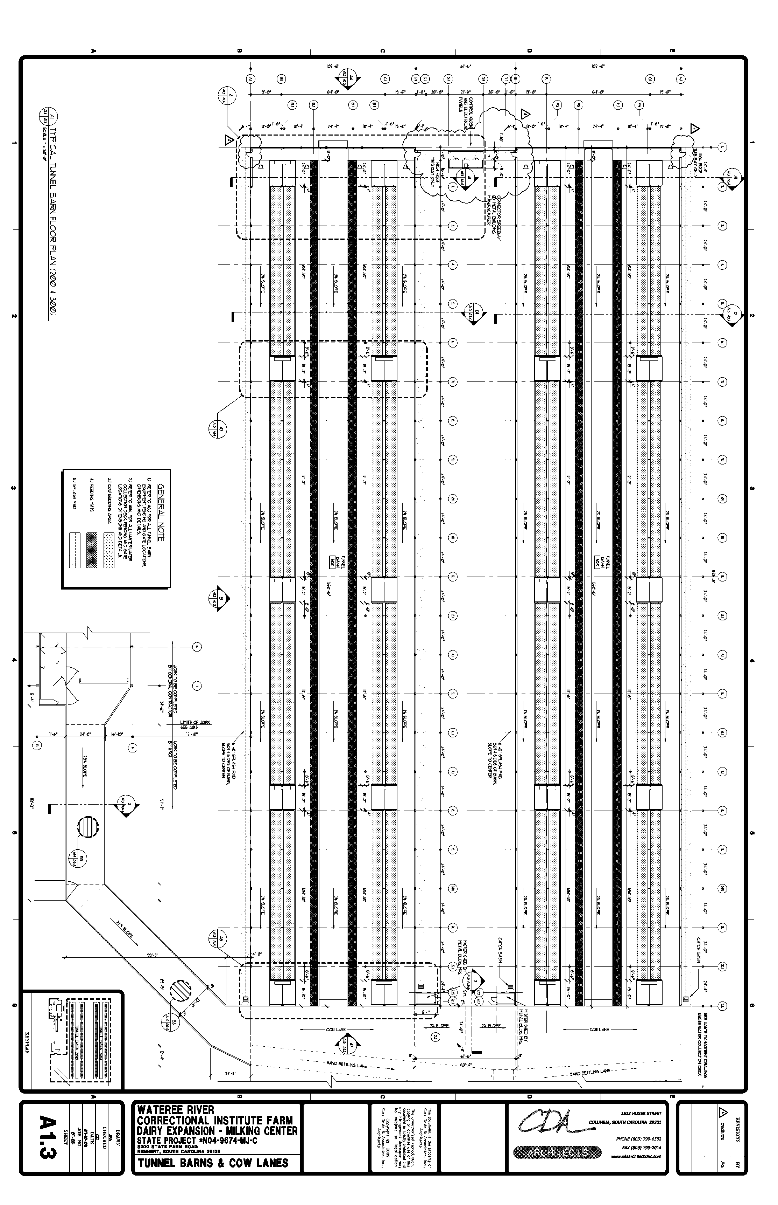
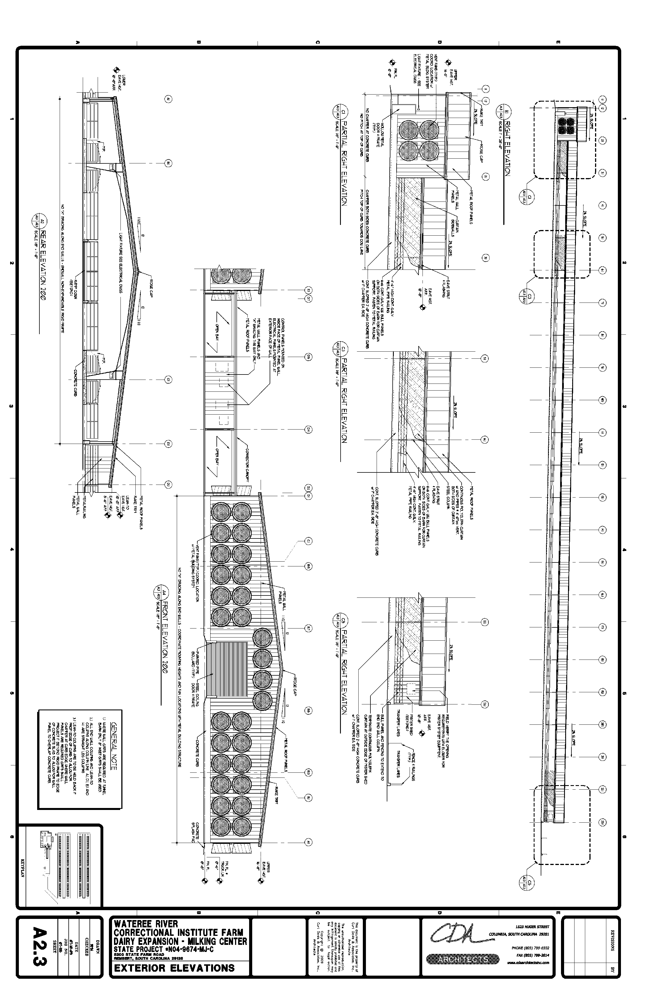
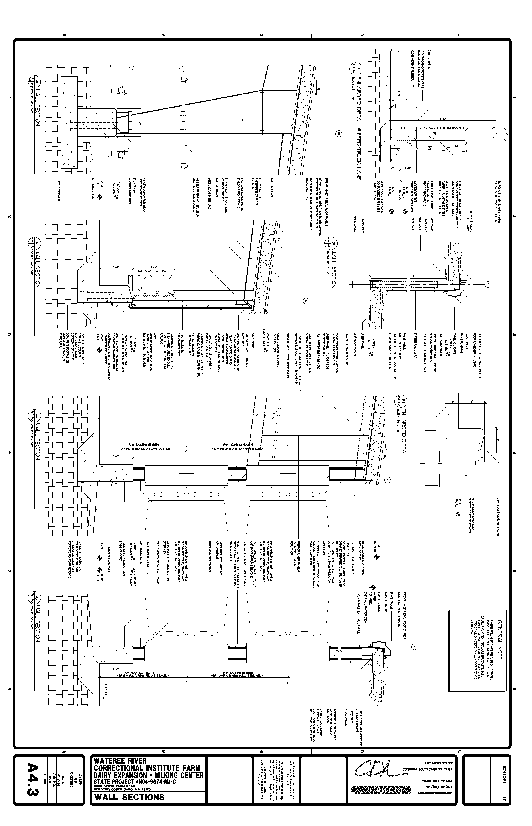
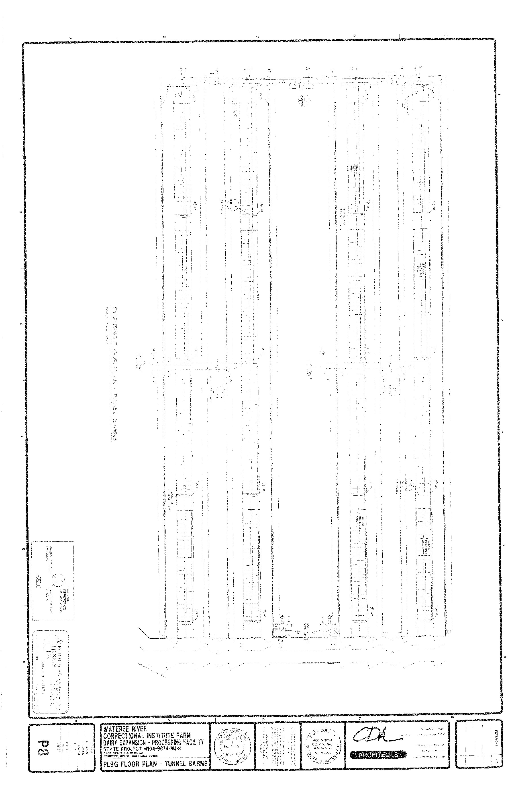
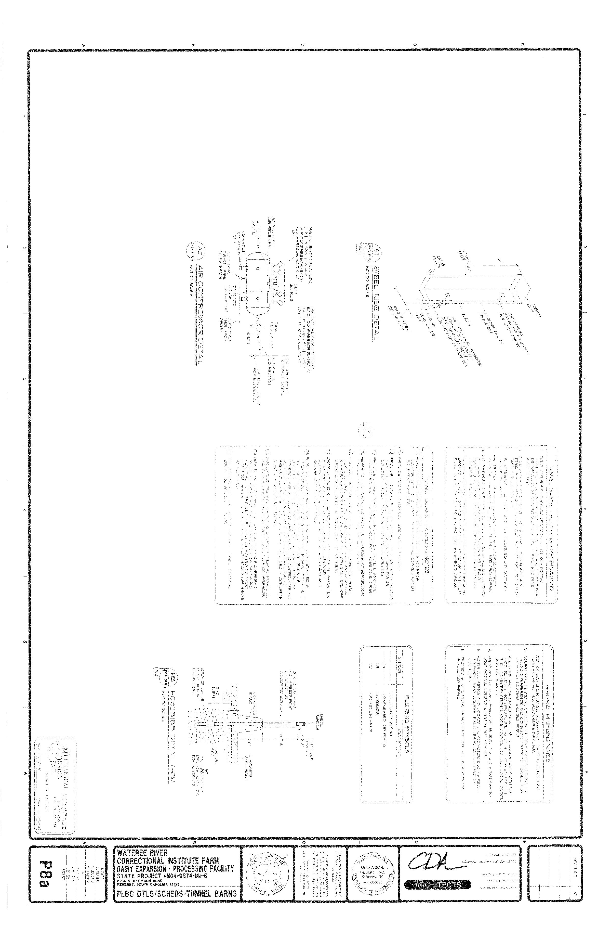
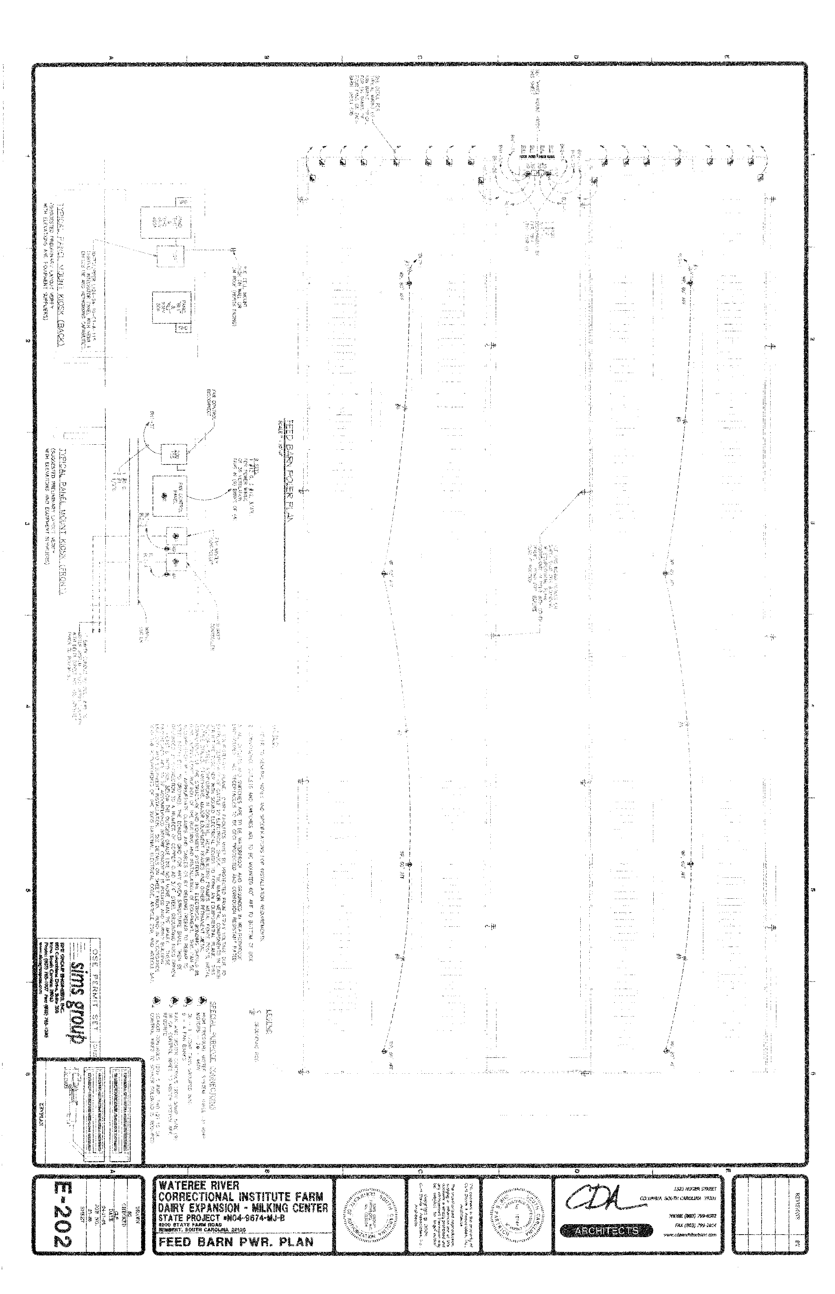
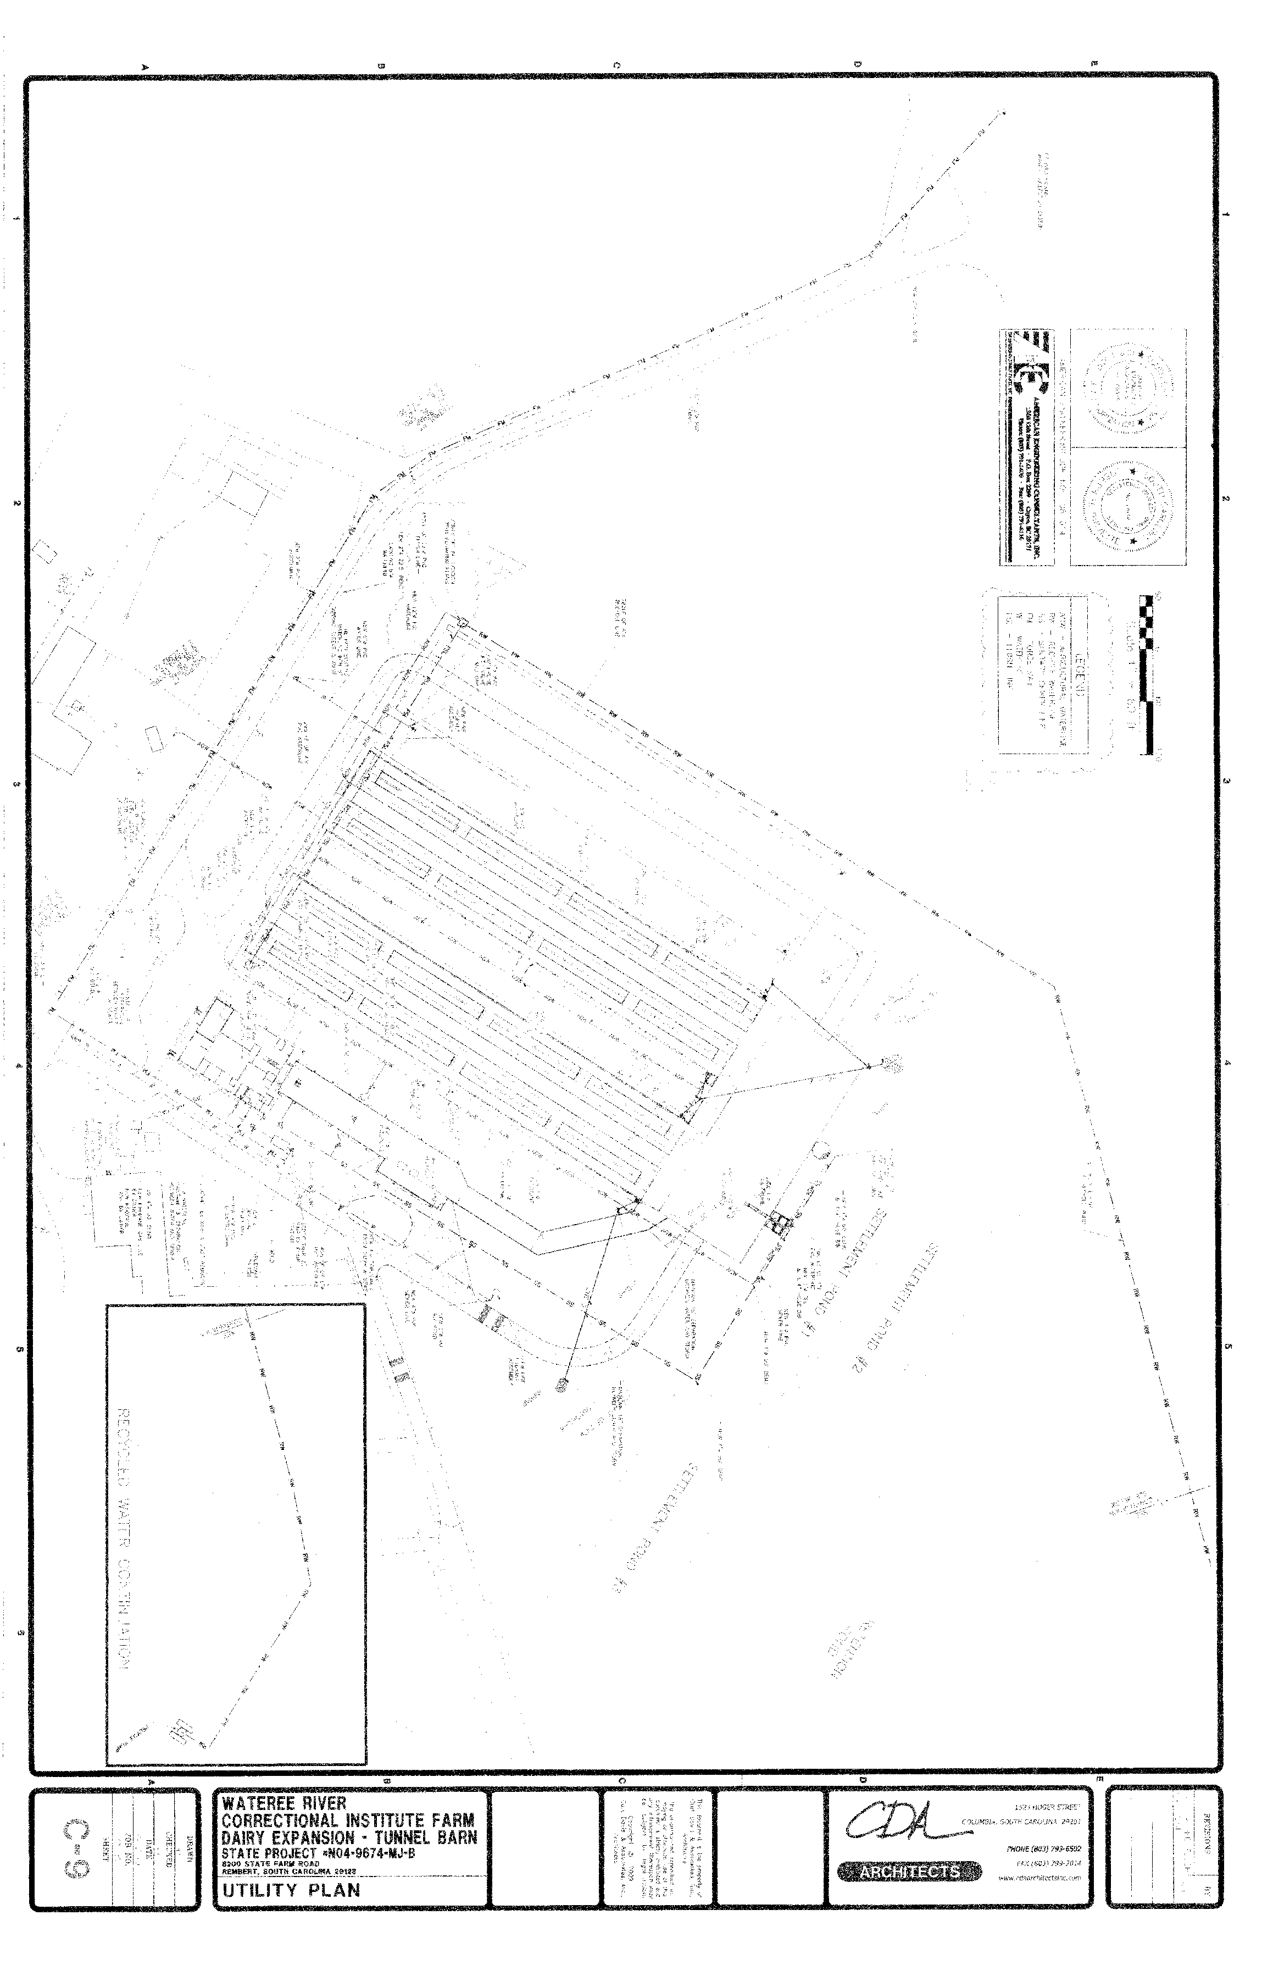
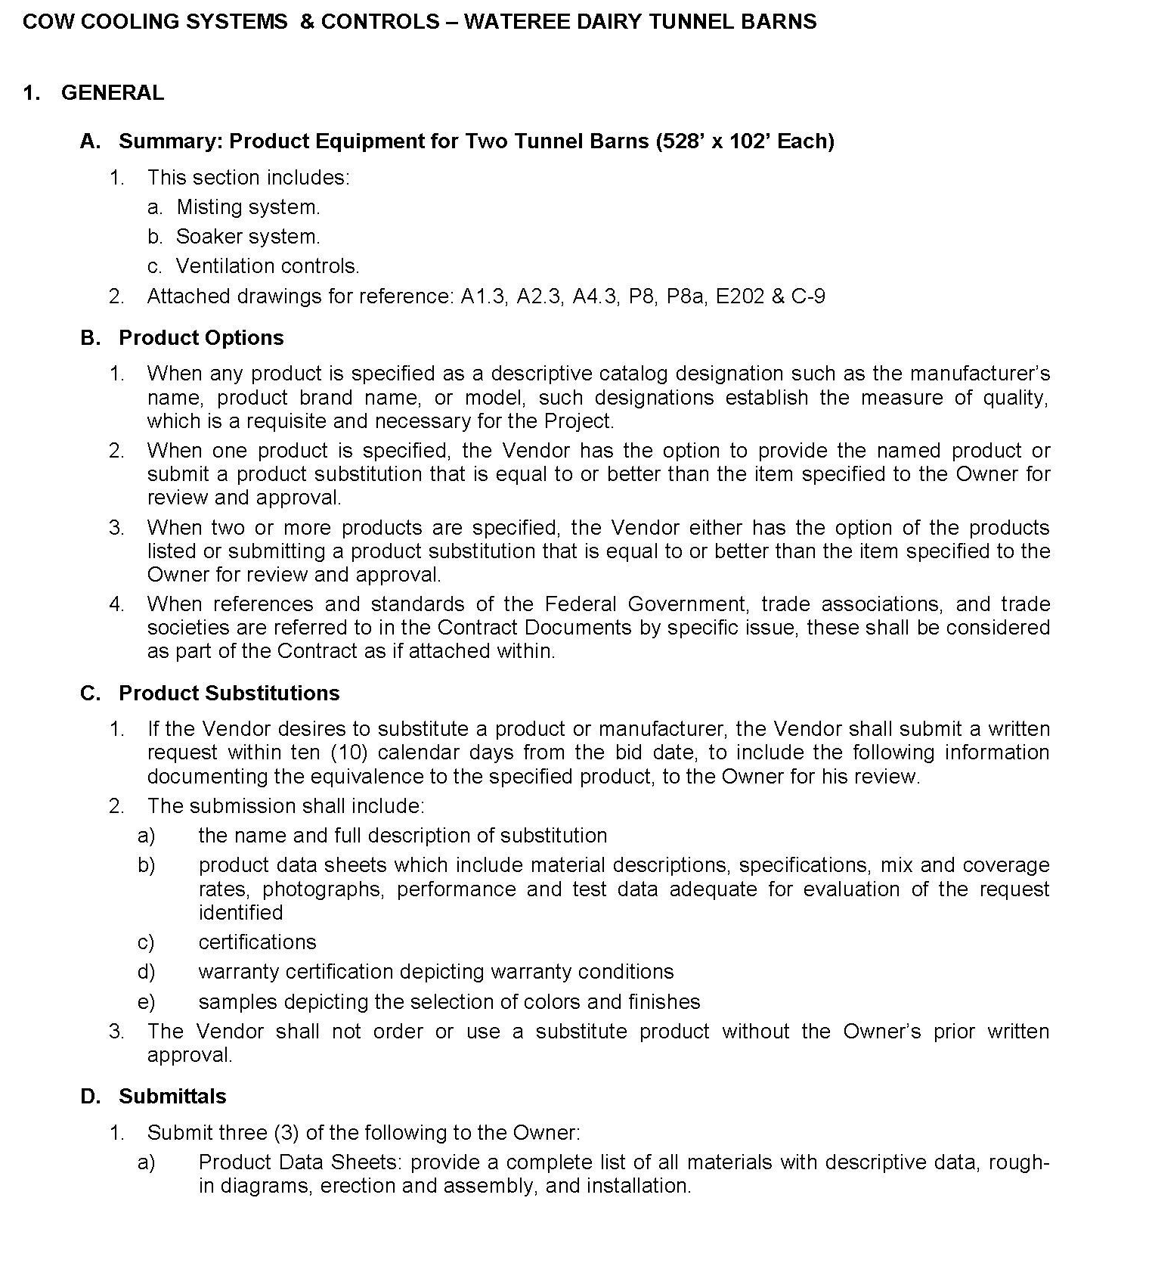

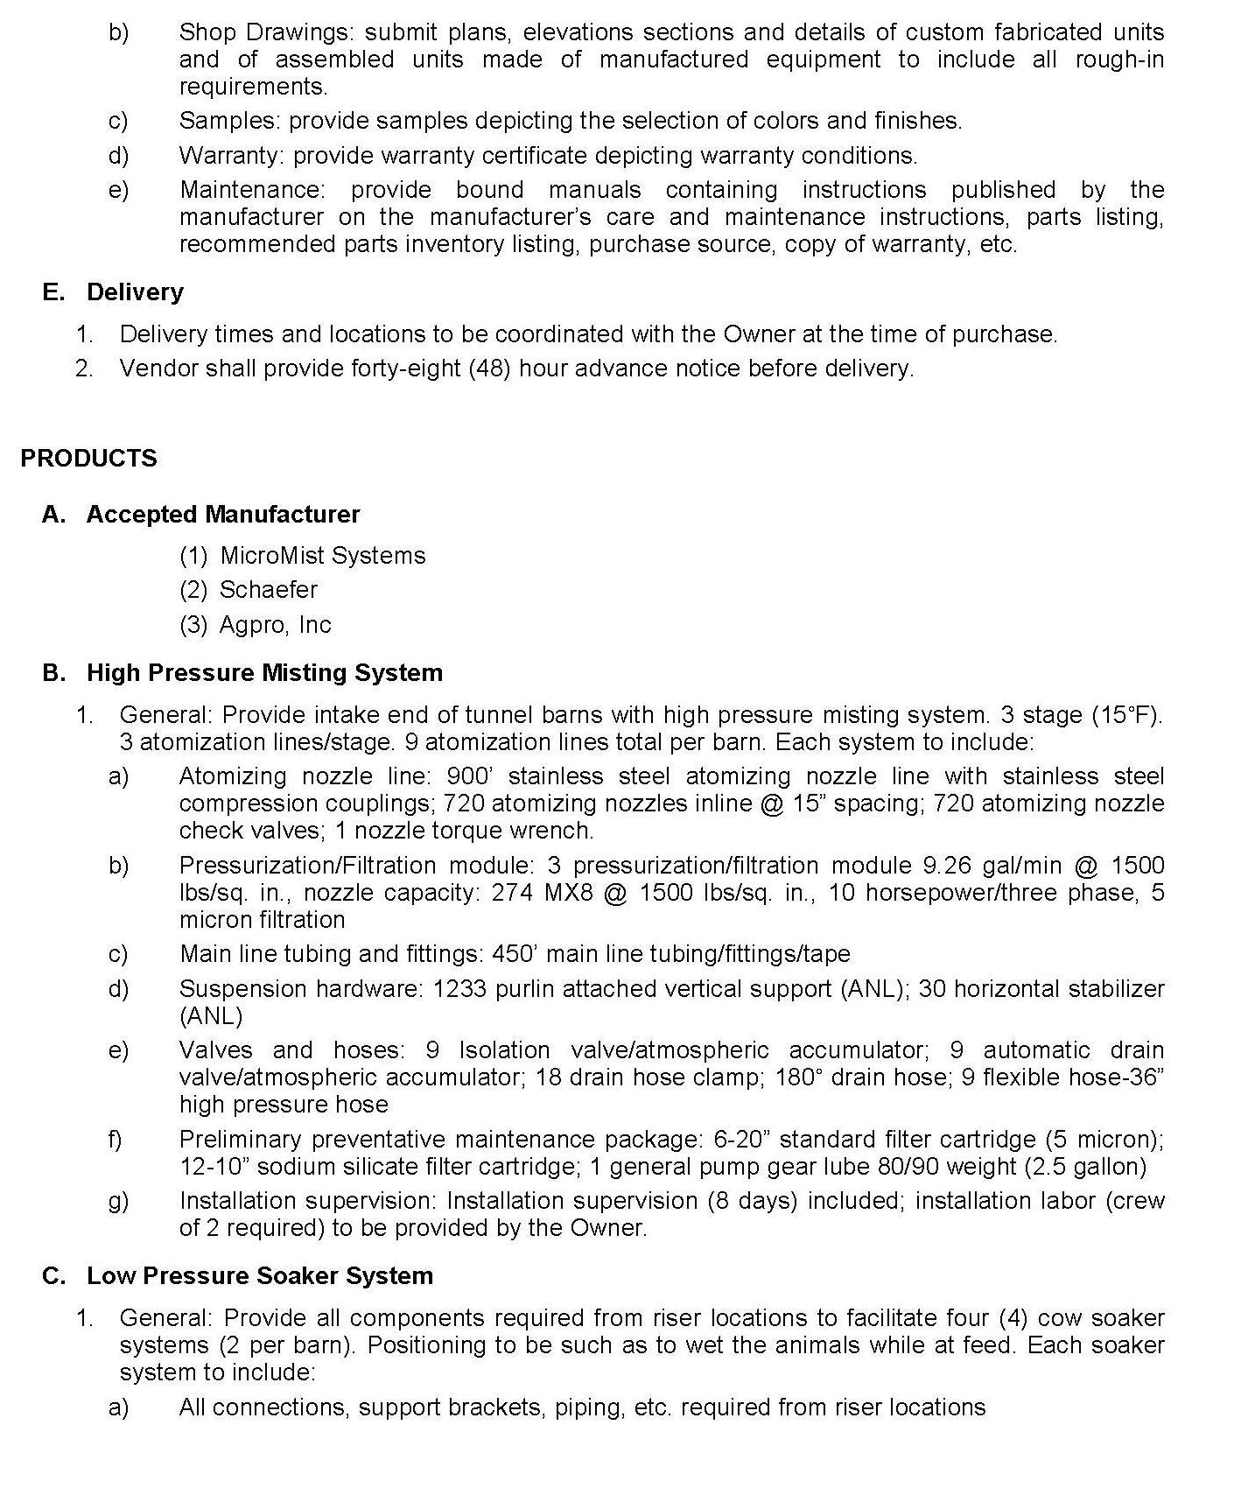

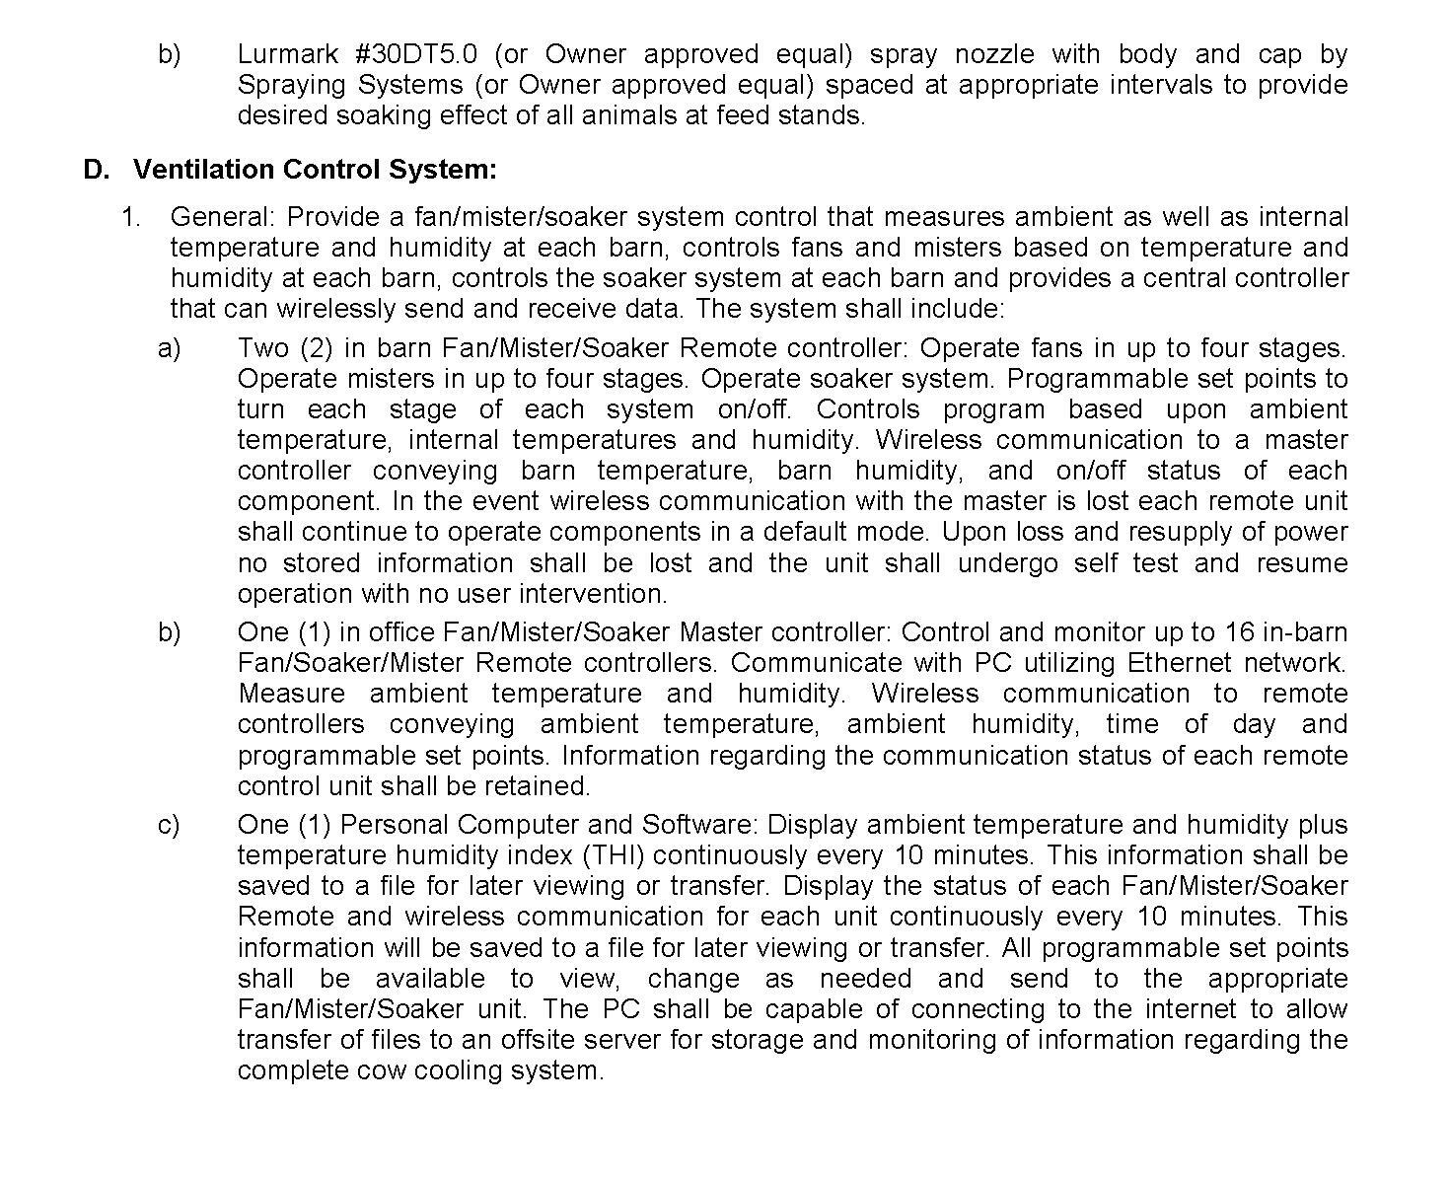

VIII. Bidding Schedule / Price-Business Proposal

Agency Req: 347809
Item | Quantity |  | Unit of  Measure | Unit Price | Extended Price
1 | 1 |  | EACH
Description: COW COOLINS SYSTEMS & CONTROLS :
    - HIGH PRESSURE MISTING SYSTEM
    - LOW PRESSURE SOAKER SYSTEM
    - CONTROL PANEL TO INTERFACE MISTING & SOAKER SYSTEM AND FANS

MFG/BRAND___________________________ CATALOG#____________________________

SC END PRODUCT ____YES ____NO US END PRODUCT ____YES ____NO

BIDDERS MUST SUMBIT REQUIRED DOCUMENTS IN SECTION D OF THE GENERAL SPECIFICIATIONS TO INCLUDE 3 COPIES OF 3 OF THE FOLLOWING:
- PRODUCT DATA SHEETS
- SHOP DRAWINGS
- SAMPLES
- WARRANTY
- MAINTENANCE
FAILURE TO SUBMIT REQUIRED DOCUMENTS LISTED ABOVE WILL RESULT IN A NON-RESPONSIVE BIDDER.

NOTE:
TO SEE A LARGER SET OF DRAWINGS PLEASE CONTACT SCDC’S PURCHASING DEPARTMENT @ 803-896-1949 AND REFERENCE SOLICITATION # 347809.

IX. Attachments To Solicitation

IMPORTANT TAX NOTICE - NONRESIDENTS ONLY

Withholding Requirements for Payments to Nonresidents: Section 12-8-550 of the South Carolina Code of Laws requires persons hiring or contracting with a nonresident conducting a business or performing personal services of a temporary nature within South Carolina to withhold 2% of each payment made to the nonresident. The withholding requirement does not apply to (1) payments on purchase orders for tangible personal property when the payments are not accompanied by services to be performed in South Carolina, (2) nonresidents who are not conducting business in South Carolina, (3) nonresidents for contracts that do not exceed $10,000 in a calendar year, or (4) payments to a nonresident who (a) registers with either the S.C. Department of Revenue or the S.C. Secretary of State and (b) submits a Nonresident Taxpayer Registration Affidavit - Income Tax Withholding, Form I-312 to the person letting the contract.

The withholding requirement applies to every governmental entity that uses a contract ("Using Entity"). Nonresidents should submit a separate copy of the Nonresident Taxpayer Registration Affidavit - Income Tax Withholding, Form I-312 to every Using Entity that makes payment to the nonresident pursuant to this solicitation. Once submitted, an affidavit is valid for all contracts between the nonresident and the Using Entity, unless the Using Entity receives notice from the Department of Revenue that the exemption from withholding has been revoked.
-----------------------
Section 12-8-540 requires persons making payment to a nonresident taxpayer of rentals or royalties at a rate of $1,200.00 or more a year for the use of or for the privilege of using property in South Carolina to withhold 7% of the total of each payment made to a nonresident taxpayer who is not a corporation and 5% if the payment is made to a corporation. Contact the Department of Revenue for any applicable exceptions.
-----------------------
For information about other withholding requirements (e.g., employee withholding), contact the Withholding Section at the South Carolina Department of Revenue at 803-898-5383 or visit the Department’s website at www.sctax.org.
-----------------------
This notice is for informational purposes only. This agency does not administer and has no authority over tax issues. All registration questions should be directed to the License and Registration Section at 803-898-5872 or to the South Carolina Department of Revenue, Registration Unit, Columbia, S.C. 29214-0140. All withholding questions should be directed to the Withholding Section at 803-898-5383.

BIDDER'S CHECKLIST

AVOID COMMON BIDDING MISTAKES

Review this checklist prior to submitting your bid.
If you fail to follow this checklist, you risk having your bid rejected.

DO NOT INCLUDE ANY OF YOUR STANDARD CONTRACT FORMS!

UNLESS EXPRESSLY REQUIRED, DO NOT INCLUDE ANY ADDITIONAL BOILERPLATE CONTRACT CLAUSES.

REREAD YOUR ENTIRE BID TO MAKE SURE YOUR BID DOES NOT TAKE EXCEPTION TO ANY OF THE STATE'S MANDATORY REQUIREMENTS.

MAKE SURE YOU HAVE PROPERLY MARKED ALL PROTECTED, CONFIDENTIAL, OR TRADE SECRET INFORMATION IN ACCORDANCE WITH THE HEADING ENTITLED: FOIA BIDDING INSTRUCTIONS, SUBMITTING CONFIDENTIAL INFORMATION. DO NOT MARK YOUR ENTIRE BID AS CONFIDENTIAL, TRADE SECRET, OR PROTECTED! DO NOT INCLUDE A LEGEND ON THE COVER STATING THAT YOUR ENTIRE RESPONSE IS NOT TO BE RELEASED!

HAVE YOU PROPERLY ACKNOWLEDGED ALL AMENDMENTS? INSTRUCTIONS REGARDING HOW TO ACKNOWLEDGE AN AMENDMENT SHOULD APPEAR IN ALL AMENDMENTS ISSUED.

MAKE SURE YOUR BID INCLUDES A COPY OF THE SOLICITATION COVER PAGE. MAKE SURE THE COVER PAGE IS SIGNED BY A PERSON THAT IS AUTHORIZED TO CONTRACTUALLY BIND YOUR BUSINESS.

MAKE SURE YOUR BID INCLUDES THE NUMBER OF COPIES REQUESTED.

CHECK TO ENSURE YOUR BID INCLUDES EVERYTHING REQUESTED!

CHECK AGAIN TO ENSURE YOUR BID INCLUDES EVERYTHING REQUESTED!

IF YOU HAVE CONCERNS ABOUT THE SOLICITATION, DO NOT RAISE THOSE CONCERNS IN YOUR RESPONSE! AFTER OPENING, IT IS TOO LATE! IF THIS SOLICITATION INCLUDES A PRE-BID CONFERENCE OR A QUESTION & ANSWER PERIOD, RAISE YOUR QUESTIONS AS A PART OF THAT PROCESS! PLEASE SEE BIDDING INSTRUCTIONS AND ANY PROVISIONS REGARDING PRE-BID CONFERENCES.

This checklist is included only as a reminder to help bidders avoid common mistakes.
Responsiveness will be evaluated against the solicitation, not against this checklist.
You do not need to return this checklist with your response.

WHEN SUBMITTING YOUR BID, PLEASE FILL IN THE FOLLOWING FEDERAL FORM W-9 IN ORDER THAT YOUR INFORMATION IS ENTERED INTO OUR COMPUTER SYSTEM CORRECTLY.

Form W-9  (Rev. January 2003)  Department of the Treasury  Internal Revenue Service |  |  | Request for Taxpayer  Identification Number and Certification |  |  |  |  |  |  |  | Give Form to the  Requester. Do Not  send to the IRS
Print or type  See Specific Instructions on page 2 | Name
Print or type  See Specific Instructions on page 2 | Business name, if different form above
Print or type  See Specific Instructions on page 2 | Individual/  Check Appropriate Box Sole proprietor Corporation Partnership Other ……. |  |  |  |  |  |  |  |  |  | Exempt from Backup  Withholding
Print or type  See Specific Instructions on page 2 | Address (number, street, and apt. or suite no. |  |  |  | Requester's name and address (optional)
Print or type  See Specific Instructions on page 2 | City, and ZIP code
Print or type  See Specific Instructions on page 2 | List account number(s) here (optional)
Part I |  | Taxpayer Identification Number (TIN)
Enter your TIN in the appropriate box. For individuals, this is your social security number (SSN). Social security number However, for a resident alien, sole proprietor, or disregarded entity, see the Part I instructions on page 3. For other entities, it is your employer identification number (EIN). If you do not have a number, see How to get a TIN on page 3.
or
Note: If the account is in more than one name, see the chart on page 4 for guidelines on whose number to enter.
 |  |  |  |  |  |  | or
Part II |  | Certification
Under penalties of perjury, I certify that:

- The number shown on this form is my correct taxpayer identification number (or I am waiting for a number to be issued to me), and

2. I am not subject to backup withholding because: (a) I am exempt from backup withholding, or (b) I have not been notified by the Internal Revenue Service (IRS) that I am subject to backup withholding as a result of a failure to report all interest or dividends, or (c) the IRS has notified me that I am no longer subject to backup withholding, and

- I am a U.S. person (including a U.S. resident alien).

Certification instructions. You must cross out item 2 above if you have been notified by the IRS that you are currently subject to backup withholding because you have failed to report all interest and dividends on your tax return. For real estate transactions, item 2 does not apply. For mortgage interest paid, acquisition or abandonment of secured property, cancellation of debt, contributions to an individual retirement arrangement (IRA). and generally, payments other than interest and dividends, you are not required to sign the Certification, but you must provide your correct TIN. (See the instructions on page 4.)
Sign Here | Signature of  U. S. person |  |  |  |  | Date
Purpose of Form  A person who is required to file an information return with the IRS,. must obtain your correct taxpayer identification number CnN) to report, for example, income paid to you, real estate transactions, mortgage interest you paid, acquisition or abandonment of secured property, cancellation of debt, or contributions you made to an IRA.  U.S. person. Use Form W-9 only if you are a U.S. person (including a resident alien), to provide your correct TIN to the person requesting it (the requester) and, when applicable, to:  1. Certify that the TIN you are giving is correct (or you are waiting for a number to be issued),  2. Certify that you are not subject to backup withholding,  3. Claim exemption from backup withholding if you are a U.S. exempt payee. -  Note: If a requester gives you a form other than Form W-9 to request your TIN, you must use the requester’s form if it is substantially similar to this Form W-9.  Foreign person. If you are a foreign person, use the  appropriate Form W-8 (see Pub. 515, Withholding of Tax on Nonresident Aliens and Foreign Entities).  or |  |  |  | Nonresident alien who becomes a resident alien.  Generally, only a nonresident alien individual may use the terms of a tax treaty to reduce or eliminate U.S. tax on certain types of income. However, most tax treaties Contain a provision known as a “saving clause.” Exceptions specified in the saving clause may permit an exemption from tax to continue for certain types of income even after the recipient has otherwise become a U.S. resident alien for tax purposes.  If you are a U.S. resident alien who is relying on an exception contained in the saving clause of a tax treaty to claim an exemption from U.S. tax on certain types of income, you must attach a statement that specifies the following five items:  1. The treaty country. Generally, this must be the same treaty under which you claimed exemption from tax as a nonresident alien.  2. The treaty article addressing the income.  3. The article number (or location) in the tax treaty that contains the saving clause and its exceptions.  4. The type and amount of income that qualifies for the exemption from tax.  5. Sufficient facts to justify the exemption from tax under the terms of the treaty article.

