
INVITATION FOR BID (IFB)

IFB Number: 12911

PR Number: 017972

Replaces Contract: 12144

Date Mailed: March 15, 2010

Closing Date: April 5, 2010, 2:00 PM

Procurement Officer: John T. Lowe
Telephone: 785-296-3126
E-Mail Address: john.lowe@da.ks.gov
Web Address: http://da.ks.gov/purch

Item: Blades For Graders And Plows

Agency: Department of Transportation
Location(s): Topeka, Kansas

Period of Contract: June 1, 2010 through May 31, 2011

Guarantee: No Monetary Guarantee Required

Scope: This Contract shall cover the procurement of Blades for Graders and Plows for the Department of Transportation, Topeka, Kansas, during the contract period referenced above.

READ THIS REQUEST CAREFULLY

Failure to abide by all of the conditions of this Request may result in the rejection of a bid. Inquiries about this Request should indicate the contract number and be directed to the procurement officer. Return in a sealed envelope or other container only the signature page and bid forms not later than the closing date indicated above. Retain the remaining documents for reference.

It shall be the vendor's responsibility to monitor this website on a regular basis for any changes/addenda.

SIGNATURE SHEET

Item: Blades For Graders And Plows

Agency: Department of Transportation

Closing Date: April 5, 2010

By submission of a bid and the signatures affixed thereto, the bidder certifies all products and services proposed in the bid meet or exceed all requirements of this specification as set forth in the request and that all exceptions are clearly identified.

Legal Name of Person, Firm or Corporation

Mailing Address City & State Zip

Toll Free Telephone Local Cell: Fax

Tax Number
CAUTION: If your tax number is the same as your Social Security Number (SSN), you must leave this line blank. DO NOT enter your SSN on this signature sheet. If your SSN is required to process a contract award, including any tax clearance requirements, you will be contacted by an authorized representative of the Division of Purchases at a later date.

E-Mail

Signature Date

Typed Name Title

In the event the contact for the bidding process is different from above, indicate contact information below.

Bidding Process Contact Name

Mailing Address City & State Zip

Toll Free Telephone Local Cell: Fax

E-Mail

If awarded a contract and purchase orders are to be directed to an address other than above, indicate mailing address and telephone number below.

Award Contact Name

Mailing Address City & State Zip

Toll Free Telephone Local Cell: Fax

E-Mail

Pricing is available to political subdivisions. Yes ____ No ___
(Refusal will not be a determining factor in award of this contract.)

Agencies may use the Business Procurement Card for contract purchases. Yes ____ No ___
(Refusal will not be a determining factor in award of this contract.)

State of Kansas
Department of Administration
Division of Purchases

Supplier Diversity Survey Form

Why is the Division of Purchases requesting this information?

Current statutes governing the activities of the Kansas Division of Purchases do not include preferences or set-asides for Small Business Enterprises (SBEs). The Division of Purchases is interested in determining to what extent purchase orders and contracts are awarded to SBEs under existing work efforts. Please Note: You must submit this form with each bid opportunity.

Persons or concerns wishing to receive a Purchase Order or Contract Award resulting from this bid opportunity must provide the information contained in this document before the award is made. To help expedite this procurement, it is requested that you submit this form with your bid.

COMPANY DATA

Legal Company Name
Doing Business As (if applicable)
Federal Tax ID Number / FEIN
CAUTION: If your tax number is the same as your Social Security Number (SSN), you must leave this line blank. DO NOT enter your SSN on this sheet. If your SSN is required for any reason, you will be contacted by an authorized representative of the Division of Purchases at a later date.

Diversity Program Contact Name Title
Phone Number Fax Number
E-Mail Address Company Web
Address
City State Zip Code
Legal Structure: □ Corporation □ Partnership □ Non-Profit □ Sole Proprietorship □ LLC

Signature Date:

COMPANY DIVERSITY DATA

(A) Business Classification (See Appendix A for definitions):
Is your business a Small Business Enterprise (SBE) as defined by the SBA?
□ Yes □ No □ Don’t Know
Check all that Apply: □ Disabled (DIS) □ SBA-Small Disadvantage Business (SDB)
□ Veteran-Owned (VBE) □ Women-Owned (WBE) □ Service-Disabled Veterans-Owned (DVBE)
□ African American □ Native American □ Minority-Owned Business Enterprise (MBE)
□ Hispanic American □ Asian Pacific American □ Disadvantaged Business Enterprise (DBE)
□ Asian Subcontinent American □ Other: __________________________________________________________

(B) Has your Business Classification Status been certified by a state, municipal, federal or other certifying agency?
□ No □ Yes Certifying Entity:

Other State of Kansas Resources for Small Business Enterprises (SBE)

Kansas Department of Commerce
Office of Minority/Women Business Development
http://www.kansas.gov/ksbdc/
State of Kansas
Department of Administration
Division of Purchases
Supplier Diversity Survey Form

Appendix A
Definition of Terms

Small Business Enterprise / Concern (SBE)
SBEs are businesses that do not exceed the size standard for the product or service it is providing as measured by its employment and/or business receipts in accordance with the U.S. SBA numerical size standards. These standards are defined as FAR 52.219-8, 13 CFR Part 121 and 13 CFR 121.410.

Disadvantaged Business Enterprise (DBE)
DBEs are defined as a business which are (a) owned by socially disadvantaged individuals who have been subjected to racial or ethnic
prejudice or cultural bias because of their identity as a member of a group without regard to their individual qualities; or (b) owned by economically disadvantaged individuals whose ability to compete in the free enterprise system has been impaired due to diminished opportunities to obtain capital and credit as compared to others in the same line of business who are not socially disadvantaged.

Disabled Business Enterprise (DIS)
DIS businesses are at least 51% owned and controlled by one or more U.S. citizens who has a physical or mental impairment which substantially limits one or more of such person’s major life activities.

Small Disadvantage Business Concern (SDB)
SDB businesses are certified by the SBA as meeting the following criteria: (1) they are small business concern and (2) must be at least 51% owned and controlled by one or more U.S. citizens who are socially and economically disadvantaged. African Americans, Asian Pacific Americans, Asian Subcontinent Americans, Hispanic Americans and Native Americans are presumed to qualify as being socially disadvantaged. Other individuals can qualify if they show by a preponderance of the evidence that they are socially disadvantaged. In addition, the personal net worth of each eligible owner applicant must be less than $750,000, excluding the values of the applicant’s ownership interest in the business seeking certification and the owner’s primary residence. Successful applicants must also meet applicable size standards for small businesses in their industry. SDB regulations can be found in FAR 52.219-8 and 13 CFR parts 121 & 124.

Veterans-Owned Business Concern (VBE)
VBE businesses are at least 51% owned and controlled by one or more U.S. citizens who are Veterans of the U.S. Armed Forces. In the case of any publicly owned business, at least 51% of the stock is owned by one or more veterans and one or more veterans must control the management and daily business operation. The term “Veteran” means a person who served in the active military, naval or air service and who was discharged or released there from under conditions other than dishonorable. VBE regulations can be found in FAR 52.219-9 & 38 USC 101 (2).

Service-Disabled Veterans-Owned Business Concern (DVBE)
DVBE businesses are at least 51% owned and controlled by one or more U.S. citizens who are service-disabled Veterans of the U.S. Armed Forces. In the case of any publicly owned business, at least 51% of the stock is owned by one or more service-disabled veterans and one or more veterans must control the management and daily business operation. The term “Veteran” means a person who served in the active military, naval or air service and who was discharged or released there from under conditions other than dishonorable. The term “Service-Disabled” means a veteran of the U.S. Military Service has a service-connected disability with a disability rating of 0%-100%. In the case of permanent or severe disability, the spouse of caregiver of such a service-disabled veteran may control the management and daily operations. DVBE regulations can be found in FAR 52.219-9 & 38 USC 101 (2) & USC 101 (16).

Women-Owned Business Concern (WBE)
WBE businesses are at least 51% owned and controlled by one or more U.S. citizens who are female gender. In the case of any publicly owned business, at least 51% of the stock is owned by one or more women and one or more women must control the management and daily business operations. For Federal contracting regulations see FAR 52-219-8.

Minority-Owned Business Enterprise (MBE)
MBE businesses are at least 51% owned and controlled by one or more U.S. citizens belonging to certain ethnic minority groups. In the case of any publicly owned business, at least 51 % of the stock is owned by one or more minorities, and one or more minorities must control the management and daily business operations. “Ethnic Minority Groups” are people of Asian Pacific American, Asian Subcontinent American, African American, Hispanic American and Native American descent.
- African Americans: People whose origins lay in any of the Black racial groups of Africa.
- Asian Pacific Americans: People whose origins lay in Brunei, Burma, China, Guam, Indonesia, Japan, Kampuchea (Cambodia), Korea, Laos, Malaysia, Northern Mariana Islands, Republic of the Marshall Islands, Federated States of Micronesia, Republic of Palau (U.S. Trust Territory of the Pacific Islands), the Philippines, Samoa, Singapore, Taiwan, Thailand and Vietnam.
- Asian Subcontinent Americans: People whose origins lay in Bangladesh, Bhutan, India, Pakistan, Sri Lanka or Nepal.
- Hispanic Americans: People whose origins are in the South and Central America, Mexico, Puerto Rico, Cuba or the Iberian Peninsula (including Portugal).
- Native Americans: American Indians, Inuit (Eskimos), Aleuts, and native Hawaiians of Polynesian ancestry.

Date of Last Update: March, 2007
Tax Clearance INSTRUCTIONS
PLEASE NOTE: This information has changed effective 10/27/09

A “Tax Clearance” is a comprehensive tax account review to determine and ensure that the account is compliant with all primary Kansas Tax Laws administered by the Kansas Department of Revenue (KDOR) Director of Taxation. Information pertaining to a Tax Clearance is subject to change(s), which may arise as a result of a State Tax Audit, Federal Revenue Agent Report, or other lawful adjustment(s).

To obtain a Tax Clearance Certificate, you must:
- Go to http://www.ksrevenue.org/taxclearance.htm to request a Tax Clearance Certificate
- Return to the website the following working day to see if KDOR will issue the certificate
- If issued an official certificate, print it and attach it to your bid response
- If denied a certificate, engage KDOR in a discussion about why a certificate wasn’t issued

Bidders (and their subcontractors) are expected to submit a current Tax Clearance Certificate with every event response.

Per KSA 75-3740-(c), the Director of Purchases may reject the bid of any bidder who is in arrears on taxes due the State of Kansas. The Secretary of the Kansas Department of Revenue is authorized to exchange such information with the Director of Purchases as is necessary to determine a bidder’s tax clearance status, notwithstanding any other provision of law prohibiting disclosure of the contents of taxpayer records or information.

Please Note: Individual and business applications are available. For applications entered prior to 5:00 PM Monday through Friday, results typically will be available the following business day. Tax clearance requests may be denied if the request includes incomplete or incorrect information.

Please Note: You will need to sign back into the KDOR website to view and print the official tax clearance certificate.

Information about Tax Registration can be found at the following website:
http://www.ksrevenue.org/busregistration.htm

The Division of Purchases reserves the right to confirm tax status of all potential contractors and subcontractors prior to the release of a purchase order or contract award.

In the event that a current tax certificate is unavailable, the Division of Purchases reserves the right to notify a bidder (one that has submitted a timely event response) that they have to provide a current Tax Clearance Certificate within ten (10) calendar days, or the Division may proceed with an award to the next lowest responsive bidder, whichever is determined by the Director of Purchases to be in the best interest of the State.

CERTIFICATION REGARDING
IMMIGRATION REFORM & CONTROL

All Contractors are expected to comply with the Immigration and Reform Control Act of 1986 (IRCA), as may be amended from time to time. This Act, with certain limitations, requires the verification of the employment status of all individuals who were hired on or after November 6, 1986, by the Contractor as well as any subcontractor or sub-subcontractor. The usual method of verification is through the Employment Verification (I-9) Form. With the submission of this bid, the Contractor hereby certifies without exception that Contractor has complied with all federal and state laws relating to immigration and reform. Any misrepresentation in this regard or any employment of persons not authorized to work in the United States constitutes a material breach and, at the State’s option, may subject the contract to termination and any applicable damages.

Contractor certifies that, should it be awarded a contract by the State, Contractor will comply with all applicable federal and state laws, standards, orders and regulations affecting a person’s participation and eligibility in any program or activity undertaken by the Contractor pursuant to this contract. Contractor further certifies that it will remain in compliance throughout the term of the contract.

At the State’s request, Contractor is expected to produce to the State any documentation or other such evidence to verify Contractor’s compliance with any provision, duty, certification, or the like under the contract.

Contractor agrees to include this Certification in contracts between itself and any subcontractors in connection with the services performed under this contract.

____________________________________________ ______________________
Signature, Title of Contractor date
SECTION I
CONDITIONS TO BIDDING

Solicitation Reference Number: The above-number has been assigned to this Solicitation and MUST be shown on all correspondence or other documents associated with this Solicitation and MUST be referred to in all verbal communications. All inquiries, written or verbal, shall be directed to the procurement officer only.

John T. Lowe
Telephone: 785-296-3126
Facsimile: 785-296-7240
E-Mail Address: john.lowe@da.ks.gov
Kansas Division of Purchases
900 SW Jackson, Room 102N
Topeka, KS 66612-1286

Failure to notify the Procurement Officer of any conflicts or ambiguities in the Request may result in items being resolved in the best interest of the State. Any modification to this Request as a result of the pre-proposal conference, as well as written answers to written questions, shall be made in writing by addendum and mailed to all vendors who received the original request from the Division of Purchases. Only written communications are binding.

Cost of Preparing Bid Response: The cost of developing and submitting the bid response is entirely the responsibility of the vendor. This includes costs to determine the nature of the engagement, preparation of the bid response, submitting the bid response, negotiating for the contract and other costs associated with this Solicitation. All responses will become the property of the State of Kansas and will be a matter of public record subsequent to signing of the contract or rejection of all bids.

Evaluation of Bids: Award shall be to the lowest responsible bidder taking into consideration conformity with the specifications, terms of delivery and other conditions imposed by this Invitation For Bid. Award will be by line item, group totals, or total lot, whichever is in the best interest of the State of Kansas.

Acceptance or Rejection: The State of Kansas reserves the right to accept or reject any or all bid responses or part of a bid response; to waive any informalities or technicalities; clarify any ambiguities in bid responses; modify any criteria in this Solicitation; and unless otherwise specified, to accept any item in a bid response.

Contract: The successful vendor will be required to enter into a written contract with the State. The vendor agrees to accept the provisions of form DA-146a, Contractual Provisions Attachment, which is incorporated into all contracts with the State and is attached to this Solicitation.

Contract Documents: This Solicitation and any amendments and the bid response and any amendments of the successful vendor shall be incorporated along with the DA-146a into the written contract award which shall compose the complete understanding of the parties.

In the event of a conflict in terms of language among the documents, the following order of precedence shall govern:

1. Form DA-146a;
2. written modifications to the executed contract;
3. written contract signed by the parties;
4. this Solicitation including any and all addenda; and
5. contractor's written bid response submitted in response to this Request as finalized.

Contract Formation: No contract shall be considered to have been entered into by the State until all statutorily required signatures and certifications have been rendered; funds for the contract have been encumbered with the Division of Accounts and Reports; and a written contract has been signed by the successful vendor.

Open Records Act (K.S.A. 45-215 et seq.): All bid responses become the property of the State of Kansas. Kansas law requires all information contained in bid responses to become open for public review once a contract is signed or all bid responses are rejected.
Federal, State and Local Taxes-Governmental Entity: Unless otherwise specified, the bid response price shall include all applicable federal, state and local taxes. The successful vendor shall pay all taxes lawfully imposed on it with respect to any product or service delivered in accordance with this Solicitation. The State of Kansas is exempt from state sales or use taxes and federal excise taxes for direct purchases. These taxes shall not be included in the vendor's price quotations.

Debarment of State Contractors. Any vendor who defaults on delivery as defined in this Solicitation may, be barred (a) After reasonable notice to the person involved and reasonable opportunity for that person to be heard, the secretary of administration, after consultation with the contracting agency and the attorney general, shall have authority to debar a person for cause from consideration for award of contracts. The debarment shall not be for a period exceeding three years. The secretary, after consultation with the contracting agency and the attorney general, shall have authority to suspend a person from consideration for award of contracts if there is probable cause to believe that the person has engaged in any activity which might lead to debarment. The suspension shall not be for a period exceeding three months unless an indictment has been issued for an offense which would be a cause for debarment under subsection (b), in which case the suspension shall, at the request of the attorney general, remain in effect until after the trial of the suspended person.

Insurance: The State shall not be required to purchase any insurance against loss or damage to any personal property nor shall the State establish a "self-insurance" fund to protect against any loss or damage. Subject to the provisions of the Kansas Tort Claims Act, the vendor shall bear the risk of any loss or damage to any personal property.
SECTION II
BID INSTRUCTIONS

Preparation of Bid Response: Prices are to be entered in spaces provided on the BID FORM if provided herein. Computations and totals shall be indicated where required. The State has the right to rely on any price quotes provided by vendors. The vendor shall be responsible for any mathematical error in price quotes. The State reserves the right to reject bid responses which contain errors.

Vendors are instructed to prepare their Bid Response following the same sequence as the Invitation For Bid.

Submission of Bid Responses: Vendor's bid response shall consist of:
• Signature Sheet
• Two (2) copies of the bid response, including literature and other supporting documents;

Vendor's bid response, sealed securely in an envelope or other container, shall be received promptly at 2:00 p.m., Central Standard or Daylight Savings Time, whichever is in effect, on
April 5, 2010, addressed as follows:

Kansas Division of Purchases
Proposal #12144
Closing: April 5, 2010
900 SW Jackson Street, Room 102N
Topeka, KS 66612-1286

It is the vendor’s responsibility to ensure bids are received by the closing date and time. Delays in mail delivery or any other means of transmittal, including couriers or agents of the issuing entity shall not excuse late bid submissions.

PLEASE NOTE: If you expect to deliver your bid in person, watch for a major construction project which result in the closure of streets around the Landon State Office Building at various times throughout 2009. This construction activity will affect ease of access to the building. Please plan accordingly.

Faxed or telephone bids are not acceptable unless this Solicitation is for an amount less than $25,000.00.

Bid responses received prior to the closing date shall be kept secured and sealed until closing. The State shall not be responsible for the premature opening of a bid response or for the rejection of a bid response that was not received prior to the closing date because it was not properly identified on the outside of the envelope or container. Late Bid Response will be retained unopened in the file and not receive consideration.

Signature of Bid Responses: Each bid response shall give the complete mailing address of the vendor and be signed by an authorized representative by original signature with his or her name and legal title typed below the signature line.

Acknowledgment of Addenda: All vendors shall acknowledge receipt of any addenda to this Solicitation. Failure to acknowledge receipt of any addenda may render the bid response to be non-responsive. Changes to this Solicitation shall be issued only by the Division of Purchases in writing.

Modification of Bid Responses: A vendor may modify a bid response by letter or by FAX transmission at any time prior to the closing date and time for receipt of bid responses.

Withdrawal of Bid Responses: A bid response may be withdrawn on written request from the vendor to the Procurement Officer at the Division of Purchases prior to the closing date.

Bid Disclosures: At the time of closing, bid prices shall be made public information. Interested vendors or their representatives may be present at the announcement at the following location:

Kansas Division of Purchases
900 Jackson Street, Room 102N
Topeka, KS 66612-1286

Bid results will not be given to individuals over the telephone. Results may be obtained after contract finalization by obtaining a bid tabulation from the Division of Purchases. Bid results can be obtained by sending (do not include with bid):

1. A check for $3.00, payable to the State of Kansas and
2. A self -addressed, stamped envelope;
3. Invitation For Bid Number,

Send to:
Kansas Division of Purchases
Attention: Bid Results/Copies
900 SW Jackson, Room 102N
Topeka, KS 66612-1286

Copies of individual bid responses may be obtained under the Kansas Open Records Act by calling 785-296-0002 to request an estimate of the cost to reproduce the documents and remitting that amount with a written request to the above address or a vendor may make an appointment by calling the above number to view the bid file. Upon receipt of the funds, the documents will be mailed. Information in bid files shall not be released until a contract has been executed or all bid responses have been rejected.

Notice of Award: An award is made on execution of the written contract by all parties. Only the State is authorized to issue news releases relating to this Solicitation, its evaluation, award and/or performance of the contract. The Division of Purchases shall issue either a purchase order or a written contract to the successful vendor.
SECTION III
GENERAL PROVISIONS

Inspection: The State reserves the right to reject, on arrival at destination, any items which do not conform with specification of this Solicitation.

Termination for Cause: The Director of Purchases may terminate this contract, or any part of this contract, for cause under any one of the following circumstances:

1. the Contractor fails to make delivery of goods or services as specified in this contract; or

2. the Contractor fails to perform any of the provisions of this contract, or so fails to make progress as to endanger performance of this contract in accordance with its terms.

The Director of Purchases shall provide Contractor with written notice of the conditions endangering performance. If the Contractor fails to remedy the conditions within ten (10) days from the receipt of the notice (or such longer period as State may authorize in writing), the Director of Purchases shall issue the Contractor an order to stop work immediately. Receipt of the notice shall be presumed to have occurred within three (3) days of the date of the notice.

Termination for Convenience: The Director of Purchases may terminate performance of work under this contract in whole or in part whenever, for any reason, the Director of Purchases shall determine that the termination is in the best interest of the State of Kansas. In the event that the Director of Purchases elects to terminate this contract pursuant to this provision, it shall provide the Contractor written notice at least thirty (30) days prior to the termination date. The termination shall be effective as of the date specified in the notice. The Contractor shall continue to perform any part of the work that may have not been terminated by the notice.

Notices: All notices, demands, requests, approvals, reports, instructions, consents or other communications (collectively "notices") which may be required or desired to be given by either party to the other shall be IN WRITING and addressed as follows:

John T. Lowe
Kansas Division of Purchases
900 SW Jackson St, Room 102N
Topeka, KS 66612-1286

or to any other persons or addresses as may be designated by notice from one party to the other.

Rights and Remedies: If this contract is terminated, the State, in addition to any other rights provided for in this contract, may require the Contractor to transfer title and deliver to the State in the manner and to the extent directed, any completed materials. The State shall be obligated only for those services and materials rendered and accepted prior to the date of termination.

If it is determined, after notice of termination for cause, that Contractor's failure was due to causes beyond the control of or negligence of the Contractor, the termination shall be a termination for convenience.

In the event of termination, the Contractor shall receive payment pro rated for that portion of the contract period services were provided to and/or goods were accepted by State subject to any offset by State for actual damages including loss of federal matching funds.

The rights and remedies of the State provided for in this contract shall not be exclusive and are in addition to any other rights and remedies provided by law.

Force Majeure: The Contractor shall not be held liable if the failure to perform under this contract arises out of causes beyond the control of the Contractor. Causes may include, but are not limited to, acts of nature, fires, tornadoes, quarantine, strikes other than by Contractor's employees, and freight embargoes, etc.

Waiver: Waiver of any breach of any provision in this contract shall not be a waiver of any prior or subsequent breach. Any waiver shall be in writing and any forbearance or indulgence in any other form or manner by State shall not constitute a waiver.

Ownership: All data, forms, procedures, software, manuals, system descriptions and work flows developed or accumulated by the Contractor under this contract shall be owned by the using agency. The Contractor may not release any materials without the written approval of the using agency.

Independent Contractor: Both parties, in the performance of this contract, shall be acting in their individual capacity and not as agents, employees, partners, joint ventures or associates of one another. The employees or agents of one party shall not be construed to be the employees or agents of the other party for any purpose whatsoever.

The Contractor accepts full responsibility for payment of unemployment insurance, workers compensation and social security as well as all income tax deductions and any other taxes or payroll deductions required by law for its employees engaged in work authorized by this contract.

Staff Qualifications: The Contractor shall warrant that all persons assigned by it to the performance of this contract shall be employees of the Contractor (or specified Subcontractor) and shall be fully qualified to perform the work required. The Contractor shall include a similar provision in any contract with any Subcontractor selected to perform work under this contract.

Failure of the Contractor to provide qualified staffing at the level required by the proposal specifications may result in termination of this contract and/or damages.

Conflict of Interest: The Contractor shall not knowingly employ, during the period of this contract or any extensions to it, any professional personnel who are also in the employ of the State and who are providing services involving this contract or services similar in nature to the scope of this contract to the State. Furthermore, the Contractor shall not knowingly employ, during the period of this contract or any extensions to it, any state employee who has participated in the making of this contract until at least two years after his/her termination of employment with the State.

Confidentiality: The Contractor may have access to private or confidential data maintained by State to the extent necessary to carry out its responsibilities under this contract. Contractor must comply with all the requirements of the Kansas Open Records Act in providing services under this contract. Contractor shall accept full responsibility for providing adequate supervision and training to its agents and employees to ensure compliance with the Act. No private or confidential data collected, maintained or used in the course of performance of this contract shall be disseminated by either party except as authorized by statute, either during the period of the contract or thereafter. Contractor must agree to return any or all data furnished by the State promptly at the request of State in whatever form it is maintained by contractor. On the termination of expiration of this contract, contractor will not use any of such data or any material derived from the data for any purpose and, where so instructed by State, will destroy or render it unreadable.

Reviews and Hearings: The Contractor agrees to advise the Director of Purchases of all complaints of recipients made known to the Contractor and refer all appeals or fair hearing requests to the Director of Purchases. The State has the discretion to require the Contractor to participate in any review, appeal, fair hearing or litigation involving issues related to this contract.

Nondiscrimination and Workplace Safety: The Contractor agrees to abide by all federal, state and local laws, rules and regulations prohibiting discrimination in employment and controlling workplace safety. Any violations of applicable laws, rules and regulations may result in termination of this contract.

Environmental Protection: The Contractor shall abide by all federal, state and local laws, rules and regulations regarding the protection of the environment. The Contractor shall report any violations to the applicable governmental agency. A violation of applicable laws, rule or regulations may result in termination of this contract.

Hold Harmless: The Contractor shall indemnify the State against any and all loss or damage to the extent arising out of the Contractor’s negligence in the performance of services under this contract and for infringement of any copyright or patent occurring in connection with or in any way incidental to or arising out of the occupancy, use, service, operations or performance of work under this contract.
The State shall not be precluded from receiving the benefits of any insurance the Contractor may carry which provides for indemnification for any loss or damage to property in the Contractor's custody and control, where such loss or destruction is to state property. The Contractor shall do nothing to prejudice the State's right to recover against third parties for any loss, destruction or damage to State property.

Care of State Property: The Contractor shall be responsible for the proper care and custody of any state-owned personal tangible property and real property furnished for Contractor's use in connection with the performance of this contract, and Contractor will reimburse State for such property's loss or damage caused by Contractor, normal wear and tear excepted.

Prohibition of Gratuities: Neither the Contractor nor any person, firm or corporation employed by the Contractor in the performance of this contract shall offer or give any gift, money or anything of value or any promise for future reward or compensation to any State employee at any time.

Retention of Records: Unless the State specifies in writing a shorter period of time, the Contractor agrees to preserve and make available all of its books, documents, papers, records and other evidence involving transactions related to this contract for a period of five (5) years from the date of the expiration or termination of this contract.

Matters involving litigation shall be kept for one (1) year following the termination of litigation, including all appeals, if the litigation exceeds five (5) years.

The Contractor agrees that authorized federal and state representatives, including but not limited to, personnel of the using agency; independent auditors acting on behalf of state and/or federal agencies shall have access to and the right to examine records during the contract period and during the five (5) year post-contract period. Delivery of and access to the records shall be at no cost to the state.

Federal, State and Local Taxes Contractor: The State make no representation as to the exemption from liability of any tax imposed by any governmental entity on the Contractor.

Antitrust: If the Contractor elects not to proceed, the Contractor assigns to the State all rights to and interests in any cause of action it has or may acquire under the anti-trust laws of the United States and the State of Kansas relating to the particular products or services purchased or acquired by the State pursuant to this contract.

Modification: This contract shall be modified only by the written agreement of the parties with the approval of the Director of Purchases. No alteration or variation of the terms and conditions of the contract shall be valid unless made in writing and signed by the parties. Every amendment shall specify the date on which its provisions shall be effective.

Assignment: The Contractor shall not assign, convey, encumber, or otherwise transfer its rights or duties under this contract without the prior written consent of the State.

This contract may terminate in the event of its assignment, conveyance, encumbrance or other transfer by the Contractor without the prior written consent of the State.

Third Party Beneficiaries: This contract shall not be construed as providing an enforceable right to any third party.

Captions: The captions or headings in this contract are for reference only and do not define, describe, extend, or limit the scope or intent of this contract.

Severability: If any provision of this contract is determined by a court of competent jurisdiction to be invalid or unenforceable to any extent, the remainder of this contract shall not be affected and each provision of this contract shall be enforced to the fullest extent permitted by law.

Governing Law: This contract shall be governed by the laws of the State of Kansas and shall be deemed executed at Topeka, Shawnee County, Kansas.

Jurisdiction: The parties shall bring any and all legal proceedings arising hereunder in the State of Kansas, District Court of Shawnee County. The United States District Court for the State of Kansas sitting in Topeka, Shawnee County, Kansas, shall be the venue for any federal action or proceeding arising hereunder in which the State is a party.

Mandatory Provisions: The provisions found in Contractual Provisions Attachment (DA-146a) which is attached are incorporated by reference and made a part of this contract.

Integration: This contract, in its final composite form, shall represent the entire agreement between the parties and shall supersede all prior negotiations, representations or agreements, either written or oral, between the parties relating to the subject matter hereof. This contract between the parties shall be independent of and have no effect on any other contracts of either party.

Procurement Card (P-Card): Presently, many State Agencies use a State of Kansas Business Procurement Card (Visa-branded) in lieu of a state warrant to pay for some of its purchases. No additional charges will be allowed for using the card. Please indicate on the Signature Sheet if you will accept the Business Procurement Card for payment.

Criminal Or Civil Offense Of An Individual Or Entity That Controls A Company Or Organization Or Will Perform Work Under This Contract: Any conviction for a criminal or civil offense that indicates a lack of business integrity or business honesty must be disclosed. This includes (1) conviction of a criminal offense as an incident to obtaining or attempting to obtain a public or private contract or subcontract or in the performance of such contract or subcontract; (2) conviction under state or federal statutes of embezzlement, theft, forgery, bribery, falsification or destruction of records, receiving stolen property; (3) conviction under state or federal antitrust statutes; and (4) any other offense to be so serious and compelling as to affect responsibility as a state contractor. For the purpose of this section, an individual or entity shall be presumed to have control of a company or organization if the individual or entity directly or indirectly, or acting in concert with one or more individuals or entities, owns or controls 25 percent or more of its equity, or otherwise controls its management or policies. Failure to disclose an offense may result in disqualification of the bid or termination of the contract.

Competition: The purpose of this Solicitation is to seek competition. The vendor shall advise the Division of Purchases if any specification, language or other requirement inadvertently restricts or limits bidding to a single source. Notification shall be in writing and must be received by the Division of Purchases no later than five (5) business days prior to the bid closing date. The Director of Purchases reserves the right to waive minor deviations in the specifications which do not hinder the intent of this Solicitation.

Political Subdivisions: Political subdivisions (City, County, School Districts, etc.) are permitted to utilize contracts administered by the Division of Purchases. Please state in the area provided on the Signature Sheet whether or not you will allow this usage. Conditions included in this contract shall be the same for political subdivisions. The State has no responsibility for payments owed by political subdivisions. The vendor must deal directly with the political subdivision.

Injunctions: Should Kansas be prevented or enjoined from proceeding with the acquisition before or after contract execution by reason of any litigation or other reason beyond the control of the State, vendor shall not be entitled to make or assert claim for damage by reason of said delay.

Acceptance: No contract provision or use of items by the State shall constitute acceptance or relieve the vendor of liability in respect to any expressed or implied warranties.

Breach: Waiver or any breach of any contract term or condition shall not be deemed a waiver of any prior or subsequent breach. No contract term or condition shall be held to be waived, modified, or deleted except by a written instrument signed by the parties thereto.

If any contract term or condition or application thereof to any person(s) or circumstances is held invalid, such invalidity shall not affect other terms, conditions, or applications which can be given effect without the invalid term, condition or application. To this end the contract terms and conditions are severable.

Statutes: Each and every provision of law and clause required by law to be inserted in the contract shall be deemed to be inserted herein and the contract shall be read and enforced as though it were included herein. If through mistake or otherwise any such provision is not inserted, or is not correctly inserted, then on the application of either party the contract shall be amended to make such insertion or correction.

New Materials, Supplies or Equipment: Unless otherwise specified, all materials, supplies or equipment offered by a vendor shall be new, unused in any regard and of most current design. All materials, supplies and equipment shall be first class in all respects. Seconds or flawed items will not be acceptable. All materials, supplies or equipment shall be suitable for their intended purpose and, unless otherwise specified, fully assembled and ready for use on delivery.

Payment Terms: Unless specified otherwise, Payment Terms are Net 30 days. Payment date and receipt of order date shall be based upon K.S.A. 75-6403(b). This Statute requires state agencies to pay the full amount due for goods or services on or before the 30th calendar day after the date the agency receives such goods or services or the bill for the goods and services, whichever is later, unless other provisions for payment are agreed to in writing by the vendor and the state agency. NOTE: If the 30th calendar day noted above falls on a Saturday, Sunday, or legal holiday, the following workday will become the required payment date.

The statute further defines the date goods or services are received as the date such goods or services are completely delivered and finally accepted by the state agency. The date the payment is made by the state agency is defined as the date on which the warrant or check for such payment is dated, i.e. warrant issue date.

Quarterly Reports: The vendor is required to submit a quarterly report to the Division of Purchases detailing all acquisitions made by the State from this contract. This report should include as a minimum the agency name, quantity, description and amount.

Disclosure of Proposal Content: The laws of the State of Kansas require public information be placed in the public domain at the conclusion of the selection process, and be available for examination by all interested parties. No proposals shall be disclosed until after a Contract Award has been issued. The State reserves the right to destroy all proposals if the RFP is withdrawn, a Contract Award is withdrawn, or otherwise in the normal course of business.

Trade secrets or proprietary information legally recognized as such and protected by law may be withheld if they are clearly labeled “Proprietary” in the margin of each individual page where they appear in the proposal response package. Pricing information is normally not considered proprietary. The Vendor’s entire proposal response package shall not be considered proprietary.

SECTION IV
SPECIAL PROVISIONS
Motor Grader and Snow Plow Blades
Wing Plow and Backing Blades

1. This Invitation for Bid is intended to provide for the establishment of a contract to furnish motor grader and snow plow blades, wing plow and backing blades to the Kansas Department of Transportation (KDOT).

2. Contract Period: June 1, 2010 through May 31, 2011.

As an “Alternate Bid” pricing may be quoted for the period June 1, 2010 through December 31, 2010 on Type VI blades.

3. This contract may be terminated by the Division of Purchases if the contractor does not satisfactorily provide grader and snow plow blades as indicated in the specifications herein. The agency will submit to the Division of Purchases adequate documentation of unsatisfactory performance which shall include copies of correspondence to the contractor before a notice of termination will be issued. The notice of termination will be in written form to the contractor, with a copy to the agency and be effective seven days after the date of the notice. In addition, the State of Kansas reserves the unilateral right to terminate the contract to prevent unnecessary expense, waste of materials, of the State of Kansas.

4. Destinations: Deliveries are to be made to all KDOT locations noted on the Schedule of Prices.

5. Quantities: The quantities indicated herein are estimated quantities only. The successful bidder shall agree to furnish the actual quantities required during the contract period.

6. Prices: All prices quoted are to remain firm throughout the contract period. Pricing will be F.O.B. destination, freight paid by the vendor.

7. Bid Specification: Blades shall be in accordance with Specification SS 16.24, dated 11-1-96, attached.

Alternate Bid Specification, Type VI blades: Type VI blades shall reasonably comply with Specification SS 16.24, dated 11-1-96, with the exception that they may be produced using thru-hardened steel in lieu of case/flame hardened steel, providing a guarantee against breakage up to 100% wear is provided.

Bid shall include descriptive literature and information on products being offered.

8. Orders and Delivery: The successful contractor shall make delivery to KDOT Districts based on minimum order quantities.

Orders will be placed for those quantities needed by Purchase Authority (DOT Form 455-A), using facsimile, telephone, or U.S. Mail.

All shipments shall be by truck and shall arrive at the destinations at a satisfactory time for unloading during regular working hours between 8:00 a.m. and 4:30 p.m., Monday through Friday, except holidays.

9. Sampling: Random sampling and testing of grader and snow plow blades furnished may be performed for compliance with Specification SS 16.24, attached hereto.

10. Blades shipped to an ordering location found not to be in compliance with the above referenced specification shall be returned at the vendor’s expense.

KANSAS DEPARTMENT OF TRANSPORTATION
PRICING PAGE

Type III Blades

F.O.B. Delivered  To KDOT  Location | Blade Length | Minimum Order Quantity | Estimated  Quantity | Unit Price | Estimated  Total Cost
Salina | 11 Ft. | 100 | 200 | $ | $
Salina | 12 Ft. | 50 | 50 | $ | $
Norton | 12 Ft. | 25 | 25 | $ | $
Norton | 12 Ft. | 25 | 25 | $ | $
Chanute | 11 Ft. | 90 | 90 | $ | $
Chanute | 12 Ft. | 25 | 25 | $ | $
Hutchinson | 11 Ft. | 60 | 120 | $ | $
Hutchinson | 12 Ft. | 60 | 120 | $ | $
Garden City | 10 Ft. | 10 | 10 | $ | $
Garden City | 11 Ft. | 10 | 10 | $ | $
Garden City | 12 Ft. | 10 | 10 | $ | $

Payment Terms are Net 30 days. Show Discount(s) if payment is made in less than thirty (30) days _________________

Delivery shall be made ______________ days After Receipt of Order.

Name of Manufacture:____________________________________________________

Plant Location: _________________________________________________________

Shipping Point, if different than above: _______________________________________

For this bid to be considered, one of the following must be checked:

_______ Product complies with all specifications.
_______ Product offered deviates from the specification as follows:

_________________________________________________________________________

_________________________________________________________________________

KANSAS DEPARTMENT OF TRANSPORTATION
PRICING PAGE
Type IV Blades

F.O. B.  Delivered  To KDOT  Location | Blade Length | Minimum Order Quantity | Estimated  Quantity | Unit Price | Estimated  Total Cost
Topeka | 3 Ft. | 100 | 200 | $ | $
Topeka | 4 Ft. | 200 | 800 | $ | $
Salina | 3 Ft. | 100 | 300 | $ | $
Salina | 4 Ft. | 200 | 600 | $ | $
Norton | 3 Ft. | 25 | 25 | $ | $
Norton | 4 Ft. | 25 | 25 | $ | $
Chanute | 3 Ft. | 150 | 150 | $ | $
Chanute | 4 Ft. | 170 | 340 | $ | $
Hutchinson | 3 Ft. | 75 | 150 | $ | $
Hutchinson | 4 Ft. | 200 | 400 | $ | $
Garden City | 3 Ft. | 150 | 150 | $ | $
Garden City | 4 Ft. | 200 | 200 | $ | $

Payment Terms are Net 30 days. Show Discount(s) if payment is made in less than 30 days _________________

Delivery shall be made ______________ days After Receipt of Order.

Name of Manufacture:____________________________________________________

Plant Location: _________________________________________________________

Shipping Point, if different than above: _______________________________________

For this bid to be considered, one of the following must be checked:

_______ Product complies with all specifications.
_______ Product offered deviates from the specification as follows:

_________________________________________________________________________
KANSAS DEPARTMENT OF TRANSPORTATION
PRICING PAGE
Type VI Blades

F.O. B.  Delivered  To KDOT  Location | Blade Length | Minimum Order Quantity | Estimated  Quantity | Unit Price | Estimated  Total Cost
Topeka | 6 Ft. | 20 | 50 | $ | $
Salina | 6 Ft. | 20 | 20 | $ | $
Salina | 7 Ft. | 50 | 100 | $ | $
Norton | 6 Ft. | 25 | 25 | $ | $
Norton | 8 Ft. | 25 | 25 | $ | $
Chanute | 6 Ft. | 80 | 80 | $ | $
Garden City | 6 Ft. | 100 | 100 | $ | $
Garden City | 8 Ft. | 100 | 100 | $ | $

Payment Terms are Net 30 days. Show Discount(s) if payment is made in less than 30 days _________________

Delivery shall be made ______________ days After Receipt of Order.

Name of Manufacture:____________________________________________________

Plant Location: _________________________________________________________

Shipping Point, if different than above: _______________________________________

For this bid to be considered, one of the following must be checked:

_______ Product complies with all specifications.
_______ Product offered deviates from the specification as follows:

_________________________________________________________________________

_________________________________________________________________________

KANSAS DEPARTMENT OF TRANSPORTATION
ALTERNATE BID
CONTRACT PRICING VALID THROUGH DECEMBER 31, 2010
PRICING PAGE

Type VI Blades, SAME AS BASE BID BLADES

F.O. B.  Delivered  To KDOT  Location | Blade Length | Minimum Order Quantity | Estimated  Quantity | Unit Price | Estimated  Total Cost
Topeka | 6 Ft. | 20 | 50 | $ | $
Salina | 6 Ft. | 20 | 20 | $ | $
Salina | 7 Ft. | 50 | 100 | $ | $
Norton | 6 Ft. | 25 | 25 | $ | $
Norton | 8 Ft. | 25 | 25 | $ | $
Chanute | 6 Ft. | 80 | 80 | $ | $
Garden City | 6 Ft. | 100 | 100 | $ | $
Garden City | 8 Ft. | 100 | 100 | $ | $

Payment Terms are Net 30 days. Show Discount(s) if payment is made in less than 30 days _________________

Delivery shall be made ______________ days After Receipt of Order.

Name of Manufacture:____________________________________________________

Plant Location: _________________________________________________________

Shipping Point, if different than above: _______________________________________

For this bid to be considered, one of the following must be checked:

_______ Product complies with all specifications.
_______ Product offered deviates from the specification as follows:

_________________________________________________________________________

_________________________________________________________________________

KANSAS DEPARTMENT OF TRANSPORTATION
ALTERNATE BID TYPE VI BLADES
PRICING PAGE
(1X8” CDB THROUGH HARDENED STEEL W/GUARANTEE AGAINST BREAKAGE)

F.O. B.  Delivered  To KDOT  Location | Blade Length | Minimum Order Quantity | Estimated  Quantity | Unit Price | Estimated  Total Cost
Topeka | 7 Ft. | 20 | 50 | $ | $
Norton | 6 Ft. | 25 | 25 | $ | $
Norton | 8 Ft. | 25 | 25 | $ | $
Chanute | 6 Ft. | 40 | 80 | $ | $

Payment Terms are Net 30 days. Show Discount(s) if payment is made in less than 30 days _________________

Delivery shall be made ______________ days After Receipt of Order.

Name of Manufacture:____________________________________________________

Plant Location: _________________________________________________________

Shipping Point, if different than above: _______________________________________

For this bid to be considered, one of the following must be checked:

_______ Product complies with all specifications.
_______ Product offered deviates from the specification as follows:

_________________________________________________________________________

_________________________________________________________________________
KANSAS DEPARTMENT OF TRANSPORTATION
SPECIFICATION FOR WING PLOW BLADES

Carbide insert blade for truck mounted wing plow, ¾” x 8” x 48”. With standard highway AASHTO punching. Bolts shall be countersunk in 1 1/16” diameter x 80° hole with 11/16” square punching for 5/8” plow bolts. Bolt hole distance from top of cutting edge shall be 1 ½”. The carbide inserts shall be positioned in the milled groove as close as possible to each other, the entire length of each cutting edge section. Inserts shall have no visible fractures or other defects. The brazing material recommended to secure the inserts to the blade shall be of a high strength alloy type with the required shear strength to withstand a high impact loading. The inserts may be trapezoidal in shape with approximately the following dimensional tolerance:

Height: 0.625” +0.010 (long side)
Thickness: 0.375” +0.010
Length: 1”nominal
Angle: 25° ±5°

KANSAS DEPARTMENT OF TRANSPORTATION
PRICING
WING PLOW BLADES
FOB: DELIVERED TO KDOT LOCATION: | ESTIMATED  QUANTITY: | UNIT  PRICE: | EXTENDED COST:
Topeka, KS | 50 | $ | $
Salina, KS | 50 | $ | $
Norton, KS | 25 | $ | $
Garden City, KS | 40 | $ | $

Pricing to include freight charges to the delivery location.

For this bid to be considered, one of the following must be checked:

_______ Product complies with all specifications.

_______ Product offered deviates from the specification as follows:

_________________________________________________________________________

_________________________________________________________________________
KANSAS DEPARTMENT OF TRANSPORTATION
SPECIFICATION FOR WING PLOW BACKING BLADES

Blade for truck mounted wing plow, 3/4”” x 8” x 96”; 1/2” x 6” x 96” or 1/2” x 8” x 96”, dimensions specified below. With standard highway AASHTO punching. Attaches to wing plow blade.

KANSAS DEPARTMENT OF TRANSPORTATION
PRICING
WING PLOW BACKING BLADES, 1/2" x 6" x 96"
FOB: DELIVERED TO KDOT LOCATION: | MINIMUM ORDER QUANTITY | ESTIMATED  QUANTITY: | UNIT  PRICE: | EXTENDED  COST:
Topeka, KS | 20 | 20 | $ | $
Salina, KS | 80 | 80 | $ | $
Chanute, KS | 25 | 25 | $ | $

PRICING
WING PLOW BACKING BLADES, 1/2" x 8" x 96"
FOB: DELIVERED TO KDOT LOCATION: | MINIMUM ORDER QUANTITY | ESTIMATED  QUANTITY: | UNIT  PRICE: | EXTENDED  COST:
Salina, KS | 50 | 50 | $ | $
Norton, KS | 20 | 20 | $ | $

Pricing to include freight charges to the delivery location.

For this bid to be considered one of the following must be checked:

_____ Product complies with all specifications.

_____ Product offered deviates from the specification as follows:

_____________________________________________________________________________

_____________________________________________________________________________

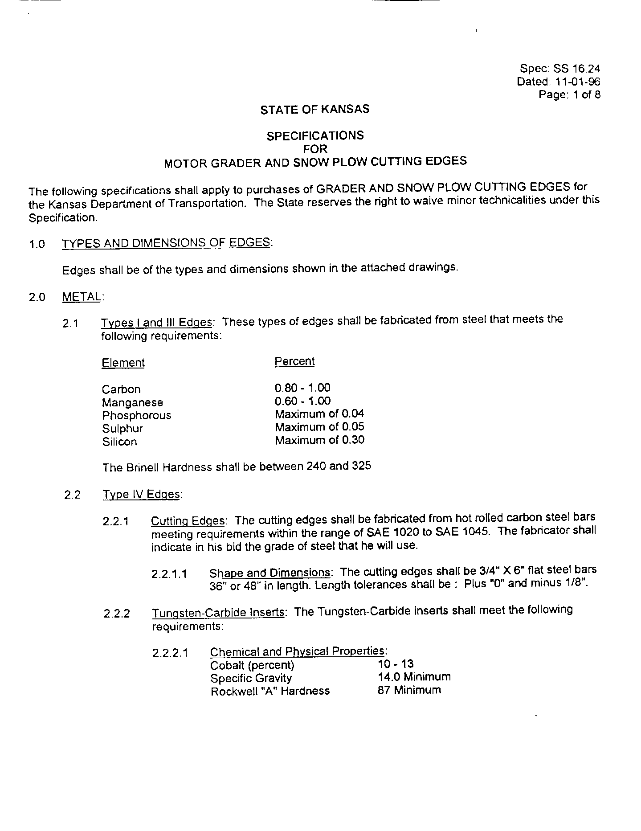
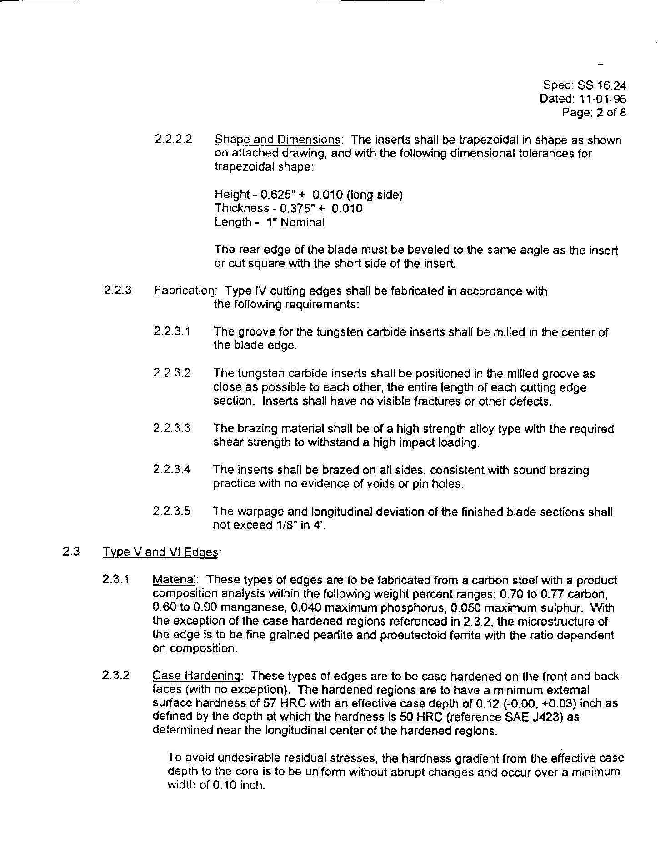
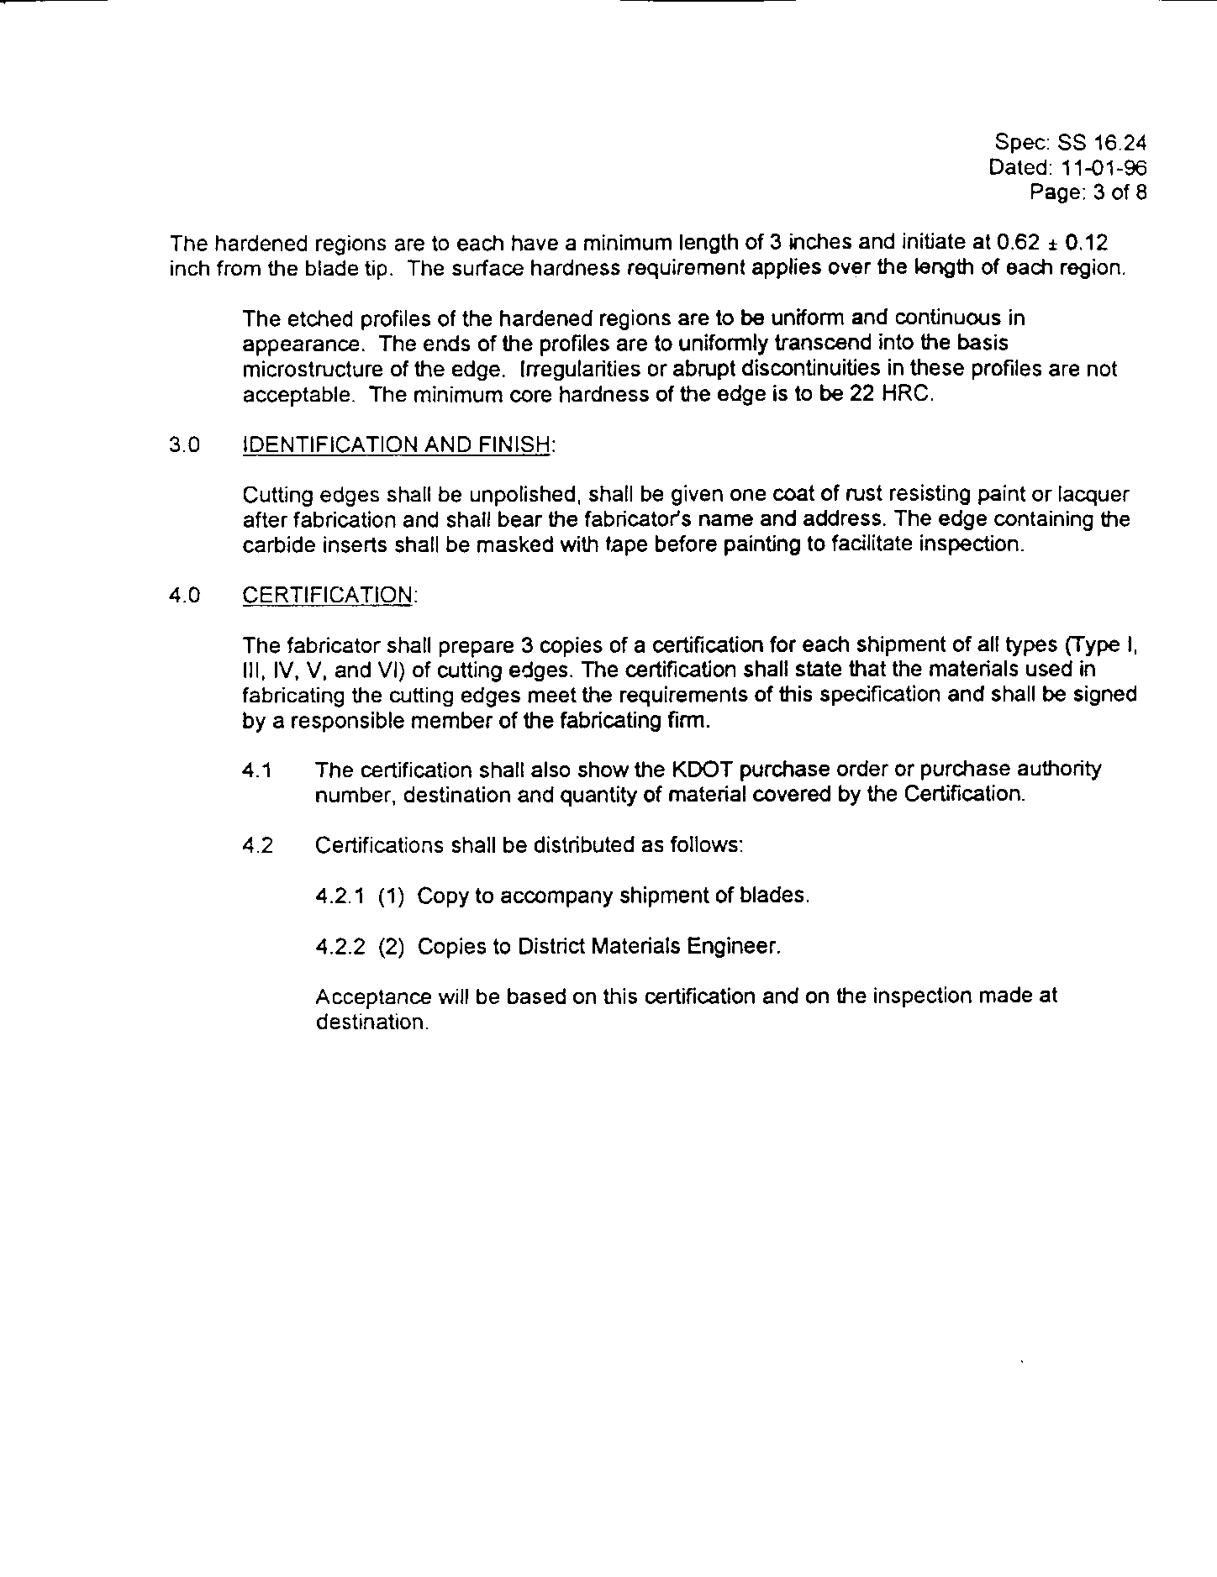
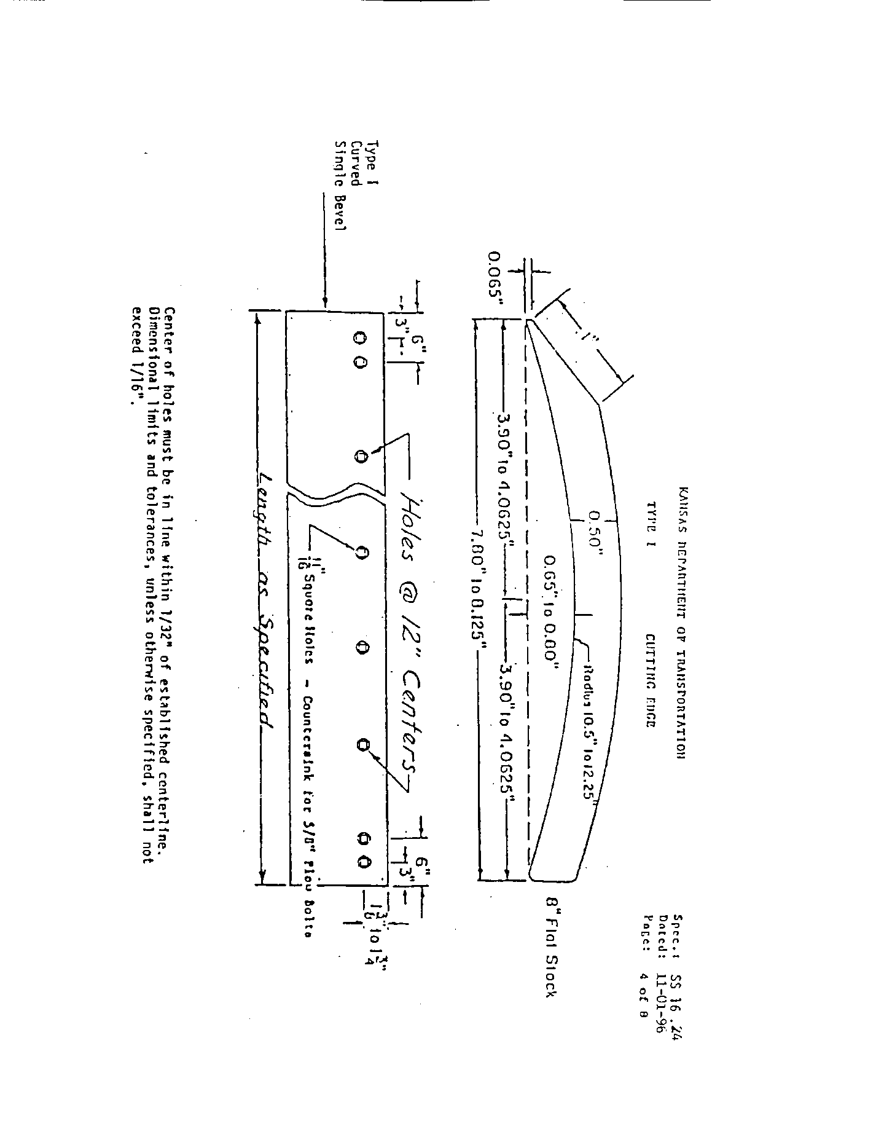
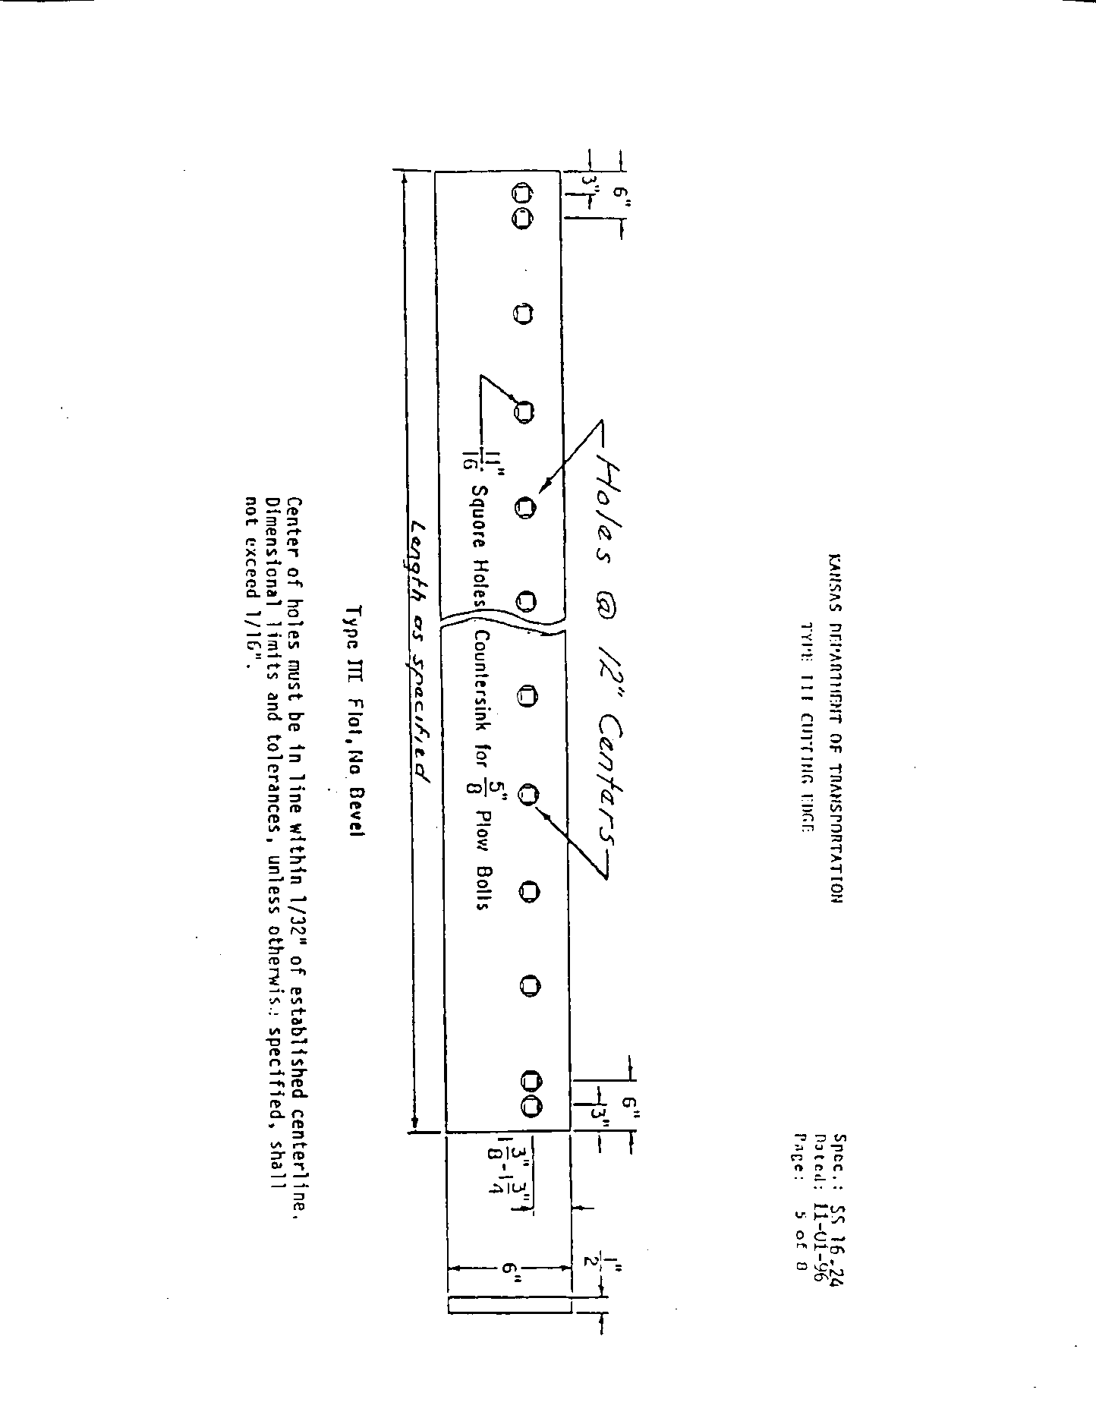
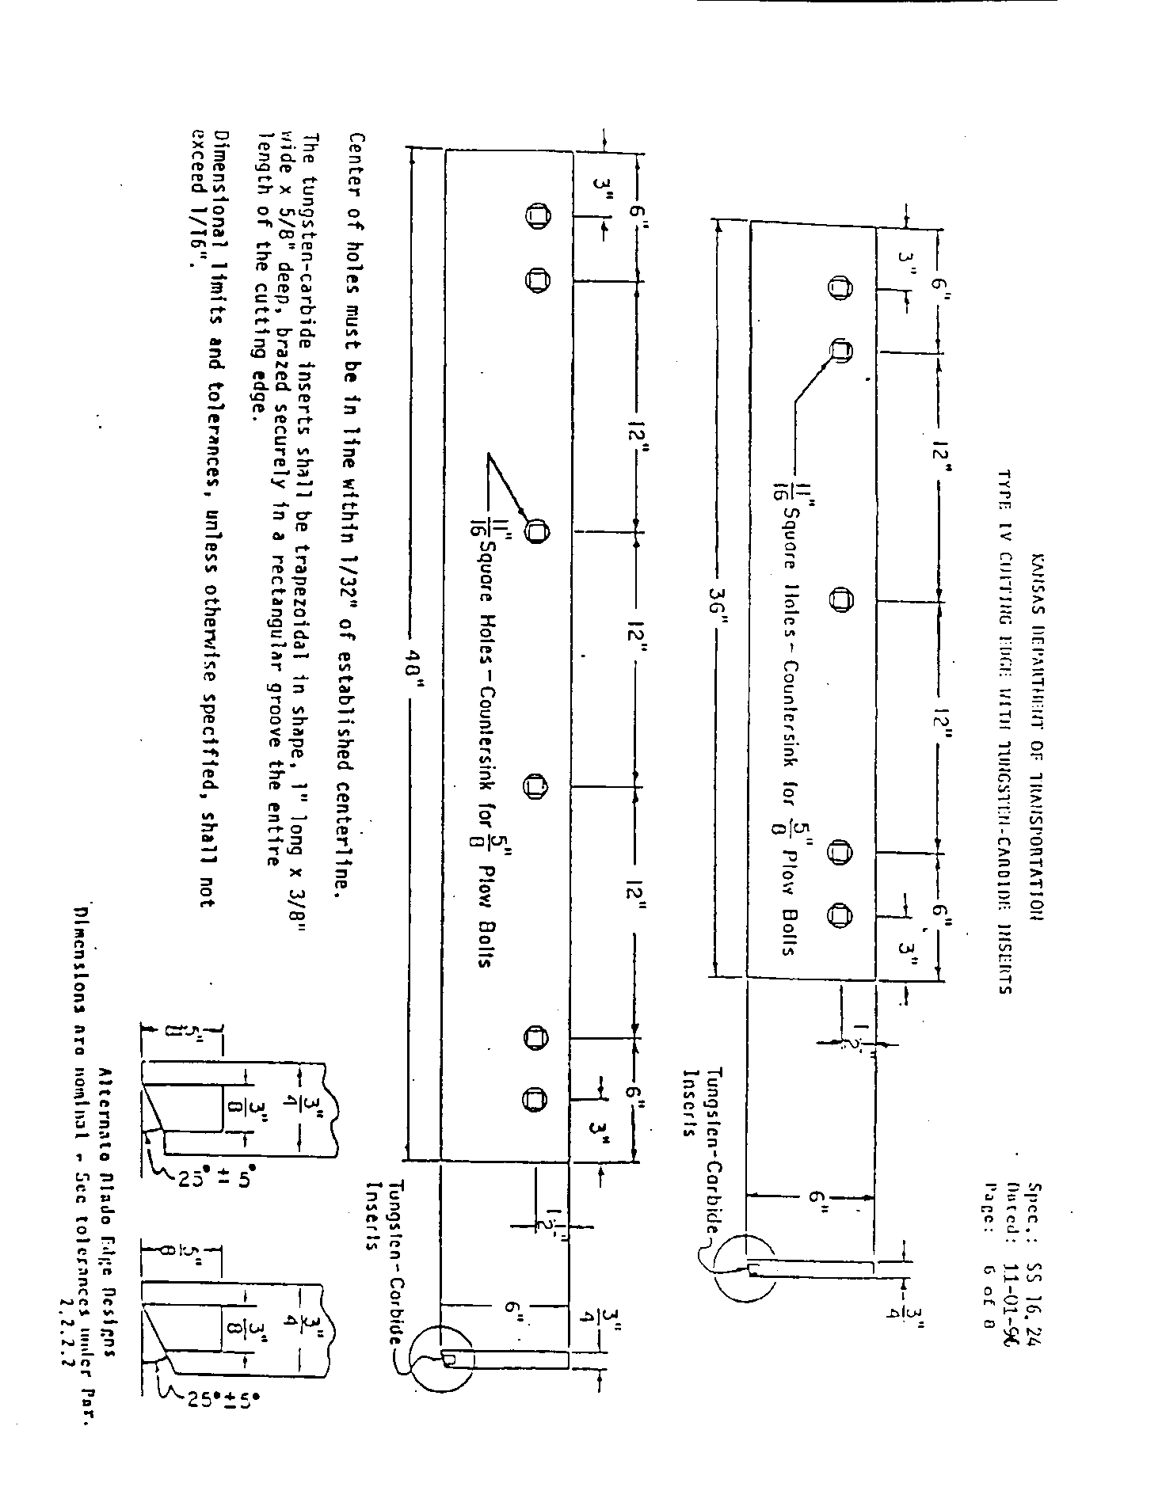
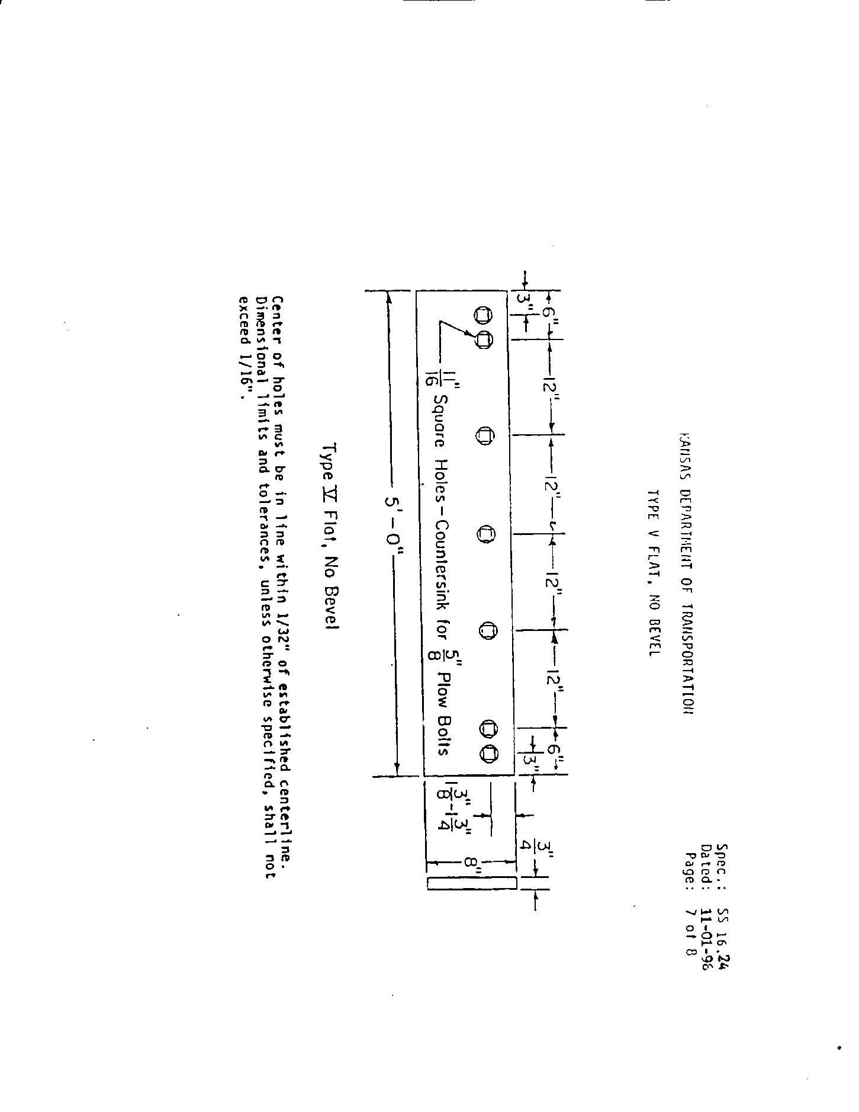
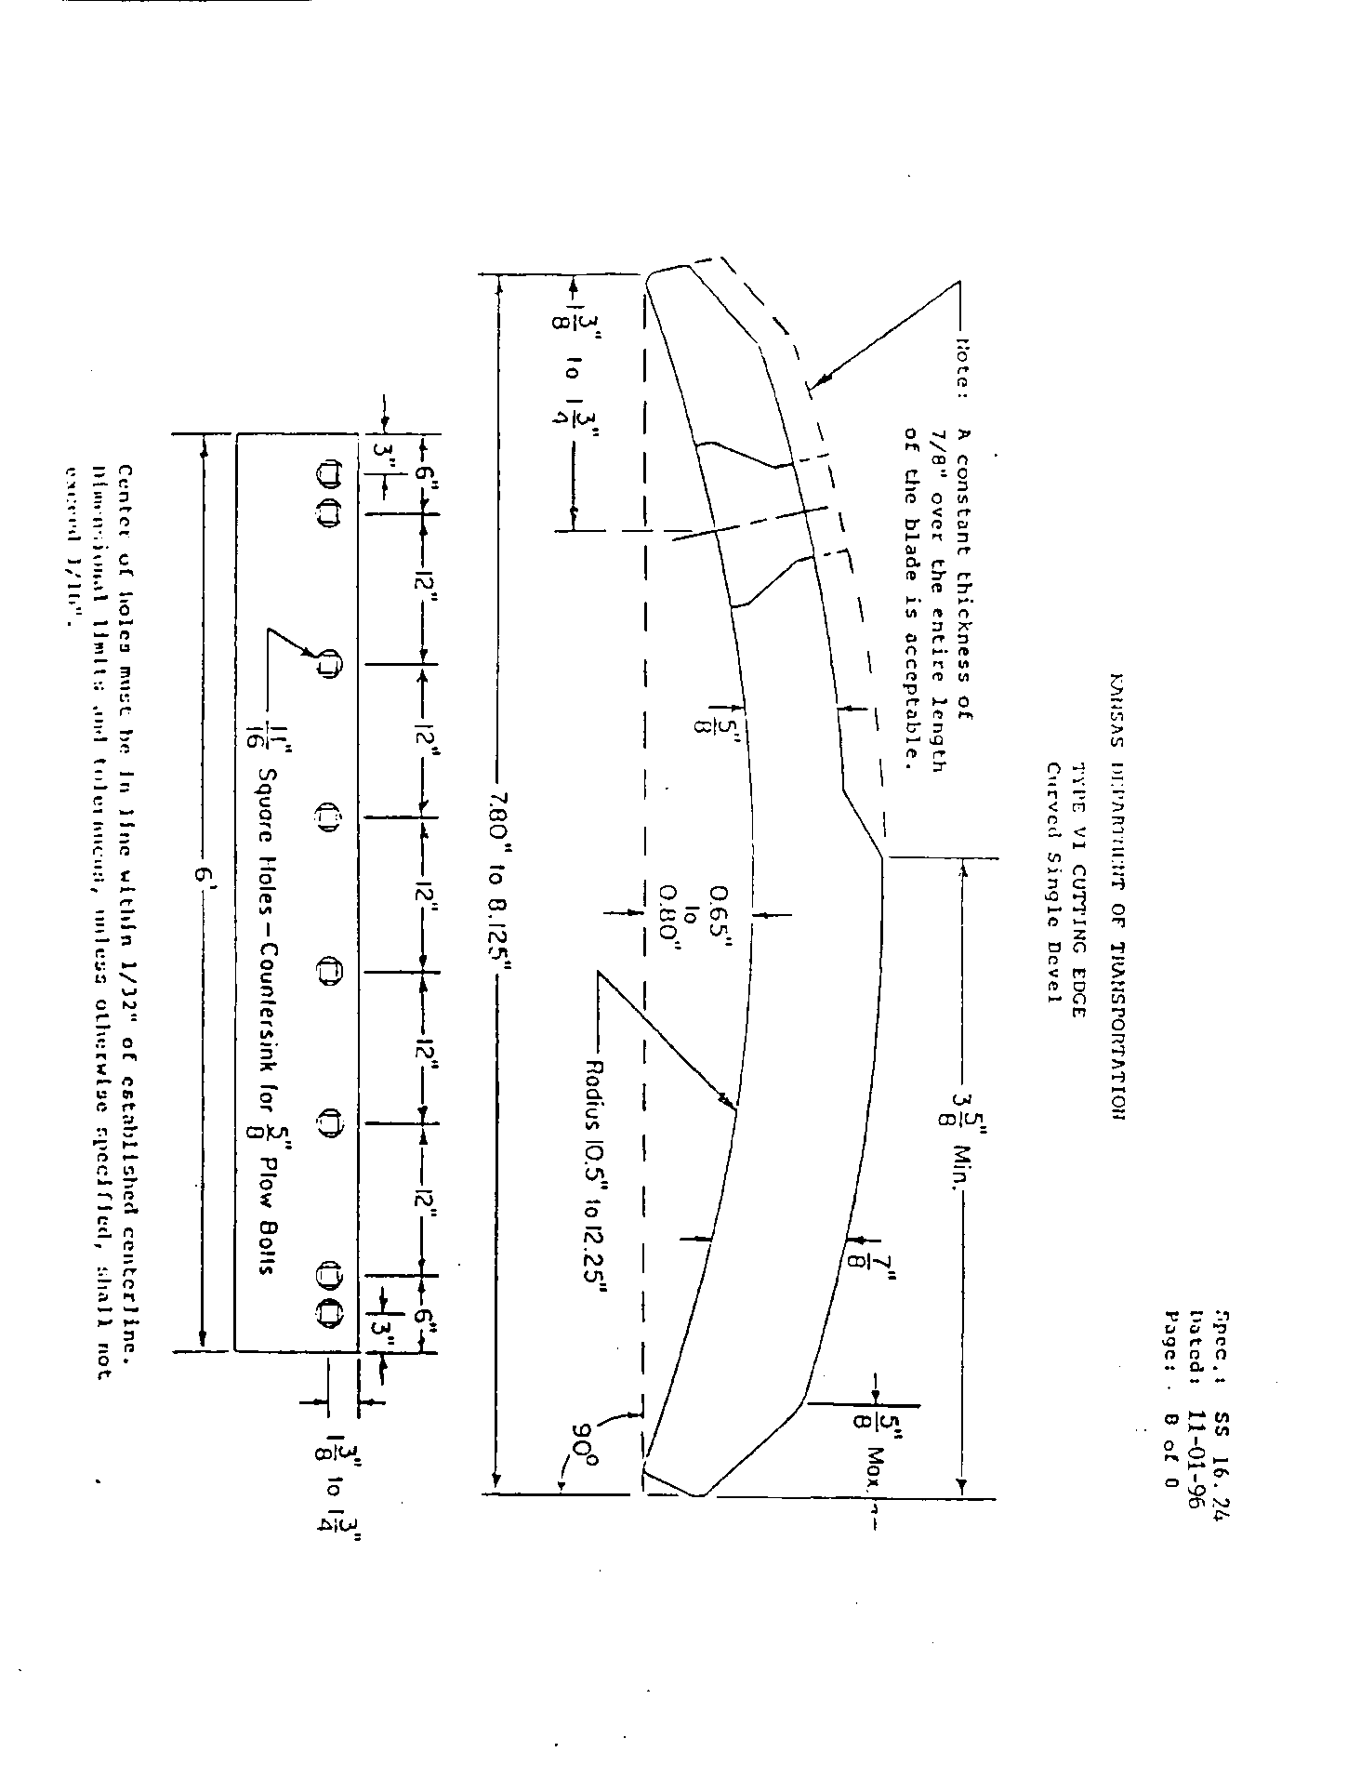
State of Kansas
Department of Administration
DA-146a (Rev. 1-01)

CONTRACTUAL PROVISIONS ATTACHMENT

Important: This form contains mandatory contract provisions and must be attached to or incorporated in all copies of any contractual agreement. If it is attached to the vendor/contractor's standard contract form, then that form must be altered to contain the following provision:

"The Provisions found in Contractual Provisions Attachment (Form DA-146a, Rev. 1-01), which is attached hereto, are hereby incorporated in this contract and made a part thereof."

The parties agree that the following provisions are hereby incorporated into the contract to which it is attached and made a part thereof, said contract being the _____ day of ____________________, 20_____.

1. Terms Herein Controlling Provisions: It is expressly agreed that the terms of each and every provision in this attachment shall prevail and control over the terms of any other conflicting provision in any other document relating to and a part of the contract in which this attachment is incorporated.

2. Agreement With Kansas Law: All contractual agreements shall be subject to, governed by, and construed according to the laws of the State of Kansas.

3. Termination Due To Lack Of Funding Appropriation: If, in the judgment of the Director of Accounts and Reports, Department of Administration, sufficient funds are not appropriated to continue the function performed in this agreement and for the payment of the charges hereunder, State may terminate this agreement at the end of its current fiscal year. State agrees to give written notice of termination to contractor at least 30 days prior to the end of its current fiscal year, and shall give such notice for a greater period prior to the end of such fiscal year as may be provided in this contract, except that such notice shall not be required prior to 90 days before the end of such fiscal year. Contractor shall have the right, at the end of such fiscal year, to take possession of any equipment provided State under the contract. State will pay to the contractor all regular contractual payments incurred through the end of such fiscal year, plus contractual charges incidental to the return of any such equipment. Upon termination of the agreement by State, title to any such equipment shall revert to contractor at the end of State's current fiscal year. The termination of the contract pursuant to this paragraph shall not cause any penalty to be charged to the agency or the contractor.

4. Disclaimer Of Liability: Neither the State of Kansas nor any agency thereof shall hold harmless or indemnify any contractor beyond that liability incurred under the Kansas Tort Claims Act (K.S.A. 75-6101 et seq.).

5. Anti-Discrimination Clause: The contractor agrees: (a) to comply with the Kansas Act Against Discrimination (K.S.A. 44-1001 et seq.) and the Kansas Age Discrimination in Employment Act (K.S.A. 44-1111 et seq.) and the applicable provisions of the Americans With Disabilities Act (42 U.S.C. 12101 et seq.) (ADA) and to not discriminate against any person because of race, religion, color, sex, disability, national origin or ancestry, or age in the admission or access to, or treatment or employment in, its programs or activities; (b) to include in all solicitations or advertisements for employees, the phrase "equal opportunity employer"; (c) to comply with the reporting requirements set out at K.S.A. 44-1031 and K.S.A. 44-1116; (d) to include those provisions in every subcontract or purchase order so that they are binding upon such subcontractor or vendor; (e) that a failure to comply with the reporting requirements of (c) above or if the contractor is found guilty of any violation of such acts by the Kansas Human Rights Commission, such violation shall constitute a breach of contract and the contract may be cancelled, terminated or suspended, in whole or in part, by the contracting state agency or the Kansas Department of Administration; (f) if it is determined that the contractor has violated applicable provisions of ADA, such violation shall constitute a breach of contract and the contract may be cancelled, terminated or suspended, in whole or in part, by the contracting state agency or the Kansas Department of Administration.

Parties to this contract understand that the provisions of this paragraph number 5 (with the exception of those provisions relating to the ADA) are not applicable to a contractor who employs fewer than four employees during the term of such contract or whose contracts with the contracting state agency cumulatively total $5,000 or less during the fiscal year of such agency.

6. Acceptance Of Contract: This contract shall not be considered accepted, approved or otherwise effective until the statutorily required approvals and certifications have been given.

7. Arbitration, Damages, Warranties: Notwithstanding any language to the contrary, no interpretation shall be allowed to find the State or any agency thereof has agreed to binding arbitration, or the payment of damages or penalties upon the occurrence of a contingency. Further, the State of Kansas shall not agree to pay attorney fees and late payment charges beyond those available under the Kansas Prompt Payment Act (K.S.A. 75-6403), and no provision will be given effect which attempts to exclude, modify, disclaim or otherwise attempt to limit implied warranties of merchantability and fitness for a particular purpose.

8. Representative's Authority To Contract: By signing this contract, the representative of the contractor thereby represents that such person is duly authorized by the contractor to execute this contract on behalf of the contractor and that the contractor agrees to be bound by the provisions thereof.

9. Responsibility For Taxes: The State of Kansas shall not be responsible for, nor indemnify a contractor for, any federal, state or local taxes which may be imposed or levied upon the subject matter of this contract.

10. Insurance: The State of Kansas shall not be required to purchase, any insurance against loss or damage to any personal property to which this contract relates, nor shall this contract require the State to establish a "self-insurance" fund to protect against any such loss or damage. Subject to the provisions of the Kansas Tort Claims Act (K.S.A. 75-6101 et seq.), the vendor or lessor shall bear the risk of any loss or damage to any personal property in which vendor or lessor holds title.

11. Information: No provision of this contract shall be construed as limiting the Legislative Division of Post Audit from having access to information pursuant to K.S.A. 46-1101 et seq.

12. The Eleventh Amendment: "The Eleventh Amendment is an inherent and incumbent protection with the State of Kansas and need not be reserved, but prudence requires the State to reiterate that nothing related to this contract shall be deemed a waiver of the Eleventh Amendment."

