State Of Louisiana
Department of Public Safety
Request For Proposals
for
Automated DWI Processing Solution

RFP #:__4218121_______________________

TABLE OF CONTENTS
1 GENERAL INFORMATION 1
1.1 Purpose 1
1.2 Background 1
1.3 Scope of Services 1
2 ADMINISTRATIVE INFORMATION 1
2.1 Term of Contract 1
2.2 Pre-proposal Conference 1
2.4 Definitions 2
2.5 Schedule of Events 3
3 PROPOSAL INFORMATION 4
3.1 Minimum Qualifications of Proposer 4
3.2 Determination of Responsibility 4
3.2.1 Right to Prohibit Award 4
3.3 RFP Addenda 4
3.4 Waiver of Administrative Informalities 5
3.5 Proposal Rejection/RFP Cancellation 5
3.6 Withdrawal of Proposal 5
3.7 Subcontracting Information 5
3.8 Ownership of Proposal 5
3.9 Proprietary Information 5
3.10 Cost of Preparing Proposals 6
3.11 Errors and Omissions in Proposal 6
3.12 Contract Award and Execution 6
3.13 Code of Ethics 6
4 RESPONSE INSTRUCTION 6
4.1 Proposal Submission 6
4.1 Proposal Format 7
4.2 Cover Letter 7
4.3 Technical and Cost Proposal 7
4.4 Certification Statement 7
5 PROPOSAL CONTENT 7
5.1 Table of Contents 8
5.2 Executive Summary 8
5.3 Corporate Background and Experience 8
5.4 Proposed Project Staff 9
5.5 Approach and Methodology 9
5.6 Innovative Concepts 9
5.7 Project Timeline/Schedule 10
5.8 Cost Information 10
6 EVALUATION AND SELECTION 10
6.1 Evaluation Team 10
6.2 Administrative and Mandatory Screening 10
6.3 Clarification of Proposals 10
6.4 Oral Presentations/Discussions 10
6.5 Evaluation and Review 11
6.6 Announcement of Contractor 12
7 SUCCESSFUL CONTRACTOR REQUIREMENTS 12
7.1 Corporation Requirements 12
7.2 Billing and Payment 12
7.3 Confidentiality 13
ATTACHMENT I: SCOPE OF SERVICES 14
1 Overview 14
2 Tasks and Services 14
2.1 Introductory Briefing 14
2.2 Requirements Review 15
2.3 Detailed Design 15
3 Deliverables 15
4 Functional Requirements 21
5 Technical Requirements 23
5.1 Hardware 23
5.2 Software 24
5.3 Network 25
5.4 Database 26
5.5 Testing 27
5.6 Training 27
5.7 Forms 27
5.8 Reports 28
5.9 Security 29
5.10 Maintenance and Support 29
6 Project Requirements 30
ATTACHMENT II: CERTIFICATION STATEMENT 31
ATTACHMENT III: SAMPLE CONTRACT 32
ATTACHMENT IV: COST PROPOSAL 60
ATTACHMENT V: Insurance Requirements for Contractors 61
ATTACHMENT VI: Contractor and Subcontractor Reference FORM 64
ATTACHMENT VII: System Required Input Forms Record Layout 65
ATTACHMENT VIII: Judicial Districts 87

- GENERAL INFORMATION

Purpose
This Request for Proposals (RFP) is issued by the Louisiana Highway Safety Commission in conjunction with the Louisiana Department of Public Safety’s Information Technology Group (herein referred to as the State) for the purpose of obtaining competitive proposals from bona fide, qualified proposers who are interested in providing the software, labor, support, and effort required to meet the State of Louisiana requirements for a fully functional turn-key statewide Automated DWI Processing system for a contract term of three (3) years.

Background
The State’s current DWI processing system consists of a labor intensive manual process. Each DWI arrest is documented on five (5) principal forms, namely Uniform DWI Arrest Citation, Arrestee’s Rights Form, Intoxilyzer Check List, Intoxilyzer Report and Probable Cause Affidavit. Current procedures require the arresting officer to make redundant entries on the same form as well as across multiple forms. When completed, the DWI Arrest Packet consists of an 11–page report that must be manually reviewed, copied and filed. Office personnel make three (3) copies…one for the Prosecutor’s office, one for the Office of Motor Vehicles and one for file. This process is costly and labor intensive.
The State’s decision to embrace new and emerging technology to automate the DWI arrest processing from issuance to the Prosecutor’s case file will increase effectiveness and efficiency in the criminal justice system.

Scope of Services
Attachment I details the scope of services and deliverables or desired results that the State requires of the selected Contractor.
- ADMINISTRATIVE INFORMATION

Term of Contract
The period of any contract resulting from this RFP is tentatively scheduled to begin on or about December 1, 2011 and to continue through November 30, 2014.

Pre-proposal Conference
A Non Mandatory pre-proposal conference will be held at 10:00am CST, September 22, 2011 at the Department of Public Safety Data Processing Center 8001 Independence Blvd, Baton Rouge La, 70806. The purpose of the conference is for proposers to obtain clarification of the requirements of the RFP and to receive answers to relevant questions. Any firm or joint venture intending to submit a proposal must have at least one duly authorized representative attend the pre-proposal conference.
Although impromptu questions will be permitted and spontaneous answers will be provided during the conference, the only official answer or position of the State will be stated in writing in response to written questions. Therefore, potential proposers should submit all questions in writing even if an answer has already been given to an oral question. After the conference, questions will be researched and the official response will be distributed in writing and/or posted on the Internet.
2.3 Proposer Inquiries
Written questions regarding RFP requirements or Scope of Services must be submitted to the RFP Coordinator as listed below.
David Rosenberger
IT Center Operations Manager
225 925-4772 (P)
225 925-4019 (F)
David.rosenberger@dps.la.gov
The State will consider written inquiries and requests for clarification of the content of this RFP received from potential proposers. Written inquiries must be received by 10:00 AM CST on the date specified in the Schedule of Events. The State reserves the right to modify the RFP should a change be identified that is in the best interest of the State.
Official responses to all questions submitted by potential proposers will be posted by October 14, 2011 at http://wwwprd.doa.louisiana.gov/osp/lapac/pubmain.asp
Only the RFP Coordinator has the authority to officially respond to proposer’s questions on behalf of the State. Any communications from any other individuals are not binding to the State.

Definitions

TERM | DEFINITION
Contractor | Any person having a contract with a governmental body
Proposal | A response to an RFP
Proposer | Any person who responds to an RFP
Successful Proposer | The top scoring proposer after proposal evaluation
RFP | A request for proposals
Shall | Denotes mandatory requirements per R.S. 39:1556(24)
Shall or Will | Denotes mandatory language; a requirement that shall be met without alteration
Should, Can, or May | Denotes desirable, non-mandatory language
State | State of Louisiana, Louisiana Department of Public Safety, Highway Safety Commission
Agency | Any department, State, council, board, office, bureau, committee, institution, agency, government, corporation, or other establishment of the executive branch of this state authorized to participate in any contract resulting from this solicitation.
LEMS | Law Enforcement Messaging Switch
Discussions | For the purposes of this RFP, a formal, structured means of conducting written or oral communications/presentations with responsible Proposers who submit proposals in response to this RFP.
DWI | DWI – Driving While Intoxicated
CCH | Computerized Criminal History

Schedule of Events

EVENT | DATE | TIME
RFP advertised and mailed to prospective Proposers | Sept 2 2011 | 10:00 AM CST
Non Mandatory Pre-proposal Conference | Sept 22 2011 | 10:00 AM CST
Deadline for receiving Proposer written inquiries | Sept 30 2011 | 4:00 PM CST
Deadline to respond to Proposer written inquiries | Oct 14 2011 | 4:00 PM CST
Proposal Deadline Date (Deadline for submitting proposals) | Nov 15 2011 | 4:00 PM CST
Oral Presentations (Upon request of State) | TBD
Notice of Intent to Award to be mailed | TBD
Contract Initiation | TBD

NOTE: The State of Louisiana reserves the right to change this schedule of RFP events, as it deems necessary.

- PROPOSAL INFORMATION

Minimum Qualifications of Proposer
Proposers must meet the following minimum qualifications:
- Minimum of three (3) years of proven experience in developing and implementing web based systems of similar scope and nature.
- Provide sufficient personnel dedicated to work on this project with a minimum of three (3) years experience in technologies in the proposed solution.

Determination of Responsibility
Determination of the proposer’s responsibility relating to this RFP shall be made according to the standards set forth in LAC 34: 136. The State must find that the selected proposer:
Has adequate financial resources for performance, or has the ability to obtain such resources as required during performance;
Has the necessary experience, organization, technical qualifications, skills, and facilities, or has the ability to obtain them;
Is able to comply with the proposed or required time of delivery or performance schedule;
Has a satisfactory record of integrity, judgment, and performance; and
Is otherwise qualified and eligible to receive an award under applicable laws and regulations.
Proposers should ensure that their proposals contain sufficient information for the State to make its determination by presenting acceptable evidence of the above to perform the contracted services.

Right to Prohibit Award
In accordance with the provisions of R.S. 39:2192, in awarding contracts after August 15, 2010, any public entity is authorized to reject a proposal or bid from, or not award the contract to, a business in which any individual with an ownership interest of five percent or more, has been convicted of, or has entered a plea of guilty or nolo contendere to any state felony or equivalent federal felony crime committed in the solicitation or execution of a contract or bid awarded under the laws governing public contracts under the provisions of Chapter 10 of Title 38 of the Louisiana Revised Statutes of 1950, professional, personal, consulting, and social services procurement under the provisions of Chapter 16 of this Title, or the Louisiana Procurement Code under the provisions of Chapter 17 of this Title.

RFP Addenda
State reserves the right to change the schedule of events or revise any part of the RFP by issuing an addendum to the RFP at any time. Addenda, if any, will be posted at http://wwwprd.doa.louisiana.gov/osp/lapac/pubmain.asp. It is the responsibility of the proposer to check the website for addenda to the RFP, if any.

Waiver of Administrative Informalities
The State reserves the right, at its sole discretion, to waive administrative informalities contained in any proposal.

Proposal Rejection/RFP Cancellation
Issuance of this RFP in no way constitutes a commitment by the State to award a contract. The State reserves the right to accept or reject, in whole or part, all proposals submitted and/or cancel this announcement if it is determined to be in the State’s best interest.

Withdrawal of Proposal
A proposer may withdraw a proposal that has been submitted at any time up to the date and time the proposal is due. To accomplish this, a written request signed by the authorized representative of the proposer must be submitted to the RFP Coordinator.

Subcontracting Information
The State shall have a single prime contractor as the result of any contract negotiation, and that prime contractor shall be responsible for all deliverables specified in the RFP and proposal. This general requirement notwithstanding, proposers may enter into subcontractor arrangements, however, should acknowledge in their proposals total responsibility for the entire contract.
If the proposer intends to subcontract for portions of the work, the proposer should identify any subcontractor relationships and include specific designations of the tasks to be performed by the subcontractor. Information required of the proposer under the terms of this RFP is also required for each subcontractor. The prime contractor shall be the single point of contact for all subcontract work.
Unless provided for in the contract with the State, the prime contractor shall not contract with any other party for any of the services herein contracted without the express prior written approval of the State.

Ownership of Proposal
All materials submitted in response to this request shall become the property of the State. Selection or rejection of a proposal does not affect this right.

Proprietary Information
Only information which is in the nature of legitimate trade secrets or non-published financial data may be deemed proprietary or confidential. Any material within a proposal identified as such must be clearly marked in the proposal and will be handled in accordance with the Louisiana Public Records Act, R.S. 44: 1-44 and applicable rules and regulations. Any proposal marked as confidential or proprietary in its entirety may be rejected without further consideration or recourse.

Cost of Preparing Proposals
The State shall not be liable for any costs incurred by proposers prior to issuance of or entering into a contract. Costs associated with developing the proposal, preparing for oral presentations, and any other expenses incurred by the Proposer in responding to this RFP are entirely the responsibility of the Proposer and shall not be reimbursed in any manner by the State.

Errors and Omissions in Proposal
The State will not be liable for any errors in proposals. The State reserves the right to make corrections or amendments due to errors identified in proposals by State or the Proposer. The State, at its option, has the right to request clarification or additional information from the proposers.

Contract Award and Execution
The State reserves the right to enter into a contract without further discussion of the proposal submitted based on the initial offers received.
The State reserves the right to contract for all or a partial list of services offered in the proposal.
The RFP and proposal of the selected Proposer shall become part of any contract initiated by the State.
The selected Proposer shall be expected to enter into a contract that is substantially the same as the sample contract included in Attachment III. In no event shall a Proposer submit its own standard contract terms and conditions as a response to this RFP. The Proposer should submit with its proposal any exceptions or exact contract deviations that its firm wishes to negotiate. Negotiations may begin with the announcement of the selected Proposer.
If the contract negotiation period exceeds thirty (30) days or if the selected Proposer fails to sign the final contract within fifteen (15) business days of delivery, the State may elect to cancel the award and award the contract to the next-highest-ranked Proposer.

Code of Ethics
Proposers are responsible for determining that there will be no conflict or violation of the Ethics Code if their company is awarded the contract. The Louisiana Board of Ethics is the only entity which can officially rule on ethics issues.
- RESPONSE INSTRUCTION

Proposal Submission
Firms/individuals who are interested in providing services requested under this RFP must submit a proposal containing the information specified in this section. The proposal must be received in hard copy (printed) version by the RFP Coordinator on or before 10:00 AM Central Daylight Time on the date specified in the Schedule of Events. FAX or e-mail submissions are not acceptable. Proposers mailing their proposals should allow sufficient mail delivery time to ensure receipt of their proposal by the time specified. The proposal package must be delivered at the proposer's expense to:
David Rosenberger
LA Dept. of Public Safety
8001 Independence Blvd Baton Rouge, LA 70806
For courier delivery, the street address is 8001 Independence Blvd and the telephone number is (225 922-6226). It is solely the responsibility of each Proposer to ensure that their proposal is delivered at the specified place and prior to the deadline for submission. Proposals received after the deadline will not be considered.
The State requests that seven (7) copies of the proposal be submitted to the RFP Coordinator at the address specified. At least 1 copy of the proposal should contain original signatures of those company officials or agents duly authorized to sign proposals or contracts on behalf of the organization. One (1) electronic copy of the proposal should accompany the submission. A certified copy of a board resolution granting such authority should be submitted if proposer is a corporation. The copy of the proposal with original signatures will be retained for incorporation in any contract resulting from this RFP.

Proposal Format
Proposers should respond to this RFP with a Technical Proposal and Cost Proposal. No pricing information should be included in the Technical Proposal

Cover Letter
A cover letter should be submitted on the Proposer's official business letterhead explaining the intent of the Proposer.

Technical and Cost Proposal
Proposals should be submitted as specified in Section 5, and should include enough information to satisfy evaluators that the Proposer has the appropriate experience and qualifications to perform the scope of services as described herein. Proposers should respond to all requested areas.

Certification Statement
The Proposer must sign and submit the Certification Statement shown in Attachment II.
- PROPOSAL CONTENT
Proposer shall submit a technical proposal which clearly responds to all requirements detailing how the requirement is integrated into or satisfied by the proposed system and not merely acknowledge or restate the requirements. Proposer should respond to all areas requested.
Proposals should be prepared as simply as possible (i.e. single-sided, with standard, 1-inch margins, and with 1.5 line spacing) and provide a straightforward, concise description of the Proposer's capabilities to satisfy the requirements of this RFP. Expensive bindings, color displays, promotional material, etc. are neither necessary nor desired. EMPHASIS SHOULD BE ON ACCURACY, COMPLETENESS, CREATIVITY OF TECHNICAL SOLUTION, AND CLARITY OF CONTENT. All parts, pages, figures, and tables should be numbered and clearly labeled.
Proposals submitted for consideration should follow the format and order of presentation described below:

Table of Contents
Organized in the order cited in the format contained herein.

Executive Summary
This section should serve to introduce the scope of the proposal. It should include administrative information including, at a minimum, Proposer contact name and phone number, and the stipulation that the proposal is valid for a time period of at least 90 days from the date of submission. This section should also include a summary of the Proposer's qualifications and ability to meet the State agency's overall requirements in the timeframes set by the agency..
It should include a positive statement of compliance with the contract terms. If the Proposer cannot comply with any of the contract terms, an explanation of each exception must be supplied. The Proposer must address the specific language in Attachment III Sample Contracts, and submit whatever exceptions or exact contract modifications that its firm may seek . While final wording will be resolved during contract negotiations, the intent of the provisions will not be substantially altered.

Corporate Background and Experience
The Proposer should give a brief description of their company including a brief history, corporate structure and organization, number of years in business, and copies of its latest financial statement, preferably audited.
This section should provide a detailed discussion of the Proposer's prior experience in working on projects similar in size, scope, and function to the proposed contract. Proposers should describe their experience in other states or in corporate/governmental entities of comparable size and diversity with references from previous clients including names and telephone numbers.
The Proposer should provide the names of three clients to whom similar services have been provided within the last three (3) years including contractual rate, exact functions performed by Proposer, dates work was performed, and the name, address, phone number, and email address of persons who can validate the accuracy of the information and/or quality of service provided. The State reserves the right to obtain information from any resources deemed necessary regardless of whether or not the Proposer provides the source.
If a subcontractor will be used, the proposer shall clearly identify any subcontractor arrangements.

Proposed Project Staff
The Proposer shall provide detailed information about the experience and qualifications of the Proposer's assigned personnel considered key to the success of the project.
This information shall include education, training, technical experience, functional experience, specific dates and names of employers, relevant and related experience, past and present projects with dates and responsibilities and any applicable certifications. This should also specifically include the role and responsibilities of each person on this project, their planned level of effort, their anticipated duration of involvement, and their on-site availability. Customer references (name, title, company name, address, and telephone number) should be provided for the cited projects in the individual resumes.

Approach and Methodology
Each Proposer should address how they will meet all requirements of this RFP with particular attention to the following:
- Proposer's understanding of the nature of the project and how its proposal will best meet the needs of the state agency.
- Proposer should define its functional approach in providing the services.
- Proposer should define its functional approach in identifying the tasks necessary to meet requirements.
- Describe the approach to Project Management and Quality Assurance.
- Provide a proposed Project Work Plan that reflects the approach and methodology, tasks and services to be performed, deliverables, timetables, and staffing.
- Proposer should define its functional approach in developing a detailed design reflecting the most effective means of accomplishing system functions within the agency’s existing infrastructure.
- Proposer should define its strategy for project team organization and task assignments to transfer application knowledge, to position the State to be self-sufficient after implementation.
- Proposer should define its approach for defining system and data security.
- Proposer should identify areas of project risk and procedures to mitigate these risks.
- Proposer should define the methodology to be utilized for system design.
- Proposer should explain how each task and service will be performed (this should take into account project phasing, use of tools, technologies, etc.).

Innovative Concepts
Presentation of innovative concepts, if any, for consideration.

Project Timeline/Schedule
Detailed schedule of implementation plan for a pilot implementation as well as full statewide implementation. This schedule is to include implementation actions, timelines, responsible parties, etc.

Cost Information
Provide the total cost (inclusive of travel and all project expenses). For information purposes, provide the total estimated number of hours, by classification, for the Proposer's project staff, the billing rate by classification, and an estimated percentage of the effort that will be completed by a subcontractor (if applicable).
The proposal shall include prices per Attachment IV, as well as other potential charges (if any) for proposed services associated with the RFP program implementation and administration that you wish the State to consider.

- EVALUATION AND SELECTION

Evaluation Team
The evaluation of proposals will be accomplished by an evaluation team, to be designated by the state, which will determine the proposal most advantageous to the state, taking into consideration price and the other evaluation factors set forth in the RFP.

Administrative and Mandatory Screening
All proposals will be reviewed to determine compliance with administrative and mandatory requirements as specified in the RFP. Proposals that are not in compliance will be rejected from further consideration.

Clarification of Proposals
The State reserves the right to seek clarification of any proposal for the purpose of identifying and eliminating minor irregularities or informalities.

Oral Presentations/Discussions
The State, at its sole discretion, may require all proposers reasonably susceptible of being selected for the award to provide an oral presentation of how it proposes to meet the agency’s program objectives. Commitments made by the Proposer at the oral presentation, if any, will be considered binding.

Evaluation and Review
Proposals that pass the preliminary screening and mandatory requirements review will be evaluated based on information provided in the proposal. The evaluation will be conducted according to the following.
The scores for the Financial and Technical Proposals will be combined to determine the overall score. The Proposer with the highest overall score will be recommended for award.
Financial Proposal (Value of 35 Points)
Prices proposed by the Proposers should be submitted on the price schedule furnished in Attachment IV. Prices proposed shall be firm. The information provided in response to this section will be used in the Financial Evaluation to calculate lowest evaluated cost. A proposer’s base cost score will be based on the cost information provided in Attachment IV and computed as follows:
BCS = (LPC/PC X 35)
Where: BCS = Computed cost score (points) for proposer being evaluated
LPC = Lowest proposed cost of all proposers
PC = Total cost of proposer being evaluated
The proposer must include an itemized listing of all expenses or fees, if applicable, (including travel) that are expected to be paid by the agency. Travel and other allowable expenses shall be reimbursed in accordance with the Division of Administration State General Travel Regulations, within the limits established for State Employees as defined in Division of Administration Policy and Procedure Memorandum No. 49.
Technical Proposal (Value of 65 Points)
The following criteria are of importance and relevance to the evaluation of this RFP and will be used by the Evaluation Committee in the evaluation of the technical proposal. Such factors may include but are not limited to:
- Service and Support Requirements
The information submitted for review shall include an overview of the project requirements detailing the proposers understanding of and approach to the project and how each element of the Scope of Services will be accomplished. Any work to be performed by subcontractors shall also be identified. Other resources required per the RFP shall be addressed here including committed financial and personnel resources, other available service requirements such as proposers quality assurance plan, proposers reporting and billing capabilities, emergency service, complaint handling, and support, etc.
- Organization and Experience
Proposer shall include information required per the RFP which will support financial strength and stability, experience with related services and products, existing customer satisfaction, demonstrated technical support, etc. Proposer shall list all relevant work experience and qualifications of the proposer, proposed staff, and subcontractors (see Attachment VI) relevant to this RFP. The proposer shall list at least three (3) references with names and phone number of contact persons. These references shall be of sufficient size, complexity, and similarity to this proposal to allow judgment on the proposer’s ability to implement its proposal. The references of the proposer and subcontractors may be researched. Additionally, the proposer’s past performance with State of Louisiana may be used in the evaluation process.
- Implementation/Orientation Plan
Proposer shall submit a schedule and method of implementation of the services required by this RFP. The proposer shall detail how the project will be accomplished including schedules, Gantt charts, deliverables, quality assurance, etc. To be included are any other requirements deemed necessary by the proposers for successful contract start-up and monitoring.
The Evaluation Team will compile the scores and make a recommendation to the head of the agency on the basis of the responsive and responsible proposer with the highest score.

Announcement of Contractor
The State will notify the successful Proposer and proceed to negotiate terms for final contract. Unsuccessful proposers will be notified in writing accordingly.
The proposals received (except for that information appropriately designated as confidential in accordance with R.S. 44.1 et seq), selection memorandum along with list of criteria used along with the weight assigned each criteria; scores of each proposal considered along with overall scores of each proposal considered, and a narrative justifying selection shall be made available, upon request, to all interested parties after the “Notice of Intent to Award” letter has been issued.
Any contractor aggrieved by the proposed award has the right to submit a protest in writing to the head of the agency issuing the proposal within 14 days after the award has been announced by the agency.
The award of a contract is subject to the approval of the Division of Administration, Office of Contractual Review.
- SUCCESSFUL CONTRACTOR REQUIREMENTS

Corporation Requirements
If the contractor is a corporation not incorporated under the laws of the State of Louisiana, the contractor shall have obtained a certificate of authority pursuant to R. S. 12:301-302 from the Secretary of State of Louisiana.
If the contractor is a for-profit corporation whose stock is not publicly traded, the contractor shall ensure that a disclosure of ownership form has been properly filed with the Secretary of State of Louisiana.

Billing and Payment
Billing and payment terms shall be negotiated with the successful Proposer.

Confidentiality
All financial, statistical, personal, technical and other data and information relating to the State's operation which are designated confidential by the State and made available to the contractor in order to carry out this contract, or which become available to the contractor in carrying out this contract, shall be protected by the contractor from unauthorized use and disclosure through the observance of the same or more effective procedural requirements as are applicable to the State. The identification of all such confidential data and information as well as the State's procedural requirements for protection of such data and information from unauthorized use and disclosure shall be provided by the State in writing to the contractor. If the methods and procedures employed by the contractor for the protection of the contractor's data and information are deemed by the State to be adequate for the protection of the State's confidential information, such methods and procedures may be used, with the written consent of the State, to carry out the intent of this paragraph. The contractor shall not be required under the provisions of the paragraph to keep confidential any data or information which is or becomes publicly available, is already rightfully in the contractor's possession, is independently developed by the contractor outside the scope of the contract, or is rightfully obtained from third parties.
Under no circumstance shall the contractor discuss and/or release information to the media concerning this project without prior express written approval of the LA Department of Public Safety.

- SCOPE OF SERVICES
- Overview
The State desires to implement and maintain a DWI database accessible to the various statewide entities involved in the DWI issuance, prosecution and records keeping processes. The State is seeking a turnkey solution to automate the existing manual process. The successful Proposer shall provide an Automated DWI Processing solution which includes at a minimum all software, installation of all hardware and software, maintenance, training, and support (The State reserves the right to purchase all hardware via State procurement procedures). The Proposed solution shall meet or exceed all mandatory requirements as defined in this RFP. The successful proposer shall provide an Automated DWI Processing solution that will allow the electronic completion and filing of all documents involved in the DWI arrest process. The successful proposer shall provide software maintenance for a period of three (3) years

The state seeks a solution to replace the existing manual process that:

- Is scalable to meet state requirements from initial deployment to full implementation.. (see Section 5.1 item 7 on page 24)
- Utilizes non-proprietary communications, database, and file formats
- Provides for comprehensive testing, training, and quality support
- Provides a web based application with a client contingent
- Provides for testing, arrest, conviction processes and documentation for all involved agencies across the State
- Provides full process automation from document creation to distribution and filing, including field searches for defendant information, electronic report generation, scanning report attachments, combining report with scans and electronic delivery to the Prosecutor’s office and the Office of Motor Vehicles.
- Provides real time DWI statistics to local and state agencies
- Provides a workflow document approval process
- Interfaces with existing law enforcement databases such as
  - NCIC
  - Louisiana CCH
- Interfaces with newer models of Intoxilyzer machines

- Tasks and Services
          - Introductory Briefing
- The Contractor shall prepare and deliver an introductory briefing for the State’s management and selected staff (approximately 20 people) that introduces key Contractor staff, provides a high-level overview of the proposed solution and how it will be implemented, and reviews the proposed implementation schedule and major milestones.
- The Contractor may include other topics that are relevant to promote a better understanding of the project.
- The Contractor shall submit the agenda and presentation materials for this briefing to the State’s Project Manager for review and approval prior to presentation.
- The Contractor shall provide the presentation materials and handouts used during this briefing in both a paper and electronic format.
- The electronic format shall be provided by the Contractor in Microsoft PowerPoint, Visio, and/or Microsoft Word format.
          - Requirements Review
- The Contractor shall review and clarify all of the requirements in this Scope of Services with the State’s staff prior to starting work to assure a common understanding of the solution, document any clarifications or LADPS approved modifications, and provide a baseline for development.
- The Contractor shall submit the completed requirements to the State’s staff for review and approval and make any requested modifications before completing the detailed design.
          - Detailed Design
- The Contractor shall develop and provide virtual and physical diagrams, specifications, and any other additional documentation as required to completely describe the Automated DWI Processing System.
The Contractor shall submit the completed detailed design to the State’s staff for review and approval.
- Deliverables
The deliverables listed in this section are the minimum desired from the successful proposer. All proposals shall describe how the Contractor intends to meet the deliverable requirements.

Project Plan
Detailed Project Plan | Within 7 business days of the Introductory Briefing meeting described in Section 2.1 the Vendor will update the draft Project Plan from their proposal. For all project tasks, subtasks, and activities, the detailed plan will:  - Include a schedule and Gantt chart, milestones, and deliverables.  - Include Vendor and State resources that exist as line items within the Project Plan.  - Include the following date-related information:  - Originally scheduled start and end dates (including milestones and deliverables)  - Anticipated start dates and end dates for future tasks, subtasks, and activities, if schedule fluctuation has occurred  - Actual start and end dates for all current and completed tasks, subtasks, and activities  - Be updated, at a minimum, weekly and  - Identify issues that affect deadlines.
Phase 1. Project Initiation, Business Process Analysis, Technology Research, Infrastructure Preparation
Initiation and Project Management
Contractor’s responsibilities | - Develop Project Plan, including quality assurance plans  - Establish a Facilitator to work with the project team  - Clarify roles and responsibilities, which include diagramming how deliverables, comments, and outstanding issue will flow between the different project team members and their counterparts within their own agency, along with the format for comments (i.e. blank comment sheet that clearly defines the section being commented on)  - Establish a mechanism to track all project communications and deliverables and allow the project members to access the information  - Provide weekly conference calls throughout the project duration and facilitate group discussion for all the calls  - Submit project monthly reports
State Responsibilities | - Coordinate Contractor resources needed  - Provide work area  - Define project standards and controls required by the State  - Attend project kickoff
Deliverables | - Project plan (including Gantt chart, all steps/tasks, review and revision time frames for documentation (i.e. schedules, plans, and system documentation, and application testing. Estimate of the hours of work required from Contractor staff. The Project GANTT chart shall be updated as needed to reflect project status.)  - One (1) project kickoff meeting to introduce team members and their roles/responsibilities in the project.(see section 2.1)  - Host Weekly conference calls, facilitate discussion and issue conference call and meeting minutes  - Monthly project reports
Acceptance Criteria | The project team will approve the project plan, call minutes, and monthly project reports, and then the project manager will approve for final acceptance.
Business Process Analysis and Technology Research
Contractor’s responsibilities | - Develop Requirements Document  - Document the system Data flow requirements, including all, data elements, and business processes for all participating entities/patners..
State Staff Responsibilities | - Coordinate state resources needed  - Provide work area  - Define project standards and controls required by the State.
Deliverables | - Business Requirements Document with focus on partner-level processing needs, flow requirements, including data elements to exchange and evaluation of needs from project participants  - Technology Recommendation Report to provide technical options to implement an Automated DWI Processing solution
Acceptance Criteria | The Business Requirement document will be reviewed by the project team to compare all content deliverables to the defined project business requirements specified by the program area experts. The Technology Recommendation will be followed by a review and approval of the individual contractor information technology staff involved in application development, security and web based design/hosting. Once this is accomplished, then final approval will be provided by the project manager.
Partner Readiness Assessment
Contractor’s responsibilities | - Assess each partner’s technical readiness to proceed with the project  - Analyze each partner to identify infrastructure needs & node-to-node data exchanges  - Document the partner data exchange requirements.  - Finalize the members of the pilot demonstration based on the state recommendations and developed criteria  - Conduct kickoff meeting
State Staff Responsibilities | - Review the Assessment and Readiness reports  - Schedule and attend business requirement analysis meetings
Deliverables | - Readiness Assessment Reports with focus on partner-level technical needs (e.g. processing needs, data exchange requirements with the DWI system, infrastructure needs, node-to-node data exchanges)  - A Project Program/Technical Conference with partners (program area and IT) and LA Highway Safety representatives (as appropriate to the project) to determine and/or verify business requirements, policies and standards
Acceptance Criteria | Verify and receive sign-off from the State Project Team of report content and compliance with program area requirements, IT standards and procedures. Once this is accomplished, then final approval will be provided by the project manager.
Infrastructure Preparation to Support the Automated DWI System.
Contractor’s responsibilities | - Determine system requirements  - Document infrastructure requirements to support the Automated DWI system.  - Create development environment  - Install required development hardware and software  - Establish security procedures
State Staff Responsibilities | - Provide access to infrastructure for installation  - Schedule State staff required  - Ensure resources available as needed  - Adopt standards and procedures required
Deliverables | Report for Technology & Security Requirements (1 report) to support the Automated DWI System, including any applicable:  - Infrastructure requirements  - Software requirements  - Technical standards  - Security standards  - Technical procedures
Acceptance Criteria | Verify and receive sign-off from the state of report content & compliance with required standards and procedures for infrastructure hosting, installation, testing & deployment. Once this is accomplished, then final approval will be provided by the project manager.
Phase 2. Design and Development of Automated DWI Processing Solution
Design and Development of Automated DWI Processing
Contractor’s responsibilities | - Create the DWI Processing Solution code and data exchange system design for review.
State Staff Responsibilities | - Review documents and verify accuracy  - Develop initial use case document that vendor will use and finalize
Deliverables | - DWI Processing Solution code and data exchange
Acceptance Criteria | Review and approval by State project representatives, including program area experts, to ensure acceptance of data elements, then approval by partner IT staff experts for compliance with IT web based applications/hosting and security. . Once these reviews are completed, the project manager will consider the deliverables acceptable and approve all invoices for payment.
Phase 3. Data Flow Design and Development
Partner-Specific Data Flow System Design Documents
Contractor’s responsibilities | - Verify the business requirement findings in the assessment reports prepared in Phase 1 for the functionality to be implemented, including the use of any applicable Exchange Network protocols, data standards and related requirements  - Data element dictionary and data crosswalk documentation  - Develop the node client functionality with web service interface capabilities for submitting/approving DWI documents.  - Configure software and/or equipment based on the Partner’s unique business requirements to include:  - Web entry forms for data access (e.g. via a model DWI Processing Solution System described in Phase 2)  - Partner Node configuration (e.g. to retrieve data from the DWI Processing Solution and send certification information to the system)  - Define user training and additional documentation requirements.  - Develop a test plan for 1) Partner-to-State Node-to-Node data flow/transfer, and 2) State to Partner database transfer functionality  - Develop a data flow implementation guide covering:  - Data exchange between the DWI Processing System and the state OMV.  - Data exchange between the DWI Processing System and the appropriate prosecutor.  - Data exchange between the DWI Processing System and CCH.
State Staff Responsibilities | - Coordinate appropriate program area and IT staff attendance at all conference call and meetings,  - Provide access to the State’s web hosting and database systems with the appropriate IT staff supervision,  - Provide all reference materials and user documents as required.  - Provide vendor with business rules for data.
Deliverables | - General System Design Documents (SDD) for each of the data flows i.e OMV,CCH etc. The SDD shall provide a completed partner-specific Data Flow System Design Document customized for each partner to implement DWI record data flow.  - Web entry forms for data access via a model DWI Processing System in Phase 2)  - Test plan for 1) Partner-to-State Node-to-Node data flow/transfer, and 2) State node to Partner database transfer functionality
Acceptance Criteria | Review and approval by partner project representatives, including program area experts, then approval by partner IT staff experts followed by sign-off by project manager prior to agreement to reimburse.
Partner-Specific Data Flow Development
Contractor’s responsibilities | - Develop data flows in accordance with the approved partner System Design Documents (SDD)
State Staff Responsibilities | - Provide comments on the system development.
Deliverables | - Partner data flows (i.e. one for each defined interface).
Acceptance Criteria | Review and approval by partner project representatives, including program area experts, then approval by partner IT staff experts followed by sign-off by project manager prior to agreement to reimburse.
Phase 4. Partner Data Flow Installation
Configure Test and Production Environments
Vendor’s Responsibilities | - Production planning meeting agenda and web hosting production planning meeting,  - Work with partner web hosting teams to acquire the test and production environments,  - System test plan and test scripts provided to web hosting and data base teams  - Production system specification verification  - Perform full system testing.
State Staff Responsibilities | - Provide staff resources and server access needed for testing and production environments  - Work with contractor to develop user acceptance test criteria for test scripts  - Validate system installation on test and production environments  - Perform user acceptance testing  - Validate/accept test scripts and testing results  - Signoff on system install
Deliverables | - Test – production planning meetings with web hosting teams  - Provision of test plan and test scripts to partner web hosting teams
Acceptance Criteria | Review and approval by state project representatives. Once these reviews are completed, the project manager will consider the deliverables acceptable and approve all invoices for payment.
Data Flow Installation/Implementation
Contractor’s responsibilities | - Coordinate tasks for implementation, including scheduling logistics  - Implement/install the data flows
State Staff Responsibilities | - Validate the production environment  - Facilitate the contractor to implement/install flows according to agreed upon schedule
Deliverables | - Production setup plan and schedule  - Production system installed, tested and validated for each partner
Acceptance Criteria | Review and approval by state project representatives, followed by sign-off by project manager prior to agreement to reimburse
Conduct End-User Training
Contractor’s responsibilities | - Develop and provide end user training guidance documents/manuals for end users of the system – i.e. program staff, facility managers  - Provide training to state technical, program and facility staff (this may be a WebEx facilitated session)
State Staff Responsibilities | - Identify State/Tribal and facility representatives for training attendance  - Provide feedback on training documentation  - Provide and schedule training rooms  - Establish appropriate training sessions and agenda.  - Conduct end user training
Deliverables | - End user training documents  - Training plan  - User training sessions
Acceptance Criteria | Review and approval by partner project representatives followed by sign-off by project manager prior to agreement to reimburse
Phase 5. Post Implementation/Lessons Learned
Post Production Support
Contractor’s responsibilities | - Provide 3 months free maintenance and support after the system is accepted by the State, to resolve any implementation issues and problems, as detected.  - Develop lessons learned report to communicate the lessons learned. Include guidance to serve as a “How to Manual” for the project  - Consider development of a Team Project website for hosting deliverables, notes, etc  - Provide a document that maps the data elements between the back-end data systems and the schema (If there are elements missing from the back-end system, the Vendor should produce a report listing them and how they should be addressed.)
State Staff Responsibilities | - Provide support to user community  - Develop an annual plan for enhancements and maintenance
Deliverables | - Lessons Learned Report
Acceptance Criteria | Review and approval by partner project representatives, followed by sign-off by project manager prior to agreement to reimburse

- Functional Requirements
This section defines the functional requirements for the Automated DWI Processing Solution based on each business process. Each business process will be discussed and agreed upon between the State and the Contractor based on the system requirements. Additional information on the proposal’s submission requirements and instructions for addressing various types of requirements are contained in Section 5, Technical Requirements.
- The proposed system shall be developed to interface with the State’s existing LEMS system. Information from a LEMS Driver License inquiry shall be used to auto populate personal information on arresting documents.
- The proposed system shall be developed to interface with the State’s existing Computerized Criminal History (CCH) system. Links to arresting documents shall be provided to CCH to coincide with the respective arrest record via a web service.
- The proposed system shall be developed to interface with the State’s existing Office of Motor Vehicles Drivers Management system. An electronic file (XML) shall be generated to replace the existing manual paper file. LADPS IT staff will work with the successful proposer to establish the file format.

- The proposed system shall be developed to interface with the case management systems employed by the State’s various prosecutorial offices. An electronic file (XML) shall be generated to replace the existing manual paper file. LADPS IT staff will work with the successful proposer to establish the file format.

- The proposed system shall allow for the completion of all DWI arresting Documents without duplicate entry of data..

- The proposed system shall have the ability to use data validation and selective tables to limit user errors: Drop downs shall be provided in all applicable fiels. Example: Auto populate date field with current date, create state table to select state in field, vehicle desciptors.

- The proposed solution shall be able to accept an electronic signature from the arresting officer.
- The proposed system shall provide the ability to store uncompleted documents. These documents should be retrievable at a later time to allow completion of all documents.
- The proposed system shall provide a web service to fulfill the electronic transfer requirements of the State and applicable Prosecutor offices.
- The proposed system shall provide security and audit functionality that allows the State to authorize selected personnel to add, modify, approve, inquire and print all related DWI arrest documents.
- The proposed system shall include an approval process of all DWI arresting documents prior to submission to the case management systems employed by the State’s various prosecutorial offices and the State Office of Motor Vehicles.

- The approval process shall be structured to prevent further modifications of the documents while under the approval process. The approvers will have the option to release the documents back to the submitter “prior to approval” for additional updates. Once the submitter updates the documents he/she can resubmit for approval.

- The approval process shall be structured to prevent further modification to the report once the approval process has been completed.

- The proposed system shall allow for additional supplemental documentation to be added to the report once the report has been submitted.

- The proposed system shall provide inquiry access to approved personnel to enable viewing of DWI data arrest information.

- The proposed system shall allow for the inquiry and printing of all arresting documents related to a specified DWI arrest by the approved personnel.

- The proposed system shall provide the ability to generate reports as specified by the state on DWI statistics. A sample report may be the total number of DWI arrest issued during a specified time frame.

- The proposed system shall provide the ability to populate appropriate data entry fields with initial data extracted by swiping the Driver’s License through MagStrip barcode readers as identified. The State shall supply the successful proposer with the MagStrip format and data fields.

- The proposed system shall have the ability to use designated abbreviations that are expanded automatically in the system.

- The proposed system shall have the ability to use auto-completion on selected data fields (e.g., addresses).

- The proposed system shall have the ability to create and maintain user defined help files that the system users can access as a quick reference. (e.g., including but not limited to description of functionality and valid values).

- The proposed system shall comply with and be maintained in reference to the requirements to track all DWI information submitted thru a client and with the additional functionality for the law enforcement officers to use a similar web interface entry method. The DWI System will consist of the functionality to enter information from all of the current forms that have been included in this RFP.

- The proposed system shall support an environment where the arresting officer may not have network access to the DWI database at the time of arrest. The arresting officer shall be able to complete all DWI arrest documents locally and upload them to the database at a later time when access is available.

- The proposed system shall have the ability to selectively upload DWI arrest documents to the backend database using a menu selection, function key, or command.

- The proposed system shall interface with the newer models of Intoxilyzer machines to allow the importing of results in the DWI arrest database.

- The proposed system shall allow for the attachment of other external documents to the DWI arrest record.

- Technical Requirements
- The proposed system shall be developed using open standards-based technology and web services for ease of integration with existing or new systems including hardware, software, and all interfaces.
- The proposed system shall be available on a 24 X 7 basis. All scheduled downtime shall be requested and approved by LADPS Information Services prior to initiation
          - Hardware
- The Contractor shall identify all required hardware to implement their proposed solution. The State will purchase this hardware separately after the contract has been awarded.
- Hardware prices for laptops and desktops required to access the system by the users shall not be included in this proposal.
- All hardware shall at a minimum meet LA. State OIT standards.
http://doa.louisiana.gov/oit/Standards.htm
- The hardware shall meet at a minimum the following requirements:
  - Servers shall be Windows Server 2008 or higher and must be under mainstream support throughout the duration of the contract.
  - The server platform shall be configured to ensure that no system resource (processor, memory, disk, etc.) is utilized more than 40% during peak processing.
  - The platform shall be designed to connect to the existing TCP/IP LAN at the LADPS Data Processing Center.
  - All hardware shall be standards-based technology for ease of integration, scalability and upgrades with existing or new systems
- The Contractor shall provide a detailed description of the physical space, electrical, and environmental requirements of all hardware related to the operations of the proposed system.
- The Proposed solution shall interface with the current State’s network, hardware and software environment.
- The Proposed solution shall use the following estimates for sizing hardware calculations for the duration of the contract. The proposed system shall support a minimum of 1,200 users at startup and scalable to support over 8,000 users at full implementation. The proposed system shall support a minimum of 400 concurrent users.
- The Contractor shall install the equipment according to the installation schedule mutually agreed upon by the State and the Contractor. All hardware shall arrive prior to the Contractor’s installation team on the scheduled installation date.
- The Contractor shall be responsible for loss or damage to all equipment, parts and goods (supplied by the contractor) during shipment, delivery and installation.
- The Proposed system shall be securely backed up to the State’s current backup environment. The state currently uses Tivoli to back up all servers.

          - Software
- The Contractor shall install and support all software required in the proposed system.
- The State will provide OS support for all hardware located in the LADPS data center. This support includes OS patches, antivirus updates and backups.
- The Contractor shall be responsible for any license conditions, fees, and or use agreements not disclosed in its proposal.
- The Contractor shall provide licenses, and associated cost, for the duration of the proposed contract.
- The proposed system shall have the ability to automatically distribute software updates from the central site servers to remote clients.
- The proposed system shall be capable of supporting a minimum of 1,200 users at startup and scalable to over 8000 at full implementation. Specific system performance criteria will be developed and mutually agreed upon by DPS and the Contractor.
- The Proposed system software shall meet at a minimum the following requirements:
  - The proposed system shall have the ability to operate in a "multiple windows" environment to support concurrent functions with true "multi-tasking" (e.g. processing a license inquiry in its own "window" while working on another Report in another "window").
  - The proposed system software shall be functional with client laptops and desktops running on Windows XP and later versions.
  - All software shall conform to National Information Exchange Model (NIEM) standards. Information on NIEM guidelines can be found at the following website. http://www.niem.gov/.
  - All software shall be compatible with Internet Explorer 7.0 and higher. In addition, the proposed solution shall be compatible with other industry browsers such as Mozilla Firefox, Opera and Safari.
- All mandatory features and capabilities shall be provided at start-up time.
- Ownership documents /Intellectual Property/ Source Code
The Source Code, databases and all associated system components shall become the exclusive property of the state. The state shall own all of the rights, including copyright, copyright renewals, and copyright extensions, title and interest in and to all data, and other information developed for this project and versions thereof.

Source Code includes individual modules, class layers, images, and pieces of computer programming that are compiled together to make up the software program.
The State will also own all Intellectual Property developed including copyrights, patents, and any other form of Intellectual Property rights covering any data bases, software, training manuals, system design or other proprietary information in any form of medium.

The State will treat the Source Code as a strategic and confidential asset and will provide for its security. The Code will not be shared with other states or with private enterprises except with the explicit and written consent of the National Highway Traffic Safety Administration and/or the Louisiana Highway Safety Commission.

Any/All interfaces developed for this contract shall not be proprietary and shall become property of the state.
          - Network

The diagram below provides a high-level view of the network architecture inherent to the LADPS environment.

          - Database
- The Contractor shall provide and maintain a Louisiana DWI Database containing all Louisiana DWI arrest data. All records shall have a retention period of ten (10) years.
- The Contractor shall be responsible for providing the software to create and maintain the DWI database.
- The Database will reside on the State’s existing HP P4500 G2 ISCSI SAN running SAN/IQ 8.5 The Contractor Shall provide the state with the storage requirements based on the projection of 75,000 DWI arrest records for the 5 year contract period. The state will provide the required storage for the DWI database.
- The Contractor shall be responsible for providing the software to create and maintain a database of Louisiana DWI USER account names and addresses for correspondence and notifications for user sign on authorization.
- The Contractor shall be responsible for the integrity of the data pertaining to the solution for the State of Louisiana; however, the State shall retain full ownership of all data collected on behalf of the State.
- The database collected on behalf of this contract shall be proprietary to the State of Louisiana and shall neither be tampered with nor deleted unless or otherwise approved by the LADPS Information Technology Director.
- A relational database shall be used for all document storage.
- The State requires the proposed solution to use Microsoft SQL Server, IBM DB2 or Oracle. The State desires Microsoft SQL server 2008 as the database software for this solution.
- The Contractor shall supply the State with a database dictionary for the proposed solution.
- The Contractor shall provide the State with a database management plan.

          - Testing

- Prior to commencement of testing, a comprehensive set of test procedures must be prepared and delivered for review, providing the specific steps that will be followed to perform each inspection, functional test, operational test, and benchmark test.
- The procedures also must establish test criteria that must be achieved for each individual test procedure.
- At the conclusion of each phase of testing, a test report must be compiled and delivered that includes:
  - Completed and signed checklists documenting the successful performance of each inspection or test.
  - Detailed schedule for discrepancy correction and retesting.

          - Training

- The Contractor must provide a comprehensive user and system administrator training program. In addition, a training conference must be conducted and a detailed training plan must be prepared and delivered for review and acceptance.
- Training shall include:
  - Train the trainer for the field users and system administrators.
  - Directed and detailed software and application training for programming staff.
  - Directed and detailed hardware training for system operations staff.
  - Directed and detailed DBA training.

          - Forms

- The system shall provide the capability to create, update, download/upload, print and retrieve the law enforcement forms outlined below in an electronic format: (see Attachment VII for form description). The forms in attachment VII are for documentation purposes. The form designs may include minor changes to accommodate the move to a common statewide form.
  - Uniform DWI Arrest Citation (DPSSP 6622) – This is a six-page form that provides the foundation of the probable cause for, and the conditions surrounding the arrest, contains pertinent defendant information, and provides a record of the field sobriety test.
  - Arrestee’s Rights Form (DPSSP 6621) – This is front and back seven page form designed to insure that defendants are aware of their rights as defined by Louisiana’s Implied Consent Law. The arresting officer shall write his/her name five times in addition to redundant entries for the defendant. This document is also used to provide the arrestee with a Temporary Drivers Permit, provide instructions on the revocation appeal process and provides other instructional information.
  - Intoxilyzer 5000 Operational Checklist (DPSSP 4634) – This is a one page form that requires the officer to again write the defendant’s name, driver’s license number, operator’s name and other data relevant to the Intoxilyzer being used.
  - Intoxilyzer Print Document (CMI Document) – This Form is automatically created and printed by the Intoxilyzer 5000/Intoxilyzer 8000 and is made a part of the DWI Arrest package.
  - Arrest Affidavit – This form is a requirement of the Judicial District in which the DWI arrest is made and generally serves the same purpose and contains similar information documented on the Uniform DWI Arrest Citation. Affidavits are not uniform and are currently manual. The arrest affidavit is actually 42 different formats and is required as a part of the DWI Packet and specific to each district. The selected vendor shall be able to provide the format in an electronic format for each judicial district (reference attachment VIII) thus providing its unique affidavit for the system to populate. Work is in progress to develop a uniform affidavit that can be used throughout the state environment. Until the uniform affidavit is finalized and approved the selected proposer shall provide a method to generate an electronic format specific to a Prosecutor’s office or municipal court in addition to the 42 formats identified above. The update forms will require field level data since each form has specific legal descriptions that very seldom change, but is required to be printed when the packet is created.
  - Uniform Traffic Summons (DPSSP 3101) – This is a four-page form that provides the foundation of the probable cause for, and the conditions surrounding a traffic violation and contains pertinent defendant information and related charges.
- Printing of all forms must be supported in both the officer’s unit and office environments.
- The proposed solution shall allow for authorized State personnel to have the capability to modify existing forms and create new forms. The proposed solution shall have the capability to allow for distribution of these new and modified forms from the central site servers to remote clients.

          - Reports

- The Contractor solution shall provide the ability to generate real time reports
- The system shall provide the ability to selectively generate/print reports based on the following criterion:
  - A single record.
  - A group/all records.
  - A specified listing of records.
  - All except a specific record/records.
  - Print a specific page requested
  - Print selected text.

          - Security

- The Proposer shall adhere to the LADPS security policy. This includes physical and network security policies. Questions concerning LADPS security policy shall be submitted in writing to LADPS Security Coordinator.
- All data in relation to the DWI arresting documents shall be transmitted using a minimum 128 bit AES encryption. All data shall be encrypted at the application level.
- The proposed system shall only allow authorized personnel to access the system.
- The proposed system shall have at a minimum a three (3) tiered user security authorization level. These levels shall account for the user (arresting officers), document approver/s and the local administrator/s. It is the intent to allow the local law enforcement agencies to administer the user accounts for their respective personnel.
- The proposed system shall segregate Local agency DWI arrest records prior to the submittal of the arresting documents to the appropriate prosecutors. This will restrict viewing and/or modifications of documents by personnel not associated with the arresting law enforcement agency prior to submittal.
- Each user shall have a unique user-id and password.
- The proposed system shall restrict users from accessing system support files.
- The proposed system shall maintain previously used passwords and not allow a user to reuse their previous three passwords. Passwords shall be a minimum of five alphanumeric characters. The system shall ensure that a user is forced to changed passwords every 28 days.
- The proposed system shall provide audit functionality for the entire DWI arrest process.
- An archive feature shall be available that allows the purging / storage of log files and document records based on identified State/Federal retention period requirements.
- The Contractor shall provide a document describing the method they will use to store and archive electronic DWI records in the proposal.
- All employees requiring access to the LADPS Data Center shall be required to submit to and pass a Contractor Background Check.

          - Maintenance and Support

- The Contractor shall provide a description of a comprehensive maintenance and operations support program that includes:
- Preventive maintenance
- Remedial maintenance
- Help desk support
- An explanation of anticipated response times for unscheduled services.

- The Contractor shall provide a maintenance and support program for the life of the contract.

- Project Requirements
[Describe what the state agency’s requirements are in regard to how the project will be structured and managed. This will include items such as: project management responsibility, progress and time reporting, issue management and control, project staffing and organization, resources to be provided by the State agency and the Contractor, etc.]

ATTACHMENT II: CERTIFICATION STATEMENT
The undersigned hereby acknowledges she/he has read and understands all requirements and specifications of the Request for Proposals (RFP), including attachments.
OFFICIAL CONTACT. The State requests that the Proposer designate one person to receive all documents and the method in which the documents are best delivered. Identify the Contact name and fill in the information below: (Print Clearly)
Date |  |  | Official Contact Name:
A. | E-mail Address:
B. | Facsimile Number with area code: |  |  | ( )
C. | US Mail Address:
Proposer certifies that the above information is true and grants permission to the State or Agencies to contact the above named person or otherwise verify the information provided.
By its submission of this proposal and authorized signature below, Proposer certifies that:
- The information contained in its response to this RFP is accurate;
- Proposer complies with each of the mandatory requirements listed in the RFP and will meet or exceed the functional and technical requirements specified therein;
- Proposer accepts the procedures, evaluation criteria, mandatory contract terms and conditions, and all other administrative requirements set forth in this RFP.
- Proposer's quote is valid for at least 90 days from the date of proposal's signature below;
- Proposer understands that if selected as the successful Proposer, he/she will have _____business days from the date of delivery of final contract in which to complete contract negotiations, if any, and execute the final contract document. (Agency insert number of days to correspond to same number referenced in RFP section number 3.12 Contract Award and Execution.)
- Proposer certifies, by signing and submitting a proposal for $25,000 or more, that their company, any subcontractors, or principals are not suspended or debarred by the General Services Administration (GSA) in accordance with the requirements in OMB Circular A-133. (A list of parties who have been suspended or debarred can be viewed via the internet at www.epls.gov .)
Authorized Signature:
Typed or Printed Name:
Title:
Company Name:
Address:
City: |  |  | State: |  | Zip:
SIGNATURE of Proposer's Authorized Representative |  |  |  |  |  | DATE

ATTACHMENT III: SAMPLE CONTRACT
STATE OF LOUISIANA
CONTRACT
On this____ day of _______, 20__, the (Agency Name), hereinafter sometimes referred to as the "State", and (Contractor's name and legal address including zip code), hereinafter sometimes referred to as the "Contractor", do hereby enter into a contract under the following terms and conditions.
1.0 SCOPE OF SERVICES
Contractor hereby agrees to furnish services to State as specified in Section 3.0.
1.1 CONCISE DESCRIPTION OF SERVICES
[Provide the concise description of the data processing consulting services to be acquired]
1.2 COMPLETE DESCRIPTION OF SERVICES
A full description of the scope of services is contained in the following Attachments which are made a part of this contract:
Attachment I - Statement of Work
Attachment II - Hardware/Software Environment
Attachment III - Contractor Personnel and Other Resources
Attachment IV - State Furnished Resources
2.0 ADMINISTRATIVE REQUIREMENTS
2.1 TERM OF CONTRACT
This contract shall begin on _____________ and shall end on __________. State has the right to extend this contract up to a total of three years with the concurrence of the Contractor.
2.2 WARRANTIES
Contractor shall indemnify State against any loss or expense arising out of any breach of any specified Warranty.
A. Period of Coverage. The Warranty period for software and system components covered under this Contract will begin on the date of acceptance or date of first productive use, whichever occurs later, and will terminate (spell-out) (n) months thereafter.
B. Free from Defects. Contractor warrants that the system developed hereunder shall be free from defect in design and implementation and will continue to meet the specifications agreed to during system design and Contractor will, without additional charge to the State, correct any such defect and make such additions, modifications, or adjustments to the system as may be necessary to operate as specified in the Technical Deliverables accepted by the State.
C. Software Standards Compliance. Contractor warrants that all software and other products delivered hereunder will comply with State standards and/or guidelines for resource names, programming languages, and documentation as referenced in Attachment II.
D. Software Performance. Specific operating performance characteristics of the software developed and/or installed hereunder are warranted by the Contractor as stated in Attachment I.
E. Original Development. Contractor warrants that all materials produced hereunder will be of original development by Contractor, and will be specifically developed for the fulfillment of this contract. In the event the Contractor elects to use or incorporate in the materials to be produced any components of a system already existing, Contractor shall first notify the State, which after whatever investigation the State may elect to make, may direct the Contractor not to use or incorporate any such components. If the State does not object, Contractor may use or incorporate such components at Contractor's expense and shall furnish written consent of the party owning the same to the State in all events. Such components shall be warranted as set forth herein (except for originality) by the Contractor and the Contractor will arrange to transfer title or the perpetual license for the use of such components to the State for purposes of the contract.
F. No Surreptitious Code Warranty. Contractor warrants that software provided hereunder will be free from any "Self-Help Code". "Self-Help Code" means any back door, time bomb, or drop dead device or other routine designed to disable a computer program with the passage of time or under the positive control of a person or party other than the State. Excluded from this prohibition are identified and State-authorized features designed for purposes of maintenance or technical support. "Unauthorized Code" means any virus, Trojan horse, worm or other software routine or component designed to permit unauthorized access to disable, erase, or otherwise harm software, equipment, or data, or to perform any other such actions. "Unauthorized Code" does not include "Self-Help Code".
2.3 STAFF INSURANCE
Contractor shall procure and maintain for the duration of the contract insurance against claims for injuries to persons or damages to property which may arise from or in connection with the performance of the work hereunder by the Contractor, his agents, representatives, employees or subcontractors. The cost of such insurance shall be included in the total contract amount included in Section 5.0. For insurance requirements, refer to Attachment V.
2.4 LICENSES AND PERMITS
Contractor shall secure and maintain all licenses and permits, and pay inspection fees required to do the work required to complete this contract.
2.5 SECURITY
Contractor's personnel will always comply with all security regulations in effect at the State's premises, and externally for materials belonging to the State or to the project. Contractor is responsible for reporting any breach of security to the State promptly.
2.6 TAXES
Contractor is responsible for payment of all applicable taxes from the funds to be received under this contract. Contractor's federal tax identification number is .
2.7 CONFIDENTIALITY
All financial, statistical, personal, technical and other data and information relating to the State's operations which are designated confidential by the State and made available to the Contractor in order to carry out this Contract, or which becomes available to the Contractor in carrying out this contract, shall be protected by the Contractor from unauthorized use and disclosure through the observance of the same or more effective procedural requirements as are applicable to the State. Contractor shall not be required to keep confidential any data or information which is or becomes publicly available, is already rightfully in the Contractor's possession, is independently developed by the Contractor outside the scope of this Contract, or is rightfully obtained from third parties.
3.0 TECHNICAL REQUIREMENTS
3.1 STATEMENT OF WORK
Contractor will perform services according to the terms of this Contract and according to the Statement of Work (SOW) in Attachment I.
3.2 CONFIGURATION REQUIREMENTS
The software system being installed shall be designed and configured by the Contractor to operate within the State's hardware, software, and networking environments as specified in Attachment II.
3.3 PROJECT MANAGEMENT
Contractor shall provide, at a minimum, the following project management functions:
A. Provide Project Management - Contractor will provide day-to-day project management using best management practices for all tasks and activities necessary to complete the Statement of Work.
B.Provide Project Work Plan - Contractor shall develop and maintain a Project Work Plan which breaks down the work to be performed into manageable phases, activities and tasks as appropriate. The work plan will identify: activities/tasks to be performed, project personnel requirements (both State and Contractor), estimated workdays/personnel hours to complete, expected start and completion dates. Scheduled completion dates for each deliverable shall specifically be included. Written concurrence of both parties will be required to amend the Work Plan. The Project Work Plan shall be approved by the State before project payments are made.
C. Provide Project Progress Reports - Contractor shall submit monthly progress reports signed by the Contractor's Project Manager to the State, no later than 10 days after the close of each calendar month. Each progress report shall describe the status of the Contractor's performance since the preceding report, including the products delivered, descriptions of problems encountered with a plan for resolving them, the work to be accomplished in the coming reporting period, and identifying issues requiring management attention, particularly those which may affect the scope of services, the project budget, or the deliverables to be provided by the Contractor. Each report shall identify activities by reference to the Project Work plan.
D. Provide Time Sheets - Accompanying each Progress Report, the Contractor shall submit time sheets to the State Project Director indicating effort expended and work performed by each member of its, or its subcontractors' staff, participating in this contract. Time sheets shall, at a minimum, identify the name of the individual performing the work and the number of hours worked during the period by Work Plan task.
E. Provide Issue Control. Contractor will develop and implement with State approval, procedures and forms to monitor the identification and resolution of key project issues and problems.
3.4 QUALITY ASSURANCE REVIEWS
State reserves the right to conduct Quality Assurance Reviews at appropriate checkpoints throughout the project. Contractor will facilitate the review process by making staff and information available as requested by the reviewers at no additional cost to the State.
3.5 CONTRACTOR RESOURCES
Contractor agrees to provide the following Contract related resources:
A. Project Manager. Contractor shall provide a project manager to provide day-to-day management of project tasks and activities, coordination of Contractor support and administrative activities, and for supervision of Contractor employees. The project manager shall possess the technical and functional skills and knowledge to direct all aspects of the project.
B. Key Personnel. Contractor shall assign staff who possess the knowledge, skills, and abilities to successfully perform assigned tasks. Individuals to be assigned by the Contractor are listed in Attachment III.
C. Personnel Changes. Contractor's Project Manager and other key personnel assigned to this Contract may not be replaced without the written consent of the State. Such consent shall not be unreasonably withheld or delayed provided an equally qualified replacement is offered. In the event that any State or Contractor personnel become unavailable due to resignation, illness or other factors, excluding assignment to project outside this contract, outside of the State's or Contractor's reasonable control, as the case may be, the State or the Contractor, as the case may be, shall be responsible for providing an equally qualified replacement in time to avoid delays to the work plan.
D. Other Resources. Contractor will provide other resources as specified in Attachment III.
3.6 STATE PROJECT DIRECTOR
State shall appoint a Project Director for this Contract who will provide oversight of the activities conducted hereunder. The Project Director is identified in Attachment IV. Notwithstanding the Contractor's responsibility for total management during the performance of this Contract, the assigned State Project Director shall be the principal point of contact on behalf of the State and will be the principal point of contact for Contractor concerning Contractor's performance under this Contract.
3.7 STATE FURNISHED RESOURCES
State will make available to the Contractor for use in fulfillment of this contract those resources described in Attachment IV.
3.8 STATE STANDARDS AND GUIDELINES
Contractor shall comply with State standards and guidelines related to systems development, installation, software distribution, security, networking, and usage of State resources described in Attachment II.
3.9 ELECTRONICALLY FORMATTED INFORMATION
Where applicable, State shall be provided all documents in electronic format, as well as hard-copy. Electronic media prepared by the Contractor for use by the State will be compatible with the State's comparable desktop application (e.g., spreadsheets, word processing documents). Conversion of files, if necessary, will be Contractor's responsibility. Conversely, as required, Contractor must accept and be able to process electronic documents and files created by the State's current desktop applications as described in Attachment II.
4.0 ACCEPTANCE OF DELIVERABLES
Contract deliverables will be submitted, reviewed, and accepted according to the following procedure:
A. General.Except where this Contract provides different criteria, work will be accepted if it has been performed in accordance with the applicable specifications for Contractor's work in the Statement of Work, the Request for Proposals, the Contractor's Proposal, and/or as subsequently modified in State- approved design documents developed within this Project, and in the accepted final documentation.
B. Submittal and Initial Review. Upon written notification by Contractor that a Deliverable is completed and available for review and acceptance, the State Project Director will use best efforts to review the Deliverable within five (5) business days after the Deliverable is presented to the State Project Director, but in no event later than ten (10) business days after the Deliverable is presented to the State Project Director. Within the applicable period, the State Project Director will direct the appropriate review process, coordinate any review outside the Project team, and present results to any user committees and/or Steering Committee for approval, as needed. The initial review process will be comprehensive with a view toward identifying all items which must be modified or added to enable a Deliverable to be approved. A failure to deliver all or any essential part of a Deliverable shall be cause for non-acceptance.
C. Notification of Acceptance or Rejection. If no notification is delivered to Contractor within the applicable period, the Deliverable will be considered approved. If State disapproves a Deliverable, State will notify Contractor in writing of such disapproval, and will specify those items which, if modified or added, will cause the Deliverable to be approved.
D. Resubmitting Corrected Deliverables. With respect to such Deliverables, Contractor will resubmit the Deliverable with requested modifications and the State Project Director will review such modifications within five (5) business days. If no notification is delivered to Contractor within those five (5) business days, the Deliverable is considered approved. If the State disapproves that Deliverable, the State will notify Contractor in writing of any additional deficiencies which result from such modifications and Contractor will resubmit the Deliverable with the requested modifications. The parties agree to repeat this process as required until all such identified deficiencies are corrected or a determination of breach or default is made. The payment by the State for each activity is contingent upon correction of all such deficiencies and acceptance by the State.
F. Payment of Retainage Based on Acceptance. Final payment of any retainage will be contingent on completion and acceptance of all contract deliverables.
5.0 COMPENSATION AND MAXIMUM AMOUNT OF CONTRACT
In consideration of the services required by this contract, State hereby agrees to pay to Contractor a maximum fee of $. Contractor will comply with the Division of Administration State General Travel Regulations, as set forth in Division of Administration Policy and Procedure Memorandum No. 49. Payment will be made only on approval of _________________________________ (Name of Designee).
(There are many payment terms that can be negotiated with the Contractor. Below are examples of some that are used. Any one or combination of these is acceptable as long as payment is tied to the Acceptance of the Deliverables. The terms used are illustrative only)
Example A.Payment by Task.
The Contract resulting from this Request for Proposal shall be compensated on a firm fixed price basis with progress payments upon completion of all deliverables within a series of tasks. Certain tasks have been identified as payment tasks (see below).
Payments, less retainage, will be made upon successful completion and after review and written approval by the State of the tasks and deliverables. All completed work and deliverables shall be in conformity with the Request for Proposal specifications and commonly accepted industry standards.
Payment Schedule
State has identified certain tasks as payment tasks. Payment tasks are those which represent the completion of major milestones of the project. Payment tasks are as follows:
$000.00 Task 4 Verify Functional Requirements
$000.00 Task 5 Develop Detailed Design for Modified WIS System
$000.00 Task 7 WIS System Modifications and Testing
$000.00 Task 9 Develop System Documentation
$000.00 Task 12 Conduct Pilot Test
$000.00 Task 14 Statewide Implementation
Payments are predicated upon successful completion and written approval by the State of the described tasks and deliverables as provided in the Acceptance of Deliverables Section 4.0. Payments will be made to the Contractor after written acceptance by the State of the payment task and receipt of an invoice. State will make every reasonable effort to make payments within 25 work days of the receipt of invoice.
The amount of the payment will be determined in the following manner.
- Tasks specified as non-payment tasks will accumulate forward to the next payment task. For example, the first payment task is Task 4. Upon completion of Task 4, the Contractor will be paid for all allowable charges incurred up through Task 4, less retainage.
- The allowable payment amount will be multiplied by 90 percent, giving the amount which will be remitted to the Contractor. Ten percent of the allowable milestone payment will be retained until written acceptance by the State of all deliverables provided by the contract.
- Upon written State acceptance of the system's successful implementation, one-half of the retained funds will be paid to the Contractor.
- The remaining retained funds will be paid to the Contractor upon State acceptance of the system following the warranty/maintenance period.
- No interest on retained funds shall accrue to the Contractor.
Prohibition Against Advance Payments. No compensation or payment of any nature will be made in advance of services actually performed and/or supplies furnished.
Example B.Payment by Percentage of Completion
Payment for the development of the Project will be based on completion of project milestones by Contractor and accepted as per Section 4.0. Each Project milestone has been assigned a percentage. This percentage will be used to determine the portion of Contractor's fee for developing the Project that shall be paid upon successful completion and acceptance of deliverables resulting from the Project milestone as provided in Section 4.0. The project milestones and payment percentages are listed below:
Project Milestone Percentage
Project Schedule showing start and end dates for key
project milestones accepted by the State and conclusion
of initial project meeting where objectives and time
tables are agreed to by the State and the Contractor. 10%
Applications and Analysis Completed 40%
Testing procedures accepted by the State and training
of State personnel 30%
Final Plan accepted by the State 20%
6.0 TERMINATION
6.1 TERMINATION FOR CAUSE
State may terminate this Contract for cause based upon the failure of Contractor to comply with the terms and/or conditions of the Contract; provided that the State shall give the Contractor written notice specifying the Contractor's failure. If within thirty (30) days after receipt of such notice, the Contractor shall not have either corrected such failure or, in the case of failure which cannot be corrected in thirty (30) days, begun in good faith to correct said failure and thereafter proceeded diligently to complete such correction, then the State may, at its option, place the Contractor in default and the Contract shall terminate on the date specified in such notice. Contractor may exercise any rights available to it under Louisiana law to terminate for cause upon the failure of the State to comply with the terms and conditions of this contract; provided that the Contractor shall give the State written notice specifying the State's failure and a reasonable opportunity for the state to cure the defect.
6.2 TERMINATION FOR CONVENIENCE
State may terminate the Contract at any time without penalty by giving thirty (30) days written notice to the Contractor of such termination or negotiating with the Contractor an effective date thereof. Contractor shall be entitled to payment for deliverables in progress, to the extent work has been performed satisfactorily.
  - INDEMNIFICATION AND LIMITATION OF LIABILITY
Neither party shall be liable for any delay or failure in performance beyond its control resulting from acts of God or force majeure. The parties shall use reasonable efforts to eliminate or minimize the effect of such events upon performance of their respective duties under Contract.
Contractor shall be fully liable for the actions of its agents, employees, partners or subcontractors and shall fully indemnify and hold harmless the State and its Authorized Users from suits, actions, damages and costs of every name and description relating to personal injury and damage to real or personal tangible property caused by Contractor, its agents, employees, partners or subcontractors, without limitation; provided, however, that the Contractor shall not indemnify for that portion of any claim, loss or damage arising hereunder due to the negligent act or failure to act of the State. {Rework this}
If applicable, Contractor will indemnify, defend and hold the State and its Authorized Users harmless, without limitation, from and against any and all damages, expenses (including reasonable attorneys' fees), claims, judgments, liabilities and costs which may be finally assessed against the State in any action for infringement of a United States Letter Patent with respect to the Products furnished, or of any copyright, trademark, trade secret or intellectual property right, provided that the State shall give the Contractor: (i) prompt written notice of any action, claim or threat of infringement suit, or other suit, (ii) the opportunity to take over, settle or defend such action, claim or suit at Contractor's sole expense, and (iii) assistance in the defense of any such action at the expense of Contractor. Where a dispute or claim arises relative to a real or anticipated infringement, the State or its Authorized Users may require Contractor, at its sole expense, to submit such information and documentation, including formal patent attorney opinions, as the Commissioner of Administration shall require.
The Contractor shall not be obligated to indemnify that portion of a claim or dispute based upon: i) Authorized User's unauthorized modification or alteration of a Product, Material or Service; ii) Authorized User's use of the Product in combination with other products not furnished by Contractor; iii) Authorized User's use in other than the specified operating conditions and environment.
In addition to the foregoing, if the use of any item(s) or part(s) thereof shall be enjoined for any reason or if Contractor believes that it may be enjoined, Contractor shall have the right, at its own expense and sole discretion as the Authorized User's exclusive remedy to take action in the following order of precedence: (i) to procure for the State the right to continue using such item(s) or part (s) thereof, as applicable; (ii) to modify the component so that it becomes non-infringing equipment of at least equal quality and performance; or (iii) to replace said item(s) or part(s) thereof, as applicable, with non-infringing components of at least equal quality and performance, or (iv) if none of the foregoing is commercially reasonable, then provide monetary compensation to the State up to the dollar amount of the Contract.
For all other claims against the Contractor where liability is not otherwise set forth in the Contract as being "without limitation", and regardless of the basis on which the claim is made, Contractor's liability for direct damages, shall be the greater of $100,000, the dollar amount of the Contract, or two (2) times the charges rendered by the Contractor under the Contract. Unless otherwise specifically enumerated herein or in the work order mutually agreed between the parties, neither party shall be liable to the other for special, indirect or consequential damages, including lost data or records (unless the Contractor is required to back-up the data or records as part of the work plan), even if the party has been advised of the possibility of such damages. Neither party shall be liable for lost profits, lost revenue or lost institutional operating savings.
The State and Authorized User may, in addition to other remedies available to them at law or equity and upon notice to the Contractor, retain such monies from amounts due Contractor, or may proceed against the performance and payment bond, if any, as may be necessary to satisfy any claim for damages, penalties, costs and the like asserted by or against them.

7.0 REMEDIES FOR DEFAULT
Any claim or controversy arising out of the contract shall be resolved by the provisions of LSA - R.S. 39:1524 - 1526.
8.0 AVAILABILITY OF FUNDS
The continuation of this contract is contingent upon the appropriation of funds by the legislature to fulfill the requirements of the contract. If the legislature fails to appropriate sufficient monies to provide for the continuation of the contract, or if such appropriation is reduced by the veto of the Governor or by any means provided in the appropriations act to prevent the total appropriation for the year from exceeding revenues for that year, or for any other lawful purpose, and the effect of such reduction is to provide insufficient monies for the continuation of the contract, the contract shall terminate on the date of the beginning of the first fiscal year for which funds have not been appropriated. Such termination shall be without penalty or expense to the State except for payments which have been earned prior to the termination.
  - OWNERSHIP OF PRODUCT
Upon completion of this contract, or if terminated earlier, all software, data files, documentation, records, worksheets, or any other materials related to this contract shall become the property of State. All such software, records, worksheets, or materials shall be delivered to the State within thirty days of the completion or termination of this contract.
10.0 NONASSIGNABILITY
No contractor shall assign any interest in this contract by assignment, transfer, or novation, without prior written consent of the State. This provision shall not be construed to prohibit the contractor from assigning his bank, trust company, or other financial institution any money due or to become due from approved contracts without such prior written consent. Notice of any such assignment or transfer shall be furnished promptly to the State.
11.0 RIGHT TO AUDIT
Contractor grants to the Office of the Legislative Auditor, Inspector General's Office, the Federal Government, and any other duly authorized agencies of the State where appropriate the right to inspect and review all books and records pertaining to services rendered under this contract. Contractor shall comply with federal and/or state laws authorizing an audit of Contractor's operation as a whole, or of specific program activities.
12.0 RECORD RETENTION
Contractor agrees to retain all books, records, and other documents relevant to this contract and the funds expended hereunder for at least three years after final payment, or as required by applicable Federal law, ifFederal funds are used to fund this contract.
13.0 AMENDMENTS IN WRITING
Any alteration, variation, modification, or waiver of provisions of this contract shall be valid only when they have been reduced to writing, duly signed. No amendment shall be valid until it has been executed by all parties and approved by the Director of the Office of Contractual Review, Division of Administration.
14.0 FUND USE
Contractor agrees not to use funds received for services rendered under this Contract to urge any elector to vote for or against any candidate or proposition on an election ballot nor shall such funds be used to lobby for or against any proposition or matter having the effect of law being considered by the Louisiana Legislature or any local governing authority. This provision shall not prevent the normal dissemination of factual information relative to a proposition on any election ballot or a proposition or matter having the effect of law being considered by the Louisiana Legislature or any local governing authority.
15.0 NON-DISCRIMINATION
Contractor agrees to abide by the requirements of the following as applicableTitle VI of the Civil Rights Act of 1964 and Title VII of the Civil Rights Act of 1964, as amended by the Equal Employment Opportunity Act of 1972, Federal Executive Order 11246 as amended, the Rehabilitation Act of 1973, as amended, the Vietnam Era Veteran's Readjustment Assistance Act of 1974, Title IX of the Education Amendments of 1972, the Age Discrimination Act of 1975, the Fair Housing Act of 1968 as amended, and Contractor agrees to abide by the requirements of the Americans with Disabilities Act of 1990. Contractor agrees not to discriminate in its employment practices, and will render services under this contract without regard to race, color, religion, sex, national origin, veteran status, political affiliation, or disabilities. Any act of discrimination committed by Contractor, or failure to comply with these obligations when applicable shall be grounds for termination of this contract.
16.0 HEADINGS
Descriptive headings in this contract are for convenience only and shall not affect the construction or meaning of contractual language.
17.0 ENTIRE AGREEMENT AND ORDER OF PRECEDENCE (Optional Clause:should only be used ina contractthat was awarded throughRFP)
This contract, (together with the Request for Proposals and addenda issued thereto by the State, the proposal submitted by the Contractor in response to the State's Request for Proposals, and any exhibits specifically incorporated herein by reference) constitutes the entire agreement between the parties with respect to the subject matter.
This contract shall, to the extent possible, be construed to give effect to all provisions contained therein: however, where provisions are in conflict, first priority shall be given to the provisions of the contract, excluding the Request for Proposals and the Proposal; second priority shall be given to the provisions of the Request for Proposals and amendments thereto; and third priority shall be given to the provisions of the Proposal.
THUS DONE AND SIGNED on the date(s) noted below
_________________________________
CONTRACTOR'S SIGNATURE
_________________________________
DATE
_________________________________
STATE'S SIGNATURE
_________________________________
DATE
OPTIONAL FEDERAL REQUIREMENTS
ANTI-KICKBACK CLAUSE
Contractor agrees to adhere to the mandate dictated by the Copeland "Anti-Kickback" Act which provides that each Contractor or subgrantee shall be prohibited from inducing, by any means, any person employed in the completion of work, to give up any part of the compensation to which he is otherwise entitled.
CLEAN AIR ACT
Contractor agrees to adhere to the provisions which require compliance with all applicable standards, orders or requirements issued under Section 306 of the Clean Air Act which prohibits the use under nonexempt Federal contracts, grants or loans of facilities included on the EPA list of Violating Facilities.
ENERGY POLICY AND CONSERVATION ACT
Contractor recognizes the mandatory standards and policies relating to energy efficiency with are contained in the State energy conservation plan issued in compliance with the Energy Policy and Conservation Act (P.L. 94-163).
CLEAN WATER ACT
Contractor agrees to adhere to all applicable standards, orders, or requirements issued under Section 508 of the Clean Water Act which prohibits the use under nonexempt Federal contracts, grants, or loans of facilities included on the EPA List of Violating Facilities.
ATTACHMENT I
STATEMENT OF WORK
1.0 INTRODUCTION
[ State here a brief description of project and a general description of its scope and objectives. Other topics which may be appropriate to include are: background, relationship of project to department plans and programs, purpose of system being implemented, problems system is intended to address, etc.]
2.0 DESCRIPTION OF SERVICES/TASKS
[Describe here tasks or services to be performed by Contractor in terms of scope and expected outcomes or results. This may involve description of major project phases or subsystems.]
3.0 SCHEDULE REQUIREMENTS
[Describe here major schedule milestones, such as: project start, when work plan will be finalized and approved, project phases, dates for contract deliverables, implementation target date, etc.]
4.0 PERFORMANCE MEASURES AND MONITORING PLAN
[Describe the performance measures to be taken during the project and monitoring plan.]
5.0 DELIVERABLES
Contractor agrees to provide the following deliverables within the time frames specified herein:
[List the project deliverables with a description of each deliverable. More information can be placed in a separate attachment or included by reference to the specific Request for Proposals and/or the proposal provisions.]
Examples are as follows:
Examples of Deliverables
Deliverable | Description
Technical Assessment | Provide Technical Assessment. Contractor will review those areas of the State's data processing environment; such as: standards and guidelines, development tools, technical resources, hardware capacities, software supported, networks, facilities, specified arrangements, etc related to the Statement of Work to be provided; and, if warranted, prepare a memorandum identifying areas where, in Contractor's opinion, the State's technical environment may materially impair Contractor from successfully completing the Contract. The Project Environment memorandum, if prepared, shall be submitted prior to delivery of the Project Work Plan.
Information Planning | Provide Information Planning. Contractor will perform necessary analysis tasks and develop an Information Systems Plan incorporating the functional and technical requirements as specified in the Statement of Work. The systems planning project will encompass such tasks as: defining business strategies, information needs, organization strategies, application strategies. information technology strategies, implementation strategies; and defining and planning specific projects to be implemented. An outline specifying the nature of the content, format, and level of detail for the Information Systems Plan will be developed/finalized by the Contractor and approved by the State Project Director.
Functional Systems Requirements | Provide Functional System Requirements. Contractor will perform necessary information gathering and analysis tasks and develop a Functional Systems Requirements report that incorporates the functional and technical requirements of the State according to the Statement of Work. An outline specifying the nature of the content, format, and level of detail for this document will be developed/finalized by the Contractor and approved by the State Project Director. (Note: depending on the nature of the project, this deliverable may be called Preliminary Systems Design, Conceptual Design, Logical Data and Process Model Design, or something appropriately descriptive. The narrative shouldcommunicate the context of the work to be performed and the deliverable to be provided.)
Technical Design/ Technical Architecture Report | Provide Technical Design/Technical Architecture Report. Contractor will perform necessary technical design tasks and develop a Technical Design Report that satisfies the provisions of the Statement of Work, the Configuration Requirements, and the Functional Systems Requirements. An outline specifying the nature of the content, format, and level of detail for this report will be developed/finalized by the Contractor and approved by the State Project Director. (Note: depending on the nature of the project, this deliverable may be called Preliminary Systems Design, Conceptual Design, Logical Data and Process Model Design, or something appropriately descriptive. The narrative should communicate the context of the work to be performed and the deliverable to be provided.)
Demonstration Model or Prototype | Provide Demonstration Model. Contractor will develop a demonstration model or prototype of the system as a "proof of concept" for key components in the functional and technical design.
Implementation Planning Report | Provide Implementation Planning Report. Contractor will perform necessary information gathering and analysis tasks to develop an Implementation Planning Report describing the strategy for implementing the system; including: systems testing, acceptance testing, integration, software installation, interfaces, conversion, software distribution, training, "going live", and support. The plan should address resources, time frames, responsibilities, and contingencies. An outline specifying the nature of the content, format, and level of detail for this report will be developed/finalized by the Contractor and approved by the State Project Director.
Programming/Custom Modifications | Provide Programming/Custom Modifications. Contractor will perform programming/coding tasks necessary to produce the software specified in the functional requirements and technical design reports. Tasks performed may include use of scripts, macros, or procedural or command languages which may be required by the development tools being used
Software Installation | Provide Software Installation.Contractor will perform software installation tasks as applicable; such as: database setup, file sizing, software retrofitting, installation of software releases, application table setup, operation setup, file migrations, installation test, system integration, integration test, and performance tuning.
Systems Test and Acceptance Test Support | Provide Systems Test and Acceptance Test Support. This includes tasks such as functional support on system functionality, script development and data setup, technical support on executing special jobs or cycles to facilitate testing, assisting in the actual execution of test scripts and review of results, and development of an acceptance test calendar with all of the appropriate cycles.
Interface Testing | Provide Interface Testing. This includes such tasks as: development and testing of extract programs, input interfaces, output interfaces, and front-end programs that are identified in the Implementation Planning document.
Implementation Support | Provide Implementation Support. Contractor will provide functional support as specified in the Implementation Plan, including such tasks as developing a cut-over schedule, augmenting help-desk operations, etc. ProvideTraining Delivery. Contractor will provide xxx (nn) training days of instructor training for delivering the ILT course to State personnel as described in the Implementation Plan.
Training Materials | Provide Training Materials. This includes: all Instructor Lead Training (ILT) materials; Computer Based Training (CBT) materials; and application student guides as described in the Implementation Plan.
Documentation | Provide Documentation. This includes: Online Features Manuals; User Guides; Errors and Diagnostics Manual; Operations Guide; Reports Manual; and Application Quick Reference Cards as specified in the Implementation Plan.
WWW Presence | Provide WWW Presence. This includes providing Intranet/Internet access via standard WWW browsers to documentation, training materials; as well as dynamically supporting generation of reports, data queries, submittal of input forms, and other system functions as specified.
Post Implementation Support | Provide Post Implementation Support to the State after the implementation of the system. Contractor will provide xxx (n) qualified staff for XXX month following implementation
Change Control | Provide Change Control.Contractor will develop and implement with State approval, procedures and forms to provide a method for defining, reviewing, prioritizing, scheduling, and approving changes to specifications, designs, programs, procedures, and documentation that may be required within the scope of this project.
Final Project Report | Provide Final Project Report. At the conclusion of the project, the extent and manner to which the project objectives have been met, as well as follow-on recommendations, will be described in a final report. As scheduled in the Work Plan, an outline of this report will be developed by the Contractor and approved by the State Project Director.
5.0 STANDARD OF PERFORMANCE
As stipulated in the warranty provisions of this Contract, the following standards of performance for the products delivered hereunder will be warranted as described below:
[Describe here any unique operating characteristics of the software or system that must be warranted to a specified level of performance.]
ATTACHMENT II
HARDWARE/SOFTWARE ENVIRONMENT
The system to be installed must be able to operate on the State data processing facility and configuration as follows:
1.0 HARDWARE AND OPERATING SYSTEM SOFTWARE
[List and/or describe here the hardware devices, operating system software, and network infrastructures on which the proposed system must operate, such as: CPU, Operating System/System Utility Software, Disk, Workstations, Teleprocessing Monitor, Networking Protocols, etc.]
2.0 SPECIAL REQUIREMENTS
[List here additional software or equipment necessary to support or augment the software to be installed, such as: Database Management System, Data Dictionary, 4 GL, Query Language, GUI Tools, etc.]
3.0 STANDARDS AND GUIDELINES
[List here references to applicable standards and/or guidelines or indicate "NONE'.]
[Also, describe any exceptions to State standards and guidelines that will be permitted under this project. However, the State should takes steps to assure control over matters affecting its technical direction. Accordingly, specific emphasis should be given to assure that technologies promoting common infrastructure services (TCP/IP, SNMP), interoperability (both statewide and intra-department), and an open (non-proprietary) systems environment are used.]
ATTACHMENT III
CONTRACTOR PERSONNEL AND OTHER RESOURCES
1.0 CONTRACTOR PERSONNEL
The following individuals are assigned to the project, on a full time basis (unless otherwise indicated), and in the capacities set forth below:
Name/Company Responsibilities/Classification RateExpected Duration
...
...
...
...
[List here all personnel, including subcontractors, who will be assigned to the project. Personnel who will be assigned at a future date may be listed by job classification. Contract may also specify qualifications for each unnamed person.]
2.0 PC WORKSTATIONS
Contractor will provide its own workstations, any workstation resident software and maintenance thereof.
3.0 NETWORK CONNECTIVITY
Any Contractor-provided workstations or devices to be connected to the State's network, must comply with State network and security standards. Contractor must provide the hardware components, operating system, and software licenses necessary to function as part of the State network. All hardware and software must be reviewed before it is used on the Local Area Network, and may be made operable on the Local Area Network with written approval of the State.
ATTACHMENT IV
STATE FURNISHED RESOURCES
Any resources of the State furnished to the Contractor shall be used only for the performance of this Contract. State will make available to the Contractor, for Contractor's use in fulfillment of this contract, resources as described below:
1.0 PROJECT DIRECTOR
The Project Director appointed by the State as described in Section 3.6 is ________________ who is the principal point of contract for this contract on behalf of the State.
2.0 TECHNICAL STAFF
State will provide xxx (#) technical employees to be manpower loaded at no more than ##% of normal work hours. The level of effort required and time frames will be documented in a memorandum based upon the work plan. Reasonable access to other technical specialists on a limited basis will be coordinated through the State Project Director.
3.0 FUNCTIONAL STAFF
State will provide xxx (#)functional employees to be manpower loaded at no more than ##% of normal work hours. The level of effort required and time frames will be documented in a memorandum based upon the work plan. Reasonable access to other functional personnel on a limited basis will be coordinated through the State Project Director.
4.0 OFFICE FACILITIES
State will provide reasonable and normal office space, clerical support, local telephone service, and limited usage of copiers.
5.0 COMPUTER FACILITIES
State will make available use of computer facilities at reasonable times and in reasonable time increments to support system development, test, and installation activities. Special facility requirements, such as stress testing or conversion, shall be addressed in the appropriate planning documents or documented by the Contractor in a memorandum.
ATTACHMENT V
INSURANCE REQUIREMENTS FOR CONTRACTORS
1.0 MINIMUM SCOPE OF INSURANCE
Coverage shall be at least as broad as:
1. Insurance Services Office form number GL 0002 (Ed. 1/73) covering Comprehensive General Liability and Insurance Services Office form number GL 0404 covering Broad Form Comprehensive General Liability; or Insurance Services Office Commercial General Liability coverage ("occurrence" form CG 001). "Claims Made" form is unacceptable. The "occurrence form" shall not have a "sunset clause".
2. Insurance Services Office form number CA 0001 (Ed 1/78) covering Automobile Liability and endorsement CA 0025 or CA 0001 12 90. The policy shall provide coverage for owned, hired, and non-owned coverage. If an automobile is to be utilized in the execution of this contract, and the contractor does not own a vehicle, then proof of hired and non-owned coverage is sufficient.
3. Workers' Compensation insurance as required by the Labor Code of the State of Louisiana, including Employers Liability insurance.
2.0 MINIMUM LIMITS OF INSURANCE
Contractor shall maintain limits no less than:
1. Commercial General Liability: $1,000,000 combined single limit per occurrence for bodily injury, personal injury and property damage.
2. Automobile Liability: $1,000,000 combined single limit per accident, for bodily injury and property damage.
3. Workers Compensation and Employers Liability: Workers' Compensation limits as required by the Labor Code of the State of Louisiana and Employers Liability coverage. Exception: Employers liability limit is to be $1,000,000 when work is to be over water and involves maritime exposure.
3.0 DEDUCTIBLES AND SELF-INSURED RETENTIONS
Any deductibles or self-insured retentions must be declared to and approved by the Agency. At the option of the Agency, either: the insurer shall reduce or eliminate such deductibles or self-insured retentions as respects the Agency, its officers, officials, employees and volunteers; or the Contractor shall procure a bond guaranteeing payment of losses and related investigations, claim administration and defense expenses.
4.0 OTHER INSURANCE PROVISIONS
The policies are to contain, or be endorsed to contain, the following provisions:
1. General Liability and Automobile Liability Coverages
a. The Agency, its officials, employees, Boards and Commissions and volunteers are to be added as "additional insureds" as respects liability arising out of activities performed by or on behalf of the Contractor; products and completed operations of the Contractor, premises owned, occupied or used by the Contractor. The coverage shall contain no special limitations on the scope of protection afforded to the Agency, its officers, officials, employees or volunteers. It is understood that the business auto policy under "Who is an Insured" automatically provides liability coverage in favor of the State of Louisiana.
b. Any failure to comply with reporting provision of the policy shall not affect coverage provided to the Agency, its officers, officials, employees Boards and Commissions or volunteers.
c. The Contractor's insurance shall apply separately to each insured against whom claim is made or suit is brought, except with respect to the limits of the insurer's liability.
2. Workers' Compensation and Employers Liability Coverage
The insurer shall agree to waive all rights of subrogation against the Agency, its officers, officials, employees and volunteers for losses arising from work performed by the Contractor for the Agency.
3. All Coverages
Each insurance policy required by this clause shall be endorsed to state that coverage shall not be suspended, voided, canceled by either party, or reduced in coverage or in limits except after thirty (30) days' prior written notice by certified mail, return receipt requested, has been given to the Agency.
5.0 ACCEPTABILITY OF INSURERS
Insurance is to be placed with insurers with a Best's rating of A-:VI or higher. This rating requirement may be waived for workers' compensation coverage only.
6.0 VERIFICATION OF COVERAGE
Contractor shall furnish the Agency with certificates of insurance affecting coverage required by this clause. The certificates for each insurance policy are to be signed by a person authorized by that insurer to bind coverage on its behalf. The certificates are to be received and approved by the Agency before work commences. The Agency reserves the right to require complete, certified copies of all required insurance policies, at any time.
7.0 SUBCONTRACTORS
Contractor shall include all subcontractors as insureds under its policies or shall furnish separate certificates for each subcontractor. All coverages for subcontractors shall be subject to all of the requirements state herein.

ATTACHMENT IV: COST PROPOSAL
The Proposer shall submit the Cost Proposal identifying the Total Costs to implement their solution. The Proposer shall also identify all Hardware associated with their solution. All hardware and associated costs are for information purposes only and will not be part of the evaluation.

The Cost Proposal shall identify the total costs as follows:

Service Item |  |  |  |  | Total
Software |  |  |  |  | $$$$
Software Maintenance | Year 1 | Year 2 | Year 3
 | $$$$ | $$$$ | $$$$ |  | $$$$
Design & Implementation | Year1 | Year 2
 | $$$$ | $$$$ |  |  | $$$$
Total Proposal Cost |  |  |  |  | $$$$$

ATTACHMENT V: Insurance Requirements for Contractors
The Contractor shall procure and maintain for the duration of the contract insurance against claims for injuries to persons or damages to property, which may arise from or in connection with the performance of the work hereunder by the Contractor, his agents, representatives, employees or subcontractors. The cost of such insurance shall be included in the Contractor’s proposal.

MINIMUM SCOPE OF INSURANCE

Coverage shall be at least as broad as:

- Insurance Services Office Commercial General Liability “occurrence” coverage form CG 00 01 (current form approved for use in Louisiana). “Claims Made” form is unacceptable.

- Insurance Services Office form number CA 00 01 (current form approved for use in Louisiana). The policy shall provide coverage for owned, hired, and non-owned coverage. If an automobile is to be utilized in the execution of this contract, and the vendor/contractor does not own a vehicle, then proof of hired and non-owned coverage is sufficient.

- Workers’ Compensation insurance as required by the Labor Code of the State of Louisiana, including Employers Liability insurance.

MINIMUM LIMITS OF INSURANCE

Contractor shall maintain limits no less than:

- Commercial General Liability: $1,000,000 combined single limit per occurrence for bodily injury, personal injury and property damage.

- Automobile Liability: $1,000,000 combined single limit per accident, for bodily injury and property damage.

- Workers Compensation and Employers Liability: Workers’ Compensation limits as required by the Labor Code of the State of Louisiana and Employers Liability coverage. Exception: Employers liability limit is to be $1,000,000 when work is to be over water and involves maritime exposure.

DEDUCTIBLES AND SELF-INSURED RETENTIONS

Any deductibles or self-insured retentions must be declared to and approved by the Agency. At the option of the Agency, either 1) the insurer shall reduce or eliminate such deductibles or self-insured retentions as respects the Agency, its officers, officials, employees and volunteers, or 2) the Contractor shall procure a bond guaranteeing payment of losses and related investigations, claim administration and defense expenses.

OTHER INSURANCE PROVISIONS

The policies are to contain, or be endorsed to contain, the following provisions:

- General Liability and Automobile Liability Coverages.

- The Agency, its officers, officials, employees, Boards and Commissions and volunteers are to be added as “additional insureds” as respects liability arising out of activities performed by or on behalf of the Contractor; products and completed operations of the Contractor, premises owned, occupied or used by the Contractor. The coverage shall contain no special limitations on the scope of protection afforded to the Agency, its officers, officials, employees or volunteers. It is understood that the business auto policy under “Who is an Insured” automatically provides liability coverage in favor of the State of Louisiana.

- Any failure to comply with reporting provisions of the policy shall not affect coverage provided to the Agency, its officers, officials, employees, Boards and Commissions, or volunteers.

- The Contractor’s insurance shall apply separately to each insured against whom claim is made or suit is brought, except with respect to the limits of the insurer’s liability.

- Workers’ Compensation and Employers Liability Coverage.

The insurer shall agree to waive all rights of subrogation against the Agency, its officers, officials, employees and volunteers for losses arising from work performed by the Contractor for the Agency.

- All Coverages.

Each insurance policy required by this clause shall be endorsed to state that coverage shall not be suspended, voided, canceled by either party, or reduced in coverage or in limits except after thirty (30) days’ prior written notice by certified mail, return receipt requested, has been given to the Agency.

ACCEPTABILITY OF INSURERS

Insurance is to be placed with insurers with a Best’s rating of A-:VI or higher. This rating requirement may be waived for workers’ compensation coverage only.

VERIFICATION OF COVERAGE

Contractor shall furnish the Agency with certificates of insurance affecting coverage required by this clause. The certificates for each insurance policy are to be signed by a person authorized by that insurer to bind coverage on its behalf. The certificates are to be received and approved by the Agency before work commences. The Agency reserves the right to require complete, certified copies of all required insurance policies, at any time.

SUBCONTRACTORS

Contractor shall include all subcontractors as insureds under its policies or shall furnish separate certificates for each subcontractor. All coverages for subcontractors shall be subject to all of the requirements stated herein.

ATTACHMENT VI: Contractor and Subcontractor Reference FORM

Complete a separate form for the Prime and for each subcontractor proposed:

Contact name:

Company name:

Address:

Phone number:

Email:

Scope of services to be provided by each contractor/subcontractor

ATTACHMENT VII: System Required Input Forms Record Layout
- Uniform DWI Arrest Citation / DWI Long Arrest Form (DPSSP 6622)

Uniform DWI Arrest Citation / DWI Long Arrest Form (DPSSP 6622) – Page 1 and 2
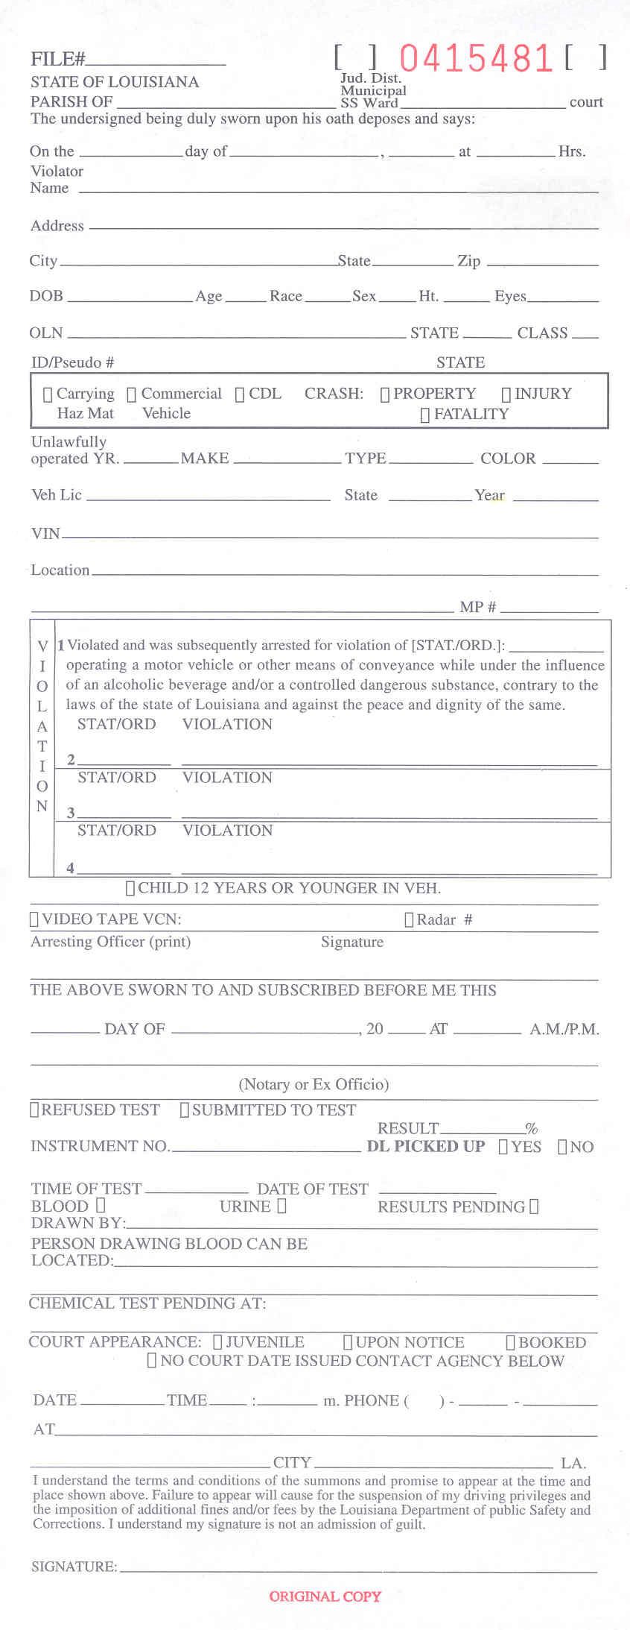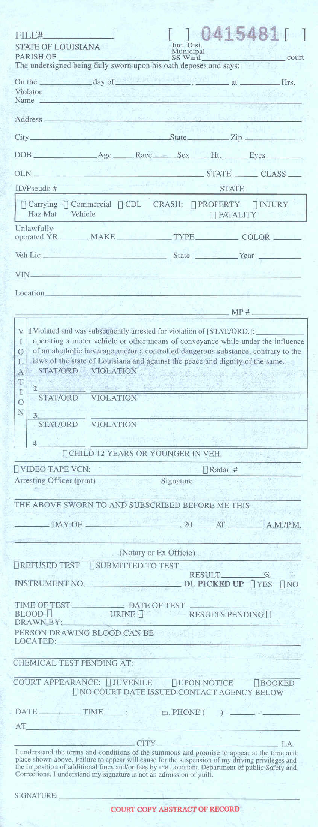

Uniform DWI Arrest Citation / DWI Long Arrest Form (DPSSP 6622) – Page 3 and 4
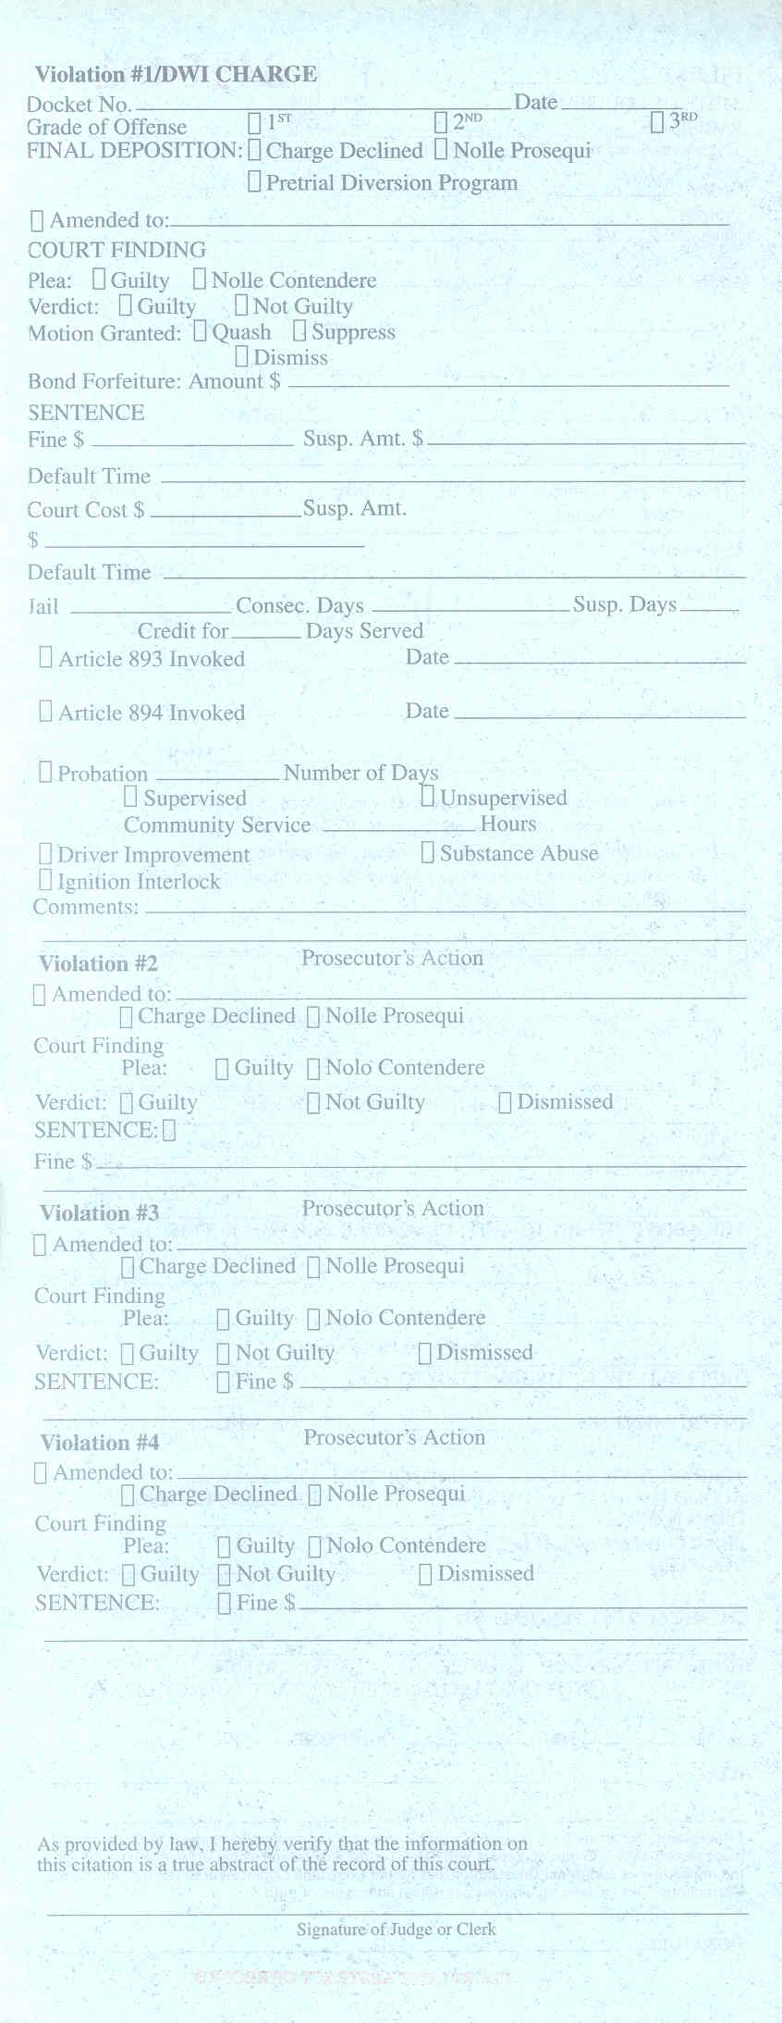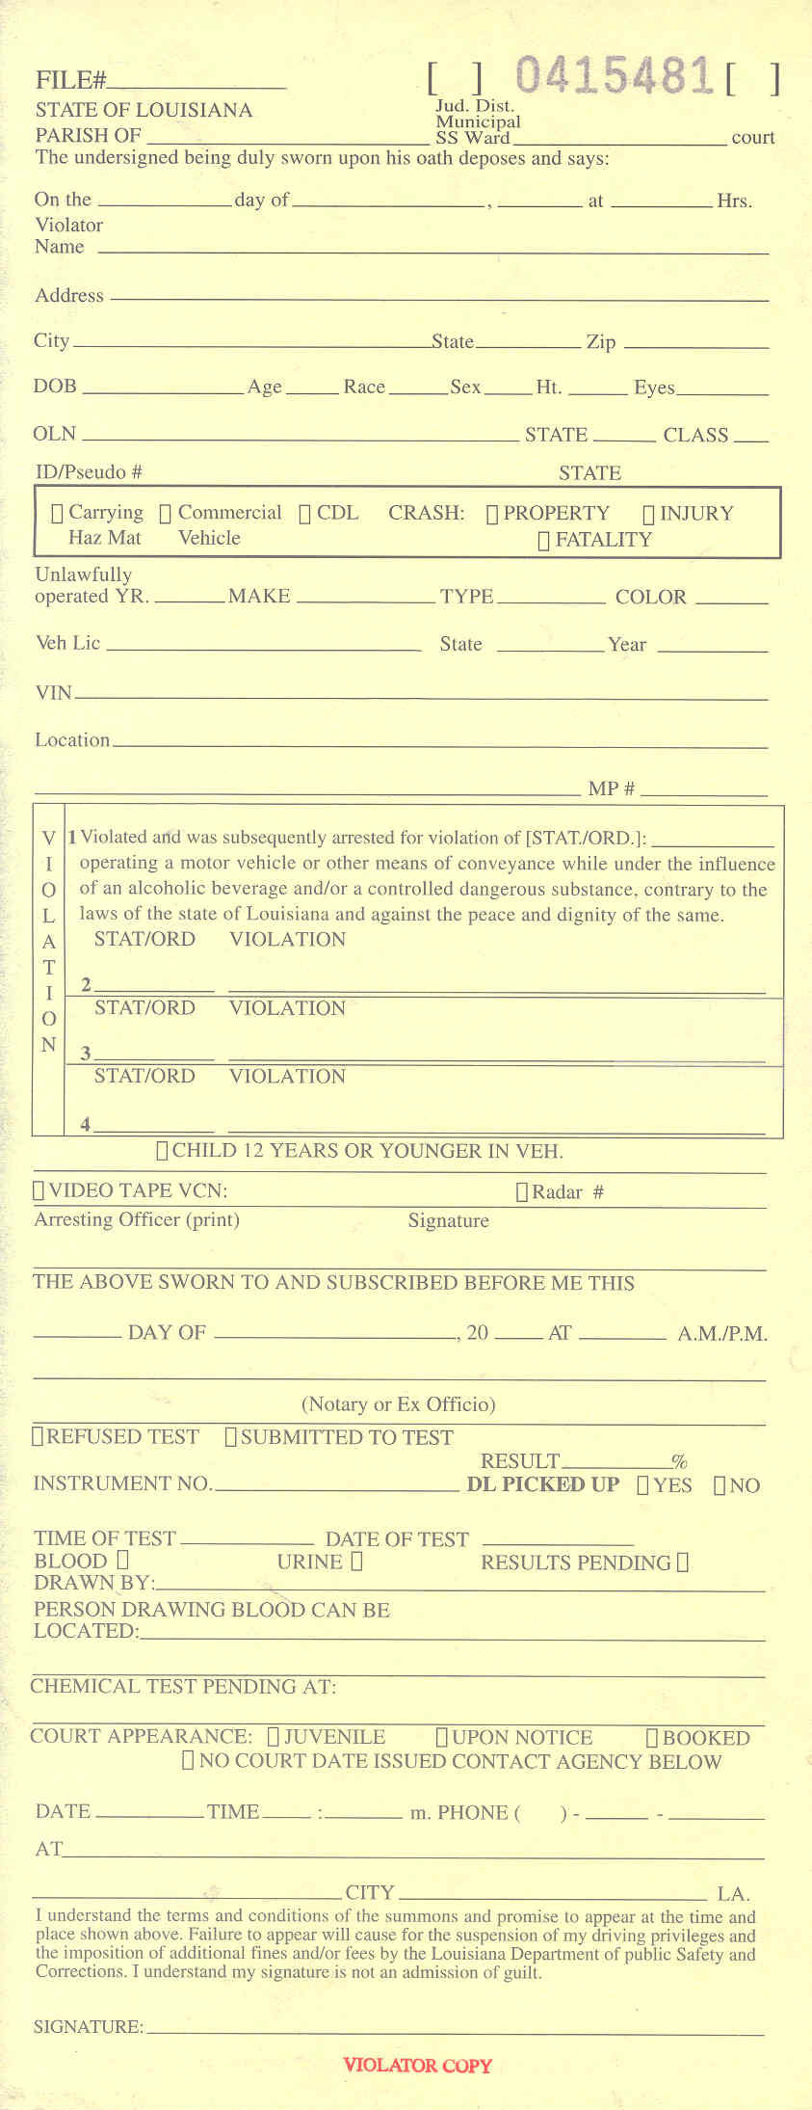

Uniform DWI Arrest Citation / DWI Long Arrest Form (DPSSP 6622) – Page 5

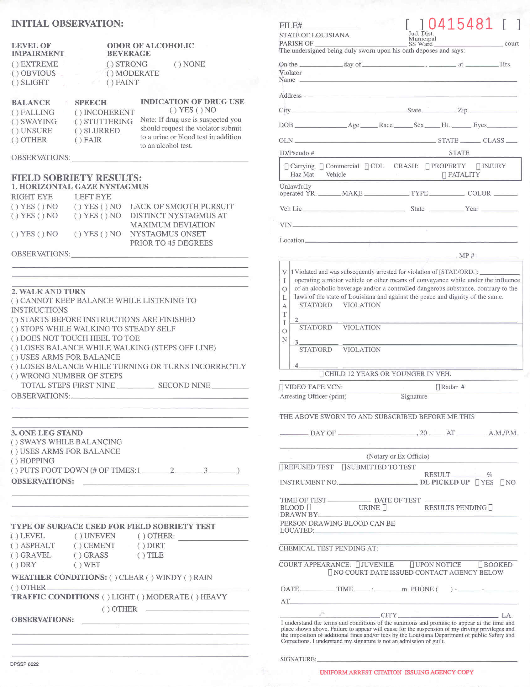

Uniform DWI Arrest Citation / DWI Long Arrest Form (DPSSP 6622) – Page 6

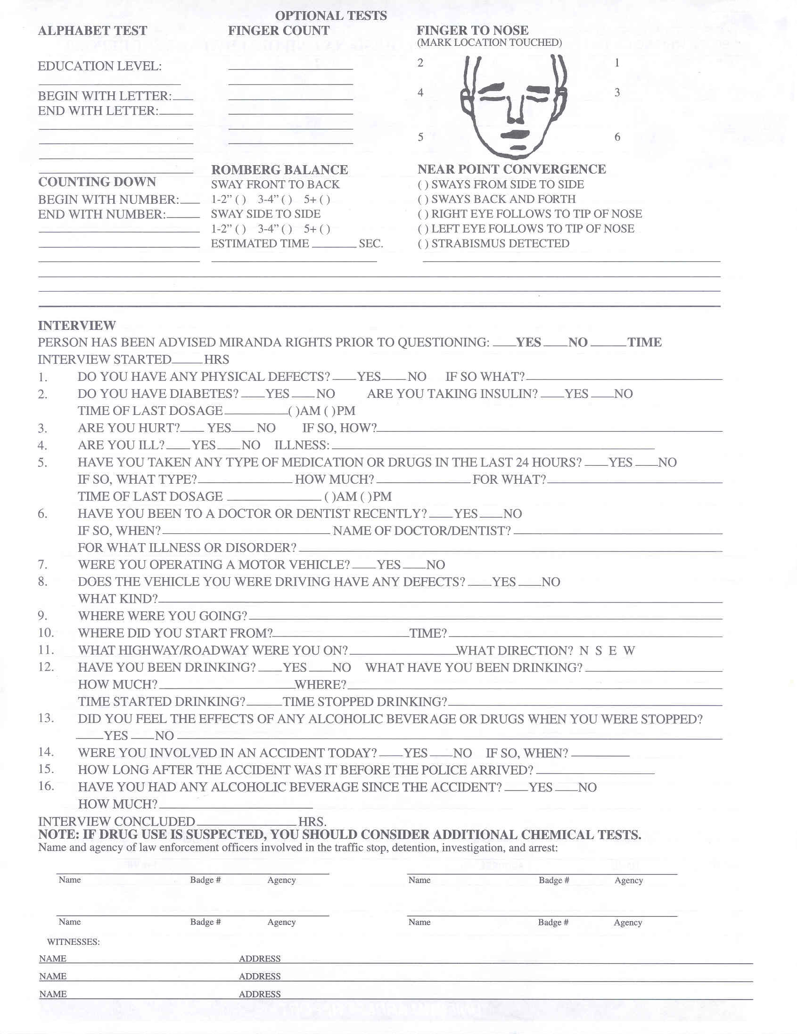

Uniform DWI Arrest Citation / DWI Long Arrest Form (DPSSP 6622) – Page 7

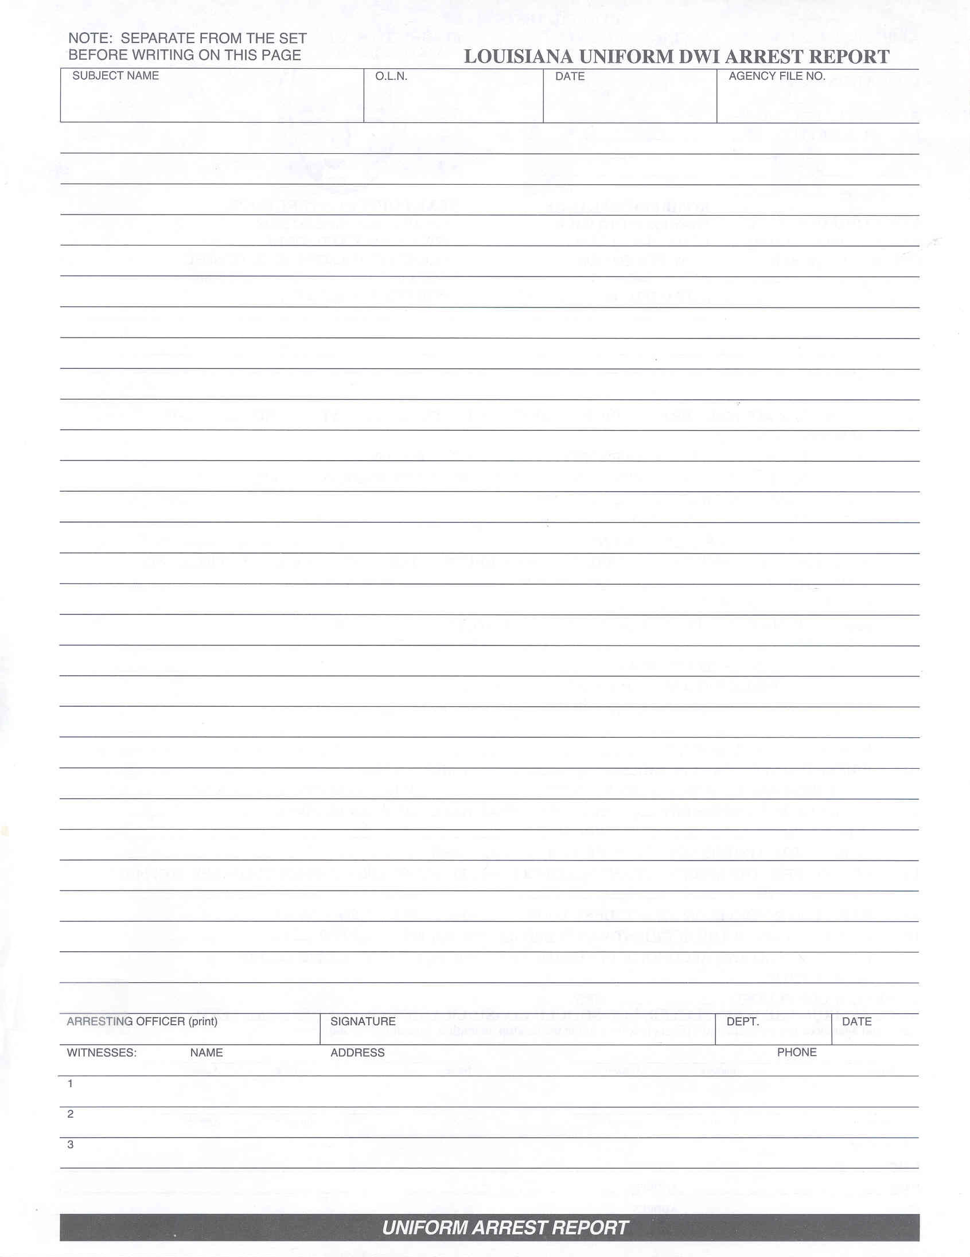

- Required Data Fields for Uniform DWI Arrest Citation / DWI Long Arrest Form

Required Data Fields that shall be entered into the DWI system solution on the Mobile Data Computer or using the Web.

Uniform DWI Arrest Citation / DWI Long Arrest Form (DPSSP 6622) – Pages 1 through 4

Main Entry Information
- File Number – Numeric
- File-Approval-flag – Alpha (P- Pending) (A-Approved)
- Judicial District – Numeric
- Ticket Report Number – Numeric
- Parish Of – Alpha
- Court – Alpha
- Date of Violation – Date
- Month of Violation – Month
- Year Of Violation – Year
- Time of Violation (hrs) – Time
- Violator Name – Alpha
- Violator Address – Alpha Numeric
- Violator City or Town – Alpha
- Violator State – Alpha
- Violator Zip – Numeric
- Violator DOB
- Violator age – Numeric
- Violator race – Alpha
- Violator height – Numeric
- Violator color of eyes – Alpha
- Violators OLN Number – Numeric
- Violator State Issued – Alpha
- Violator Class – Alpha
- Violator Id/Pseudo Number – Alphanumeric
- Violator State Issued – Alpha
- Violator Carrying Hazmat Flag – Checkbox
- Commercial Vehicle Flag – Checkbox
- CDL Flag – Checkbox
- Crash Property – Checkbox
- Crash Injury – Checkbox
- Crash Fatality – Checkbox
- Violator unlawfully operated Year – Numeric
- Violator Make of Vehicle – Alpha
- Violator Type of Vehicle – Alpha
- Violator Color of Vehicle – Alpha
- Violator License Plate Number – Alphanumeric
- Violator Vehicle State – Alpha
- Violator Vehicle Year – numeric
- Violator Vehicle Vin Number – Alphanumeric
- Location of Incident – Alphanumeric
- Milepost Number – Numeric

Violation Information
- Violation/Ordinance1 – Numeric
- Violation1 Description 1 – Standard for all DWI/DUI Arrest
- Violation/Ordinance2 – Numeric
- Violation Description2 – Alphanumeric
- Violation/Ordinance3 – Numeric
- Violation/Description3 – Alphanumeric
- Violation/Ordinance4 – Numeric
- Violation Description4 – Alpha Numeric
- Child under 12 Flag – Checkbox
- Video Tape Flag – Checkbox
- Video Tape Number – Numeric
- Radar Flag – Checkbox
- Radar Unit Number – Numeric
- Arresting Officer print name – Alpha
- Arresting Officer Signature – Alpha
- Notary Day (Day of the Month) – Numeric
- Notary Month – Alpha
- Notary Year – Numeric
- Notary Time – Time
- Notary/Ex-Officio – Alpha

Citation Additional Information
- Refused Test – Checkbox
- Submitted To Test – Checkbox
- Instrument Number – Numeric
- Result per cent – Numeric
- Dl Picked Up Yes – Checkbox
- Dl Picked Up No – Checkbox
- Time Of Test – Time
- Date Of Test – Date
- Blood – Checkbox
- Urine – Checkbox
- Results Pending – Checkbox
- Drawn by – Alpha
- Person Drawing Located Address – Alphanumeric
- Chemical Test Pending At – Alphanumeric
- Court Juvenile – Checkbox
- Court Upon Notice – Checkbox
- Court Booked – Checkbox
- Court Date – Date
- Court Date – Checkbox
- Court Time – Time
- Phone – Numeric Include area-code
- Court Name – Alphanumeric
- Court Address – Alphanumeric
- Court City – Alpha
- Violators Signature – Alpha

Uniform DWI Arrest Citation / DWI Long Arrest Form (DPSSP 6622) – Page 5
This section will be used to enter supporting information from the Citation (DPSC 6622).

Initial Observations
- Level of Impairment Extreme – Checkbox
- Level of Impairment Obvious – Checkbox
- Level of Impairment Slight – Checkbox
- Odor of Alcohol Beverage strong – Checkbox
- Odor of Alcohol Beverage Moderate – Checkbox
- Odor of Alcohol Beverage Faint – Checkbox
- Odor of Alcohol Beverage None – Checkbox
- Balance Falling – Checkbox
- Balance Swaying – Checkbox
- Balance Unsure – Checkbox
- Balance Other – Checkbox
- Speech Incoherent – Checkbox
- Speech Stuttering – Checkbox
- Speech Slurred – Checkbox
- Speech Fair – Checkbox
- Indication of drug use – Checkbox (Y / N)
- Initial Observations – Alphanumeric

Field Sobriety Results
- Lack of Smooth Pursuit Right Eye – Check Box (Y / N)
- Lack of Smooth Pursuit Left Eye – Check Box (Y / N)
- Distinct Nystagmus at Maximum Deviation Right Eye – Check Box (Y / N)
- Distinct Nystagmus at Maximum Deviation Left Eye – Check Box (Y / N)
- Nystagmus Onset Prior to 45 Degrees Right Eye – Check Box (Y / N)
- Nystagmus Onset Prior to 45 Degrees Left Eye – Check Box (Y / N)
- Field Sobriety Observations – Alphanumeric
- Walk and turn cannot keep balance while list to instructions – Check Box
- Starts before instructions are finished – Checkbox
- Stops By Walking To Steady Self – Checkbox
- Does Not Touch heal To Toe – Checkbox
- Loses Balance While Walking (Steps Off Line) – Checkbox
- Uses Arms For Balance – Checkbox
- Loses balance While Turning Or Turns Incorrectly – Checkbox
- Wrong Number Of Steps – Checkbox
- Total Steps First Nine – Numeric
- Second Nine – Numeric
- Walk And Turn Observations – Alphanumeric
- One Leg Stand Sways while Balancing – Checkbox
- One leg Stand Uses Arms For Balance – Checkbox
- One Leg Stand Hopping – Checkbox
- Puts Foot Down Number of Times1 – Numeric
- Puts Foot Down Number of Times2 – Numeric
- Puts Foot Down Number of Times3 – Numeric
- Leg stand Observations – Alphanumeric
- Type of Surface Level – Checkbox
- Type of Surface Asphalt – Checkbox
- Type of Surface Gravel – Checkbox
- Type of Surface Dry – Checkbox
- Type of Surface Uneven – Checkbox
- Type of Surface Cement – Checkbox
- Type of Surface Grass – Checkbox
- Type of Surface Wet – Checkbox
- Type of Surface Other – Checkbox
- Type of Surface Dirt – Checkbox
- Type of Surface Tile – Checkbox
- Weather Conditions Clear – Checkbox
- Weather Conditions Windy – Checkbox
- Weather Conditions Rain – Checkbox
- Weather Conditions Other – Checkbox
- Traffic Conditions Light – Checkbox
- Traffic Conditions Moderate – Checkbox
- Traffic Conditions Heavy – Checkbox
- Traffic Conditions Other – Checkbox
- Traffic Observations – Alphanumeric

Uniform DWI Arrest Citation / DWI Long Arrest Form (DPSSP 6622) – Page 6
This section will be used to enter optional test information.

Optional Test Information
Alphabet Test
- Educational Level – Alphanumeric
- No High School – Checkbox
- GED – Checkbox
- High School Graduate – Checkbox
- Some College – Checkbox
- Two Year Degree – Checkbox
- Four Year Degree – Checkbox
- Beyond Four Degree – Checkbox
- Begin Letter – Alpha
- End-letter – Alpha
- Counting Down Begin Number – Numeric (Person may begin with 100)
- Count Down End Number – Numeric (Person may begin with 100)
- Count Comments – Alphanumeric
- Finger Count – Numeric
- Romberg Balance Sway FTB 1-2 – Checkbox
- Romberg Balance Sway FTB 3-4 – Checkbox
- Romberg Balance Sway FTB 5+ – Checkbox
- Romberg Balance Sway STS 1-2 – Checkbox
- Romberg Balance Sway STS 3-4 – Checkbox
- Romberg Balance Sway STS 5+ – Checkbox
- Estimated Time in seconds – Numeric
- Romberg comments – Alphanumeric

Finger to Nose Test
- Finger To Nose Location 2 – Checkbox
- Finger To Nose Location 1 – Checkbox
- Finger To Nose Location 4 – Checkbox
- Finger To Nose Location 3 – Checkbox
- Finger To Nose Location 5 – Checkbox
- Finger To Nose Location 6 – Checkbox

Near Point Convergence Test
- Sways From Side To Side – Checkbox
- Sways Back And Forth – Checkbox
- Right Eye Follows To Tip Of Nose – Checkbox
- Left Eye Follows To Tip Of Nose – Checkbox
- Strabismus Detected – Checkbox
- Near Point Convergence Comments – Alphanumeric

Interview
This section will be used to add Interview information on the person.

- Person advised of Miranda rights – Checkbox (Yes/No)
- Time of Rights – Numeric
- Interview Started – Time
- Diabetes – Checkbox (Yes/No)
- Are you Taking Insulin – Checkbox (Yes/No)
- Time of last Dosage – Numeric
- Diabetes AM PM – Checkbox
- Are You Hurt – Checkbox (Yes/No)
- If So How – Alphanumeric
- Are You Ill – Checkbox (Yes/No)
- Person response Illness – Alpha
- Medication question – Checkbox (Yes/No)
- What Type – Alpha
- How Much – Alphanumeric
- For What Comment – Alpha
- Time of Last Dosage – Numeric
- Medication AM PM – Numeric
- Doctor or Dentist Question – Checkbox (Yes/No)
- If so When Response – Alphanumeric
- Name of Dr or Dentist – Alpha
- Dentist Illness – Alpha
- Where you operating a motor Vehicle – Checkbox (Yes/No)
- Does the vehicle have any Defects – Checkbox (Yes/No)
- Vehicle defects Explained – Alphanumeric comments
- Question where were you going – Alpha
- Question Where Did You Start From – Alpha
- Time you started from – Time
- Question What Highway Roadway were you going on – Alpha
- Question What Direction – Checkbox (N,S, E, W)
- Question Have You Been Drinking Check-box
- What Have You Been Drinking Beer – Checkbox
- What Have You Been Drinking Wine – Checkbox
- What Have You Been Drinking Whiskey – Checkbox
- What Have You Been Drinking Other Alcohol Beverage – Checkbox
- What Have You Been Drinking Drugs – Checkbox
- What Have You Been Drinking Combination Drugs Alcohol – Checkbox
- What Have You Been Drinking Other – Checkbox
- How Much Have You Been Drinking
- Number of Bottles – Numeric
- Number of Shots – Numeric
- Number of Glasses – Numeric
- Number of Pills – Numeric
- Number of Doses/Hits – Numeric
- Where Did You Have Your last Drink
- Home – Checkbox
- Bar – Checkbox
- Restaurant – Checkbox
- Friends Party – Checkbox
- Sports Event – Checkbox
- Fishing – Checkbox
- Hunting – Checkbox
- Boating – Checkbox
- Time Started Drinking – Numeric
- Time Stopped Drinking – Numeric
- Question on Do You Feel The Effects – Checkbox (Yes/No)
- Do You Feel the Effects Comments – Alpha
- Question Where You Involved In An Accident Today – Checkbox (Y/N)
- Accident Time Response – Alphanumeric
- Question How Long Did It Take Police To Arrive – Alpha
- Question Have You Had Any Alcohol Since The Accident – checkbox
- Response on How Much Alcohol – Alpha (Allow for Comments)
- Interview Concluded – Numeric
- Officer1 Name – Alpha
- Officer1 Badge Number – Numeric
- Officer1 Agency – Alpha
- Officer2 Name – Alpha
- Officer2 Badge Number – Numeric
- Officer2 Agency – Alpha
- Interview Witness-1 Name – Alpha
- Interview Witness Address1 – Alphanumeric
- Interview Witness-2 Name – Alpha
- Interview Witness Address2 – Alphanumeric
- Interview Witness-3 Name – Alpha
- Interview Witness Address3 – Alphanumeric

Estimated Economical Level
- Less Than 9999 Welfare – Checkbox
- 10000 To 14999 – Checkbox
- 15000 To 24999 – Checkbox
- 25000 To 34999 – Checkbox
- 35000 To 49999 – Checkbox
- 50000 To 74999 – Checkbox
- 75000 To 99999 – Checkbox
- 100000 To 149999 – Checkbox
- 150000 To 199999 – Checkbox
- 200000 And Above – Checkbox

DWI Long Arrest Form (DPSSP 6622) – Page 7
This section can be used to add the Officers detailed arrest report information.

- Subject Name – Alpha
- Subject OLN – Numeric
- Date Of Arrest – Date
- Agency File Number – Alphanumeric
- Arrest Report Detail Comments – Alpha
- Arresting Officer Print – Alpha
- Arresting Officer Signature – Alpha
- Dept – Alpha
- Date Arrest Form – Date
- Arrest Witness Name1 – Alpha
- Arrest Witness Address1 – Alphanumeric
- Arrest Phone1 – Numeric
- Arrest Witness Name2 – Alpha
- Arrest Witness Address2 – Alphanumeric
- Arrest Phone2 – Numeric
- Arrest Witness Name3 – Alpha
- Arrest Witness Address3 – Alphanumeric
- Arrest Phone3 – Numeric

Arrestee’s Rights Form (DPSSP 6621

Intoxilyzer 5000 Operational Checklist Form (DPSSP 4634) – Page 1
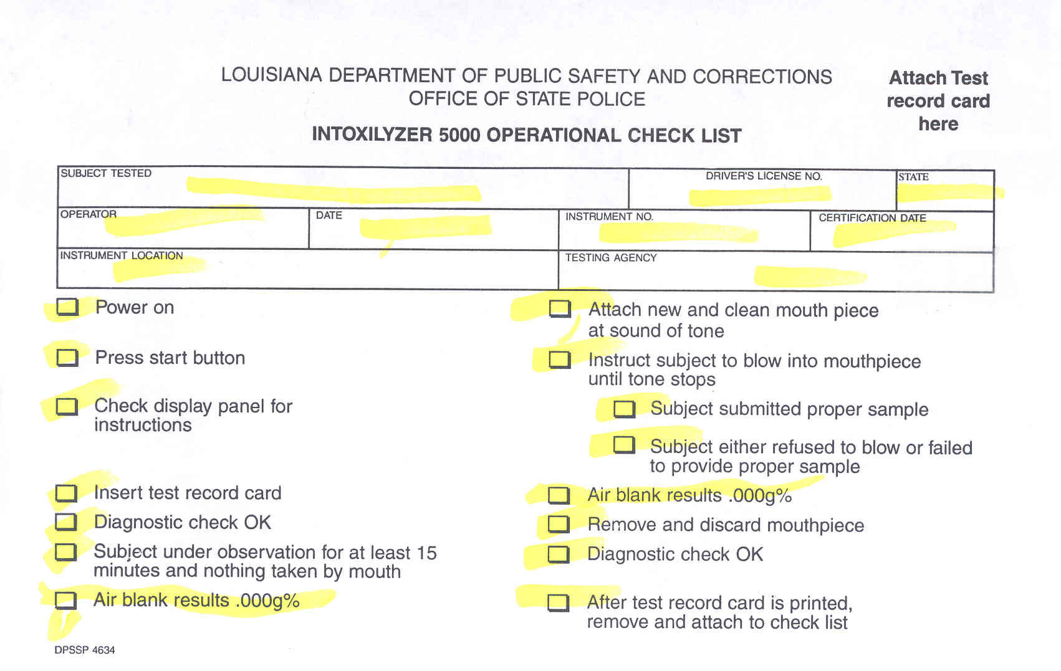

Intoxilyzer 5000 Operational Checklist Form (DPSSP 4634) – Page 2
CMI Test Results Printout

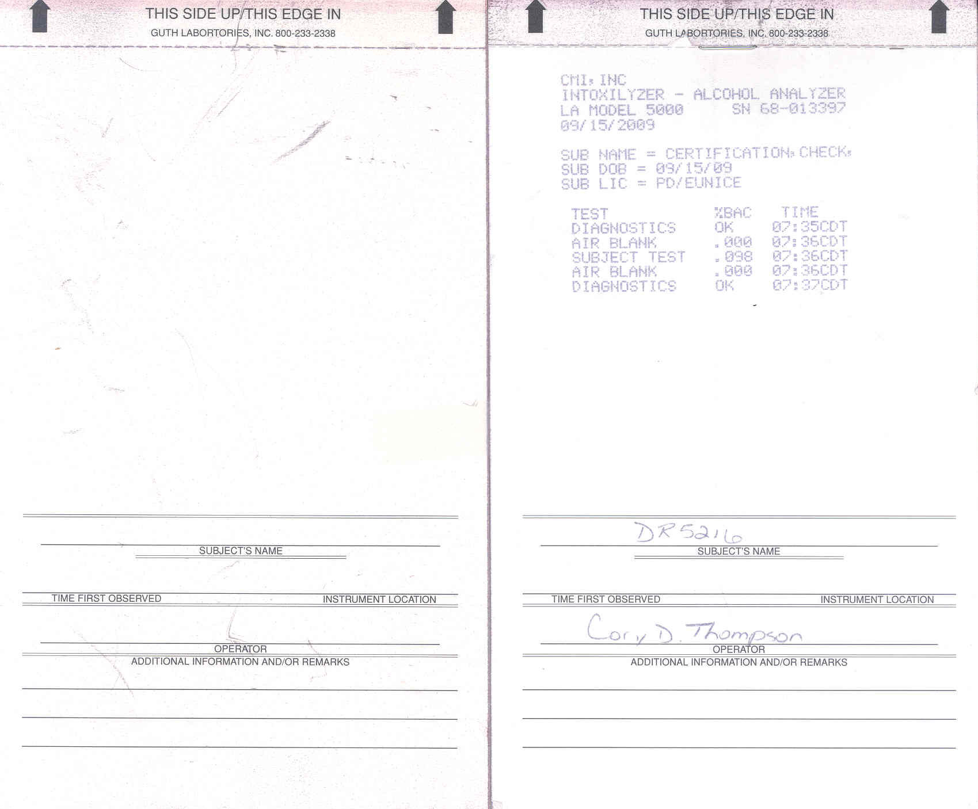

- Required Data Fields for Intoxilyzer 5000 Operational Checklist Form (DPSSP 4634)

Required Data Fields that shall be entered into the DWI system solution on the Mobile Data Computer or using the Web.

Intoxilyzer 5000 Operational Checklist Form (DPSSP 4634) – Page 1
- Subject Name / Tested – Alpha
- Drivers License Number – Numeric
- Driver State – Alpha
- Intox Operator – Alpha
- Date of Test – Date
- Instrument Number / Serial Number – Alphanumeric
- Certification Date – Date
- Instrument Location – Alphanumeric
- Testing Agency – Alpha
- Power On – Checkbox
- Press Start Button – Checkbox
- Check Display Panel for Instructions – Checkbox
- Insert Test record Card – Checkbox
- Diagnostic Check OK – Checkbox
- Subject Under Observation For 15 Minutes – Checkbox
- Air Blank results 1 – Checkbox
- Attach New And Clean Mouthpiece at Sound of Tone – Checkbox
- Instruct subject to blow into Mouthpiece Subject submitted – Checkbox
- Subject Refused to Blow Or Failed to Provide Proper Sample – Checkbox
- Air Blank results 2 – Checkbox
- Remove and Discard Mouthpiece – Checkbox
- Check box for after card is printed

Intoxilyzer 5000 Operational Checklist Form (DPSSP 4634) – Page 2
- Sub Name – Alpha
- Sub DOB _ Numeric
- Sub Lic – Alpha
- Test Diagnostics1 % Bac – Alpha
- Test Diagnostics1 Time – Numeric (07:35CDT)
- Test Air Blank1 %Bac – Numeric (.000)
- Test Air Blank1 Time – Numeric (07:36CDT)
- Subject Test %Bac – Numeric (.098)
- Subject Test Time – Numeric (07:35CDT)
- Test Air Blank2 %Bac – Numeric (.000)
- Test Air Blank2 Time – Numeric (07:36CDT)
- Test Diagnostics2 % Bac – Alpha
- Test Diagnostics2 Time – Numeric (07:35CDT)
- Subject Name – Alpha
- Time First Observed – Alphanumeric
- Instrument Location – Alpha
- Signature of Operator – Alpha
- Additional Information Narrative – Alpha

- Uniform Traffic Summons (DPSSP 3101) –
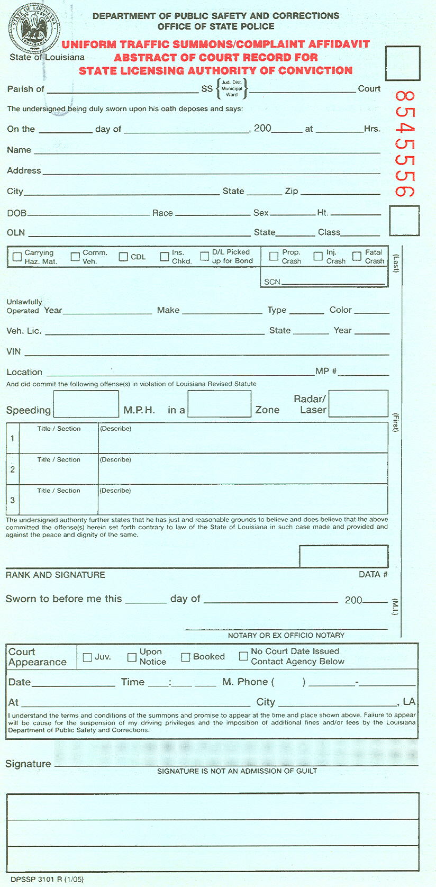

- Required Data Fields for Uniform Traffic Summons Form (DPSSP 3101)

Required Data Fields that shall be entered into the DWI system solution on the Mobile Data Computer or using the Web.

  - Audit Number – Numeric
  - Approval-flag - Alpha
  - Parish Of – Alpha
  - SS – Checkbox (Value JUD Dist, Municipal, Ward)
  - Court – Alpha
  - Day – Numeric
  - Month – Alpha
  - Year – Numeric
  - Hours – Numeric
  - Name – Alpha
  - Address – Alpha
  - City – Alpha
  - State – Alpha
  - Zip – Numeric
  - DOB – Numeric
  - Race – Alpha
  - Sex – Alpha
  - HT – Numeric
  - OLN – Alpha-Numeric
  - State License Issued – Alpha
  - Class – Alpha
  - Carrying Haz Mat – Checkbox
  - Comm Vehicle – Checkbox
  - CDL – Checkbox
  - Ins Check – Checkbox
  - DL picked up for Bond – Checkbox
  - Prop Crash – Checkbox
  - INJ Crash – Checkbox
  - Fatal Crash – Checkbox
  - SCN – Numeric
  - Unlawfully operated Year – Numeric
  - Unlawfully operated Make – Alpha
  - Unlawfully operated Type – Alpha
  - Unlawfully operated Color – Alpha
  - Vehicle License – Alphanumeric
  - Vehicle State – Alpha
  - Vehicle Year – Numeric
  - VIN – Alphanumeric
  - Location – Alphanumeric
  - MP – Numeric
  - Speeding – Numeric
  - In A Zone – Alpha
  - Radar/Laser – Numeric
  - Title section1 – Alphanumeric (Description would have to be displayed for copy given to driver)
  - Title section2 – Alphanumeric (Description would have to be displayed for copy given to driver)
  - Title section3 – Alphanumeric (Description would have to be displayed for copy given to driver)
  - Rank and signature – Alphanumeric
  - Data Number – Numeric
  - Court Appearance Upon Notice – Checkbox
  - Court Appearance Booked – Checkbox
  - No Court Appearance Contact agency – Checkbox
  - Date of Court- Numeric
  - Time – Numeric
  - MPhone – Numeric (Include area code)
  - Court Address – Alphanumeric
  - Court City – Alpha
  - Signature of Defendant – Alpha
  - Special Note Information that has already been entered on form shall be used to create the Temporary Operators Permit when operator’s license is taken in Lieu of bond (Requirement listed on page 4 Of the Document)

ATTACHMENT VIII: Judicial Districts


